 | CENTRAL BOARD OF SECONDARY EDUCATION

JAWAHAR NAVODAYA VIDYALAYA
TARIKHET ALMORA UTTARAKHAND 263663
INFORMATION TECHNOLOGY (402)
PROJECT FILE
On
HOSPITAL MANAGEMENT SYSTEM
LIBRE OFFICE BASE & WRITER
SUBMITTED BY :
S. No | Name | CBSE Roll
1.
2.
3.
4.

CLASS : X
SECTION(A/B) :

INTERNAL EXAMINER  (PANKAJ BHILINGWAL) |  | PRINCIPAL  (PANKAJ KUMAR SRIVASTAVA)

ACKNOWLEDGEMENT
First of all, I thank my teacher Pankaj Bhilingwal Sir, PGT Computer Science, J.N.V Tarikhet Almora. He explained databases to us in a very easy way and guided us at every step of this project.
I am grateful to our principal Pankaj Kumar Srivastava Sir, who always encourages us and gave us the computer lab to do our work.
Last but not least, I thank my family and my project partners. Without their help and teamwork we could not have finished this Hospital Management System.

NAME :
S. No | Name | CBSE Roll
1.
2.
3.
4.

CLASS : X
SECTION(A/B) :

CERTIFICATE
This is to certify that,
S. No | Name | CBSE Roll
1.
2.
3.
4.
Certified that the students named above, of Class X, J.N.V Tarikhet Almora, have made this project on “Hospital Management System” by themselves in the session 2026-27. They worked sincerely on it under my guidance for the Information Technology (402) project of CBSE.

Internal Examiner
Signature

PREFACE
A hospital has to keep the records of many patients and doctors every day. Writing names, booking appointments and keeping bills on paper is slow, and papers can get lost. If all this is saved in a computer database, it stays safe and can be found easily.
LibreOffice Base is an important part of our Class X Information Technology (402) syllabus. To use what we learnt in the session 2026-27, we made a Hospital Management System that keeps the records of patients, doctors and appointments.
While making this project we understood how tables are joined and how forms, queries and reports make a database easy to use. We thank everyone who helped us.

INDEX
Table of Contents
About Project 5
Introduction: 5
Objective: 5
System Components: 5
Database Design: 5
System Functionality: 5
System Implementation: 6
Challenges Faced: 6
Future Enhancements: 6
Conclusion: 6
Table : Relationship 7
Table Creation Steps 8
Query Creation Steps 11
Form Creation Steps 13
Report Generation Steps 18
Final Report 22
Technological requirements: Hardware & Software 23
Software 23
Hardware 23
References 24

About Project
Introduction:
Our project is a Hospital Management System. When we visit a hospital, the person at the reception writes our name, finds a doctor for us and gives us a slip. We thought of doing this work on the computer. In this project we have made a database in LibreOffice Base to keep the records of patients, doctors and their appointments.
Objective:
- To keep the record of every patient who comes to the hospital.
- To save the details of doctors, what they treat and their fee.
- To book an appointment of a patient with a doctor.
- To keep the bill amount of each appointment.
- To make the work of the reception easy and quick.
System Components:
The system consists of 3 main tables:
1. Patients Table:
- Fields: PatientID (Primary Key), PatientName, Gender, Age, BloodGroup, Address, Phone.
2. Doctors Table:
- Fields: DoctorID (Primary Key), DoctorName, Specialization, Phone, ConsultationFee, AvailableDays.
3. Appointments Table:
- Fields: AppointmentID (Primary Key), PatientID (Foreign Key referencing Patients Table), DoctorID (Foreign Key referencing Doctors Table), AppointmentDate, AppointmentTime, Problem, Status, BillAmount.
Database Design:
1. Patients Table:
- It keeps the details of the patients.
- PatientID is the primary key, so every patient has a different ID.
- BloodGroup is useful in an emergency.
2. Doctors Table:
- It keeps the details of the doctors.
- DoctorID is the primary key.
- ConsultationFee is the fee of the doctor.
3. Appointments Table:
- It keeps the appointments of patients with doctors.
- AppointmentID is the primary key.
- PatientID and DoctorID are foreign keys. They join this table with the Patients and Doctors tables.
System Functionality:
Patient Records:
- A new patient is added with name, gender, age, blood group, address and phone number.
- The details of a patient can be searched and changed using the form.
Doctor Records:
- Each doctor is saved with what he or she treats, phone number, fee and the days the doctor is available.
Appointments:
- An appointment is booked for a patient with a doctor on a date and time.
- We can see if the appointment is Scheduled, Completed or Cancelled.
- The bill amount of every appointment is saved.
System Implementation:
- We used LibreOffice Base with its built-in HSQLDB database.
- The Patients, Doctors and Appointments tables are joined by foreign keys in the Appointments table.
- An SQL query shows every appointment with the patient's name and the doctor's name.
- A form helps to add new patients and a report shows the appointments of each doctor.
Challenges Faced:
- Deciding which fields should go in which table was a little confusing in the beginning.
- We had to check that every appointment had a correct PatientID and DoctorID.
- Entering date and time in the right format took practice.
Future Enhancements:
- A medicine table can be added to print the prescription.
- Patients can get an SMS before their appointment.
- Beds and wards for admitted patients can also be added.
Conclusion:
This project helped us understand how hospitals can use computers to save time. With our Hospital Management System the details of patients, doctors and appointments are kept safely and can be found quickly. We learnt a lot while making it as a team.

Table : Relationship
This picture is from Tools > Relationships. It shows how our tables are joined. A patient can come for many appointments and a doctor can see many patients. So the Appointments table is on the “n” side of both the lines.
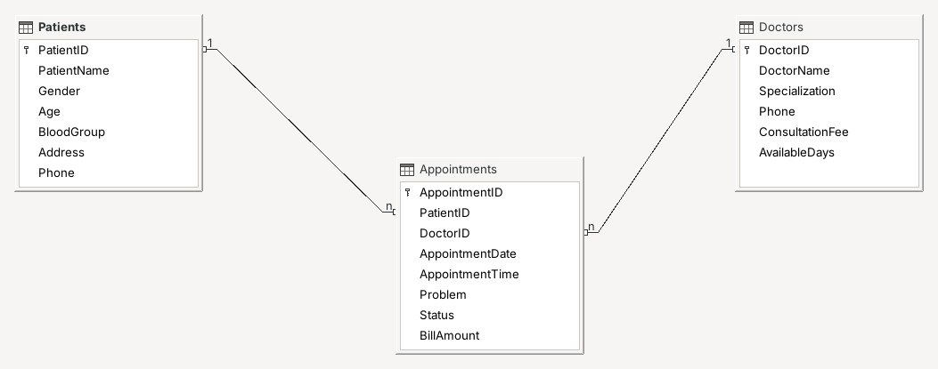

Table Creation Steps
We made the tables of our Hospital Management System in the Table Design window. Here is how we did it, step by step:
1. Start the Database Wizard:
- Open LibreOffice Base. The Database Wizard opens by itself.
- Choose “Create a new database” and click “Next”.
2. Save the Database:
- Click “Finish”.
- Type the file name “Hospital.odb” and click “Save”.
3. Open Design View:
- Click “Tables” in the Database box.
- Click “Create Table in Design View...” (marked in red).
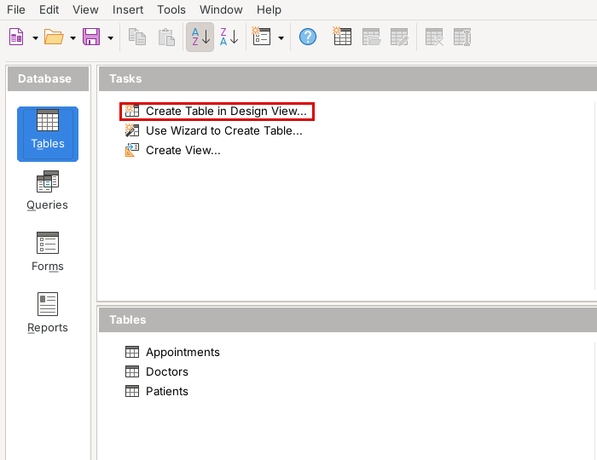
4. Type the Fields:
- Write the field names such as PatientID, PatientName, Gender and Age.
- Select the type of each field from the Field Type list.
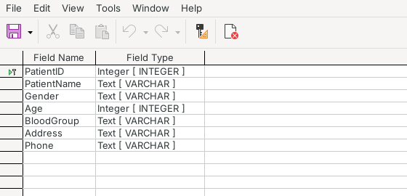
Patients Table – Design View
5. Make PatientID the Primary Key:
- Right-click on the small grey box before PatientID and choose “Primary Key”.
6. Save the Table:
- Click the Save button, write “Patients” as the table name and click “OK”.
In the same way we made the Doctors and Appointments tables. Their design is given here:
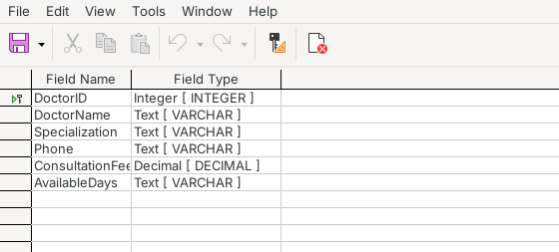
Doctors Table – Design View
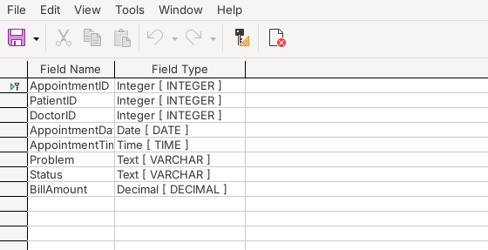
Appointments Table – Design View
7. Fill the Data:
- Open each table by double-clicking on it.
- Type the details of patients, doctors and appointments in the rows.
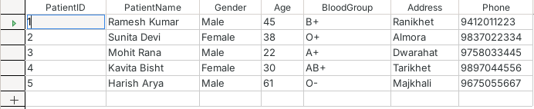
Patients Table
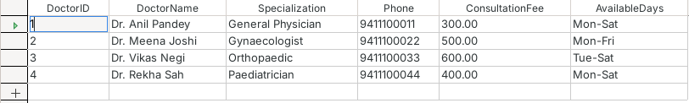
Doctors Table
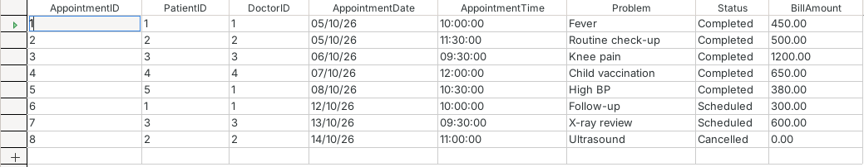
Appointments Table

Query Creation Steps
Queries help us to get answers from the database. At the reception they need to see the patient's name and the doctor's name for each appointment. So we wrote an SQL query which shows the patient's name, the doctor's name, the date, the problem, the status and the bill by taking data from the Patients, Doctors and Appointments tables together.
1. Click on Queries:
- Select “Queries” in the left box.
2. Open the SQL Window:
- Click “Create Query in SQL View...” in the Tasks list.
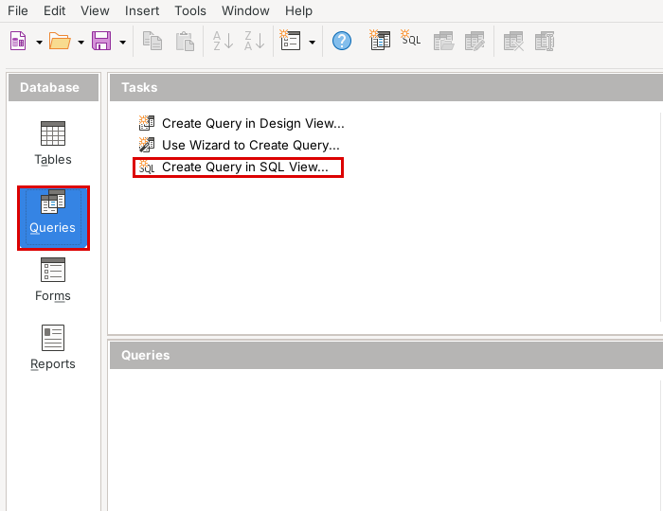
3. Write the Query:
- Type this SQL command. It joins the Appointments table with the Patients and Doctors tables:
SELECT "Patients"."PatientName",
"Doctors"."DoctorName",
"Appointments"."AppointmentDate",
"Appointments"."Problem",
"Appointments"."Status",
"Appointments"."BillAmount"
FROM "Appointments",
"Patients",
"Doctors"
WHERE "Appointments"."PatientID" = "Patients"."PatientID"
AND "Appointments"."DoctorID" = "Doctors"."DoctorID"
ORDER BY "Appointments"."AppointmentDate"
4. Run It:
- Click the Run Query button or press F5 to see the result.
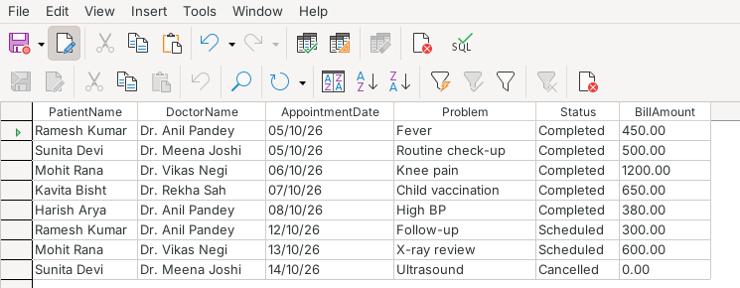
Appointment_Details_Query – Result
5. Save It:
- Save the query with the name “Appointment_Details_Query”. It now shows in the list of queries.
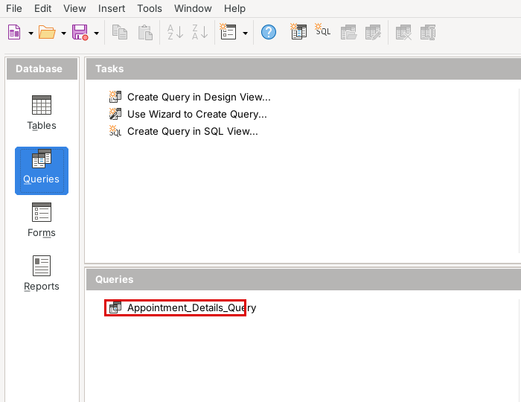

Form Creation Steps
To add new patients easily, we made a form with the Form Wizard. The form shows one patient at a time and has buttons at the bottom to move from one record to another:
1. Click on Forms:
- Open Hospital.odb and click the “Forms” icon.
2. Start the Wizard:
- Click “Use Wizard to Create Form...”. The Form Wizard opens.
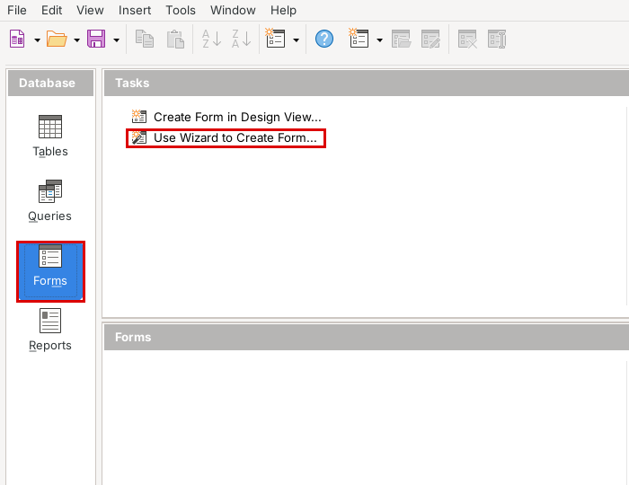
3. Select the Fields:
- In “Tables or queries” choose “Table: Patients”.
- Press >> to add all the fields and click “Next”.
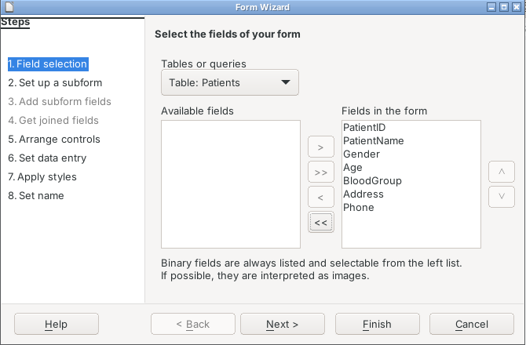
4. Subform:
- We do not need a subform, so just click “Next”.
5. Arrange Controls:
- Click the first layout, “Columnar – Labels Left”.
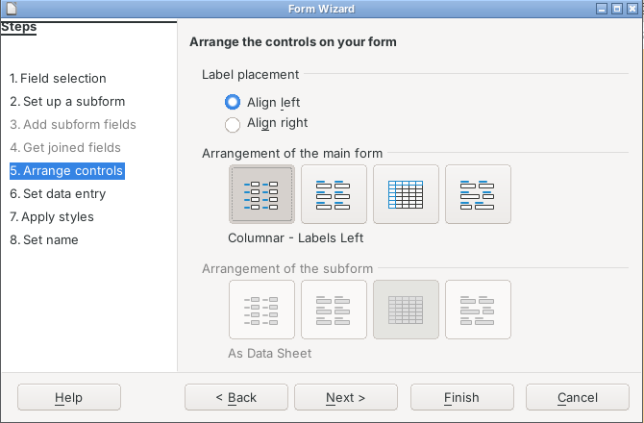
6. Give the Form a Name:
- Name it “Patients_Form” and keep “Work with the form” selected.
- Click “Finish”.
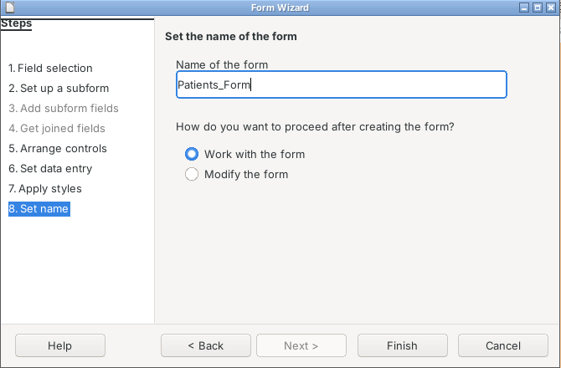
7. Add Patients:
- The form shows one patient at a time. We can add a new patient and save it with the Save Record button (red box).
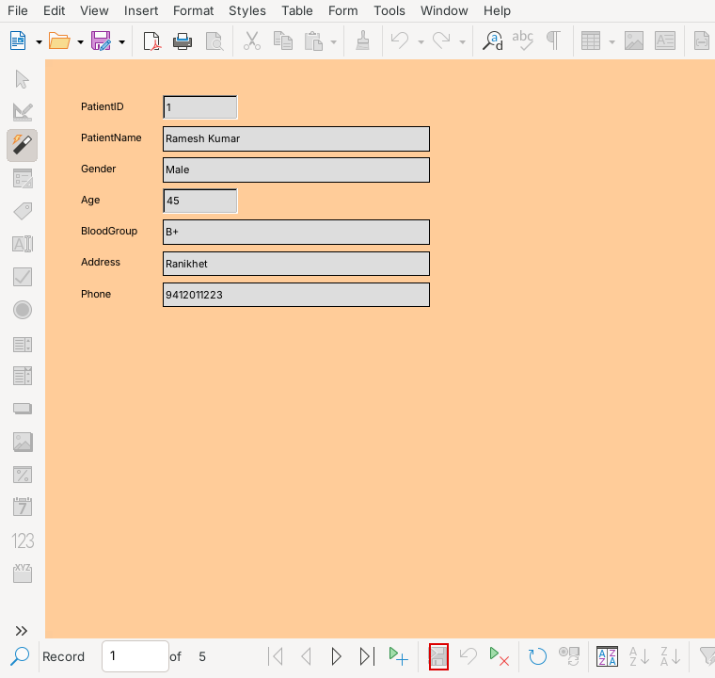
Patients_Form
8. Save the Database:
- The form is now in the Forms list. Click File > Save.
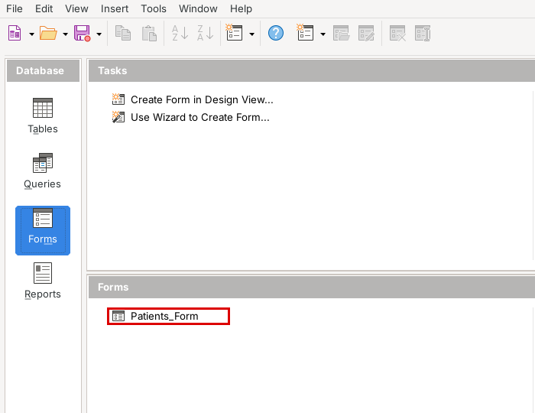

Report Generation Steps
The hospital needs a printed list of appointments for each doctor. We made this report with the Report Wizard like this:
1. Click on Reports:
- Choose “Reports” in the left box.
2. Open the Report Wizard:
- Click “Use Wizard to Create Report...”.
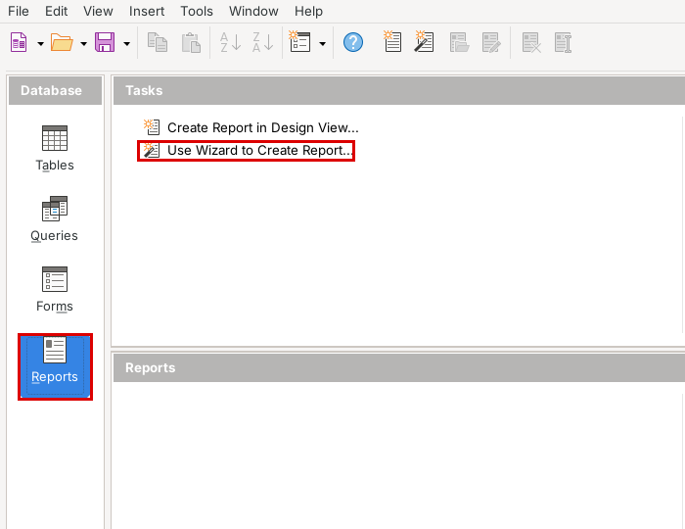
3. Select the Fields:
- Choose “Table: Appointments” and add all the fields with the >> button.
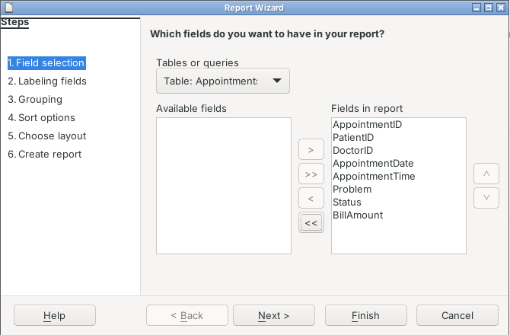
4. Labels:
- Click “Next” to keep the field names as labels.
5. Grouping:
- Move DoctorID to Groupings so that the appointments of each doctor come together.
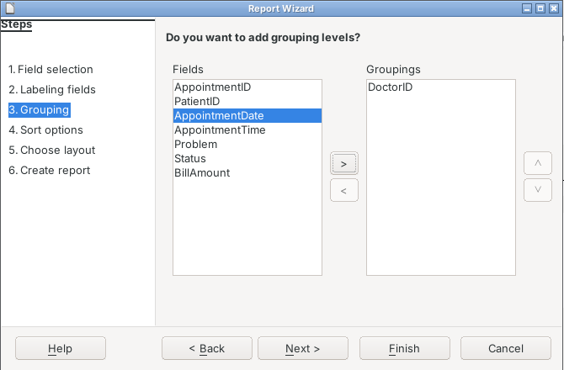
6. Sorting:
- Click “Next”.
7. Layout:
- Choose “Tabular” and Landscape page.
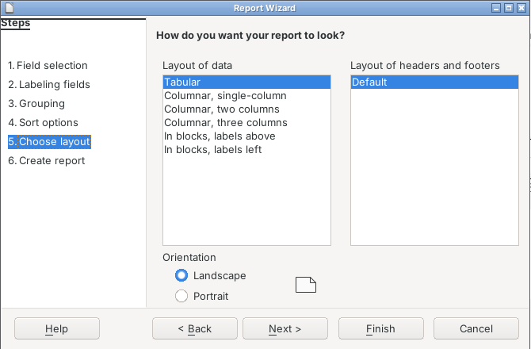
8. Create the Report:
- Write the title “Appointments_Report”.
- Choose “Dynamic report” so it always shows the latest data, and click “Finish”.
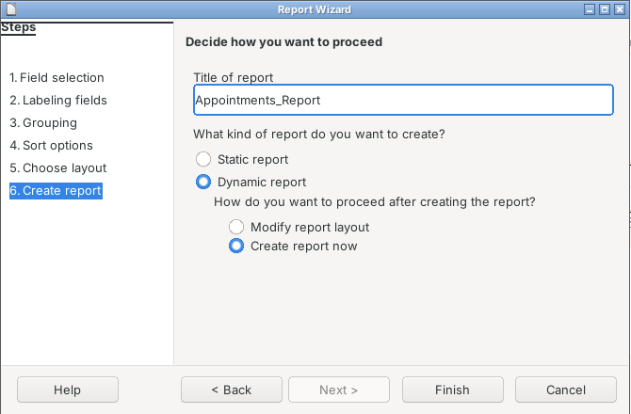
9. Open the Report:
- The report is saved in the Reports list. Double-click it whenever we need the latest list.
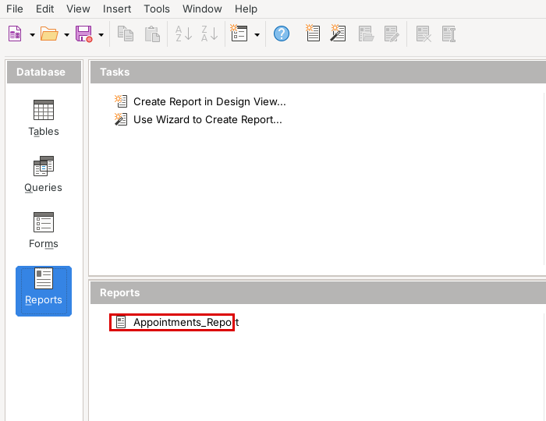

Final Report
Appointment Report
Here is the appointment report made by LibreOffice Base. The appointments are grouped by DoctorID, so we can easily see which patients each doctor has.
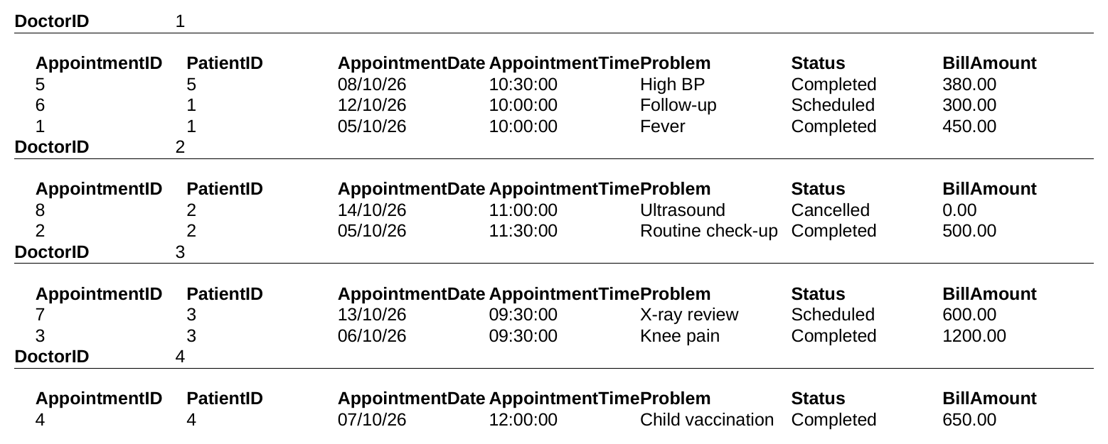

Technological requirements: Hardware & Software
Software
1. LibreOffice Base and LibreOffice Writer
2. Java Runtime Environment (JRE)
3. Snipping Tool / Lightshot for screenshots
Hardware
1. Computer with 4 GB RAM or more
2. Keyboard, mouse and monitor
3. Printer

References
1. https://books.libreoffice.org/en/BG76/BG76.html (Base Guide)
2. https://www.libreoffice.org/
3. https://help.libreoffice.org/latest/en-US/text/shared/explorer/database/02010100.html (Query Design)
4. Information Technology (402) Class X book by CBSE

