 | CENTRAL BOARD OF SECONDARY EDUCATION

JAWAHAR NAVODAYA VIDYALAYA
TARIKHET ALMORA UTTARAKHAND 263663
INFORMATION TECHNOLOGY (402)
PROJECT FILE
On
LIBRARY MANAGEMENT SYSTEM
LIBRE OFFICE BASE & WRITER
SUBMITTED BY :
S. No | Name | CBSE Roll
1.
2.
3.
4.

CLASS : X
SECTION(A/B) :

INTERNAL EXAMINER  (PANKAJ BHILINGWAL) |  | PRINCIPAL  (PANKAJ KUMAR SRIVASTAVA)

ACKNOWLEDGEMENT
I wish to thank our IT teacher Pankaj Bhilingwal Sir, PGT Computer Science, J.N.V Tarikhet Almora, for his help, advice and guidance. He showed us how to use LibreOffice Base and checked our work again and again.
I am thankful to our principal Pankaj Kumar Srivastava Sir and the school for giving us the computer lab and the time to make this project file.
I also thank our librarian, who told us how the school library works, and my classmates and group members who helped me complete this Library Management System.

NAME :
S. No | Name | CBSE Roll
1.
2.
3.
4.

CLASS : X
SECTION(A/B) :

CERTIFICATE
This is to certify that,
S. No | Name | CBSE Roll
1.
2.
3.
4.
This is to certify that the students named above, of Class X, J.N.V Tarikhet Almora, have completed the project file on “Library Management System” during the session 2026-27. They made it themselves under my supervision for the Information Technology (402) project evaluation of CBSE, and their work is satisfactory.

Internal Examiner
Signature

PREFACE
Our school library has hundreds of books and every day many students and teachers borrow and return them. When all this is written in a register, it is difficult to know which book is with whom and whose book is late. A computer can do this work much faster.
LibreOffice Base is a part of our Class X Information Technology (402) syllabus. In the session 2026-27 we used it to make a Library Management System for our school library, with tables, relationships, a query, a form and a report.
We learnt a lot by doing this project ourselves. We would like to thank our teacher, our parents, our friends and our project partners for their help and support.

INDEX
Table of Contents
About Project 5
Introduction: 5
Objective: 5
System Components: 5
Database Design: 5
System Functionality: 5
System Implementation: 6
Challenges Faced: 6
Future Enhancements: 6
Conclusion: 6
Table : Relationship 7
Table Creation Steps 8
Query Creation Steps 11
Form Creation Steps 13
Report Generation Steps 18
Final Report 22
Technological requirements: Hardware & Software 23
Software 23
Hardware 23
References 24

About Project
Introduction:
Our project is a Library Management System for our school library. In the library, the librarian writes the name of every book that is issued in a register, and it is hard to find who has which book or whose book is late. In this project we have made a database in LibreOffice Base to keep the record of books, library members and the books they borrow and return. It also keeps the fine for books returned late.
Objective:
- To keep a list of all the books in the library with their shelf.
- To keep the details of students and teachers who use the library.
- To write down every book that is issued and returned.
- To find the fine when a book is returned after the due date.
- To make a report of the books taken by each member.
System Components:
The system consists of 3 main tables:
1. Books Table:
- Fields: BookID (Primary Key), Title, Author, ISBN, Genre, PublishedYear, Quantity, ShelfLocation.
2. Users Table:
- Fields: UserID (Primary Key), FirstName, LastName, Address, PhoneNumber, Email, MembershipStatus, MembershipExpiryDate.
3. Transactions Table:
- Fields: TransactionID (Primary Key), BookID (Foreign Key referencing Books Table), UserID (Foreign Key referencing Users Table), TransactionType, TransactionDate, DueDate, ReturnDate, FineAmount.
Database Design:
1. Books Table:
- It keeps the details of every book in the library.
- BookID is the primary key, so every book has its own ID.
- Quantity tells how many copies of the book we have.
2. Users Table:
- It keeps the details of the students and teachers who use the library.
- UserID is the primary key.
- MembershipExpiryDate tells till when the library card is valid.
3. Transactions Table:
- It keeps the record of books issued and returned.
- TransactionID is the primary key.
- BookID and UserID are foreign keys. They join this table with the Books and Users tables.
System Functionality:
Books:
- A new book is added with title, author, ISBN, genre, year, number of copies and shelf.
- We can quickly see on which shelf a book is kept.
Members:
- Students and teachers are added with name, address, phone number, e-mail and type of membership.
Issue and Return:
- When a book is issued, the issue date and due date (14 days later) are saved.
- When the book comes back, the return date is written.
- If the book is late, a fine of Rs. 2 per day is saved.
System Implementation:
- The system is made in LibreOffice Base using its HSQLDB database.
- The Books and Users tables are joined with the Transactions table using foreign keys.
- An SQL query shows which member has which book and the fine to be paid.
- A form is used to add books and a report shows the books taken by each member.
Challenges Faced:
- Writing the dates in the correct format was a little difficult in the beginning.
- We had to check that every transaction has a correct BookID and UserID.
- Working out the fine for late books needed careful counting of days.
Future Enhancements:
- The fine can be worked out by the computer itself.
- Members can reserve a book that is already issued.
- A list of books not returned on time can be printed every week.
Conclusion:
Making this project showed us how a library can save a lot of time with a computer. With our Library Management System the librarian can easily see which book is with whom and who has to pay a fine. We enjoyed making it and learnt how tables, queries, forms and reports work together.

Table : Relationship
We joined the tables in Tools > Relationships. A book can be issued many times and a member can borrow many books. So the Transactions table is on the “n” side, and Books and Users are on the “1” side.
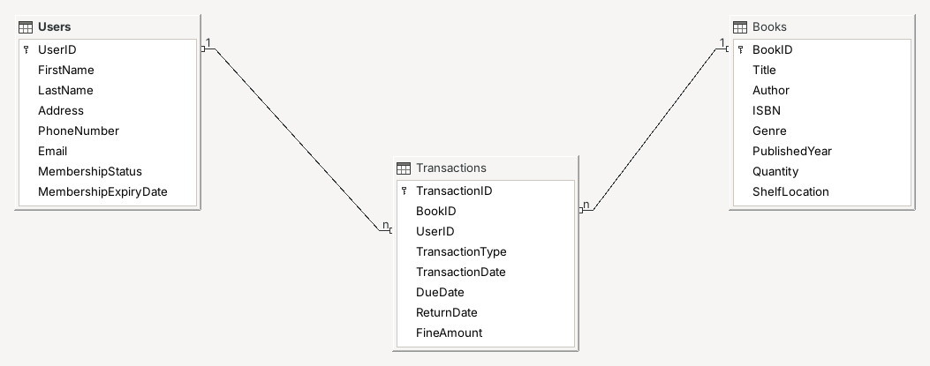

Table Creation Steps
The tables of our Library Management System were made in Design View of LibreOffice Base. These are the steps we followed to make a table:
1. Open LibreOffice Base:
- Start LibreOffice Base. The Database Wizard will open.
2. Create the Database:
- Choose “Create a new database”, click “Next” and then “Finish”.
- Save it as “Library.odb”.
3. Go to Design View:
- Click “Tables” in the left box.
- Click “Create Table in Design View...” (shown in red).
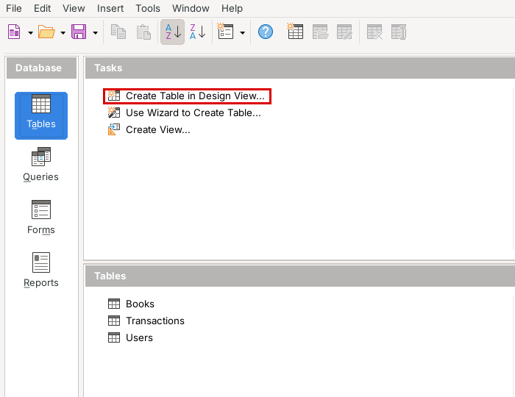
4. Enter Field Names and Types:
- Type the fields BookID, Title, Author, ISBN, Genre, PublishedYear, Quantity and ShelfLocation.
- Choose Integer for numbers and Text [VARCHAR] for words.
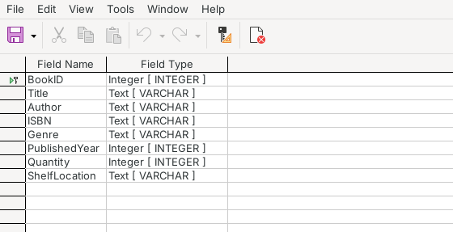
Books Table – Design View
5. Set the Primary Key:
- Right-click on BookID and select “Primary Key”.
6. Save the Table:
- Click Save, type “Books” and click “OK”.
The Users and Transactions tables were also made in the same way. Their design is shown below:
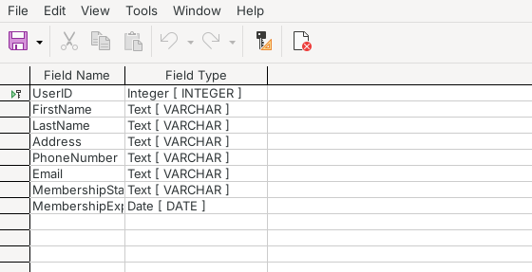
Users Table – Design View
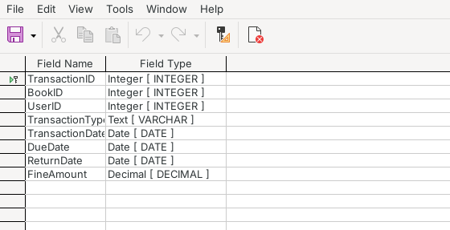
Transactions Table – Design View
7. Add the Data:
- Double-click a table name to open it in Data View.
- Type the records of books, members and transactions. Each row is saved when we move to the next row.
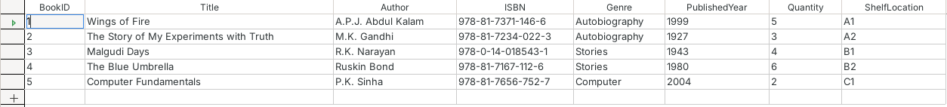
Books Table
Users Table
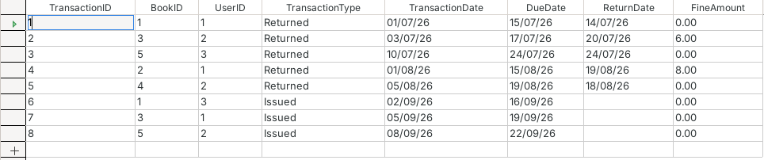
Transactions Table

Query Creation Steps
The Transactions table shows only BookID and UserID, so it is not easy to read. To see the real names we made an SQL query which shows the member's name, the book title, the issue date, the due date and the fine by taking data from the Users, Books and Transactions tables together.
1. Click Queries:
- Click the “Queries” icon in the left box.
2. Open SQL View:
- Click “Create Query in SQL View...”.
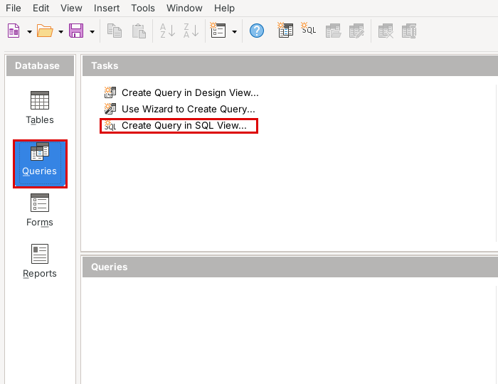
3. Write the SQL Command:
- Type the command below. It joins the Transactions table with the Books and Users tables:
SELECT "Users"."FirstName",
"Users"."LastName",
"Books"."Title",
"Transactions"."TransactionDate",
"Transactions"."DueDate",
"Transactions"."FineAmount"
FROM "Transactions",
"Books",
"Users"
WHERE "Transactions"."BookID" = "Books"."BookID"
AND "Transactions"."UserID" = "Users"."UserID"
ORDER BY "Transactions"."TransactionDate"
4. Run the Query:
- Press F5 to run it. Now we can see the member name and book title for every transaction.
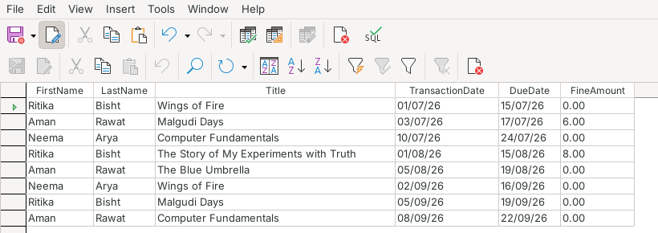
Issued_Books_Query – Result
5. Save the Query:
- Press Ctrl+S, give the name “Issued_Books_Query” and click “OK”.
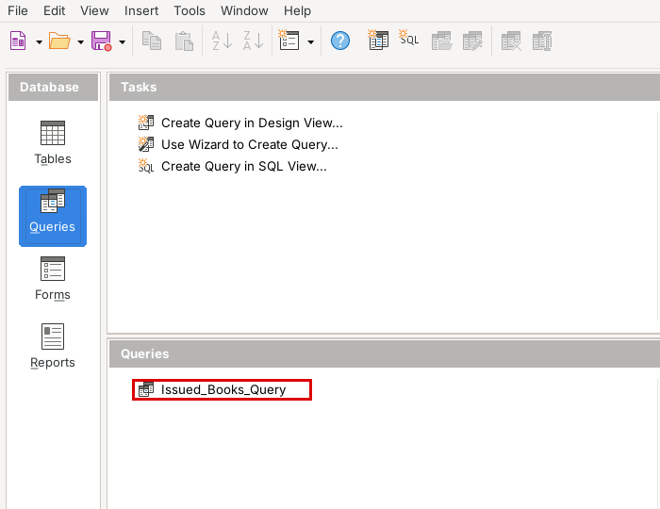

Form Creation Steps
A form makes it easy for the librarian to add new books one by one. We used the Form Wizard to make the book form:
1. Open Forms:
- Click the “Forms” icon in Library.odb.
2. Start the Form Wizard:
- Click “Use Wizard to Create Form...”.
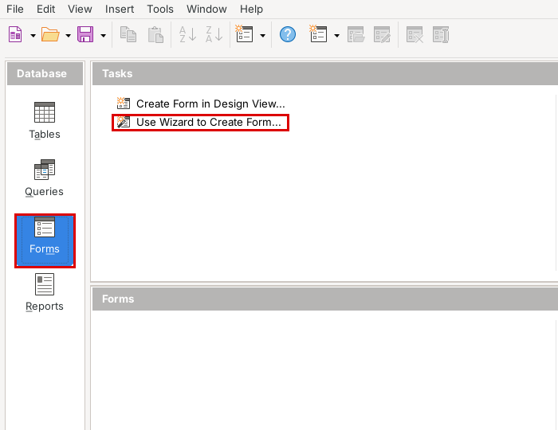
3. Select Table and Fields:
- Choose “Table: Books”.
- Click >> to add all the fields and click “Next”.
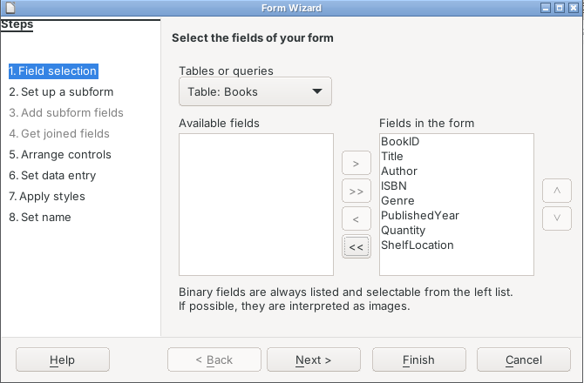
4. Set Up a Subform:
- We do not need a subform. Click “Next”.
5. Arrange the Controls:
- Choose “Columnar – Labels Left”.
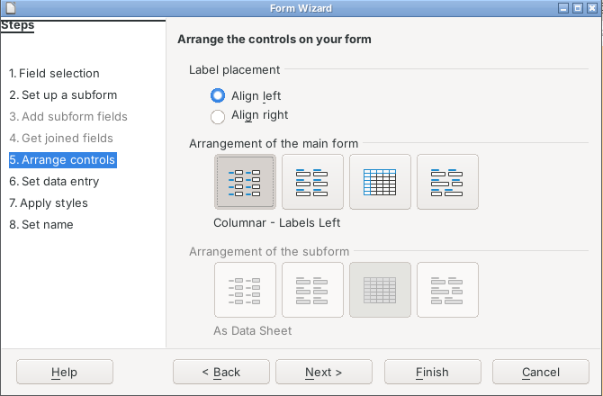
6. Data Entry and Style:
- Keep the default settings, choose a style and click “Next”.
7. Name the Form:
- Type “Books_Form”, keep “Work with the form” and click “Finish”.
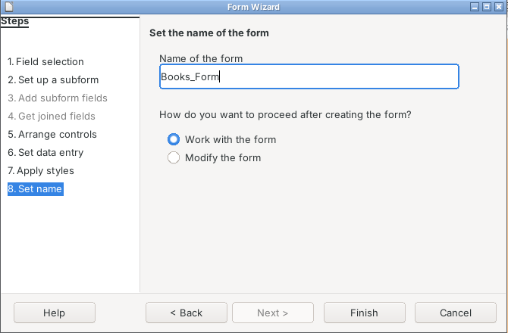
8. Use the Form:
- The form shows one book at a time. We can add a new book and save it with the Save Record button (red box).
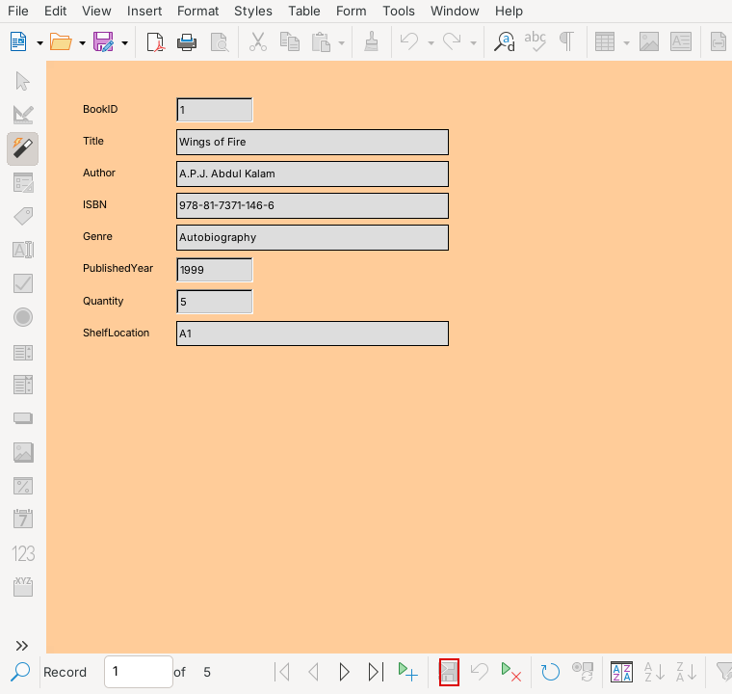
Books_Form
9. Save the Database:
- The form now appears under Forms. Click File > Save.
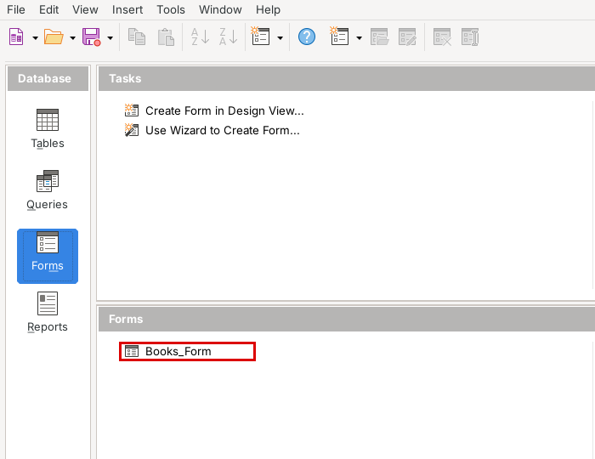

Report Generation Steps
We made a report of all the transactions, grouped member-wise, so that the librarian can see the books taken by each member. These are the steps:
1. Open Reports:
- Click the “Reports” icon.
2. Start the Report Wizard:
- Click “Use Wizard to Create Report...”.
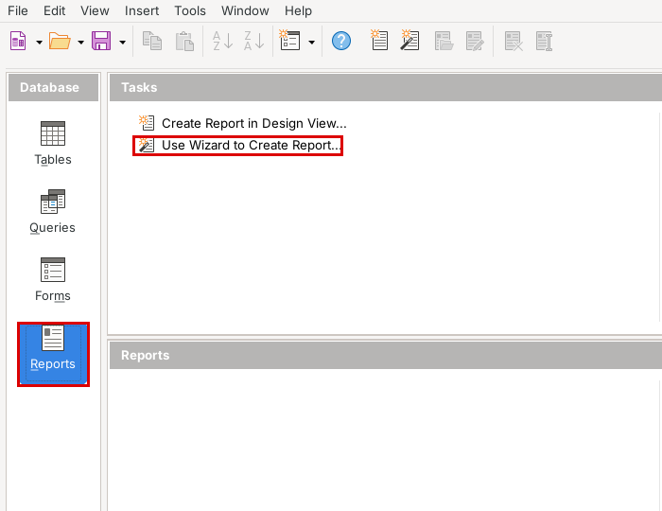
3. Select Table and Fields:
- Choose “Table: Transactions” and click >> to add all the fields.
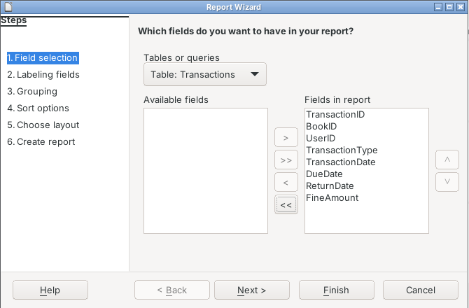
4. Labels:
- Keep the labels and click “Next”.
5. Grouping:
- Select UserID and click >, so that the books of each member come together.
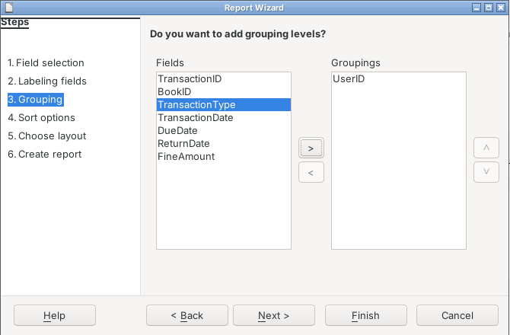
6. Sort Options:
- Click “Next”.
7. Layout:
- Choose “Tabular” and Landscape page.
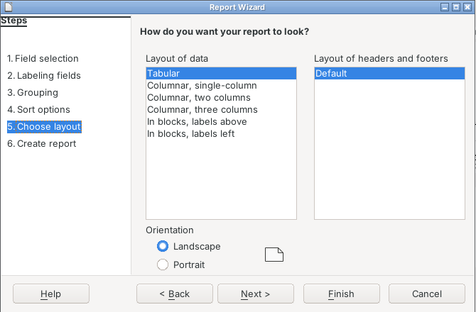
8. Create the Report:
- Type “Transactions_Report” as the title, choose “Dynamic report” and “Create report now”, and click “Finish”.
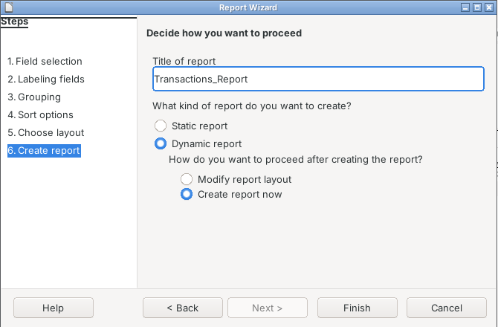
9. Open the Report:
- The report is saved under Reports. Double-click it to see the latest list at any time.
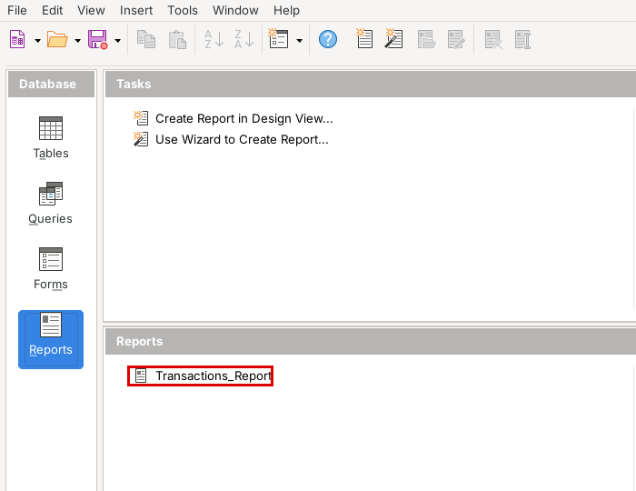

Final Report
Transaction Report
This is the transaction report made by LibreOffice Base. The books issued and returned are grouped by UserID.
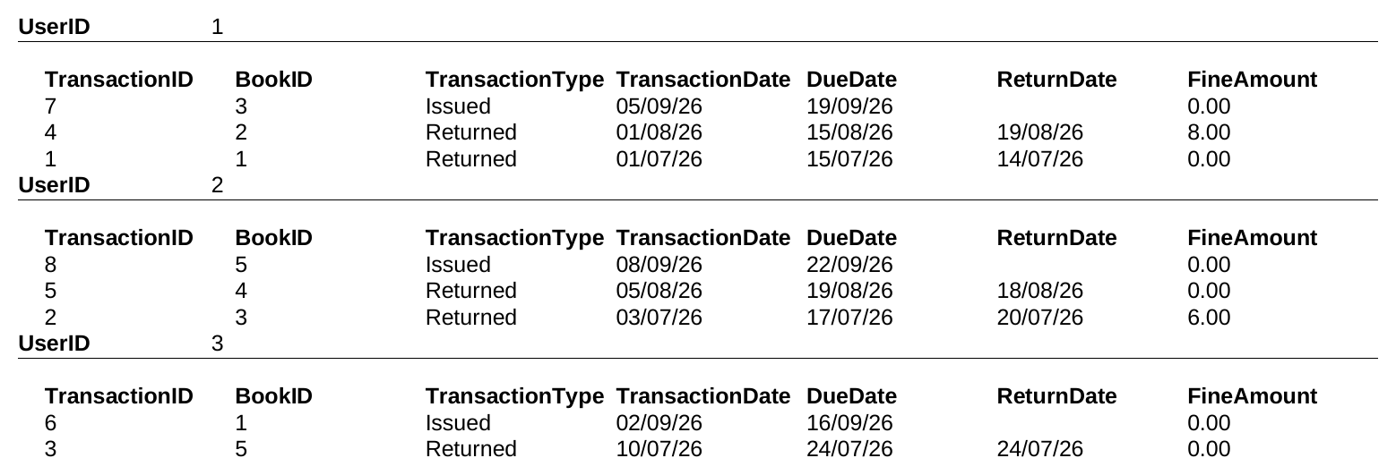

Technological requirements: Hardware & Software
Software
1. LibreOffice (Base and Writer)
2. Java Runtime Environment
3. Lightshot (for capturing screenshots)
Hardware
1. Laptop / PC
2. Printer

References
1. https://www.libreoffice.org/
2. https://help.libreoffice.org/latest/en-US/text/sdatabase/main.html
3. https://books.libreoffice.org/en/BG76/BG76.html (Base Guide)
4. CBSE Information Technology (402) Class X textbook

