 | CENTRAL BOARD OF SECONDARY EDUCATION

JAWAHAR NAVODAYA VIDYALAYA
TARIKHET ALMORA UTTARAKHAND 263663
INFORMATION TECHNOLOGY (402)
PROJECT FILE
On
STUDENT RESULT MANAGEMENT SYSTEM
LIBRE OFFICE BASE & WRITER
SUBMITTED BY :
S. No | Name | CBSE Roll
1.
2.
3.
4.

CLASS : X
SECTION(A/B) :

INTERNAL EXAMINER  (PANKAJ BHILINGWAL) |  | PRINCIPAL  (PANKAJ KUMAR SRIVASTAVA)

ACKNOWLEDGEMENT
I would like to thank my IT teacher Pankaj Bhilingwal Sir, PGT Computer Science, J.N.V Tarikhet Almora. He taught us LibreOffice Base step by step and helped us whenever we got stuck while making this project.
I am also thankful to our principal Pankaj Kumar Srivastava Sir for giving us a good computer lab where we could work on our project.
I also thank my parents, my friends and my group members. We worked together and completed the Student Result Management System on time.

NAME :
S. No | Name | CBSE Roll
1.
2.
3.
4.

CLASS : X
SECTION(A/B) :

CERTIFICATE
This is to certify that,
S. No | Name | CBSE Roll
1.
2.
3.
4.
This is to certify that the students whose names are written above, of Class X, J.N.V Tarikhet Almora, have made the project “Student Result Management System” in LibreOffice Base during the session 2026-27. They have done this work under my guidance for the Information Technology (402) practical exam of CBSE.

Internal Examiner
Signature

PREFACE
In our school a lot of information about students and their marks is kept in registers. Finding the marks of one student or making the result takes a lot of time and sometimes mistakes happen. A computer database can keep all this information neatly, and we can find anything in a few seconds.
In Class X we learnt LibreOffice Base in our Information Technology (402) subject. In the session 2026-27 we used what we learnt to make a small Student Result Management System. We made tables, joined them, wrote a query and made a form and a report.
This project taught us how a real database works. We thank our teacher, our parents and our friends who helped us in making it.

INDEX
Table of Contents
About Project 5
Introduction: 5
Objective: 5
System Components: 5
Database Design: 5
System Functionality: 5
System Implementation: 6
Challenges Faced: 6
Future Enhancements: 6
Conclusion: 6
Table : Relationship 7
Table Creation Steps 8
Query Creation Steps 11
Form Creation Steps 13
Report Generation Steps 18
Final Report 22
Technological requirements: Hardware & Software 23
Software 23
Hardware 23
References 24

About Project
Introduction:
Our project is a Student Result Management System. In our school, teachers keep the marks of students in registers and it takes a lot of time to make the result. In this project we have made a small database in LibreOffice Base where we can save the details of students, the subjects and the marks they get in exams. With this, the result of any student can be seen in a few seconds.
Objective:
- To keep the record of all the students of our class in one place.
- To save the list of subjects with their maximum marks and teacher.
- To enter the marks of every student in each exam.
- To give a grade to the student according to the marks.
- To print a report that shows the marks of each student.
System Components:
The system consists of 3 main tables:
1. Students Table:
- Fields: StudentID (Primary Key), FirstName, LastName, Class, Section, Gender, DateOfBirth, ParentPhone.
2. Subjects Table:
- Fields: SubjectID (Primary Key), SubjectName, SubjectCode, MaxMarks, Teacher.
3. Marks Table:
- Fields: MarkID (Primary Key), StudentID (Foreign Key referencing Students Table), SubjectID (Foreign Key referencing Subjects Table), ExamType, ExamDate, MarksObtained, Grade.
Database Design:
1. Students Table:
- It keeps the details of each student.
- StudentID is the primary key, so no two students get the same ID.
- ParentPhone is the phone number of the parent.
2. Subjects Table:
- It keeps the details of each subject.
- SubjectID is the primary key.
- MaxMarks tells the maximum marks of the subject.
3. Marks Table:
- It keeps the marks of students in each exam.
- MarkID is the primary key.
- StudentID and SubjectID are foreign keys. They connect this table with the Students and Subjects tables.
System Functionality:
Student Details:
- We can add a new student with name, class, section, gender, date of birth and parent's phone number.
- We can find, change or delete a record easily using the form.
Subject Details:
- Each subject is saved with its code, maximum marks and the name of the teacher.
Marks and Result:
- Marks of each student are entered subject-wise for every exam.
- A grade like A1, A2 or B1 is given according to the marks.
- The report shows the marks of every student together.
System Implementation:
- We made the project in LibreOffice Base with the HSQLDB database that comes with it.
- We made three tables in Design View and joined them using primary and foreign keys.
- We wrote an SQL query to see the marks of each student with the subject name.
- We made a form to enter student details and a report to print the marks.
Challenges Faced:
- At first we did not understand how to connect the three tables. Our teacher helped us with the relationships.
- We had to be careful to enter the correct StudentID and SubjectID in the Marks table.
- Giving the right grade for every mark took some time.
Future Enhancements:
- We can add total, percentage and rank of each student.
- We can print report cards for parents from the database.
- We can also add the attendance of students.
Conclusion:
By making this project we learnt how a database is used in real life. Our Student Result Management System saves paper and time, and the marks of any student can be found easily. We enjoyed making it and learnt a lot about LibreOffice Base.

Table : Relationship
We opened Tools > Relationships to join our tables. One student can have marks in many subjects, and one subject can have marks of many students. So both lines are one-to-many (1 : n), and the Marks table is on the “n” side.
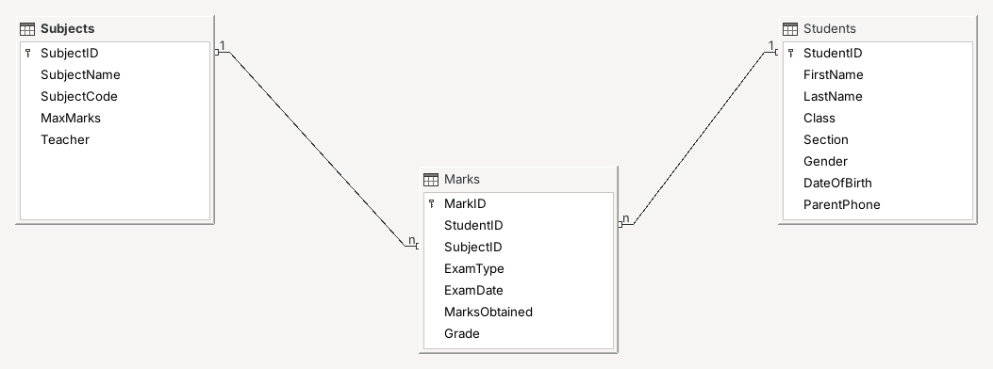

Table Creation Steps
We made all our tables in Design View. In Design View we write the name of each field and choose what type of data it will store. These are the steps we followed:
1. Open LibreOffice Base:
- Open LibreOffice and click on “Base Database”.
2. Make a New Database:
- Choose “Create a new database” and click “Next”.
- Save the file with the name “StudentResult.odb” and click “Finish”.
3. Go to Tables:
- Click on the “Tables” icon on the left side.
- Click “Create Table in Design View...” in the Tasks box (shown in red).
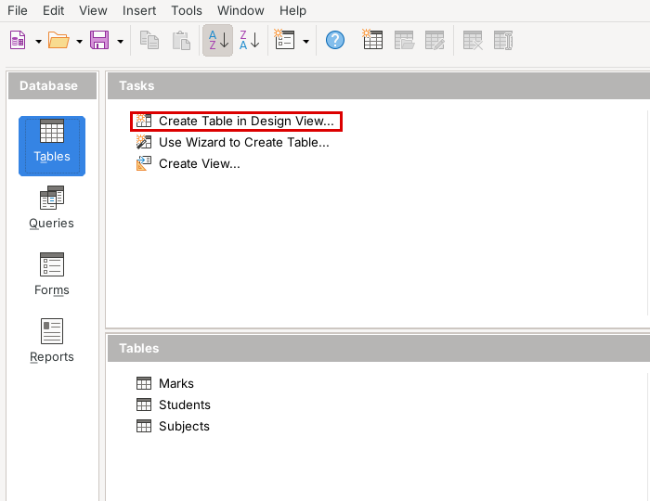
4. Write the Fields:
- Type the field names like StudentID, FirstName and LastName.
- Choose the Field Type: Integer for ID numbers, Text [VARCHAR] for names and Date for date of birth.
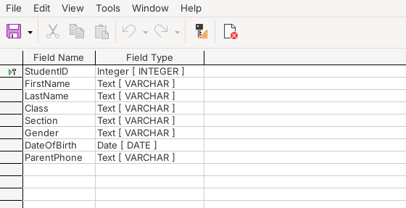
Students Table – Design View
5. Set the Primary Key:
- Right-click on StudentID and click “Primary Key”. A small key sign comes before it.
6. Save the Table:
- Press Ctrl+S, type “Students” and click “OK”.
We made the Subjects and Marks tables in the same way. Their design is shown below:
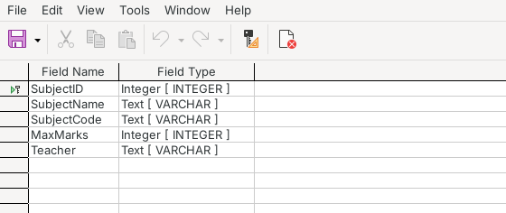
Subjects Table – Design View
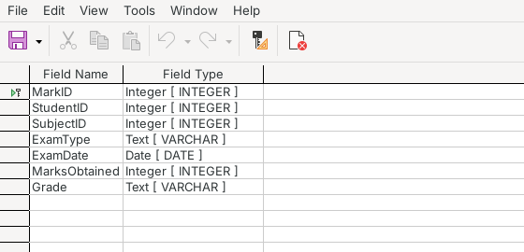
Marks Table – Design View
7. Enter the Data:
- Double-click on a table to open it.
- Type the records one by one. A record is saved by itself when we go to the next row.
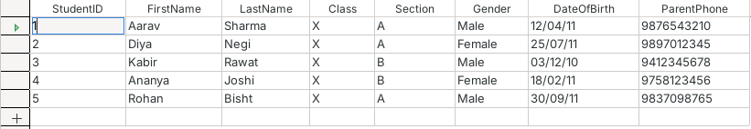
Students Table
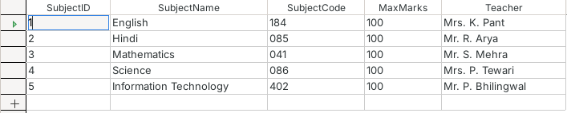
Subjects Table
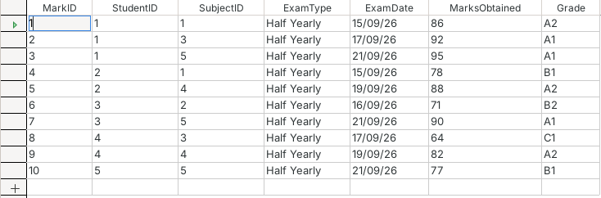
Marks Table

Query Creation Steps
A query is used to get only the information we need from the tables. The Marks table has only ID numbers, so it is hard to read. That is why we wrote a query in SQL which shows the student's name, the subject name, the marks and the grade by taking data from the Students, Subjects and Marks tables together.
1. Go to Queries:
- Click the “Queries” icon on the left side.
2. Open SQL View:
- Click “Create Query in SQL View...”. An empty box opens where we can type SQL.
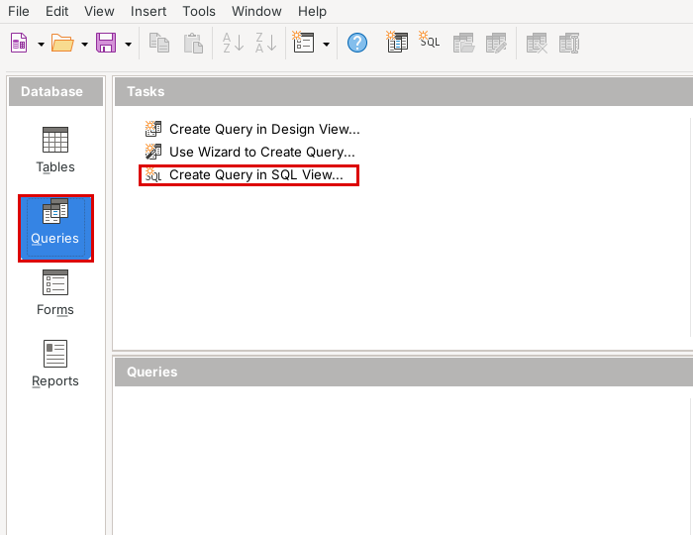
3. Type the Query:
- Type the command given below. Table names and field names are written inside double quotes.
SELECT "Students"."FirstName",
"Students"."LastName",
"Subjects"."SubjectName",
"Marks"."MarksObtained",
"Marks"."Grade"
FROM "Marks",
"Students",
"Subjects"
WHERE "Marks"."StudentID" = "Students"."StudentID"
AND "Marks"."SubjectID" = "Subjects"."SubjectID"
ORDER BY "Students"."FirstName"
4. Run the Query:
- Press F5. The answer is shown at the top of the window.
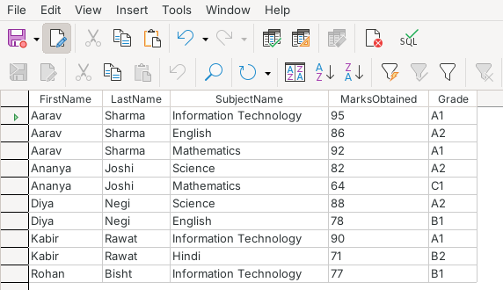
Student_Marks_Query – Result
5. Save the Query:
- Press Ctrl+S, type “Student_Marks_Query” and click “OK”.
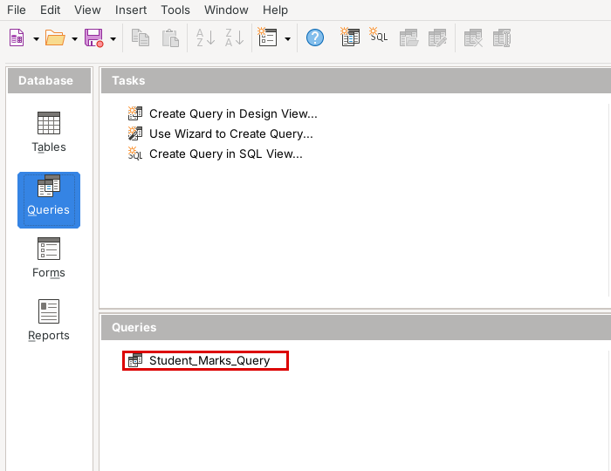

Form Creation Steps
A form gives a simple screen to enter and see one record at a time. It is easier than typing in the table. We made the student form using the Form Wizard:
1. Go to Forms:
- Click “Forms” on the left side of StudentResult.odb.
2. Open the Form Wizard:
- Click “Use Wizard to Create Form...”.
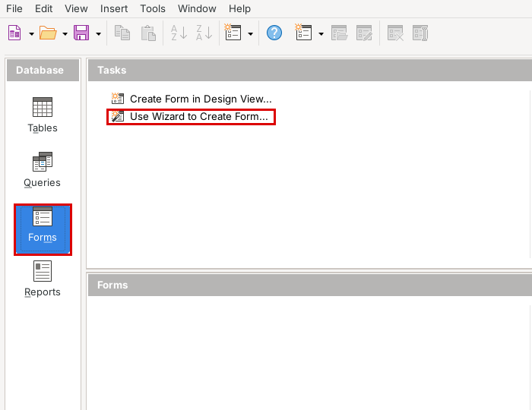
3. Choose the Table and Fields:
- Select “Table: Students”.
- Click >> to bring all the fields to the right side and click “Next”.
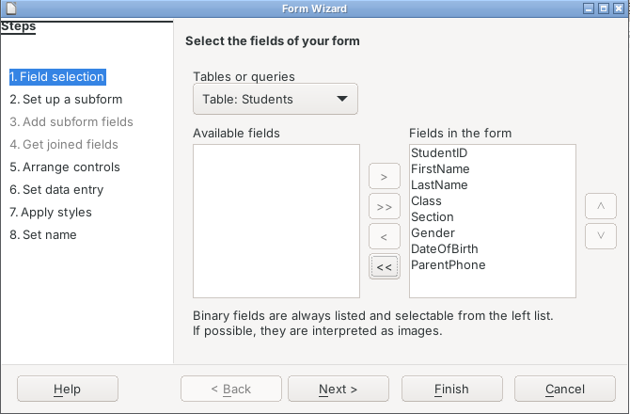
4. Arrange the Controls:
- Choose “Columnar – Labels Left”. Now each label comes on the left of its box.
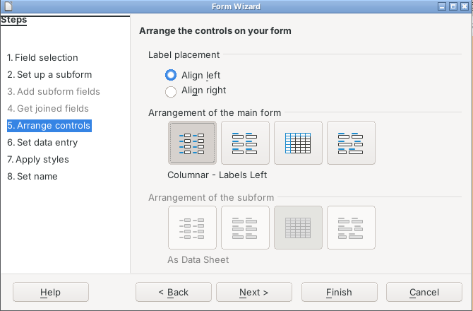
5. Data Entry and Style:
- Keep the settings as they are, choose any colour and click “Next”.
6. Name the Form:
- Type “Students_Form”, select “Work with the form” and click “Finish”.
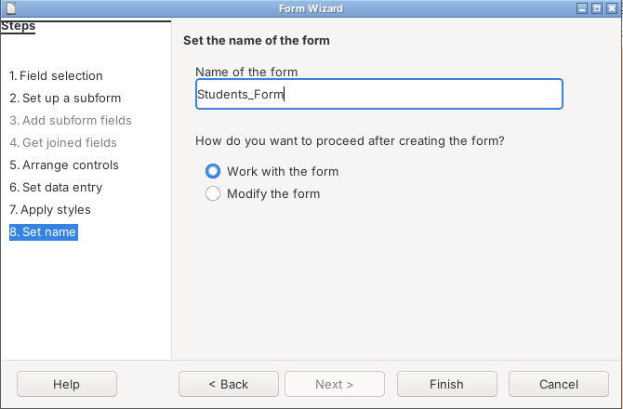
7. Use the Form:
- The form opens with the first student. The arrow buttons at the bottom take us to the next or previous student. The button in the red box saves the record.
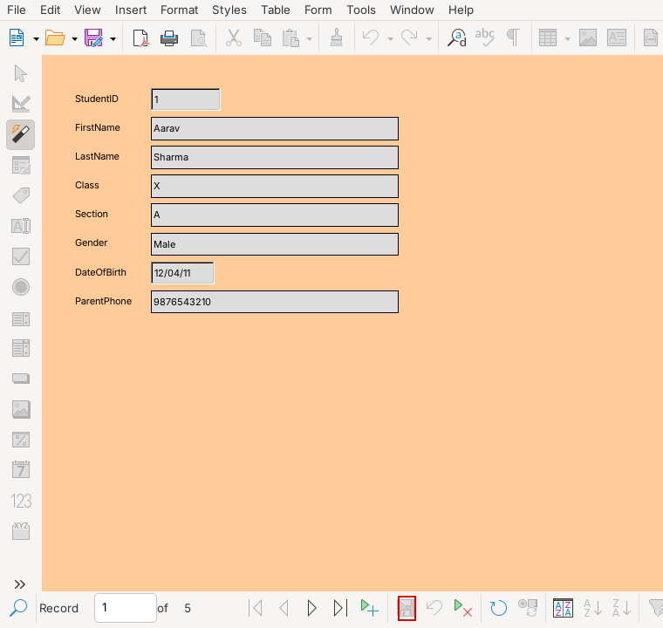
Students_Form
8. See the Form in the List:
- Our form is now shown under “Forms”. Press Ctrl+S to save the database.
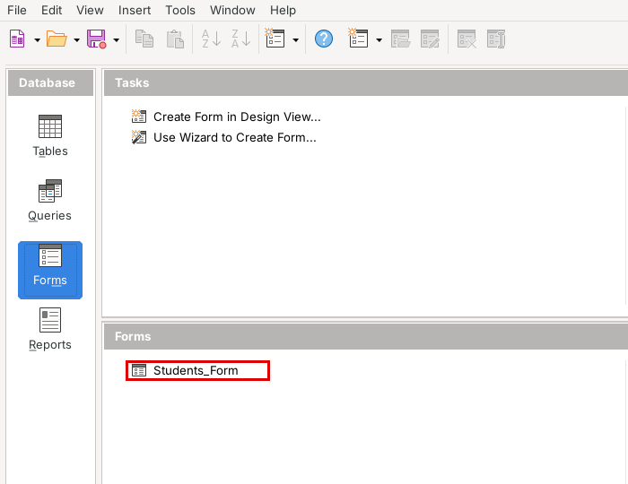

Report Generation Steps
A report shows the data in a neat way so that it can be printed. We made a marks report using the Report Wizard, with the marks of each student shown together:
1. Go to Reports:
- Click “Reports” on the left side.
2. Open the Report Wizard:
- Click “Use Wizard to Create Report...”.
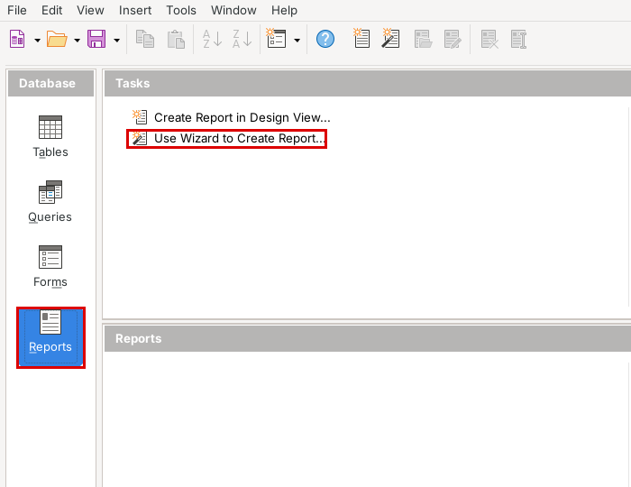
3. Choose the Table and Fields:
- Select “Table: Marks” and click >> to add all the fields.
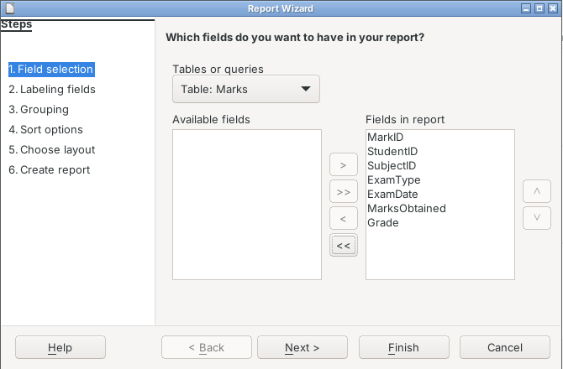
4. Labels:
- We can change the labels if we want. Click “Next”.
5. Group the Records:
- Select StudentID and click >. Now the marks of each student come together.
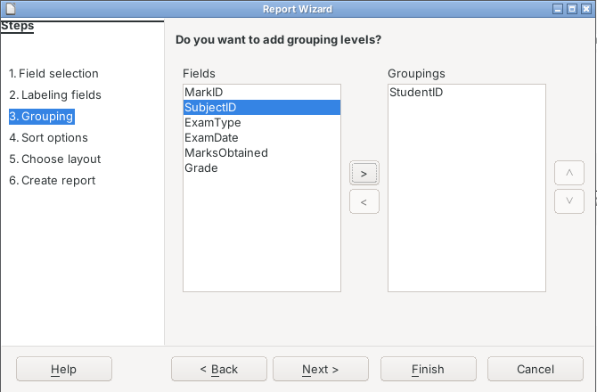
6. Sort:
- Leave it as it is and click “Next”.
7. Choose a Layout:
- Select “Tabular” and the page orientation.
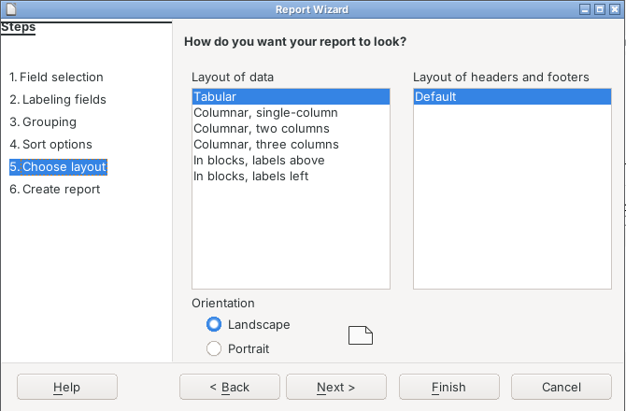
8. Make the Report:
- Type the title “Marks_Report”, select “Dynamic report” and “Create report now”, then click “Finish”.
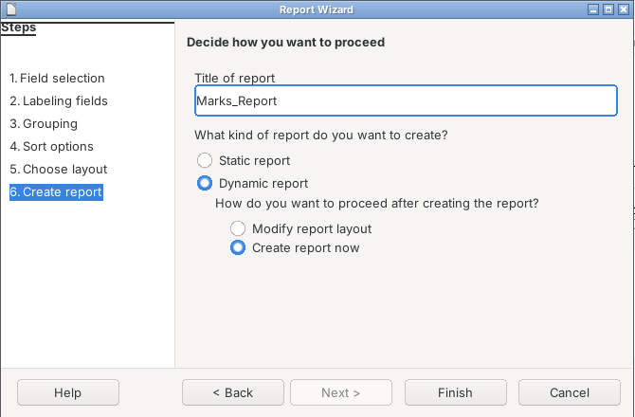
9. Open the Report:
- The report opens in Writer. It is also saved under “Reports”, so we can open it again any time.
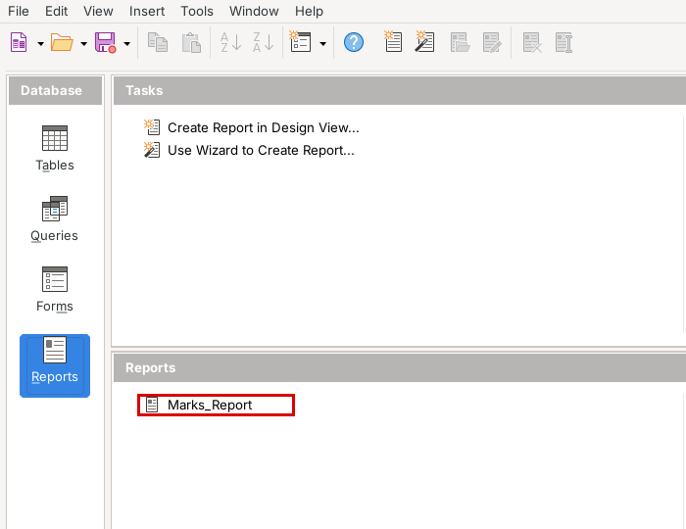

Final Report
Marks Report
This is the report made by LibreOffice Base. It shows the marks of every student. The marks are grouped by StudentID.
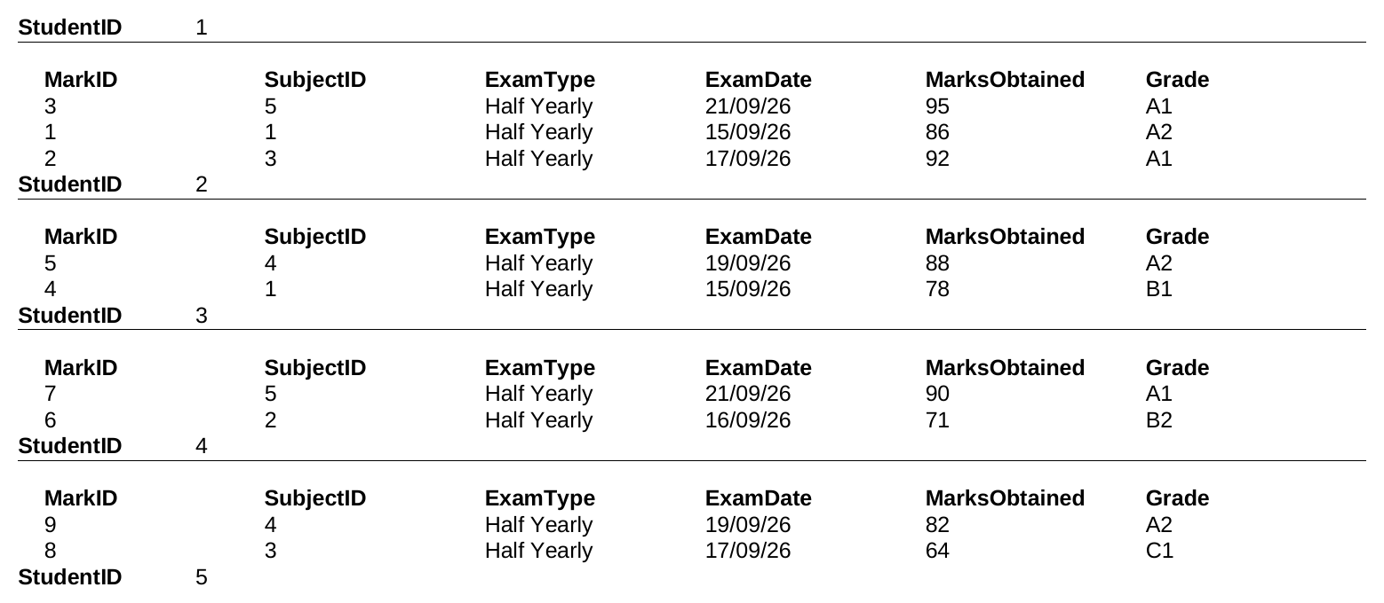

Technological requirements: Hardware & Software
Software
1. LibreOffice 24.2 (Base and Writer)
2. Java Runtime Environment (needed for reports)
3. Windows / Linux operating system
Hardware
1. Computer or laptop
2. Printer

References
1. https://www.libreoffice.org/discover/base/
2. https://help.libreoffice.org/latest/en-US/text/sdatabase/main.html
3. CBSE Information Technology (402) Class X book – Database Management System
4. Class notes and practicals done in our computer lab

