 | CENTRAL BOARD OF SECONDARY EDUCATION

JAWAHAR NAVODAYA VIDYALAYA
TARIKHET ALMORA UTTARAKHAND 263663
INFORMATION TECHNOLOGY (402)
PROJECT FILE
On
INVENTORY AND SALES MANAGEMENT SYSTEM
LIBRE OFFICE BASE & WRITER
SUBMITTED BY :
S. No | Name | CBSE Roll
1.
2.
3.
4.

CLASS : X
SECTION(A/B) :

INTERNAL EXAMINER  (PANKAJ BHILINGWAL) |  | PRINCIPAL  (PANKAJ KUMAR SRIVASTAVA)

ACKNOWLEDGEMENT
We could not have made this project without the help of our IT teacher Pankaj Bhilingwal Sir, PGT Computer Science, J.N.V Tarikhet Almora. I am really thankful to him for his time and for teaching us so patiently.
I also thank our principal Pankaj Kumar Srivastava Sir for giving us the chance to do this project and for letting us use the computer lab whenever we needed it.
A big thanks to my friends and team members. We all worked happily together to finish the Inventory and Sales Management System.

NAME :
S. No | Name | CBSE Roll
1.
2.
3.
4.

CLASS : X
SECTION(A/B) :

CERTIFICATE
This is to certify that,
S. No | Name | CBSE Roll
1.
2.
3.
4.
This is to certify that the students written above, studying in Class X at J.N.V Tarikhet Almora, have made this project on “Inventory and Sales Management System” using LibreOffice Base and Writer in the session 2026-27. Their work is their own and is good enough for the CBSE Information Technology (402) project.

Internal Examiner
Signature

PREFACE
A shopkeeper has to know how many items are left in the shop, what has been sold and to whom. Writing all this in a register becomes difficult when the shop grows. With a database, stock and sales can be saved quickly and checked at any time.
Our Class X Information Technology (402) syllabus has a unit on LibreOffice Base. In the session 2026-27 we used it to make an Inventory and Sales Management System for a school stationery shop.
From this project we learnt how to make tables, join them and use queries, forms and reports. We thank our teacher, our parents and our classmates for their help.

INDEX
Table of Contents
About Project 5
Introduction: 5
Objective: 5
System Components: 5
Database Design: 5
System Functionality: 5
System Implementation: 6
Challenges Faced: 6
Future Enhancements: 6
Conclusion: 6
Table : Relationship 7
Table Creation Steps 8
Query Creation Steps 11
Form Creation Steps 13
Report Generation Steps 18
Final Report 22
Technological requirements: Hardware & Software 23
Software 23
Hardware 23
References 24

About Project
Introduction:
Our project is an Inventory and Sales Management System for a small stationery shop. A shopkeeper has to remember how many notebooks, pens and bags are left and who bought what. In this project we have made a database in LibreOffice Base to save the details of products, customers and every sale made in the shop.
Objective:
- To keep a list of all the products in the shop.
- To know the price and the stock left of each product.
- To save the details of regular customers.
- To write down every sale with date, quantity, amount and payment mode.
- To make a sales report so the shopkeeper knows what is selling.
System Components:
The system consists of 3 main tables:
1. Products Table:
- Fields: ProductID (Primary Key), ProductName, Category, UnitPrice, StockQty, Supplier.
2. Customers Table:
- Fields: CustomerID (Primary Key), CustomerName, Phone, City, Email.
3. Sales Table:
- Fields: SaleID (Primary Key), ProductID (Foreign Key referencing Products Table), CustomerID (Foreign Key referencing Customers Table), SaleDate, Quantity, TotalAmount, PaymentMode.
Database Design:
1. Products Table:
- It keeps the details of each product.
- ProductID is the primary key, so two products cannot have the same ID.
- StockQty tells how many pieces are left in the shop.
2. Customers Table:
- It keeps the details of the customers.
- CustomerID is the primary key.
3. Sales Table:
- It keeps a record of every sale.
- SaleID is the primary key.
- ProductID and CustomerID are foreign keys. They link this table with the Products and Customers tables.
System Functionality:
Products:
- A product is added with its name, category, price, stock and supplier.
- The stock is changed when new items come or when items are sold.
Customers:
- A customer is saved with name, phone number, city and e-mail.
Sales:
- Every sale is saved with the product, customer, date and quantity.
- The total amount and payment mode (Cash, UPI or Card) are saved.
- The report shows what each customer has bought.
System Implementation:
- The project is made in LibreOffice Base using its HSQLDB database.
- The Products and Customers tables are joined with the Sales table using foreign keys.
- An SQL query shows which customer bought which product and for how much.
- We made a product form and a customer-wise sales report using the wizards.
Challenges Faced:
- We had to choose the correct data type for price, so we used Decimal.
- Linking the Sales table with two other tables was new for us.
- We had to keep the stock and the sales matching each other.
Future Enhancements:
- The computer can warn the shopkeeper when stock is low.
- A bill can be printed for every customer.
- A table for items bought from suppliers can be added.
Conclusion:
While making this project we saw how useful a database is for a shop. Our Inventory and Sales Management System keeps the stock and sales record neat and correct, and the shopkeeper does not need to write everything in a register. It was fun to work on it together.

Table : Relationship
This is how our tables are joined. One product can be sold many times and one customer can buy many times. So the Sales table is joined to both the other tables with one-to-many lines.
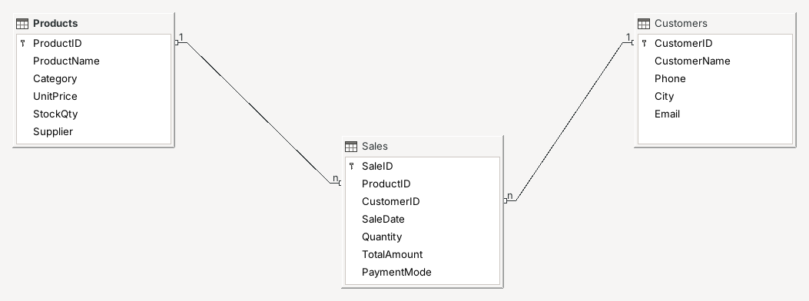

Table Creation Steps
We made every table of our Inventory and Sales Management System in Design View. These steps show how we made a table in LibreOffice Base:
1. Create a New Database:
- Open LibreOffice Base and choose “Create a new database”.
- Click “Next” and then “Finish”.
2. Give a Name:
- Save the database in a folder with the name “Inventory.odb”.
3. Open Table Design:
- Click on “Tables” on the left.
- Click “Create Table in Design View...” (red box).
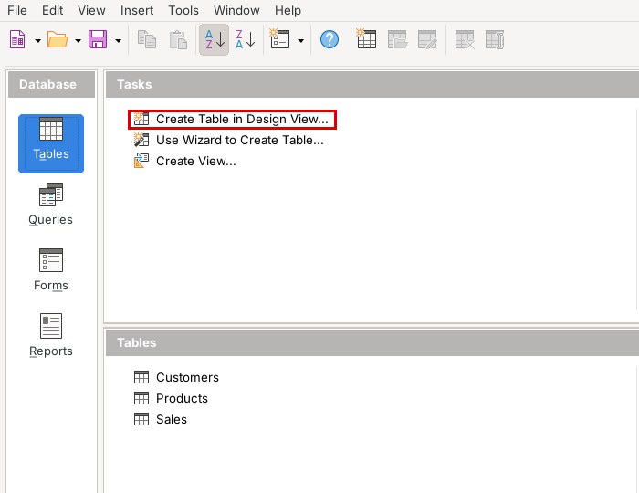
4. Add Fields and their Types:
- Write the fields ProductID, ProductName, Category, UnitPrice, StockQty and Supplier.
- Use Integer for numbers, Decimal for price and Text [VARCHAR] for names.
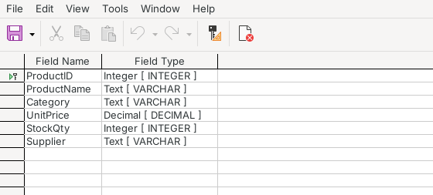
Products Table – Design View
5. Set the Primary Key:
- Right-click on ProductID and click “Primary Key” so that no two products get the same ID.
6. Save the Table:
- Go to File > Save, name the table “Products” and click “OK”.
The other tables, Customers and Sales, were made in the same way:
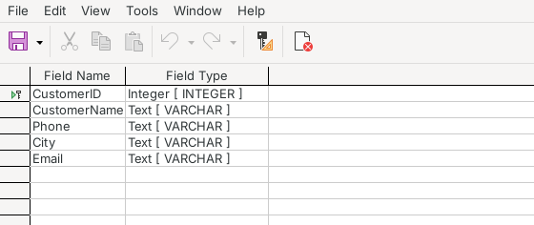
Customers Table – Design View
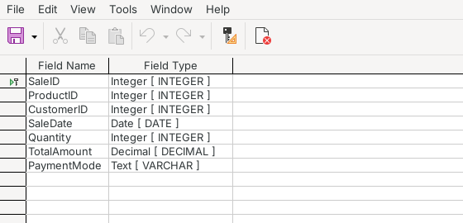
Sales Table – Design View
7. Put the Records:
- Double-click the table name to open it.
- Enter the product, customer and sales records. Use the last empty row (+) for a new record.
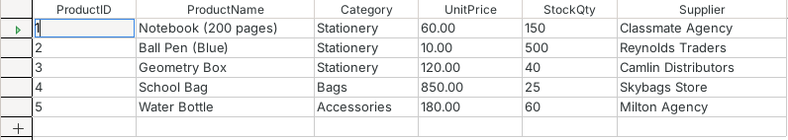
Products Table
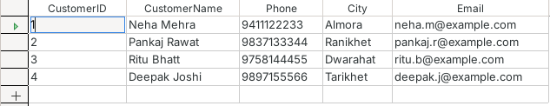
Customers Table
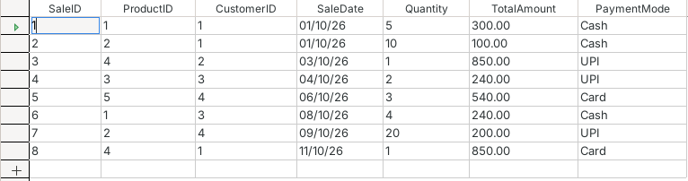
Sales Table

Query Creation Steps
The shopkeeper wants to see the sales with the product name and the customer name, not just ID numbers. For this we made an SQL query which shows the product name, the customer name, the date, the quantity and the amount of each sale by taking data from the Products, Customers and Sales tables together.
1. Select Queries:
- Click the “Queries” button on the left.
2. Choose SQL View:
- Click “Create Query in SQL View...”.
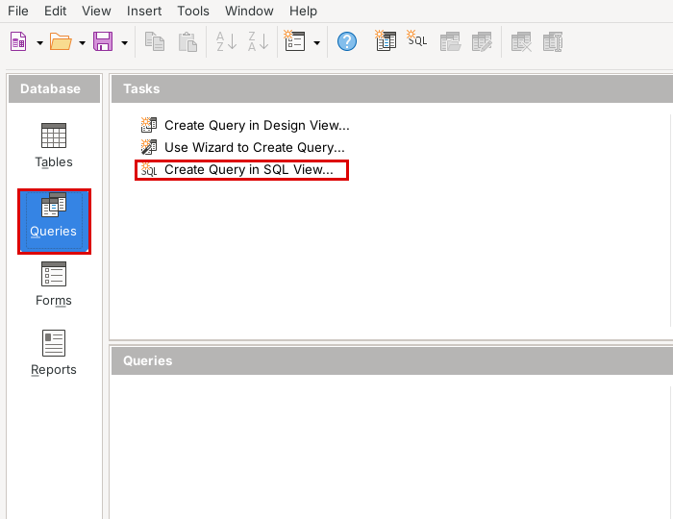
3. Type the SQL:
- Type the command below. It takes data from the Sales, Products and Customers tables together:
SELECT "Products"."ProductName",
"Customers"."CustomerName",
"Sales"."SaleDate",
"Sales"."Quantity",
"Sales"."TotalAmount"
FROM "Sales",
"Products",
"Customers"
WHERE "Sales"."ProductID" = "Products"."ProductID"
AND "Sales"."CustomerID" = "Customers"."CustomerID"
ORDER BY "Sales"."SaleDate"
4. See the Result:
- Press F5. Now we can see the product name and customer name with every sale.
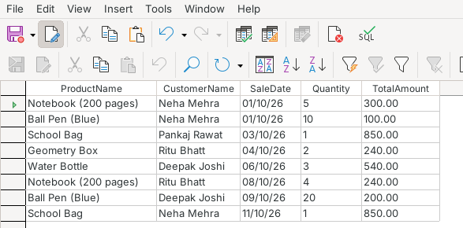
Sales_Details_Query – Result
5. Save the Query:
- Press Ctrl+S and type the name “Sales_Details_Query”.
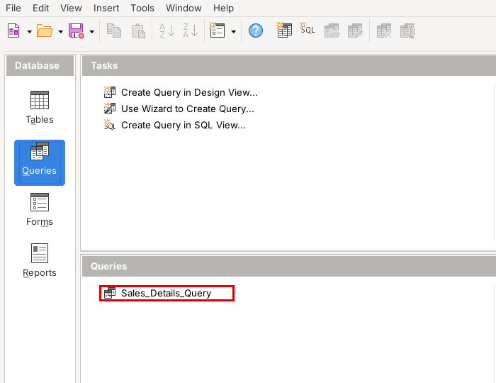

Form Creation Steps
A form makes it easy to add new products and change their stock. We made the product form with the Form Wizard in these steps:
1. Click on Forms:
- In the Base window click the “Forms” icon.
2. Open the Form Wizard:
- Click “Use Wizard to Create Form...”.
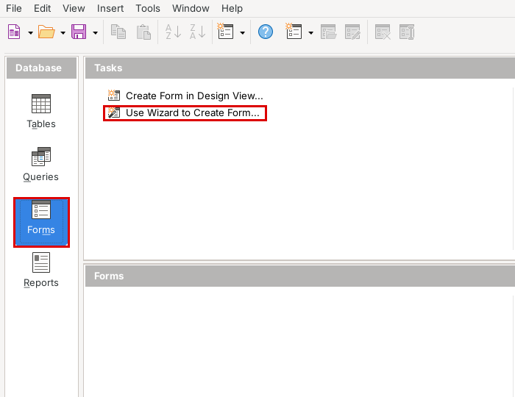
3. Pick the Table and Fields:
- Choose “Table: Products”.
- Use >> to bring all the fields into the form and click “Next”.
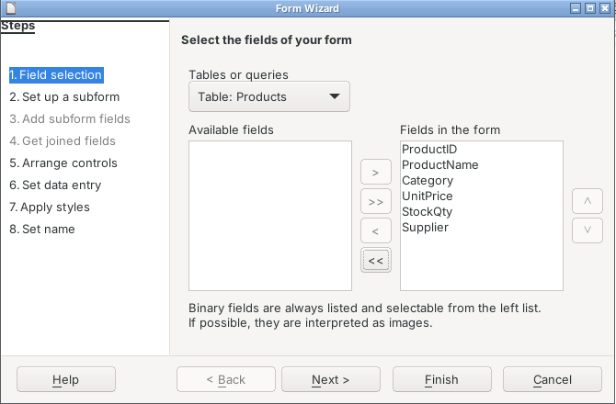
4. Choose a Layout:
- Go to step 5 and choose “Columnar – Labels Left”.
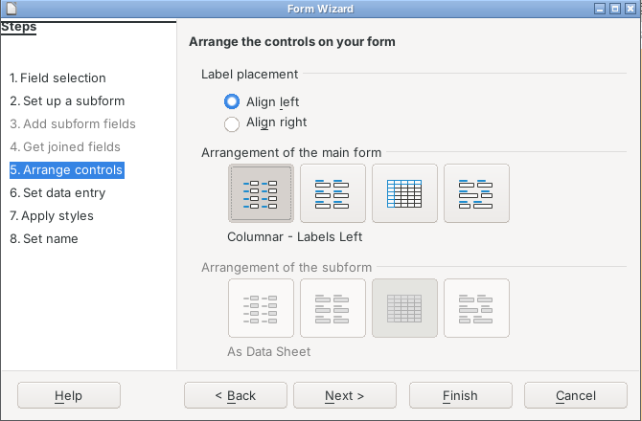
5. Data Entry and Colour:
- Keep the data entry setting as it is, pick a colour and click “Next”.
6. Name the Form:
- Type “Products_Form” as the name and press “Finish”.
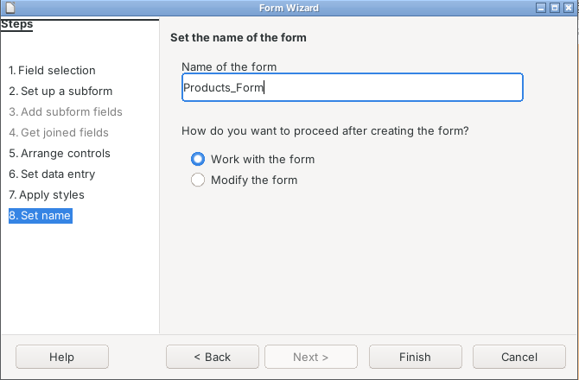
7. Work with the Form:
- The form shows one product at a time. We can change the stock here and save it with the Save Record button.
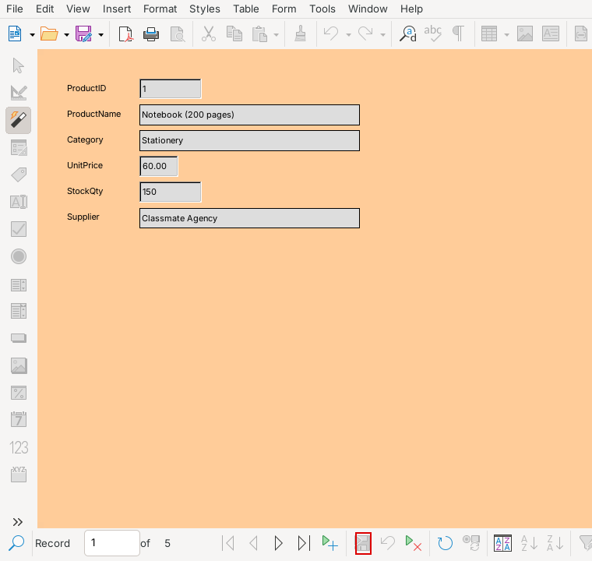
Products_Form
8. Save Everything:
- The new form is listed under Forms. Save the database.
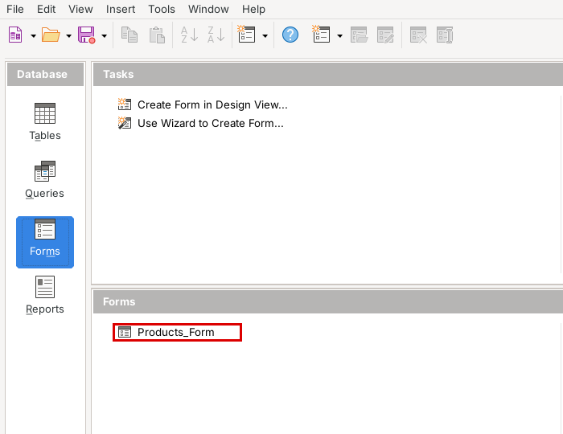

Report Generation Steps
The sales report shows everything bought by each customer. We made it with the Report Wizard as explained below:
1. Click on Reports:
- Select the “Reports” icon.
2. Start the Report Wizard:
- Click “Use Wizard to Create Report...”.
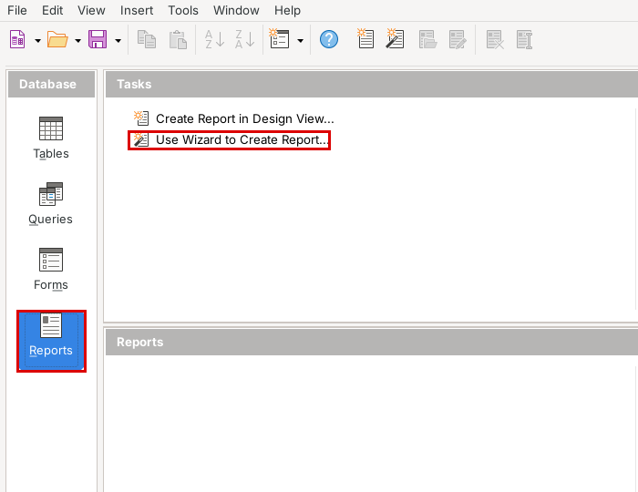
3. Choose the Table and Fields:
- Choose “Table: Sales” and click >>.
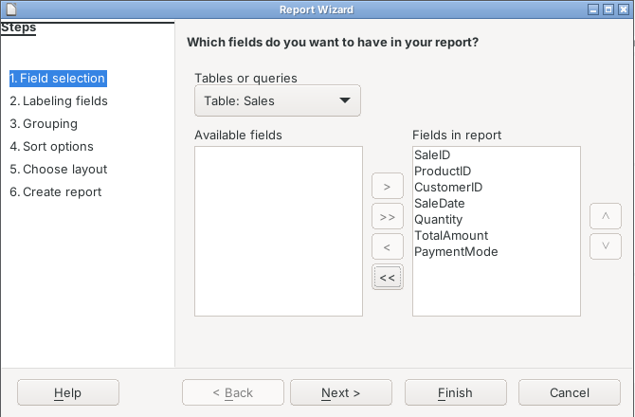
4. Labels:
- Keep the labels and click “Next”.
5. Add a Group:
- Move CustomerID to the Groupings box to show the sales of each customer separately.
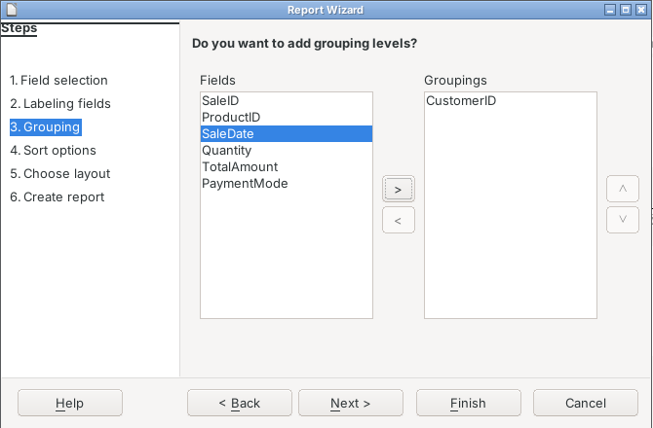
6. Sorting:
- We do not need any sorting, so click “Next”.
7. Layout:
- Choose “Tabular” as the layout of data.
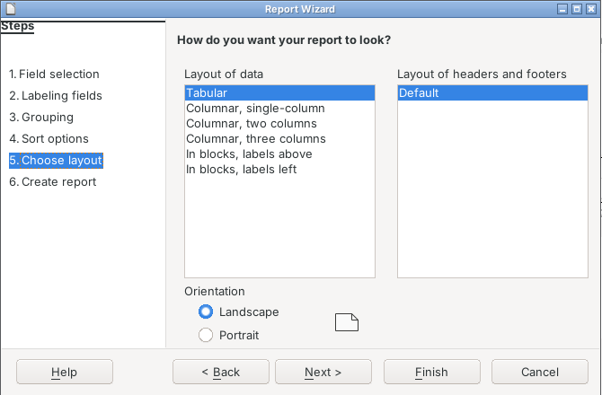
8. Finish the Report:
- Type “Sales_Report” as the title, keep “Create report now” and click “Finish”.
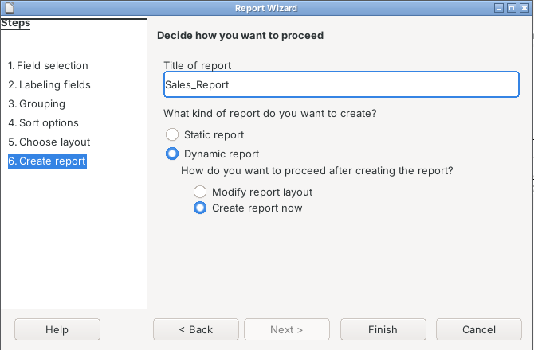
9. Open the Report:
- The report is now under Reports and can be printed from Writer.
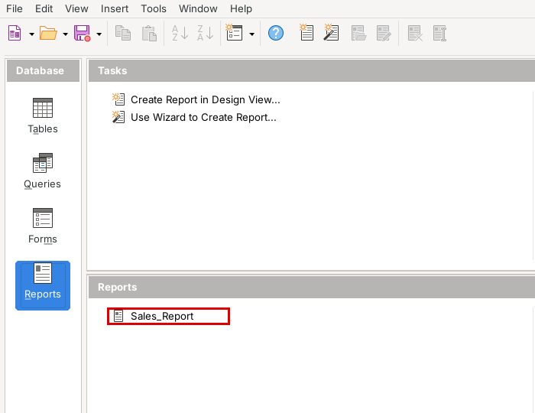

Final Report
Sales Report
This is the final sales report made from our database. The sales are grouped by CustomerID.
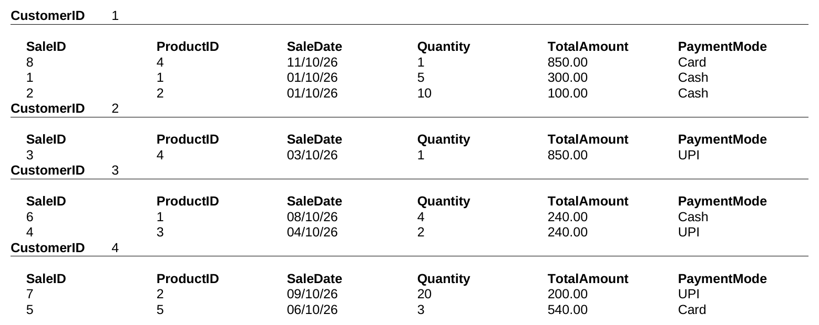

Technological requirements: Hardware & Software
Software
1. LibreOffice Base (database) and Writer (report)
2. Java Runtime Environment
3. Lightshot (for taking screenshots)
Hardware
1. Laptop / Desktop PC
2. Printer

References
1. https://www.libreoffice.org/get-help/documentation/
2. https://help.libreoffice.org/latest/en-US/text/sdatabase/main.html
3. https://books.libreoffice.org/en/BG76/BG76.html
4. CBSE Class X Information Technology (402) study material

