
CENTRAL BOARD OF SECONDARY EDUCATION


JAWAHAR NAVODAYA VIDYALAYA
TARIKHET ALMORA UTTARAKHAND 263663

COMPUTER SCIENCE (083)
PROJECT FILE
On
WORD GUESSING GAME USING PYTHON
SUBMITTED BY :

S. No | Name | CBSE Roll
CLASS : XII
SECTION : SCIENCE

PRINCIPAL
(D.S RAWAT)

INTERNAL EXAMINER
(PANKAJ BHILINGWAL)

EXTERNAL EXAMINER

ACKNOWLEDGEMENT

I wish to express my deep sense of gratitude and indebtedness to our learned teacher Pankaj Bhilingwal, PGT Computer Science, J.N.V Tarikhet Almora for his invaluable help, advice and guidance in the preparation of this project file.
I am also greatly indebted to our principal D.S Rawat and school authorities for providing me with the facilities and requisite laboratory conditions for making this project file.
I also extend my thanks to a number of teachers, my classmates and friends who helped me to complete this project file successfully.
NAME :

S. No | Name | CBSE Roll

CLASS : XII
SECTION : SCIENCE

CERTIFICATE

This is to certify that,
S. No | Name | CBSE Roll

Student of Class XII, J.N.V Tarikhet Almora has completed the PROJECT FILE during the academic year 2026-27 towards partial fulfilment of credit for the Computer Science Project evaluation of CBSE and submitted satisfactory report, as compiled in the following pages, under my supervision.

Internal Examiner External Examiner
Signature Signature

PREFACE

In the field of Computer Science, the term PROJECT refers to a Computerization Work that is completely performed by using a computer. Today when every field is going to be computerized means that all task of any field now a days done by using computer and their appropriate computer programs, then to do every field’s different-different works, today different programs or software’s are available in the form of Project.
Learning Python in schools is a part of our syllabus, and according to the syllabus worked out by the CBSE, to which my school is affiliated, I enjoyed doing project work for the session 2026-27. I learned a lot, especially learning by doing was a great experience. The report is a summary of what I observed and learnt in school. My humble thanks are going to all the concerned related to my project.
I also feel that it is the right time to thank my teacher, who guided me during my project. I also feel that it is the right time to thank my parents, friends and my project partners for their constant assistance, cooperation extended by them time to time.

INDEX
Table of Contents
About Project 5
Introduction: 5
Modules Used: 5
How to Run the Program: 5
Game Overview: 5
User Interaction: 5
Flow Chart 6
Project Code 7
Output 10
Technological requirements: Hardware & Software 12
References 13

About Project

Introduction:
Welcome to our interactive and entertaining project - the Word Guessing Game implemented in Python! In this project, we have developed a classic word guessing game where players attempt to guess a randomly selected word within a limited number of tries.
Programming Language: The project is implemented using the Python programming language, known for its simplicity and versatility. Python's ease of use makes it an ideal choice for developing interactive and enjoyable games.

Modules Used:
- Random Module: We leverage the random module in Python to select a random word from a predefined list. This ensures a dynamic and unpredictable gameplay experience for the users.
- Pickle Module: The pickle module comes into play for efficient handling of file operations. We use it to load words from a file ('words_file.dat') and deserialize the stored data.

How to Run the Program:
- Run the Script: Open a terminal or command prompt, navigate to the directory containing the script, and run the following command:
python your_script_name.py
Replace your_script_name.py with the actual name of the Python script.
- Enjoy the Game: Follow the on-screen instructions to guess the hidden word. The flow of the game's logic will be revealed through textual feedback, enhancing your understanding of the program.

Game Overview:
Players start the game by attempting to guess a hidden word. With each guess, the program provides feedback, indicating whether the guessed letter is correct or not. The game continues until the player either successfully guesses the word or exhausts all allowed tries.

User Interaction:
The game prompts users to input their guesses, enforcing validation to ensure proper input. Additionally, players have the option to play the game again or exit, enhancing the overall user experience.
This project not only provides an enjoyable gaming experience but also showcases the use of fundamental Python modules. Get ready to embark on a journey of word exploration and challenge your vocabulary in our Word Guessing Game!

Flow Chart

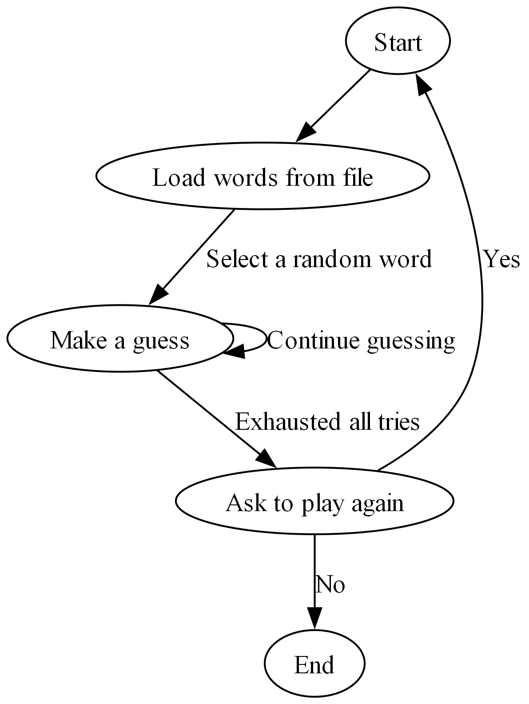

Project Code
import random
import pickle

def load_words_from_file(filename):
with open(filename, 'rb') as file:
words = pickle.load(file)
return words

def display_word(word, revealed_letters):
return ''.join([char if char in revealed_letters else '_' for char in word])

def initial_reveal(word):
revealed_letters = ['_' if char.isalpha() and random.random() < 0.5 else char for char in word]
return revealed_letters

def update_revealed_letters(hidden_word, revealed_letters, user_input):
for index, char in enumerate(hidden_word):
if char.isalpha() and user_input == char:
revealed_letters[index] = char

def guess(hidden_word):
revealed_letters = initial_reveal(hidden_word)
user_input = []
max_tries = len(hidden_word) + 2

tries = 0

while tries < max_tries:
coded_word = display_word(hidden_word, revealed_letters)
print(f"Coded Word is: '{coded_word}', Guess in {max_tries - tries} tries")

user_input1 = input("Enter a letter: ").lower()

if not user_input1:
print("Please enter something.")
elif len(user_input1) > 1:
print("Please enter only one letter at a time.")
elif user_input1 in user_input:
print("You've already entered that letter. Try something else.")
print(f"Alphabets already used: '{' '.join(user_input)}'")
else:
user_input.append(user_input1)
user_input.sort()

if user_input1 in hidden_word:
update_revealed_letters(hidden_word, revealed_letters, user_input1)
print("You guessed right!")
else:
tries += 1
print(f"Sorry, wrong guess. {max_tries - tries} tries left.")

print(f"Alphabets already used: '{' '.join(user_input)}'")

if all(char.isalpha() and char != '_' for char in revealed_letters):
print(f"Congratulations! You guessed the word. The word was '{hidden_word}' in {tries + 1} tries.\n")
break

if tries == max_tries:
print(f"Sorry, you've exhausted all tries. The correct answer was: '{hidden_word}'")

def main():
loaded_words = load_words_from_file('words_file.dat')
guess(loaded_words[random.randint(0, len(loaded_words))])
while True:
ch=input("Do you want to play again (Y/N)")
if ch in "Yy":
main()
elif ch in "Nn":
break
else:
print("Wrong Choice !!")

if __name__ == "__main__":
main()

Output

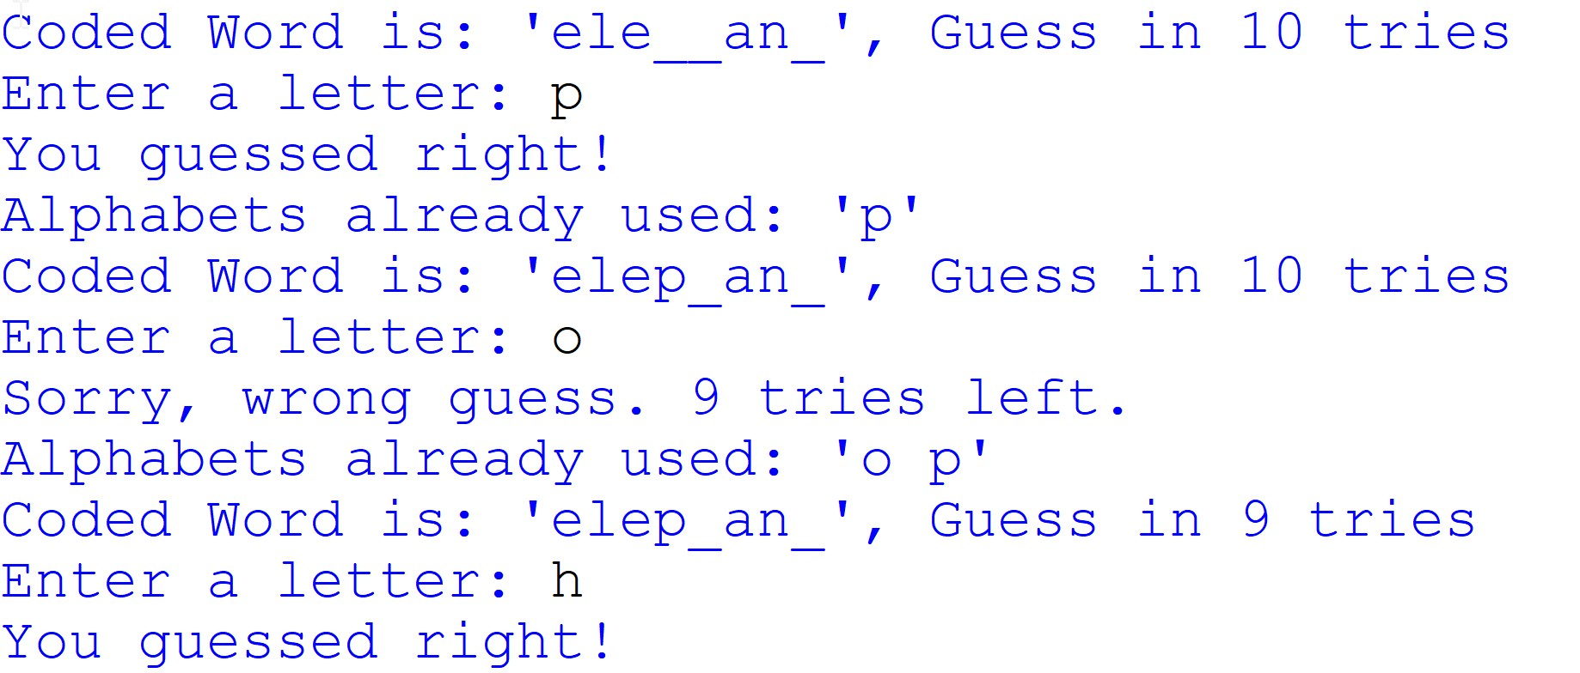
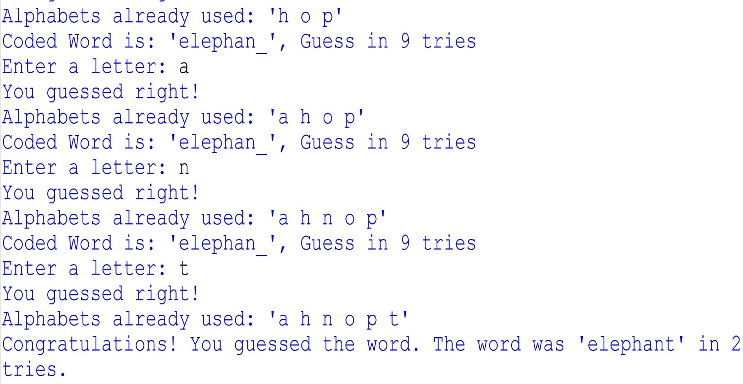

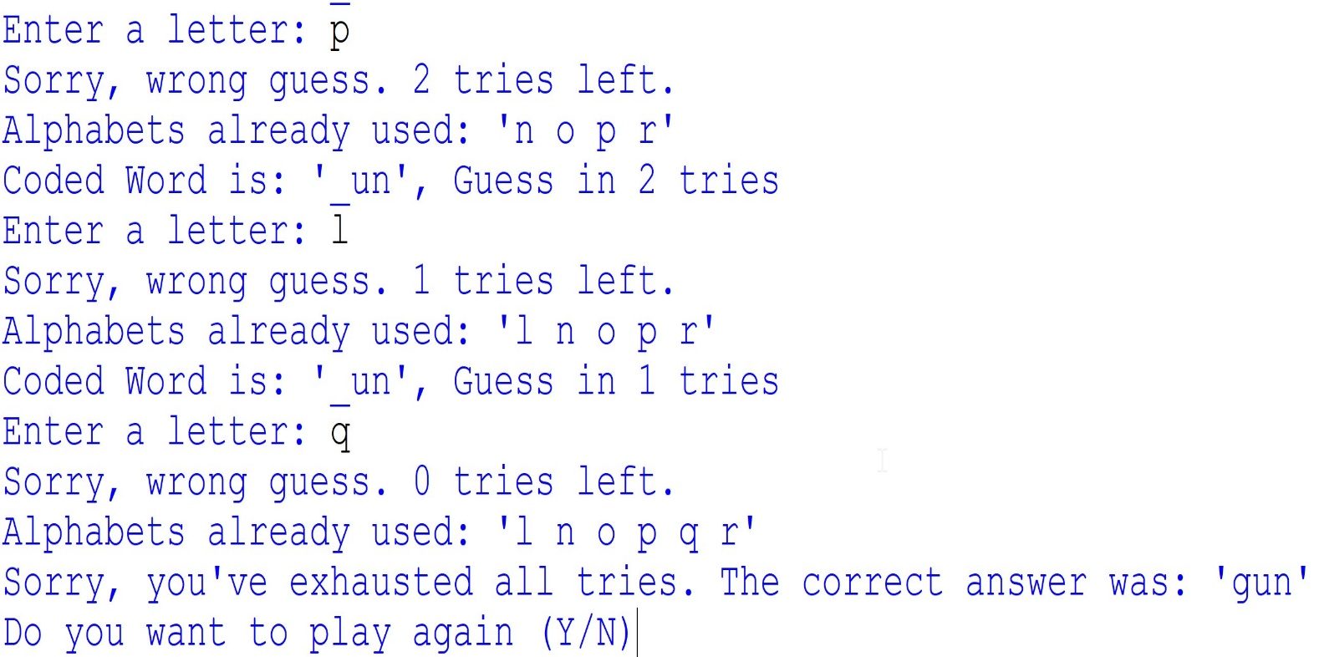
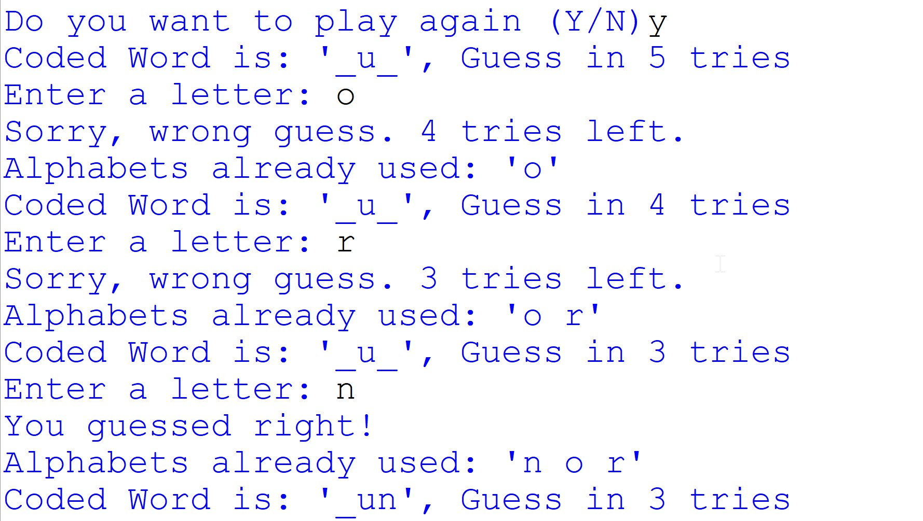

Technological requirements: Hardware & Software

Software
- Python
- VS Code

Hardware
- Laptop/PC

References

- https://www.python.org/
- https://realpython.com/python-pickle-module/
- https://www.tutorialspoint.com/python-pickling
- https://www.w3schools.com/python/module_random.asp

