|  |
| --- |
|  |
| Final Project - Paul's Blogging Site |
| **External Documentation** |
| All work Copyright © 2013 by Paul Bialo  All rights reserved. |
| **Paul Bialo** |
|  |



|  |
| --- |
| April 26, 2013 |

# Table of Contents

Table of Contents 2

I. Site Description 3

II. Nav Bar 3

III. Colours 3

IV. Typography 4

V. Wireframes 5

VI. Branding 5

# Detailed Description

*Paul's Blogging Site is a web site that allows one to post blogs after registering and logging in. Logged in users can view each other's blog posts and make comments on each.*

*Initially, a user must register with a username, e-mail, address, and password. The username/password combination is used to log in at which point a session variable is set that allows the user to access various pages of the site.*

*Upon logging in, the user is shown the most recent blog post made by anyone followed by a list of previous blogs. Each blog title can be clicked on to go the blog page that includes the blog content as well as a comments section. Users can comment on any blog that hasn't had comments disabled by the blog author. Users can also choose to make a new blog post by entering a blog title and content.*

*Other functionality includes an edit profile page that currently only changes the user's e-mail address as well as a logout that destroys the user session.*

# Wireframes

# Screen Captures

*index.php when not logged in:*

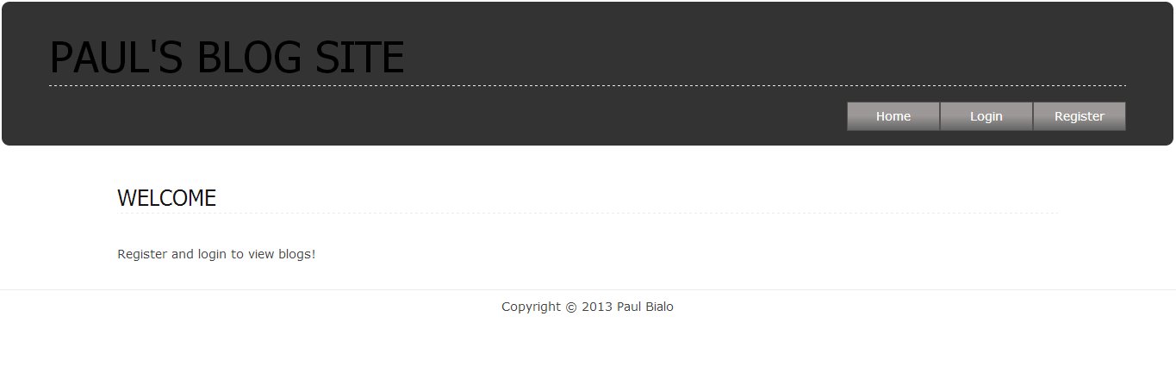

*login.php:*

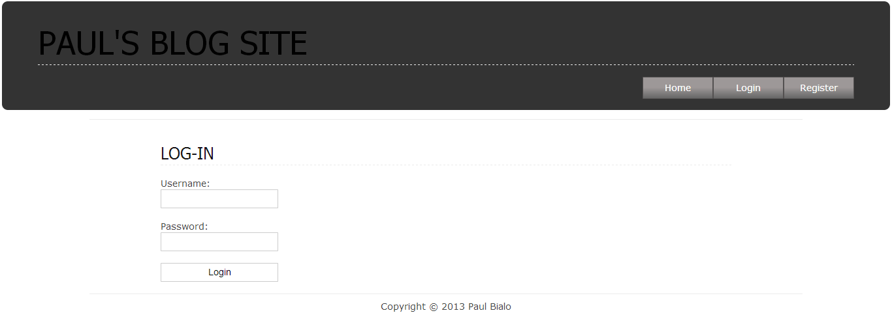

*register.php:*

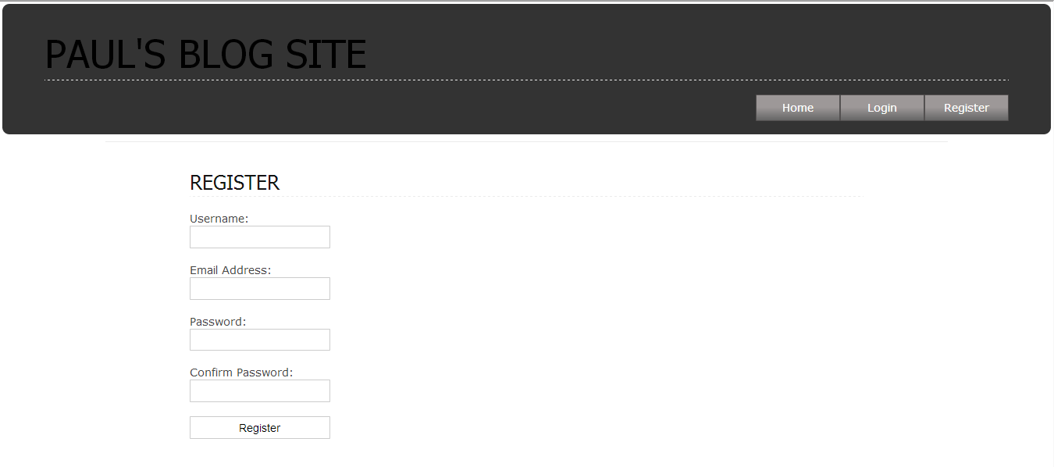

*index.php when loggedin:*

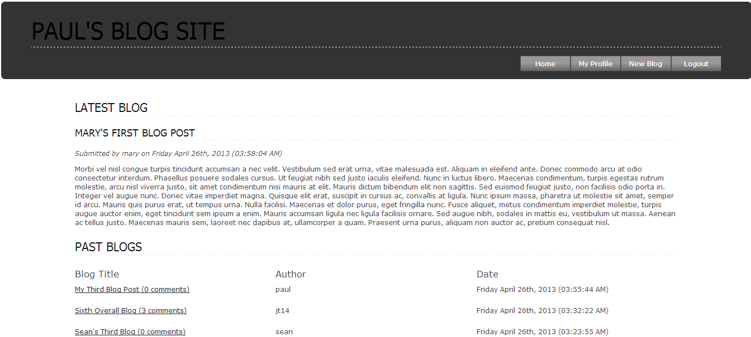

*edit_profile.php:*

**

*post_blog.php:*

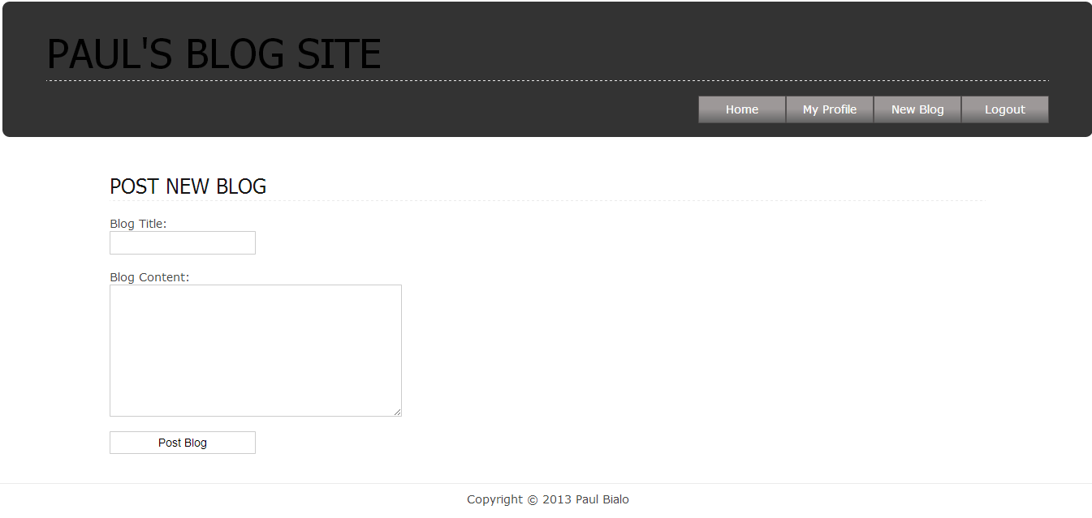

*blog.php:*

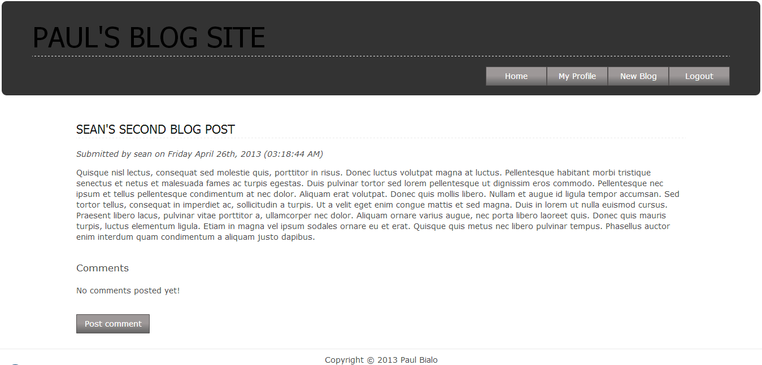

*post_comment.php:*

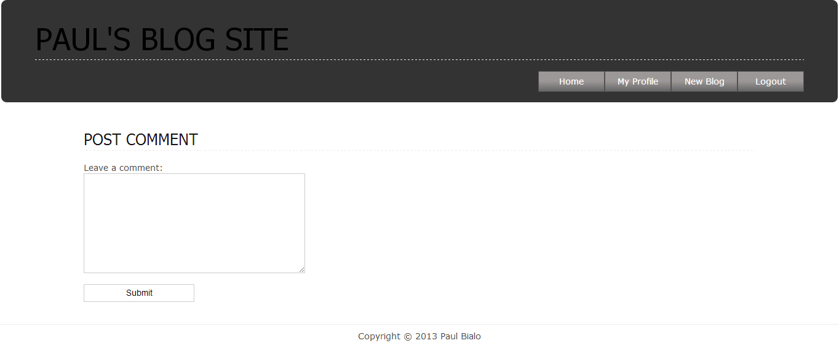

# Potential Future Functionality

* *Expanded user profiles to include names, avatars, birthdays, etc.*
* *post_comment.php to be moved into blog page instead of a separate page.*
* *CAPTCHA implementation in user registration, blog posting, and comment posting.*
* *Implement styling of blog posts.*
* *Miscellaneous security features such as use of a salt for password encryption and anti SQL injection techniques.*
* *Improved site aesthetics.*