|  |
| --- |
|  |
| Personal Portfolio Web Site |
| **External Documentation** |
| All work Copyright © 2013 by Paul Bialo  All rights reserved. |
| **Paul Bialo** |
|  |



|  |
| --- |
| April 4, 2013 |

# Table of Contents

Table of Contents 2

I. Site Description 3

II. Controls 3

III. Interface Sketch 3

IV. Screen Descriptions 4

V. Characters 5

VI. Enemies 5

VII. Scoring 6

VIII. Sound Index 6

IX. Art Index 6

# Site Description

*This is a simple web site that acts as my online personal portfolio. It highlights my skills, past experiences, and how I can be reached.*

# Nav Bar

*The nav bar contains links to all of the web site pages along with an external link to my GitHub account. The nav bar link for the currently selected page will turn black.*

**

Will link straight to my GitHub account

Current page will stand out from rest of links in nav bar

# 

# Colours

|  |  |  |
| --- | --- | --- |
| ***Colour*** | ***Hex Value*** | ***Example*** |
| *Black* | *#000000* |  |
| *Grey* | *#2f2f2f* |  |
| *Dark yellow* | *#ccb647* |  |
| *Light grey* | *#efefef* |  |

# Typography

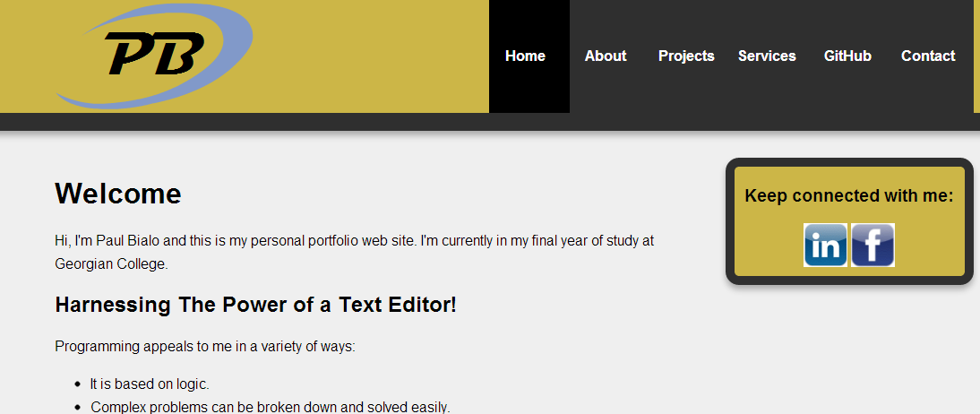

4

3

2

1

|  |  |  |  |  |
| --- | --- | --- | --- | --- |
| ***#*** | ***Usage*** | ***Font*** | ***Size*** | ***Colour*** |
| *1* | *Nav bar* | *Helvetica* | *16px* | *White* |
| *2* | *Heading 1* | *Helvetica* | *32px* | *Black* |
| *3* | *Paragraph* | *Helvetica* | *16px* | *Black* |
| *4* | *Heading 2* | *Helvetica* | *20px* | *Black* |

# Wireframes

# Branding

*Logo used: Black (#000000), dark yellow (#ccb647), light blue (#8199C9)*

**

*index.html:*

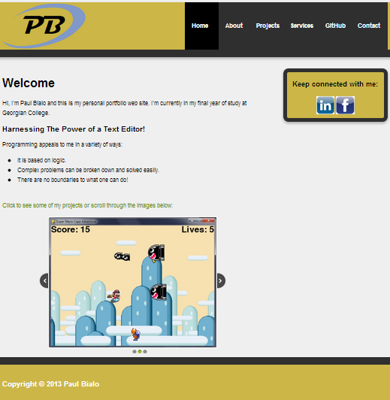

*about.html:*

**

*projects.html:*

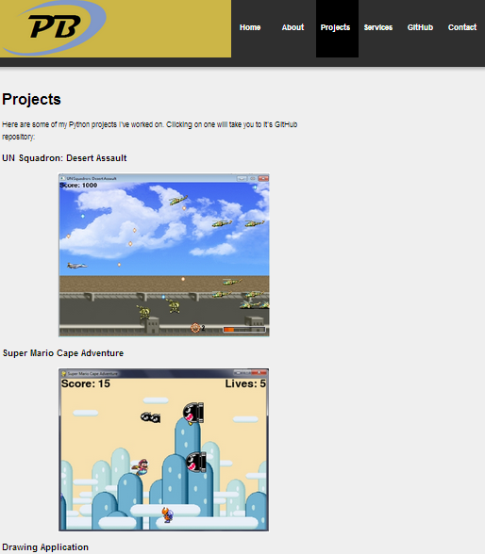

*services.html:*

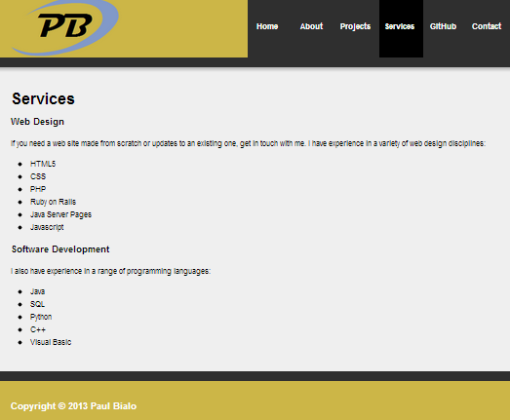

*contact.html:*

**