|  |
| --- |
| Plan b software development |
| Paint 2.0 |
| **External Documentation** |
| Version #2.0  All work Copyright © 2012 by Plan B Software Development.  All rights reserved. |
| **Paul Bialo** |
|  |

****

|  |
| --- |
| June 22th 2012 |

# Table of Contents

[Table of Contents 2](#_Toc328170620)

[Version History 3](#_Toc328170621)

[I. Detailed Application Description 4](#_Toc328170622)

[II. Controls 4](#_Toc328170623)

[III. Interface Sketch 4](#_Toc328170624)

[IV. Screen Descriptions 5](#_Toc328170625)

[V. Art Index 6](#_Toc328170626)

# Version History

**Version 1.0** - The program by Andy Harris used as a starting point for our updated version.

**Version 1.1** - The GUI was created. This includes splitting up the work area from the toolbar as well as all of the buttons being placed. Additionally, functionality was added to switching line thickness with the buttons.

**Version 1.2** - Implemented the save, load, reset, and colour selection features.

**Version 1.3** **-** Implemented functionality for the line, ellipse and rectangle tools. As well, the fill tool was implemented which applies to the ellipse and rectangle tools.

**Version 1.4** **-** The spray can tool (aka airbrush) was implemented.

**Version 2.0 -** Release version. Unused code from 1.0 was removed.

# Detailed Application Description

*Paint 2.0 is a simple drawing program developed using python and pygame. The user is given a canvas to draw on using a variety of methods such a spray can tool or a rectangle tool. The user may select line thickness and colour while using a tool. The canvas may be saved and then loaded again. There is also a reset canvas feature.*

# Controls

*The user uses their mouse to select tools from the toolbar and then to draw on the canvas. The keyboard is only used when saving or loading.*

# Interface Sketch

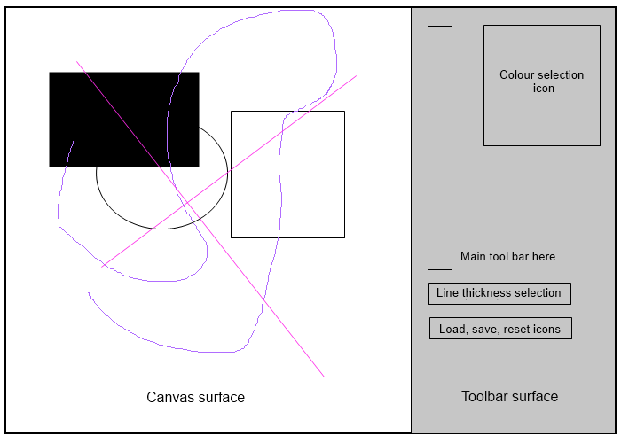

# Screen Descriptions

*A sample drawing created with Paint 2.0. The toolbar has been re-arranged since the original sketch.*

*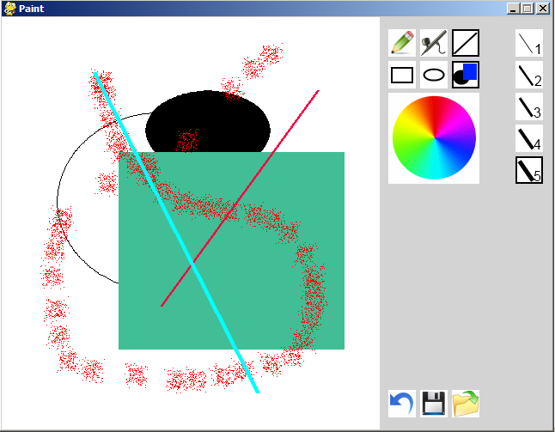*

*The colour selection dialog:*

*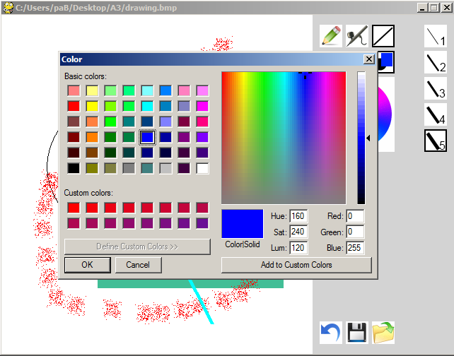*

# Art Index

*The following image files are used in the game:*

|  |  |  |
| --- | --- | --- |
| ***File name*** | ***Image*** | ***Size*** |
| *clear.gif* | *C:\Users\paB\Desktop\A3\img\clear.gif* | *2 kB* |
| *colour\_large.gif* | *C:\Users\paB\Desktop\A3\img\colour_large.gif* | *5 kB* |
| *ellipse\_selected.gif* | *C:\Users\paB\Desktop\A3\img\ellipse_selected.gif* | *2 kB* |
| *ellipse\_unselected.gif* | *C:\Users\paB\Desktop\A3\img\ellipse_unselected.gif* | *1 kB* |
| *filled\_selected.gif* | *C:\Users\paB\Desktop\A3\img\filled_selected.gif* | *1 kB* |
| *filled\_unselected.gif* | *C:\Users\paB\Desktop\A3\img\filled_unselected.gif* | *1 kB* |
| *line\_selected.gif* | *C:\Users\paB\Desktop\A3\img\line_selected.gif* | *1 kB* |
| *line\_unselected.gif* | *C:\Users\paB\Desktop\A3\img\line_unselected.gif* | *1 kB* |
| *load.gif* | *C:\Users\paB\Desktop\A3\img\load.gif* | *2 kB* |
| *outline\_selected.gif* | *C:\Users\paB\Desktop\A3\img\outline_selected.gif* | *2 kB* |
| *outline\_unselected.gif* | *C:\Users\paB\Desktop\A3\img\outline_unselected.gif* | *2 kB* |
| *pencil\_selected.gif* | *C:\Users\paB\Desktop\A3\img\pencil_selected.gif* | *2 kB* |
| *pencil\_unselected.gif* | *C:\Users\paB\Desktop\A3\img\pencil_unselected.gif* | *2 kB* |
| *rectangle\_selected.gif* | *C:\Users\paB\Desktop\A3\img\rectangle_selected.gif* | *1 kB* |
| *rectangle\_unselected.gif* | *C:\Users\paB\Desktop\A3\img\rectangle_unselected.gif* | *1 kB* |
| *save.gif* | *C:\Users\paB\Desktop\A3\img\save.gif* | *2 kB* |
| *spraybrush\_selected.gif* | *C:\Users\paB\Desktop\A3\img\spraybrush_selected.gif* | *2 kB* |
| *spraybrush\_unselected.gif* | *C:\Users\paB\Desktop\A3\img\spraybrush_unselected.gif* | *2 kB* |
| *thickness1\_selected.gif* | *C:\Users\paB\Desktop\A3\img\thickness1_selected.gif* | *1 kB* |
| *thickness1\_unselected.gif* | *C:\Users\paB\Desktop\A3\img\thickness1_unselected.gif* | *1 kB* |
| *thickness2\_selected.gif* | *C:\Users\paB\Desktop\A3\img\thickness2_selected.gif* | *2 kB* |
| *thickness2\_unselected.gif* | *C:\Users\paB\Desktop\A3\img\thickness2_unselected.gif* | *1 kB* |
| *thickness3\_selected.gif* | *C:\Users\paB\Desktop\A3\img\thickness3_selected.gif* | *2 kB* |
| *thickness3\_unselected.gif* | *C:\Users\paB\Desktop\A3\img\thickness3_unselected.gif* | *2 kB* |
| *thickness4\_selected.gif* | *C:\Users\paB\Desktop\A3\img\thickness4_selected.gif* | *2 kB* |
| *thickness4\_unselected.gif* | *C:\Users\paB\Desktop\A3\img\thickness4_unselected.gif* | *2 kB* |
| *thickness5\_selected.gif* | *C:\Users\paB\Desktop\A3\img\thickness5_selected.gif* | *2 kB* |
| *thickness5\_unselected.gif* | *C:\Users\paB\Desktop\A3\img\thickness5_unselected.gif* | *2 kB* |