|  |
| --- |
| Plan b software development |
| Super Mario Cape Adventure |
| **External Documentation** |
| Version #2.0  All work Copyright © 2012 by Plan B Software Development.  All rights reserved. |
| **Paul Bialo** |
|  |



|  |
| --- |
| July 12th 2012 |

# Table of Contents

Table of Contents 2

Version History 3

I. Detailed Application Description 4

II. Controls 4

III. Interface Sketch 4

IV. Screen Descriptions 5

V. Characters 6

VI. Enemies 6

VII. Scoring 7

VIII. Sound Index 7

IX. Art Index 7

# Version History

**Version 1.0** - Sprite for the game's avatar is implemented (control and animation).

**Version 1.1** - Coins added.

**Version 1.2** - Various enemies added.

**Version 1.3** **-** Collisions implemented with sounds. The background was also implemented

**Version 1.4** **-** The info board was implemented (score and lives). Some fixes to how the sprites were being drawn also added.

**Version 1.5** **-** Adding the introduction and gameover states to the game. One-up mushrooms added. Extra enemies added. Scoring was changed.

**Version 2.0 -** Release version. Minor touch-ups to code.

# Detailed Application Description

*Super Mario Cape Adventure is a side-scrolling game made with Python. The user takes control of Mario and navigates the skies avoiding enemies while collecting coins.Colliding with an enemy results in a loss of a life. Enemies are somewhat randomized in how they move across the screen.*

# Controls

*Mario's position is entirely controlled with a mouse. Hitting the escape key during the introduction or game over screens will exit the game.*

# Interface Sketch

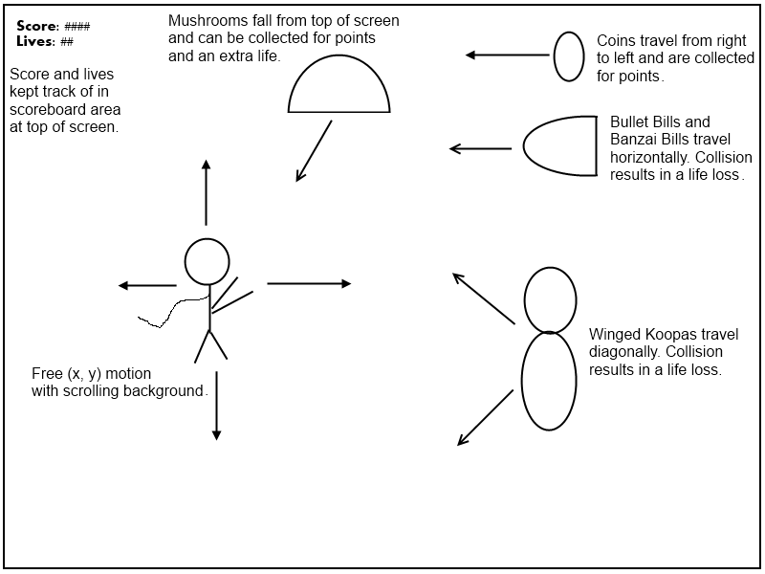

# Screen Descriptions

*The introduction screen. Music plays and the game background scrolls by. All of the text is generated with an image:*

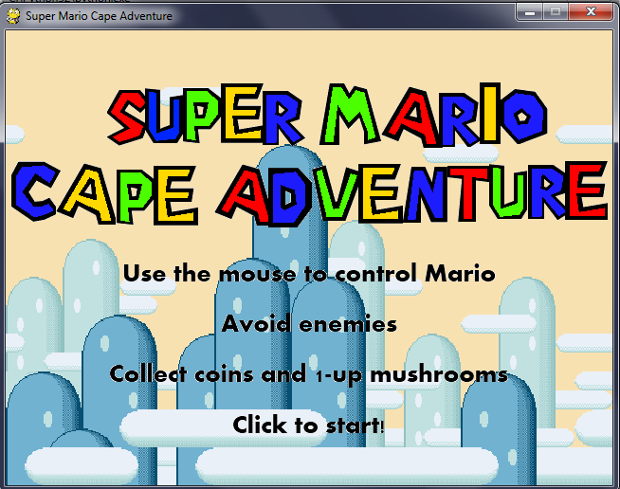

*The game screen. Mario is controlled with the mouse. Enemies need to be avoided while coins get collected. Score and lives are constantly updated:*

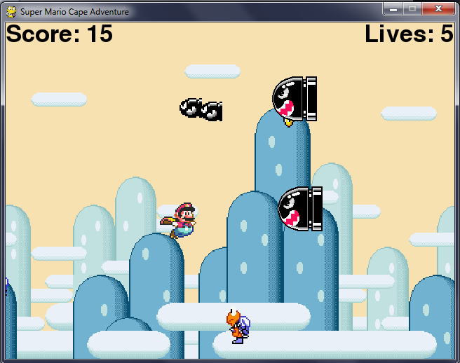

*The game over screen.The player's score is shown and the option to play again is given:*

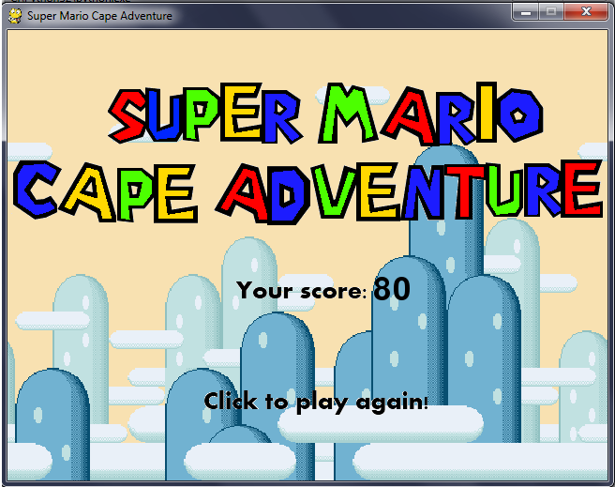

# Characters

*The only character in the game is Mario. In this game he has the flying powers of a cape and is controlled with the mouse. His sprite is drawn using two images that alternate to give a simple animation.*

# Enemies

*Three enemies exist in the game. Banzai Bills are large missiles that travel horizontally across the screen at random speeds. Bullet Bills are a smaller version of Banzai Bills that travel faster. The y-position of both of these is random each time they enter the screen but it stays constant until reaching theleft side of the screen.Winged Koopas follow a diagonal path across the screen starting at random y coordinate on the right side of the screen. As they reach the top or bottom of the screen, they switch in the opposite y direction.*

# Scoring

*The player gains 10 points for each coin he collects. Missing a coin (by reaching the left side of the screen) results in a loss of 25 points. Collecting a one-up mushroom yields 50 points .*

# Sound Index

|  |  |  |
| --- | --- | --- |
| ***File name*** | ***Description*** | ***Size*** |
| *bill.wav* | *Played when a Bullet Bill or Banzai Bill enter the game screen* | *17 KB* |
| *coin.ogg* | *Played when a coin is collected* | *9 KB* |
| *gamemusic.ogg* | *Played during the game screen* | *1,567 KB* |
| *gameover.ogg* | *Played when the player runs out of lives* | *41 KB* |
| *intromusic.ogg* | *Played during the introduction screen* | *1,324 KB* |
| *loselife.ogg* | *Played when the player collides with an enemy* | *19 KB* |
| *oneup.ogg* | *Played when a mushroom is collected* | *11 KB* |

# Art Index

*The following image files are used in the game:*

|  |  |  |
| --- | --- | --- |
| ***File name*** | ***Image*** | ***Size*** |
| *background.gif* |  | *37 KB* |
| *banzaibill.gif* |  | *2 KB* |
| *bulletbill.gif* |  | *1 KB* |
| *coin0.gif* |  | *1 KB* |
| *coin1.gif* |  | *1 KB* |
| *coin2.gif* |  | *1 KB* |
| *coin4.gif* |  | *1 KB* |
| *gameover.gif* |  | *14 KB* |
| *instructions.gif* |  | *17 KB* |
| *mario0.gif* |  | *2 KB* |
| *mario1.gif* |  | *2 KB* |
| *onneup.gif* |  | *2 KB* |
| *wingkoopa0.gif* |  | *2 KB* |
| *wingkoopa1.gif* |  | *2 KB* |