|  |
| --- |
| Plan b software development |
| UN Squadron: Desert Assault |
| **External Documentation** |
| Version #2.0  All work Copyright © 2012 by Plan B Software Development.  All rights reserved. |
| **Paul Bialo** |
|  |

****

|  |
| --- |
| August 9th, 2012 |

# Table of Contents

[Table of Contents 2](#_Toc329845614)

[Version History 3](#_Toc329845615)

[I. Detailed Application Description 4](#_Toc329845616)

[II. Controls 4](#_Toc329845617)

[III. Interface Sketch 4](#_Toc329845618)

[IV. Screen Descriptions 5](#_Toc329845619)

[V. Characters 6](#_Toc329845620)

[VI. Enemies 6](#_Toc329845621)

[VII. Scoring 7](#_Toc329845622)

[VIII. Sound Index 7](#_Toc329845623)

[IX. Art Index 7](#_Toc329845624)

# Version History

**Version 1.0** - The basic jet controls and backgrounds implemented

**Version 1.1** - The timer, bomb, cluster classes were all added.

**Version 1.2** - Various classes added: The enemy Heli (with 3 patterns), helishot (fired from helis and turrets) as well as an explosion class. Collision was implemented between the player weapons and the enemies. A targeting system was added to make enemy shots more accurate. Finally, a file reader was implemented as a way to set-up how enemies are spawned during the game.

**Version 1.3** **-** The small turret and flame turret enemy classes were added. Health was assigned to all enemies and player weapons damage was adjusted.

**Version 1.4** **-** Several GUI elements were added (score, cluster quantity, health). The start and end screens were added. Sounds also implemented.

**Version 2.0 -** Release version. Minor touch-ups to code.

# Detailed Game Description

*UN Squadron: Desert Assault is a side-scrolling jet fighter styled shoot-em-up game. The player takes control of a jet equipped with various weapons to destroy enemies. Surviving to the end while destroying many enemies will generate a higher score.*

# Controls

*The plane's position is controlled with the directional arrows on the keyboard. Weapons are used with the Z, X, and C keys.*

# Interface Sketch

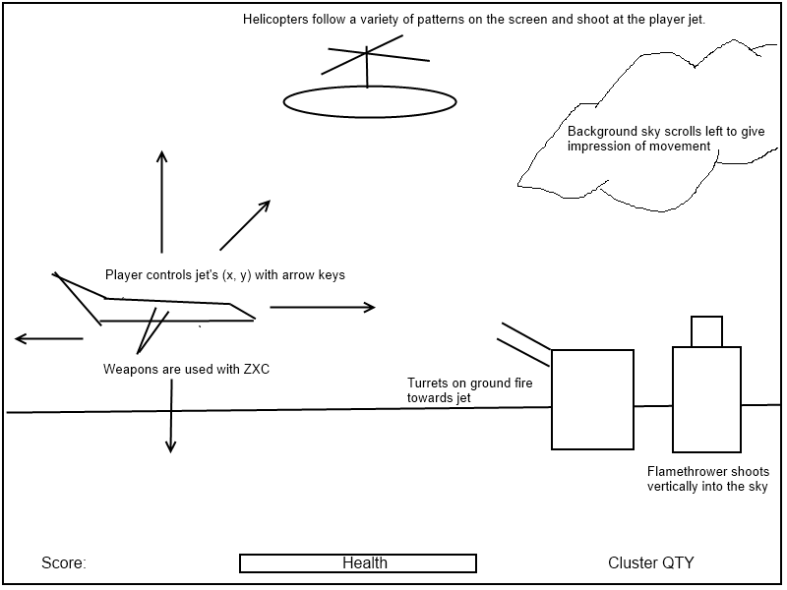

# Screen Descriptions

*The introduction screen. Player instructions are displayed:*

*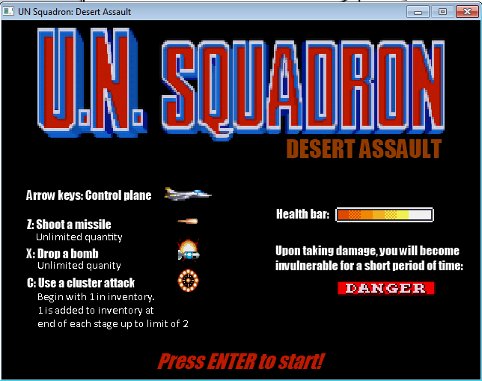*

*For the first section of the game, only heli enemies appear:*

*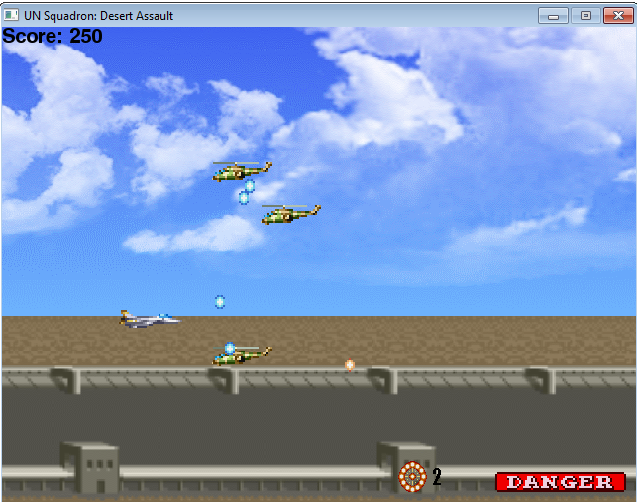*

*In the second section, ground turrets appear and there are more enemies:*

*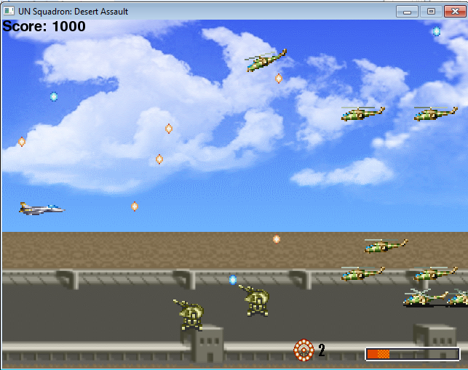*

*In the final section of the game, flame turrets are added:*

*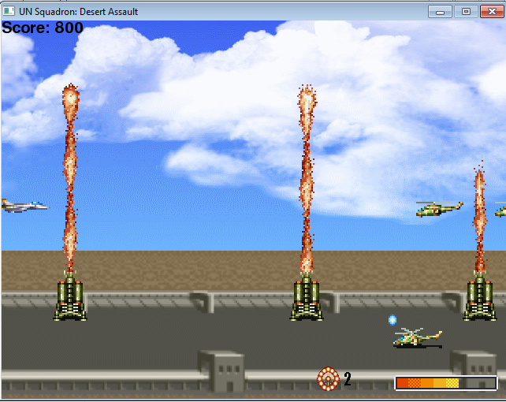*

*Two game-over screens are shown depending on the outcome of the game:*

*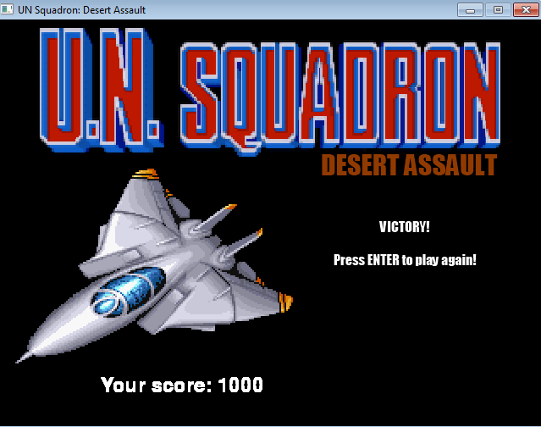*

*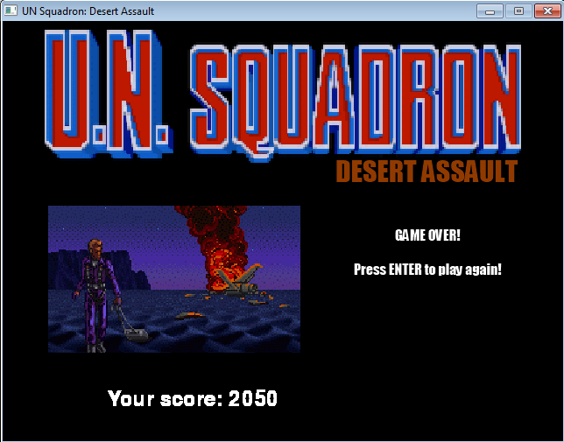*

# Game World

*You are part of a United Nations Squadron that is dispatched to an unnamed desert to destroy as many enemy units as possible along a high priority air-strip.*

# Levels

*The game consists of three sections that flow into one another. In the first section, only simple heli enemies appear and there are not too many. In the second section, small turrets are added to the fray in addition to some more complex heli combinations. In the third section, flame turrets are added to the list of enemies. The game gets progressively harder as more units are attacking you.*

# Characters/Vehicles

*The player takes control of a jet fighter which can move around freely within the game screen. It had a variety of weapons at its disposal. Taking damage leads to a short period of invulnerability but with the loss of some health. Losing all health leads to destruction and the game over screen.*

# Enemies

*Three enemies exist in the game. The most common is the heli. It is very easy to destroy however it moves around in a variety of patterns and also fires back at the player. The second enemy is the small turret. It is fixed to the ground but is able to take a bit more damage than the heli before being destroyed. The final enemy is the flame turret. It shoots a large stream of flames directly above it and takes the most damage before being destroyed.*

# Weapons

*The player has three weapons at his disposal. The first is the standard attack which shoots a missile straight forward from the front of the jet. It deals low damage. The second weapon is a bomb that is dropped from the jet. It deals moderate damage but is a bit tricky to land accurately. The final weapon is the cluster. This sets off a barrage of explosions around the player destroying all enemies it hits. At the start of the game, a player has only one cluster in his inventory but gains one at the end of each section. The player may only carry two clusters at one time.*

# Scoring

*The player generates score by destroying enemies and collecting the bonus power-up that occasionally appears. Stronger enemies generate more points. A bonus is given to the player upon completion of the game. The more life leftover, the bigger the bonus.*

# Sound Index

|  |  |  |
| --- | --- | --- |
| ***File name*** | ***Description*** | ***Size*** |
| *bomb.ogg* | *Played when a bomb explodes* | *10 KB* |
| *bonus.ogg* | *Played when a bonus item is collected* | *16.2 KB* |
| *bullet.ogg* | *Played when the player shoots a missile* | *14.8 KB* |
| *cluster.ogg* | *Played when the player uses a cluster* | *34.4 KB* |
| *explosion.ogg* | *Played during certain enemy explosions* | *109 KB* |
| *flame.ogg* | *The sound made by the flame turret* | *109 KB* |
| *gamemusic.ogg* | *Song played during the game portion.* | *2.070 MB* |
| *gameoverlosemusic.ogg* | *Song played when the player dies* | *960 KB* |
| *gameoverwinmusic.ogg* | *Song played upon completing the game* | *131 KB* |
| *medexplosion.ogg* | *Played during certain enemy explosions* | *13.8 KB* |
| *startmusic.pgg* | *Song played during the startscreen* | *3.21 MB* |
| *warning.ogg* | *Played when the player takes damage* | *41.8 KB* |

# Art Index

*The following image files are used in the game:*

|  |  |  |
| --- | --- | --- |
| ***File name*** | ***Image*** | ***Size*** |
| *road.gif* | *C:\Users\pB\Documents\2B\COMP2069_Intro_To_Graphics\Project\img\backgrounds\road.gif* | *96.2 KB* |
| *sky.gif* | *C:\Users\pB\Documents\2B\COMP2069_Intro_To_Graphics\Project\img\backgrounds\sky.gif* | *2 KB* |
| *bonus.gif* | *C:\Users\pB\Documents\2B\COMP2069_Intro_To_Graphics\Project\img\enemies\bonus0.gif* | *1 KB* |
| *flameshot.gif* | *C:\Users\pB\Documents\2B\COMP2069_Intro_To_Graphics\Project\img\enemies\flameshot14.gif* | *2 KB* |
| *flameturret.gif* | *C:\Users\pB\Documents\2B\COMP2069_Intro_To_Graphics\Project\img\enemies\flameturret2.gif* | *1.54 KB* |
| *heli.gif* | *C:\Users\pB\Documents\2B\COMP2069_Intro_To_Graphics\Project\img\enemies\heli0.gif* | *1.12 KB* |
| *helishot.gif* | *C:\Users\pB\Documents\2B\COMP2069_Intro_To_Graphics\Project\img\enemies\helishot3.gif* | *1 KB* |
| *smallturret.gif* | *C:\Users\pB\Documents\2B\COMP2069_Intro_To_Graphics\Project\img\enemies\smallturret0.gif* | *1 KZB* |
| *bomb.gif (explosion)* | *C:\Users\pB\Documents\2B\COMP2069_Intro_To_Graphics\Project\img\explosions\bomb2.gif* | *3 KB* |
| *medexplosion.gif* | *C:\Users\pB\Documents\2B\COMP2069_Intro_To_Graphics\Project\img\explosions\med3.gif* | *1 KB* |
| *cluster.gif (UI)* | *C:\Users\pB\Documents\2B\COMP2069_Intro_To_Graphics\Project\img\gui\cluster0.gif* | *1 KB* |
| *healthbar.gif* | *C:\Users\pB\Documents\2B\COMP2069_Intro_To_Graphics\Project\img\gui\hp7.gif* | *1 KB* |
| *A0.gif* | *C:\Users\pB\Documents\2B\COMP2069_Intro_To_Graphics\Project\img\jets\A0.gif* | *1 KB* |
| *bomb.gif* | *C:\Users\pB\Documents\2B\COMP2069_Intro_To_Graphics\Project\img\weapons\bomb0.gif* | *1 KB* |
| *cluster.gif* | *C:\Users\pB\Documents\2B\COMP2069_Intro_To_Graphics\Project\img\weapons\cluster1.gif* | *3 KB* |
| *bullet.gif* | *C:\Users\pB\Documents\2B\COMP2069_Intro_To_Graphics\Project\img\weapons\bullet.gif* | *1 KB* |