App Specification & Description
eHatyai.com — Accommodation Booking Platform
Search-first booking flow (Agoda / Booking.com pattern)
Field | Value
Document title | App Specification & Description — eHatyai.com
Version | 1.0 (Confirmed user flow, 11 steps)
Date | 4 July 2026
Status | Approved flow — ready for build prompt / development
Prepared by | BI Technologist — Supply Chain Analytics & AI Workflow Design
Flow pattern | Search-first; login required at booking step (step 5)

Table of contents

1. Introduction

1.1 Purpose
This document specifies the functional behavior, user flow, business rules, and data requirements of eHatyai.com, an online accommodation booking platform. It is the single source of truth for the confirmed 11-step user flow and is intended for use by developers, UI/UX designers, QA testers, and AI build prompts (vibe-coding workflows).

1.2 Scope
In scope: guest browsing and search, property/room selection, member registration and login, booking creation, payment, and booking confirmation with email/SMS notification. Out of scope (this version): cancellation and refund flow, guest checkout without an account, host/property-owner management portal, and loyalty programs.

1.3 Definitions
Term | Meaning
Login wall | The point in the flow where authentication becomes mandatory (step 5, after room selection).
Booking ID | Unique reference issued by the system when a booking is confirmed (step 9).
Net amount | Booking total after discounts, taxes, and fees. If net amount = 0, payment is skipped automatically.
OTP | One-time password sent by email/SMS to verify a new user's identity during registration.

2. Product overview
eHatyai.com lets travelers search accommodation freely without an account, compare results with filters, and select a property and room. Authentication is deferred until the booking step, following the pattern used by leading OTA platforms (Agoda, Booking.com): browsing is frictionless, and identity is required only when a reservation is created. The system remembers the selected room across the login step so the user never restarts the flow.

2.1 Target users
- Guest visitor — browses and searches without an account; converts at the login wall.
- New user — registers with email/phone + OTP verification at step 5, then continues the same booking.
- Returning member — logs in at step 5; booker details are pre-filled from the account profile.
- Admin (system) — receives booking records and notification logs (operational scope, not a UI in this version).

3. User flow (confirmed)
The confirmed flow contains 6 phases and 11 steps. Steps 5 (login wall) and 8 (payment) are the two critical gates; steps 9–11 form the confirmation stretch. Loop-backs exist at steps 3 (filter refinement), 7 (room unavailable), and 8 (payment retry).
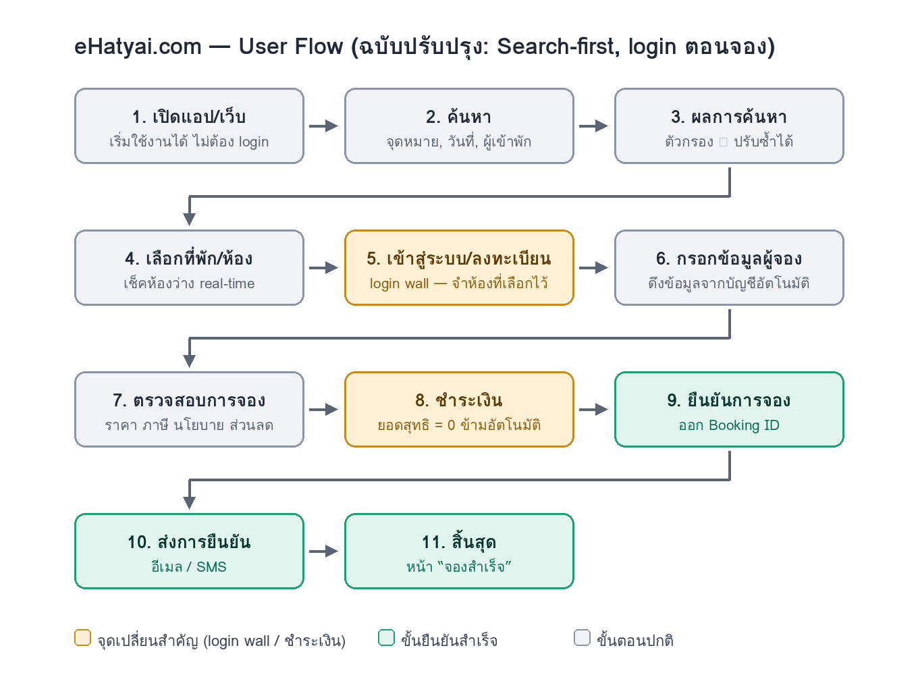
Figure 1 — eHatyai.com user flow (search-first, login at booking)

3.1 Step-by-step specification
No. | Step (Thai) | Description | System behavior
1 | เปิดแอป/เว็บ | User opens the app or website. No login required. | Load home page; start anonymous session.
2 | ค้นหา | Enter destination, check-in/check-out dates, number of guests. | Validate dates (check-out > check-in); query available properties.
3 | ผลการค้นหา | Browse results; apply filters (price, type, amenities) iteratively; view details. | Filter loop 3 ⇄ filters. If no results, suggest adjusting criteria and return to step 2.
4 | เลือกที่พัก/ห้อง | Select property and room; press “จองเลย” (Book now). | Real-time availability check; hold selection in session.
5 | เข้าสู่ระบบ / ลงทะเบียน | LOGIN WALL. Existing member logs in; new user registers with OTP verification, then is logged in automatically. | Persist the selected room across authentication; on success continue to step 6 without restarting.
6 | กรอกข้อมูลผู้จอง | Enter/confirm booker details (name, email, phone, special requests). | Pre-fill from account profile; editable.
7 | ตรวจสอบการจอง | Review booking summary: room, dates, price, taxes/fees, cancellation policy; apply promo code. | Re-verify availability. If room became unavailable, notify and return to step 4.
8 | ชำระเงิน | If net amount > 0: choose payment method (card / PromptPay / e-Wallet) and pay. If net amount = 0: skip automatically. | On failure: show reason, allow retry or change method (max 3 attempts, then hold booking as Pending-Payment).
9 | ยืนยันการจอง | System confirms the booking. | Issue unique Booking ID; set status = Confirmed.
10 | ส่งการยืนยัน | Send confirmation to the user. | Email + SMS with booking details and check-in QR code; log delivery.
11 | สิ้นสุด | Flow ends on the success screen. | Show “จองสำเร็จ” page with Booking ID and a “My bookings” button.

4. Business rules
Rule | Statement
BR-1 | Search-first: steps 1–4 must be fully usable without authentication. No login prompt may appear before the user presses “Book now”.
BR-2 | Login wall placement: authentication is required exactly once, at step 5, after room selection. The selected property, room, dates, and guest count must persist across login/registration.
BR-3 | Single login point: no other step may re-request authentication within the same session.
BR-4 | Zero-amount bypass: if the net amount after discounts equals 0, the payment step is skipped automatically and the flow proceeds directly to confirmation (step 9).
BR-5 | Payment retry: a failed payment allows retry or change of method, limited to 3 attempts; after that the booking is held as Pending-Payment and the room hold is released after a timeout.
BR-6 | Availability re-check: room availability is verified in real time at step 4 and re-verified at step 7. If the room becomes unavailable, the user is notified and returned to selection.
BR-7 | Confirmation guarantee: a Booking ID is issued only after successful payment (or zero-amount bypass), and every confirmed booking triggers an email + SMS notification (step 10).

5. Functional requirements by module
ID | Module | Requirement
FR-1.1 | Search | Search form with destination autocomplete, date range picker, and guest/room count selector.
FR-1.2 | Search | Results list with sorting (price, rating) and iterative filters (price range, property type, amenities).
FR-1.3 | Search | Empty-state handling: no results screen with suggestions to adjust dates or destination.
FR-2.1 | Selection | Property detail page: photos, description, room types, prices, reviews, map location.
FR-2.2 | Selection | Room availability shown in real time for the searched dates before “Book now” is enabled.
FR-3.1 | Authentication | Login by email/phone + password; “forgot password” recovery.
FR-3.2 | Authentication | Registration with OTP verification (email or SMS); auto-login on success.
FR-3.3 | Authentication | Session persistence: pending booking context restored after authentication.
FR-4.1 | Booking | Booker details form pre-filled from profile; special-request free text.
FR-4.2 | Booking | Review screen with full price breakdown (room rate, taxes, fees, discount) and cancellation policy.
FR-4.3 | Booking | Promo code entry with instant recalculation of net amount.
FR-5.1 | Payment | Methods: credit/debit card, PromptPay QR, e-Wallet.
FR-5.2 | Payment | Failure handling per BR-5; clear failure reasons; secure processing via payment gateway (no card data stored).
FR-6.1 | Confirmation | Booking ID generation; status transition to Confirmed.
FR-6.2 | Confirmation | Email + SMS confirmation with booking summary and check-in QR code; delivery logged.
FR-6.3 | Confirmation | Success screen with Booking ID and link to “My bookings”.

6. Alternate and exception flows
Trigger | System response | Flow returns to
No search results (step 3) | Show empty state with suggestions to adjust dates/destination/filters. | Step 2 — ค้นหา
Room becomes unavailable (step 7) | Notify user; release the hold; show alternatives in the same property. | Step 4 — เลือกที่พัก/ห้อง
Payment failed (step 8) | Show reason; offer retry or change method (max 3 attempts). | Step 8 — ชำระเงิน
Payment attempts exhausted | Hold booking as Pending-Payment; notify user; release room after timeout. | Flow ends (recoverable from My bookings)
OTP not received / expired (step 5) | Resend OTP with cooldown; allow switch between email and SMS. | Step 5 — เข้าสู่ระบบ/ลงทะเบียน

7. Non-functional requirements
- Performance: search results render within 2 seconds for typical queries; availability checks within 1 second.
- Security: all payment processing via a certified gateway; no card data stored by the platform; sessions protected against fixation across the login wall.
- Localization: Thai as primary UI language with English toggle; prices in THB (฿) with 2-decimal formatting.
- Responsiveness: mobile-first layout for search and booking; desktop-optimized review and payment screens.
- Reliability: notification delivery (email/SMS) logged and retryable; Booking ID generation must be idempotent per payment.

8. Key data entities
Entity | Key attributes | Notes
User | id, name, email, phone, password hash, verified flag | Created at step 5 for new users
Property | id, name, location, type, amenities, photos, rating | Search index source
RoomType | id, propertyId, name, capacity, base price, inventory per date | Availability checked at steps 4 and 7
Booking | id (Booking ID), userId, roomTypeId, check-in/out, guests, price breakdown, status | Status: Draft → Pending-Payment → Confirmed → (Cancelled)
Payment | id, bookingId, method, amount, status, attempts, gateway ref | Max 3 attempts (BR-5)
Notification | id, bookingId, channel (email/SMS), sentAt, delivery status | Written at step 10

9. Change log vs. original flow diagram
- Removed duplicated step 5 (ลงทะเบียน/เข้าสู่ระบบ appeared twice); authentication now occurs exactly once, and numbering runs 1–11 cleanly.
- Adopted search-first pattern: login moved after room selection (Agoda/Booking.com behavior) instead of requiring an account before search; the pending booking survives the login wall.
- Removed the dead-end “ข้าม” (skip) branch; guest checkout is out of scope in this version — login is required at booking.
- Made the payment condition explicit: net amount = 0 bypasses payment automatically (was an implicit note “กรณียอดเงินไม่เป็น 0”).
- Added failure paths: no search results, room unavailable at review, payment failure with 3-attempt retry limit.
- Added step 10 (ส่งการยืนยัน — email/SMS with QR) which was missing between Booking ID and end.
- Filter interaction defined as an iterative loop (3 ⇄ ตัวกรอง), not a one-way branch.

10. Open items
- Cancellation and refund flow — pending decision on scope for version 1.1.
- Guest checkout (booking without account) — currently excluded; revisit if conversion data shows drop-off at the login wall.
- Payment retry limit fixed at 3 attempts — confirm with payment gateway policy.

