**Comprehensive graphical presentation of data from incurred sample reanalysis**

P.J. Rudzki*1, P. Biecek2, M. Kaza1

1 Pharmaceutical Research Institute, Pharmacology Department, 8 Rydygiera, 01-793 Warsaw, Poland

2 Faculty of Mathematics and Information Science, Warsaw University of Technology Koszykowa 75, 00-662 Warsaw, Poland

*Correspondence to: Piotr J. Rudzki, Pharmaceutical Research Institute, Pharmacology Department, 8 Rydygiera, 01-793 Warsaw, Poland. Mobile: +48 601 585 453. Fax: +48 22 456 38 38. E-mail: p.rudzki@ifarm.eu.

**Abstract**

**Keywords (5-10):** incurred sample reanalysis, visualization, bioanalysis; regulatory compliance; pharmacokinetics; visual inspection of data; data processing methodology; data quality.

# Introduction

Since rejuvenation of incurred sample reanalysis (ISR) reported after the 3rd AAPS / FDA Bioanalytical Workshop [Rocci], the ISR became a widely discussed topic in bioanalytical and pharmaceutical literature. Its contribution to assure reliability of pharmacokinetic studies can not be overestimated as it may reveal some issues that are invisible during bioanalytical method validation. Numerous case studies show that failed ISR [Yadav] – or even unmatched results in passed ISR [Tan] – lead to valuable observations and increased reliability of results.

Although ISR methodology was adopted in the regulatory guidelines [EMA, FDA], not all the questions asked by the bioanalytical community have been answered. It seems that one of those unsolved issues is the graphical presentation of data as different authors use various plots to illustrate their ISR findings. Among previously reported plots and graphs were: Bland-Altman [Rocci] and its variations [Tan, Barfield], box-and-whisker [de Boer] and bar chart [Yadav]. Different approaches to the visual inspection of data quality are essential as the bioanalytical community is still developing the optimal ISR methodology. However, some unification could help to compare results from different laboratories during both scientific and regulatory data review.

Why visual inspection of data quality is important? The researchers, clinical and pharmacokinetic laboratory managers, quality assurance or control staff as well as regulatory assessors are too busy nowadays, they have to evaluate too much data. Tabulated data – especially containing a huge amount of numbers what is the case in most ISR datasets – is difficult to interpret. Thus, a clear graphical presentation may help to find quickly a needle in a haystack. The statement by Tukey “*The greatest value of a picture is when it forces us to notice what we never expected to see*” [Tukey] seems to be ideally fitted to the ISR topic, because all unexpected issues have to be solved before tested drug is available to patients.

In this paper we aimed to answer the question if there is an universal approach to visualize ISR data. Our secondary goal was to propose graphical standard which shows at a glance whether ISR acceptance criteria are met or not. We evaluated the advantages and limitations of different graphical presentations – both applied previously and our novel proposals.

# Methods

Calculations and acceptance criteria were in line with EMA bioanalytical method validation guideline [EMA]. The %difference (Equation 1) should be within ±20% of their mean for small molecules which are discussed in this paper (for large molecules the limit is ±30% of the mean).

$\%difference=\frac{repeat value-initial value}{mean value}×100\%$ (Equation 1)

The percent of ISR results meeting above criteria (%ISR, Equation 2) should be at least 67%.

$\%ISR=\frac{Number of ISR pairs with \%difference between-20\% and 20\%}{Total number of ISR pairs}×100\%$ (Equation 2)

Normal distribution of initial and repeat values as well as %difference was assumed.

Figure 5 was generated in Statistica (version 10, Statsoft Inc.). All other figures were generated in Microsoft Excel 2003 or 2007.

Different methods of graphical presentation of data were tested in datasets including limited, standard and huge number of ISR pairs. The datasets cover passed and failed cases, including extreme sets of 0% and 100% passed as well as just below and just above regulatory limit of 67% passed (Table 1). All datasets consisted of initial result and first repeat value and were obtained for small molecular analytes. Datasets A and B were based on the literature data [Cote, Fu]. All other dataset were generated at the GLP-certified laboratory of the Pharmacology Department in the Pharmaceutical Research Institute, Warsaw, Poland. To avoid any misinterpretation of results, the pairs containing results below or over calibration range (i.e. <LLOQ and >ULOQ), which were present in 2 datasets, were excluded from visual evaluation.

# Results and discussion

## Bland-Altman

The Bland-Altman plot was applied to visual inspection of ISR data quality by Rocci et al. [Rocci]. It shows individual results and has a strong statistical background. However, it is not in line with current regulatory guideline [EMA], because for each study different limits are calculated. Therefore, it is difficult to compare the data from different studies. One may also argue that calculation of limits is a bit sophisticated and could be an additional source of error.

## %difference vs. concentration

The %difference vs. concentration plot with fixed acceptance limits set at -20% and 20% and additional dashed line at 0% – e.g. used by Barfield et al. [Barfield] – may be considered as Bland-Altman plot adapted to meet regulatory requirements. It helps to upgrade data quality by clearly showing concentration-dependent trends in individual results. However, it fails to illustrate time-dependent ones and the overall ISR performance, especially in case of datasets with %ISR near 67% acceptance limit.

Reanalysis of samples near maximum concentration and in the elimination phase of the pharmacokinetic profile is required by EMA [EMA] so the data may be divided into two clusters representing high and low concentrations, respectively. In case of aggregation of low concentration data, the points on the plot may be dispersed by application of logarithmic scale on X axis (Figure 1, top). However, caution should be taken to avoid aggregation of high concentration data (Figure 1, bottom).

|  |  |
| --- | --- |
|  |  |
|  |  |

*Figure 1. Linear (left) or logarithmic (right) scale on X axis influence graphical presentation due to aggregation at low and high concentrations for datasets I (top) and G – (bottom), respectively.*

## %difference vs. ISR number

The %difference may be also presented against ISR number instead of concentration (e.g. Figure 1 in [Tan]). Such a plot possess similar characteristics to those described in former paragraph, except that it allows to inspect time-dependent trends (Figure 2), but fails to show concentration-dependent ones.

|  |  |
| --- | --- |
|  |  |

*Figure 2. Time-dependent trends observed after 50th ISR pairs in datasets C (left) and I (right).*

## Correlation plot

The correlation of initial and repeat values was applied for ISR visualization by de Boer and Wieling [de Boer]. It has a strong statistical background and shows individual results. However, it is not in compliant to current guideline [EMA] as it does not refer to %difference nor to %ISR values. One may also suggest that ISR pairs with small concentrations are usually overlapping, especially in huge datasets (Figure 3). Moreover, the regression parameters seem to be more meaningful for upgrading data quality than the plot itself, because graphical presentation does not indicate weather acceptance criteria were met or not.

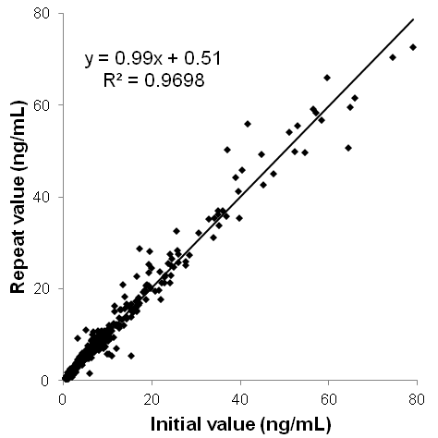

*Figure 3. Correlation plot for dataset E (n = 354) showing overlapping low concentration data.*

## Histogram and bar chart

Frequency distribution is a valuable tool in data handling. A histogram presents the variable of interest in the X axis and the number or percentage of observations (frequency) in the Y axis. A bar chart – applied by Yadav et al. [Yadav] – and the histogram have lot in common [Manikadan]. The histogram has a strong statistical background, shows deviations from normal distribution as well as it is easy for interpretation. The frequency of %difference results plotted against the %difference classes shows overall ISR performance (Figure 4). However, the histogram does not show whether the regulatory criteria are met or not, fails to show individual results and data trends.

The classes in the presented histograms were not chosen *lege artis*, i.e. are not of the same width and there are open-ended classes (< -40% and > 40%). Classes with results outside accepted %difference values are wider than classes with accepted values. The number of eight classes seems to be appropriate for intended use giving some information about the trend in acceptable and out of limits values. The histogram with one class covering %difference between -20% and 20% could have been regulatory compliant, but it does not give all information about data spread around zero value.

Not applicable to small datasets (n <30 ?).

|  |  |
| --- | --- |
| **A** | **B** |
| **C** | **D** |
| **E** | **F** |
| **G** | **H** |
| **I** | **J** |

*Figure 4. Histograms for all datasets. White bars indicate classes outside of acceptance criteria for %difference, while gray classes indicate classes where acceptance criteria are met. The letter near each plot indicates each dataset.*

## Box-and-whisker

De Boer and Wieling applied box-and-whisker plots to compare accuracy and precision of ISR with: (1) quality control samples from bioanalytical method validation, (2) quality control samples from the study and (3) incurred sample accuracy [de Boer]. This kind of plot has a strong statistical basis as it is build on quartiles or confidence interval and median or mean value. It is easy for interpretation and indirectly shows deviations from normal distribution. The box-and-whisker plot does not refer to the regulatory requirements and does not show individual results.

Among 10 analyzed datasets ISR failed to meet acceptance criteria if box based on 1st and 3rd quartile was mostly outside of ±20% limits (Figure 5). On the other hand a part of box was outside of the above limits in the dataset that passed criteria, while the whole box was within limits in the dataset that failed to meet acceptance criteria. We have also observed that for extreme datasets (A, B, C, I, J) median value was definitely nearer to the 1st quartile than to the middle of the interquartile range what indicates skewness of the data. Those observations suggest that box-and-whisker plots may be used to compare datasets, but not to conclude if ISR passed or failed to meet regulatory limit.

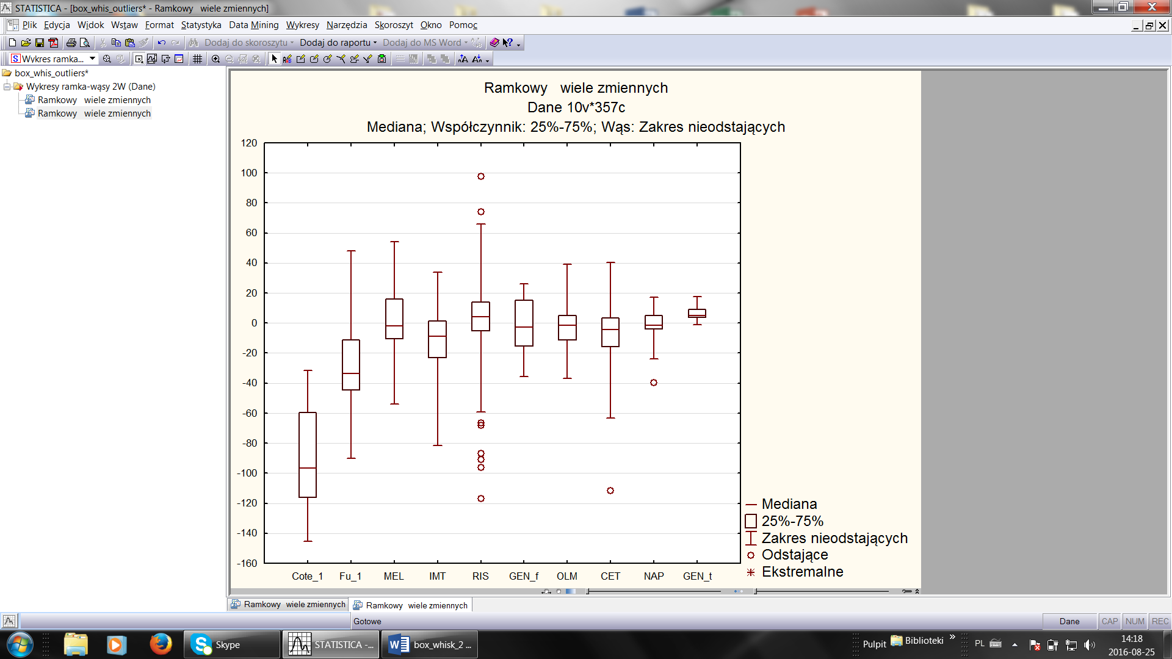

*Figure 5. Visualization of datasets as box-and-whiskers plots. Box represents 1st and 3rd quartile, horizontal line in the box – the median value, while whiskers – non-outlying values. Outlying values were defined as exceeding 3 times the interquartile range.*

outliers

## ISR performance plot

Very surprisingly, visualization of overall ISR performance was not reported up to now. Therefore, we propose in this paper a novel methodology – a plot where %ISR calculated after each analysis is presented in function of ISR number (Figure 6). This graph allows to assess contribution of individual analysis to overall ISR performance against 67% regulatory limit [EMA] and shows time- or sequence-dependent trends. It does not show %difference of individual results, but it helps to inspect whether particular data point is within ±20% limits or not. It should be noted, that the earlier course of the curve may be misleading – especially at the very beginning if few of the first analyses fail to meet %difference acceptance criteria. To facilitate interpretation of overall ISR performance we propose to put the final %ISR value on the plot.

|  |  |  |  |
| --- | --- | --- | --- |
| **A** |  | **B** |  |
| **C** |  | **D** |  |
| **E** |  | **F** |  |
| **G** |  | **H** |  |
| **I** |  | **J** |  |

*Figure 6. ISR performance plot for each dataset. The value on the plot below or over the last data point indicates %ISR calculated after all analysis. The letter near each plot indicates dataset.*

## Discussion

A picture is worth a thousand words so an appropriate plot may be worth a table with a large number of ISR results. After application of different plots and graphs to passed and failed datasets containing limited and huge number of ISR results, we failed to find an universal plot or graph to visualize ISR data (Table 2). Thus, to standardize graphical presentation of regulatory ISR data we suggest the combination of two plots. The first one is adopted Bland-Altman plot with fixed acceptance limits set at -20% and 20% and additional dashed line at 0%, which presents %difference vs. initial concentration. The second one is our novel proposal of ISR performance plot.

Combination of those two complementary plots enables visual inspection of data quality against both regulatory acceptance limits – i.e. %difference and number of pairs meeting ISR criteria (%ISR) – as well as to observe both concentration- and time-dependent trends in data (Figure 7). We could not find any other combination of two graphs that posses all those required features. Moreover, selected plots are applicable to both small and large number of results. Adopted Bland-Altman plot is compatible with both low and high concentrations and the spread of data may be additionally tuned by choosing linear or logarithmic scale on X axis. Proposed combination of complementary plots is widely applicable and clearly discriminate passed and failed ISR according to regulatory guideline [EMA].

(1)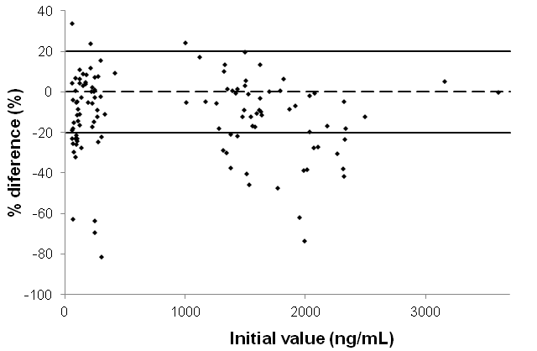

(2)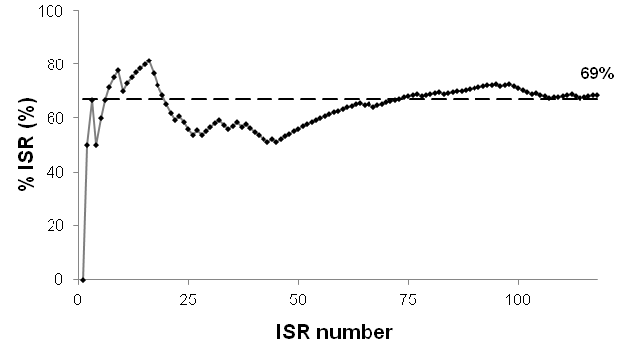

*Figure 7. Combination of (1) adopted Bland-Altman plot with fixed acceptance limits and (2) ISR performance plot for dataset D.*

To propose the standard of %difference vs. concentration plot we select initial value over the mean value. It was not an easy choice because Equation 1 [EMA] does not indicate which of those values should be used as reference. From the analytical point of view the mean value is much more certain but we decided to select initial value as reference to avoid an additional column in the table with ISR data.

Limitation of all presented graphs is that they are independent of: (1) the phase of study, (2) the time of sampling – although it is strongly correlated with high concentrations near maximum of pharmacokinetic profile and low ones in the elimination phase, (3) the medicinal product – e.g. test or reference in bioequivalence studies and (4) the analyst. However, discussed plots may be adapted to show influence of the factors mentioned above. Full standardization of %difference vs. concentration plot is difficult to achieve because selection of linear or logarithmic scale on the X axis depends on the spread of data in the particular study.

Although we have selected two complementary plots as the best-fitted solution for ISR graphical presentation, other plots are also applicable. Specific visualizations may be particularly important in defining and solving failed ISR or unmatched ISR problems. However, the proposed complementary plots may reveal the most important information, i.e. concentration- and time-dependent trends. Moreover, they are well suited for the presentation of complete ISR dataset, but they can also be used for inspection of data during the course of the study.

# Conclusion

To the best of our knowledge, there is no single plot enabling complete visual inspection of ISR data quality. Therefore, we developed combination of complementary plots: (1) %difference vs. initial value concentration and (2) ISR performance plot. The former one shows individual ISR data and concentration-dependent trends, while the latter one – contribution of individual pair to overall ISR performance and time-dependent trends. Other plots may support solving ISR problems. The standardized procedure of graphical presentation of ISR results proposed in this paper might help bioanalytical community, including regulatory assessors, in their efforts to assure the highest quality bioanalytical data.

# Future perspective

Adoption of proposed comprehensive graphical ISR presentation as a standard might be helpful for researchers, laboratory managers, quality assurance or control staff as well as regulatory assessors. It also indirectly contributes to the ISR main goal: further increase reliability of pharmacokinetic studies in order to supply efficient and safe medicines to the patients. Although proposed graphical presentation seems to completely cover ISR visualization, confirmation of usefulness of our approach for large molecules is required.

# Executive summary

Background:

* Incurred sample reanalysis (ISR) contributes to assure reliability of pharmacokinetic studies and may reveal some issues that are invisible during bioanalytical method validation.
* ISR methodology is adopted in the regulatory guidelines, but the visual inspection of ISR data quality is not standardized.

Methods:

* We examined different visual methodologies using datasets containing limited and huge number of ISR results from studies which passed and failed to meet ISR acceptance criteria.

Results:

* We failed to find an universal plot or graph to visualize ISR data. None of graphs used previously visualizes overall ISR performance.
* We propose a novel ISR performance plot, where %ISR calculated after each analysis is presented vs. ISR number.
* We developed the combination of two complementary plots: (1) %difference vs. initial value concentration and (2) ISR performance plot. This combination visualizes both regulatory acceptance limits as well as concentration- and time-dependent trends.
* Unification of graphical presentation might facilitate both scientific and regulatory data review.

# Acknowledgments

The authors gratefully acknowledge contributions of the study directors (including Mrs. Katarzyna Buś-Kwaśnik, Ms. Monika Filist, Mrs. Edyta Gilant and Michal Kaza from the Pharmacology Department of the Pharmaceutical Research Institute) and their research teams to generate regulatory compliant datasets.

Financial support of the European Union (European Regional Development Fund) is gratefully acknowledged: the datasets D and E were obtained within the projects conducted under the Polish Innovative Economy Operational Programme 2007-2013 (POIG.01.03.01-14-032/12-01 - consortium with Vipharm S.A., Poland and POIG.01.03.01-14-001/12 consortium with Pol-Nil S.A., Poland, respectively).

Financial support of the National Centre for Research and Development of the Republic of Poland is greatfully acknowledged: the dataset G was obtained within the project No. K1/IN1/14/159003/NCBR/12 (consortium with LEK-AM Pharmaceutical Company Ltd., Poland); the datasets F and J were obtained within the project PBS1/B7/7/2012 (consortium with Biopharm Ltd., Poland).

The authors gratefully acknowledge Prof. Andrzej Kutner and xxxxxxxxx from the Pharmacology Department for the critical reviewing of the manuscript. Technical assistance of student trainee Ms. Diana Matyskiel is gratefully acknowledged.

# References

[Rocci] AAPS J. 2007 Oct 5;9(3):E336-43. doi: 10.1208/aapsj0903040.  
*Confirmatory reanalysis of incurred bioanalytical samples.***Rocci** ML Jr, Devanarayan V, Haughey DB, Jardieu P.

** Discussion of ISR role in the bioanalysis and detailed description of the Bland-Altman plot.

[Yadav] Bioanalysis. 2011 May;3(9):1007-24. doi: 10.4155/bio.11.76.   
*Incurred sample reanalysis (ISR): a decisive tool in bioanalytical research.***Yadav** M, Shrivastav PS.

[Tan] Bioanalysis. 2011 May;3(9):1031-8. doi: 10.4155/bio.10.205.  
*Beyond successful ISR: case-by-case investigations for unmatched reassay results when ISR passed.***Tan** A, Gagnon-Carignan S, Lachance S, Boudreau N, Lévesque A, Massé R.

** Case studies including graphical presentations of time-, concentration- and analyst-dependent trends.

[**Barfield**] Bioanalysis. 2011 May;3(9):1025-30. doi: 10.4155/bio.11.56.  
*GlaxoSmithKline's experience of incurred sample reanalysis for dried blood spot samples.***Barfield** M, Ahmad S, Busz M.

[6] Bioanalysis. 2011 May;3(9):983-92. doi: 10.4155/bio.11.36.  
*Incurred sample accuracy assessment: design of experiments based on standard addition.***de Boer** T, Wieling J.

** Application of correlation and box-and-whisker plots.

[**de Boer**] Bioanalysis. 2011 May;3(9):951-65. doi: 10.4155/bio.11.59.  
*Impact of methylation of acyl glucuronide metabolites on incurred sample reanalysis evaluation: ramiprilat case study.***Côté** C, Lahaie M, Latour S, Bergeron M, Dicaire C, Savoie N, Furtado M, Garofolo F.

[Fu] Bioanalysis. 2011 May;3(9):967-72. doi: 10.4155/bio.11.65.  
*An investigation of incurred human urine sample reanalysis failure.***Fu** Y, Li W, Smith HT, Tse FL.

[EMA] Guideline on bioanalytical method validation. European Medicines Agency, London, UK (2011).

[FDA] Guidance for Industry Bioanalytical Method Validation. US Department of Health and Human Services, US FDA, Rockville, MD, USA (2001).

[IMT] Acta Pol Pharm. 2016 accepted for publication  
*HPLC-UV assay of imatinib in human plasma optimized for bioequivalence studies.*  
Kaza M, Piórkowska E., Filist M, Rudzki PJ.

[NAP] Biomed Chromatogr. 2016 Jun;30(6):953-61.  
*Validated HPLC-UV method for determination of naproxen in human plasma with proven selectivity against ibuprofen and paracetamol.*  
Filist M, Szlaska I, Kaza M, Pawiński T.

OLM ?

GEN ?

Manikadan S, <http://www.ncbi.nlm.nih.gov/pmc/articles/PMC3117575/>

[Tukey] John W. Tukey, *Exploratory Data Analysis, 1977*.

data

Sample dataset table ?