**Comprehensive graphical presentation of data from incurred sample reanalysis**

Piotr J. Rudzki*1, Przemysław Biecek2, Michał Kaza1

1 Pharmaceutical Research Institute, Pharmacology Department, 8 Rydygiera, 01-793 Warsaw, Poland

2 Faculty of Mathematics and Information Science, Warsaw University of Technology,75 Koszykowa, 00-662 Warsaw, Poland

*Correspondence to: Piotr J. Rudzki, Pharmaceutical Research Institute, Pharmacology Department, 8 Rydygiera, 01-793 Warsaw, Poland. Mobile: +48 601 585 453. Fax: +48 22 456 38 38. E-mail: p.rudzki@ifarm.eu

**Abstract (120 words)**

**Background:** Incurred sample reanalysis (ISR) contributes to reliability of pharmacokinetic studies. Although ISR methodology was adopted in the regulatory guidelines, the graphical presentation of data is an unsolved issue.

**Results:** We failed to find a single, universal plot enabling visual inspection of ISR data quality. We developed combination of complementary plots: %difference vs. initial concentration and cumulative ISR plot. The former shows individual ISR data and concentration-dependent trends, while the latter presents contribution of individual pair to overall result and time-dependent trends.

**Conclusion:** Proposed visualization of ISR data shows at a glance whether acceptance criteria are met or not. The standardized graphical presentation of ISR may increase quality of bioanalytical data.

**Plain Language Summary**

Incurred sample reanalysis (ISR) is one of the tools used to confirm that drug or metabolite amount in biological material are measured properly. Tabulated data is difficult to interpret, while a well designed graphical presentation may help to find quickly a needle in a haystack. We aimed to find an universal graphical presentation of ISR data. We failed to find a single plot, so we developed combination of complementary plots.

**Keywords (5-10, 3 pola w on-line submission form):** incurred sample reanalysis, visualization, bioanalysis; regulatory compliance; pharmacokinetics; visual inspection of data; data processing methodology; data quality.

# Introduction

Since rejuvenation of incurred sample reanalysis (ISR) reported after the 3rd AAPS / FDA Bioanalytical Workshop [Rocci], the ISR became a widely discussed topic in bioanalytical and pharmaceutical literature [Findlay]. Its contribution to assure reliability of pharmacokinetic studies can not be overestimated as it may reveal some issues that are invisible during bioanalytical method validation. Numerous case studies show that failed ISR [Yadav] – or even unmatched results in passed ISR [Tan] – lead to valuable observations and increased reliability of results.

Although ISR methodology was adopted in the regulatory guidelines [EMA, FDA], not all the questions asked by the bioanalytical community have been answered. It seems that one of those unsolved issues is the graphical presentation of data as different authors use various plots to illustrate their ISR findings. Among previously reported plots and graphs were: Bland-Altman [Rocci] and its variations [Tan, Barfield, Lytle], box-and-whisker [de Boer] and bar chart [Yadav]. Different approaches to the visual inspection of data quality are essential as the bioanalytical community is still developing the optimal ISR methodology. However, some unification could help to compare results from different laboratories during both scientific and regulatory data review.

Why visual inspection of data quality is important? The researchers, clinical and pharmacokinetic laboratory managers, quality assurance or control staff as well as pharmaceutical regulatory assessors are too busy nowadays, they have to evaluate too much data. Tabulated data – especially containing a huge amount of numbers what is the case in most ISR datasets – is difficult to interpret. Thus, a clear graphical presentation may help to find quickly a needle in a haystack. The statement by Tukey “*The greatest value of a picture is when it forces us to notice what we never expected to see*” [Tukey] seems to be ideally fitted to the ISR topic, because all unexpected issues have to be solved before tested drug is available to patients.

In this paper we aimed to answer the question if there is an universal approach to visualize ISR data. Our secondary goal was to propose graphical standard which shows at a glance whether ISR acceptance criteria are met or not. We evaluated the advantages and limitations of different graphical presentations – both applied previously and our novel proposals.

# Materials & methods

Calculations and acceptance criteria were in line with European Medicines Agency (EMA) bioanalytical method validation guideline [EMA]. The %difference (Equation 1) should be within ±20% of their mean for small molecules which are discussed in this paper (for large molecules the limit is ±30% of the mean).

$\%difference=\frac{repeat value-initial value}{mean value}×100\%$ (Equation 1)

The percent of ISR results meeting above criteria (%ISR, Equation 2) should be at least 67%.

$\%ISR=\frac{Number of ISR pairs with \%difference between-20\% and 20\%}{Total number of ISR pairs}×100\%$ (Equation 2)

Figure 5 was generated in Statistica (version 10, Statsoft Inc.). All other figures were generated in Microsoft Excel 2003 or 2007.

Different methods of graphical presentation of data were tested in datasets including limited, standard and huge number of ISR pairs. The datasets cover passed and failed cases, including extreme sets of 0% and 100% passed as well as just below and just above regulatory limit of 67% passed (Table 1). All datasets consisted of initial result and first repeat value and were obtained for small molecular analytes. Datasets A and B were based on the literature data [Cote, Fu]. All other dataset were generated – during studies compliant with the Declaration of Helsinki, approved by respective regulatory agencies and ethics committees – at the GLP-certified laboratory of the Pharmacology Department in the Pharmaceutical Research Institute, Warsaw, Poland. To avoid any misinterpretation of results, the pairs containing results below or over calibration range (i.e. <LLOQ and >ULOQ), which were present in two datasets, were excluded from visual evaluation.

# Results & discussion

## Bland-Altman plot

The Bland-Altman plot was applied to visual inspection of ISR data quality by Rocci et al. [Rocci]. It shows individual results and has a strong statistical background. However, it is not in line with current regulatory guideline [EMA], because for each study different limits are calculated. Therefore, it is difficult to compare the data from different studies. One may also argue that calculation of limits is a bit sophisticated and could be an additional source of error.

The modification of Bland-Altman plot by addition of tolerance intervals was proposed by Lytle et al. [Lytle]. Although this idea seems statistically interesting, the proposed visualization method is not completely in line with EMA guideline [EMA] and like classic Bland-Altman plot uses different confidence and tolerance limits for each study.

## %difference vs. concentration

The %difference vs. concentration (e.g. initial value) plot with fixed acceptance limits set at -20% and 20% and additional dashed line at 0% – e.g. used by Barfield et al. [Barfield] – may be considered as Bland-Altman plot adapted to meet regulatory requirements. It helps to upgrade data quality by clearly showing concentration-dependent trends in individual results. However, it fails to illustrate time-dependent ones and the overall ISR performance, especially in case of datasets with %ISR near 67% acceptance limit.

Reanalysis of samples near maximum concentration and in the elimination phase of the pharmacokinetic profile is required by EMA [EMA] so the data may be divided into two clusters representing high and low values, respectively. It is easier to read the chart if points are uniformly distributed along X axis. For positively skewed data, when there is a cluster of points for small values, one should consider a transformation of the scale. One of the most common replacements is the logarithmic scale for X axis, however, caution should be taken to avoid problems on the right side of the scale (Figure 1).

|  |  |
| --- | --- |
|  |  |

***Figure 1. Linear (left) or logarithmic (right) scale on X axis influence graphical presentation due to aggregation at low and high values for dataset G.***

## %difference vs. ISR number

The %difference may be also presented against ISR number instead of concentration (e.g. Figure 1 in [Tan]). Such a plot possess similar characteristics to those described in former paragraph, except that it allows to inspect time-dependent trends (Figure 2), but fails to show concentration-dependent ones.

|  |  |
| --- | --- |
|  |  |

***Figure 2. Time-dependent trends observed after 50th ISR pairs in dataset C.***

## Correlation plot

The correlation of initial and repeat values was applied for ISR visualization by de Boer and Wieling [de Boer]. It has a strong statistical background and shows individual results. However, it is not in compliant to current guideline [EMA] as it does not refer to %difference nor to %ISR values. One may also suggest that ISR pairs with small concentrations are usually overlapping, especially in huge datasets (Figure S1 in supplementary data). Moreover, the regression parameters seem to be more meaningful for upgrading data quality than the plot itself, because graphical presentation does not indicate weather acceptance criteria were met or not.

## Probability plots

The probability plots (e.g. ordered %difference vs. inverse normal cumulative distribiution function) do not show individual concentration results nor time trends, but may be valuable tool to assess how close is distribution of error in experimental data to the normal distribution [Lytle].

## Histogram and bar chart

Frequency distribution is a valuable tool in data handling. A histogram presents the variable of interest in the X axis and the number or percentage of observations (frequency) in the Y axis. A bar chart – applied by Yadav et al. [Yadav] – and the histogram have lot in common [Manikandan]. The histogram has a strong statistical background, shows deviations from normal distribution as well as it is easy for interpretation. The frequency of %difference results plotted against the %difference classes shows overall ISR performance (Figure S2 in supplementary data). However, the histogram does not show whether the regulatory criteria are met or not, fails to show individual results and data trends.

The classes in the presented histograms were not chosen *lege artis*, i.e. are not of the same width and there are open-ended classes (< -40% and > 40%). Classes with results outside accepted %difference values are wider than classes with accepted values. The number of eight classes seems to be appropriate for intended use giving some information about the trend in acceptable and out of limits values. The histogram with one class covering %difference between -20% and 20% could have been regulatory compliant, but it does not give all information about data spread around zero value.



## Box-and-whisker

De Boer and Wieling applied box-and-whisker plots to compare accuracy and precision of ISR with: (1) quality control samples from bioanalytical method validation, (2) quality control samples from the study and (3) incurred sample accuracy [de Boer]. This kind of plot, introduced by Tukey, has a strong statistical basis as it is build on quartiles or confidence interval and median or mean value. It is easy for interpretation and indirectly shows deviations from normal distribution. The box-and-whisker plot does not refer to the regulatory requirements and does not show individual results.

Among 10 analyzed datasets ISR failed to meet acceptance criteria if box based on 1st and 3rd quartile was mostly outside of ±20% limits (Figure 3). On the other hand a part of box was outside of the above limits in the dataset that passed criteria, while the whole box was within limits in the dataset that failed to meet acceptance criteria. We have also observed that for extreme datasets (A, B, C, I, J) median value was definitely nearer to the 1st quartile than to the middle of the interquartile range what indicates skewness of the data. Those observations suggest that box-and-whisker plots may be used to compare datasets, but not to conclude if ISR passed or failed to meet regulatory limit.

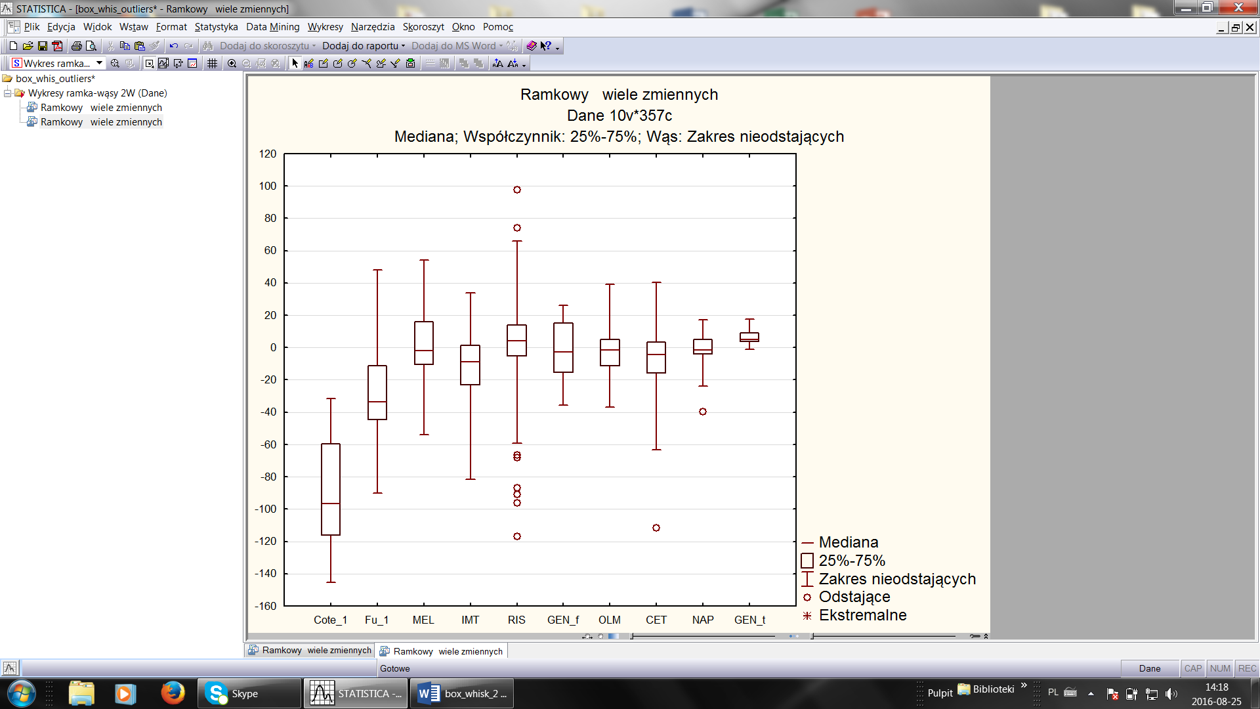

***Figure 3. Visualization of datasets as box-and-whiskers plots.*** *Box represents 1st and 3rd quartile, horizontal line in the box – the median value, while whiskers – non-outlying values. Outlying values were defined as exceeding 3 times the interquartile range.*

outliers

## Distribution of absolute %difference

## Cumulative ISR plot

Very surprisingly, visualization of overall ISR performance was not reported up to now. Therefore, we propose in this paper a novel methodology – a cumulative plot where %ISR calculated after each analysis is presented in function of ISR number (Figure 4). This graph allows to assess contribution of individual analysis to overall ISR performance against 67% regulatory limit [EMA] and shows time- or sequence-dependent trends. It does not show %difference of individual results, but it helps to inspect whether particular data point is within ±20% limits or not. It should be noted, that the earlier course of the curve may be misleading – especially at the very beginning if few of the first analyses fail to meet %difference acceptance criteria. To facilitate interpretation of cumulative ISR graphical presentation we propose to put the final %ISR value on the plot.

|  |  |  |  |
| --- | --- | --- | --- |
| **A** |  | **B** |  |
| **C** |  | **D** |  |
| **E** |  | **F** |  |
| **G** |  | **H** |  |
| **I** |  | **J** |  |

***Figure 4. Cumulative ISR plots for each dataset.*** *The value on the plot below or over the last data point indicates %ISR calculated after all analysis. The letter near each plot indicates dataset.*

## Discussion

A picture is worth a thousand words so an appropriate plot may be worth a table with a large number of ISR results. After application of different plots and graphs to passed and failed datasets containing limited and huge number of ISR results, we failed to find an universal plot or graph to visualize ISR data (Table 2). Thus, to standardize graphical presentation of regulatory ISR data we suggest the combination of two plots. The first one is adopted Bland-Altman plot with fixed acceptance limits set at -20% and 20% and additional dashed line at 0%, which presents %difference vs. initial concentration. The second one is our novel proposal of cumulative ISR plot.

Combination of those two complementary plots enables visual inspection of data quality against both regulatory acceptance limits – i.e. %difference and number of pairs meeting ISR criteria (%ISR) – as well as to observe both concentration- and time-dependent trends in data (Figure 5). We could not find any other combination of two graphs that posses all those required features. Moreover, selected plots are applicable to both small and large number of results. Adopted Bland-Altman plot is compatible with both low and high concentrations and the spread of data may be additionally tuned by choosing linear or logarithmic scale on X axis. Proposed combination of complementary plots is widely applicable and clearly discriminate passed and failed ISR according to regulatory guideline [EMA].

(1)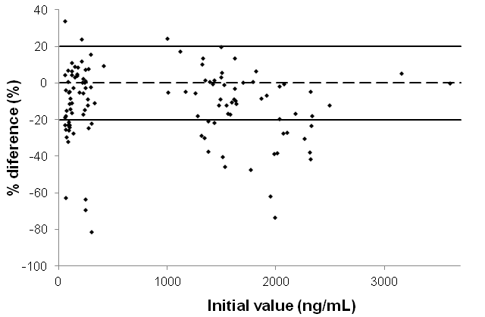

(2)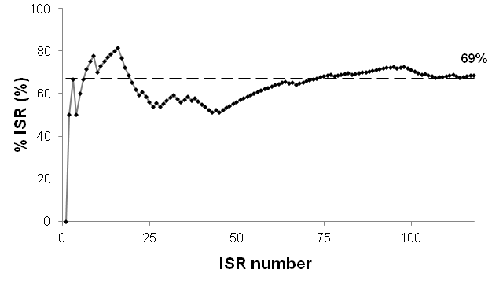

***Figure 5. Combination of (1) adopted Bland-Altman plot with fixed acceptance limits and (2) cumulative ISR plot for dataset D.***

To propose the standard of %difference vs. concentration plot we select initial value over the mean value. It was not an easy choice because Equation 1 [EMA] does not indicate which of those values should be used as reference. From the analytical point of view the mean value is much more certain but we decided to select initial value as reference because this value is used for pharmacokinetic calculations and mean may be biased by instability of analyte. Moreover, this selection allows to avoid an additional column in the table with ISR data.

Limitation of all presented graphs is that they are independent of: (1) the phase of study, (2) the time of sampling – although it is strongly correlated with high concentrations near maximum of pharmacokinetic profile and low ones in the elimination phase, (3) the medicinal product – e.g. test or reference in bioequivalence studies and (4) the analyst. However, discussed plots may be adapted to show influence of the factors mentioned above. Full standardization of %difference vs. concentration plot is difficult to achieve because selection of linear or logarithmic scale on the X axis depends on the spread of data in the particular study.

Although we have selected two complementary plots as the best-fitted solution for ISR graphical presentation, other plots are also applicable. Specific visualizations may be particularly important in defining and solving failed ISR or unmatched ISR problems. However, the proposed complementary plots may reveal the most important information, i.e. concentration- and time-dependent trends. Moreover, they are well suited for the presentation of complete ISR dataset, but they can also be used for inspection of data during the course of the study.

# Conclusion and practical tips

To the best of our knowledge, there is no single plot enabling complete visual inspection of ISR data quality. Therefore, we developed combination of complementary plots: (1) %difference vs. initial value concentration and (2) cumulative ISR plot. The former one shows individual ISR data and concentration-dependent trends, while the latter one – contribution of individual pair to overall ISR performance and time-dependent trends. Other plots may support solving ISR problems. The standardized procedure of graphical presentation of ISR results proposed in this paper might help bioanalytical community, including regulatory assessors, in their efforts to assure the highest quality bioanalytical data.

# Future perspective

Adoption of proposed comprehensive graphical ISR presentation as a standard might be helpful for researchers, laboratory managers, quality assurance or control staff as well as regulatory assessors. It also indirectly contributes to the ISR main goal: further increase reliability of pharmacokinetic studies in order to supply efficient and safe medicines to the patients. To facilitate widespread of the graphical presentation standard we have developed free on-line tool [101]. Although proposed graphical presentation seems to completely cover ISR visualization, confirmation of usefulness of our approach for large molecules is required. It will be interesting to figure out if additional features – e.g. (1) whiskers for out-of-limits results on %difference vs. concentration or ISR number plot, (2) smoothed trend line on %difference vs. concentration or ISR number plot and (3) confidence interval on cumulative ISR plot – will be accepted by the bioanalytical community.

# Executive summary

Background:

* Incurred sample reanalysis (ISR) contributes to assure reliability of pharmacokinetic studies and may reveal some issues that are invisible during bioanalytical method validation.
* ISR methodology is adopted in the regulatory guidelines, but the visual inspection of ISR data quality is not standardized.

Methods:

* We examined different visual methodologies using datasets containing limited and huge number of ISR results from studies which passed and failed to meet ISR acceptance criteria.

Results:

* We failed to find an universal plot or graph to visualize ISR data. None of graphs used previously visualizes overall ISR performance.
* We propose a novel cumulative ISR plot, where %ISR calculated after each analysis is presented vs. ISR number.
* We developed the combination of two complementary plots: (1) %difference vs. initial value concentration and (2) cumulative ISR plot. This combination visualizes both regulatory acceptance limits as well as concentration- and time-dependent trends.
* To facilitate widespread of the graphical presentation standard we have developed free on-line tool [101].
* Unification of graphical presentation might facilitate both scientific and regulatory data review.

# References

[Rocci] Rocci ML Jr, Devanarayan V, Haughey DB, Jardieu P. Confirmatory reanalysis of incurred bioanalytical samples. *AAPS J.* 9(3), E336- E343 (2007).   
** Discussion of ISR role in the bioanalysis and detailed description of the Bland-Altman plot.

[Findlay] Findlay JW, Kelley MM. ISR: background, evolution and implementation, with specific consideration for ligand-binding assays. *Bioanalysis* 6(3), 393-402 (2014).

* Review of ISR literature.

[Yadav] Yadav M, Shrivastav PS. Incurred sample reanalysis (ISR): a decisive tool in bioanalytical research. *Bioanalysis* 3(9), 1007-1024 (2011).

[Tan] Tan A, Gagnon-Carignan S, Lachance S, Boudreau N, Lévesque A, Massé R. Beyond successful ISR: case-by-case investigations for unmatched reassay results when ISR passed. *Bioanalysis* 3(9), 1031-1038 (2011).   
** Case studies including graphical presentations of time-, concentration- and analyst-dependent trends.

[Barfield] Barfield M, Ahmad S, Busz M. GlaxoSmithKline's experience of incurred sample reanalysis for dried blood spot samples. *Bioanalysis* 3(9), 1025-1030 (2011).

[Lytle] Lytle FE, Julian RK, Tabert AM. Incurred sample reanalysis: enhancing the Bland-Altman approach with tolerance intervals. *Bioanalysis* 1(4), 705-714 (2009).

** The paper introduces combination of Bland-Altman plot with tolerance intervals to ISR data and suggests probabilisty plots for evaluation of errors distribiution.

[de Boer] de Boer T, Wieling J. Incurred sample accuracy assessment: design of experiments based on standard addition. *Bioanalysis* 3(9), 983-992 (2011).

** Application of correlation and box-and-whisker plots.

[Cote] Côté C, Lahaie M, Latour S et al. Impact of methylation of acyl glucuronide metabolites on incurred sample reanalysis evaluation: ramiprilat case study. *Bioanalysis* 3(9), 951-965 (2011).

[Fu] Fu Y, Li W, Smith HT, Tse FL. An investigation of incurred human urine sample reanalysis failure. *Bioanalysis* 3(9), 967-972 (2011).

[EMA] Guideline on bioanalytical method validation. European Medicines Agency, London, UK (2011).

[FDA] Guidance for Industry Bioanalytical Method Validation. US Department of Health and Human Services, US FDA, Rockville, MD, USA (2001).

[IMT] Kaza M, Piórkowska E, Filist M, Rudzki PJ. HPLC-UV assay of imatinib in human plasma optimized for bioequivalence studies. *Acta Pol. Pharm.* 73(6), 1495-1505 (2016).

[NAP] Filist M, Szlaska I, Kaza M, Pawiński T. Validated HPLC-UV method for determination of naproxen in human plasma with proven selectivity against ibuprofen and paracetamol. *Biomed. Chromatogr.* 30(6), 953-961 (2016).

[OLM] Piórkowska E, Musijowski J, Buś-Kwaśnik K, Rudzki PJ. Is a deuterated internal standard appropriate for the reliable determination of olmesartan in human plasma? *J. Chromatogr. B* (in Press, http://dx.doi.org/10.1016/j.jchromb.2016.11.021)

GEN ?

Manikandan S. Frequency distribution. *J. Pharmacol. Pharmacother.* 2(1), 54-56 (2011).   
<http://www.ncbi.nlm.nih.gov/pmc/articles/PMC3117575/>

[Tukey] Tukey JW. Exploratory Data Analysis, Pearson, US (1977).

**Websites**

[101] On-line tool for ISR visualisation

<https://cogito.shinyapps.io/shiny2/>

(Accessed 26 November 2016)

. Thanks are also due to Prof. Andrzej Kutner and xxxxxxxxx from the Pharmacology Department for the critical reviewing of the manuscript and technical assistance of student trainee Ms. Diana Matyskiel.

# Financial & competing interests disclosure

The authors have no relevant affiliations or financial involvement with any organization or entity with a finan­cial interest in or financial conflict with the subject matter or materials discussed in the manuscript. This includes employment, consultancies, honoraria, stock ownership or options, expert testimony, grants or patents received or pend­ing, or royalties. No writing assistance was utilized in the production of this manuscript.

Financial support of the European Union (European Regional Development Fund) is gratefully acknowledged: the datasets D and E were obtained within the projects conducted under the Polish Innovative Economy Operational Programme 2007-2013 (POIG.01.03.01-14-032/12-01 - consortium with Vipharm S.A., Poland and POIG.01.03.01-14-001/12 consortium with Pol-Nil S.A., Poland, respectively).

Financial support of the National Centre for Research and Development of the Republic of Poland is greatfully acknowledged: the dataset G was obtained within the project No. K1/IN1/14/159003/NCBR/12 (consortium with LEK-AM Pharmaceutical Company Ltd., Poland); the datasets F and J were obtained within the project PBS1/B7/7/2012 (consortium with Biopharm Ltd., Poland).

The other datasets were obtained within the projects sponsored by Farmak JSC, Kiev, Ukraine (dataset C); 4 Medicine Rek sp. k., Warsaw, Poland (dataset H); Valeant Sp. z o.o. sp.j., Rzeszów, Poland (dataset I).

# Supplementary Data

***S1***

|  |  |
| --- | --- |
|  |  |
|  |  |
|  |  |
|  |  |
|  |  |

***S2***

Sample dataset table ?