**Dates**

pogRomcy danych (Data Masters) Season 1 / Episode 15

All rights reserved.  
The use shall be subject to prior consent of the author.

Press A to see the plain text instead of the slides.  
Press T to display the table of contents.

**What Is This Episode About?**

When analysing the data, we encounter different types of variables. The data and time related variables appear to be quite common.

In this Episode, we will learn:

* How to create the objects that describe dates and time in the R.
* What basic operations can be performed on the dates and time.
* How to sum up/describe the dates.

To illustrate these issues, we will use the ad hoc sets of data.

**Dates and Time**

In the R program, there are three basic types of date or time describing variables.

The class Date is used to describe the dates with accuracy of a day. On the dates, you can perform such operations as subtraction of two dates, addition of a number to a day, etc.

The class POSIXct is used to describe the dates with accuracy of a second. Time is remembered as a number of the seconds from the defined beginning. The suffix ct means *calendar time*.

The class POSIXlt is used to describe time in a format of a value list. The suffix lt means local time.

**Dates**

The construction of the class Date is the function as.Date().

It adopts the vector of character strings, which describe the dates, to be the first argument. The second, optional argument defines the date format. By default, the date format is year-month-day.

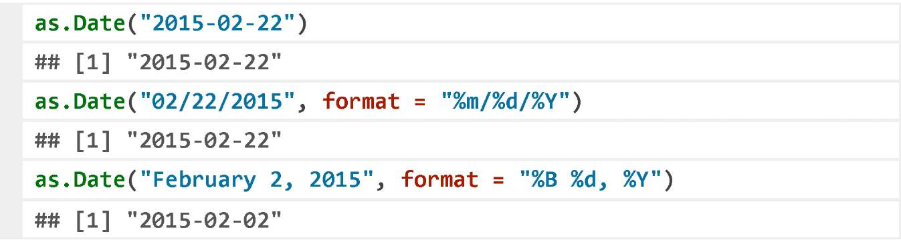

To get assistance on the date format designations, please open the help file using the instruction ?strptime.

The objects of the class Date can also be created on the basis of the integers or the POSIXct class objects, in both cases using the function as.Date().

**Calendar Time**

The constructor of the class POSIXct is the function as.POSIXct().

It adopts the vector of character strings, which describe the moments, to be the first argument. The second, optional argument defines the date format. By default, the date format is year-month-day hour:minute:second.

To get assistance on the date format designations, please open the help file using the instruction ?strptime.

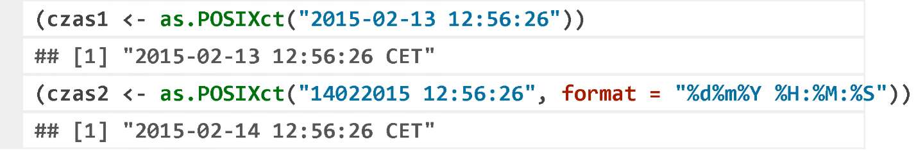

You can perform such operations on time as subtraction or addition to one time of a specified interval (days by default).

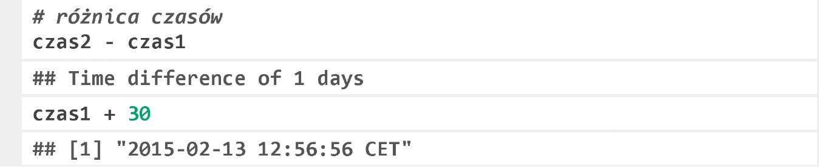

The function Sys .time() returns the current time in the format POSIXct as the result.

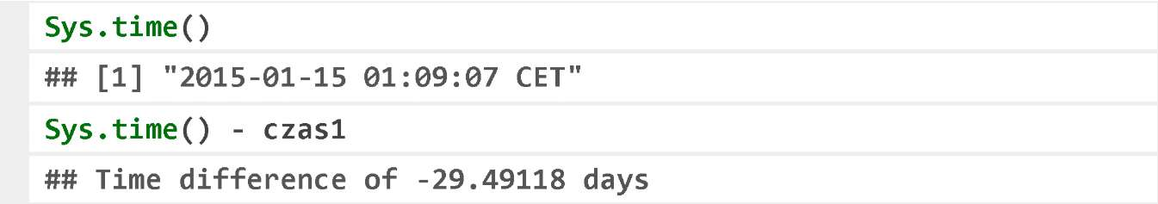

**Local Time**

The constructor of the class POSIXlt is the function as.POSIXlt().

It adopts the vector of character strings, which describe the moments, to be the first argument. The second, optional argument defines the date format. The format description is the same as in the case of the class POSIXct.

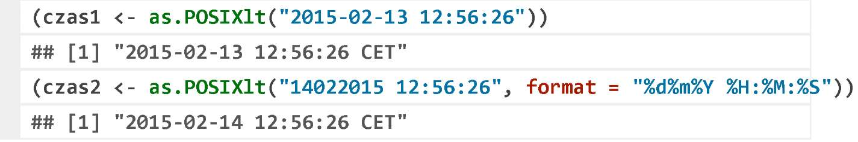

Many functions can be applied interchangeably with the objects of the class POSIXlt and POSIXct.

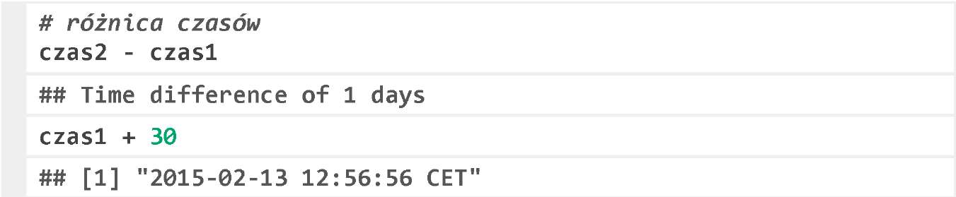

**Lubridate Package**

In the basic R program, the operations on the dates and time are not always simple. We mean, the simple operations are simple, but the complex ones are not necessarily easy.

The package lubridate contains the set of the functions that facilitate handling the dates.

One of such functions is the function now(), which returns an object that describes the present moment.

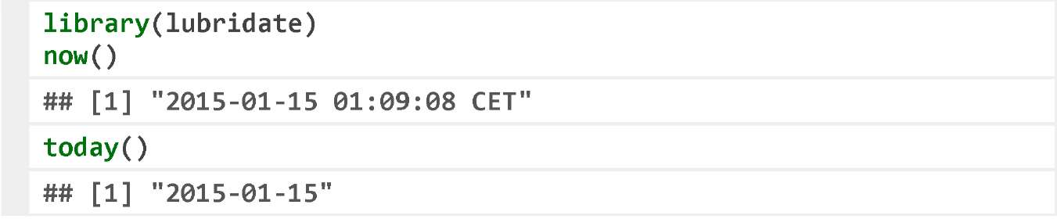

The function names used to convert the strings of characters into time were simplified. A function name becomes a format description.

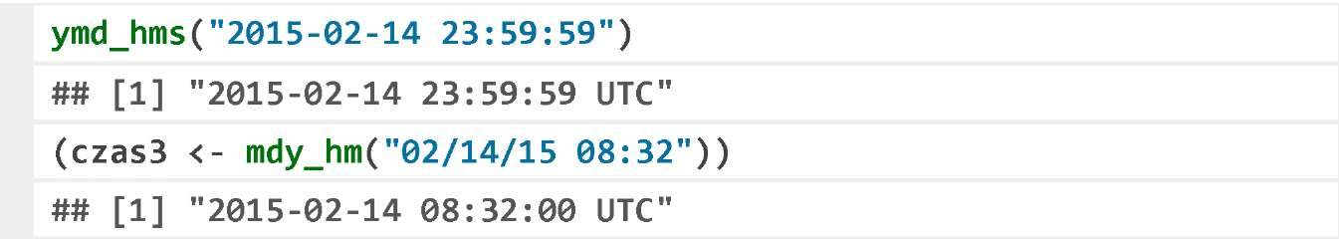

**Lubridate Package**

You can extract such information as a day of week, a day of month, etc. from the dates. Using the function wday() you can read a day of week, similarly the functions day(), month(), and year() describe the date components.

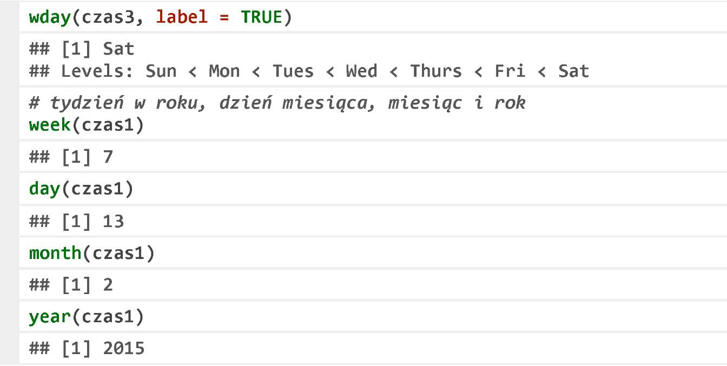

You can perform the convenient operations using the function days(), months(), years(), minutes(), and seconds() on time.

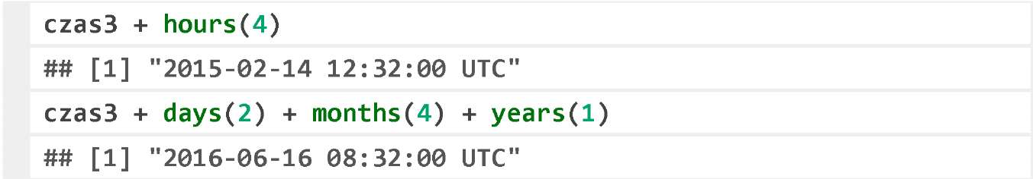

**Exercises**

* Applying the proper date format, convert the string of characters 01-15-2015 10:20:59 to the object of the class POSIXct.
* Calculate the number of the days between 1 September 1945 and 8 May 1945.
* Check what a day of week will be in 100 days starting from today.

**More Information**

You can find the useful tips how to work with time and dates in the article titled *Handling date-times in R* by Cole Beck at http://biostat.mc.vanderbilt.edu/wiki/pub/Main/ColeBeck/datestimes.pdf.

The detailed description of the package lubridate can be found in the JSS’s article at http://www.jstatsoft.org/v40/i03/paper

A lot of interesting information on handling the dates and time is available at http://en.wikibooks.org/wiki/R_Programming/Times_and_Dates