Charts which present data summaries
season 2 / episode 3

pogRomcy danych
Press A to replace slides with continuous text.
Press T to display table of contents.
What is this episode about?
However, when data are large and contain hundreds or thousands of observations it is not possible to present each of them separately. When there are too many elements on the chart, then the chart turns into great patchwork of points and curves. In this case it is often better to present summaries/statistics instead of raw data.
How to create a trend charts showing smooth averages?
How to create a box-and-whisker chart /box chart showing Tukey's five numbers?
How to create a histogram showing distribution of values?
How to create bar charts showing observation number?

In the previous episode we have shown each observation/each row from the data set on charts. Information on the subsequent rows were presented by means of points, lines or inscriptions.
In this episode we will learn how to graphically present summaries of data
In this episode we will work with auta2012 data set.
Preparation of data
For the purpose of this episode and presented examples, for this work, we will choose a fragment from the data set on car's offer prices. We will limit our attention to observations concerning Skoda Octavia and from the set of columns we will choose 5 pieces of information on the production year, price and type of fuel.

1
Model
Cena.w.PLN
Rodzaj.paliwa
Skoda
2010
benzyna
2
Octavia
16800
##
Skoda
2007
olej
##
Skoda
2009
olej
##
Skoda
2008
olej
##
Skoda
2008
olej

Data set concerning offer prices of used cars were used in the first season. These data are fully described in the file https://rawgit.com/pbiecek/MOOC/master/0_dane/0_dane.html
Full data are available in PogromcyDanych package. We will also use dplyr package which were discussed in the first season. The filter()function is used to select concerned rows and the select() function is used to select concerned columns.
library(PogromcyDanych) skody <‐ auta2012 %>%
filter(Marka == 'Skoda', Model == 'Octavia') %>%
select(Marka, Model, Rok.produkcji, Cena.w.PLN, Rodzaj.paliwa)
head(skody)
##
Marka
Rok.produkcji

olej
##
Octavia
52750
##
Skoda
2003
napedowy (diesel)
3
Octavia
38900
napedowy (diesel)
4
Octavia
39999
napedowy (diesel)
5
Octavia
28500
napedowy (diesel)
6
Octavia
36800
napedowy (diesel)
Geometry geom_point() however, not for everything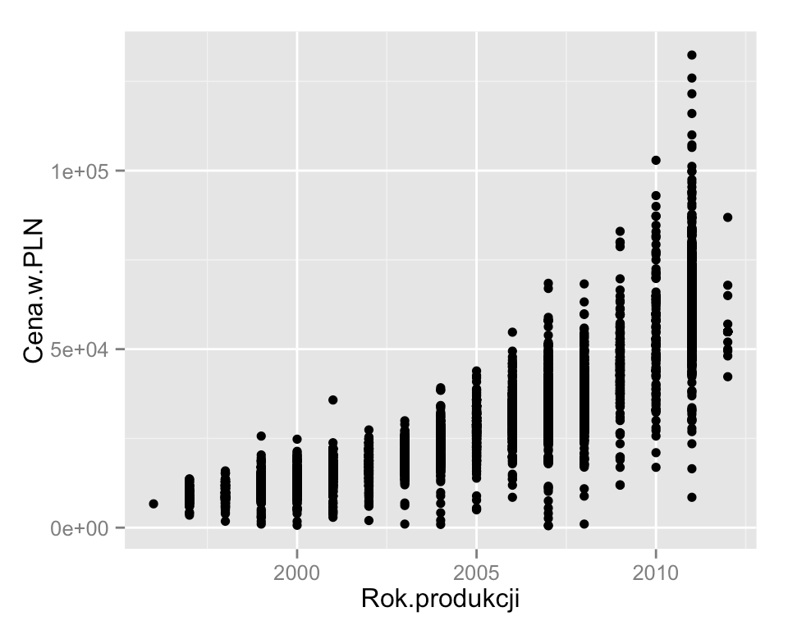
Let's compare relation between the price of a car (for 2012) and the production year. If we present these data by means of points, we notice that some dependence exists, but it is difficult for us to read it exactly. There are so many points that they overlap and it is difficult to realize which prices are typical for various statistical yearbooks.
ggplot(skody, aes(x=Rok.produkcji, y = Cena.w.PLN)) + geom_point()

When we want to present dependence between the pair of variables, geom_point() geometry point is often used. However, when there is to many points such presentation may be hardly legible. In such cases it is worth considering geom_smooth() geometry presenting smooth local average.

Geometry geom_smooth() trend charts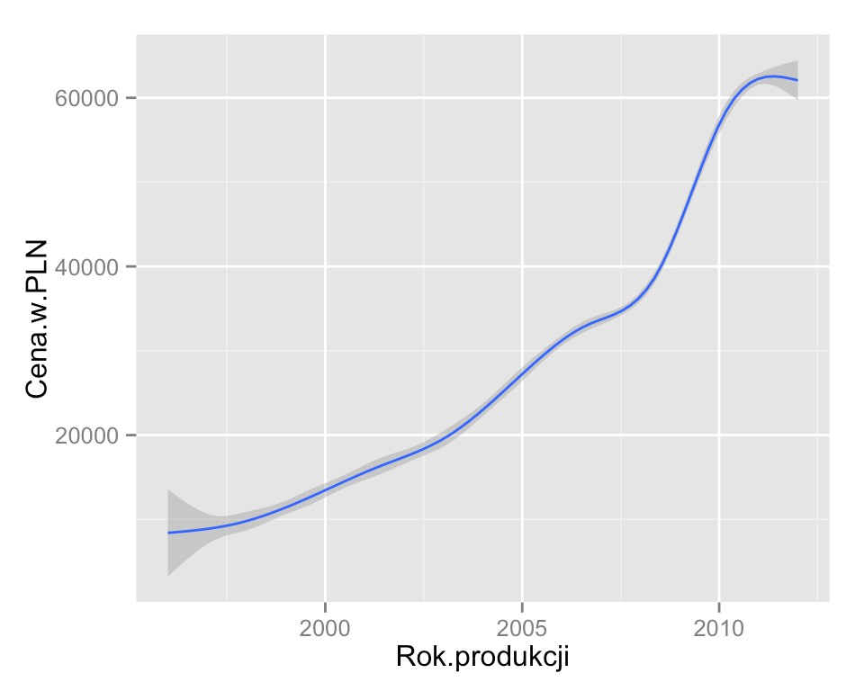
How exactly can we determine this smooth average? If data are fewer than 1000 observations to smoothening loess() (Local Polynomial Regression Fitting) function is used and if there are more than 1000 observations gam() (Generalized Additive Models) function is used. Details for each of these methods may be read from help files for loess()and gam() functions.
How does this relation between the average price and the production year look like (prices for 2012)?
ggplot(skody, aes(x=Rok.produkcji, y = Cena.w.PLN)) + geom_smooth()

Substitution of geom_point() with geom_smooth() results in the fact that smooth local average is drawn instead of points.
Geometry geom_smooth() draws information on standard error for average grade. Grey interval around the average presents precision of average estimation. At places where this average is determined on a small set of observations standard error is higher, accuracy of evaluation is lower.

Geometry geom_smooth() trend charts, standard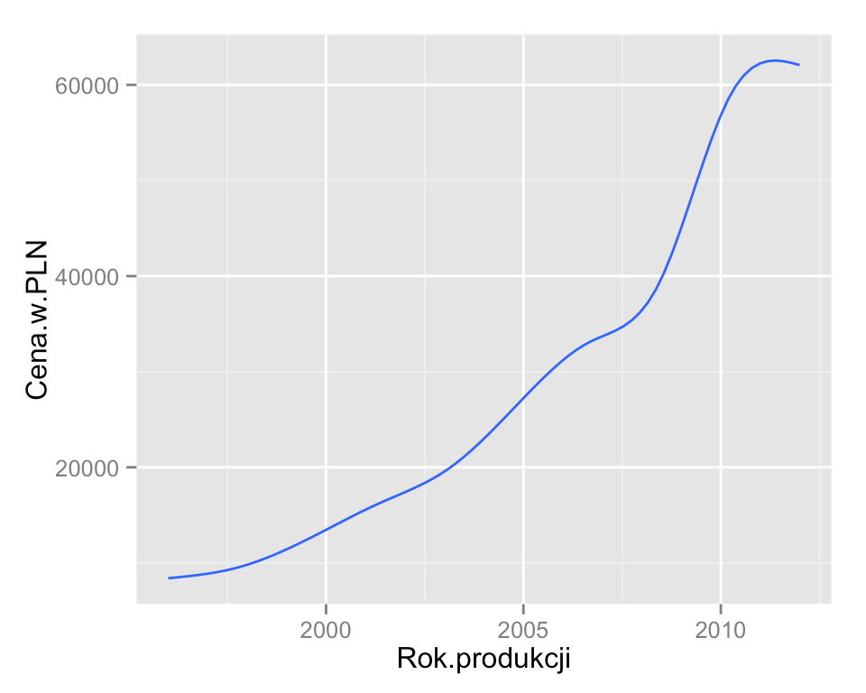
error for the average
If we change them we can obtain different degrees of smoothening (argument span for loess), different line thickness, different models used for smoothening, etc.

Parameters of geom_smooth() geometry are presented on the website http://docs.ggplot2.org/0.9.3.1/geom_smooth.html.
One of the parameters is se which is used to switch on or switch off drawing of standard errors. Frequently we are interested only in trend and additional intervals only clutter the chart. They can be switched off by adding se=FALSE.
ggplot(skody, aes(x=Rok.produkcji, y = Cena.w.PLN)) + geom_smooth(se=FALSE)
Geometry geom_smooth() composition of layers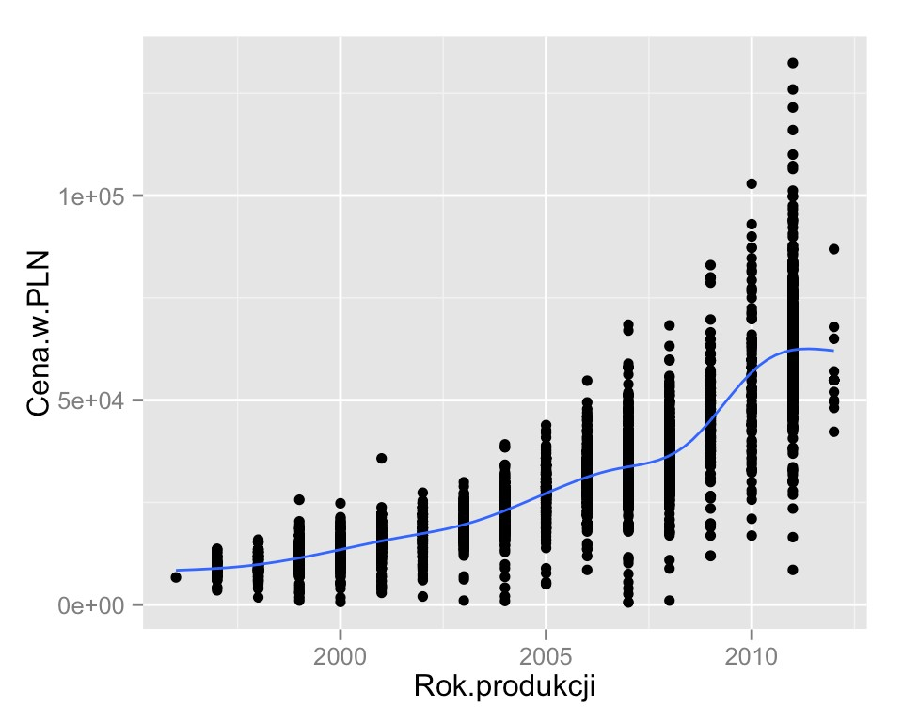
For instance, we can merge a layer which shows trends and a layer which shows single points. In many situations it is a very good way of presentation showing each observation on the second plan and a main trend in relations on the first plan.
ggplot(skody, aes(x=Rok.produkcji, y=Cena.w.PLN)) + geom_point() +
geom_smooth(se=FALSE)

In ggplot2 package we can merge in one chart layers with different geometries.

Geometry geom_smooth() composition of layers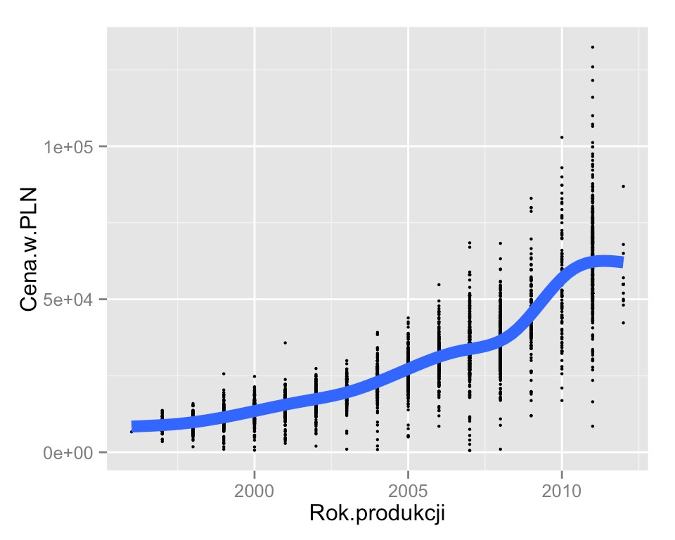
We will use size feature to emphasize the trend and decrease visibility of the layer with points. We reduce points and enlarge trend line to mark, even more strongly, which layer should be more visible.

We determine the size of lines and points by means of size argument for each layer separately.
When we have several layers on the chart, we often want to make some layers more clear and other less clear. Two features which strongly emphasize visibility are size and colour.
ggplot(skody, aes(x=Rok.produkcji, y=Cena.w.PLN)) + geom_point(size=0.8) +
geom_smooth(se=FALSE, size=3)
Geometry geom_smooth() trend charts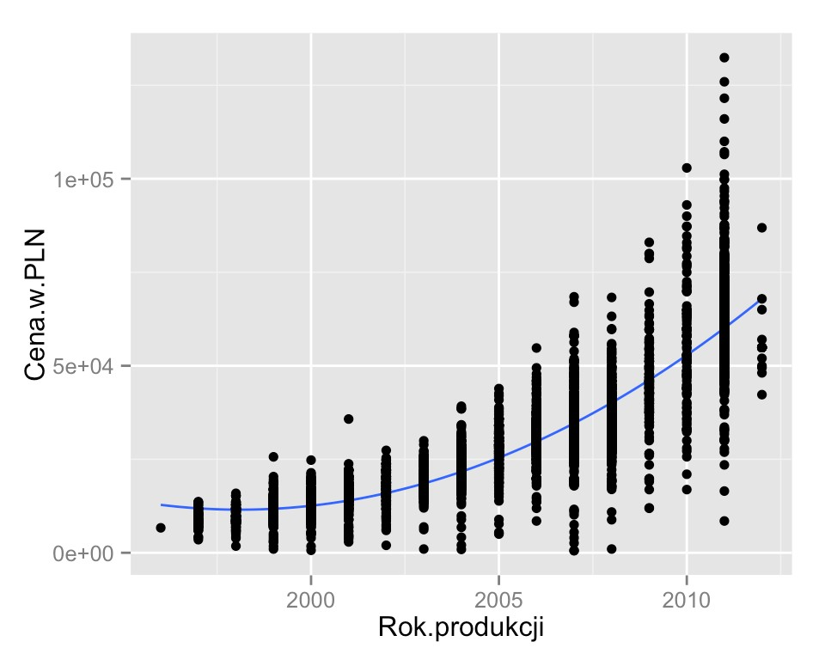
Additionally, for regression models we can adjust not only linear trend, but also polynomial, exponential or power dependencies. Description of model structure can be expressed by formula parameter, using typical R format for description of formulas.

Another useful possibility to modify geom_smooth() geometry is the possibility to change the smooth function. There is a selection, among others, of linear regression (parametr method="lm"), logistic regression and generalized models (parametr method="glm"), resistant regression (parametr method="rlm") and already listed exponential (parametr method="gam" or method="loess").
In the example below we add square trend to describe relations between variables. By formula=y~poly(x,2) argument we determine square trend, by method="lm" argument we determine the manner of calculating coefficients for this trend.
ggplot(skody, aes(x=Rok.produkcji, y=Cena.w.PLN)) + geom_smooth(se=FALSE, method="lm", formula=y~poly(x,2)) + geom_point()
Geometry geom_smooth() trend charts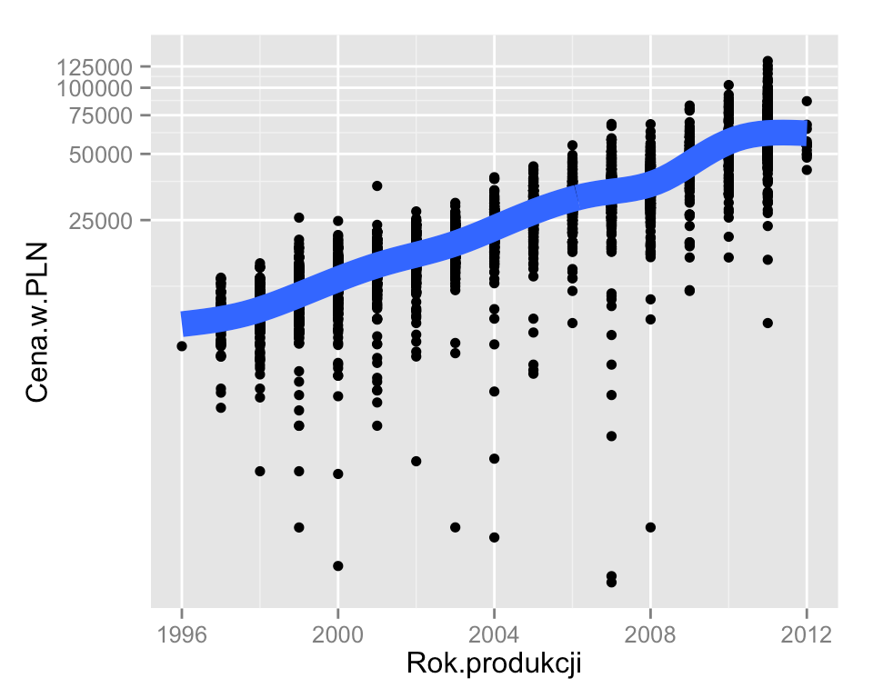
If we suspect that the change in price fall for each year has fall character of x percent and not x zloty (namely, using specialist terminology multiplicative nature rather than additive) it is good to see the same chart with OY axis in the exponential scale.
The function for axis transition is coord_trans() function which can be used for identification of whether and how particular axes must be transformed.
On the website http://docs.ggplot2.org/current/coord_trans.html the most popular transformations are presented, such as: radical, power or logarithmic.
ggplot(skody, aes(x=Rok.produkcji, y = Cena.w.PLN)) + geom_point() +
geom_smooth(se=FALSE, size=5) + coord_trans(y = "log10")

When discussing exponential, logarithmic or power models, it is worth considering another interesting option which is offered by ggplot2 package, namely axis transformations.
Functions which manage and modify axis have coord_ prefix. When we enter it in RStudio, we can press TAB key to display a list of all features starting from this word.
In the following example we use coord_trans() function to use logarithmic transformation for OY axis.

Geometry geom_smooth() trend charts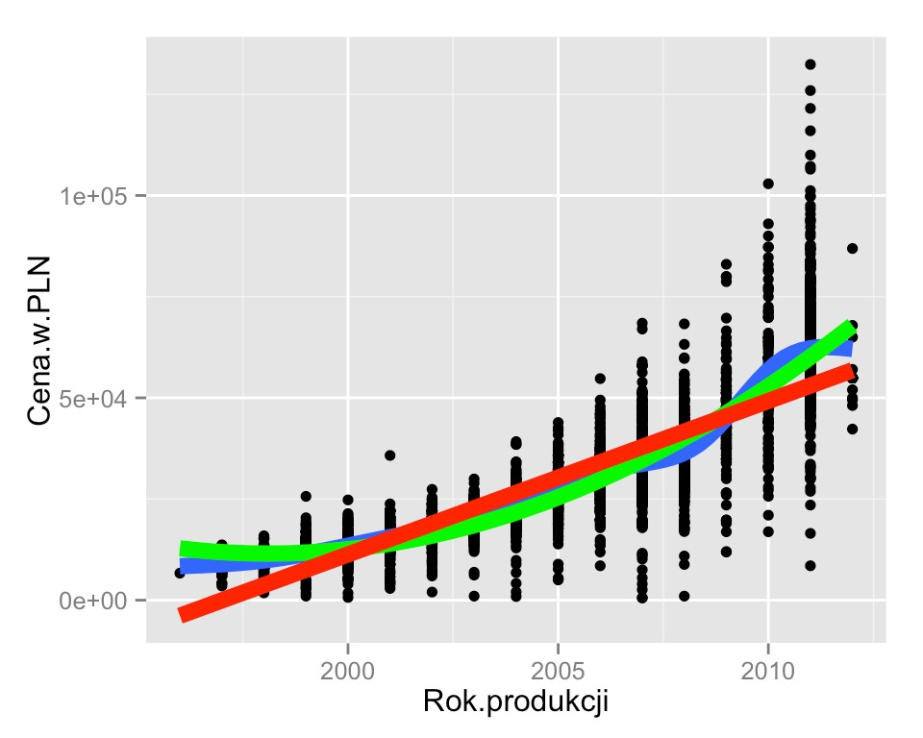
The ggplot2 package enables creation of the chart by overlapping layers one on another. It is very useful to present side by side different ways of trend determination.
") +
ggplot(skody, aes(x=Rok.produkcji, y = Cena.w.PLN)) + geom_point() +
geom_smooth(se=FALSE, size=3) +
geom_smooth(method="lm", formula=y~poly(x,2), se=FALSE, size=3, color="green geom_smooth(method="lm", se=FALSE, size=3, color="red")
Let us overlap on our chart with relation between the price and the year of production information on linear trend, trend which is calculated with GAM algorithm and square trend. Each of these trends will be drawn by geom_sooth() function with specification of additional arguments.

When we analyze trend we do not know with which trend we are dealing. In such case it is extremely important to have the possibility to compare various trends with data.

Qualitative variables
Let's now focus on geometries for presentation relations between qualitative variables. Firstly we prepare data in such a way so as to have interesting variables for presentation.
Again by means of filter() and select() functions we will choose concerned lines and columns.

1
Model
Cena.w.PLN
Rodzaj.paliwa
Skoda
2007
napedowy (diesel)
2
Octavia
38900
napedowy (diesel)
3
Octavia
32500
napedowy (diesel)
4
Octavia
32500
benzyna
5
Superb
36600
napedowy (diesel)
6
Fabia
14500
napedowy (diesel)

Geometry geom_smooth() was useful to present summaries of two quantitative variables.
We will still use data set with prices of five-year cars from Skoda model, and as qualitative variable we will use Model and Rodzaj.paliwa.
Previously we worked with cars from Octavia model, now we will work with five-year cars so we introduced the change in filter()function.
skody <‐ auta2012 %>%
filter(Marka == 'Skoda', Rok.produkcji==2007) %>%
select(Marka, Model, Rok.produkcji, Cena.w.PLN, Rodzaj.paliwa)
head(skody)
##
Marka
Rok.produkcji

olej
##
Fabia
21850
##
Skoda
2007
olej
##
Skoda
2007
olej
##
Skoda
2007

##
Skoda
2007
olej
##
Skoda
2007
olej
Geometry geom_point() again does not manage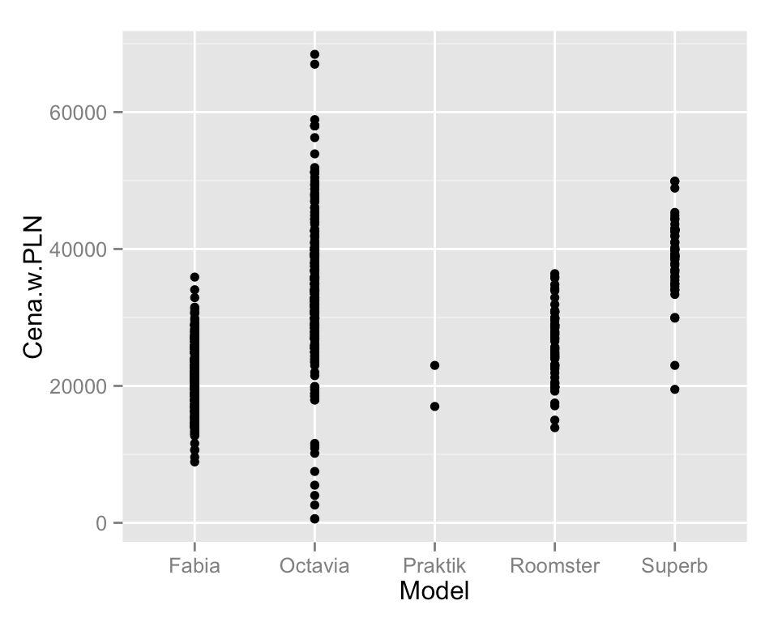
I think so. How these average prices differ and how much diverse they are? Let's try to answer this question presenting relation between the price and the model.
Is this presentation clear?
ggplot(skody, aes(x=Model, y = Cena.w.PLN)) + geom_point()

Do different models of five-year Skodas have various prices?
We can see that geom_point() geometry is able to deal with situation when one of variables is not quantitative variable, but presents the name of the model. In the following case occurs mapping of such values as Octavia, Roomster, Superb on x coefficient on the chart. By default the order corresponds to the alphabetical order of names of these coefficients.

Geometry geom_boxplot() box and whiskers chart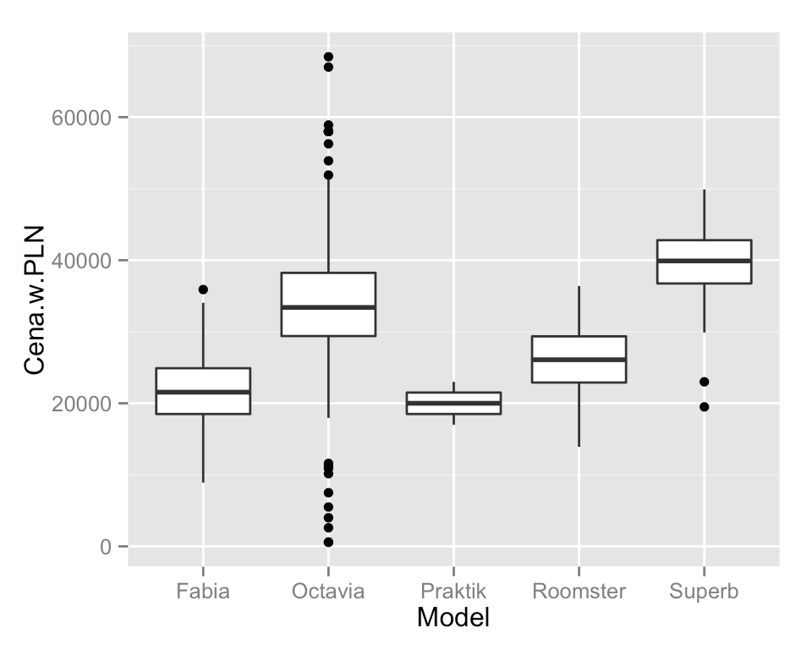
To compare numeric variable between groups, box and whiskers charts are much more suitable showing the so-called Tukey five, namely minimum observation from the group, maximum, median (middle observation) and two quartiles. These five numbers divide interval of feature variability into 4 equal intervals. From minimum value to the bottom quartile, from the bottom quartile to median, from median to the top quartile and from the top quartile to maximum element.

Considering bars of points from the previous slide it is difficult to read what the variability of prices isand what should be compared between models.
Graphically, quartiles and median present edges and centre of the frame. Minimum and maximum element constitute the lowest and the highest value on the chart. Additionally, if some observations are far from edges of the box (further than 1.5 of width of the box) it is determined by a separate point. Why are these points presented? Frequently, they help to identify outliers when one or several observations are far from the rest of the box.
ggplot(skody, aes(x=Model, y = Cena.w.PLN)) + geom_boxplot()
Geometry geom_boxplot() – box and whiskers chart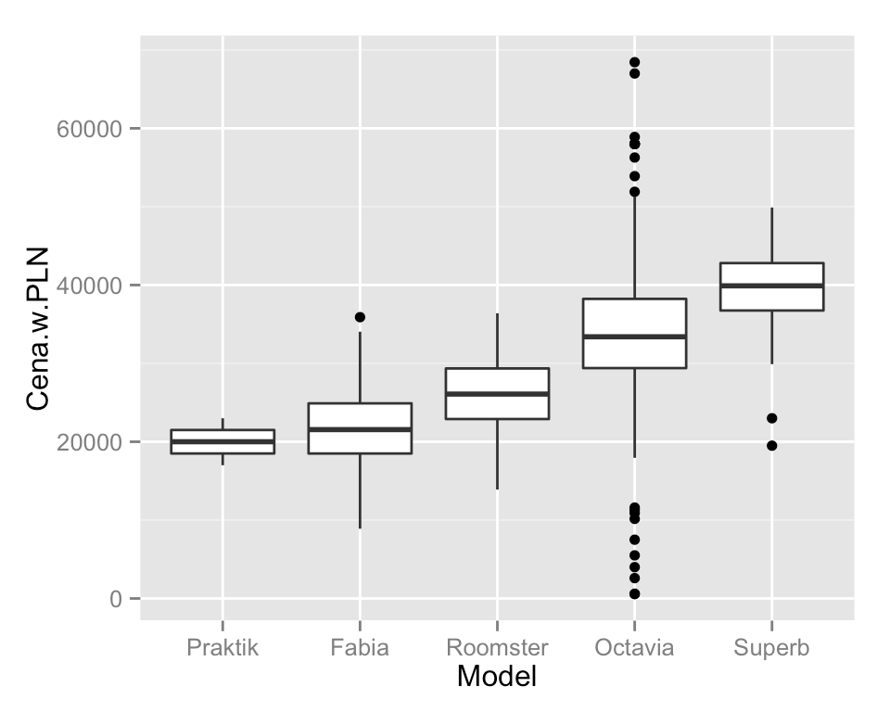
For this purpose reorder() function is used. As the first argument, it accepts a vector with grouping variable, the second argument is a vector of value and the third argument is the function. The order of levels is changed so as to meet the sequence of the function's results.

In the case of box charts, the order is of no importance. Very often, for mainly aesthetic reasons we want to arrange groups from the greatest to the smallest. In order to do this on the box-and-whisker chart we need to earlier change groups sequence in the data set.
In the example below Model coefficient levels are ordered in such a way so as to correspond to median (median() function) of prices of subsequent models.
# zmień kolejność modeli z alfabetycznego na związnaego z połówkową ceną skody$Model <‐ reorder(skody$Model, skody$Cena.w.PLN, median)
# ta sama instrukcja, prezentuje teraz inny ‐ czytelniejszy wykres ggplot(skody, aes(x=Model, y = Cena.w.PLN)) +
geom_boxplot()
Geometry geom_boxplot() – box and whiskers chart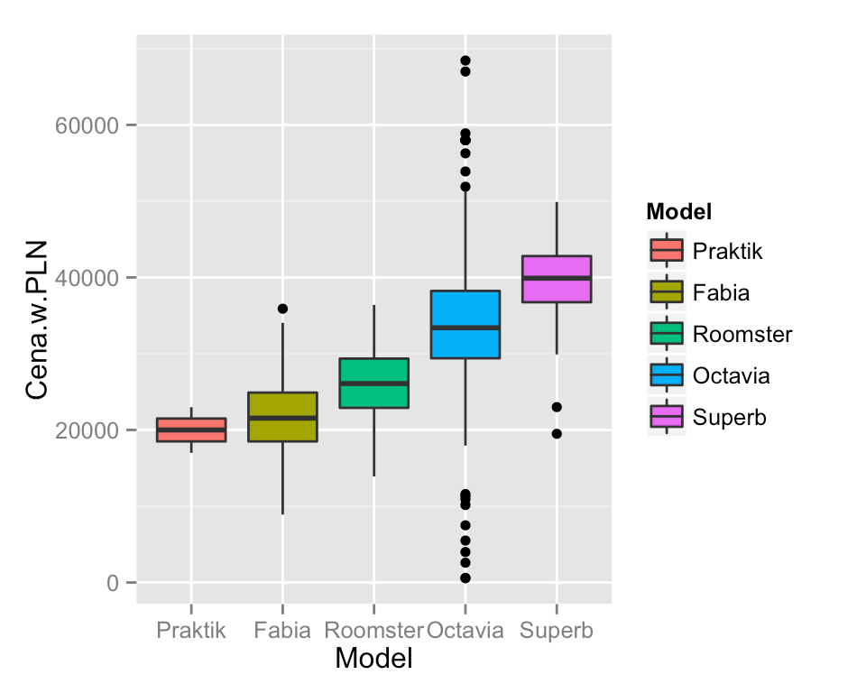
One of the interesting options, allowing fast distinction of a given group on the chart is the use of box chart's feature fill colour to present variables.
Colours itself do not bring new information to the chart, but can facilitate references to the elements of the chart. It is possible to refer e.g. to the blue box instead of the box for cars such as Skoda Octavia.
ggplot(skody, aes(x=Model, y = Cena.w.PLN, fill=Model)) + geom_boxplot()

Parameters description for geom_boxplot() function is presented on the website http://docs.ggplot2.org/0.9.3.1/geom_boxplot.html.
In order to use this feature on the chart, it is enough to add fill=Model mapping inside the function
aes(). A side effect will be the key with description of particular mappings.

Geometry geom_hist()histogram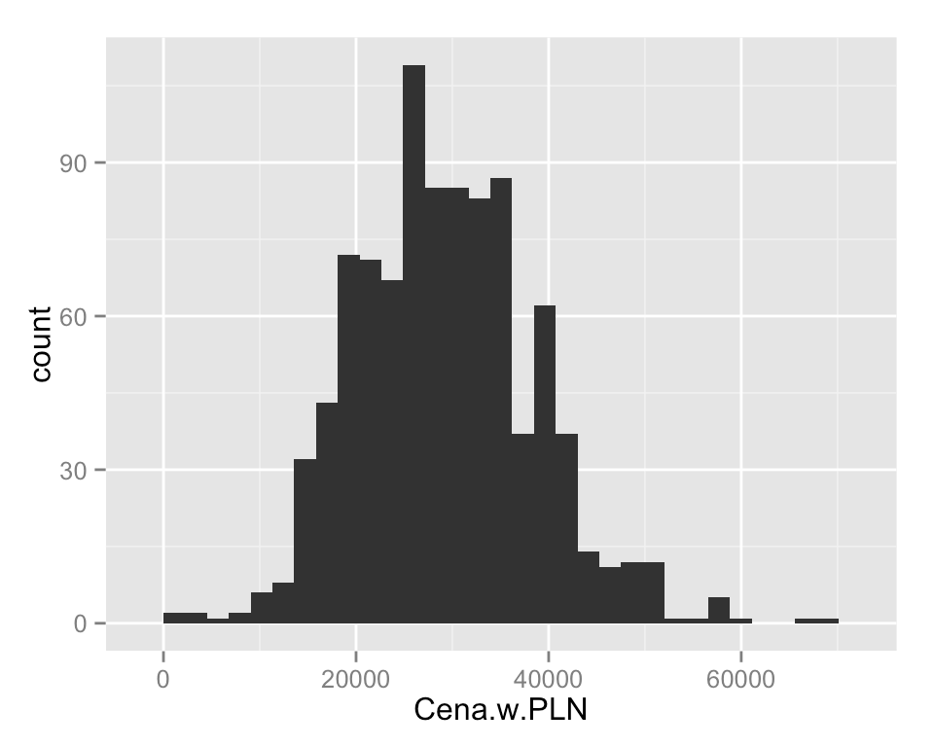
Histogram by means of bars length presents numbers (or frequency) of values in certain ranges. Definition is complex, we will see what it means on the example.
The geom_histogram() function estimates on how many equally long intervals the set of values must be divided. In this case the price was divided into approx. 30 intervals. The chart presents the number of observations which are contained in the specified section.

When we selected five-year Skodas we can see how variability of their prices looks like.
Frame-and-whiskers chart presents 5 numbers describing values in the group. More detailed description which frequently enables better understanding and presentation of variability in data is the chart: histogram.
Which additional information can be read from this chart? E.g. how many cars there are in the price below 20 thousand or above 60 thousand. Such information cannot be straightforward read from box-and-whiskers chart.
ggplot(skody, aes(x=Cena.w.PLN)) + geom_histogram()
Geometry geom_hist()histogram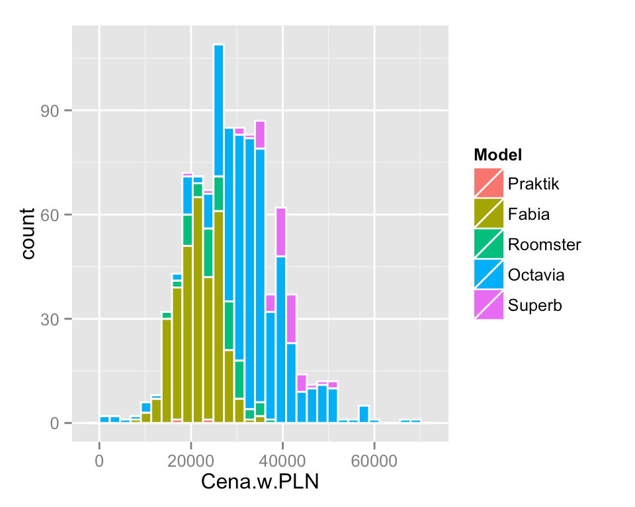
The following example presents fill colour as the car. Data contain 5 different models among five-year Skodas, each is marked by different colour. Visually, we can not only assess in which price ranges the most cars of a given model occur, but we can also estimate the number of cars of a given model in the specified ranges.
To increase legibility of particular groups by color='white'argument, we added white framing of particular bars.
ggplot(skody, aes(x=Cena.w.PLN, fill=Model)) + geom_histogram(color='white')
Presentation of data using histogram gives wide opportunities thank to adding information on observation groups. This can be done e.g. by changing fill feature, namely the fill colour for the geometry.

We can see that Fabia and Oktavia are most popular and they occupy the most space on the chart. Additionally, the value of 30 thousand very good separates these two models. Fabia are mostly cheaper and Oktavia more expensive.

Geometry geom_bar() - bar charts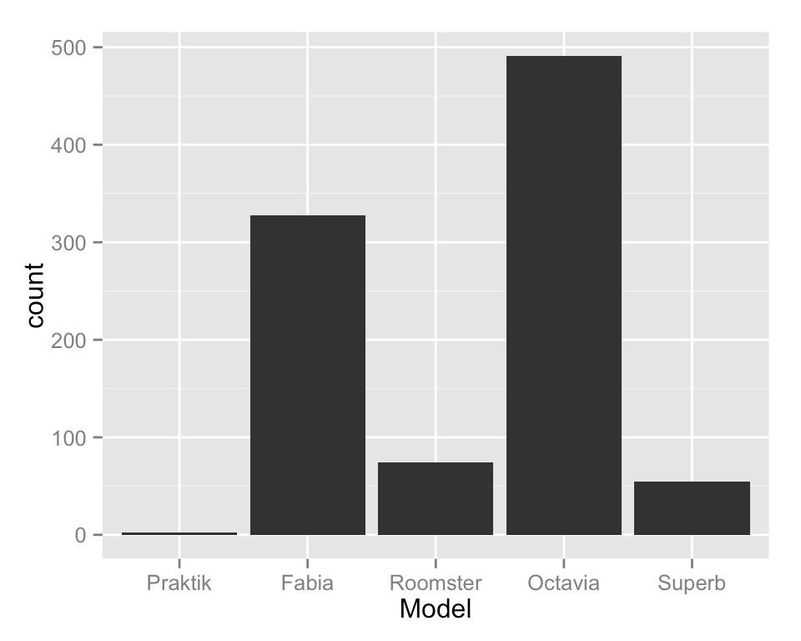
Both in usage and appearance it is similar to geom_hist() geometry. What makes them different is that one uses qualitative variables (groups) and the other quantitative variables (changing them into intervals).
Let's see which models of Skoda constitute the majority among five-year-old cars.
ggplot(skody, aes(x=Model)) + geom_bar()

One of most often observed charts are bar charts. Hence, it is time for them. In ggplot2 package such charts can be prepared using geom_bar() geometry. It counts the number of application of particular groups and presents these numbers on the chart using height of bars.
In geom_bar() geometry it is enough to indicate the grouping variable. Frequencies for levels of this variable will be designated automatically and presented on y coordinate.

Geometry geom_bar() - bar charts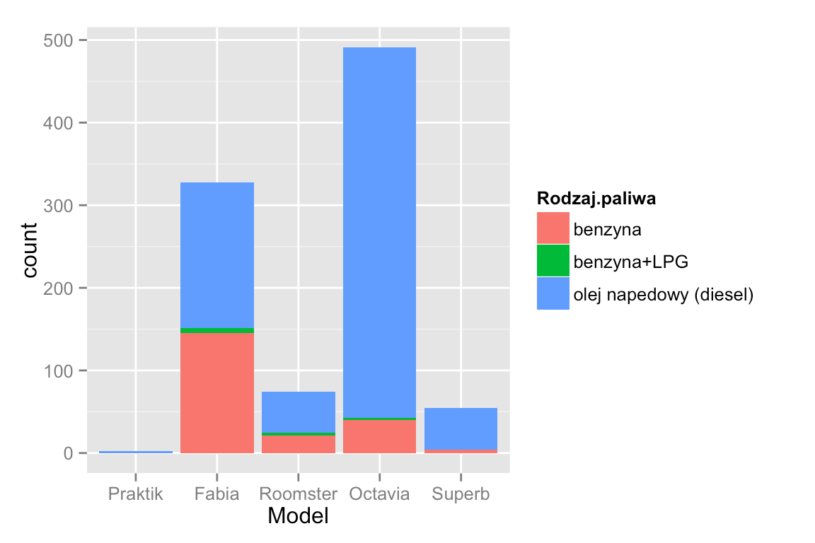
This will automatically add a key to the chart. It enables assessment of share of particular sub-groups in groups.
What can be read from this chart? There is not much Skodas with gas installation. If we are looking for a car with diesel engine much more often it can be found among Skoda Octavia rather than Superb or Roomster.
ggplot(skody, aes(x=Model, fill=Rodzaj.paliwa)) + geom_bar()

Like in the case of the histogram, in the case of bar charts we can mark on the chart additional grouping variable. It is frequently made by mapping of the grouping variable for fill colour (fill feature).
On the following example we will add information on the type of fuel. Additional mapping of fill=Rodzaj.paliwa will divide bars into fragments with lengths proportional to share of sale offers of different type of fuel.

Geometry geom_bar() bar charts, conditional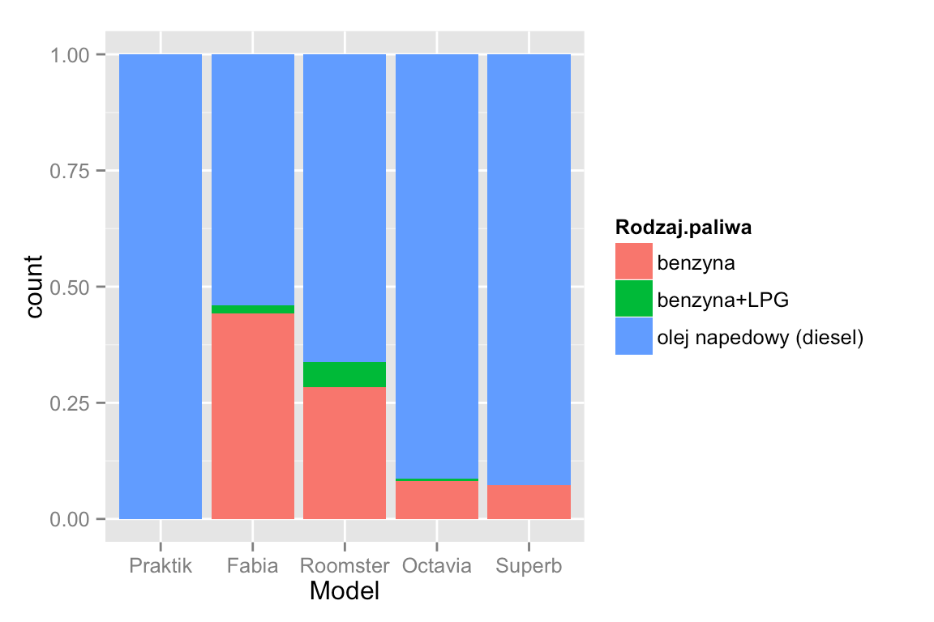 charts
However, if we begin to put in the chart information on the subsequent variables it is convenient to be independent from the size of these groups.
Such standardization can be performed in geom_bar() geometry by adding position="fill" argument.
ggplot(skody, aes(x=Model, fill=Rodzaj.paliwa)) + geom_bar(position="fill")

So far the histogram and bar charts showed the number of lines in particular groups e.g. car models.
For instance, if we are interested in considerable share of cars with diesel engine, namely relation of cars supplied with oil in Skoda Fabia group, to all cars from Skoda Fabia group we need to regulate valid numbers.

How to exactly calculate the size of groups?
It is difficult to read numeric values from it.

Source: local data frame [12 x 3] Groups: Model

Model Rodzaj.paliwa
- Praktik olej napedowy (diesel)
- Fabia benzyna
- Fabia benzyna+LPG
- Fabia olej napedowy (diesel)
- Roomster benzyna
- Roomster benzyna+LPG
- Roomster olej napedowy (diesel)
- Octavia benzyna
- Octavia benzyna+LPG
- Octavia olej napedowy (diesel)
- Superb benzyna
- Superb olej napedowy (diesel)

The chart enables the construction of fast ideas on the size of presented values.
In order to calculate accurate frequencies we can use functions which we know from the first season
group_by() and summarise().
# dla każdej kombinacji grup Model / Rodzaj.pawliwa wyznacz liczbę obserwacji skody %>%
group_by(Model, Rodzaj.paliwa) %>% summarise(liczba = n())
##
##
##
##
##
##
##
##
##
##
##
##
##
##
##
##

liczba
2
145
6
177
21
4
49
40
3
448
4
51
Where to search further
Many useful instructions can be found in the online book: ,,Cookbook for
R” http://www.cookbookr.com/Graphs/
Many interesting examples with the use of ggplot2 can be found on websites
http://www.ats.ucla.edu/stat/r/faq/ oraz http://zevross.com/blog/category/r/

More information on how to build charts in ggplot2 package can be found in Chapter 4 of the book ,,Przewodnik po pakiecie R’’. For more information on this book
http://www.biecek.pl/R/
Very extensive documentation of ggplot2 package is available on the "ggplot2" website.
http://docs.ggplot2.org/current/index.html
Task, season 2, episode 3
Select Volkswagen and draw how the average price depends on the production year,
with the use of different colours present different Volkswagen models.
For selected five-year cars from Volkswagen model present with breakdown into models whose part of cars is equipped with diesel engine.

Select Volkswagen Passat and draw how the average price depends on the production year using geom_smooth()geometry.
Select five-year cars from Volkswagen model and using box-and-whiskers chart present
how the price of car depends on the model.

