Ggplot2 package working on details
season 2 /episode 4

Press A to replace slides with continuous text.
Press T to display table of contents.
pogRomcy danych
What is this episode about?
However, while creating more complex graphics, there is frequently a need for changing some details.
How to add annotations to a chart?
How to control mapping for shape feature?
How to control mapping for colour feature?
How to modify the chart key?
How to change graphic chart themes?
In this section you will learn:

Functions from ggplot2 look good at default settings.
Notes, texts on axes and titles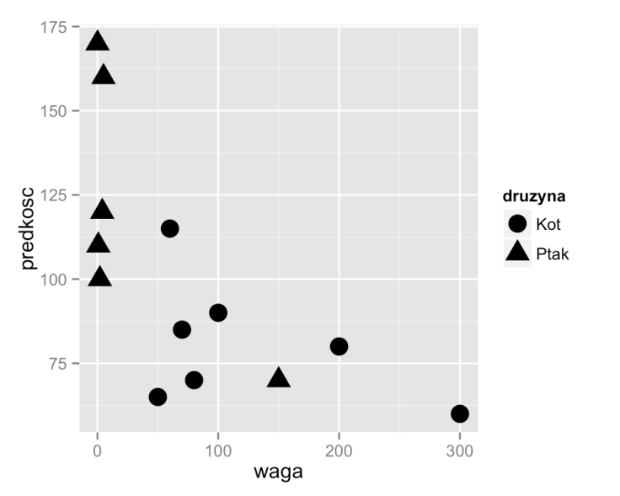
Why are they so important? Since without axis title and description the reader may not know what a topic of a chart is. If the reader does not know what is presented on the chart, then the chart is useless.
We will create very good charts, because at our charts everything will be clear and described. Let's have a closer look at the chart from the first episode and consider what elements should be described more accurately. Spend few minutes trying to find at least five elements needing more accurate description.
library(PogromcyDanych)
ggplot(koty_ptaki, aes(x=waga, y=predkosc, shape=druzyna)) + geom_point(size=5)

Good chart title and axes descriptions are the elements that significantly facilitate correct reading of the chart, though their contribution is often belittled.
Why is it belittled? Since thw chart creator usually knows what is presented on the chart and not necessarily feels like and has time to take care for the chart reader.

Notes, texts on axes and titles
It could be, because we have seen this chart already many times and we know, what it presents. However, if you have managed to find elements worth additional description, that's great! You started to learn analytical approach towards charts.
Axes are missing units. There is "weight" information, but what are the units? Kilograms, pounds?
Aimilar problem concerns speed. Are these kilometers per hour or miles per hour?
The "druzyna" key description is kind of funny, but says little about the content. What team? The text cannot be understood by people not knowing about species races.
But what is it all about with this chart? Where is the title? What does it mean?
What species represent the most extreme points? What kind of cat and what kind of bird is the fastest?

Was that a difficult task?
Here is what I found:
Let's see how to prepare a chart with relevant annotations.
Notes, texts on axes and titles
1.
2.
3.
4.

To change key title argument name should be specified for the function describing mapping for size (scale_shape_discrete()), and function theme() should be used to move the key closer to the upper part of a chart.
In the example below four lines are added to a chart, each changing specified chart element.
The ggtitle() function adds chart title and function theme() changes chart title size. Larger
will be clearer.
The functions xlab() and ylab() are used for adding descriptions to axes. We added units, it would be better if the descriptions started with large letter and included Polish characters.
Function geom_text() adds labels for selected points at the chart. We marked the quickest cat and
bird.
Notes, texts on axes and titles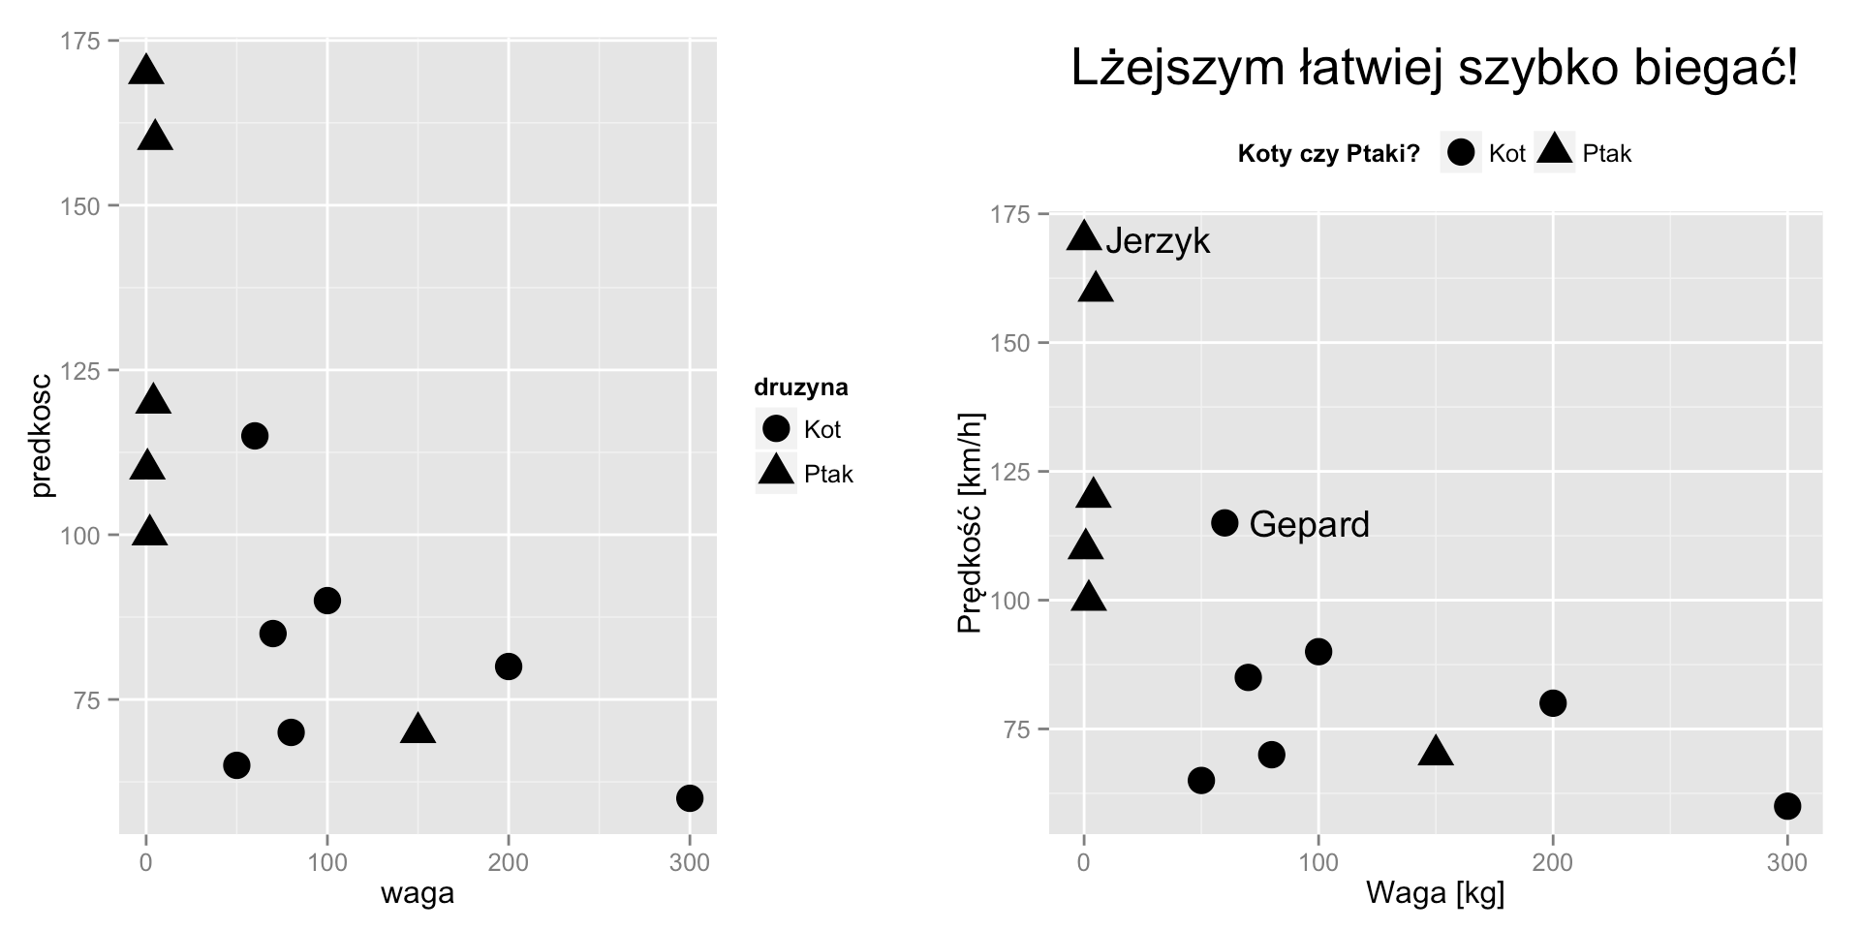

And here is the chart after adding these modifications.
# Przed [lewy]
ggplot(koty_ptaki, aes(x=waga, y=predkosc, shape=druzyna)) + geom_point(size=5)
# Po [prawy]
ggplot(koty_ptaki, aes(x=waga, y=predkosc, shape=druzyna)) + geom_point(size=5) +
# większy i czytelny tytuł
ggtitle("Lżejszym łatwiej szybko biegać!") + theme(plot.title = element_text(size=20)) +
# opisy osi
xlab("Waga [kg]") + ylab("Prędkość [km/h]") +
# tytuł w legendzie
scale_shape_discrete(name="Koty czy Ptaki?") + theme(legend.position="top") +
# dodatkowe napisy na wykresie
geom_text(data=koty_ptaki[c(6,8),], aes(label=gatunek), hjust=‐0.2)
Greater control over mapping
Sometimes, however, we would like to change the manner of variable representation, that is change the default mapping.
For instance, scale_shape_manual() function enables mapping variables on points' shapes. Argument values= enables indicating what shapes are to represent different groups while an argument breaks= enables indicating mapped variable's values in the key.
While mapping x and y features (coordinates) it is interesting to use expand= parameter, which enables identifying how large are to be margins on the axis.

Mapping is one of the largest values of ggplot2 package. You can just choose what variables are to be presented on the chart and what chart features are to describe these variables and program R will automatically select the mode of presentation taking into account variable type, checking whether it has few values or many of them, whether it is a quantitative variable or qualitative one etc.
We can do this using function of names compliant with template scale_xxx_yyy() where xxx describes feature we map (shape/size/color/x/y), and yyy describes the mode of representation.
In a similar manner scale_color_manual() enables manual (manual) indication of colours that are to code particular values.
Greater control over mapping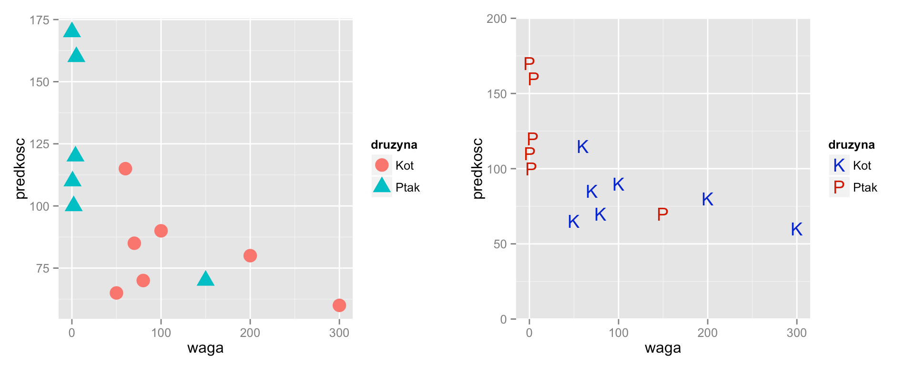

And here is the exemplary application of all of these mapping modifications.
# Przed [lewy]
ggplot(koty_ptaki, aes(x=waga, y=predkosc, shape=druzyna, color=druzyna)) + geom_point(size=5)
# Po [prawy]
ggplot(koty_ptaki, aes(x=waga, y=predkosc, shape=druzyna, color=druzyna)) + geom_point(size=5) +
# określamy kształty poszczególnych grup K/P oraz etykiety w legndzie scale_shape_manual(values=c("K", "P"), breaks=c("Kot", "Ptak")) +
# określamy kolory (ciemnoniebieski i ciemnoczerwony) scale_color_manual(values=c("blue3", "red3"), breaks=c("Kot", "Ptak")) +
# dla osi OY usuwany marginesy poza zakresem 0‐200 scale_y_continuous(limits=c(0,200), expand=c(0,0))
Greater control over volatile continuous mapping
If we do not like default selection of colours (for continuous variables from black to blue), using function
scale_color_gradient() we can define what values low=and high=should colours scale reach.
More information about possible additional parameters can be found in functions help file.
?scale_color_gradient and ?scale_size_continuous

Let's see how control of mapping of continuous variables looks like. As an example we will use zywotnosc variable. We will map it on colour and size of a point.
For the size of a point we determine what interval life span is to be presented=and what point size this interval is to be presented range=.
Greater control over volatile continuous mapping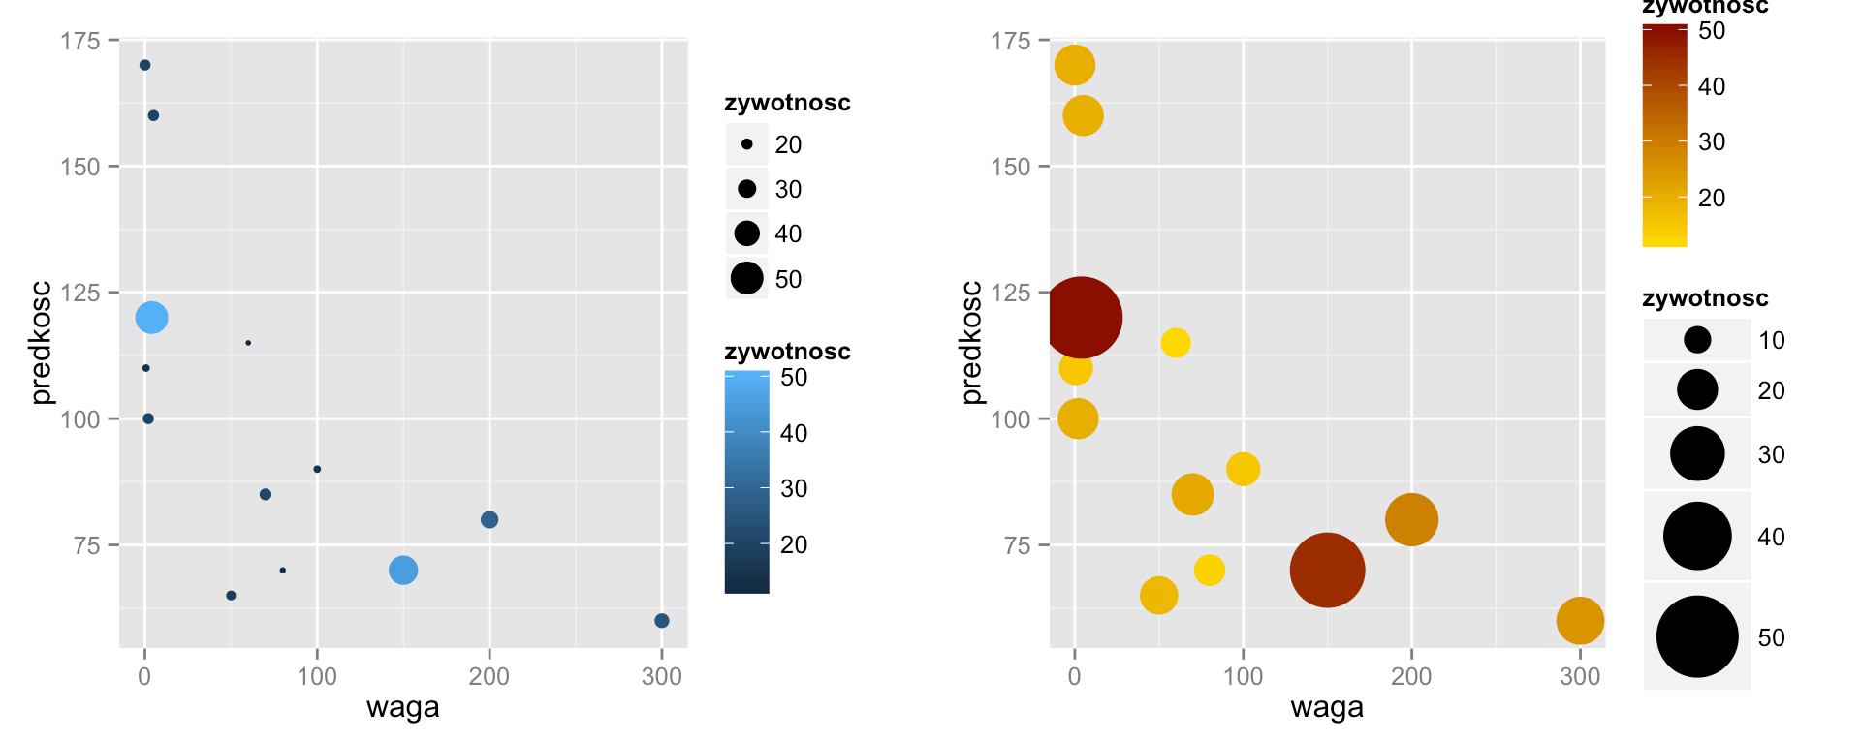

And here is the exemplary application of all of these mapping modifications.
# Przed [lewy]
ggplot(koty_ptaki, aes(x=waga, y=predkosc, size=zywotnosc, color=zywotnosc)) + geom_point()
# Po [prawy]
ggplot(koty_ptaki, aes(x=waga, y=predkosc, size=zywotnosc, color=zywotnosc)) + geom_point() +
# zmiana zakresu wartości dla wielkosci punktów scale_size_continuous(range=c(5,15), limits=c(10,50)) +
# zmiana skali kolorów (ciągła skala podaje się dwa skrajne kolory) scale_color_gradient(low="gold", high="red4")
Chart key modification
It all can be done, most often it is enough to modify particular theme arguments, using function
theme().

Package ggplot2 automatically creates and draws the key. In many cases this default preservation is sufficient and the key is legible enough. But sometimes we want to put the key elsewhere, title it differently or colour it.
In the window below function theme() is used for determination of background and framing colour in the key, its size and position. The scale_shape_manual() function determines mapping elements, key title and names of key's items.
Chart key modification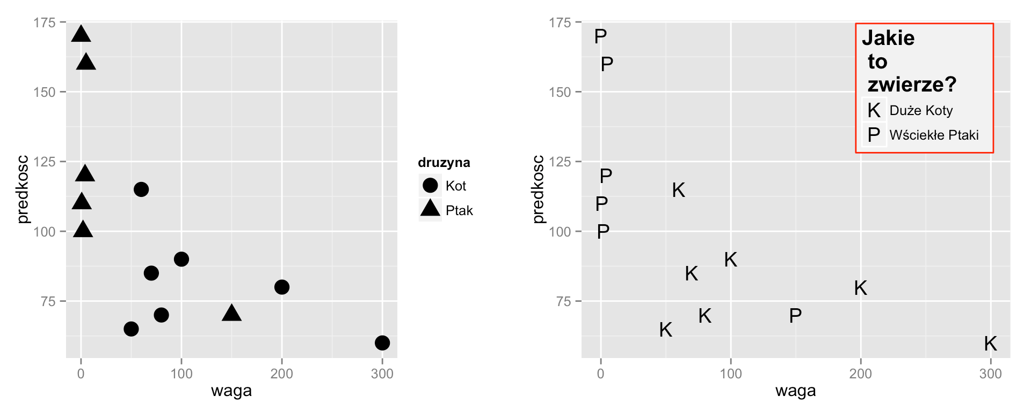
o \
# Przed [lewy]
ggplot(koty_ptaki, aes(x=waga, y=predkosc, shape=druzyna)) + geom_point(size=5)
# Po [prawy]
ggplot(koty_ptaki, aes(x=waga, y=predkosc, shape=druzyna)) + geom_point(size=5) +
# zmiana napisów w legendzie dotyczących mapowania na kształt
scale_shape_manual(values=c("K", "P"), labels=c("Duże Koty", "Wściekłe Ptaki"), name="Jakie \n t
# dodanie szarego tła, większego tytułu oraz zmiana położenia legendy theme(legend.background = element_rect(color="red", fill="grey95"),
legend.title = element_text(size=15),
legend.position=c(0.8,0.8)) # 0.8, 0.8 to współrzędne gdzie ma pojawić się legenda
Example of changes in the key

Many charts in one window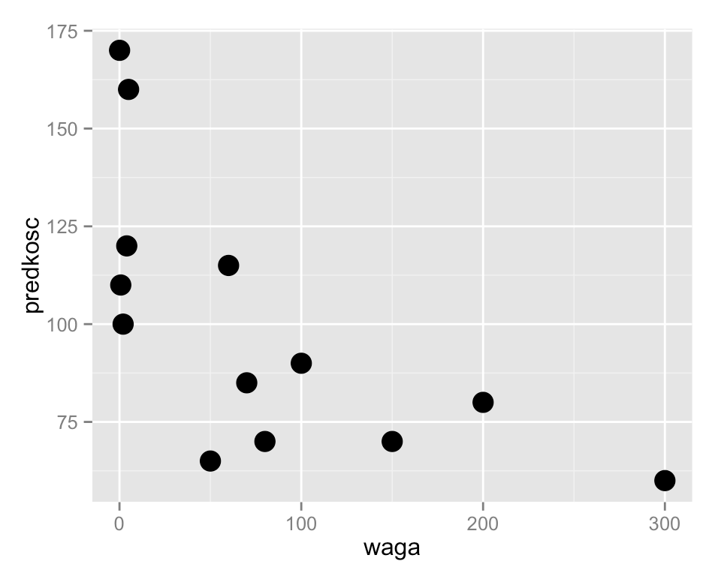
In the program R everything is an object. It means that also ggplot() function results is an object that can be assigned to a variable and later repeatedly used.
To display chart pl_waga chart, print() function can be used.
print(pl_waga)
pl_waga <‐ ggplot(koty_ptaki, aes(x=waga, y=predkosc)) + geom_point(size=5)

Very often we want to put several charts side by side. Below we will show you how to do it.
We will illustrate it with example. This instruction assigns scatter plot definitions to pl_waga variable. No chart will be drawn unless we display content of pl_waga variable.

Many charts in one window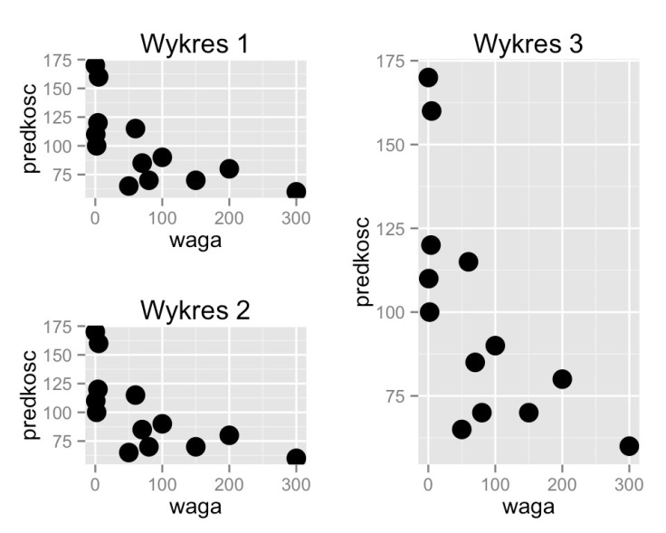
By default the whole area of coordinates [0.1] x [0.1] is outlined, but we can ask for the chart to be drawn at a smaller area.
The example below presents the same chart three times every time elsewhere and with a different title. The x and y arguments define the centre of an outlined area and width and height define the width and height of the outlined rectangle.
library(grid)
# rysujemy wykres w kwadracie o szerokości i wysokości 0.5 ekranu, w lewym górnym rogu print(pl_waga + ggtitle("Wykres 1"),
vp=viewport(x=0.25, y = 0.75, width=0.5, height=0.5))
# rysujemy wykres w kwadracie o szerokości i wysokości 0.5 ekranu, w lewym dolnym rogu print(pl_waga + ggtitle("Wykres 2"),
vp=viewport(x=0.25, y = 0.25, width=0.5, height=0.5))
# rysujemy wykres w prostokącie o szerokości 0.5 a wysokości pełnego ekranu, po prawej stronie print(pl_waga + ggtitle("Wykres 3"),
vp=viewport(x=0.75, y = 0.5, width=0.5, height=1))
One of arguments of this print() function for charts, is argument vp= enabling specifying where chart is to be drawn.

This is very convenient, if we want to place several charts side by side.

Many charts in one window
However if we want draw charts on a regular grid, it is convenient to first specify the grid with grid.layout() function
and then fill it with charts specifying grid position for outlining.
# siatka o rozmiarze dwa wiersze i dwie kolumny pushViewport(viewport(layout = grid.layout(2,2)))
# wklejanie wykresów do wybranych komórek
# rysujemy w komórce o współrzędnych 1x1 print(pl_waga + ggtitle("Wykres 1"),
vp = viewport(layout.pos.row=1, layout.pos.col=1))
# rysujemy w komórce o współrzędnych 2x1 print(pl_waga + ggtitle("Wykres 2"),
vp = viewport(layout.pos.row=2, layout.pos.col=1))
# rysujemy w komórce o współrzędnych 1:2x2 print(pl_waga + ggtitle("Wykres 3"),
vp = viewport(layout.pos.row=1:2, layout.pos.col=2))

Argument vp= enables drawing in lower part of a chart.

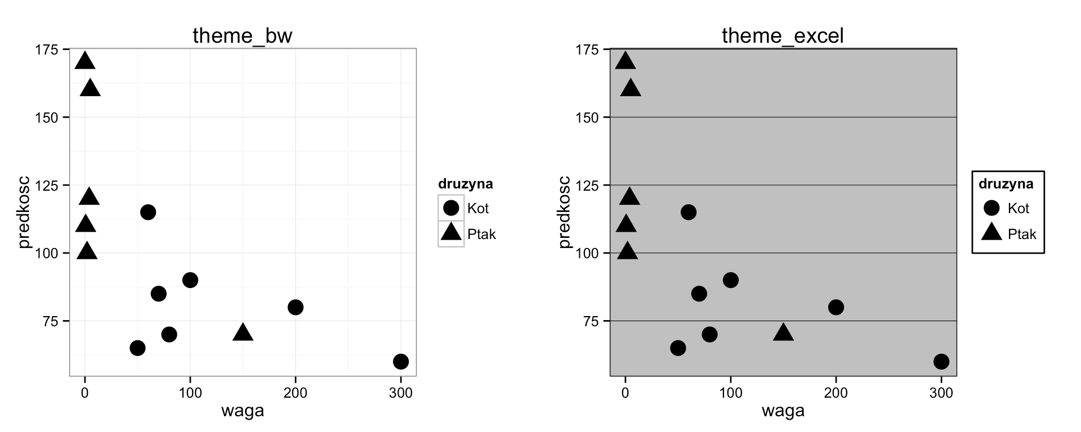
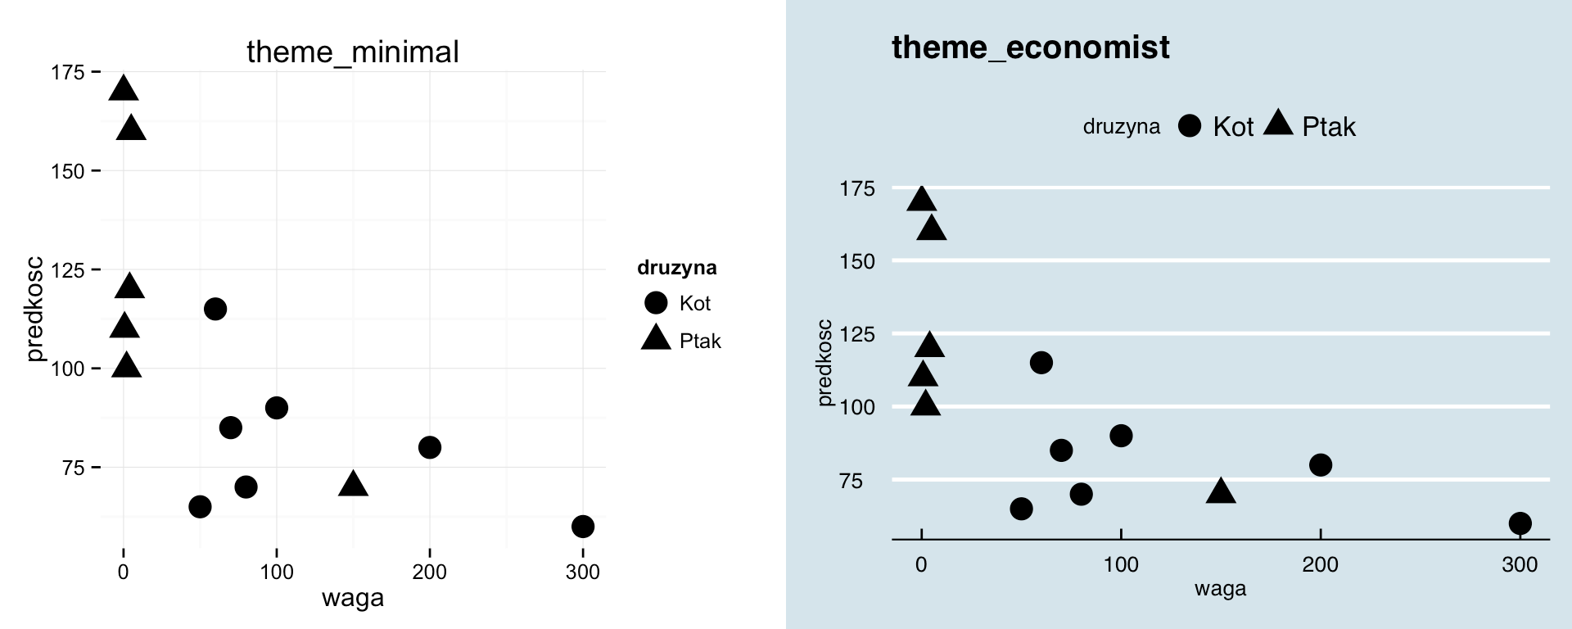
Graphic themes
It turns out that appearance of the whole chart may be changed simply by using the so-called themes, namely graphic settings sets. Many such themes are available in ggthemes package. Adding theme function is enough to change chart appearance. Names of these functions start with theme_.

Grey chart background might have become irritating by now.
Below examples of four graphic themes are presented, it is worth seeing how the rest looks like.
# przygotowujemy wykres punktowy
pl <‐ ggplot(koty_ptaki, aes(x=waga, y=predkosc, shape=druzyna)) + geom_point(size=5)
# pakiet z dodatkowymi motywami
# jeżeli nie jest zainstalowany, należy go dodać funkcją install.packages() library(ggthemes)
# białe tło i szare linie pomocnicze pl + theme_bw()
# wykres stylizowany na wykresy z Excela pl + theme_excel()
# wykres z usuniętymi dodatkowymi elementami pl + theme_minimal()
# wykres stylizowany na gazecie Economist pl + theme_economist()
Additional intersting information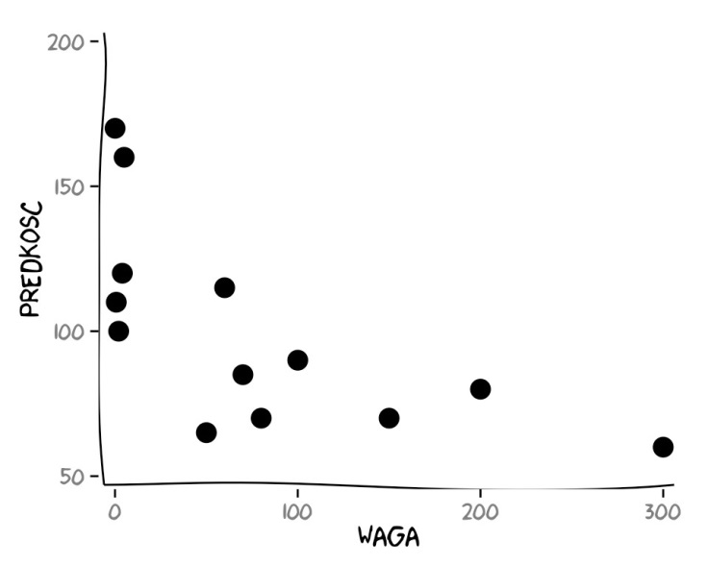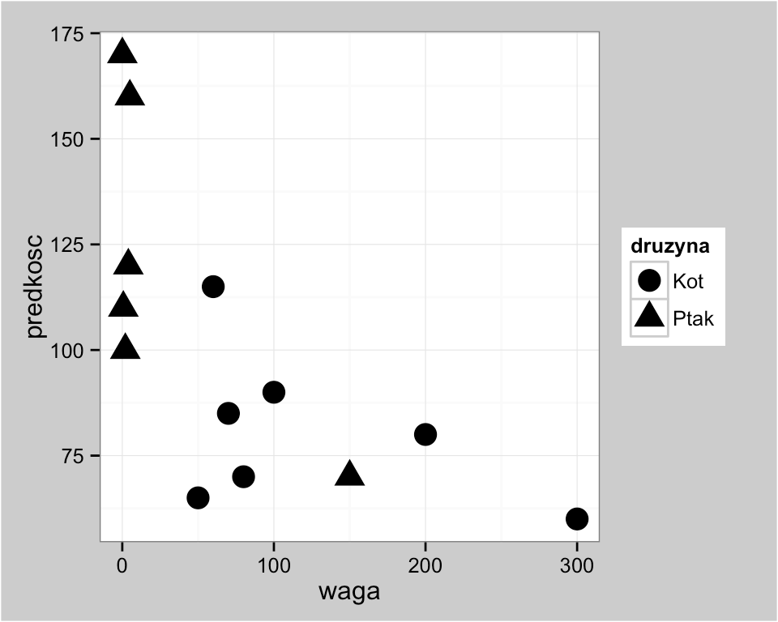
For instance, it is possible to create of charts in style of popular comics from XKCD series http://xkcd.com/.

The flexibility of ggplot2 pachage is tremendous. You can do very original things.
Based on theme of theme_bw() inversion of default charts from ggplot2 can be achieved. Maybe these are not options for everyday use, but they show that exploring ggplot2 package we will not come across a sigh saying "It cannot be done".
pl + theme_bw() + theme(plot.background = element_rect(fill = "gray80"))
# aby można było rysować wykresy jak w komiksach XKCD potrzebny jest pakiet xkcd library(xkcd)
ggplot(koty_ptaki, aes(x=waga, y=predkosc)) + geom_point(size=5) + xkcdaxis(c(0,300),c(50,200))
What's next
When pasting charts into Excel or Word we may want charts that are editable. There is a way to achieve the desired result.
http://www.sthda.com/English/wiki/createaneditablegraphfromrsoftware
On the Internet you can find many pages concerning creating good charts. Selected interesting lists of such tips are:
Do’s and Don'ts http://stat545ubc.github.io/block015_graphdosdonts.html
Ten Simple Rules for Better Figures http://www.ploscompbiol.org/article/info:doi/10.1371/journal.pcbi.1003833 Twenty rules for good graphics http://robjhyndman.com/hyndsight/graphics/

Information of different skins for ggplot2 packagecan be found on easyGgplot2.
http://www.sthda.com/english/wiki/easyggplot2
Many useful instructions can also be found in an e-book "CookBook for R" http://www.cookbookr.com/Graphs/ and in "Effective tables and graphs in official statistics" document, Government Statistical Service https://gss.civilservice.gov.uk/wpcontent/uploads/2014/12/Effectivegraphsand
tablesinofficialstatisticsversion1.pdf
Task, season 2, episode 4
Change the chart below by changing colours scale from green to red, replacing dots with squares and
adding title to a chart (and adding appropriate axis labels).
ggplot(koty_ptaki, aes(x=waga, y=predkosc, size=zywotnosc, color=zywotnosc)) + geom_point()

Like in the previous section, select Volkswagen Passat and then draw how average price changes in relation to production costs using geom_smooth() geometry. Then see how this chart looks like if you use theme_bw(), theme_excel() and theme_economist() themes.

