Ggplot2 package maps
season 2 /episode 5

Press A to replace slides with continuous text.
Press T to display table of contents.
pogRomcy danych
What is this episode about?
In this episode we will learn
In this episode we will learn how to operate on andatySejmik2014data set available in the
PogromcyDanych package.

One of a very visually attractive methods of data presentation are choropleths, i.e. popular "maps".
How to upload maps data?
How to present on maps information concerning filling colour?
How to present on maps information using point or bar sizes?
Data set
The mandatySejmik2014 data set shows the number of mandates given topoliticians of SLD, PIS, PO, and other parties in each of 16 provinces.

PSL
PO
Inne
long
1
5
16
4
16.38088
2
10
14
0
18.50218
3
10
10
0
19.40827
4
12
7
0
22.90889
5
8
10
2
15.34234
6
8
14
0
20.30085

1

2

3

4

5

6

In this episode we will work on data set concerning results of local government election of 2014 (sejmiki election).
In column ProcentWaznychGlosow the percentage of valid votes was presented (in relation to persons eligible to vote) and the last two columns present length and latitude of the province center.
# jeżeli pakiet nie jest zainstalowany, należy go najpierw zainstalować
# funkcją install.packages("PogromcyDanych") library(PogromcyDanych)
# pierwsze sześć wierszy ze zbioru danych head(mandatySejmik2014)
##
Wojewodztwo
PiS
SLD
ProcentWaznychGlosow
##
Dolnoslaskie
9
2
36.83847
##
Kujawsko‐Pomorskie
7
2
36.60884
##
Lodzkie
12
1
40.13651
##
Lubelskie
13
1
41.98316
##
Lubuskie
5
5
36.75825
##
Malopolskie
17
0
40.56634
##
lat

##
51.07988

##
53.02223

##
51.55958

##
51.24725

##
52.20549

##
49.84203

Files with maps / shapes shape files
Such data are made available in .shp files, called shape files.
After downloading data, in folder dane/POL_adm there are areas shapes at various levels of specificity. File
POL_adm0.shp is an outline of the whole country, POL_adm1.shp are outlines of provinces and POL_adm2.shp are anoutlines of communes.
Object shp1 is an object of SpatialPolygonsDataFrame class. More information on this file can be found in help file.
?SpatialPolygonsDataFrame.
Owing to error in coding we need to change its name for Łódź Province.
# W zmiennej VARNAME_1 znajdują się nazwy województw shp1@data$VARNAME_1 <‐ as.character(shp1@data$VARNAME_1) shp1@data$VARNAME_1
## [1] "Wielkopolskie" "Kujawsko‐Pomorskie" "Malopolskie"
## [4] "L\xf3dzkie" "Dolnoslaskie" "Lubelskie"
## [7] "Lubuskie" "Mazowieckie" "Opolskie"
## [10] "Podlaskie" "Pomorskie" "Slaskie"
## [13] "Podkarpackie" "Swietokrzyskie" "Warminsko‐Mazurskie"
## [16] "Zachodniopomorskie"
# poprawiamy kodowanie polskich znaków shp1@data$VARNAME_1[4] <‐ "Lodzkie"
# zanim zaczniemy pracować, potrzebujemy wczytać kilka bibliotek library(maptools)
library(rgdal) library(gpclib) gpclibPermit()
## [1] TRUE
# wczytujemy dane o kształtach województw
shp1 <‐ readShapePoly("../dane/POL_adm/POL_adm1.shp")

To present information on maps in R program, you should first upload outlines of areas from maps.
Files with shapes of polish provinces that I will use in this episode, come from GADM data base http://www.gadm.org and contain some small errors in coding that we will correct manually.
Using readShapePoly() we will upload data about provinces outlines with the shp1 variable.
For instance, variable shp1@data contains data set attached to shapes and this particular file
shp1@data$VARNAME_1 contains names of provinces.

Drawing map of provinces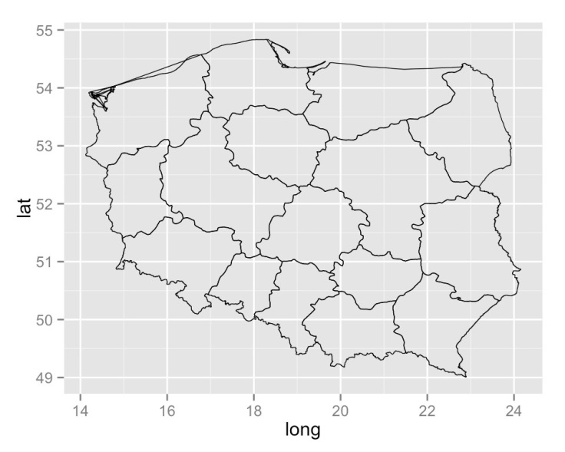
In order to draw such data with the ggplot2 package they should be converted into tabular format.The easiest way to do it is to use fortify()option. It changes data format to tabular. Below, a new format for outlines of provinces is saved in a form of shp1f variable.
After converting data into tabular format we can draw them, e.g. using geom_path. Follow the example below.
ggplot() +
geom_path(data=shp1f, aes(x=long, y=lat, group=id), colour="black", size=0.25)
library(ggplot2)
# fortify zmienia format danych na zgodny z pakietem ggplot2 shp1f <‐ fortify(shp1, region = "VARNAME_1")
head(shp1f, 4)
##
long
order
piece
id
16.16883
1
1
Lower Silesian
2
51.65255
FALSE
Lower Silesian.1
##
16.22376
3
1
Lower Silesian
4
51.66169
FALSE
Lower Silesian.1

Data read by function readShapePoly() have a specific structure of vectors list that constitute shapes of areas.One province is not always an outline of one area, for instance if we want to include islands in the outline of coastal provinces, the province outline will comprise islands outlines as well.
The first two columns of this table are geographic coordinates of points on the outline of each province.

1
lat
hole
group
##
51.66089
FALSE
Lower Silesian.1
##
16.19236
2
1
Lower Silesian
3
51.65711
FALSE
Lower Silesian.1
##
16.24667
4
1
Lower Silesian
Drawing map of provinces geom_map() 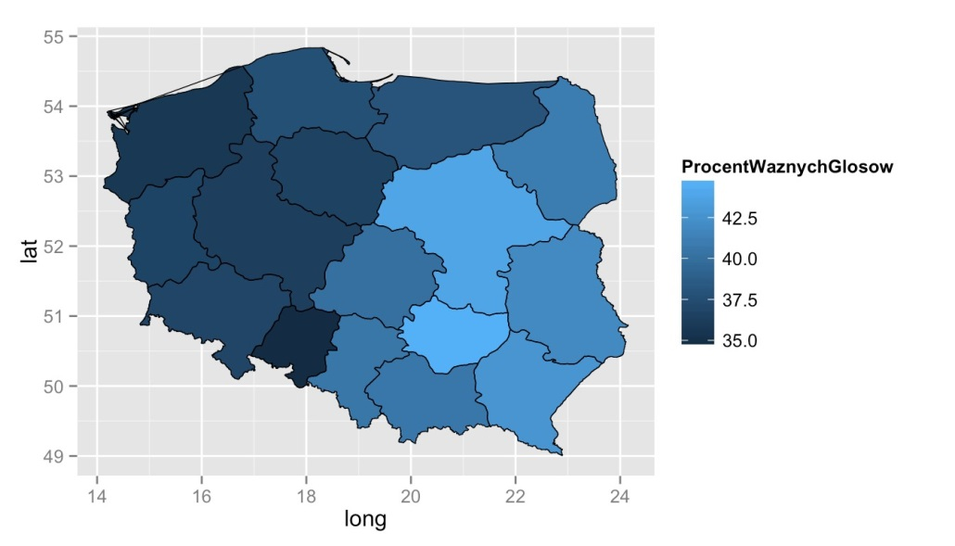
However, to mark numeric values on the map with colour filling, we will use geom_map() geometry.
The below example presents drawing a choropleth in which information of percentage of valid votes can be presented with filling colour
# pusty zrąb wykresu ggplot() +
# rysowanie wypełnień
geom_map(data=mandatySejmik2014, aes(map_id=Wojewodztwo, fill=ProcentWaznychGlosow), map=shp1f) +
# rysowanie obrysów na czarko
geom_path(data=shp1f, aes(x=long, y=lat, group=id), colour="black", size=0.25)

We will use geom_path() geometry for drawing outlines of provinces.
The argument map= of this geometry indicates objects presenting provinces (in this case shp1f). The argument data= indicates numeric data object, namely our data of mandates of sejmiki. In mapping for geom_map() geometry map_id= feature is indicated in order to present names of provinces and fill= to indicate which variable is to be presented with filling colour.

Map drawing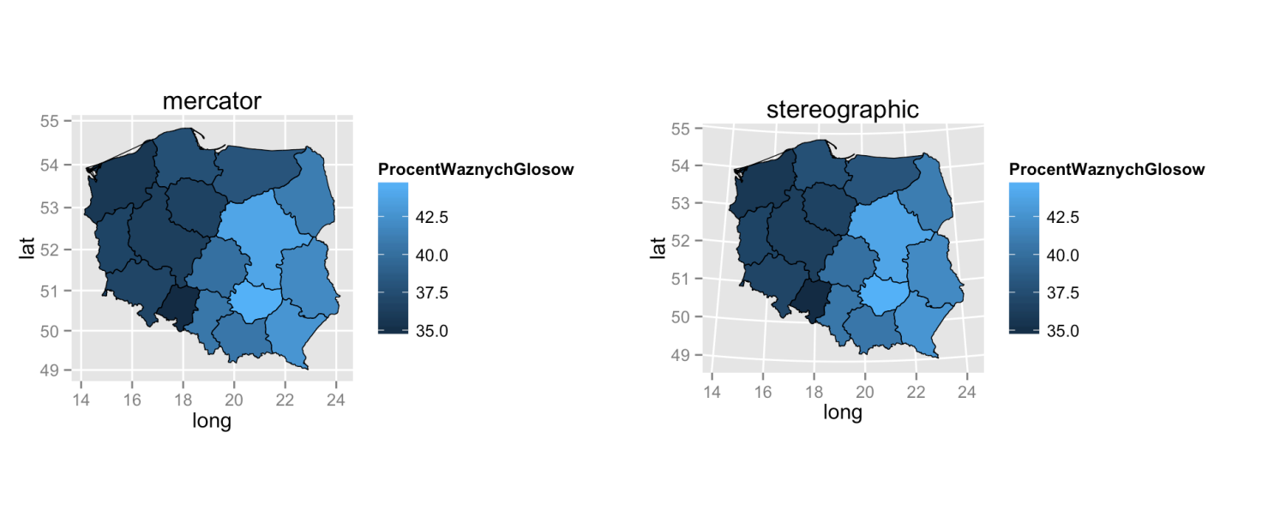
Maps can be drawn in different projections, there is no perfect projection. Some preserve areas better, other are better in presenting angles or lengths of sections. List of projections with a description of properties can be found at http://en.wikipedia.org/wiki/List_of_map_projections

Below there are two sample charts with different projections. Since in comparison to the area of the globe, the area of Poland is relatively small, differences between maps are rather subtle.
# przygotowujemy wykres, tak jak w poprzednim odcinku mapka <‐ ggplot() +
geom_map(data=mandatySejmik2014, aes(map_id=Wojewodztwo, fill=ProcentWaznychGlosow), map=shp1f) +
geom_path(data=shp1f, aes(x=long, y=lat, group=id), colour="black", size=0.25)

# przekształcamy mapę, stosując projekcję mercator (odwzorowanie walcowe równokątne)
# zachowuje kąty pomiędzy równoleżnikami a południkami
mapka + coord_map(projection="mercator") + ggtitle("mercator")
# projekcja stereographic (rzut stereograficzny)
mapka + coord_map(projection="stereographic") + ggtitle("stereographic")

The term "projection" is associated with drawing maps, it is a method of mapping three-dimensional globe surface on two-dimensional chart surface.
In R program, in package ggplot, we can use most popular projectections. To select one of them, it is enough to add function coord_map().

Drawing map working on details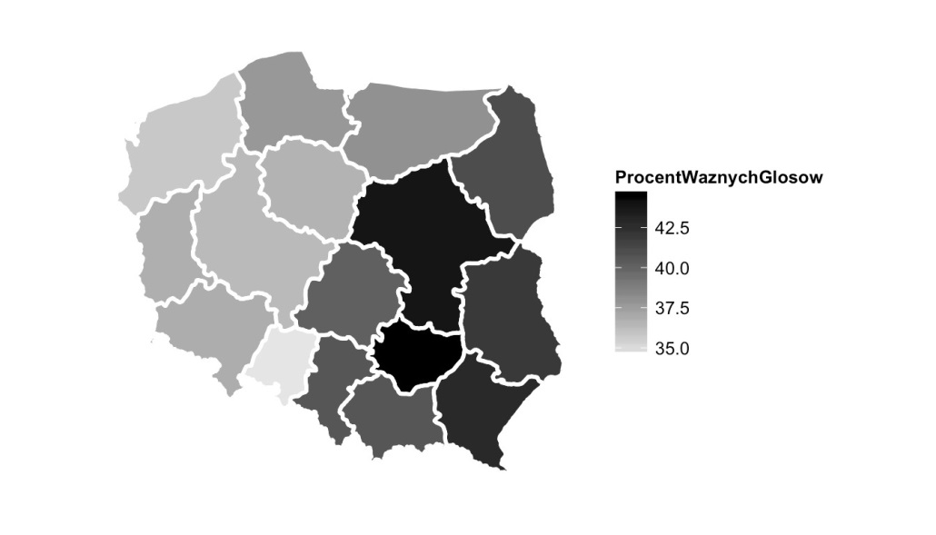
Maps made with ggplot2 package can be modified like other charts in ggplot2 package.

We have already drawn several choropleths. But they could be better. How to modify them?
In the following example we present several sample changes. Using theme_bw() function, we change default chart motive, using scale_fill_gradient() we change the manner of variable representation with filling colour, and with additional theme() function arguments we remove all additional chart elements.
ggplot() +
geom_map(data=mandatySejmik2014, aes(map_id=Wojewodztwo, fill=ProcentWaznychGlosow), map=shp1f) +
geom_path(data=shp1f, aes(x=long, y=lat, group=id), colour="white", size=1) +
# określamy projekcje mercator coord_map(projection="mercator") +
# zmieniamy motyw graficzny, usuwając szare tło theme_bw() +
# zmienną ilościową będziemy prezentować na skali kolorów od szarości po czerń scale_fill_gradient(low = "grey90", high = "black") +
# dodatkowe elementy motywu usuwają wszystko co zbędne z wykresu, linie pomocnicze, osie theme(axis.ticks = element_blank(), panel.border = element_blank(),
axis.text.x = element_blank(), axis.text.y = element_blank(), panel.grid.minor=element_blank(), panel.grid.major=element_blank(), axis.title.x = element_blank(), axis.title.y = element_blank())
Drawing map variable as item size.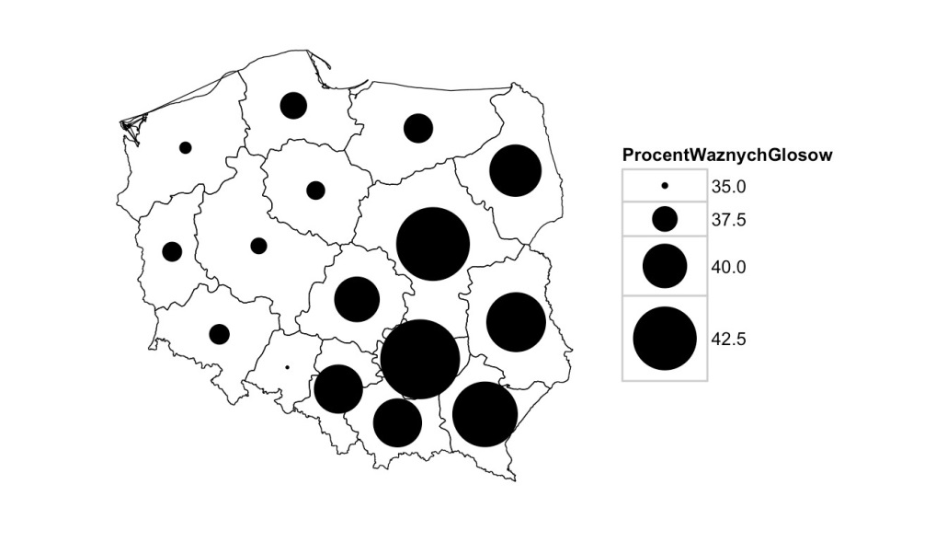
Alternative way of information presentation at the map is e.g. item size.
To make points more visible we enlarge them by modifying mapping with functions.
scale_size_continuous().
ggplot() +
geom_point(data=mandatySejmik2014, aes(x=long, y=lat, size=ProcentWaznychGlosow)) + geom_path(data=shp1f, aes(x=long, y=lat, group=id), colour="black", size=0.25) +
# określamy projekcje mercator coord_map(projection="mercator") +
# zmieniamy motyw graficzny, usuwając szare tło theme_bw() +
# zmienną ilościową będziemy prezentować na skali wielkości punktów od 1 do 20 scale_size_continuous(range=c(1,20)) +
theme(axis.ticks = element_blank(), panel.border = element_blank(), axis.text.x = element_blank(), axis.text.y = element_blank(), panel.grid.minor=element_blank(), panel.grid.major=element_blank(), axis.title.x = element_blank(), axis.title.y = element_blank())

Presenting data by means of colour filling is not always a good idea.
The geom_point() geometry can be used for points drawing, indicating as point coordinates centers of provinces and point size will be dependent on ProcentWaznychGlosow variable.

Map drawing variable as a length of a 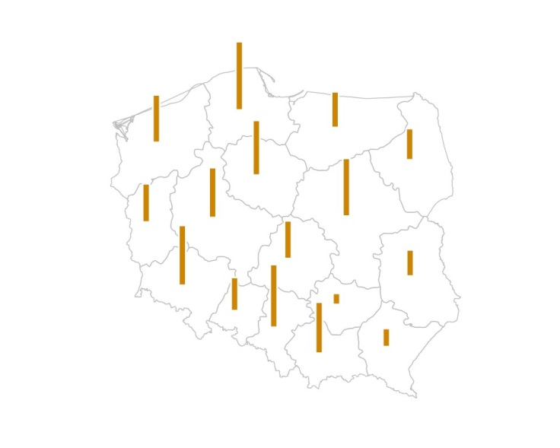bar
To add information on mandates obtained by PO we will use geom_rect() geometry.
") +
ggplot() +
geom_path(data=shp1f, aes(x=long, y=lat, group=id), colour="grey", size=0.25) + geom_rect(data=mandatySejmik2014, aes(xmin=long‐0.3, xmax=long‐0.1,
ymin=lat, ymax=lat + PO/15), fill="orange3", color="white
# określamy projekcje mercator coord_map(projection="mercator") +
# zmieniamy motyw graficzny, usuwając szare tło theme_bw() +
theme(axis.ticks = element_blank(), panel.border = element_blank(), axis.text.x = element_blank(), axis.text.y = element_blank(), panel.grid.minor=element_blank(), panel.grid.major=element_blank(), axis.title.x = element_blank(), axis.title.y = element_blank())
Another way of presenting numeric data on maps is by length of bars.

It should cover xmin and xmax coordinates denoting beginning and end of a bar and ymin and ymax depending on PO variable value.

Map drawing variable as a length of a 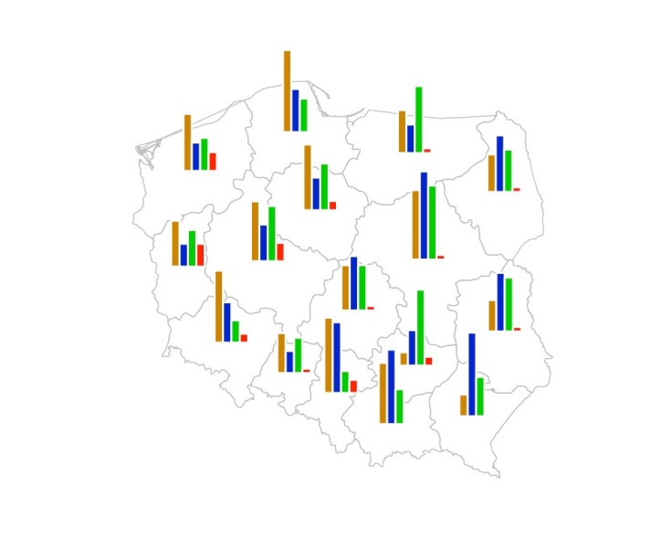bar
On the chart below we pursue this idea. We add posts presenting the number of mandates obtained by PIS, PSL and SLD, we mark each party with different colour. It makes it easier to notice which party won in which province and what was the winning margin.
) +
+
ggplot() +
geom_path(data=shp1f, aes(x=long, y=lat, group=id), colour="grey", size=0.25) +
# warstwa z paskami, prezentująca liczbę mandatów zdobytych przez PO geom_rect(data=mandatySejmik2014, aes(xmin=long‐0.3, xmax=long‐0.1,
ymin=lat, ymax=lat + PO/15), fill="orange3", color="white
# warstwa z paskami, prezentująca liczbę mandatów zdobytych przez PiS geom_rect(data=mandatySejmik2014, aes(xmin=long‐0.1, xmax=long+0.1,
ymin=lat, ymax=lat + PiS/15), fill="blue3", color="white"
# warstwa z paskami, prezentująca liczbę mandatów zdobytych przez PSL geom_rect(data=mandatySejmik2014, aes(xmin=long+0.1, xmax=long+0.3,
ymin=lat, ymax=lat + PSL/15), fill="green3", color="white
# warstwa z paskami, prezentująca liczbę mandatów zdobytych przez SLD geom_rect(data=mandatySejmik2014, aes(xmin=long+0.5, xmax=long+0.3,
ymin=lat, ymax=lat + SLD/15), fill="red", color="white")
# inne graficzne parametry, tak jak w poprzednim przykładzie coord_map(projection="mercator") +
theme_bw() + scale_size_continuous(range=c(1,20)) +
theme(axis.ticks = element_blank(), panel.border = element_blank(), axis.text.x = element_blank(), axis.text.y = element_blank(), panel.grid.minor=element_blank(), panel.grid.major=element_blank(), axis.title.x = element_blank(), axis.title.y = element_blank())

If you managed to draw results of one party, you can add subsequent layers depicting the results of subsequent parties.
") +
") +

What's next
This blog is a short summary including interesting examples: Making Maps in R
http://www.kevjohnson.org/makingmapsinr/

Great presentation of capabilities data presentation on maps is described in the article:
ggmap: Spatial Visualization with ggplot2 http://journal.rproject.org/archive/20131/kahlewickham.pdf
Many useful instructions can also be found in an e-book "CookBook for R"
http://www.cookbookr.com/Graphs/

