Objective:

The purpose of this test is to evaluate candidate’s skills using and/or applying following technologies, libraries, frameworks and architectural approaches:

* SOA oriented applications.
* Telerik components (Emphasizing radgrid component). –Available from http://www.telerik.com/products/aspnet-ajax/download.aspx-
* JQuery
* Bootstrap UI framework (http://getbootstrap.com)

# Test description:

Requested development must include an application working as a SOA endpoint and a Web application consuming services from that endpoint.

The purpose of above mentioned apps is to handle basic operations over persons collection, where a person is represented by the following structure:

* Person ID (int)
* Person name (String)
* Person AGE (int)
* Person Type (int)

And a person type would be represented like:

* Person Type (int)
* Person Type Description (String)

For this test and from SOA app point of view, you can assume that initially there are going to be two types of persons but keep in mind that many more could be added:

Type 1= Teacher

Type 2= Students

# Applications

## SOA endpoint application:

* A class with following fields must implemented:
* List <Person> Persons;
* List <PersonType> PersonTypes;

Please determine the best place to initialize above fields as well as the best way to declare them.

The purpose of this class is to preserve in memory, across many end user sessions, persons information created and/or modified using services below described.

* You are required to implement following functions and expose them using WCF services:
* GetPersons: Should retrieve a list of all created persons
* DeletePerson
* UpdatePerson: Should allow to update all person fields except Person ID.
* Create Person: Should create a new person.
* GetPersonTypes: Should return and array of available person types.

## WEB UI application:

This app would have two aspx pages:

* Page1.aspx:

Using bootstrap as layout framework implement a responsive page that implements a radgrid object displaying all available persons retrieved from SOA services. As well this grid should allow:

1. Create new person using radgrid edit forms
2. Delete a person.
3. Update a person.
4. Sort persona using any of available person fields.
5. If person type is 1 an image button with following functionality must be shown: Whenever clicked this button should open a resizable browser popup window displaying Page2.aspx and passing selected person id as a parameter.

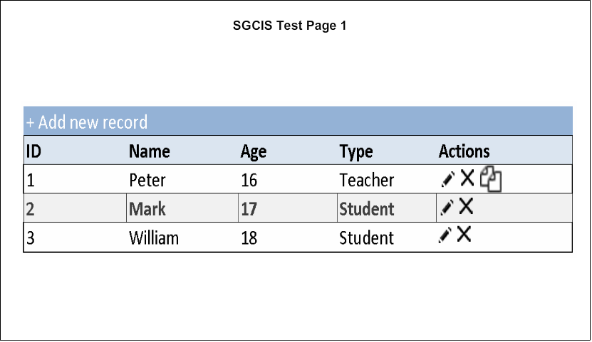

* Page2.aspx:

Using bootstrap as layout framework, implement a responsive page displaying following information:

- Person name

- Person Age

- Person type description.

Please display above information correctly in one line (one field beside each other).

As well, using a JQuery based framework of your choice (we suggest DotNet.Highcharts which is available from Nugget package repository but feel free to use anyone), please display a bar chart with ten points where x axis is going to be a random date and y axis a random int.

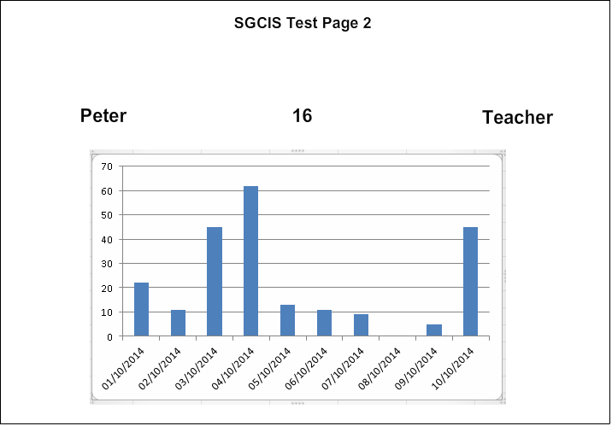

# Delivery considerations:

* All files necessary to execute the project must be delivered within a zip file.
* Keep in mind that provided images should be used just as an example so feel free to use any graphical style or object that you consider may enrich app presentation.