MIT Manipal
ICT-SDA E

STATISTICAL DATA ANALYSIS
Course Code: ICT 3130
ASSIGNMENT 1
Sampling and Exploratory Data Analysis (EDA)
Topic 15
Relationship Between Food Delivery Application
Usage and Spending Habits

Submitted by
Student Name | Roll Number
Vedh Sontha | 240953620
Pramath Bhagawatha K | 240953488
Marella Akhileshwar Reddy | 240953618

Date of Submission: 14/10/26
Relationship Between Food Delivery Application Usage and Spending Habits
ICT 3130 Statistical Data Analysis, Assignment 1: Sampling and Exploratory Data Analysis (EDA)

1. Research Question
Apps like Swiggy and Zomato have become a normal part of college life. They are quick, they offer a lot of choice, and there is almost always some discount running. But a meal ordered online usually costs much more than mess food or food from home, so a student who orders often could end up spending a lot more on food every month. We wanted to find out whether this is actually true for students at our college.
Research question: Is more frequent use of food delivery apps associated with higher monthly food expenditure among college students?
To answer this, we set ourselves three goals. The first was to find out how often students order and how much they spend. The second was to see how the number of orders relates to delivery spending and to total food spending. The third was to compare students living in hostels, PGs and at home, and to understand why students order in the first place.

2. Definition of Key Terms
Table 1 explains the terms and variables we use in this report. All amounts are in Indian rupees (Rs.) and cover the 30 days before the survey.
Table 1: Key terms, variables and concepts
Term | Meaning | Type
Food delivery app | An app like Swiggy or Zomato used to order restaurant food. | Concept
Order frequency | Orders placed through these apps in the last 30 days. | Discrete
Average order value | What a student usually pays for one order (Rs.), users only. | Continuous
Delivery app spending | Money spent on delivery apps in the last 30 days (Rs.). | Continuous
Total food spending | All food spending in the last 30 days (Rs.), our main outcome. | Continuous
Delivery share | Delivery app spending as a percentage of total food spending. | Derived (%)
Usage group | Nonuser (0), Occasional (1 to 4), Regular (5 to 12), Heavy (13+). | Ordinal
Residence | Hostel, PG or rented flat, or home with family. | Nominal
Paid membership | Pays for a plan such as Swiggy One or Zomato Gold. | Binary
Overspending score | Agreement from 1 to 5 that they spend more than they planned. | Ordinal
Outlier | A value more than 1.5 times the IQR below Q1 or above Q3. | Concept
Spearman’s rho (ρ) | A rank based measure of how strongly two variables move together. | Concept

3. Population
Our population is every student enrolled at the institute in the 2026/27 academic year. This covers all years, all genders and every type of residence, whether that is a hostel, a PG or rented flat, or home. Students who never use delivery apps are included too, since they give us a baseline, and each student is one unit of the study. We did not have access to a full list of students, and this affected how we chose our sample.

4. Sample
Our sample is made up of the students who answered our online form after we shared it on WhatsApp. The dataset we analysed has n = 84 records, and Table 2 shows how it is made up.
Table 2: Composition of the analysed dataset (n = 84)
Characteristic | Count and percentage in each category
Year of study | 1st year 4 (4.8%), 2nd year 3 (3.6%), 3rd year 58 (69.0%), 4th year 19 (22.6%)
Residence | Hostel 47 (56.0%), PG or rented flat 20 (23.8%), Home with family 17 (20.2%)
Gender | Male 56 (66.7%), Female 27 (32.1%), Prefer not to say 1 (1.2%)
Paid membership | Yes 42 (50.0%), No 42 (50.0%)
Usage group | Nonuser (0) 8 (9.5%), Occasional (1 to 4) 24 (28.6%), Regular (5 to 12) 34 (40.5%), Heavy (13 or more) 18 (21.4%)

Most of the records come from third year students (69.0%) and from students living in hostels (56.0%). This makes sense, since we mainly shared the form in our own WhatsApp groups. First and second year students together give only 7 records, which is too few to say anything about them separately. Exactly half of the respondents pay for a membership, and 90.5% ordered food at least once in the 30 days.

5. Sampling Method
We used convenience sampling together with snowball sampling, which are both nonprobability methods. We posted the form link in our class, hostel and friends’ WhatsApp groups and asked people to forward it. We had no list of all students, so simple random, systematic or stratified random sampling was not possible. WhatsApp also let us reach many students quickly and for free, and posting in hostel, PG and day scholar groups meant we heard from all three kinds of residence. The downside is that people decided for themselves whether to answer, students from our own year are overrepresented, and the sampling error cannot be measured. So our results describe this sample and should be applied to the whole college only with care.

6. Methodology
Survey form. We made a Google Form with 14 questions in four parts. These were consent, details about the student (year, gender, residence and an optional monthly allowance), questions about the last 30 days (apps used, number of orders, usual amount per order, total delivery spending, total food spending, main reason, usual time of ordering and paid membership), and one statement rated from 1 to 5, “I usually spend more on food delivery than I planned to”. Number questions only accepted numbers in a sensible range, so we got exact values instead of ranges, and we did not collect names, email addresses or phone numbers.
Data collection. We shared the link on WhatsApp on 7 October 2026. The answers were saved automatically in a Google Sheet, which we downloaded as a CSV file for analysis.
Cleaning and analysis. We cleaned and analysed the data in Python (pandas, NumPy, SciPy, Matplotlib and Seaborn) using a Jupyter notebook. App names typed in different ways, such as “changepay” and “Change Pay”, were merged, and every record was checked for answers that did not fit together, like zero orders but some money spent. Rather than deleting such records, we fixed 7 values in 6 records using the person’s other answers where we could (for example, orders = delivery spend ÷ average order value), and otherwise used the median for numbers and the mode for categories. Real zeros from students who never order were kept, and the optional allowance question was left as it was. The analysis used descriptive statistics, histograms, boxplots with the 1.5 × IQR rule, scatter plots with a least squares line, and Pearson and Spearman correlations.

7. Data Collected
The final dataset has 84 records and 14 survey variables. Table 3 shows the first ten responses as they came in, before any cleaning. A few problems are easy to spot. Respondent 6 says they spent Rs.20,000 on delivery but only Rs.10,000 on food in total, and respondent 10 reports Rs.500 of spending with zero orders. We fixed issues like these during cleaning (Section 6).
Table 3: First ten survey responses before cleaning (amounts in Rs.)
No. | Year | Residence | Orders | Avg. order | Delivery spend | Food spend | Main reason | Member
1 | 3rd | PG / Rented flat | 25 | 100 | 1,500 | 3,000 | Convenience / saves time | Yes
2 | 3rd | Hostel | 30 | 150 | 4,500 | 4,500 | Mess or home food is not good enough | Yes
3 | 3rd | Home with family | 15 | 150 | 2,250 | 4,000 | Offers and discounts | Yes
4 | 4th | PG / Rented flat | 12 | 350 | 4,000 | 10,000 | Convenience / saves time | No
5 | 3rd | Hostel | 12 | 180 | 1,500 | 3,000 | Mess or home food is not good enough | No
6 | 4th | Home with family | 30 | 900 | 20,000 | 10,000 | Ordering with friends / social | Yes
7 | 4th | PG / Rented flat | 8 | 300 | 2,500 | 5,000 | Ordering with friends / social | No
8 | 3rd | Hostel | 0 | 0 | 0 | 3,000 | Convenience / saves time | No
9 | 3rd | Hostel | 6 | 140 | 840 | 1,000 | Late night cravings | No
10 | 3rd | Hostel | 0 | 0 | 500 | 2,000 | Convenience / saves time | No

8. Exploratory Data Analysis

8.1 Descriptive Statistics
Table 4: Descriptive statistics of the numerical variables (n = 84)
Variable | n | Mean | Median | Mode | Variance | Std. dev. | Min | Max | Skewness
Orders (last 30 days) | 84 | 8.87 | 7 | 3 | 67.63 | 8.22 | 0 | 30 | 1.24
Avg. order value (Rs.)* | 76 | 241.45 | 205 | 200 | 13,372.54 | 115.64 | 100 | 900 | 2.83
Delivery app spend (Rs.) | 84 | 2,146.31 | 1,500 | 0 | 6,718,372.96 | 2,591.98 | 0 | 20,000 | 4.19
Total food spend (Rs.) | 84 | 4,516.19 | 3,250 | 3,000 | 15,271,888.93 | 3,907.93 | 500 | 21,880 | 2.30
Delivery share (%) | 84 | 46.49 | 50 | 0 | 780.01 | 27.93 | 0 | 100 | 0.06
Monthly allowance (Rs.)† | 50 | 7,460.00 | 6,000 | 10,000 | 33,284,081.63 | 5,769.24 | 1,500 | 35,000 | 2.52
Overspending (1 to 5) | 84 | 3.17 | 3 | 3 | 1.56 | 1.25 | 1 | 5 | 0.02
* Only the 76 students who ordered. † Optional question, answered by 50 students. Variance is in squared units, and we used the sample formula that divides by n minus 1.
Table 4 gives the descriptive statistics. A typical student in our data placed 7 orders in 30 days, paid about Rs.205 per order and spent Rs.1,500 on delivery apps out of Rs.3,250 on food overall. These are medians, and they show that delivery apps take up about half of a typical student’s food budget. All the money variables are strongly skewed to the right (skewness between 2.3 and 4.2), and none of them is normally distributed (Shapiro Wilk test, p < 0.001). The mean is always higher than the median (Rs.2,146 compared with Rs.1,500 for delivery spending), and the standard deviation of delivery spending is even larger than its mean. Because of this, the median describes a typical student better than the mean does. The mode of delivery spending is 0 because 8 students did not order at all.

8.2 Visualizations
Histograms (Figure 1). All four histograms have a long tail on the right, and in each one the mean (dashed line) sits to the right of the median (dotted line). About 79% of students placed 12 orders or fewer, but some placed as many as 30 in a month. Of the 76 students who ordered, 72 usually pay between Rs.100 and Rs.400 per order. Delivery spending was Rs.5,000 or less for 78 of the 84 students.
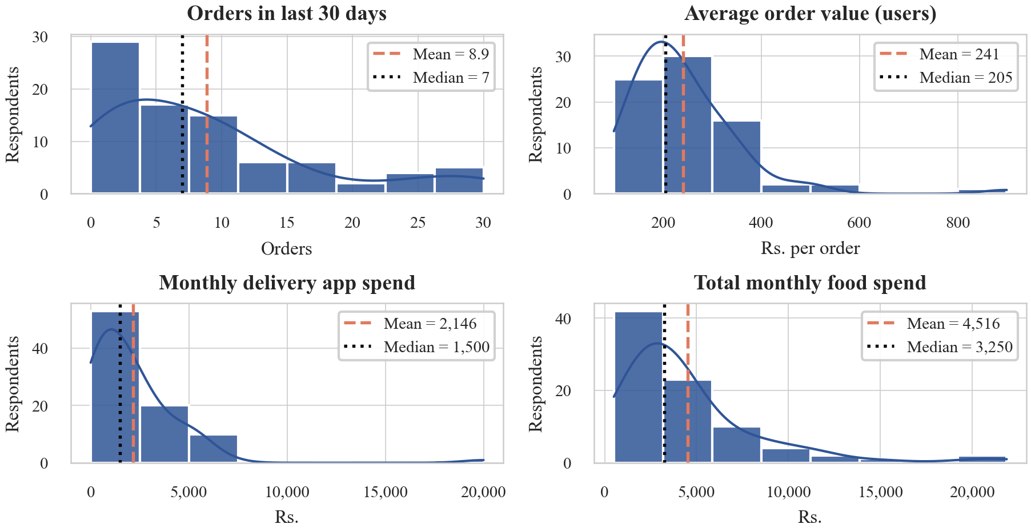
Figure 1: Histograms of the four main variables (average order value only for students who ordered). The dashed line is the mean and the dotted line is the median.
Boxplots (Figure 2). The middle half of students spent between Rs.600 and Rs.3,000 on delivery and between Rs.2,000 and Rs.5,000 on food in total. Using the 1.5 × IQR rule, we found 7 outliers in orders (26 to 30 orders), 1 in average order value (Rs.900), 2 in delivery spending (Rs.6,800 and Rs.20,000) and 8 in total food spending (Rs.10,000 to Rs.21,880). These look like genuine heavy users, so we kept them. They do pull the means up, though. Without them, the mean delivery spending would be Rs.1,872 instead of Rs.2,146 and the mean food spending Rs.3,513 instead of Rs.4,516, while the medians would not change.
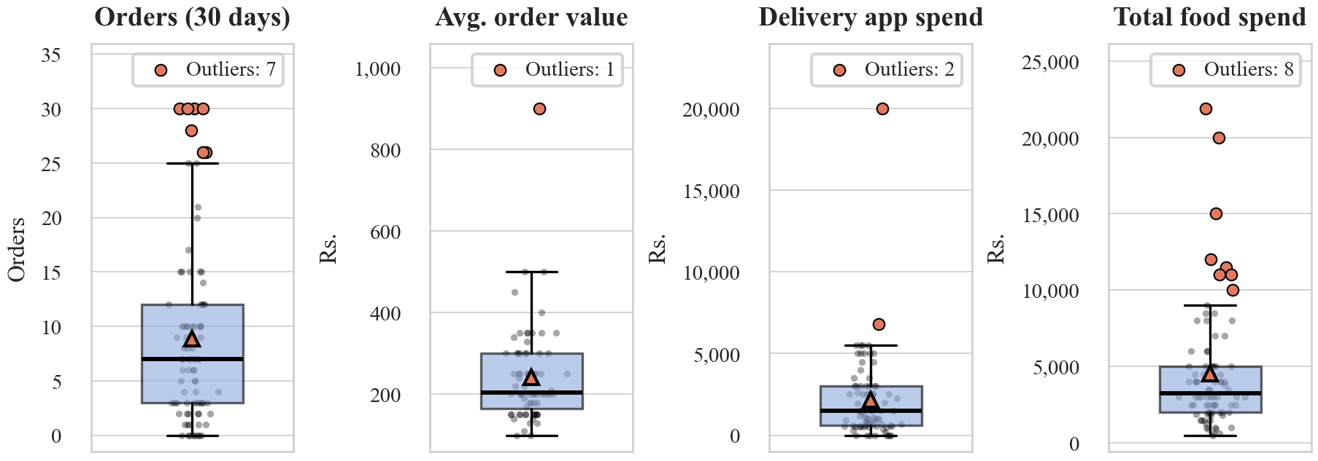
Figure 2: Boxplots of the main variables. Triangles mark the mean and orange points are outliers beyond 1.5 × IQR.
Scatter plots (Figure 3). In both plots the points rise from left to right, which answers our research question most directly. The number of orders has a very strong link with delivery spending (Spearman’s ρ = 0.92, Pearson’s r = 0.76), and each extra order adds about Rs.240 to the monthly delivery bill. It also has a strong link with total food spending (ρ = 0.70, r = 0.61), with about Rs.291 more for every extra order. Pearson’s r comes out lower in both cases because a few extreme points, such as one student with 30 orders and Rs.20,000 of delivery spending, pull the straight line away from the rest. For this reason we rely more on Spearman’s ρ, which works with ranks.
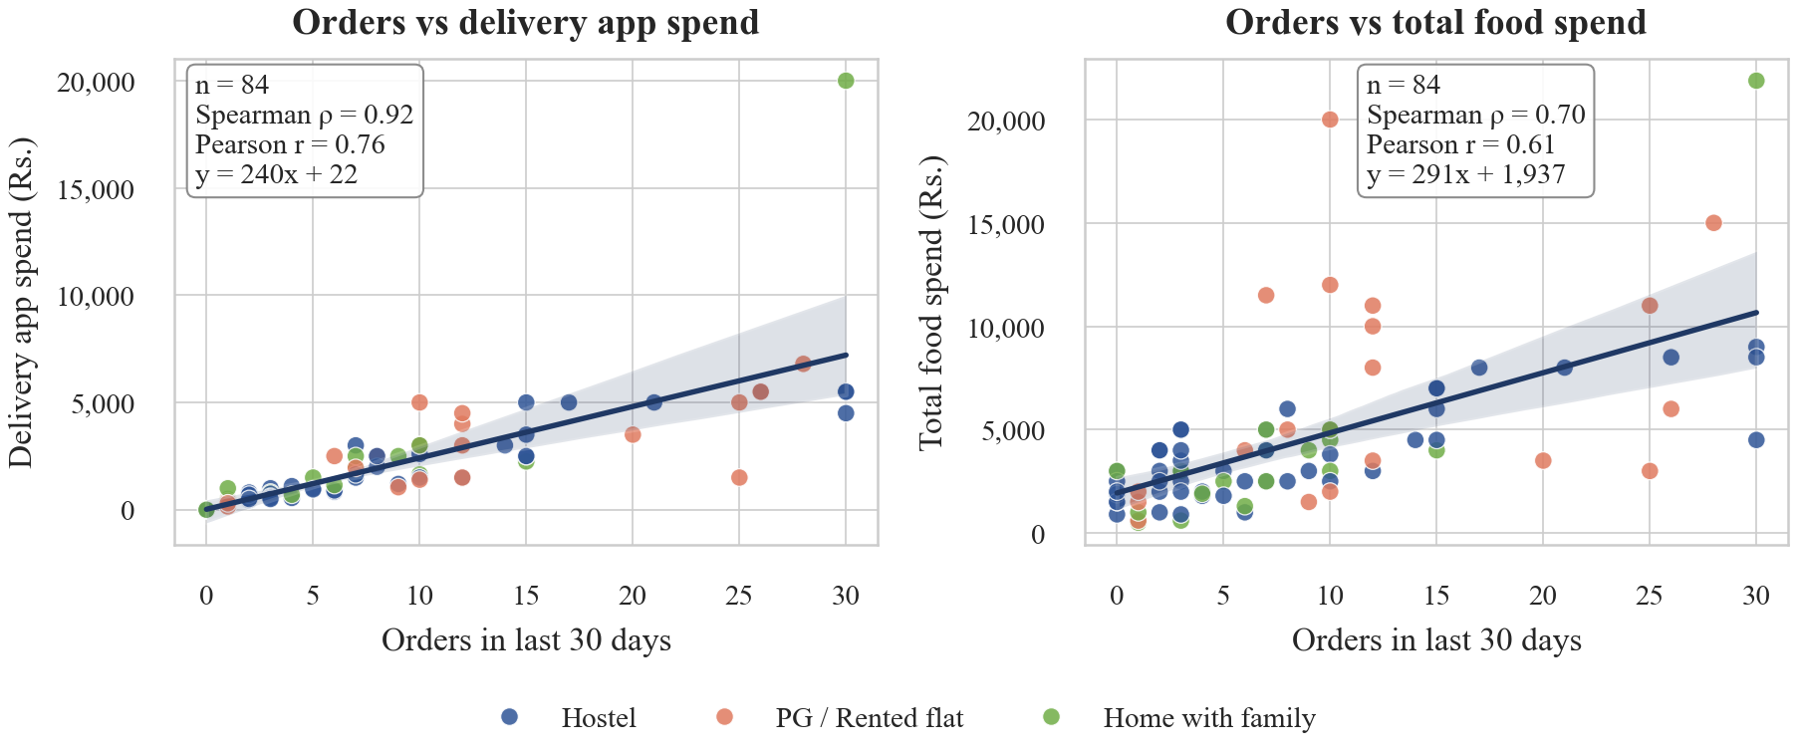
Figure 3: Number of orders against monthly delivery app spending (left) and total food spending (right), coloured by residence, with least squares lines and 95% confidence bands.
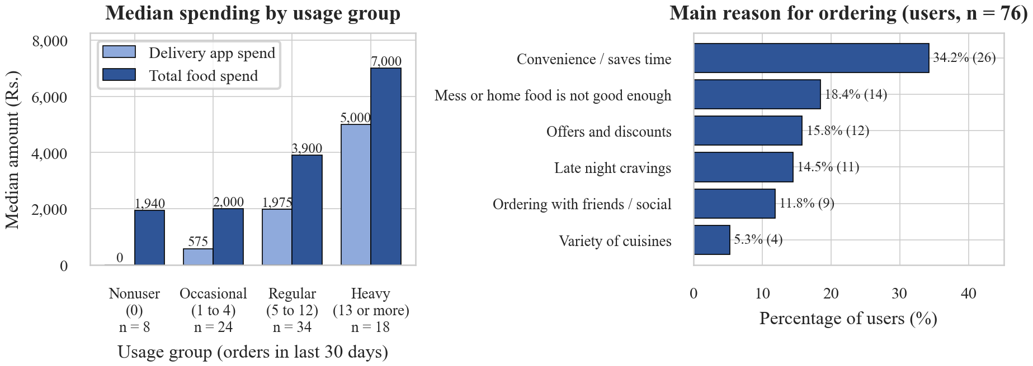
Figure 4: Median monthly delivery app spending and total food spending by usage group (left) and the main reason for ordering among users (right).
Bar charts (Figure 4). The left chart shows that median food spending goes up with every usage group, from Rs.1,940 for nonusers and Rs.2,000 for occasional users to Rs.3,900 for regular users and Rs.7,000 for heavy users. That is 3.6 times the nonuser level. The share of the food budget going to delivery apps also climbs, from 23.5% for occasional users to 63.6% for heavy users. The right chart shows that convenience is the most common reason for ordering (34.2% of users), followed by poor mess or home food (18.4%), offers and discounts (15.8%) and late night cravings (14.5%). Swiggy (81.0% of respondents) and Zomato (63.1%) are the most used apps, 63.1% of students use two or more apps, and dinner is the most common time to order (61.8% of users).

8.3 Observations and Insights
- More orders, more spending. The number of orders is strongly linked to total food spending (ρ = 0.70) and very strongly linked to delivery spending (ρ = 0.92). Heavy users spend 3.6 times as much on food as nonusers.
- How often matters more than how much. The usual price of an order has only a weak link with monthly delivery spending (ρ = 0.17).
- Where students live matters. Students in PGs or rented flats spend the most on delivery (median Rs.2,750) and hostel students the least (Rs.950). We were surprised that students living at home spent more than hostel students (Rs.1,600), and half of them named offers as their main reason (8 of 16). For hostel students, poor mess food was the most common reason (13 of 40). Students with a paid membership also order more often (10.1 orders on average against 7.6).
- Spending more than planned. 36.9% of respondents feel they spend more on delivery than they plan to, and this feeling grows with actual spending (ρ = 0.46). Monthly allowance shows almost no link with delivery spending (ρ = 0.06, n = 50).

9. Conclusion
For our sample, the answer to the research question is yes. Students who order more often through food delivery apps also spend more on food each month. The number of orders is strongly linked to total food spending (ρ = 0.70), and median food spending rises from Rs.1,940 for nonusers to Rs.7,000 for heavy users. A typical student orders about seven times a month and spends around Rs.1,500 on delivery, roughly half of their food budget, mostly at dinner and mostly for convenience.
These results describe our data but do not prove cause and effect, since the sample is mostly third year students, the answers are estimates, and hostel students may have left out prepaid mess fees. In Assignment 2 we will test the relationship using nonparametric tests such as Spearman’s correlation test and the Mann Whitney U or Kruskal Wallis test.

