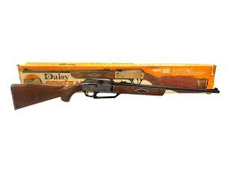I’ve been shooting air rifles since I was five years old. It started with a Daisy model 105 and by 12 I had graduated up to a used Daisy 881. My best friend and I squirrel hunted the local woods for years with those 881s. I can’t count how many squirrels we killed and eat. I always looked forward to getting out of town and using shotguns and 22s to hunt squirrels. Fast forward 30 years (and many squirrels and deer later) I happened to be visiting my Dad at his house. While we were in the backyard he noticed a squirrel raiding the pecan tree and reached in the garage for his Benjamin pellet rifle. That triggered my memories of chasing squirrels with the old 881. That night I went to the local sporting goods store looking for a new air rifle. I found the Winchester 1977XS, I returned to dad’s house the next weekend to visit/squirrel hunt. Dad and I got two squirrels and a rabbit that afternoon. It was a fun day with dad. I live in a rural area where I can use firearms so I left the 1977 in Dad’s garage. The next fall when visiting my parents I reached for the 1977 and it would not hold pressure. I though it was strange given the gun was barely a year old. I put it back and picked up Dad’s Benjamin. Same story, no pressure. I guess the cold and humidity in the garage did the seals in. I took both guns home and ordered rebuild kits. After rebuilding both guns they were ready to hunt again. While rebuilding the 1977 I noticed the similarity to the old 881. That caused me to do more research, there is a large following for the 880 family of guns. I was impressed with the power the 1977 is making and after reading about some of the mods people have done to the 880 I started moding the 1977. I removed the trigger and filled the sear for a better trigger pull. I also removed the flat spring (disclaimer: modifying any gun can cause serious injury or death). I enjoy shooting the 1977 so much now I put my 17 HMR, 22s, and shotguns back in the cabinet and pick up the 1977 for squirrels. I decided to get a second one to make a custom gun (Thanks Honey, best Christmas present ever). I am going to remove the barrel and valve assembly to transplant into a custom made wood stock with carbon fiber barrel shroud, and metal receiver top. For the receiver top I am going to modify a Daisy 853 bridge. I am going to fabricate a metal pump arm, trigger guard, and bolt assembly. I also plan on preforming a power modification on the valve body. The mod is documented by Geo on the [Airgun Universe website](https://www.airgununiverse.net/wp/daisy-880-power-valve-mods/). My goal is to ekk 18 to 20 foot pounds of energy out of it in 177 caliber. Before diving into a long semi-expensive build I wanted to see if my power goals were realistic. I ordered several different pellets of different weights to see how the 1977 would handle the weight. The results were very promising. It kept wanting more. The heaviest pellet I can find is the H&N Pile Driver. Weighing in at 21 grains I was concerned the 1977 wouldn’t have enough pressure and volume to drive a pellet that heavy efficiently. At the time of my testing the Pile Driver was out of stock everywhere I looked. The heaviest pellet I could find in stock was the JSM Beast weighing in at a hefty 16.2 grains. I was hoping the 1977 could push a pellet weighing in at .22 caliber weights but in .177. A .177 caliber pellet will travel much further, have less wind drift, be more accurate, and penetrate deeper than a .22 caliber pellet of the same weight. I have dispatched many animals with a 22 LR and can say a poorly placed shot is not likely to end well. Therefore, I don’t buy into the 22 pellet is a better hunting round strictly due to is diameter. If I can push a 177 with equal energy I would argue the 177 is a better hunting round. Squirrels won’t know the difference when hit in the head or vitals.

Daisy Powerline 881

Winchester 1977XS

Daisy 853 Bridge

To test the 1977 I shot five pellets of each weight in both my rebuilt 1977 and the brand new one. All I did to the new one was put a few drops of [EWL oil](https://slip2000.com/pages/about-ewl-extreme-weapons-lubricant) on the piston. That actually skewed the results from the first pellet weight and made it difficult to pump. Once the oil dissipated the numbers settled and the pumping became easier, although still harder to pump than the rebuilt gun. I believe the rebuilt gun’s pump is not sealing as well as the new gun based on the numbers. It takes one to two more pumps on the rebuilt gun to get 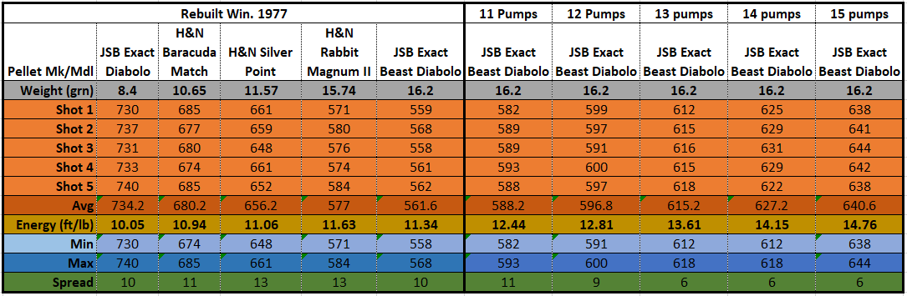the same numbers as the new gun. The test results can be seen below.

The thing that is most impressive with these results is that the energy keeps climbing with pellet weight all the way to the 16.2 grain Beast. I am excited to get my hands on the Pile Drivers. The rebuilt 1977 was able to be “over Pumped” without experiencing valve lock during any of the firings. All other shots were conducted at 10 pumps. The new 1977 was only pumped 10 times for each shot. One interesting observation during testing was the speed difference between the H&N Rabbit Magnum II and the JSB Beast. The Beasts averaged a significantly higher velocity than the Rabbits while being slightly heavier. I believe this is due to the slug like skirtless design of the Rabbits, while the Beasts have a slight skirt. That does make me a little concerned that the Pile Drivers may not be as efficient as the Beasts due to the Pile Drivers boat tail design. The Pile Drivers do have sealing Bands and splines for rifling contact that may help. I am hoping, because I will be very happy if the 1977 can sling a Pile Driver over 600 fps. I anticipate the 1977 being able to push a Pile Driver around 615 fps for close to 18 foot pounds of Energy (FPE). That will take over 10 pumps but I believe it can reliably be done without valve lock on a stock valve body. With porting I believe the 1977 will be getting close to the 20 FPE mark with Beasts or Pile Drivers. That is crazy coming from a gun that can be purchased for $70.

After testing I was excited to hit the woods with the JSB Beasts so I sighted the 1977 in at 20 yards. The Beasts did not disappoint in their accuracy either. Concentrating and taking my time with each shot it was not difficult to touch holes at 20 yards. At 40 yards the scope that comes with the 1977 was extremely difficult to use. The group opened up to 1.5 inches due to each shot being work to focus and locate the bulls eye. The factory trigger on the 1977 is bad, largely due to the stiffer hammer spring. Preforming a trigger job makes a big difference. The 1977 trigger is interchangeable with the Daisy 880. These triggers can be purchased individually at several online venders and ebay. They are just a couple of dollars so I ordered several. Having extra triggers is a good idea when preforming a trigger job, just in case you take off too much material you can scrap that one and try again. I know there is good 40 yard potential with this gun and pellet combo so I ordered a [UTG® 4-16X44 30mm Scope](https://leapers.com/index.php?act=prod_detail&status=best&allids=714&itemno=SCP3-U416AOIEW). There have been some interesting test done on pellet ballistics and it is worth a look. Check out the Beasts ballistics results provide by [HardAirMagazine](https://hardairmagazine.com/ballistic-coefficients/), compared to other pellets the Beast is twice as efficient. I was so excited to test the Beast pellets out on a squirrel I decided to A picture containing ground, stone
walk down to the woods out back to see if a squirrel or two might volunteer as a test subject. It just so happens that two bushy tails volunteered. One was at 25 yards the other at 30. Both were dispatched quickly. These pellets hit very hard. I heard both hits very distinctly, it sounded like hitting a mattress with a ball bat. While shooting the Beasts it was obvious that they are much easier to load than most pellets. Due to their length and balance they roll into the loading slot much better than most. I had very few that tried to rotate or turn when loading.

I realize building a custom gun will cost many times what the donor gun did but I have 35 years with this design and I like it. I could buy a PCP gun for the time and money I will put in a custom 1977 but I prefer variable pumps for their simplicity, all you need is pellets, no tanks, pumps, etc…. its so simple and light. For me it is akin to bow hunting verses gun hunting for deer. Both are fun but there is something special about releasing an arrow and seeing/hearing it strike true on a deer. I get a similar feeling when I squeeze the trigger on the 1977/880 and hear that pellet smack!