RingCentral [RC-Free] Plugin

User Guide



Prepared by: Paladin Business Solutions  
<https://paladin-bs.com>



Plugin Version 1.5.5 (January 2024)  
Documentation Version 2.1 (January 2024)

This is a short guide on how to install and setup your RingCentral [RC-Free] Plugin. There are 2 main areas where this plugin has an effect; the back-end (admin area) and the front-end (public web).

## Plugin Features

The features of this plugin are listed here. Most of these will be discussed in detail throughout this guide.

* RingCentral Embedded Phone app - RingCentral's embedded phone app can be turned on or off and calls can be made from within the WordPress Admin area.
* Call Me Request widget - Feature for adding a Call Me request Widget to the sidebar on the public side of your WordPress installation. This allows Website visitors to call you (using the RingCentral RingOut feature) and if no one is on-line to answer at the time of the call, the request will be stored on the WordPress admin side.
* Newsletter Sign Up widget - Feature for adding a Newsletter (New Blog Post) signup Widget to the sidebar on the public side of your WordPress installation. Asking for either email address or mobile number (or both) as communication points (double opt-in for email and 2FA for Mobile).
* New Newsletter (Blog Post) announcements - Based on configuration settings, you can send out automatic announcements to your collected newsletter list based on their provided (double opt-in or 2FA) contact information: email and / or mobile.
* Manually add subscribers - Feature to manually add to your list of Newsletter (Blog Post) announcement subscribers with contact name, email, and mobile number. The new subscriber will still have to opt-in to the list.
* List / Manage subscribers - Feature to display your existing list of Newsletter (Blog Post) announcement subscribers. You can delete individually or collectively. There is no edit feature as changes will need to be initiated by the subscriber and re-validated via the respective opt-in process.
* List / Manage Call Me Requests - Feature to display your existing list of Call Me requests. You can delete individually or collectively. The list shows caller name, call back number, and reason for the call.
* Default pages are created for you to customize - Default WordPress pages are created upon installation and activation of the plugin. A very basic confirmation of the email opt-in pages is provided. A basic page for confirming email opt-out requests is also provided. Page names are: 'RingCentral Email Confirmation', ' RingCentral Email Unsubscribe'.   
    
  **NOTE:** The permalinks setting must be set to "Post name" in admin => Settings => Permalinks
* New Database tables are created - New tables are created in the database and seeded with basic starting data in order for the plugin to operate correctly. All table names are prefixed by 'ringcentral_' . The plugin drops these tables if the plugin is ever deleted, so be sure to save any data if you ever plan on deleting the plugin and may need the database information in the future.

## Getting the Plugin

You can locate the plugin by searching the plugin area within any WordPress Admin area using the keywords “RingCentral Free” or “RingCentral”. Install and activate the plugin as you would with any other WordPress Plugin.   
  
You can also download the plugin from Paladin’s website and install it manually. The URL for locating and downloading the plugin is: <https://paladin-bs.com/plugins>

## Manually installing the plugin To manually install the plugin you can follow these steps. Once you have located the plugin, simply download and save it to your local system. Next, go to the Plugins => “Add New” page in the admin area and click on the “Upload plugin” button at the top of the page. After this you will be presented with a file browsing dialog. Locate the plugin’s ZIP file you just downloaded called “RingCentral_free.zip, select it, and then click the “Install Now” button shown in Figure 1.

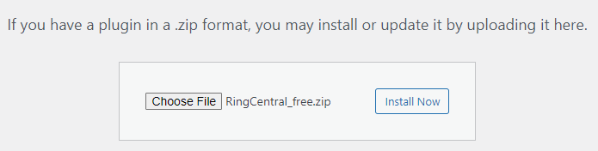

Figure

After installing the plugin be sure to activate it as well.

## The back-end

Once the plugin is installed and activated you should see the new menu item in the admin dashboard as shown in figure 2

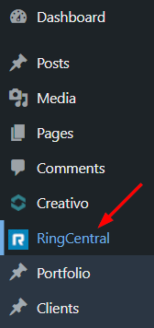

Figure

Clicking that menu item (RingCentral) will take you to the settings page. Here you can set up your connections to the RingCentral platform account that you will need in order to use the plugin. See Appendix A to find out more on what is required.

The Settings page looks like figure 3.

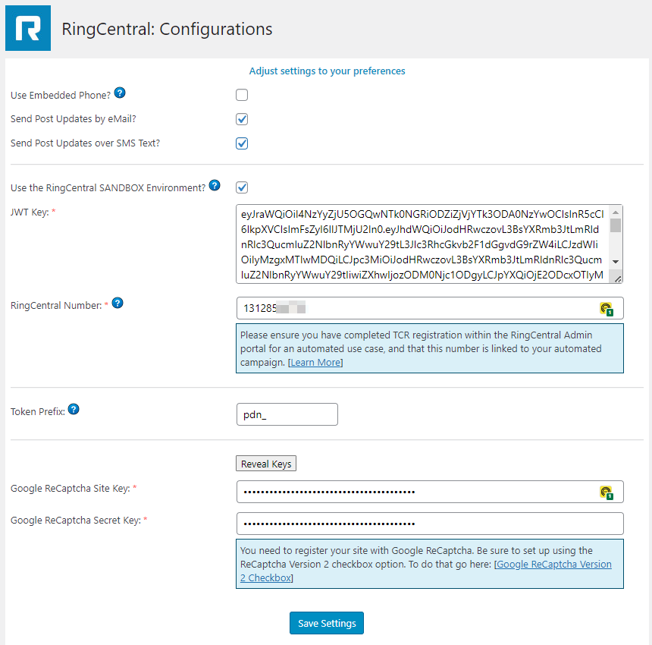

Figure

Here you will enter your RingCentral credentials for either your sandbox account or your production account.

Additionally, you can toggle the generation of emails and / or SMS text messages to your subscribers list and the embedded RingCentral Phone app. Optionally, you can set a token prefix for any generated URLs that are included in your outgoing communication emails. This will allow for a more accurate user opt-in process for email. Be sure to hover over the blue question marks for additional help on the data fields that they are connected to. You can also use the “Reveal Keys” button to temporarily view the Google ReCaptcha keys.

**NOTE:** In order to get proper credentials for this plugin you will have to go to the RingCentral website to create a new developer account (for sandbox use) or a new regular account for live use. Both types of access must come from within a paid account. See Appendix A in this document for more guidance. The JWT key that is being asked for here will be created during that process.   
  
For developer account access go to the following appropriate link to get started:   
  
**LIVE:** <https://ringcentral.com>  
**Developer:** <https://developers.ringcentral.com>

## Subscribers

If you want to add subscribers yourself to the list then you can use the “Add Subscribers” menu option to open a data entry form. It should look like that shown in figure 4.

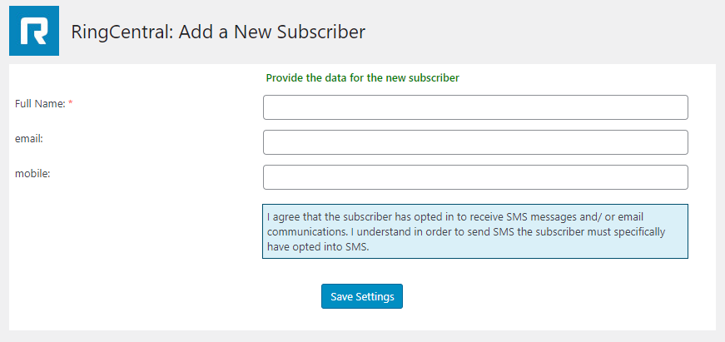

Figure

Here you can add the subscriber’s name and either their email address, mobile phone number, or both. The entered user will still have to opt-in to the list you are adding them to, so their data will not show up as fully active until they indeed opt-in.

The list of all your current subscribers can be accessed by clicking on the “List Subscribers” admin menu option. The subsequent screen should look like figure 5.

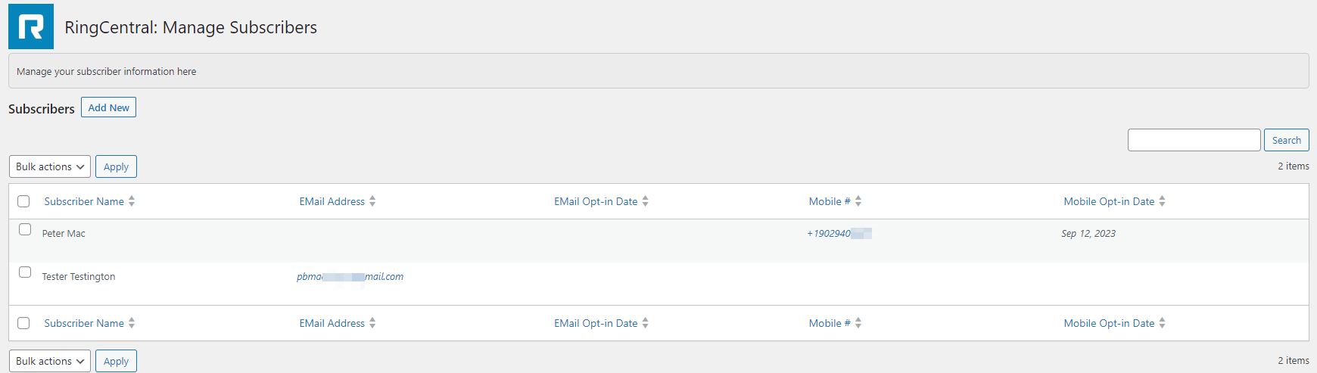

Figure

Here you can see at a glance if and when your subscribers have opted in to a list. The email address for each subscriber is clickable to trigger a new email message via the “mailto” HTML directive, and the phone number for each opted in subscriber is also clickable. This will trigger an attempt to connect to the RingCentral phone app (if it’s turned on) and allows for the creation and sending of an individual SMS text message or actually placing a call to that number as well.

## Widgets

This plugin also provides 2 widgets that you can add to the sidebar of your public website. One of the widgets will allow for website visitors to sign up for your news feed (new blog post) announcements when they are published. The other widget will allow your site visitors to send you a call request that will initiate a phone call to you (if that service is available and you are online at the time of the request). If you are not available at the time of the request the data will be saved to the database for you to view at a later time and alternately you can return the call if desired.

To add a widget to a sidebar, simply select Appearance => widgets from your admin menu. When the page loads you should see a page similar to that of figure 6. You may have to roll down the page to locate these options.

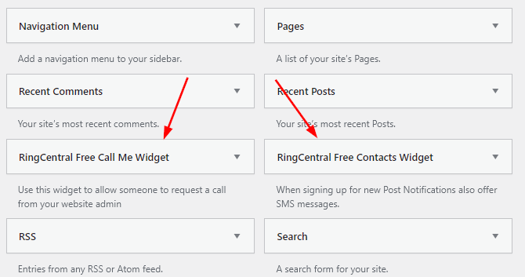

Figure

Select the desired widget and drop it in the desired sidebar area and adjust the title heading if you want. See figure 7 for an example.

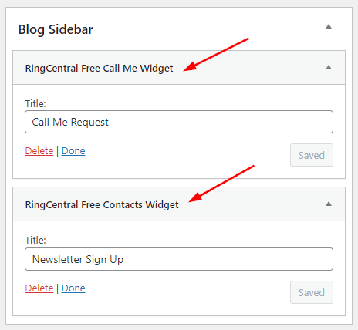

Figure

On the public side of your website your sidebar should look something like figures 8 & 9 with the 2 widgets added. Both widgets will also have the Google ReCaptcha checkbox added to their respective forms if the ReCaptcha keys were properly stored in the admin settings for this plugin.

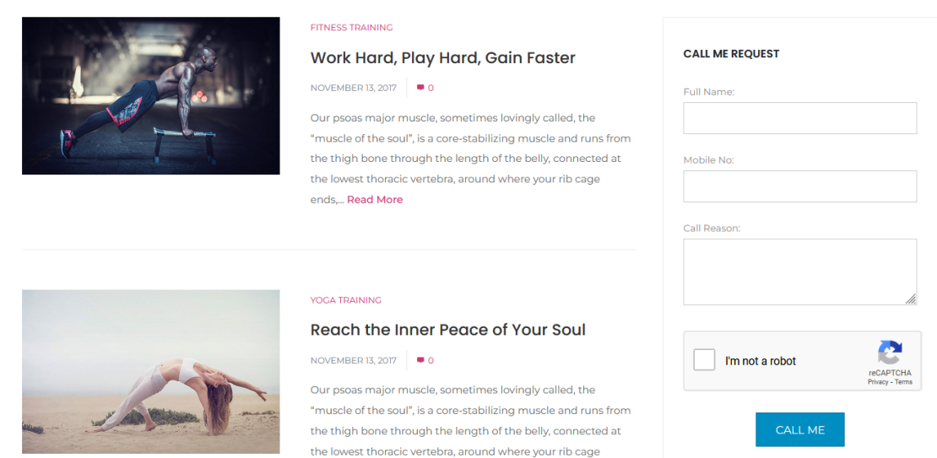

Figure

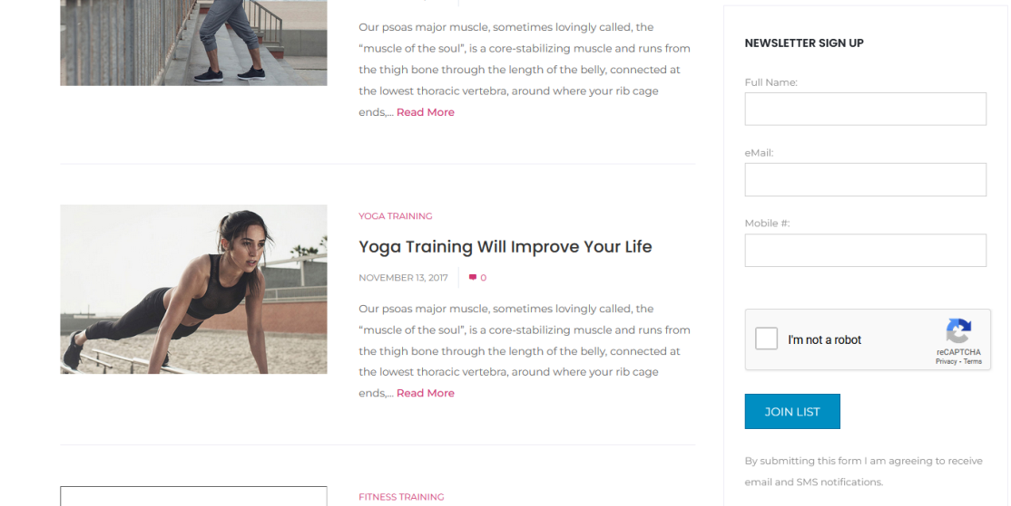

Figure

## Opt-in Process

The plugin creates 2 pages for you during installation and activation. They are for the email Opt-in / Opt-out process.

Email Opt-in process

The first created page is for the email opt-in process. It is a basic confirmation page that can be displayed when a new subscriber completes the 2nd step of the opt-in process. Feel free to edit the text on this page as desired to display a customized welcome message to your newly confirmed subscriber. Be sure not to alter the permalink address. You can find this page in the Admin=> Pages list after the plugin is installed and activated.

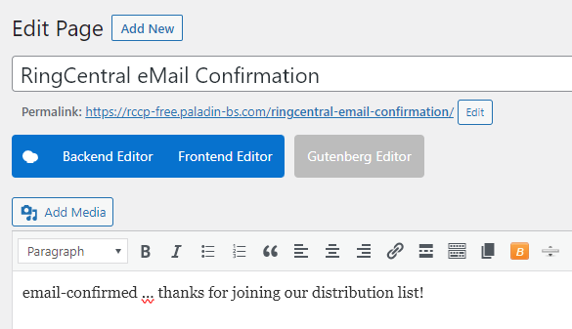

Figure

The second page that goes along with the email aspect of the plugin is that of a confirmation page when a subscriber un-subscribes from your distribution list. It should look something like the image shown in figure 11. Again, you can edit the content of this page as desired, but be sure not to alter the permalink address.

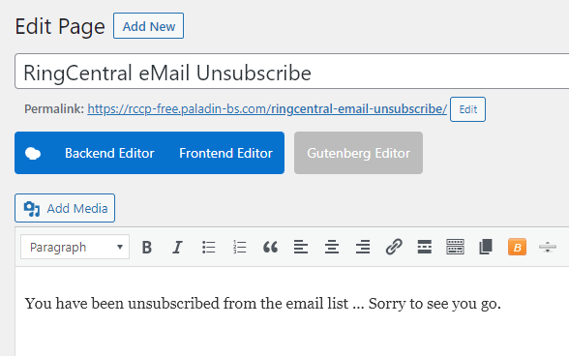

Figure

SMS 2FA process

The processes for opting in / out over SMS are different. Here a client will get an SMS message asking them to reply “START” to confirm the signup process. They can send “STOP” at any time in the future to be removed from the distribution list.

## 2FA for WordPress Users

In this new version of the plugin a higher level of security was added that will allow for 2FA (Two-Factor Authentication) to be used during the admin login process. To add a mobile number to a user account (anyone that would access the admin area of your WordPress site be they administrators, editors, or contributors) access the Users => All Users list on the admin dashboard and select an account to update. Roll to the section of the account profile page to see the area titled: “SMS Two-Factor Authentication Settings”. Check the “Turn on 2FA” box and then enter a valid North American mobile phone number that the selected user has access to. The screen should look like figure 12.

**NOTE:** This feature of sending out SMS messages and reacting to START / STOP messaging depends on the JWT key and the RingCentral number being accurately provided on the configuration screen. Be sure to follow the steps in appendix A before you attempt to start sending SMS messages.

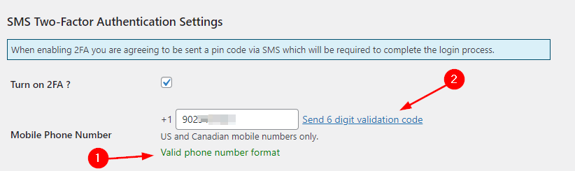

Figure

After you provide a valid phone number and turn on the checkbox a new link appears “Send 6 digit validation code” to the right of the phone number. Click on this link to send a randomized code, 6 digits long, to the provided mobile number. When this is done, the profile page refreshes and a new data entry box appears ready to accept the code. Figure 13 shows this.

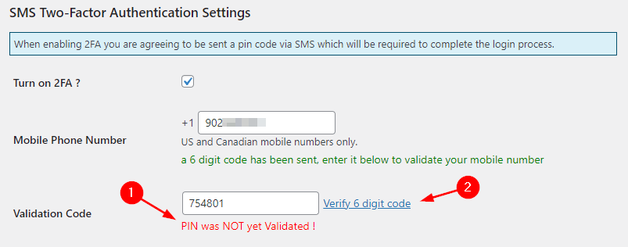

Figure

The warning message “**PIN was NOT yet validated!**” will display until the “Verify 6 digit code” link is clicked and the correct matching number is keyed in. Once the correct matching code is provided the screen will refresh again and the “Entered mobile number has been 2FA validated” message will appear as in figure 14.

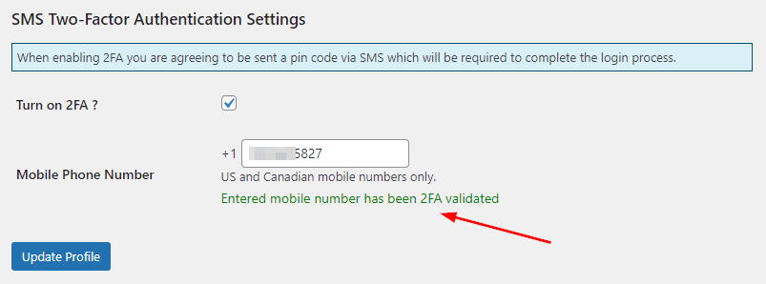

Figure

This is now a user account that will be 2FA tested each time they attempt to login to the admin area of your WordPress site. The challenge screen will look like that shown in figure 15, which will appear after the user provides their username and password credentials.

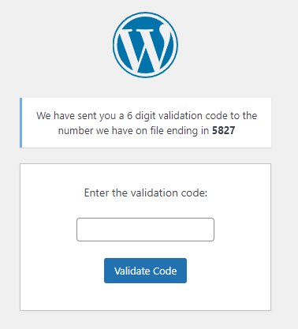

Figure

## Support

For RingCentral specific issues go to: <https://support.ringcentral.com>

For Plugin support or bug reporting contact Paladin Business Solutions here:   
<https://paladin-bs.com/contact>

# APPENDIX “A”

Go to [developers.ringcentral.com](https://developers.ringcentral.com) and select “Sign up” in the top right corner to begin the process of setting up a new developers account.

In the RingCentral Developer platform you can create your JWT Key for use within the WordPress plugin. Once you have signed in to the developer platform simply click on your profile name **[1]** to access the pull-down menu. Click on “Credentials” **[2]** as shown in figure A-1.

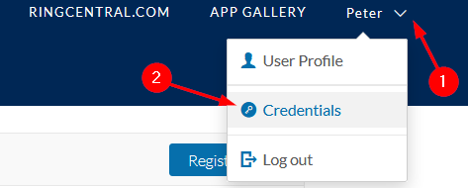

Figure A-1

Once inside the Credentials area you can either update any existing JWT key information or create a new JWT key. To create a new key select the “Create JWT” button and you should see a screen similar to that of figure A-2.

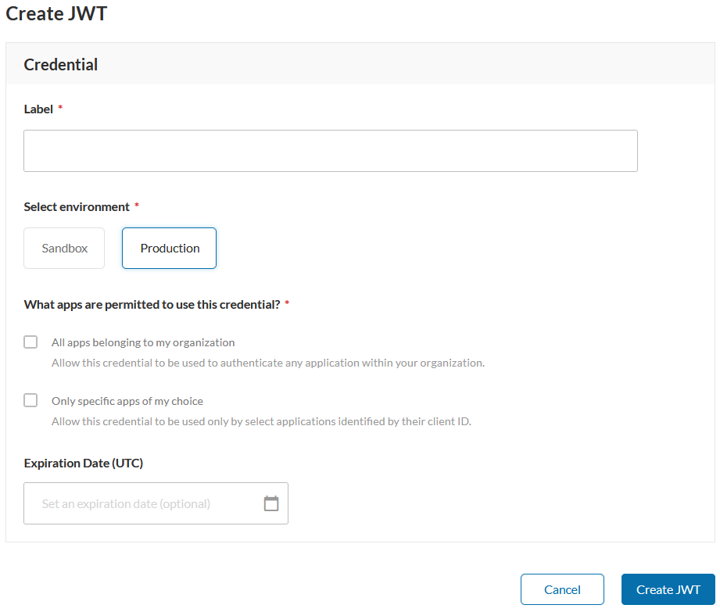  
  
Figure A-2

Here you can give the Key a descriptive label for easy identification going forward; “RingCentral WordPress Plugin” for example. Select the environment where you will be using the key (“Sandbox” or “Production”). If you just setup a developer’s account then Sandbox will be your only option. Production accounts are only granted to paying RingCentral customers. Designate what apps will have access to this key, and finally, set an expiration date on the key if desired. Since you are only creating a JWT key for a specific application, this WordPress Plugin, select the checkbox “Only specific apps of my choice” and provide the Client ID code for the particular app (code provided below). Figure A-3 shows the entering of the Client ID. There is no real reason to enter an expiration date unless you want to manually regenerate the JWT key on a regular basis for added security or you are only setting up the WordPress plugin for a set period of time.

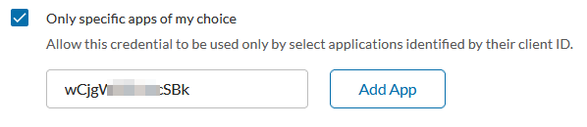  
  
Figure A-3

Below are the correct Client IDs to use within each environment.

|  |  |
| --- | --- |
| **Sandbox Environment Client ID** | **Production Environment Client ID** |
| 2F8P8KXOVj7fk8uKqeLHqX | 1wCjgWSFtUucSBkvWsHuhe |

Copy the appropriate Client ID from the table above and paste it into the JWT creation form. A completed sample for the sandbox environment is shown in Figure A-4.

this is the phone number that you have to put into the plugin settings page for “RingCentral Number”, including the “1” prefix, but not the “+” symbol. Be sure to click the “Add App” button **[1]** to connect the Client ID to this JWT key, and then click “Create JWT” **[2]** to generate the key.

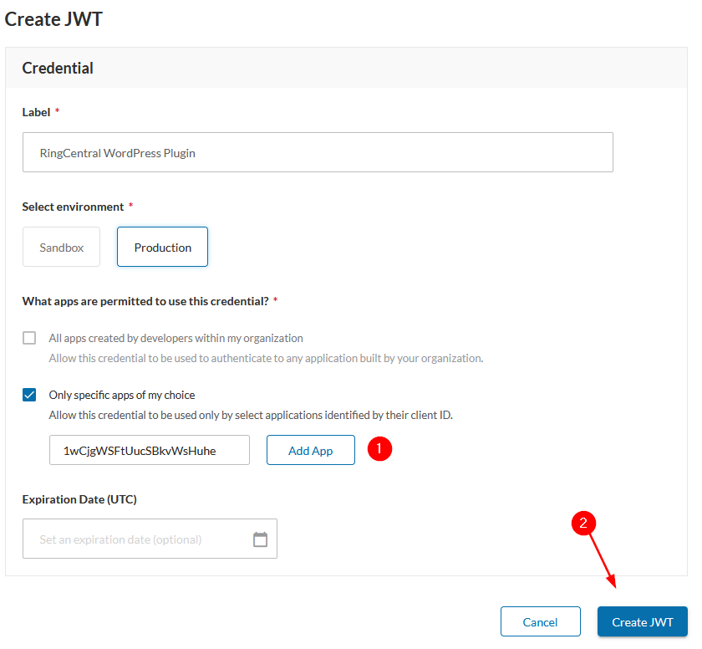   
Figure A-4

The JWT will be generated and you can see it on the list of Keys that have been created.  Click on the label name for the JWT key that you just created to reveal the settings. When the selected JWT key screen is displayed you can select “Click to see” and then click the copy button to copy the full JWT key and paste it into the RingCentral WordPress Settings page in the WordPress Plugin. Figure A-5 shows this for you.

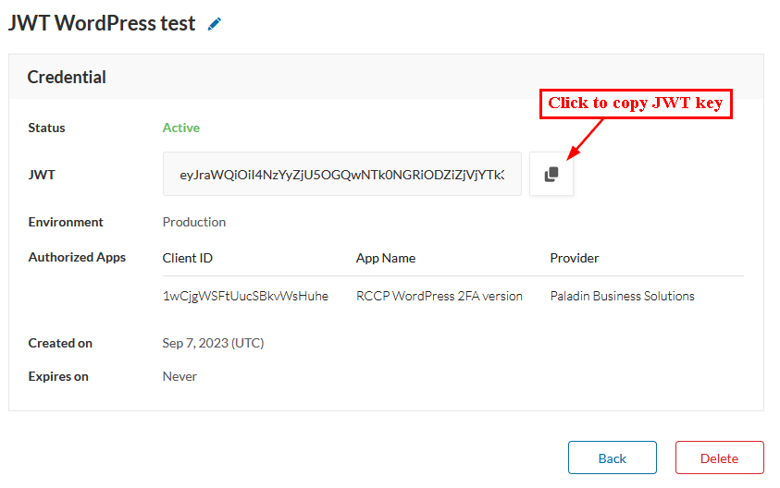

Figure A-5

Once you have the JWT key and the phone number saved into the RingCentral WordPress settings page all the RingCentral specific features like SMS and the embedded phone should be working as expected. Be sure to use the phone number from your developer account that has the ability to send SMS messages. You can verify this with RingCentral developer support.