RingCentral Communications

[RCCP-Free] Plugin

User Guide



Prepared by: Paladin Business Solutions  
<https://paladin-bs.com>



Version 1.0 : April 2019  
Version 1.4.0 : July 2020

This is a short guide on how to install and setup your RingCentral Communications [RCCP-Free] Plugin. There are 2 main areas where this plugin has an effect; the back-end (admin area) and the front-end (public web).

## Plugin Features

The features of this plugin are listed here. Most of these will be discussed in detail throughout this guide.

* RingCentral Embedded Phone app - RingCentral's embedded phone app can be turned on or off and calls can be made from within the WordPress Admin area.
* Call Me Request widget - Feature for adding a Call Me request Widget to the sidebar on the public side of your WordPress installation. This allows Website visitors to call you (using the RingCentral RingOut feature) and if no one is on-line to answer the request will be stored on the admin side.
* Newsletter Sign Up widget - Feature for adding a Newsletter (New Post) signup Widget to the sidebar on the public side of your WordPress installation. Asking for both email address and mobile number as communication points (double opt-in).
* New Newsletter (Post) announcements - Based on configuration settings, you can send out automatic announcements to your collected newsletter list based on their provided (double opt-in) contact information: email and / or mobile.
* Manually add subscribers - Feature to manually add to your list of Newsletter announcement subscribers with name email and mobile number. The new subscriber will still have to opt-in to the list.
* List / Manage subscribers - Feature to display your existing list of Newsletter announcement subscribers. You can delete individually or collectively. No edit feature as changes will need to be initiated by the subscriber and re-validate via the opt-in process.
* List / Manage Call Me Requests - Feature to display your existing list of Call Me requests. You can delete individually or collectively. List shows caller name, phone number to call back, reason for the call.
* Chat / Manage Team Messaging - Feature to display and control the Team Messaging (GLIP) feature of RingCentral’s API. You can embed the chat portion into the admin area or simply connect to the Team Messaging area and post to it via the API.
* Default pages are created for you to customize - Default WordPress pages are created upon activation of the plugin. Very basic confirmation of email and SMS opt-in pages are provided. Basic pages for confirming opt-out request are also provided. Page names are: 'eMail Confirmation', 'eMail Unsubscribe', 'Mobile Confirmation', and 'Mobile Unsubscribe' NOTE: permainks must be set to "Post name"
* New Database tables are created - New tables are created in the database and seeded with basic starting data in order for the plugin to operate correctly. All table names are prefixed by 'ringcentral_'. The plugin drops these tables if the plugin is ever deleted, so be sure to save any data if you ever plan on deleting the plugin.
* Team Messaging (Glip) embedded - Team Messaging (Glip) has been added as an embeddable option with width and height controls.
* Team Messaging (Glip) Messages - Team Messaging (Glip) messages can be posted directly to the stand-alone Messaging interface through the API.

## Getting the Plugin

You can locate the plugin by searching the plugin area within any WordPress Admin area using the keywords “RCCP” or “RingCentral”. Install and activate the plugin as you would with any other WordPress Plugin.   
  
You can also download the plugin from Paladin’s website and install it manually. The URL for locating and downloading the plugin is:

https://paladin-bs.com/plugins/

## Manually installing the plugin As a manual process for installing the plugin you can follow these steps. Once you have located the plugin, simply download and save it to your local system. Next, go to the Plugins => “Add New” page in the admin area and click on the “Upload plugin” button at the top of the page. After this you will be presented with a file browsing dialog. Locate the plugin’s ZIP file you just downloaded, select it, and then click the “Install Now” button shown in Figure 1.

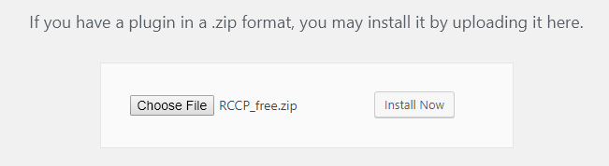

Figure

After installing the plugin be sure to activate it as well.

## The back-end

Once the plugin is installed and activated you should see the new menu item as shown in figure 2

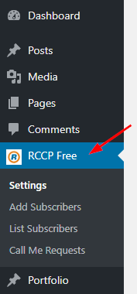

Figure

Clicking that menu item will take you to the settings page. Here you can set up your connections to the RingCentral platform account that you will need in order to use the plugin.

The Settings page looks like figure 3.

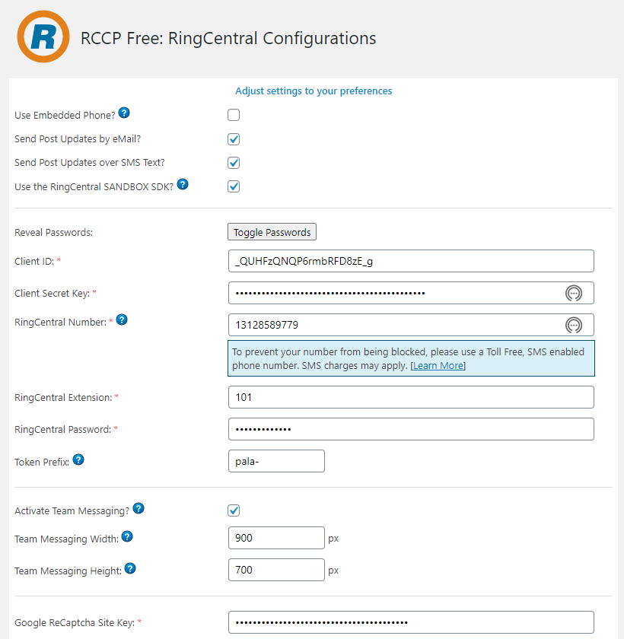

Figure

Here you will enter your RingCentral credentials for either your sandbox account or your production account. Additionally, you can toggle the generation of emails and / or SMS text messages to your subscribers list and the embedded RingCentral Phone app. Optionally, you can set a token prefix for any generated URLs that are included in your outgoing communication. This will allow for a more accurate user opt-in process for both email and SMS text messaging. Be sure to hover over the blue question marks for additional help on the data fields that they are connected to. You can also use the “Toggle Passwords” button to temporarily view the keys or passwords for the Client Secret Key and RingCentral Password fields.

**NOTE:** In order to get proper credentials for this plugin you will have to go to the RingCentral website to create a new developer account (for sandbox use) or a new regular account for live use.  
Go here to get started:   
**LIVE:** <https://ringcentral.com>  
**Developer:** <https://developers.ringcentral.com>

## Subscribers

If you want to add subscribers yourself to the list then you can use the “Add Subscribers” menu option to open the data entry form. It should look like that shown in figure 4.

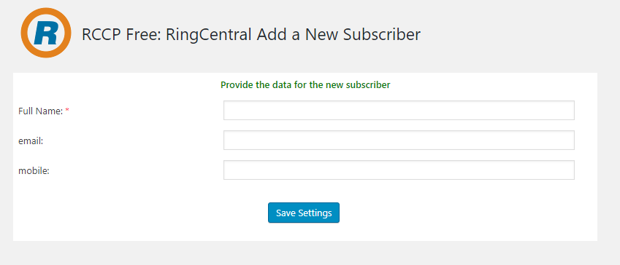

Figure

Here you can add the subscriber’s name and either their email address or mobile phone number or both. The entered user will still have to opt-in to the list you are adding them to, so their data will not show up as fully added until they indeed opt-in.

The list of all your current subscribers can be accessed by clicking on the “List Subscribers” admin menu option. The subsequent screen should look like figure 5.

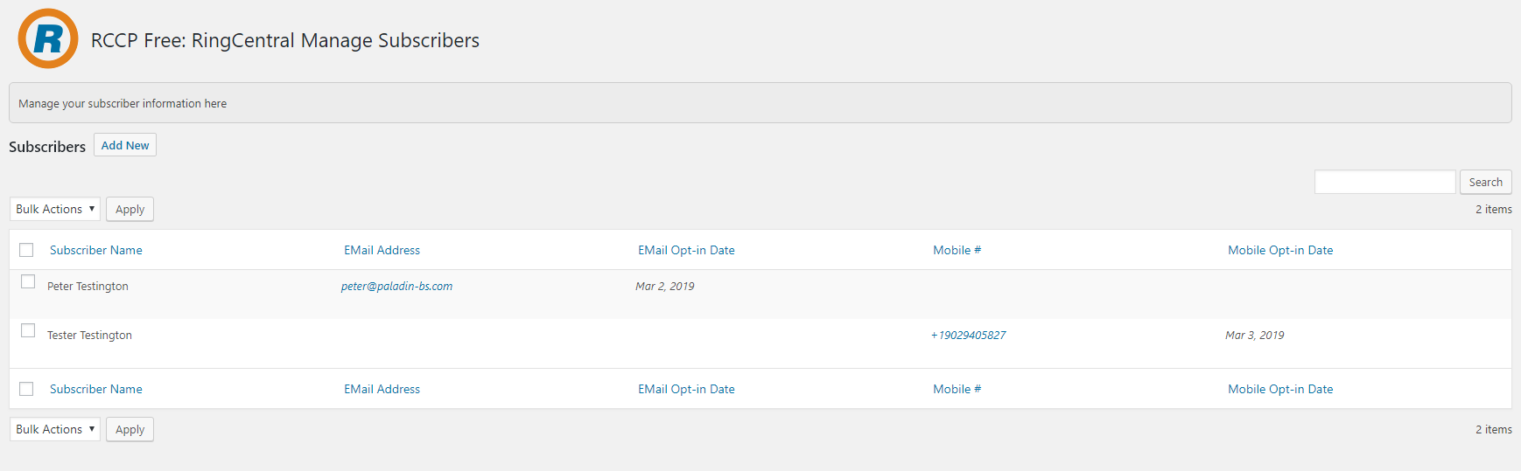

Figure

Here you can see at a glance if and when your subscribers have opted in to a list. The email address for each subscriber is clickable to trigger a new email message via the “mailto” HTML directive, and the phone number for each opted in subscriber is also clickable. This will trigger an attempt to connect to the RingCentral phone app (if it’s turned on) and allows for the creation and sending of an individual SMS text message.

## Widget

This plugin provides 2 widgets that you can add to the side bar of your public website. One of the widgets will allow for website visitors to sign up for your news feed (blog post) announcements when they are published. The other widget will allow your site visitors to send you a call request, that will initiate a phone call to you (if that service is available and you are online at the time of the request) . If you are not available at the time of the request the data will be saved to the database for you to view at a later time and alternately return the call if desired.

To add a widget to a sidebar, simply select Appearance => widgets from your admin menu. When the page loads you should see a page similar to that of figure 6.

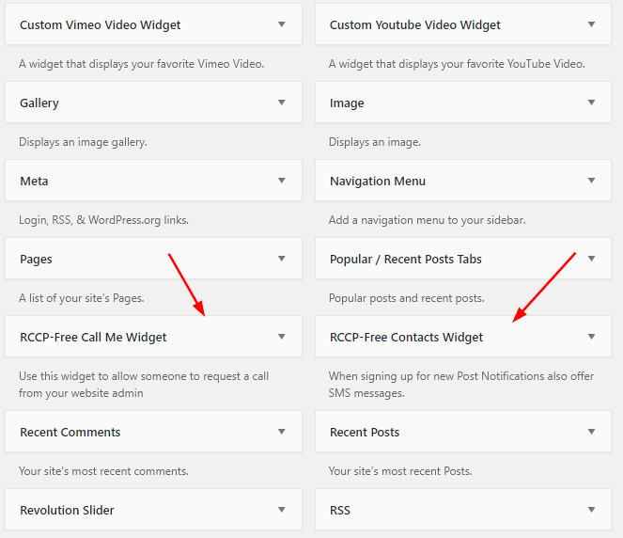

Figure

Select the desired widget and drop it in the desired sidebar area and adjust the title heading if you want. See figure 7 for an example.

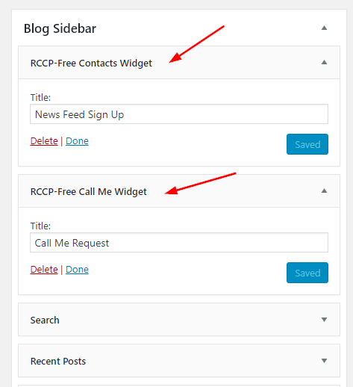

Figure

On the public side of your website your side bar should look something like figures 8 & 9 with the 2 widgets added.

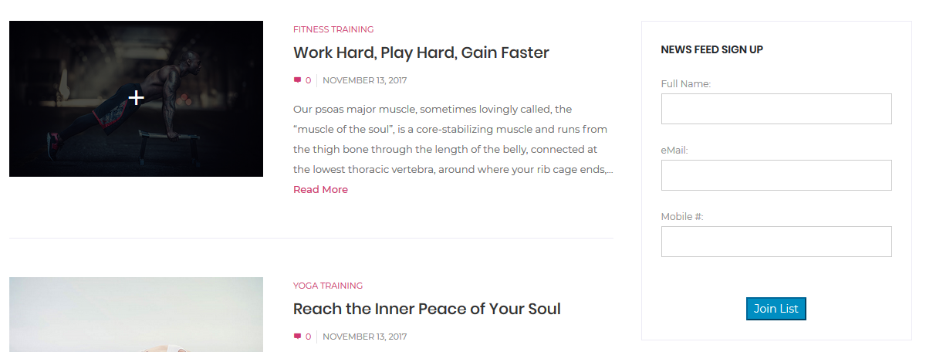

Figure

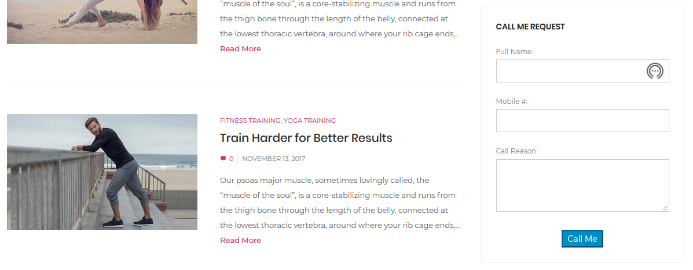

Figure

## Opt-in Process

The plugin creates 4 pages for you upon installation and activation. 2 are for the email process and 2 are for the SMS process.

Email process

The first page that is created is for the email opt-in process. It is a basic confirmation page that can be displayed when a new subscriber completes the 2nd step of the opt-in process. Feel free to edit this page as desired to send a customized welcome message to your newly confirmed subscriber.

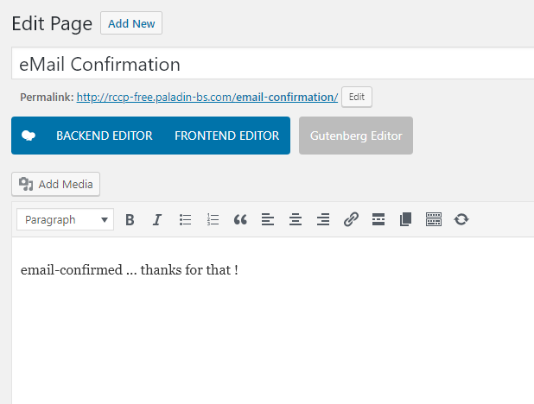

Figure

The second page that goes along with the email aspect of the plugin is that of a confirmation page when a subscriber un-subscribes from your list. It should look something like the image shown in figure 11.

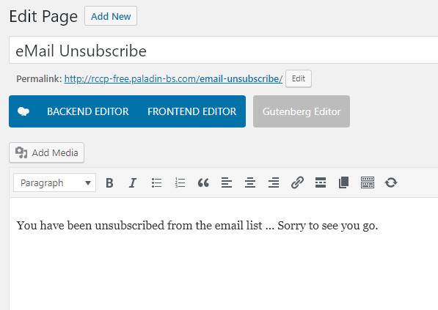

Figure

SMS text process

The same 2 processes and therefore pages are available for the SMS texting aspect of the subscribers list. Figure 12 shows the welcome page and figure 13 shows the un-subscribe message that the departing subscriber would see.

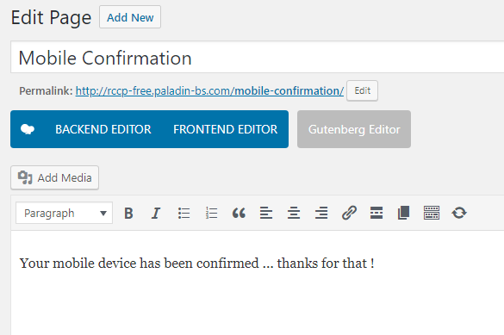

Figure

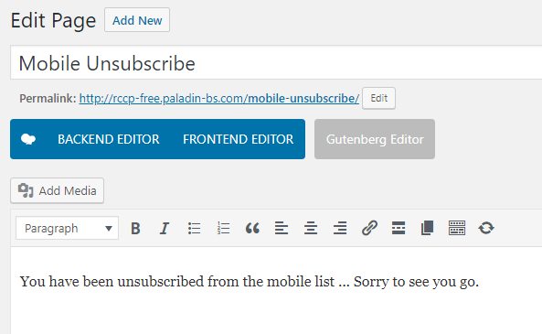

Figure

## Team Messaging (Glip) features

New to version 1.4.0 is the inclusion of Team Messaging (Glip) features. These can be turned on / off on the settings page, see figure 3 above.

The first part of the Team Messaging portion of this plugin is accessed by the RCCP Free->Send a Team Message menu option. The following screen (figure 14) should appear:

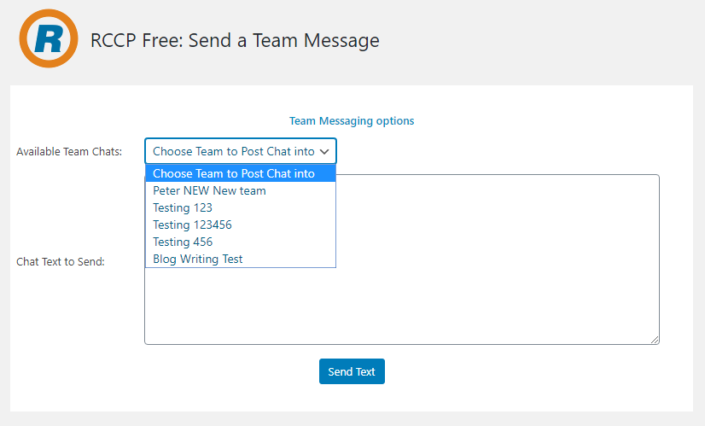

Figure

Here the RingCentral API is directed to connect to the Team Messaging tool and return all the group chats that the current user has access to. These are then listed in the Available Team Chats drop down list. The chat area is then used to type in your desired message and then the text message can be sent to the selected team chat.

The next feature of the Team Messaging additional features can be reached with the RCCP Free->Embedded Team Messaging menu option. This page should look similar to that shown in figure 15.

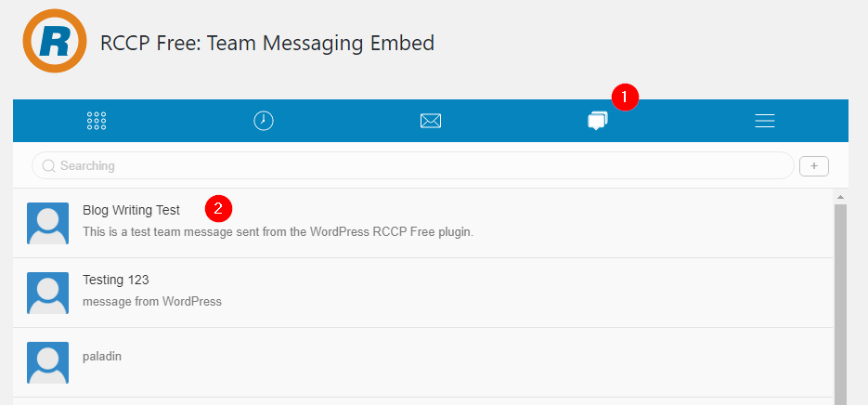

Figure

Here you can directly interface with any of the account’s active team chats. With the Team Messaging area selected (1) you can then directly type in your chat text, send the text, and view any chat text posted by other members of that Team Chat. You can set the pixel width and height for the embedded chat box for the Team Messaging interface on the settings page, see figure 3 above.

## Support

For RingCentral specific issues go to: <https://support.ringcentral.com>

For Plugin support or bug reporting contact Paladin Business Solutions here:   
<https://paladin-bs.com/contact>

## Pro Version

The professional version of this plugin has the following additional features:

* Customization of newsletter opt-in email and SMS messages
* Once a month purge [customizable time frame] of non-opted in email & SMS contacts
* Customization of newsletter announcement email and SMS messages
* Ability to send individual or group SMS messages from WP-Admin
* Ability to book RingCentral group meetings from WP-Admin
* Ability to send Faxes from WP-Admin
* Ability to listen to RingCentral voice messages
* Ability to send SMS to admin when a new voice message arrives
* Short code [RC-Newsletter] for Newsletter signup
* Short code [RC-CallMe] for Call Me request
* Click-to-call feature on Call Me requests list for call back from WP-Admin
* Google reCaptcha V2 Checkbox on Newsletter signup forms
* Google reCaptcha V2 Checkbox on Call Me request forms

You can purchase the Pro version here: <https://paladin-bs.com/plugins>