# Running the application

1. Set WebApi as Start up Project

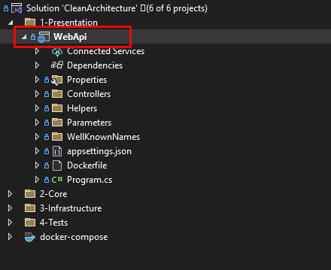

1. Select docker-compose from launch setting selector

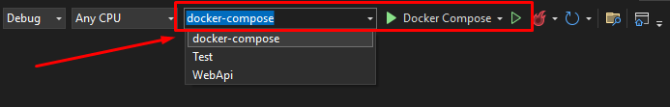

1. Run the application normally (ctrl + f5). In Docker desktop application you can see the application running inside containers

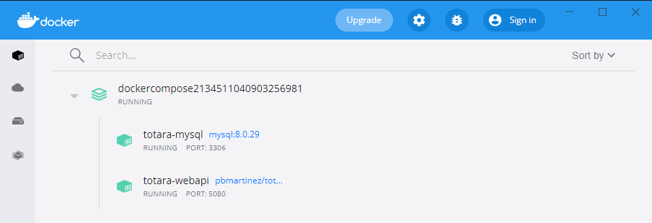

1. Application link <http://localhost:5080/swagger/index.html> to see swagger in action.

# Running tests

For running integration tests specify local connection string in appsettings.Testing.json. Therefore, you must provide a database where test will be run against which is independent from development or production database.

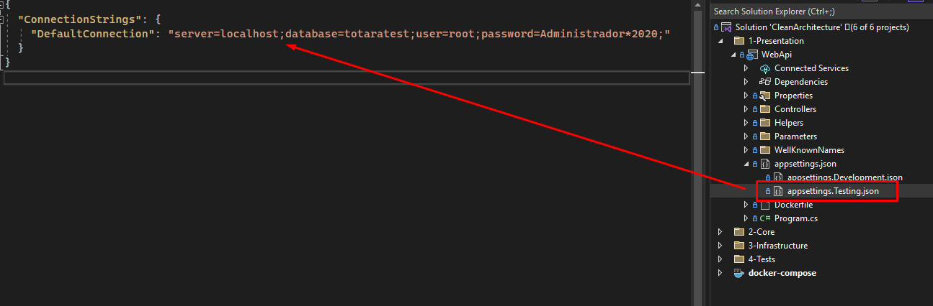

# Migrations

There is no need to run migrations manually. Application at start up runs pending migrations.

1. In Package Manager Console, select Infrastructure as default project

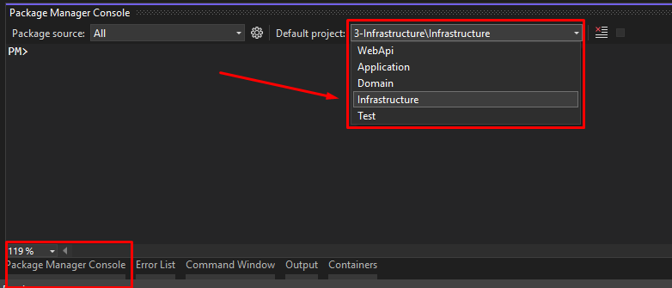

1. Add new migrations as follows

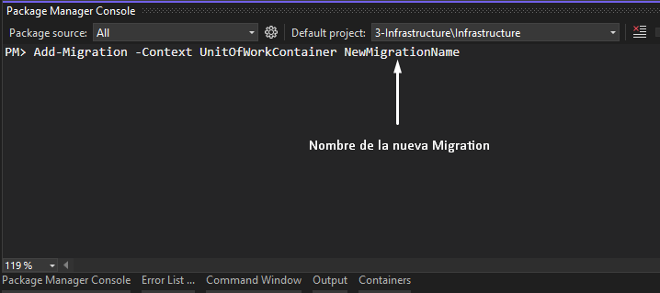

1. Check new migrations in place

