Polar Air Website Customization Questionnaire
Prepared to help customize the website mockup before launch.
Use this document to collect the owner details needed to customize the Polar Air website and social media mockup.
Instructions for the owner:
- Please answer directly under each question.
- If the mockup wording/design should stay as shown, write "Keep as shown."
- If a number or claim is not verified yet, write "Need to verify."
- Please attach any logo files, team photos, truck photos, jobsite photos, certificates, license information, reviews, or brand assets you want used.

1. Business Name, Logo, and Brand Identity
Screenshot: Logo choices shown in the mockup

Use this screenshot to see which part of the website the questions below will customize.
What this affects: the logo picker, website header logo, hero logo, footer branding, and social profile images.
1. What is the exact legal business name that should appear on the website?
Answer:
______________________________________________________________________________________
______________________________________________________________________________________
2. Is the customer-facing name "Polar Air Express," "Polar Air Solutions," or something else?
Answer:
______________________________________________________________________________________
______________________________________________________________________________________
3. Which logo option from the mockup do you prefer: Option 1, Option 2, Option 3, or Option 4?
Answer:
______________________________________________________________________________________
______________________________________________________________________________________
4. Do you already have a final logo file? If yes, please provide PNG, SVG, PDF, or AI files.
Answer:
______________________________________________________________________________________
______________________________________________________________________________________
5. Are there specific brand colors we should use or avoid?
Answer:
______________________________________________________________________________________
______________________________________________________________________________________
6. Do you have a tagline or slogan you want used?
Answer:
______________________________________________________________________________________
______________________________________________________________________________________
7. Should the brand feel more premium, family-owned/local, fast emergency-service focused, budget-friendly, or commercial/professional?
Answer:
______________________________________________________________________________________
______________________________________________________________________________________
8. Are there any words, claims, or design styles you do not want associated with the business?
Answer:
______________________________________________________________________________________
______________________________________________________________________________________

2. Header, Contact Information, and Navigation
Screenshot: Header, navigation, and hero section
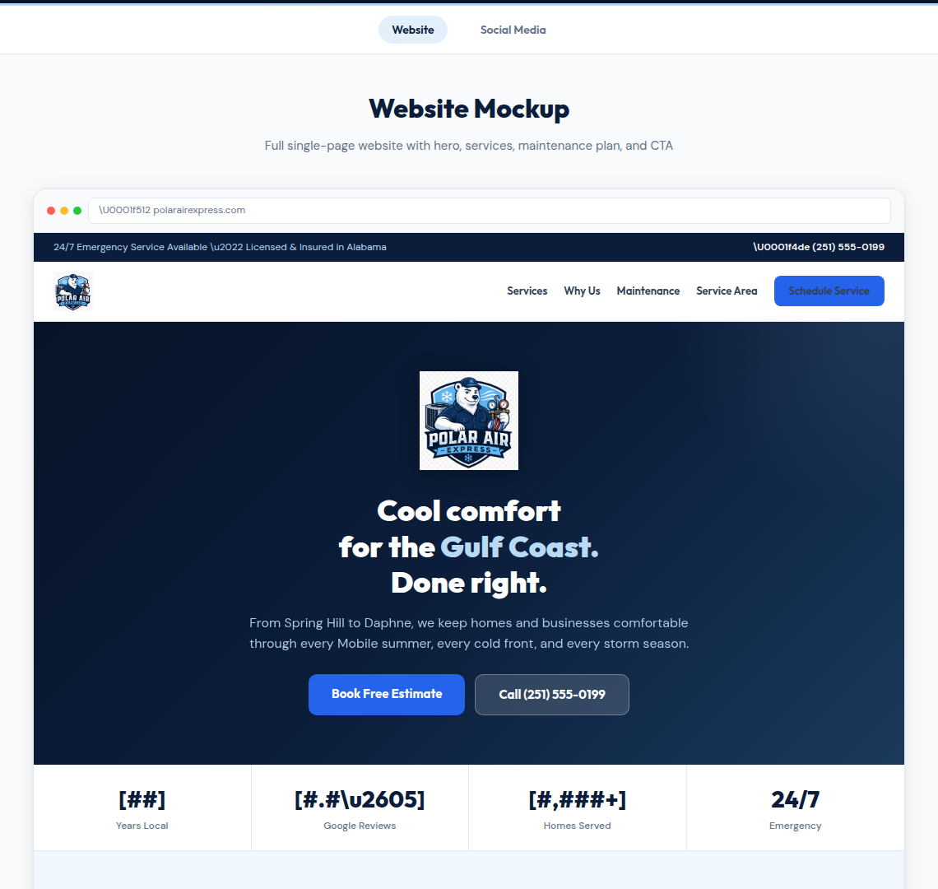
Use this screenshot to see which part of the website the questions below will customize.
What this affects: the top blue announcement bar, phone number, navigation links, and "Schedule Service" button.
1. What phone number should appear on the website?
Answer:
______________________________________________________________________________________
______________________________________________________________________________________
2. What email address should customers use?
Answer:
______________________________________________________________________________________
______________________________________________________________________________________
3. What physical address or service-area location should appear, if any?
Answer:
______________________________________________________________________________________
______________________________________________________________________________________
4. What are your normal business hours?
Answer:
______________________________________________________________________________________
______________________________________________________________________________________
5. Do you truly offer 24/7 emergency service? If yes, are there limits, after-hours fees, or specific emergency criteria?
Answer:
______________________________________________________________________________________
______________________________________________________________________________________
6. Are you licensed and insured in Alabama? Please provide the exact license number and wording we are allowed to publish.
Answer:
______________________________________________________________________________________
______________________________________________________________________________________
7. Which navigation links do you want in the main menu? Current mockup links are Services, Why Us, Maintenance, and Service Area.
Answer:
______________________________________________________________________________________
______________________________________________________________________________________
8. What should the main header button say: Schedule Service, Book Now, Request Estimate, Call Now, or something else?
Answer:
______________________________________________________________________________________
______________________________________________________________________________________
9. Where should that button send visitors: phone call, contact form, booking calendar, text message, or another link?
Answer:
______________________________________________________________________________________
______________________________________________________________________________________

3. Hero Section and Main Message
Screenshot: Header, navigation, and hero section

Use this screenshot to see which part of the website the questions below will customize.
What this affects: the first impression, main headline, subheadline, service area wording, and primary calls to action.
1. Does the headline "Cool comfort for the Gulf Coast. Done right." fit the business, or should it be rewritten?
Answer:
______________________________________________________________________________________
______________________________________________________________________________________
2. What is the most important message you want customers to understand in the first 5 seconds?
Answer:
______________________________________________________________________________________
______________________________________________________________________________________
3. Which locations should be named in the intro text? Current mockup mentions Spring Hill, Daphne, Mobile summers, cold fronts, and storm season.
Answer:
______________________________________________________________________________________
______________________________________________________________________________________
4. Should the homepage focus mainly on residential customers, commercial customers, property managers, or a mix?
Answer:
______________________________________________________________________________________
______________________________________________________________________________________
5. Do you offer free estimates, free diagnostics, second opinions, or paid diagnostic visits?
Answer:
______________________________________________________________________________________
______________________________________________________________________________________
6. What should the main buttons say? Current mockup uses "Book Free Estimate" and "Call (251) 555-0199."
Answer:
______________________________________________________________________________________
______________________________________________________________________________________
7. Should the hero include real photos of the owner, technicians, trucks, equipment, or completed installs?
Answer:
______________________________________________________________________________________
______________________________________________________________________________________
8. What makes your company different from other HVAC companies in the Mobile area?
Answer:
______________________________________________________________________________________
______________________________________________________________________________________

4. Trust Stats, Reviews, and Proof
Screenshot: Trust stats and service cards
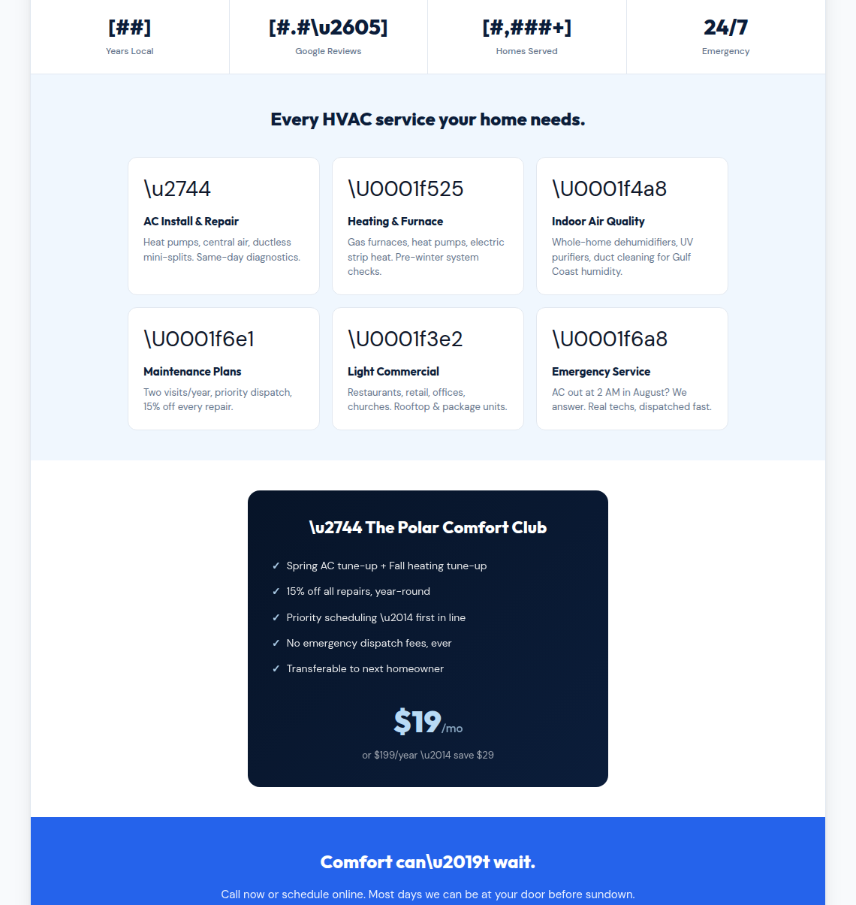
Use this screenshot to see which part of the website the questions below will customize.
What this affects: the statistic row below the hero, trust claims, review/rating claims, and credibility messaging.
1. How many years has the business served the local area?
Answer:
______________________________________________________________________________________
______________________________________________________________________________________
2. What year was the company founded?
Answer:
______________________________________________________________________________________
______________________________________________________________________________________
3. What is your current Google rating?
Answer:
______________________________________________________________________________________
______________________________________________________________________________________
4. How many Google reviews do you currently have?
Answer:
______________________________________________________________________________________
______________________________________________________________________________________
5. Approximately how many homes or customers have you served? Only include a number we can support.
Answer:
______________________________________________________________________________________
______________________________________________________________________________________
6. Are there any certifications, awards, memberships, manufacturer partnerships, BBB details, or financing partners we should show?
Answer:
______________________________________________________________________________________
______________________________________________________________________________________
7. Do you have customer testimonials we can use? Please provide the text, customer name/initials, city, and permission status.
Answer:
______________________________________________________________________________________
______________________________________________________________________________________
8. Are there any guarantees or promises we can safely publish, such as workmanship warranty, satisfaction guarantee, no-pressure estimates, or flat-rate pricing?
Answer:
______________________________________________________________________________________
______________________________________________________________________________________

5. Services Offered
Screenshot: Trust stats and service cards

Use this screenshot to see which part of the website the questions below will customize.
What this affects: the service cards for AC, heating, indoor air quality, maintenance plans, light commercial, and emergency service.
1. Which of these services do you currently offer?
- AC install and repair
- Heat pumps
- Central air
- Ductless mini-splits
- Heating and furnace service
- Indoor air quality
- Whole-home dehumidifiers
- UV purifiers
- Duct cleaning
- Maintenance plans
- Light commercial HVAC
- Emergency service
- Other:
Answer:
______________________________________________________________________________________
______________________________________________________________________________________
2. Are there any services listed in the mockup that should be removed?
Answer:
______________________________________________________________________________________
______________________________________________________________________________________
3. Are there services missing from the mockup that should be added?
Answer:
______________________________________________________________________________________
______________________________________________________________________________________
4. Which brands or systems do you install, service, or prefer?
Answer:
______________________________________________________________________________________
______________________________________________________________________________________
5. Do you service both residential and commercial equipment? If commercial, what types of businesses or equipment?
Answer:
______________________________________________________________________________________
______________________________________________________________________________________
6. What are the most profitable or highest-priority services we should emphasize?
Answer:
______________________________________________________________________________________
______________________________________________________________________________________
7. Are there service limits, counties, cities, brands, or equipment types you do not work on?
Answer:
______________________________________________________________________________________
______________________________________________________________________________________
8. What wording should we use for emergency service?
Answer:
______________________________________________________________________________________
______________________________________________________________________________________

6. Maintenance Plan / Comfort Club
Screenshot: Maintenance plan, final CTA, and footer
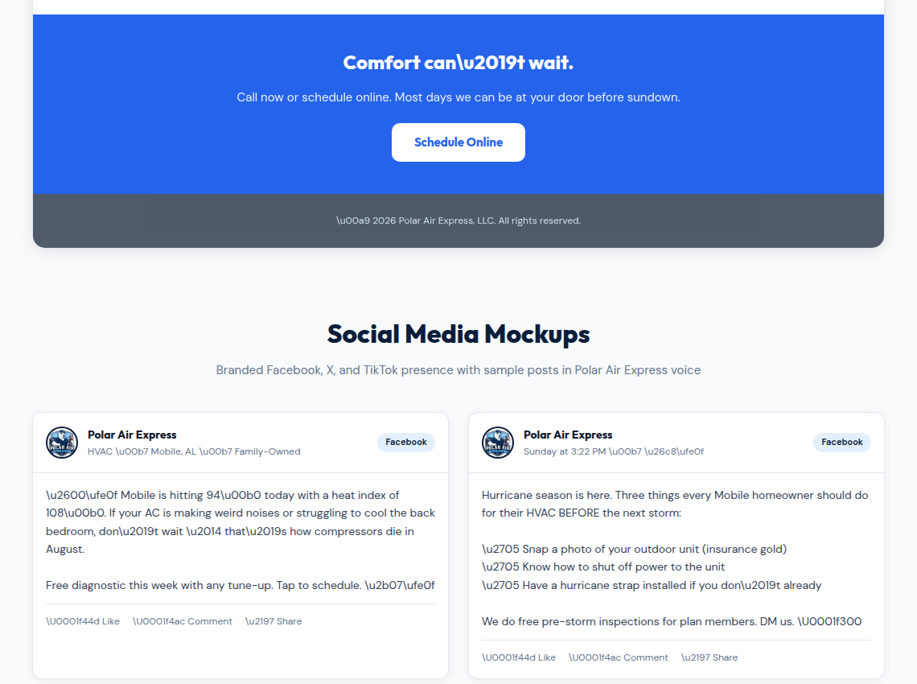
Use this screenshot to see which part of the website the questions below will customize.
What this affects: the "Polar Comfort Club" section, membership benefits, pricing, and maintenance-plan sales copy.
1. Do you want to offer a maintenance club on the website?
Answer:
______________________________________________________________________________________
______________________________________________________________________________________
2. What should the maintenance plan be called?
Answer:
______________________________________________________________________________________
______________________________________________________________________________________
3. How many tune-ups are included each year?
Answer:
______________________________________________________________________________________
______________________________________________________________________________________
4. What benefits are included? Current mockup shows 15% off repairs, priority scheduling, no emergency dispatch fees, and transferability.
Answer:
______________________________________________________________________________________
______________________________________________________________________________________
5. What should the monthly price be?
Answer:
______________________________________________________________________________________
______________________________________________________________________________________
6. What should the annual price be?
Answer:
______________________________________________________________________________________
______________________________________________________________________________________
7. Are there terms, exclusions, cancellation rules, or equipment limits we need to mention?
Answer:
______________________________________________________________________________________
______________________________________________________________________________________
8. Should plan members receive storm-season inspections, filter reminders, priority emergency response, or other perks?
Answer:
______________________________________________________________________________________
______________________________________________________________________________________

7. Calls to Action, Scheduling, and Footer Details
Screenshot: Maintenance plan, final CTA, and footer

Use this screenshot to see which part of the website the questions below will customize.
What this affects: the final "Comfort can't wait" call-to-action, scheduling flow, footer text, legal details, and contact paths.
1. What is the preferred action for website visitors: call, text, submit a form, book online, request an estimate, or finance a new system?
Answer:
______________________________________________________________________________________
______________________________________________________________________________________
2. Do you have an online booking system, CRM form, ServiceTitan, Housecall Pro, Jobber, Calendly, or another scheduling link?
Answer:
______________________________________________________________________________________
______________________________________________________________________________________
3. What fields should the contact form collect?
Answer:
______________________________________________________________________________________
______________________________________________________________________________________
4. Do you want customers to upload photos or videos of their HVAC issue?
Answer:
______________________________________________________________________________________
______________________________________________________________________________________
5. What should happen after someone submits a form?
Answer:
______________________________________________________________________________________
______________________________________________________________________________________
6. What footer details should appear: license number, address, phone, email, hours, financing, service area, privacy policy, or social links?
Answer:
______________________________________________________________________________________
______________________________________________________________________________________
7. Are there legal disclaimers, financing disclaimers, warranty details, or offer expiration dates we must include?
Answer:
______________________________________________________________________________________
______________________________________________________________________________________

8. Social Media Profiles and Content Voice
Screenshot: Facebook and X/Twitter social post examples
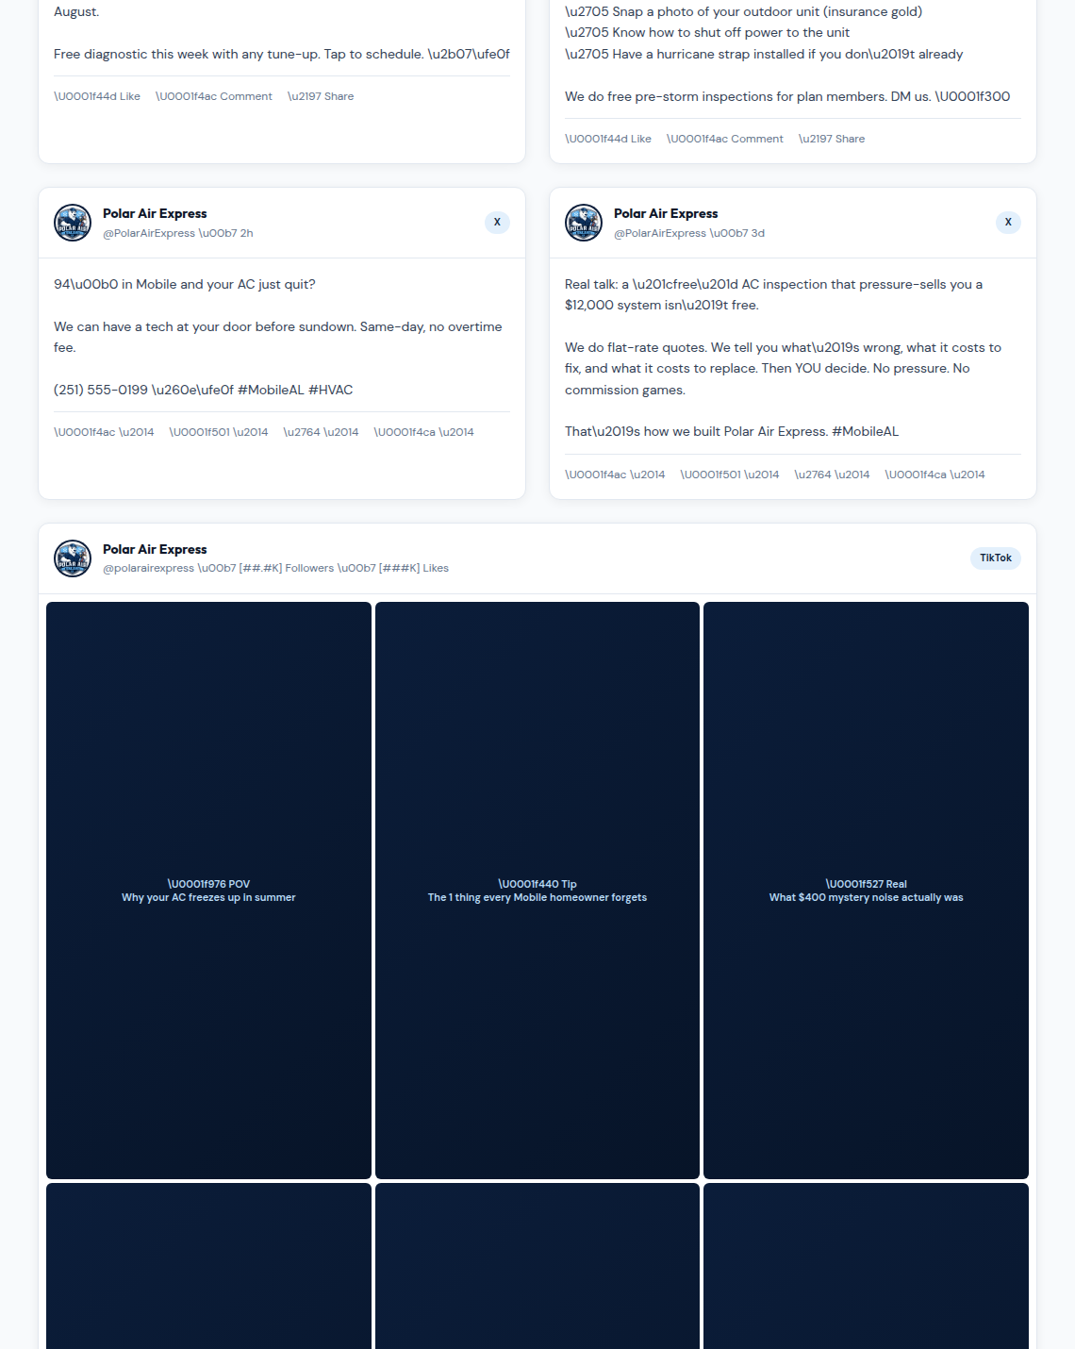
Use this screenshot to see which part of the website the questions below will customize.
What this affects: Facebook, X/Twitter, and TikTok mockups; social profile names; sample posts; tone of voice; and content strategy.
1. Which social platforms do you actively use today?
Answer:
______________________________________________________________________________________
______________________________________________________________________________________
2. What are the exact handles or page URLs for Facebook, Instagram, TikTok, YouTube, X/Twitter, LinkedIn, and Google Business Profile?
Answer:
______________________________________________________________________________________
______________________________________________________________________________________
3. Should the social voice be direct and urgent, educational, funny, family-owned/local, premium/professional, or another style?
Answer:
______________________________________________________________________________________
______________________________________________________________________________________
4. Are weather-based posts like heat index warnings and hurricane-prep reminders appropriate for your brand?
Answer:
______________________________________________________________________________________
______________________________________________________________________________________
5. Can we promote offers like free diagnostics, free pre-storm inspections, tune-up specials, or plan-member perks? If yes, what offers are real?
Answer:
______________________________________________________________________________________
______________________________________________________________________________________
6. Are there claims in the sample posts that should be changed, softened, or removed?
Answer:
______________________________________________________________________________________
______________________________________________________________________________________
7. Do you want content that criticizes pressure-sales tactics or "big HVAC companies," or should the tone stay more neutral?
Answer:
______________________________________________________________________________________
______________________________________________________________________________________
8. Who will approve social posts before they go live?
Answer:
______________________________________________________________________________________
______________________________________________________________________________________

9. TikTok / Short Video Ideas
Screenshot: TikTok / short-form video topic grid
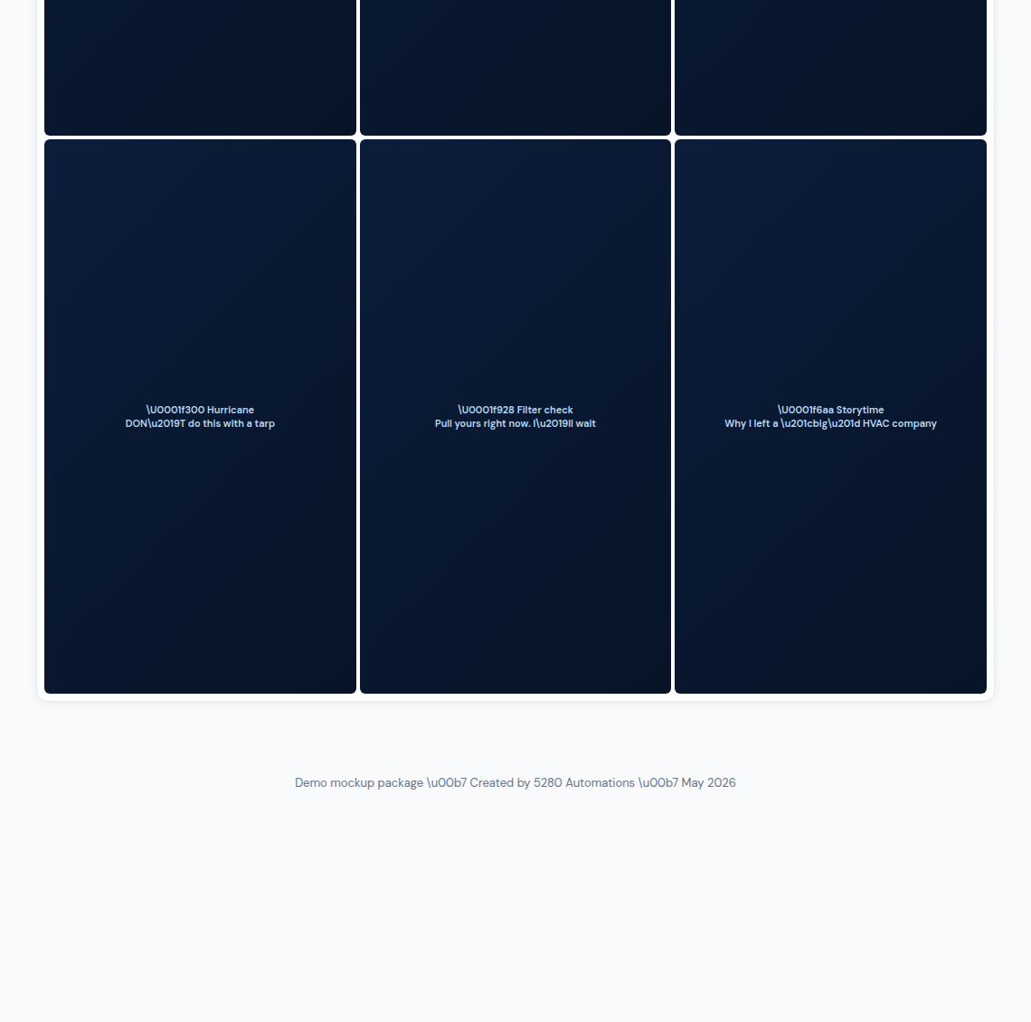
Use this screenshot to see which part of the website the questions below will customize.
What this affects: the TikTok content grid, short-form video topics, customer education content, and on-camera personality.
1. Do you want TikTok or short-form video content included in the marketing plan?
Answer:
______________________________________________________________________________________
______________________________________________________________________________________
2. Who is comfortable being on camera?
Answer:
______________________________________________________________________________________
______________________________________________________________________________________
3. Which video topics are accurate and useful for your customers?
- Why an AC freezes up in summer
- Common Mobile homeowner HVAC mistakes
- Mystery noise diagnostics
- Hurricane HVAC preparation
- Filter checks
- Storytime / owner background
- Before-and-after installs
- Customer FAQs
- Other:
Answer:
______________________________________________________________________________________
______________________________________________________________________________________
4. Are there any topics we should avoid for legal, safety, or brand reasons?
Answer:
______________________________________________________________________________________
______________________________________________________________________________________
5. Do you have real photos/videos of jobs, trucks, technicians, tools, or equipment that can be used?
Answer:
______________________________________________________________________________________
______________________________________________________________________________________
6. Should short videos include pricing ranges, financing, owner stories, tech education, customer testimonials, or seasonal reminders?
Answer:
______________________________________________________________________________________
______________________________________________________________________________________

10. Service Area and Local SEO
What this affects: homepage copy, service-area sections, Google search targeting, and city-specific messaging.
1. What cities, towns, counties, and neighborhoods do you want to target?
Answer:
______________________________________________________________________________________
______________________________________________________________________________________
2. Which locations are highest priority for new business?
Answer:
______________________________________________________________________________________
______________________________________________________________________________________
3. Are there places you do not want to service?
Answer:
______________________________________________________________________________________
______________________________________________________________________________________
4. Do you have separate physical locations or only one service base?
Answer:
______________________________________________________________________________________
______________________________________________________________________________________
5. What search phrases do you want to show up for? Examples: AC repair Mobile AL, heat pump install Daphne, emergency HVAC Mobile, furnace repair near me.
Answer:
______________________________________________________________________________________
______________________________________________________________________________________

11. Assets Needed Before Launch
What this affects: whether the final website uses real proof, real photos, and verified business details instead of placeholders.
Please provide any available items:
1. Final logo files
2. Owner/team photos
3. Truck or van photos
4. Jobsite or equipment photos
5. License number and insurance wording
6. Google Business Profile link
7. Review/testimonial examples with permission
8. Social media links
9. Scheduling/contact form destination
10. Financing partner details, if any
11. Warranty or guarantee details
12. Any existing brochures, flyers, or brand materials
Notes:

12. Final Preference Questions
1. What do you like most about the mockup?
Answer:
______________________________________________________________________________________
______________________________________________________________________________________
2. What do you dislike or want changed first?
Answer:
______________________________________________________________________________________
______________________________________________________________________________________
3. Are there competitor websites you like? Please share links and what you like about them.
Answer:
______________________________________________________________________________________
______________________________________________________________________________________
4. Are there competitor websites you dislike? Please share links and what to avoid.
Answer:
______________________________________________________________________________________
______________________________________________________________________________________
5. If the final website could only make customers feel one thing about your company, what should that be?
Answer:
______________________________________________________________________________________
______________________________________________________________________________________

Return Checklist
- Answered questionnaire
- Logo file attached
- Real contact details confirmed
- License/insurance wording confirmed
- Service list confirmed
- Maintenance plan pricing confirmed
- Reviews/testimonials supplied or marked as needed
- Photos/video assets supplied if available
- Social handles supplied

