NIRIKSHAN AI Project Reference Guide
This guide explains what the project does, why it is used, how every model and rule works, and how a reviewer should use the website.

1. Purpose
NIRIKSHAN AI is an MPLADS monitoring and review tool. It reads work descriptions, dates, sanctioned amounts, expenditure, progress, location, and related records. It highlights records that need human checking and explains why.
It is a decision-support system. A high score is not proof of fraud.

2. Complete Workflow
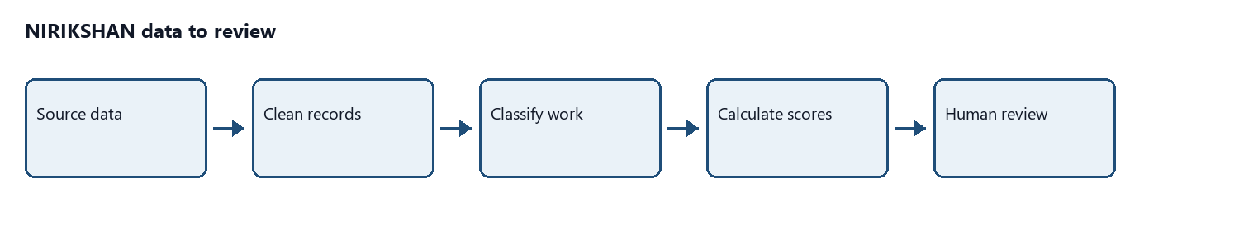

What happens at each step
1. **Source data:** recommendations, sanctions, completions, and expenditure are loaded.
2. **Cleaning:** work IDs, dates, amounts, names, locations, and descriptions are standardized.
3. **Classification:** the description is assigned to a sector and sub-sector.
4. **Scoring:** financial, duplicate, compliance, and material context checks are calculated.
5. **Final priority:** all scores are combined into one review score.
6. **Review:** Risk Monitor shows the highest-priority work first.

3. Data Used
Data | Used for
Recommended works | Recommendation date, description, repeat-work check
Sanctioned works | Sanction date, sanctioned amount, state, constituency
Completed works | Completion date and completion status
Expenditure records | Spending and progress checks
Sector cost reference | Expected cost by sector, sub-sector, quantity, and location

4. Work Classification Model

Models and conditions
- **Text cleaning:** makes words consistent and removes unnecessary text.
- **Vocabulary matching:** connects related words such as `light`, `lights`, and `lighting`.
- **TF-IDF:** gives more importance to words that help identify the type of work.
- **Linear SVM:** chooses the most likely sector and sub-sector from learned word patterns.
- **Confidence:** shows how strongly the description supports the selected class. It is not proof that the classification is correct.
- **Quantity reading:** finds numbers and units such as `9 poles`, `3 lights`, `1 km`, and `2 rooms`.

5. Financial Anomaly Model
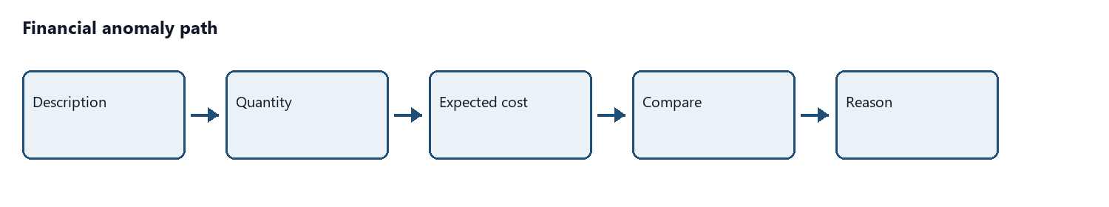

Financial calculations
1. **Expected total:** reference unit cost × quantity × location multiplier.
2. **Expected range:** used when the exact subtype is not certain.
3. **Peer median:** the middle sanctioned amount among similar sector and state works.
4. **Peer ratio:** sanctioned amount ÷ peer median.
5. **Percentile:** shows how high the amount is compared with similar works.
6. **IQR upper limit:** `Q3 + 1.5 × (Q3 - Q1)` identifies unusually high amounts.
7. **Isolation Forest:** checks amount, expenditure, peer ratio, payment count, and expenditure-to-sanction ratio together.
Important condition: if a quantity-based expected range exists and the cost is inside it, the work is not marked financially risky only because the broad peer median is lower.

6. Compliance Rules
Compliance has the highest weight in the final score because it checks dates, progress, required records, and approved money.
ID | Rule | Condition | Result
C01 | Recommendation to sanction | More than 45 days | Critical
C02 | Repeat recommendation | Similar work and location within 180 days | Critical
C03 | Minimum completion window | Completed in under 15 days | Critical
C04 | Normal completion window | Completed from 15 days to 1 year | Compliant
C05 | No progress after 1 year | No completion or recorded progress | Anomaly
C06 | Extended completion window | Partial progress within 18 months | Monitor
C07 | Beyond 18 months | Partial-progress work still incomplete | Critical
C08 | Date consistency | Recommendation <= sanction <= start <= completion | Warning or critical
C09 | Expenditure consistency | Spending is above sanctioned amount | Warning or critical
C10 | Invalid financial data | Negative or impossible values | Data quality
C11 | Required information | Critical fields are missing | Data quality
C12 | Completion consistency | Status and completion date disagree | Data quality

Image verification is optional. A missing image does not create a compliance failure by itself.

7. Duplicate and Repeat Work Checks
- Similar descriptions are compared within the same constituency.
- A high similarity is only a candidate, not a confirmed duplicate.
- C02 flags a similar normalized description in the same or similar location within 180 days.
- The Duplicate Inspector shows the pair so the reviewer can compare dates, location, amount, and purpose.

8. Final Risk Score
The final score is a review priority, not a finding of wrongdoing.

Composite = 0.40 × Compliance
+ 0.35 × Financial
+ 0.23 × Duplicate
+ 0.02 × Material context
Part | Weight | Meaning
Compliance | 40% | Date, progress, required-field, status, and money checks
Financial | 35% | Cost compared with expected cost and similar works
Duplicate | 23% | Similarity with another work description
Material context | 2% | Supporting price context

Risk levels:
- **LOW:** below 35
- **MEDIUM:** 35 to 64
- **HIGH:** 65 to 84
- **CRITICAL:** 85 and above

9. Website Screens
Screen | Purpose
Overview | Portfolio totals, risk by sector, and state summaries
Risk Monitor | Highest-priority works first; click a row to open details
Projects | Searchable directory in cards or table view
Duplicate Inspector | Similar work pairs and the 180-day repeat check
Analytics | Financial, duplicate, and compliance patterns
Methodology | Models, rules, weights, and limits

10. Reviewer Workflow
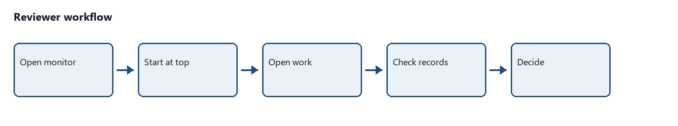
Review in this order:
1. Compliance reason
2. Financial reason
3. Duplicate reason
4. Supporting material context
Check dates, quantity, location, sanction, expenditure, progress, evidence, and related works before making a decision.

11. Running the Website
From `P:\SIH\mplads-main`, open two terminals.
Terminal 1:

npm run backend
Terminal 2:

npm run frontend
Open `http://localhost:3000`.
Backend API: `http://127.0.0.1:8000`.
To rebuild analytical outputs after changing data or rules:

npm run pipeline

12. Main Code Files
File | Purpose
`src/data/master_builder.py` | Builds the master analytical dataset
`src/modules/sector_classifier.py` | Assigns sector and sub-sector
`src/modules/financial_anomaly.py` | Calculates financial risk
`src/modules/duplicate_detection.py` | Finds similar descriptions
`src/modules/compliance_engine.py` | Runs C01 to C12
`src/risk/composite_risk_engine.py` | Combines scores and creates reasons
`src/backend/app.py` | Serves dashboard API data
`frontend/` | Website screens and interactions
`data/features/` | Generated analytical outputs

13. Important Limits
- A high score means unusual or incomplete information, not proven fraud.
- Results depend on the quality of the source records.
- Similarity requires human verification.
- Images are optional and are never invented by the system.
- Model confidence describes text matching, not the truth of a project.

