Piotr Bonar
Artificial Intelligence
Problems nr 4

Problem 1: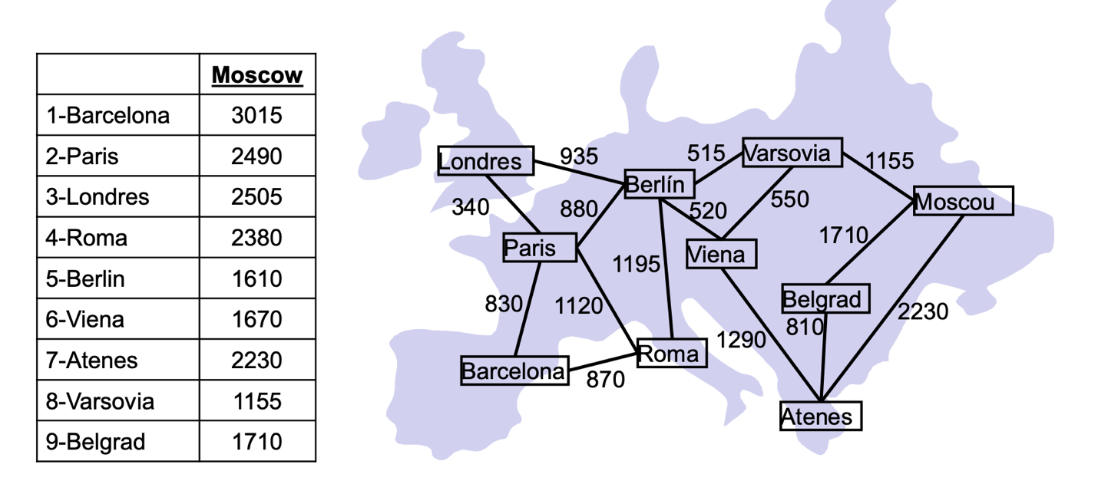
Notation: [sum of g and h, [route], g, h]
Step 1.
[3015, [1], 0, 3015]
Step 2.
Extending: [3015, [1], 0, 3015]
[3250, [1,4], 870, 2380], [3320, [1,2], 830, 2490]
Step 3.
Extending: [3250, [1,4], 870, 2380]
[3320, [1,2], 830, 2490], [3675, [1,4,5], 2065, 1610], [4480, [1,4,2], 1990, 2380],
[4755, [1,4,1], 1740, 3015]
Step 4.
Extending: [3320, [1,2], 830, 2490]
[3320, [1,2,5], 1710, 1610], [3675, [1,4,5], 2065, 1610], [3675, [1,2,3], 1170, 2505],
[4330, [1,2,4], 1950, 2380], [4675, [1,2,1], 1660, 3015]
Step 5.
Extending: [3320, [1,2,5], 1710, 1610]
[3380, [1,2,5,8], 2225, 1155], [3675, [1,2,3], 1170, 2505], [3900, [1,2,5,6], 2230, 1670],
[…, [1,2,5,4], …, …], […, [1,2,5,2], …, …], […, [1,2,5,3], …, …]
Step 6.
Extending: [3380, [1,2,5,8], 2225, 1155],
[3380, [1,2,5,8, Moscow], 3380, 0], [3675, [1,2,3], 1170, 2505], [3900, [1,2,5,6], 2230, 1670],
[…, [1,2,5,8,5], …, …], […, [1,2,5,8,6], …, …]

Problem 2:
Price per liter (P): 0.75 euros / liter
Fuel usage per km (F): 12 liters / km
Minimum taxes per facility (T): 6000 euros
Distance between A and B: D(A, B)

Cost(A, B) = P * F * D(A, B) + T

h(n) = P * F * D(n, goal) + T

g(h) = sum of all Cost(A,B) from the route

Problem 3:
b* from h₁ ~ 1.5 (best)
b* from h₂ ~ 3 (worst)
b* from h₃ ~ 1.75 (2nd)
b* from h₄ ~ 2.5 (3rd)

Problem 4:
b* from h₅ ~ 2 (worst)
b* from h₆ ~ 1.75 (3rd)
b* from h₇ ~ 1. 5 (2nd)
b* from h₈ ~ 1.25 (best)

Problem 5:
Best to worst:
h_{8,} h_{1,} h_{7,} h_{6,} h_{3,} h_{5,} h_{4,} h₂

