Piotr Bonar
Artificial Inteligence
Problems nr 2

Exercise 1.
Representing the problem
- State space: all valid positions in the room
- Inicial state: robots position on beginning
- Goal state: position, where robot I supposed to do the action
- Action space: all the possible moves (up, down, right, left)
- Cost function: step counter, every step has a cost of 1

Branches, nodes and branching factors
- Nodes: position where robot can be
- Branches: Valid moves from one node to another
- Branching factor: number of possible moves from one node to other ones

The best Algoritms
- BFS: guarantees the shortest path in terms of steps
- DFS: It could have sense if we include cycles detection (makes most sense if we don’t plan to first find the root and then start moving, just start moving, because this way we wont have to go back that many times)
- Uniform Cost Search: also guaranties the shortest path
The Tree
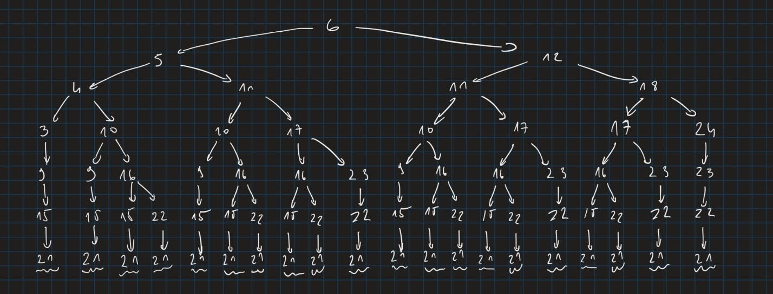

Exercise 2.
a)
BFS:
Iteration 1 – [[1]]
Iteration 2 – [[2, 1], [3, 1]]
Iteration 3 – [[4, 2, 1], [5, 2, 1], [6, 3, 1], [7, 3, 1]]
Iteration 4 – [[8, 4, 2, 1], [9, 4, 2, 1], [10, 5, 2, 1], [11, 5, 2, 1], [6, 3, 1], [7, 3, 1]]

Output: [11, 5, 2, 1]
Cost: 18

DFS:
Iteration 1 – [[1]]
Iteration 2 – [[2, 1]]
Iteration 3 – [[4, 2, 1]]
Iteration 4 – [[8, 4, 2, 1]] (no possible moves, come back)
Iteration 5 - [[9, 4, 2, 1]]
Iteration 6 - [[13, 9, 4, 2, 1]]
Iteration 7 - [[19, 13, 9, 4, 2, 1]]

Output: [[19, 13, 9, 4, 2, 1]]
Cost: 37

UCS:
Iteration 1 – [(0, [1])]
Iteration 2 – [(3, [1,2]), (4, [1,3])]
Iteration 3 – [(4, [1,3]), (13, [1,2,5]) , (23, [1,2,4])]
Iteration 4 – [(7, [1,3,6]), (13, [1,2,5]), (23, [1,2,4])]
Iteration 5 – [(9, [1,3,6,12]), (13, [1,2,5]), (23, [1,2,4])]
Iteration 6 – [(10, [1,3,6,12,18]), (13, [1,2,5]), (16, [1,3,6,12,17]), (23, [1,2,4])]
Iteration 7 – [(12, [1,3,6,12,18,22]), (13, [1,2,5]), (16, [1,3,6,12,17]), (23, [1,2,4])]

Output: [1,3,6,12,18,22]
Cost: 12

b)
Q. 1
What algorithms guarantee that they will always come up with a solution if it
exists?
BFS (if graph is not infinite), UCS (if all step costs positive), DFS (if no infinite loops)
Q. 2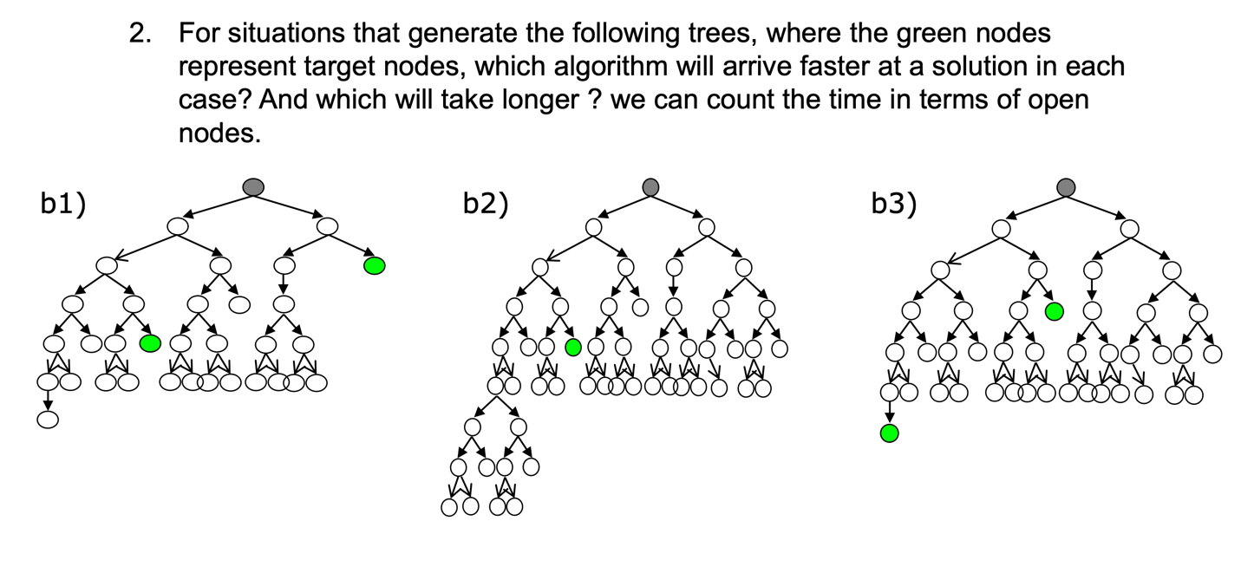
I do not take UCS into account because the costs aren’t shown and if all the jumps are worth the same it would work like BFS
b1)
the fastest: BFS (~ 7 nodes)
the slowest: DFS (~ 17 nodes)
b2)
the fastest: BFS (~ 18 nodes)
the slowest: DFS (~ 23 nodes if always left one is first)
b3)
the fastest: DFS (~ 7 nodes)
the slowest: BFS (~ 11 nodes)

