Piotr Bonar
Artificial Intelligence
Problems nr 6

Problem 1:
- True
- False
- True
- True

Continuing with the previous problem:
d₁(x) = x₁ - x₂
d₂(x) = x₁ + x₂
And the decision function:
If (d₁(x) >= 0, d₂(x) >= 0)
Return C2
Else if (d₁(x) <= 0, d₂(x) >= 0)
Return C1
Else if (d₁(x) <= 0, d₂(x) <= 0)
Return C4
Else if (d₁(x) >= 0, d₂(x) <= 0)
Return C3

With using the polar coordinates
If ( O >= -45 and O <= 45)
Return C1
Else if ( O >= 45 and O <= 135)
Return C2
Else if ( O >= -135 and O <= -45)
Return C4
Else
Return C3
Problem 2:
- Length and Width
- Principal Component Analysis
- We could try to compute something like a estimated area by length * width
- KNN could work well

Problem 3:
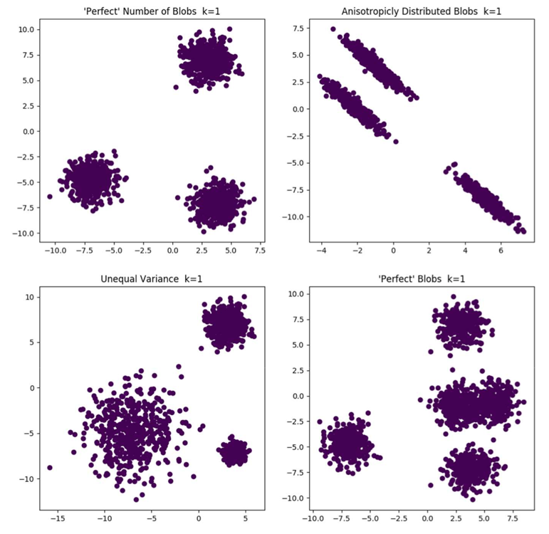
Part 1.
Which method /metrics we could use to
Automatically establish the optimal number
of clusters?
- k = 3
- K = 3
- K = 3
- K = 5
Part 2.
Which method / metrics we could use
to automatically establish the optimal
number of clusters?

Problem 4:
- The quality may not be perfect,
because I don’t have my iPad
with me

- 3 classes
- K-Means with result of classifying each point to one of classes
- Function classify: C_{i} = argmin({distance(y, c_{i})})

