Sequence Diagram

The description language is highly derived from http://www.websequencediagrams.com .

Let's have few example :
Basic examples
The sequence "->" is used to draw a message between two participants. Participants do not have to be explicitly declared.

To have a dotted arrow, you use -->

It is also possible to use <- et <--. That does not change the drawing, but may improve lisibility.

@startuml img/sequence_img001.png
Alice -> Bob: Authentication Request A
Bob --> Alice: Authentication Response B

Alice -> Bob: Another authentication Request
Alice <-- Bob: another authentication Response
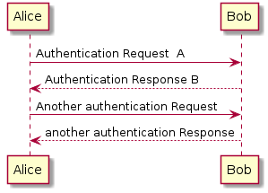
@enduml

Declaring participant
It is possible to change participant order using the participant keyword. .

It is also possible to use the actor keyword to use a stickman instead of a box for the participant.

You can rename a participant using the as keyword.

You can also change the background color of actor or participant.

Everything that starts with simple quote ' is a comment.

@startuml img/sequence_img002.png
actor Bob #red
' The only difference between actor and participant is the drawing
participant Alice
participant "I have a really\nlong name" as L #99FF99

Alice->Bob: Authentication Request
Bob->Alice: Authentication Response
Bob->L: Log transaction
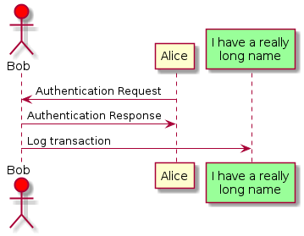
@enduml

#########
Message to Self
A participant can send a message to itself.

It is also possible to have multilines using \n.

@startuml img/sequence_img003.png
Alice->Alice: This is a signal to self.\nIt also demonstrates\nmultiline \ntext
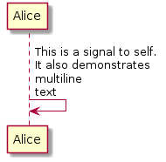
@enduml

#########
Message sequence numbering
The keyword autonumber is used to automatically add number to messages.

@startuml img/sequence_img004.png
autonumber
Bob -> Alice : Authentication Request
Bob <- Alice : Authentication Response
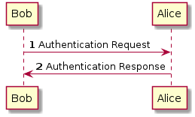
@enduml

You can specify a startnumber with autonumber 'start' , and also an increment with autonumber 'start' 'increment'

@startuml img/sequence_img005.png
autonumber
Bob -> Alice : Authentication Request
Bob <- Alice : Authentication Response

autonumber 15
Bob -> Alice : Another authentication Request
Bob <- Alice : Another authentication Response

autonumber 40 10
Bob -> Alice : Yet another authentication Request
Bob <- Alice : Yet another authentication Response
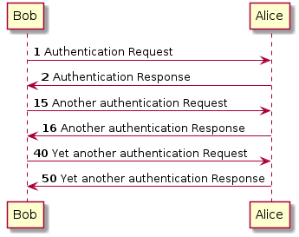
@enduml

You can specify a format for your number by using between double-quote.

The formatting is done with the Java class DecimalFormat ('0' means digit, '#' means digit and zero if absent).

You can use some html tag in the format.

@startuml img/sequence_img006.png
autonumber "<b>[000]"
Bob -> Alice : Authentication Request
Bob <- Alice : Authentication Response

autonumber 15 "<b>(<u>##</u>)"
Bob -> Alice : Another authentication Request
Bob <- Alice : Another authentication Response

autonumber 40 10 "<font color=red><b>Message 0 "
Bob -> Alice : Yet another authentication Request
Bob <- Alice : Yet another authentication Response
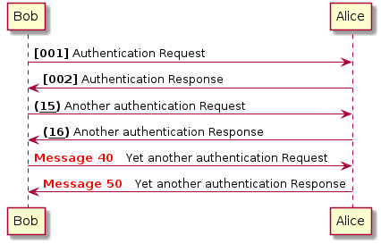
@enduml

Title
The title keywords is used to put a title.

@startuml img/sequence_img007.png

title Simple communication example

Alice -> Bob: Authentication Request
Bob --> Alice: Authentication Response
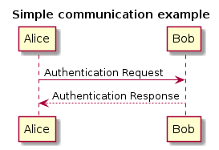
@enduml

Splitting diagrams
The newpage keyword is used to split a diagram into several images.

You can put a title for the new page just after the newpage keyword.

This is very handy with Word to print long diagram on several pages.

@startuml img/sequence_img008.png

Alice -> Bob : message 1
Alice -> Bob : message 2

newpage

Alice -> Bob : message 3
Alice -> Bob : message 4

newpage A title for the\nlast page

Alice -> Bob : message 5
Alice -> Bob : message 6
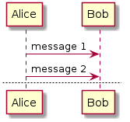
@enduml

Grouping message

It is possible to group messages together using alt/else, opt or loop keywords.

It is possible a add a text that will be displayed into the header.

The end keyword is used to close the group.

Note that it is possible to nest groups.

@startuml img/sequence_img009.png
Alice -> Bob: Authentication Request
alt successful case
Bob -> Alice: Authentication Accepted
else some kind of failure
Bob -> Alice: Authentication Failure
opt
loop 1000 times
Alice -> Bob: DNS Attack
end
end
else Another type of failure
Bob -> Alice: Please repeat
end
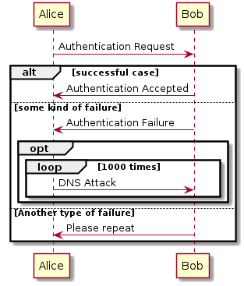
@enduml

Notes on messages
It is possible to put notes on message using the note left or note right keywords just after the message .

You can have multilines note using the end note keywords.

@startuml img/sequence_img010.png
Alice->Bob : hello
note left: this is a first note

Bob->Alice : ok
note right: this is another note

Bob->Bob : I am thinking
note left
a note
can also be defined
on several lines
end note
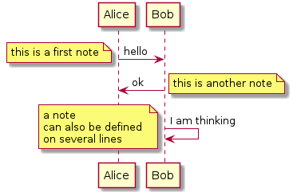
@enduml

Some other notes
It is also possible to place notes relative to participant with note left of , note right of or note over keywords.

It is possible to highlight a note by changing its background color.

You can also have multilines note using the end note keywords.

@startuml img/sequence_img011.png
participant Alice
participant Bob
note left of Alice #aqua
This is displayed
left of Alice.
end note

note right of Alice: This is displayed right of Alice.

note over Alice: This is displayed over Alice.

note over Alice, Bob #FFAAAA: This is displayed\n over Bob and Alice.

note over Bob, Alice
This is yet another
example of
a long note.
end note
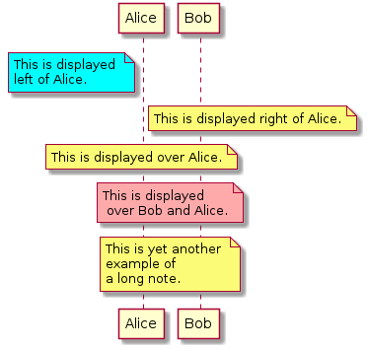
@enduml

Formatting using HTML
It is also possible to use few html tags like :

* <b>
* <u>
* <i>
* <s>, <del>, <strike>
* <font color="#AAAAAA"> or <font color="colorName">
* <img src="file"> : the file must be accessible by the filesystem

@startuml img/sequence_img012.png
participant Alice
participant "The <b>Famous</b> Bob" as Bob

Alice -> Bob : A <i>well formated</i> message
note right of Alice
This is displayed
<u>left of</u> Alice.
end note
note left of Bob
This is <font color=#118888>displayed</font>
<b><font color=purple>left of</font> <strike>Alice</strike> Bob</b>.
end note
note over Alice, Bob
This is hosted by <img src=sourceforge.jpg>
end note

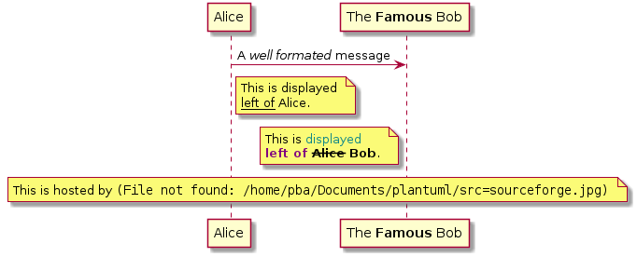
@enduml

Divider
If you want, you can split a diagram using == separator to divide your diagram into logical steps.

@startuml img/sequence_img012a.png

== Initialisation ==

Alice -> Bob: Authentication Request
Bob --> Alice: Authentication Response

== Repetiton ==

Alice -> Bob: Another authentication Request
Alice <-- Bob: another authentication Response
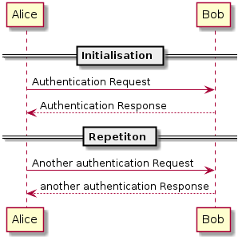
@enduml

Lifeline Activation and Destruction
The activate and deactivate are used to denote participant activation.

Once a participant is activated, its lifeline appears.

The activate et deactivate apply on the previous message.

The destroy denote the end of the lifeline of a participant.

@startuml img/sequence_img013.png
participant User

User -> A: DoWork
activate A

A -> B: << createRequest >>
activate B

B -> C: DoWork
activate C
C --> B: WorkDone
destroy C

B --> A: RequestCreated
deactivate B

A -> User: Done
deactivate A
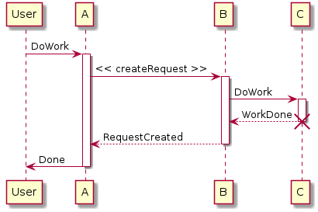
@enduml

Nested lifeline can be used, and it is possible to add a color on the lifeline.

@startuml img/sequence_img014.png
participant User

User -> A: DoWork
activate A #FFBBBB

A -> A: Internal call
activate A #DarkSalmon

A -> B: << createRequest >>
activate B

B --> A: RequestCreated
deactivate B
deactivate A
A -> User: Done
deactivate A
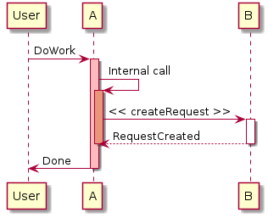
@enduml

Stereotypes and Spots
It is possible to add stereotypes to participants using << and >>.

In the stereotype, you can add a spotted character in a colored circle using the syntax (X,color).

@startuml img/sequence_img015.png

participant "Famous Bob" as Bob << Generated >>
participant Alice << (C,#ADD1B2) Testable >>

Bob->Alice: First message
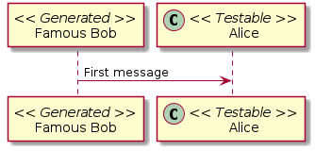
@enduml

@startuml img/sequence_img016.png

participant Bob << (C,#ADD1B2) >>
participant Alice << (C,#ADD1B2) >>

Bob->Alice: First message
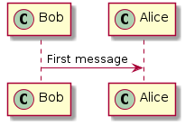
@enduml

More information on titles
You can use some HTML tags in the title.

@startuml img/sequence_img017.png

title <u>Simple</u> communication example

Alice -> Bob: Authentication Request
Bob --> Alice: Authentication Response
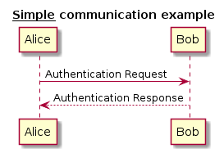
@enduml

You can add newline using \n in the title description.

@startuml img/sequence_img018.png

title <u>Simple</u> communication example\non several lines

Alice -> Bob: Authentication Request
Bob --> Alice: Authentication Response
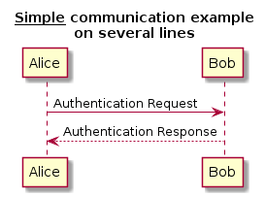
@enduml

You can also define title on several lines using title and end title keywords.

@startuml img/sequence_img019.png

title
<u>Simple</u> communication example
on <i>several</i> lines and using <font color=red>html</font>
This is hosted by <img src=sourceforge.jpg>
end title

Alice -> Bob: Authentication Request
Bob --> Alice: Authentication Response
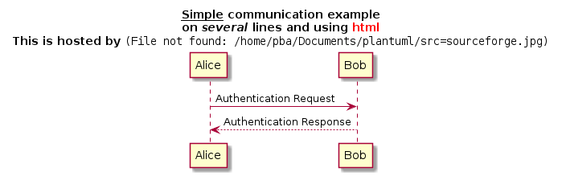
@enduml

Removing Footer
You can use the footbox off keywords to remove the footer of the diagram.

@startuml img/sequence_img020.png

footbox off
title Footer removed

Alice -> Bob: Authentication Request
Bob --> Alice: Authentication Response
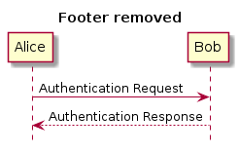
@enduml

Skinparam
You can use the skinparam command to change colors and fonts for the drawing.

You can use this command :

* In the diagram definition, like any other commands,
* In an included file,
* In a configuration file, provided in the command line or the ANT task.

@startuml img/sequence_img021.png
skinparam backgroundColor #EEEBDC

skinparam sequenceArrowColor DeepSkyBlue
skinparam sequenceParticipantBorderColor DeepSkyBlue
skinparam sequenceActorBorderColor DeepSkyBlue
skinparam sequenceLifeLineBorderColor blue

skinparam sequenceParticipantBackgroundColor DodgerBlue
skinparam sequenceParticipantFontName Impact
skinparam sequenceParticipantFontSize 17
skinparam sequenceParticipantFontColor #A9DCDF

skinparam sequenceActorBackgroundColor aqua
skinparam sequenceActorFontColor DeepSkyBlue
skinparam sequenceActorFontSize 17
skinparam sequenceActorFontName Aapex

skinparam sequenceLifeLineBackgroundColor #A9DCDF

actor User
participant "First Class" as A
participant "Second Class" as B
participant "Last Class" as C

User -> A: DoWork
activate A

A -> B: Create Request
activate B

B -> C: DoWork
activate C
C --> B: WorkDone
destroy C

B --> A: Request Created
deactivate B

A --> User: Done
deactivate A
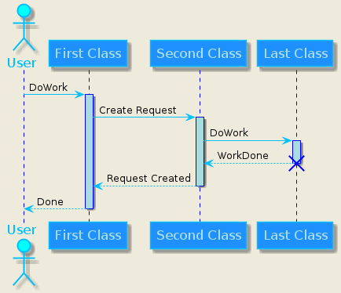
@enduml

Skin
Use the keyword skin to change the look of the generated diagram.

There are only two skins available today (Rose, which is the default, and BlueModern), but it is possible to write your own skin.

@startuml img/sequence_img022.png
skin BlueModern

actor User
participant "First Class" as A
participant "Second Class" as B
participant "Last Class" as C

User -> A: DoWork
activate A

A -> B: << createRequest >>
activate B

B -> C: DoWork
activate C
C --> B: WorkDone
destroy C

B --> A: Request <u>Created</u>
deactivate B

A --> User: Done
deactivate A
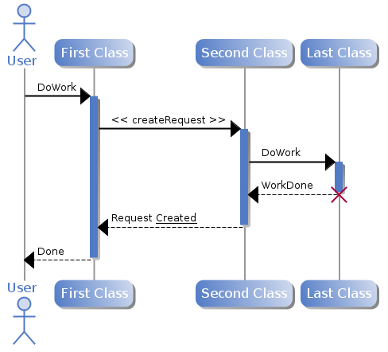
@enduml

Use Case Diagram

To be able to generate those diagrams, you must have Graphviz software installed on your machine in the default directory c:\Program Files\GraphvizX.XX or /usr/bin/dot.

You can have a look here if you have installed Graphviz somewhere else.

Let's have a fews examples :
Usecases
Use cases are enclosed using between parentheses (because two parentheses looks like an oval).

You can also use the usecase keyword to define a usecase. And you can define an alias, using the as keyword. This alias will be used latter, when defining relations.

@startuml img/usecase_imgx01.png

(First usecase)
(Another usecase) as (UC2)
usecase UC3
usecase (Last\nusecase) as UC4
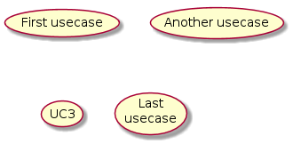
@enduml

Actors
Actor are enclosed using between two points.

You can also use the actor keyword to define an actor. And you can define an alias, using the as keyword. This alias will be used latter, when defining relations.

We will see latter than actor definitions is optional.

@startuml img/usecase_imgx02.png

:First Actor:
:Another\nactor: as Men2
actor Men3
actor :Last actor: as Men4
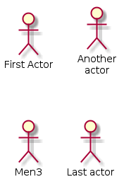
@enduml

Basic example

To link actors and use cases, the arrow --> is used.

The more dashes "-" in the arrow, the longer the arrow. You can add a label on the arrow, by adding a ":" character in the arrow definition.

In this example, you see that User has not been defined before, and is used as an actor.

@startuml img/usecase_img01.png

User -> (Start)
User --> (Use the application) : A small label

:Main Admin: ---> (Use the application) : This is\nyet another\nlabel
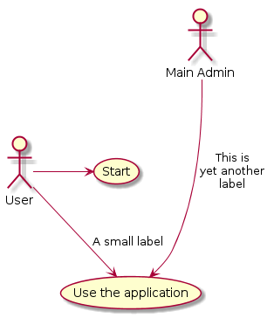
@enduml

Extension
If one actor/use case extends another one, you can use the symbol <|-- (which stands for #########) .
As for smiley, when you turn your head, you will see the symbol

@startuml img/usecase_img03.png
:Main Admin: as Admin
(Use the application) as (Use)

User <|-- Admin
(Start) <|-- (Use)
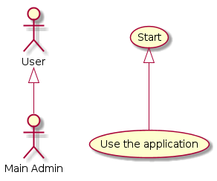
@enduml

Using notes
You can use the note left of , note right of , note top of , note bottom of keywords to define notes related to a single object.

A note can be also define alone with the note keywords, then linked to other objects using the .. symbol.

@startuml img/usecase_img04.png
:Main Admin: as Admin
(Use the application) as (Use)

User -> (Start)
User --> (Use)

Admin ---> (Use)

note right of Admin : This is an example.

note right of (Use)
A note can also
be on several lines
end note

note "This note is connected\nto several objects." as N2
(Start) .. N2
N2 .. (Use)
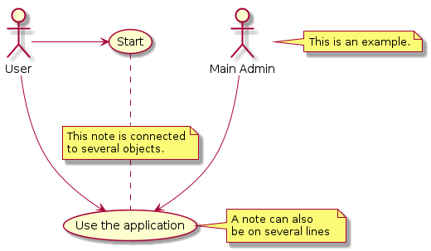
@enduml

Stereotypes
You can add stereotypes while defining actors and use cases using " << " and " >> "

@startuml img/usecase_img05.png
User << Human >>
:Main Database: as MySql << Application >>
(Start) << One Shot >>
(Use the application) as (Use) << Main >>

User -> (Start)
User --> (Use)

MySql --> (Use)
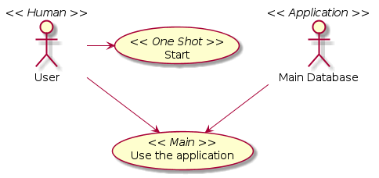
@enduml

Title the diagram
The title keywords is used to put a title.

You can use title and end title keywords for a longer title, as in sequence diagrams.

@startuml img/usecase_img06.png
title Simple <b>Usecase</b>\nwith one actor

usecase (Use the application) as (Use)
User -> (Use)
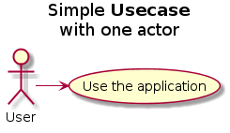
@enduml

Left to right direction
The general default behaviour when building diagram is top to bottom.

@startuml img/usecase_img09.png
#default
top to bottom direction
user1 --> (Usecase 1)
user2 --> (Usecase 2)
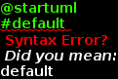
@enduml

You may change to left to right using the left to right direction command. The result is often better with this direction.

@startuml img/usecase_img08.png

left to right direction
user1 --> (Usecase 1)
user2 --> (Usecase 2)
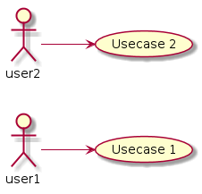
@enduml

Skinparam
You can use the skinparam command to change colors and fonts for the drawing.

You can use this command :

* In the diagram definition, like any other commands,
* In an included file,
* In a configuration file, provided in the command line or the ANT task.

@startuml img/usecase_img07.png

skinparam usecaseBackgroundColor DarkSeaGreen
skinparam usecaseArrowColor Olive
skinparam actorBorderColor black
skinparam usecaseBorderColor DarkSlateGray
skinparam usecaseActorFontName Courier

User << Human >>
:Main Database: as MySql << Application >>
(Start) << One Shot >>
(Use the application) as (Use) << Main >>

User -> (Start)
User --> (Use)

MySql --> (Use)
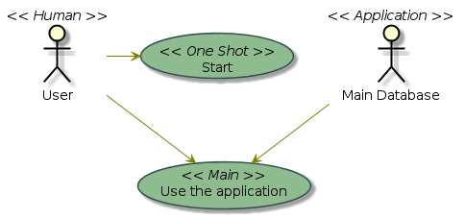
@enduml

Class Diagram

To be able to generate those diagrams, you must have Graphviz software installed on your machine in the default directory c:\Program Files\GraphvizX.XX or /usr/bin/dot.

You can have a look here if you have installed Graphviz somewhere else.

The description of class diagram is similar to the description of use case diagrams.
Relations between classes
Relations between classes are defined using the following symbols :

Extension <|--
Composition *--
Agregation o--

It is possible to replace -- by .. to have a dotted line.

Knowing thoses rules, it is possible to draw the following drawings:

@startuml img/classes01.png
Class01 <|-- Class02
Class03 *-- Class04
Class05 o-- Class06
Class07 .. Class08
Class09 -- Class10
Class11 <|.. Class12
Class13 --> Class14
Class15 ..> Class16
Class17 ..|> Class18
Class19 <--* Class20
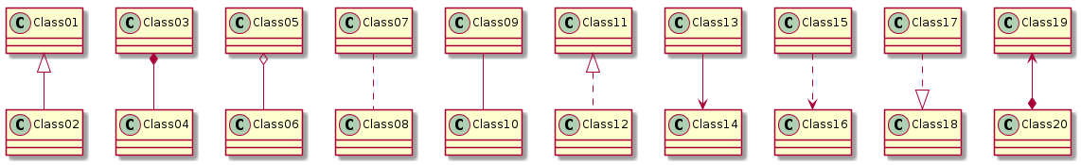
@enduml

Label on relations
It is possible a add a label on the relation, using " : ", followed by the text of the label.

For cardinality, you can use double-quotes "" on each side of the relation.

@startuml img/classes02.png

Class01 "1" *-- "many" Class02 : contains

Class03 o-- Class04 : agregation

Class05 --> "1" Class06
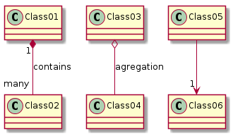
@enduml

Adding methods
To declare fields and methods, you can use the symbol ":" followed by the field's or method's name.

The system checks for parenthesis to choose between methods and fields.

@startuml img/classes03.png
Object <|-- ArrayList

Object : equals()
ArrayList : Object[] elementData
ArrayList : size()
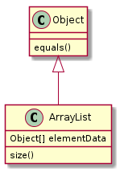
@enduml

Notes and stereotypes
Stereotypes are defined with the class keyword, " << " and " >> ".

You can alse define notes using note left of , note right of , note top of , note bottom of keywords.

A note can be also define alone with the note keywords, then linked to other objects using the .. symbol.

@startuml img/classes05.png
class Object << general >>
Object <|--- ArrayList

note top of Object : In java, every class\nextends this one.

note "This is a floating note" as N1
note "This note is connected\nto several objects." as N2
Object .. N2
N2 .. ArrayList
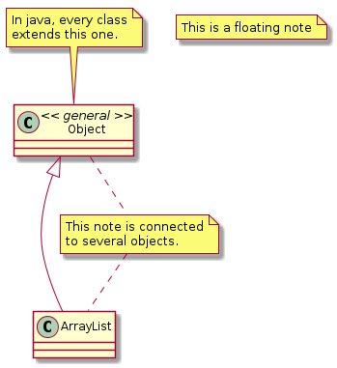
@enduml

More on notes
It is also possible to use few html tags like :

* <b>
* <u>
* <i>
* <s>, <del>, <strike>
* <font color="#AAAAAA"> or <font color="colorName">
* <img src="file"> : the file must be accessible by the filesystem

You can also have a note on several lines

@startuml img/classes06.png

note top of Object
In java, every <u>class</u>
<b>extends</b>
<i>this</i> one.
end note

note as N1
This note is <u>also</u>
<b><font color=royalBlue>on several</font>
<s>words</s> lines
And this is hosted by <img src=sourceforge.jpg>
end note
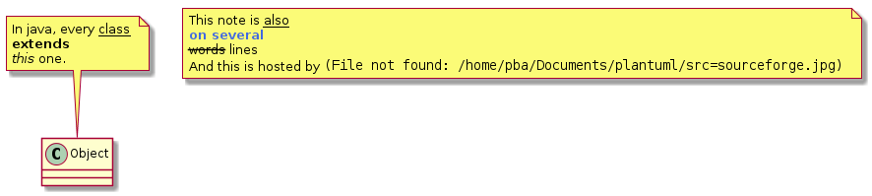
@enduml

Abstract class and interface
You can declare a class as abstract using "abstract" or "abstract class" keywords.

The class will be printed in italic.

You can use the interface and enum keywords too.

@startuml img/classes04.png

abstract class AbstractList
abstract AbstractCollection
interface List
interface Collection

List <|-- AbstractList
Collection <|-- AbstractCollection

Collection <|- List
AbstractCollection <|- AbstractList
AbstractList <|-- ArrayList

ArrayList : Object[] elementData
ArrayList : size()

enum TimeUnit
TimeUnit : DAYS
TimeUnit : HOURS
TimeUnit : MINUTES
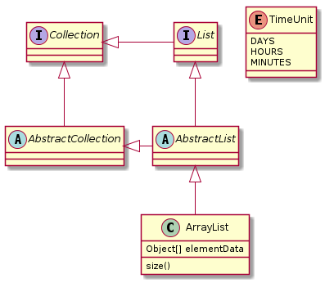
@enduml

Specific Spot
Usually, a spotted character (C, I, E or A) is used for classes, interface, enum and abstract classes.

But you can define your own spot for a class when you define the stereotype, adding a single character and a color, like in this example:

@startuml img/classes08.png

class System << (S,#FF7700) Singleton >>
class Date << (D,orchid) >>
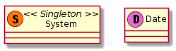
@enduml

Packages
You can define a package using the package keyword, and optionally declare a background color for your package (Using a html color code or name).

When you declare classes, they are automatically put in the last used package, and you can close the package definition using the end package keyword. You can also use brackets {}.

Note that package definitions can be nested.

@startuml img/classes10.png

package "Classic Collections" #DDDDDD {
Object <|-- ArrayList
}

package net.sourceforge.plantuml
Object <|-- Demo1
Demo1 *- Demo2
end package
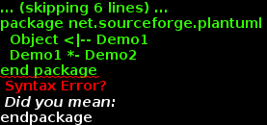
@enduml

You can also define links between packages, like in the following example:

@startuml img/classes10a.png

package foo1.foo2
end package

package foo1.foo2.foo3 {
class Object
}

foo1.foo2 +-- foo1.foo2.foo3
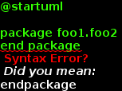
@enduml

Namespaces
In packages, the name of a class is the unique identifier of this class. It means that you cannot have two classes with the very same name in different packages.

In that case, you should use namespaces instead of packages.

You can refer to classes from other namespaces by fully qualify them. Classes from the default namespace are qualified with a starting dot.

Note that you don't have to explicitly create namespace : a fully qualified class is automatically put in the right namespace.

@startuml img/classes10e.png

class BaseClass

namespace net.dummy #DDDDDD
.BaseClass <|-- Person
Meeting o-- Person

.BaseClass <|- Meeting

end namespace

namespace net.foo {
net.dummy.Person <|- Person
.BaseClass <|-- Person

net.dummy.Meeting o-- Person
}

BaseClass <|-- net.unused.Person
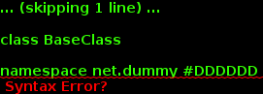
@enduml

Title the diagram
The title keywords is used to put a title.

You can use title and end title keywords for a longer title, as in sequence diagrams.

@startuml img/classes15.png
title Simple <b>example</b>\nof title

Object <|-- ArrayList
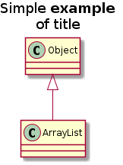
@enduml

Association classes
You can define association class after that a relation has been defined between two classes, like in this example:

@startuml img/classes16.png
Student : Name
Student "0..*" - "1..*" Course
(Student, Course) .. Enrollment

Enrollment : drop()
Enrollment : cancel()
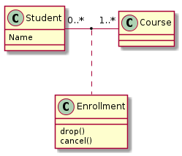
@enduml

You can define it in another direction:

@startuml img/classes17.png
Student : Name
Student "0..*" -- "1..*" Course
(Student, Course) . Enrollment

Enrollment : drop()
Enrollment : cancel()
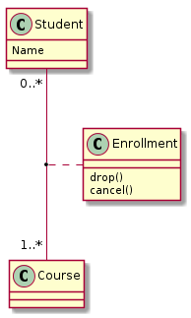
@enduml

Skinparam
You can use the skinparam command to change colors and fonts for the drawing.

You can use this command :

* In the diagram definition, like any other commands,
* In an included file,
* In a configuration file, provided in the command line or the ANT task.

@startuml img/classes18.png

skinparam classBackgroundColor PaleGreen
skinparam classArrowColor SeaGreen
skinparam classBorderColor SpringGreen
skinparam stereotypeCBackgroundColor YellowGreen

Class01 "1" *-- "many" Class02 : contains

Class03 o-- Class04 : agregation
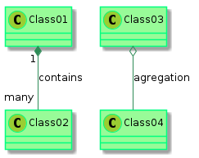
@enduml

Splitting large files
Sometimes, you will get some very large image files.

You can use the "page (hpages)x(vpages)" command to split the generated image into several files :

hpages is a number that indicated the number of horizontal pages, and vpages is a number that indicated the number of vertical pages.

@startuml img/classes09.png
' Split into 4 pages
page 2x2

class BaseClass

namespace net.dummy #DDDDDD
.BaseClass <|-- Person
Meeting o-- Person

.BaseClass <|- Meeting

end namespace

namespace net.foo {
net.dummy.Person <|- Person
.BaseClass <|-- Person

net.dummy.Meeting o-- Person
}

BaseClass <|-- net.unused.Person
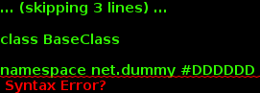
@enduml

Activity Diagram

To be able to generate those diagram, you must have Graphviz software installed on your machine in the default directory c:\Program Files\GraphvizX.XX or /usr/bin/dot.

You can have a look here if you have installed Graphviz somewhere else.
Simple Activity
You can use (*) for the starting point and ending point of the activity diagram.

Use --> for arrows.

@startuml img/activity_img01.png

(*) --> "First Activity"
"First Activity" --> (*)
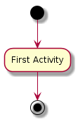
@enduml

Arrows
You can use -> for horizontal arrows.

You can use ---> for longer arrows.

By default, an arrow starts at the last used activity.

@startuml img/activity_img02.png

(*) -> "First Activity"
--> "Second Activity" : You can put also labels
"Third Activity" <- "Second Activity"
--> (*)

"First Activity" ---> Last
--> (*)
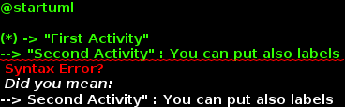
@enduml

Branches
You can use <> followed with an internal label for branches.

The notation [some label] always refers to the last used branche.

@startuml img/activity_img03.png

(*) --> "Make a test"
--> <> B1

--> [true] "Some Activity"
--> "Another activity"

-> [false] "Something else"
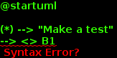
@enduml

Synchronization
You can use === code === to display synchronization bars.

@startuml img/activity_img04.png

(*) --> ===B1===
--> "Parallel Activity 1"
--> ===B2===

===B1=== --> "Parallel Activity 2"
--> ===B2===

--> (*)
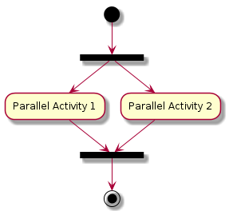
@enduml

Long activity description
When you declare activities, you can span on several lines the description text. You can also add \n in the description.

It is also possible to use few html tags like :

* <b>
* <i>
* <font size="16">
* <font color="#AAAAAA"> or <font color="colorName">

You can also give a short code to the activity with the as keyword. This code can be used latter in the diagram description.

@startuml img/activity_img05.png

(*) --> "this <font size=20>activity</font>
is <b>very</b> <font color=red>long</font>
and defined on several lines
that contains many <i>text</i>" as A1

--> "Another activity\n on several lines"

A1 --> "Short activity"
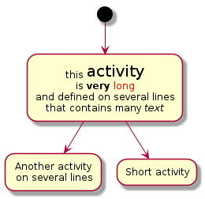
@enduml

Notes
You can add notes on a activity using the command note left, note right, note top or note bottom, just after the description of the activity you want to note.

If you want to put a note on the starting point, define the note at the very beginning of the diagram description.

You can also have a note on several lines, using the end note keywords.

@startuml img/activity_img05a.png

(*) --> "Some Activity"
note right: This activity has to be defined
"Some Activity" --> (*)
note left
This note is on
several lines
end note
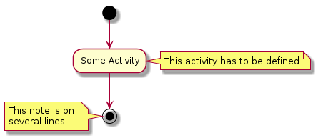
@enduml

Partition
You can define a partition using the partition keyword, and optionally declare a background color for your partition (Using a html color code or name)

When you declare activities, they are automatically put in the last used partition.

You can close the partition definition using the end partition keyword.

@startuml img/activity_img06.png

partition Conductor
(*) --> "Climbs on Platform"
--> === S1 ===
--> Bows
end partition

partition Audience LightSkyBlue
=== S1 === --> Applauds

partition Conductor
Bows --> === S2 ===
--> WavesArmes
Applauds --> === S2 ===
end partition

partition Orchestra #CCCCEE
WavesArmes --> Introduction
--> "Play music"
end partition

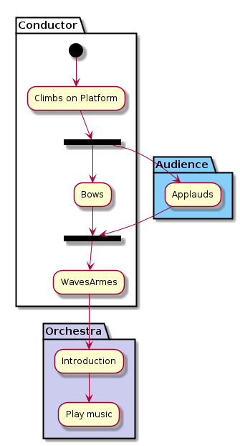
@enduml

Title the diagram
The title keywords is used to put a title.

You can use title and end title keywords for a longer title, as in sequence diagrams.

@startuml img/activity_img07.png
title Simple example\nof title

(*) --> "First activity"
--> (*)
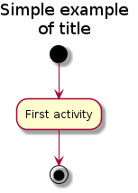
@enduml

Skinparam
You can use the skinparam command to change colors and fonts for the drawing.

You can use this command :

* In the diagram definition, like any other commands,
* In an included file,
* In a configuration file, provided in the command line or the ANT task.

@startuml img/activity_img08.png

skinparam backgroundColor #AAFFFF
skinparam activityStartColor red
skinparam activityBarColor SaddleBrown
skinparam activityEndColor Silver
skinparam activityBackgroundColor Peru
skinparam activityBorderColor Peru
skinparam activityFontName Impact

(*) --> "Climbs on Platform"
--> === S1 ===
--> Bows
--> === S2 ===
--> WavesArmes
--> (*)
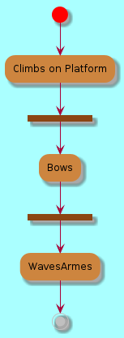
@enduml

Complete example

@startuml img/activity_img20.png

(*) --> "Verify the reservation"

--> <>B1
-> [incorrect] "Send To Airport"
--> (*)
--> [correct] "Get preferences"
--> ===Y1===

===Y1=== --> <>B2
[nobagage] --> ===Y2===
[bagage] --> "Receive the Baggages"
--> ===Y2===

===Y1=== --> "Print the Boadingboard"
--> ===Y2===

--> GiveTravelDocumentation
--> (*)
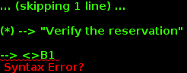
@enduml

Component Diagram

To be able to generate those diagrams, you must have Graphviz software installed on your machine in the default directory c:\Program Files\GraphvizX.XX or /usr/bin/dot.

You can have a look here if you have installed Graphviz somewhere else.

Let's have a fews examples :
Components
Components must be bracketed.

You can also use the component keyword to defines a component. And you can define an alias, using the as keyword. This alias will be used latter, when defining relations.

@startuml img/component_imgx01.png

[First component]
[Another component] as Comp2
component Comp3
component [Last\ncomponent] as Comp4
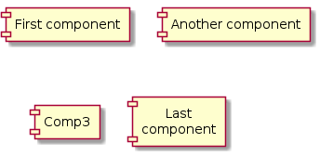
@enduml

Interfaces
Interface can be defined using the () symbole (because this looks like a circle).

You can also use the interface keyword to defines a usecase. And you can define an alias, using the as keyword. This alias will be used latter, when defining relations.

We will see latter that interface definition is optional.

@startuml img/component_imgx02.png

() "First Interface"
() "Another interface" as Interf2
interface Interf3
interface "Last\ninterface" as Interf4
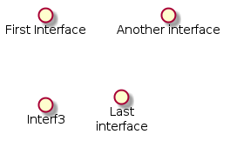
@enduml

Basic example

Links between elements are made using combinaisons of dotted line (..), straight line (--), and arrows (-->) symbols.

@startuml img/component_img01.png

DataAccess - [First Component]
[First Component] ..> HTTP : use
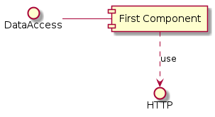
@enduml

Using notes
You can use the note left of , note right of , note top of , note bottom of keywords to define notes related to a single object.

A note can be also define alone with the note keywords, then linked to other objects using the .. symbol.

@startuml img/component_img04.png

interface "Data Access" as DA

DA - [First Component]
[First Component] ..> HTTP : use

note left of HTTP : Web Service only

note right of [First Component]
A note can also
be on several lines
end note
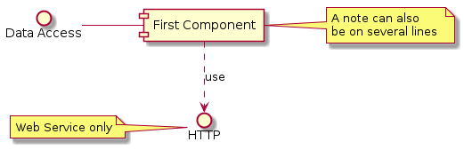
@enduml

Title the diagram
The title keywords is used to put a title.

You can use title and end title keywords for a longer title, as in sequence diagrams.

@startuml img/component_img05.png
title Very simple component\ndiagram

interface "Data Access" as DA

DA - [First Component]
[First Component] ..> HTTP : use
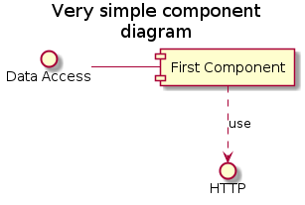
@enduml

Skinparam
You can use the skinparam command to change colors and fonts for the drawing.

You can use this command :

* In the diagram definition, like any other commands,
* In an included file,
* In a configuration file, provided in the command line or the ANT task.

@startuml img/component_img06.png

skinparam componentFontSize 13
skinparam interfaceBackgroundColor RosyBrown
skinparam interfaceBorderColor black
skinparam componentBackgroundColor gold
skinparam componentBorderColor orange
skinparam componentArrowColor #FF6655
skinparam componentArrowFontColor #777777
skinparam componentFontName Courier
skinparam componentArrowFontName Impact

() "Data Access" as DA

DA - [First Component]
[First Component] ..> () HTTP : use
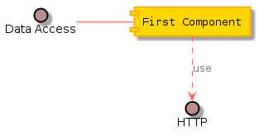
@enduml

State Diagram

To be able to generate those diagram, you must have Graphviz software installed on your machine in the default directory c:\Program Files\GraphvizX.XX or /usr/bin/dot.

You can have a look here if you have installed Graphviz somewhere else.
Simple State
You can use [*] for the starting point and ending point of the state diagram.

Use --> for arrows.

@startuml img/state_img01.png

[*] --> State1
State1 --> [*]
State1 : this is a string
State1 : this is another string

State1 -> State2
State2 --> [*]
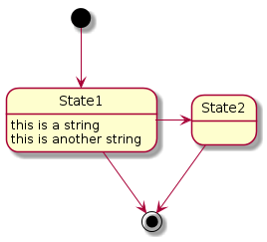
@enduml

Composite state
A state can also be composite. You have to define it using the state keywords and brackets.

@startuml img/state_img02.png

[*] --> NotShooting

state NotShooting {
[*] --> Idle
Idle --> Configuring : EvConfig
Configuring --> Idle : EvConfig
}

state Configuring {
[*] --> NewValueSelection
NewValueSelection --> NewValuePreview : EvNewValue
NewValuePreview --> NewValueSelection : EvNewValueRejected
NewValuePreview --> NewValueSelection : EvNewValueSaved

state NewValuePreview {
State1 -> State2
}

}
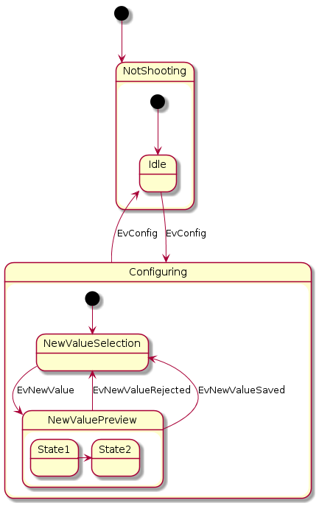
@enduml

Long name
You can also use the state keyword to use long description for states.

@startuml img/state_img03.png

[*] -> State1
State1 --> State2 : Succeeded
State1 --> [*] : Aborted
State2 --> State3 : Succeeded
State2 --> [*] : Aborted
state State3 {
state "Accumulate Enough Data\nLong State Name" as long1
long1 : Just a test
[*] --> long1
long1 --> long1 : New Data
long1 --> ProcessData : Enough Data
}
State3 --> State3 : Failed
State3 --> [*] : Succeeded / Save Result
State3 --> [*] : Aborted

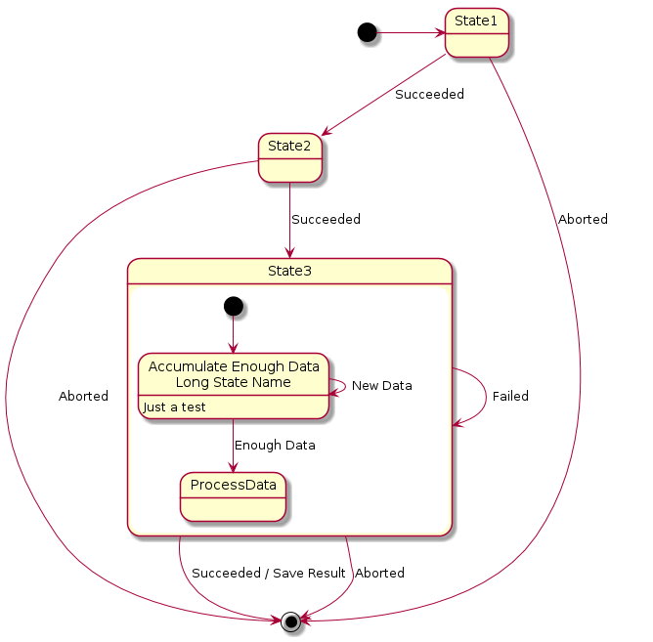
@enduml

Concurrent state
You can define concurrent state into a composite state using the -- symbol as separator.

@startuml img/state_img05.png

[*] --> Active

state Active {
[*] -> NumLockOff
NumLockOff --> NumLockOn : EvNumLockPressed
NumLockOn --> NumLockOff : EvNumLockPressed
--
[*] -> CapsLockOff
CapsLockOff --> CapsLockOn : EvCapsLockPressed
CapsLockOn --> CapsLockOff : EvCapsLockPressed
--
[*] -> ScrollLockOff
ScrollLockOff --> ScrollLockOn : EvCapsLockPressed
ScrollLockOn --> ScrollLockOff : EvCapsLockPressed
}
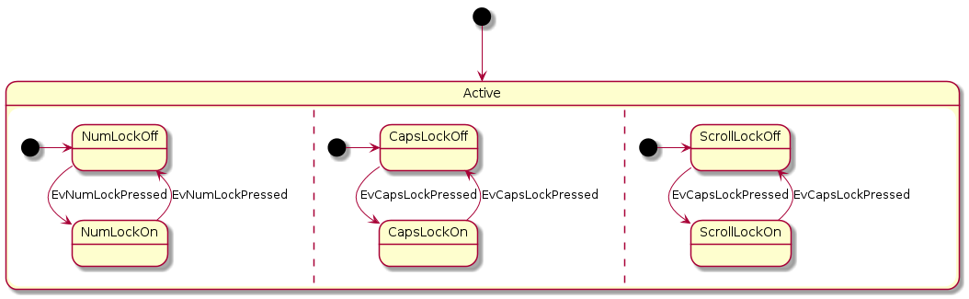
@enduml

Note
You can alse define notes using note left of, note right of, note top of, note bottom of keywords.

You can also define notes on several lines.

@startuml img/state_img06.png

[*] --> Active
Active --> Inactive

note left of Active : this is a short\nnote

note right of Inactive
A note can also
be defined on
several lines
end note
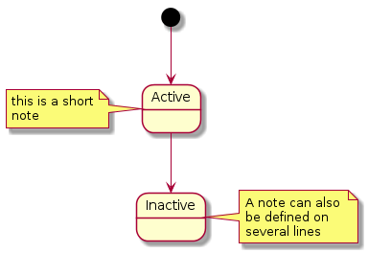
@enduml

More in notes
You can put notes on composite states.

@startuml img/state_img04.png

[*] --> NotShooting

state "Not Shooting State" as NotShooting {
state "Idle mode" as Idle
state "Configuring mode" as Configuring
[*] --> Idle
Idle --> Configuring : EvConfig
Configuring --> Idle : EvConfig
}

note right of NotShooting : This is a note on a composite state
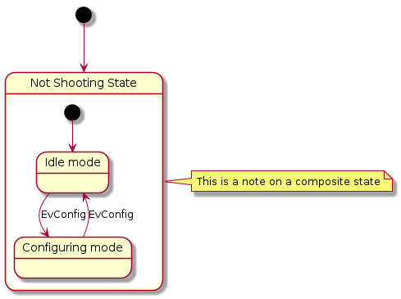
@enduml

