


Universal Proxy Design

Summary
The purpose of this document is to describe the analysis and design of the Mona Lisa Universal Proxy Application (UniProxy).

Dokument Information
Website | http://www.gatehouse.dk
Filename | uniproxy-design.odt
Copyright | GateHouse © 2011-2013
License | Creative Commons (CC BY-NC-SA 3.0)  http://creativecommons.org/licenses/by-nc-sa/3.0/

Revision History
Revision | Date | Author | Description
1.0 | 08/09-2013 | Poul Bondo | Initial release
0.1 | 20/08-2012 | Poul Bondo | Initial revision

Table of Contents
1Introduction 3
1.1Summary 3
1.2Application Description 3
2Requirement Specification 5
2.1General Requirements 6
3Security 7
3.1Authentication 7
3.2Encryption 8
3.3Web Server 8
4Use cases 8
4.1Overview 8
4.2Actors 10
4.3Use cases Uniproxy 10
4.4Use cases Security Broker 17
5Design Proxy 17
5.1General Design Criterias 17
5.2Class Hierarchy 17
5.3Compiler support 19
5.4External Dependencies 19
5.5Configuration files 20
6Initial high level requirements 21

Introduction

Application Description
The intention of the application is to provide a service that can be used for connecting authorities and other operators of maritime information. The application can be considered a simplified VPN application optimized for transferring maritime related data between authorities.

The main operation of the application is to function as a focal point where information is collected and distributed amongst the peers.

The application is intended to provide different kinds of information using different kinds of higher level protocols. The system must work without any central organisation i.e. allow peer to peer connections without central authentication.

The application is intended to work for all kinds of providers and consumers.

The Proxy terminates all incoming client connections by offering local authentication either in the proxy or a local authentication service.

The application is intended to support mutual shared trust

The application will be created in two versions:

- A peer to peer version based on mutual trust
- A peer to peer version based on layered trust

The version with layered trust may be implemented as an add on to the mutual trust version.

Mutual Trust
In the setup for mutual trust both participants in session must agree to trust each other. Through another means of communication (e.g. phone) they will exhange a time to perform the certificate exchange. At the agreed time both parties will inform their proxy to accept a certificate with a given name.


Proxy
Proxy
Proxy
Proxy
Data
Consumer
Data
Provider
On subsequent data session initiation it is not required for the operators to be involved since the relevant certificates have already been exchanged.

Notice that for this set up all possible data connections must be set up in a star configuration. Thus all participants must exchange keys with all other participants. Thus this set up will mostly be valid for low numbers of connections.

Layered Trust
In the layered trust model one or more Certificate Authorities (CA) are created. Each of the CA's must exchange main certificate.

On initial connection a client user will initiate the session. The proxy on the host side will ask its own Certificate Authority for the validity of the certificate proposed by the client. The CA may then validate the certificate or optionally ask the CA of the client to validate the certificate.

Proxy
Proxy
Proxy
Proxy
Data
Consumer
Data
Provider
CA
(A)
CA
(B)
Subsequent data sessions are handled the same way as for the mutual trust version.

Requirement Specification
This section described the general requirements set up for the application.

General Requirements

Protocol Requirements
The application must be able to support a number of different protocols. The application must be considered transparent for each protocol, but may assist where possible and practical.

For each known protocol the application must be able to allow other parties on an individual basis for access and it must be able to request access to other parties data on an individual basis.

ID | Protocol | Description
 | AIS | Handle multiple input streams.  Combine these to a single output stream labeled with a source identifier (use the one present in the source if available).  Doublet filtering.
 | Way route suggestions
 | Database tracks | Using standard SQL TCP/IP connections
 | GateHouse authentication | Handled by plugin

Platform
The application is designed to be available on a variety of platforms. The main use case is based on a server and/or workstation configuration. However the application can also be used on mobile platforms. Please notice that it may require porting to a specific language or implementing other platform constraints.

Information | Description
Platform | Linux  OS-X  MS Windows
User Interface | Web Server
Ipv4 / IPv6 | Yes / Yes

Web page information
First and foremost the application must be very easy to configure. Thus all configuration must be done through a simple web server. Notice the web server must protect access.
Information | Description
Server connection status | For each defined source:  - Supported protocols  - Connection status for each supported / requested protocol
Client connection status | For each connection:  - Access rights for each protol  - Connection status
Data throughput | - Data flow through each connection.
Data throughput history | - For several hours
Configuration Data | For each defined source:  Server address, Client port, Login credentials

Security
A primary concern for the application is security. Some of the data involved in transactions are considered confidential for the parties involved in the transactions. The security involves:

- Authentication
- Encryption

As the basis foundation for handling authentication and encryption the standard Secure Socket Layer (SSL) is used.

Notice this application is intended for civilian usage. It is not military grade security. Also it should not be used for any kind of money transfer, since it does not fullfill any of the PCI DSS requirements or similar.

Authentication
Authentication is the process of identifying the 2 parties involved in the transaction in relation to each other.

Several layers of authentication is involved within these systems. The proxy is intended as a transport layer of data. Thus the transport layer must ensure that other nodes connected to the proxy are handled by proper authorities. It is not the case for the proxy to ensure authentication of the users using the data. This must be handled by higher level applications.

Notable here is that we are authenticating systems not people in the process. This implicates that the systems must be able to be automatically authenticated to each other.

For the higher level applications the proxy will provide optional authentication methods which may or may not be used by the applications.

Information | Description
Local (authentication) | Use local users (Linux, OSX, Windows)
Forward (authentication) | PAM (Linux)  AD (Windows)  This can be implemented using plugins.
Allowed operations | Stored locally in configuration.

At the proxy level the following authentication scheme is used:
- To authenticate two systems towards each other SSL certificates are used.
- The source IP address is used for identifying the user

Encryption
The data tunnels will use standard SSL based communication.
A socket instance will be created for each of the different protocols that the client proxy requests.

Web Server
The application Web Server must be accessible for several different users, but all from within the local network.

Plugin Structure
The proxy must have a framework for plugins with the ability to provide facilities for authentication and data filtering.

Use cases
This section will describe the use cases for the proxy application and for the security broker.

Overview

Administrative use cases:
The administrative use cases covers installation and maintenance.

@startuml
title Administrative use cases
left to right direction
actor :Administrator:
actor :Remote\nSystem: as remote
(Start Application)
(Stop Application)
(Installation)
(De Installation)
(Configuration)
Administrator --> (Start Application)
Administrator --> (Stop Application)
Administrator --> (Configuration)
remote --> (Start Application)
remote --> (Stop Application)
Administrator --> (Installation)
Administrator --> (De Installation)
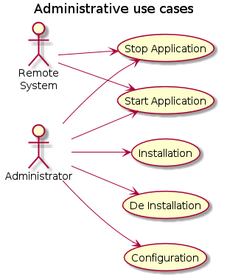
@enduml

Data Flow Use cases:
The data flow use cases covers the normal operational use cases with established connections.
@startuml
Title Data Flow use cases
left to right direction
actor :Remote\nSystem: as remote
actor :Data consumer: as consumer
actor :Data provider: as provider
(Data Flow)
(Historical\nData Flow)
consumer --> (Data Flow)
consumer --> (Historical\nData Flow)
provider --> (Data Flow)
provider --> (Historical\nData Flow)
remote --> (Data Flow)
remote --> (Historical\nData Flow)
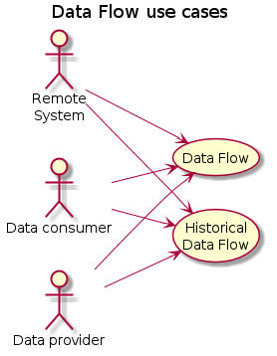
@enduml

Connection Use cases
The connection use cases covers establishing data connections.

@startuml
title Connection use cases
left to right direction
actor :Remote\nSystem: as remote
actor :Data consumer: as consumer
actor :Data provider: as provider
actor :Security Broker: as broker
(Connect To Remote Host)
(Connect From Remote Host)
remote --> (Connect To Remote Host)
remote --> (Connect From Remote Host)
provider --> (Connect From Remote Host)
broker --> (Connect To Remote Host)
broker --> (Connect From Remote Host)
consumer --> (Connect To Remote Host)
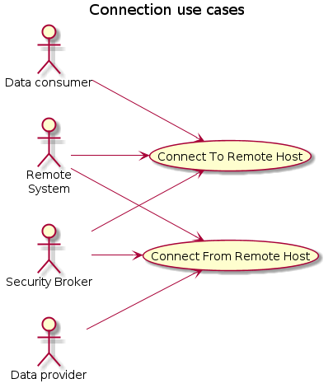
@enduml

Actors

Actors | Description
Administrator | Person (or automated system) managing the Proxy application
Remote System | Remote proxy
Data provider | Local system providing data to the remote data consumer
Data consumer | Local system requesting data from the remote data provider
Security Broker

Use cases Uniproxy

ID | Use case | Description
1 | Start | Start the application
2 | Stop | Stop the application
3 | Configuration | Configure the application
4 | Connect To Remote Host | Client Connect to local proxy  Local proxy connects to remote proxy  Disconnected and Reconnect  Authentication
5 | Connect From Remote Host | Remote proxy connect to local proxy  local proxy connects to local data provider  Disconnected and Reconnect  Authentication
6 | Monitor | Monitor the status of the application
7 | Current Data Flow | Provide current data  Handle missing data  Handle connection loses
8 | Historical Data Flow | Provide Historical data
9 | Installation | Installation of the application
10 | De installation | De installation of the application
11 | Certificates exchange | Exchange certificates between two proxy instances.

Start
Factor | Description
Goal | Run operationally
Initialization | Initiated by user or as a daemon / service
Actors
Simultaneous Occurrences | 1
Frequency | Rare
Non functional requirements | Must not require human intervention to start and reach state from previous run.  On first run it may require human intervention until configuration is complete.
Precondition | Installed
Description | - Load configuration:  - Check valid own name  - Check valid certificates  - Generate certificates if valid own name  - Start webserver  - Start server sockets (if valid certificates and configuration)  - Start client sockets (if valid certificates and configuration)
Exceptions | If no valid own name exist then start webserver and wait for configuration file upload.  If fail to generate certificates (openssl) then start webserver and inform user.
Post condition | Ready to initiate use case: Connect To Host

Stop
Factor | Description
Goal | Stop application, free all resources. Indicate to Administrator that it has stopped.
Initialization | Administrator
Actors | Administrator, Remote System
Simultaneous Occurrences | 1
Frequency | Rare
Non functional requirements | All relevant information must be stored persistent on disk.
Precondition
Description | All clients are disconnected  All connections to hosts are dropped  Application is stopped  Any javascript running in any browsers will keep running and poll for restart. This will be clearly visible with timestamp for Operator. Notice that no new connections can be established to the webserver.
Exceptions | Must always stop. Can leave information for the monitoring system.
Post condition | Application is stopped.  Webpage indicates application is stopped.

Configuration
Factor | Description
Goal | Configure, detect configuration problems, set login credentials, change password ?  Provide public service interface  Select interfaces from other proxys
Initialization | Administrator
Actors | Administrator, Remote System
Simultaneous Occurrences | 1
Frequency | Rare
Non functional requirements | It shall not be required to restart the application when configuration changes.  It shall be preferred if existing valid connections are not broken.
Precondition | Must be possible both while stopped and while running.
Description | The Administrator uploads a new configuration file or updates the configuration file and reload the service.  All clients and hosts are disconnected while the new configuration is loaded.  Any host and client also defined in the new configuration can reconnect.
Exceptions | The new configuration file is checked for valid format, but not content before being loaded.
Post condition | The system is running with the new configuration setup.

Connect To Remote Host
Factor | Description
Goal | Data consumer is connected to the local proxy  Local proxy is connected to Remote Host  Stay connected and Reconnect
Initialization | Data consumer
Actors | Data consumer, Remote System
Simultaneous Occurrences | Can happen multiple times simultaneously. In fact this will often be the case after a start application.
Frequency | Must be able to handle multiple repeated connection requirest.
Non functional requirements | If repeated connections are happening, then a grace period should be used before connecting to the Remote System.
Precondition | Running and configured.
Description | Perform authentication against Remote System
Exceptions | If connection or authentication with the Remote System fails for whatever reason the connection to the local client must also be broken.
Post condition | Connection and authentication performed to the Remote System. Transparent TCP/IP socket connection established to Remote System.

Connect From Remote System
Factor | Description
Goal | Remote proxy is connected to local proxy. Local proxy is connected to local data provider.
Initialization | Remote System
Actors | Remote System
Simultaneous Occurrences | Can happen multiple times simultaneously. In fact this will often be the case after a start application.
Frequency | Must be able to handle multiple repeated connection requirest.
Non functional requirements | If repeated connections are happening, then a grace period should be used before connecting to the host system.
Precondition | Running and configured.
Description | When a connection request is received from a Remote System  1) Authentication of certificate is performed.  2) A connection is established to the local data provider.
Exceptions | If either the authentication or the connection and validation against the local data provider fails, then the connection to the Remote System shall be dropped.
Post condition | Connection and authentication performed to the Remote System. Transparent TCP/IP socket connection established to Remote System.

Monitor
Factor | Description
Goal | Passive watch (web page), SMS, Email ?
Initialization | Upon start of application
Actors | Monitoring System
Simultaneous Occurrences | Multiple clients can connect.
Frequency | Often, i.e. at few seconds interval.
Non functional requirements
Precondition
Description | The application will provide a status web page that indicates the relevant status information for each of the configured connections.  The application will provide status information for external monitoring tools such as Nagios.  Each status request will be handled as a AJAX JSON request.
Exceptions | The webpage should indicate if there are no response to the AJAX JSON requests.
Post condition | The webpage is displayed with the proper information or the Monitoring System receives the status information.

Current Data Flow
Factor | Description
Goal | Provide a transparent TCP/IP socket
Initialization | Data consumer
Actors | Data consumer, Data provider.
Simultaneous Occurrences | Multiple clients can connect to the same Proxy on the local end. Only the first will be allowed to transmit. All clients will receive data.  Multiple remote proxys can connect to one proxy on one port. A separate connection is established for each remote proxy. Thus they should not impact each other.
Frequency | All the time.
Non functional requirements | None
Precondition | Connections have been established and authentication has been performed.
Description | Connections have been established. Simply pump data through in each direction.  Manage if no data is received/transmitted for a significant period of time upon which the connection shall be dropped, or a keep alive signal must be sent.
Exceptions | If there are significant performance difference between multiple connected local clients, then the slowest will set the barrier.
Post condition | Data is transmitted transparently between the involved participants.

Historical Data Flow
Transparent for the Proxy application. Must behave the same way as for Current Data Flow.

Installation
Factor | Description
Goal | Simple installation as a daemon / service on a server or a workstation.
Initialization | Must be provided as a single package with as few external dependencies as possible.
Actors | Administrator
Simultaneous Occurrences | No
Frequency | Rare
Non functional requirements | Expected dependencies:  1) Openssl:
Precondition | The dependencies are installed.
Description | The installation procedure must ensure that the application along with its dependencies are installed.  The installation procedure must ensure that the application are installed as a daemon / service.  The configuration use case must subsequently be performed.
Exceptions | If the external dependencies are not met and cannot be installed then the administrator must be informed.
Post condition | The application along with the dependencies are installed and the application is ready as a service and ready for configuration.

De Installation
Factor | Description
Goal | Remove the application from the system.
Initialization | Administrator
Actors | Administrator
Simultaneous Occurrences | No
Frequency | Rare
Non functional requirements | Any installed dependencies can be left on the system.  The service must be deinstalled.
Precondition | The service is installed or a de installation has failed.
Description | Must always be performed even if a previous attempt failed.
Exceptions | User rights for administrator.
Post condition | Application remove from the system and service deinstalled.

Use cases Security Broker

ID | Use case | Description
1 | Installation | Installation of the application
2 | De installation | De installation of the application
3 | Configuration | Configure the application
4 | Start | Start the application
5 | Stop | Stop the application
6 | Monitor | Monitor the status of the application
7 | Certificates exchange | Exchange certificates between security broker instances.
8 | Add / Edit / Delete a user
9 | Receive query from Proxy | Receive a confirmation request from a Proxy.

Administrative Use cases
The administrative use cases covers installation and maintenance.

@startuml
Title Administrative use cases.
left to right direction
actor :Administrator: as administrator
(Start)
(Stop)
(Installation)
(Deinstallation)
(Monitor)
administrator --> (Start)
administrator --> (Stop)
administrator --> (Installation)
administrator --> (Deinstallation)
administrator --> (Monitor)
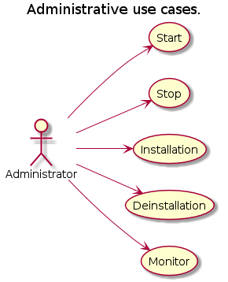
@enduml

Operational Use cases
The operational use cases covers the normal functional use cases.

@startuml
Title Operational use cases
left to right direction
actor :Proxy: as proxy
actor :Remote Security Broker: as remote
(Edit User)
(Query)
(Certificate Exchange)
administrator --> (Edit User)
administrator --> (Certificate Exchange)
proxy --> (Query)
remote --> (Certificate Exchange)

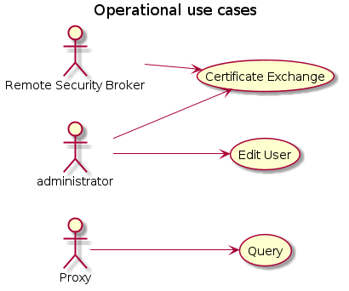
@enduml

Installation
Factor | Description
Goal | Install the application
Initialization | Administrator
Actors | Administrator
Simultaneous Occurrences | None
Frequency | Rare
Non functional requirements | The system shall run using a web server
Precondition | The required dependencies must be installed.
Description | The application must be packaged properly for simple installation  Dependencies will include:  1. OpenSSL  2. Web server  The application will normally be installed as a Service / Daemon.
Exceptions
Post condition | The system is installed and ready for configuration

Deinstallation
Factor | Description
Goal | Remove the application from the computer.
Initialization | Administrator
Actors | Administrator
Simultaneous Occurrences | None
Frequency | Rare
Non functional requirements
Precondition | The application is stopped
Description | Remove the software.  Remove configuration  Remove user settings and certificates
Exceptions | TBD: What about certificates. Shall they be deleted ?  Dependencies not installed or not found.
Post condition | The system has been deinstalled.

Configuration
Factor | Description
Goal | Get a fully configured system.
Initialization | Administrator
Actors | Administrator
Simultaneous Occurrences | None
Frequency | Rare
Non functional requirements
Precondition
Description | On the first configuration a CA certificate must be generated or imported.
Exceptions | Dependencies not installed or not found.
Post condition

Start
Factor | Description
Goal | Get the application running
Initialization | Administrator
Actors | Administrator
Simultaneous Occurrences | None
Frequency | Rare
Non functional requirements
Precondition | The system is configured.
Description | The service is started. On first startup an automatic configuration is performed.
Exceptions
Post condition | The application is running and ready to accept requests.

Stop
Factor | Description
Goal | Stop the application
Initialization | Administrator
Actors | Administrator
Simultaneous Occurrences | None
Frequency | Rare
Non functional requirements
Precondition
Description | Do not accept new requests.  Finish pending operations  Shut down.
Exceptions | Pending operations not finished in reasonable time.
Post condition | The application is stopped

Monitor
Factor | Description
Goal | Monitor the application
Initialization | Administrator
Actors | Administrator
Simultaneous Occurrences | One or few
Frequency | Often
Non functional requirements | It is the requirement for the monitoring system that it is able to understand the information from the application
Precondition | A valid monitoring system must be available such as Nagios or similar
Description | An interface must be available for quering current status including  Users / valid certificates
Exceptions
Post condition | The monitoring system is informed of the current status of the system

Certificate Exchange
Factor | Description
Goal | Allow two independent CA's to exhange certificates
Initialization | Administrator and Remote CA
Actors | Administrator and Remote CA
Simultaneous Occurrences | 1
Frequency | Rare
Non functional requirements
Precondition
Description | It must be possible to import certificates from other CA's to allow local proxy applications to query the local CA about other CA's certificate.
Exceptions | Import may fail from procedural or technical problems. The application must clearly indicate if the system was successful or not.
Post condition | Certificates are exchanged such that local proxy applications can query about other CA's certificates.

Add / Edit / Delete user
Factor | Description
Goal | Add or Edit or Delete a user from the system
Initialization | Proxy
Actors | Proxy, Administrator
Simultaneous Occurrences | Multiple. Can be limited to one at a time.
Frequency | Once for each proxy.
Non functional requirements
Precondition | The system is running and fully configured.
Description | Add: The Administrator can prepare a user (or range of users) for automatic accept by the system. Such that when a proxy send a certificate request with the correct name a positive response is sent back. As an alternative the Administrator can require that the operation is done synchronously. i.e. the Administrator and the user talk on the phone and perform the operation at the same time.  The proxy will generate its own keys and send a certificate request to the CA. The CA will sign the certificate and return it. The certificate will contain a unique name within the CA.  Edit: The user information can be updated. Also the certificate can be deleted (stored in the CRL) and a new certificate can be created for the same user.  Delete: When deleting a user the proxy certificate should be stored in the CRL until it is expired.
Exceptions | An invalid user send a certificate request. It should be ignored or a response should be sent to the user.
Post condition | Add/Edit: The user has been updated with the proper settings.  Delete: The certificate is placed in CRL.

Receive Query from Proxy
Factor | Description
Goal | Validate a certificate from a local proxy application
Initialization | Proxy
Actors | Proxy
Simultaneous Occurrences | Multiple.
Frequency | Often
Non functional requirements
Precondition | Broker application is running.  Proxy has been created on the Broker system.
Description | Whenever a proxy receives a certificate from another proxy which it does not know it should query the local CA about certificate validation.  If the certificate is valid it can be stored in the Proxy local cache. It should then be checked on a regular basis (e.g weekly).  If the certificate is expired it is not required to check with the CA.
Exceptions | No connection from the Proxy til the Broker.  On first attempt the proxy should deny the requesting proxy certificate.  On later attempts (ie the Broker has once authenticated the certificate) then it can be assumed to be acceptable. The certificate should then be checked again on next request.  If the local proxy does not exist on the broker application then the broker should reply with this information.
Post condition | The certificate is validated and stored in the proxy local cache.

Project Limitations
The actual implementation from the project Mona Lisa will be limited to the following:

- Production ready: The item will be fully ready and put in production in the GateHouse environment.
- Test and demonstration: The item will be developed and tested for demonstration purposes but may not be completely ready for production.
- Prepared but not implemented or tested: An effort has been made to ensure that it should work in theory, but no effort has been put in actual implementation and test.
- Not considered: The item is a valid operational scenario but no effort has been put into design or implementation.

Proxy Application
Group | Item | Expected output
Authentication | Peer To Peer | Production ready
 | Layered | Test and demonstration
Platform | Windows | Production ready
 | Linux | Production ready
 | MacOS | Prepared but not implemented or tested
Protocol | AIS distribution | Production ready
 | SQL | Test and demonstration (using PostgreSQL)
Redundancy | Multiple instances | Prepared but not implemented or tested

Security Broker
Group | Item | Expected output
Authentication | Layered CA | Test and demonstration
 | Layered multi CA | Prepared but not implemented or tested
Platform | Windows | Prepared but not implemented or tested
 | Linux | Test and demonstration
 | MacOS | Prepared but not implemented or tested
Redundancy | Multiple instances | Not considered

Design Proxy
The design of the proxy application will not be described in details. The application is fairly small and will evolve too fast over time to warrant keeping this design up to date. Also once released to the community as open source there will be no control over the update process.

The design described in this section is valid at the initial implementation of this application.

General Design Criterias
The design is based on an implementation in an object oriented language.

The implementation is done in C++. Although it should be fairly simple to port for other languages such as C#, Objective C or Java.

Class Hierarchy
The proxy will have a fairly simple class hierarchy based on:

- A set of classes for handling the client and server sockets for connecting the clients and hosts.
- Webserver and status message handling

Socket handling

- A class for accepting local clients (LocalHost) along with a class for each instance connecting (LocalHostSocket).
- A class for accepting remote clients (RemoteProxyHost) along with a class for each instance connecting (RemoteProxyClient).

@startuml
title Main Socket Connection Hierarchy
RemoteProxyHost "1" o-- "n" RemoteProxyClient : contains
main "1" o-- "n" RemoteProxyHost
main "1" o-- "n" LocalHost
RemoteProxyHost *-- plugin_handler
LocalHost *-- plugin_handler
LocalHost "1" o-- "n" LocalHostSocket
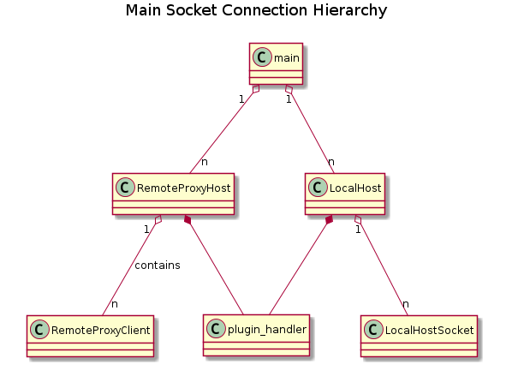
@enduml

Status handling

@startuml
title Main Web and Status Hierarchy
package cppcms {
class application
}
note left: The cppcms package
class proxy_app {
}
class main {
--
The main function
}
class proxy_global {
--
One instance
}
class session_data {
--
Holds data for each
browser connection.
}
main "1" *-- "1" proxy_global
main "1" o-- "n" proxy_app
application <|-- proxy_app
proxy_global "1" o-- "n" session_data
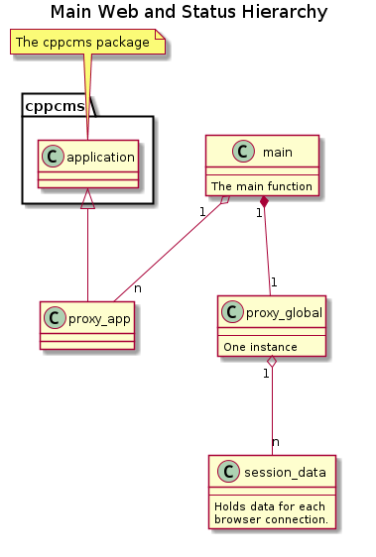
@enduml

Compiler support
Notice that the C++11 standard is used. However it is initially limited to the somewhat limited support available in Visual Studio 2010. For the Linux platform GCC G++ 4.7 is used. Thus these tools are considered the minimum requirement.

External Dependencies
The design will be based on the availability and usage of the following packages as dependencies:

- Boost library (www.boost.org)
- Openssl (www.openssl.org)
- Cppcms (www.cppcms.com)
- Webserver (Apache or Lighttpd or MS IIS) Required only for the Security Broker, not for the Proxy.

The licenses of these packages are compatible with the GPL license.

The dependencies are also available on the platforms that we expect to use for this application.

Configuration files
The configuration will be stored in a single configuration file in the JSON format. This will allow it to be easy to maintain both from a system and hand made by an operator.

Please notice that the exact format used will be defined in the user manual. This is just a guideline.

{
"clients":[
{
"local_port" : 1240,
"name" : "remote1",
"remote_hostname" : "11.22.33.44",
"remote_port":1234
},
{
"local_port" : "1241",
"name" : "remote2",
"remote_hostname" : "remote2.host.com",
"remote_port" : 1234
}
],
"hosts" :[ {
"port" : 15471,
"locals" : [{ "hostname" : "192.168.24.14", "port" : 2003 }],
"remotes" : [{ "name" : "remote1"},{ "name" : "someoneelse"}]
}],
"config" : { "name" : "mycertificatename" },
"web" : { "port" : 8085 }
}

When starting the application the first time a basic configuration is required:

{
"config" : { "name" : "mycertificatename" }
}

Initial high level requirements
The following list was the initial requirements set forward by the Danish Maritime Authorities in relation to the Mona Lisa Project.

DMA has requested a proxy that will be easily deployable and work for several (as of yet unknown) protocols.

This has been made into the following simplified requirements:

- Multiple (unknown) protocols must be supported. This will be handled by supplying a transparent TCP socket for each protocol.
- Establish identity of the connected opponent
- Encrypt data during transmission over the Internet

The basis is a VPN solution, with the following additional guidelines:

- Do not want other parties to know internal IT structure. The internal structure may change at any time.
- Make it very simple for single host clients
- Make it flexible for multi host clients.
- Make it flexible for multi client hosts.
- Provide a web interface for configuration and monitoring.
- Provide a plugin interface to enable manipulation / filtering of the data on a protocol level and handle login methods for accessing hosts.
- Possibility for buffering data when e.g. the public Internet is down.

The application will use the same principles as a standard VPN solution.

