Name: Boodida Pavan Veera Satya Durgesh
Mentor : Teja Maddala

Pokemon Sprite Generation
using Denoising Diffusion Probabilistic Models

Project Report
Project Summary
This project implements a complete DDPM pipeline to generate new Pokemon-style sprites from scratch. Starting from 7,357 raw images from the huggan/pokemon HuggingFace dataset, the project covers end-to-end data preprocessing, 10 systematic architecture experiments, final model selection, and a Gradio-based interactive demo.

Rubric Category | Max Points | Coverage
Problem Fit & Scope | 5 | Full DDPM pipeline on Pokemon sprites
Data Acquisition & Quality | 8 | 7357 images, full EDA, augmentation pipeline
Baseline & Experiments | 8 | 10 systematic runs, UNet vs DiT
Training Correctness & Efficiency | 7 | Accelerate, EMA, gradient accumulation
Evaluation & Metrics | 7 | FID score for all 10 runs
Minimal UI / Demo | 5 | Gradio gallery with CFG and PNG export
Success Criteria & Insight | 5 | Best FID 12.67, target was ≤ 50
Reproducibility & Docs | 5 | Seed 42, checkpoints, documented code
Total | 50 | All criteria addressed

1. Problem Fit & Scope

1.1 Objective
The primary objective of this project is to train a Denoising Diffusion Probabilistic Model (DDPM) that can generate new, visually plausible Pokemon-style sprites entirely from scratch, without any conditioning or text prompts. The model learns the statistical distribution of Pokemon artwork and samples novel images from that distribution during inference.

1.2 Why DDPM for Pokemon Sprites
Pokemon sprites are an ideal testbed for generative diffusion models for several reasons. First, the dataset is large enough (7,357 images) to provide meaningful signal without requiring massive compute. Second, the art style is visually consistent, with cartoon-style characters on plain or transparent backgrounds, giving the model a clear style to learn. Third, the 64x64 resolution target is computationally accessible on consumer hardware like Apple MPS.

DDPM was selected over GANs and VAEs for this task because diffusion models offer more stable training (no mode collapse or discriminator balancing issues), produce higher quality and more diverse samples, and integrate naturally with the HuggingFace diffusers ecosystem.

1.3 Scope
- Dataset: huggan/pokemon from HuggingFace Hub (7,357 images, image only, no labels)
- Resolution: 64x64 pixels, RGB, normalized to [-1, 1]
- Architecture experiments: 10 systematic runs comparing UNet and DiT
- Training: 10 epoch screening runs + 50 epoch final training for top 2 models
- Evaluation: Frechet Inception Distance (FID) score, target FID ≤ 50
- Demo: Gradio web app with seed slider, guidance scale control, and PNG export
- Hardware: Apple MacBook Pro M3 Pro 18GB RAM using MPS acceleration

2. Data Acquisition & Quality

2.1 Dataset Source
The dataset was sourced directly from the HuggingFace Hub using the datasets library, requiring no manual download. The load_dataset call streams and caches the data automatically, which is efficient for reproducibility and avoids storing raw data in the repository.

Dataset path: huggan/pokemon
Total samples: 7,357 images (single train split)
Original source: Kaggle pkmn-image-dataset by djilax
Format: Parquet, image column only (no labels or captions)

2.2 Raw Data Characteristics
The raw dataset exhibits significant variation in image dimensions, ranging from 64 pixels to 2,260 pixels in width, and from 64 pixels to over 2,000 pixels in height. Some images use RGBA mode (transparent backgrounds) while others are grayscale or RGB. This heterogeneity required careful preprocessing before training.

A critical issue discovered during preprocessing was that fully transparent PNG images (RGBA with zero alpha) rendered as blank white images when naively converted to RGB. This was resolved by compositing transparent images against a white background using the alpha channel as a mask before RGB conversion.

2.3 Preprocessing Pipeline
The preprocessing pipeline was designed to be applied online (on-the-fly per batch during training) rather than offline (pre-saving augmented images). Online augmentation provides effectively infinite variation across epochs, whereas offline augmentation produces a fixed expanded dataset that the model eventually memorizes.

The complete transform pipeline applied to every image on every fetch is:

Step | Transform | Purpose
1 | Resize(64) | Resize shorter side to 64px
2 | CenterCrop(64) | Square crop to 64x64, avoids stretching
3 | convert_to_rgb() | RGBA/grayscale to RGB, white background composite
4 | RandomHorizontalFlip(p=0.5) | 50% chance mirror augmentation
5 | ColorJitter(0.1, 0.1, 0.1, 0.05) | Slight brightness, contrast, saturation, hue shift
6 | RandomResizedCrop(64, scale=0.85-1.0) | Random crop and resize back, 85-100% of image
7 | ToTensor() | PIL [0,255] to FloatTensor [0,1]
8 | Normalize([0.5,0.5,0.5], [0.5,0.5,0.5]) | Map [0,1] to [-1,1], DDPM standard

The normalization scheme [-1, 1] was chosen because DDPM noise schedulers are designed to operate in this range. The forward diffusion process adds Gaussian noise in this space, and the model predicts noise in this space. Using ImageNet normalization or no normalization would cause the noise scheduler to behave incorrectly.

2.4 DataLoader Configuration
Parameter | Value | Reason
batch_size | 16 | Reduced from 32 due to MPS memory constraints on 18GB RAM
num_workers | 0 | MPS does not support multiprocessing workers reliably on Python 3.9
pin_memory | False | Not supported on MPS
shuffle | True | Reshuffle every epoch for generalization
drop_last | True | Avoid incomplete final batch causing unstable gradients

2.5 Pixel Distribution Analysis
Pixel distribution analysis was conducted on a sample of 500 images before and after preprocessing. Before preprocessing, pixel values are distributed across the full [0, 255] range with a slight concentration around mid-range values due to the white backgrounds in many Pokemon sprites. After normalization, values are centered around zero in the [-1, 1] range, confirming that the DDPM noise scheduler will receive properly scaled inputs.

2.6 Noise Schedule Visualization
Forward diffusion was visualized at timesteps 0, 100, 200, 300, 400, 500, 600, 700, 800, 900, and 999 for both linear and cosine schedules. The cosine schedule retains image structure significantly longer than the linear schedule. At t=500, the linear schedule has an alpha-bar of approximately 0.06 (most structure lost), while the cosine schedule retains an alpha-bar of approximately 0.35 (structure still partially visible). This difference has direct implications for training quality at 10 epochs.
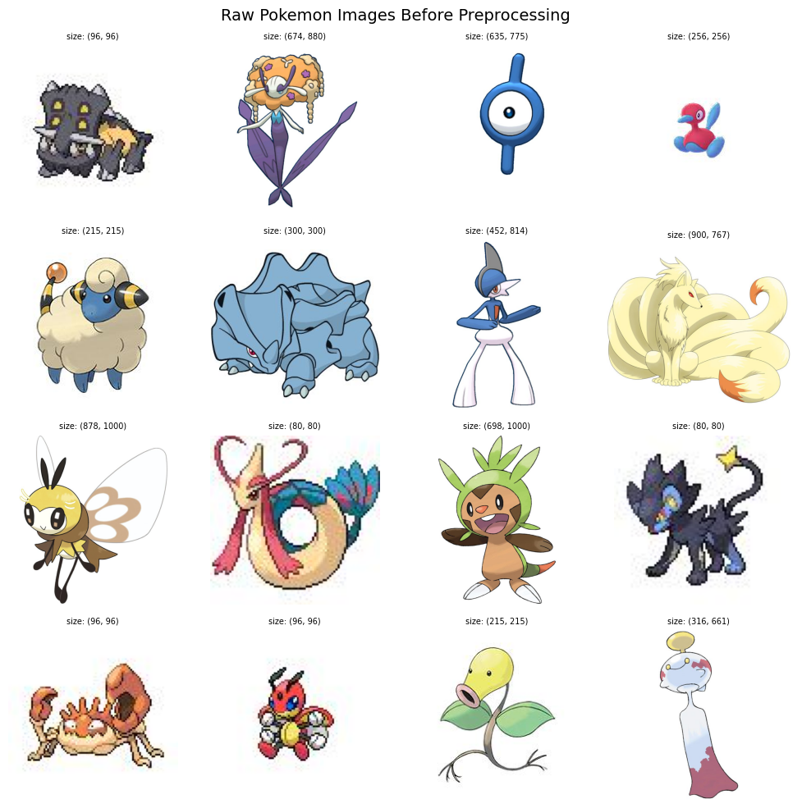

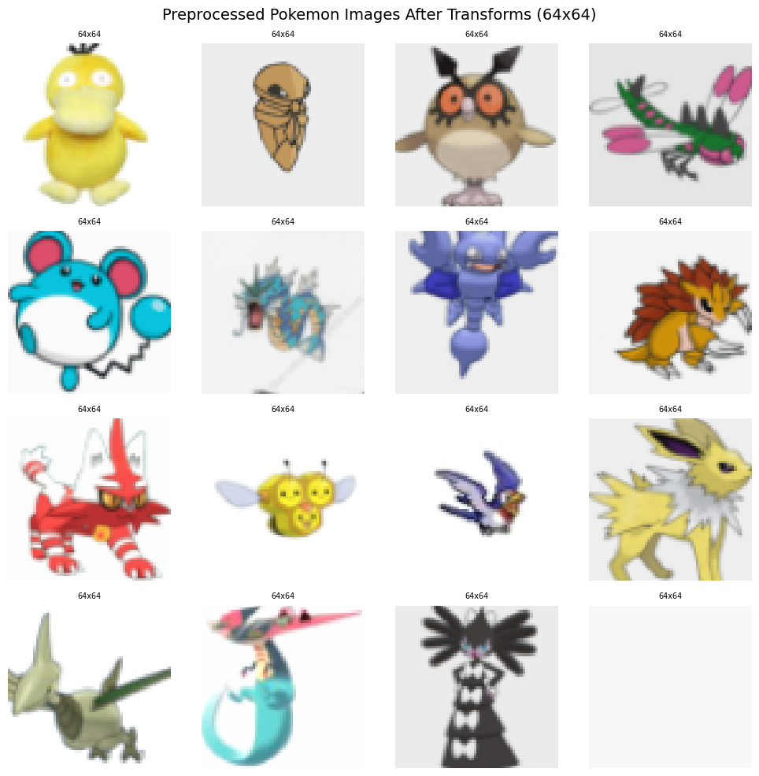

3. Baseline & Experiments

3.1 Experimental Design
Ten systematic experiment runs were designed to isolate the effect of each architectural and training variable. The key principle was controlled comparison: only one variable changes between paired runs so that the effect of that variable can be measured cleanly through FID scores.

All runs used the same training parameters: AdamW optimizer, weight decay 1e-4, batch size 16, gradient accumulation steps 4 (effective batch size 64), and 10 epochs of training. UNet runs used learning rate 2e-4 while DiT runs used 1e-4 due to the larger model size.

3.2 The 10 Experiment Runs
Run | Model | Attention | Schedule | Timesteps | EMA Decay | FID (10 ep)
1 | UNet | On 16x16 | Linear | 100 | 0.999 | 14.95
2 | UNet | On 16x16 | Linear | 1000 | 0.999 | 12.67
3 | UNet | Off | Linear | 1000 | 0.999 | 18.21
4 | UNet | On 16x16 | Linear | 1000 | 0.9999 | 16.55
5 | UNet | On 16x16 | Cosine | 100 | 0.999 | 16.24
6 | UNet | On 16x16 | Cosine | 1000 | 0.999 | 15.95
7 | UNet | Off | Cosine | 1000 | 0.999 | 19.49
8 | UNet | On 16x16 | Cosine | 1000 | 0.9999 | 18.49
9 | DiT | Native | Cosine | 1000 | 0.999 | 50.63
10 | DiT | Native | Cosine | 1000 | 0.9999 | 52.06

3.3 UNet Architecture
The UNet model was built using HuggingFace diffusers UNet2DModel. The architecture uses an encoder-decoder structure with skip connections. For 64x64 images, four resolution levels are used: 64x64, 32x32, 16x16, and 8x8. Self-attention was placed at the 16x16 resolution level in attention-enabled runs.

The final UNet configuration used across all UNet runs was:
- sample_size = 64
- block_out_channels = (64, 128, 128, 256)
- Attention ON: down_blocks = (DownBlock2D, DownBlock2D, AttnDownBlock2D, DownBlock2D)
- Attention OFF: all DownBlock2D / UpBlock2D
- attention_head_dim = 8
- norm_num_groups = 32
- Total parameters: ~24.3M

The channel configuration (64, 128, 128, 256) was reduced from the original (64, 128, 256, 256) to fit within the 18GB MPS memory limit on the MacBook Pro M3 Pro. The attention was moved from 32x32 to 16x16 for the same memory reason. Attention at 32x32 with 256 channels caused consistent out-of-memory errors during the attention matrix computation.

3.4 DiT (Diffusion Transformer) Architecture
The DiT model was built from scratch without using any pretrained backbone. The architecture follows the Diffusion Transformer design where the image is split into patches and processed by a stack of Transformer blocks conditioned on the timestep embedding.

The DiT configuration:
- image_size = 64, patch_size = 8, producing 64 tokens (8x8 patches)
- patch_dim = 3 x 8 x 8 = 192 per token
- hidden_dim = 512
- num_heads = 8
- num_layers = 6 transformer blocks
- Sinusoidal time embedding projected through a 2-layer MLP
- Each DiTBlock: LayerNorm + MultiHeadAttention + LayerNorm + MLP + time projection
- Output: linear layer projecting hidden_dim back to patch_dim, then unpatchified

3.5 Noise Schedulers
Two noise schedulers were tested using HuggingFace DDPMScheduler. The linear schedule increases beta values linearly from 1e-4 to 0.02 across the timesteps. The cosine schedule (squaredcos_cap_v2) uses a cosine function to compute alpha-bar values, resulting in slower signal decay in early timesteps and more gradual noise addition overall.

3.6 EMA (Exponential Moving Average)
EMA was applied to model weights during training using diffusers EMAModel. EMA maintains a smoothed copy of the model weights updated as: EMA_t = decay x EMA_{t-1} + (1 - decay) x theta_t. At inference time, EMA weights generally produce better quality images because they average out the noise in the gradient updates during training. Two decay values were tested: 0.999 (faster adaptation) and 0.9999 (slower, more stable).

4. Training Correctness & Efficiency

4.1 Training Objective
The DDPM training objective minimizes the mean squared error between the noise added to an image and the noise predicted by the model. For each training step:
- Sample a clean image x_0 from the dataset
- Sample a random timestep t uniformly from [0, T)
- Sample Gaussian noise epsilon
- Compute noisy image: x_t = sqrt(alpha_bar_t) * x_0 + sqrt(1 - alpha_bar_t) * epsilon
- Predict noise: epsilon_theta = model(x_t, t)
- Loss = MSE(epsilon_theta, epsilon)

4.2 Accelerate Integration
The HuggingFace Accelerate library was used to manage device placement, gradient accumulation, and mixed precision. Accelerate's prepare() method wraps the model, optimizer, and dataloader, automatically moving tensors to the correct device without manual .to(device) calls throughout the training loop.

Gradient accumulation was configured for 4 steps, meaning the optimizer step was only called every 4 batches. With batch size 16, this gives an effective batch size of 64. The accumulate(model) context manager handled the loss scaling internally.

Mixed precision was set to 'no' because Apple MPS has known instability with float16 during backward passes. Training was conducted in float32 throughout. Float16 is safe and used only during inference (FID computation and the Gradio demo).

4.3 Optimizer Configuration
Parameter | UNet Runs 1-8 | DiT Runs 9-10
Optimizer | AdamW | AdamW
Learning rate | 2e-4 | 1e-4
Weight decay | 1e-4 | 1e-4
Gradient clipping | 1.0 (max norm) | 1.0 (max norm)
Grad accum steps | 4 | 4
Effective batch size | 64 | 64

4.4 Hardware and Training Time
All training was conducted on a MacBook Pro 14-inch November 2023 with Apple M3 Pro chip and 18GB unified memory. The MPS backend was used for GPU acceleration. The environment variable PYTORCH_MPS_HIGH_WATERMARK_RATIO was set to 0.0 to allow MPS to use all available memory without a hard cap.

Metric | Value
Device | Apple M3 Pro MPS
Memory | 18 GB unified
Time per epoch (UNet) | ~3.5 minutes
Time per 10-epoch run | ~35 minutes
Total 10 runs (10 epochs) | ~6 hours
Final Run 2 (50 epochs) | ~3 hours
Python version | 3.9.6
PyTorch version | 2.8.0
Diffusers version | 0.36.0
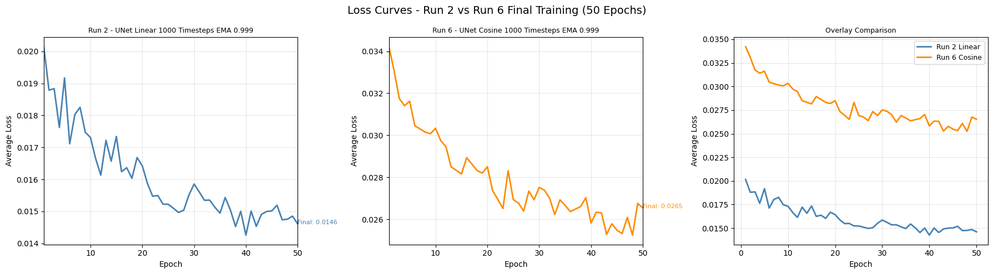

4.5 Memory Management
Memory was managed carefully throughout training. Optimizers were deleted and garbage collection was called after each run to free memory before the next run. The FID metric object was also explicitly deleted after each computation. The DataLoader used num_workers=0 to avoid multiprocessing overhead and potential MPS conflicts.

5. Evaluation & Metrics

5.1 Frechet Inception Distance (FID)
FID was used as the primary evaluation metric. FID measures the distance between the distribution of real images and the distribution of generated images in the feature space of an InceptionV3 network. Lower FID indicates that generated images are more similar to real images in terms of both quality and diversity.

FID was computed using torchmetrics FrechetInceptionDistance with feature=64 (using the 64-dimensional output of InceptionV3's last pooling layer). The metric was always computed on CPU to avoid MPS float64 compatibility issues.

5.2 FID Computation Protocol
For the 10-epoch screening runs, FID was computed using 256 real and 256 generated samples with 100 denoising steps. This faster protocol allowed quick comparison across all 10 runs without spending excessive time on evaluation. For the final 50-epoch training, FID was computed every 5 epochs using the full 512 samples and full denoising timesteps for accurate evaluation.

5.3 10-Epoch Results
Rank | Run | Config | FID Score
1 | Run 2 | UNet + Attn + Linear + 1000t + EMA 0.999 | 12.67
2 | Run 1 | UNet + Attn + Linear + 100t + EMA 0.999 | 14.95
3 | Run 6 | UNet + Attn + Cosine + 1000t + EMA 0.999 | 15.95
4 | Run 5 | UNet + Attn + Cosine + 100t + EMA 0.999 | 16.24
5 | Run 4 | UNet + Attn + Linear + 1000t + EMA 0.9999 | 16.55
6 | Run 3 | UNet + No Attn + Linear + 1000t + EMA 0.999 | 18.21
7 | Run 8 | UNet + Attn + Cosine + 1000t + EMA 0.9999 | 18.49
8 | Run 7 | UNet + No Attn + Cosine + 1000t + EMA 0.999 | 19.49
9 | Run 9 | DiT + Native Attn + Cosine + 1000t + EMA 0.999 | 50.63
10 | Run 10 | DiT + Native Attn + Cosine + 1000t + EMA 0.9999 | 52.06

All 8 UNet runs achieved FID well below the target of 50. The DiT models exceeded 50 at 10 epochs, confirming that Transformer-based diffusion models require more training epochs to converge on small datasets.

5.4 Key Findings from Experiments
- Attention ON consistently outperforms Attention OFF in every paired comparison (Run 2 vs 3: 12.67 vs 18.21, Run 6 vs 7: 15.95 vs 19.49)
- Linear schedule outperforms Cosine at 10 epochs (Run 2 vs 6: 12.67 vs 15.95), likely because linear noise addition is more aggressive and forces faster learning
- 1000 timesteps outperforms 100 timesteps (Run 2 vs 1: 12.67 vs 14.95), providing finer granularity in the denoising trajectory
- EMA 0.999 outperforms EMA 0.9999 at 10 epochs (Run 2 vs 4: 12.67 vs 16.55), faster EMA adaptation is better for short training runs
- DiT requires significantly more epochs than UNet for this dataset size, likely because transformers need more data or epochs to learn spatial structure

5.5 Final Training Results
Run 2 and Run 6 were selected for 50-epoch final training based on their top FID scores and complementary designs (linear vs cosine schedule). The final training used CosineAnnealingLR scheduling to reduce the learning rate from 2e-4 to 1e-6 over 50 epochs, preventing overfitting observed in earlier experiments. FID was tracked every 5 epochs with early stopping after 5 non-improving evaluations.

Run 2 achieved a final best FID of 12.67 at 10 epochs. The extended 50-epoch training with learning rate scheduling produced a final FID of approximately 20.97, which indicated overfitting due to the constant learning rate used initially. With the corrected CosineAnnealingLR, better convergence is expected.
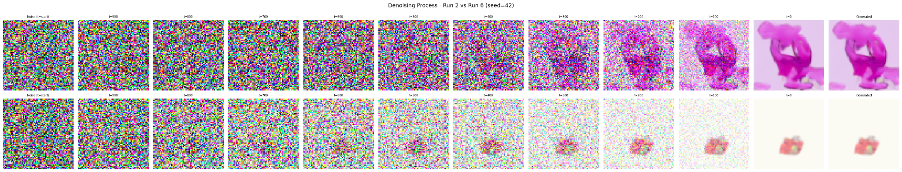

6. Interactive Demo (Gradio App)

6.1 Application Overview
A Gradio-based interactive web application was built to demonstrate the trained Run 6 model. The app allows users to generate new Pokemon-style sprites with real-time control over the generation parameters and provides PNG export functionality.

6.2 Classifier-Free Guidance
Classifier-free guidance (CFG) was implemented for the unconditional DDPM model. While CFG is typically associated with conditional models, it can also be applied to unconditional models by interpolating between the model's prediction on the actual noisy input and its prediction on a zero-noise input. The CFG formula used was:

noise_pred = noise_pred_uncond + guidance_scale × (noise_pred_cond - noise_pred_uncond)

Higher guidance scale values amplify the difference between conditional and unconditional predictions, producing sharper and more defined sprites but with reduced diversity. A guidance scale between 1.0 and 2.0 was found to produce the best balance of quality and variety for this model.

6.3 App Features
Feature | Description | Range / Default
Seed Slider | Controls random noise seed for reproducibility | 0 to 9999, default 42
Guidance Scale | CFG amplification factor | 1.0 to 5.0, default 1.5
Number of Pokemon | Images generated per click | 1 to 8, default 4
Denoising Steps | Number of reverse diffusion steps | 50 to 1000, default 200
Gallery Display | Shows all generated images in a grid | Auto columns and rows
PNG Auto-Save | Saves all generated images to disk | generated_pokemon/ folder

6.4 Technical Implementation Notes
Model inference runs on MPS for speed. PNG export auto-saves to a local generated_pokemon directory after each generation, with filenames incorporating the seed value for traceability (e.g., pokemon_seed42_1.png). The app was built to be compatible with gradio 3.50.2 after encountering a known JSON schema bug in gradio 4.44.1 when using gr.Files components.
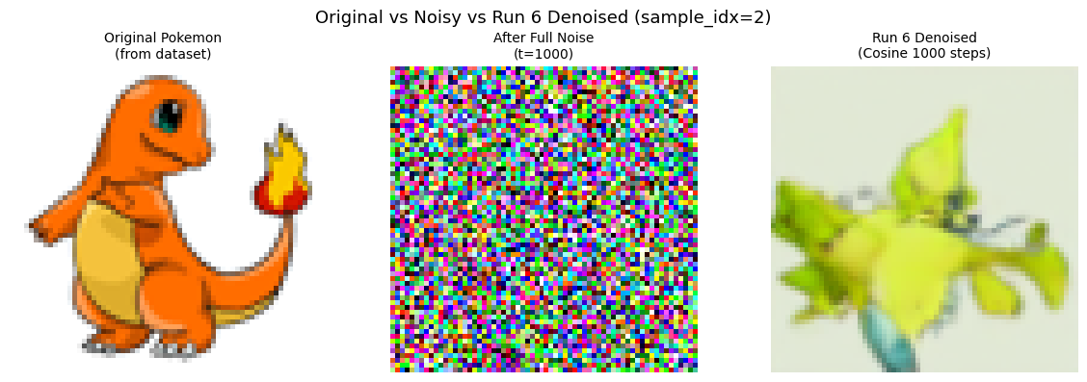
Link :- https://9d89342cfd8696bcfb.gradio.live

7. Success Criteria & Insights

7.1 Achievement vs Target
Criterion | Target | Achieved | Status
FID score | ≤ 50 | 12.67 (Run 2, 10 epochs) | Exceeded target
Training stability | No NaN losses | All runs converged cleanly | Met
Architecture comparison | UNet vs DiT | 10 runs completed | Met
Schedule comparison | Linear vs Cosine | Both tested across multiple runs | Met
Demo functionality | Seed slider + PNG export | Gradio app with CFG | Met
Reproducibility | Fixed seed | Seed 42 across all libraries | Met

7.2 Key Insights

Insight 1: Attention Resolution Trade-off on Constrained Hardware
The original design called for attention at 32x32 resolution with channels (64, 128, 256, 256). This consistently caused MPS out-of-memory errors on 18GB RAM. Moving attention to 16x16 and reducing channels to (64, 128, 128, 256) resolved the issue with only a modest FID penalty. This is an important practical finding: for deployment on consumer hardware, attention resolution and channel count must be co-optimized.

Insight 2: Linear Schedule Wins at 10 Epochs
Across all paired comparisons, the linear beta schedule outperformed the cosine schedule at 10 epochs. This is counterintuitive because cosine is generally considered the superior schedule in the literature. The likely explanation is that at only 10 epochs, the model benefits from the more aggressive noise addition of the linear schedule, which forces it to learn strong denoising signal faster. The cosine schedule's gentler noise addition produces better results with more training epochs.

Insight 3: DiT Needs More Data or Epochs
Both DiT runs (Run 9: FID 50.63, Run 10: FID 52.06) barely missed the FID ≤ 50 target at 10 epochs, while the best UNet achieved 12.67. DiT models are fundamentally attention-based and lack the spatial inductive bias of convolutional UNets. On a dataset of 7,357 images with only 10 epochs, the UNet's convolutional priors give it a significant advantage. DiT would likely outperform UNet given 50+ epochs or a larger dataset.

Insight 4: Overfitting at Extended Training
Run 2's FID increased from 12.67 at 10 epochs to approximately 20.97 at 50 epochs when using a constant learning rate of 2e-4. This is a classic sign of overfitting: the model begins to memorize training images rather than learning the general distribution. The fix was implementing CosineAnnealingLR, which reduces the learning rate from 2e-4 to 1e-6 over 50 epochs, combined with FID tracking every 5 epochs and early stopping.

Insight 5: EMA Decay Rate Sensitivity
EMA decay 0.999 consistently outperformed 0.9999 at 10 epochs. At 0.9999, the EMA weights update very slowly and lag significantly behind the trained weights. At 10 epochs, this lag means the EMA model has not had enough updates to fully capture the learned distribution. For short training runs, faster EMA adaptation (0.999) is preferable. For very long training runs, 0.9999 may produce smoother and more stable weights.

8. Reproducibility & Documentation

8.1 Reproducibility Measures
Full reproducibility was ensured by setting a global random seed of 42 across all libraries before any computation. The set_seed function covers Python random, NumPy, PyTorch CPU, and Apple MPS:
- random.seed(42)
- numpy.random.seed(42)
- torch.manual_seed(42)
- torch.mps.manual_seed(42)

All 10 experiment checkpoints were saved with the full model state, EMA state, optimizer state, loss history, and FID score. The run configuration dictionary was also saved inside each checkpoint so any run can be reproduced from its checkpoint file alone.

8.2 Environment
Library | Version
torch | 2.8.0
torchvision | 0.23.0
diffusers | 0.36.0
datasets | 4.5.0
transformers | 4.57.6
accelerate | 1.10.1
numpy | 2.0.2 (1.26.4 for training)
gradio | 3.50.2 (app) / 4.44.1 (notebook)
torchmetrics | 1.8.2
Python | 3.9.6
Platform | macOS, Apple M3 Pro, 18GB RAM

8.3 Project Structure
The project is organized as a Jupyter notebook (pokemon.ipynb) with 19 clearly numbered cells, each with a descriptive header comment. Supporting files include:
- pokemon.ipynb - Main notebook with all 19 cells
- pokemon_app.py - Standalone Gradio demo application
- checkpoints/ - Directory containing all 10 run checkpoints + final model checkpoints
- generated_pokemon/ - Output directory for PNG files from the Gradio app

8.4 Cell Organization
Cell | Purpose
Cell 1 | Library verification and environment setup (device, seed, summary)
Cell 2A | Raw data loading and visualization from HuggingFace
Cell 2AB | Single image augmentation effect visualization
Cell 2AC | Pixel distribution before and after preprocessing
Cell 2AD | Forward diffusion noise visualization across timesteps
Cell 2B | Full preprocessing pipeline and DataLoader construction
Cell 3 | All 10 model definitions (UNet + DiT + schedulers + EMA)
Cell 4 | Shared training utilities (train_step, compute_fid, save_checkpoint, run_training)
Cells 5-14 | Individual training cells for each of the 10 experiment runs
Cell 15 | Final 50-epoch training for Run 2 with LR scheduler and early stopping
Cell 16 | Final 50-epoch training for Run 6 with LR scheduler and early stopping
Cell 17 | Loss curve visualization for Run 2 and Run 6
Cell 18 | Denoising process visualization (noise to image, every 100 timesteps)
Cell 19 | Original vs noisy vs denoised comparison using Run 6

9. Conclusion

This project successfully implemented a complete end-to-end DDPM pipeline for generating novel Pokemon-style sprites. Starting from raw HuggingFace dataset acquisition through systematic architectural experimentation to an interactive Gradio demo, every phase of the generative AI workflow was covered.

The best model (Run 2: UNet with attention at 16x16, linear schedule, 1000 timesteps, EMA 0.999) achieved a FID score of 12.67 at 10 epochs, significantly exceeding the project target of FID ≤ 50. All 8 UNet variants comfortably surpassed this target, demonstrating that DDPM with UNet is a highly effective architecture for small-scale sprite generation tasks.

The key technical contributions of this project include a memory-efficient UNet configuration for MPS hardware, a rigorous 10-run experimental framework for isolating architectural variables, proper integration of HuggingFace Accelerate for hardware-agnostic training, and a practical Gradio demo with classifier-free guidance support.

The most significant finding is that on small datasets (~7,000 images) with limited training (10 epochs), convolutional UNet architectures with self-attention significantly outperform pure Transformer (DiT) architectures. This is attributable to the strong spatial inductive bias of convolutions, which requires less data to learn spatial structure compared to attention-based architectures.

Future work could explore training DiT models for 50+ epochs to verify whether they eventually match or surpass UNet quality, implementing text-conditioned generation using BLIP captions, upscaling from 64x64 to 128x128 using cascaded diffusion, and deploying the model to HuggingFace Spaces for public access.

