Generating sftp key with mobaxterm
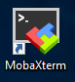
- open mobaxterm
- Select “Start Local Terminal”
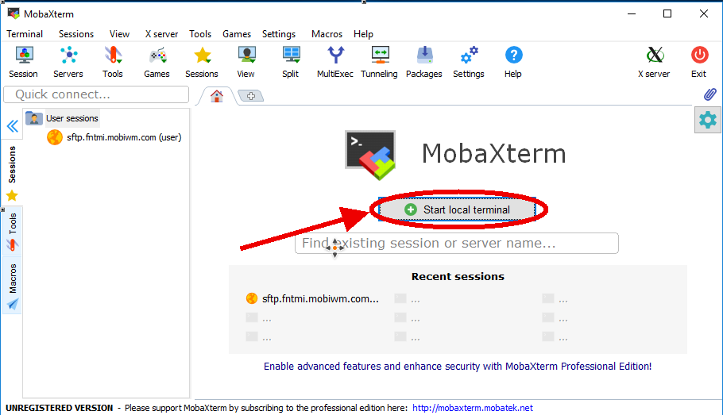
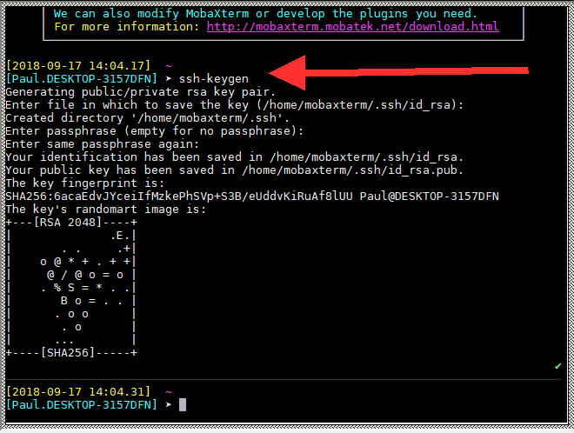
- At the prompt, type “ssh-keygen” and accept defaults, I recommend no passphrase on your keyfile to facilitate automation.
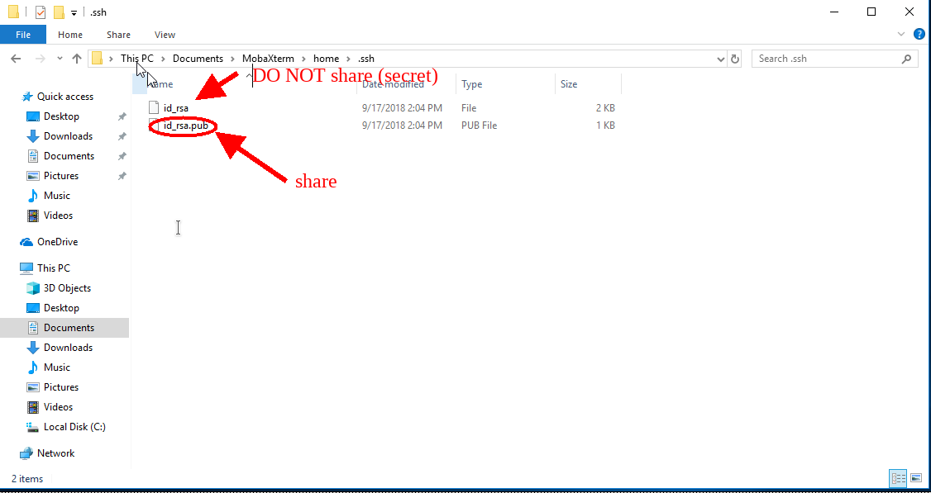
- Your key will be located in your Documents/mobaxterm/home/.ssh/
- Please send us your id_rsa.pub and use your id_rsa to logon. You can rename these keys.

