Generate SSH key with putty

- Launch puttygen
- Change number of bits to 4096 and select “Key” > “Generate key pair”
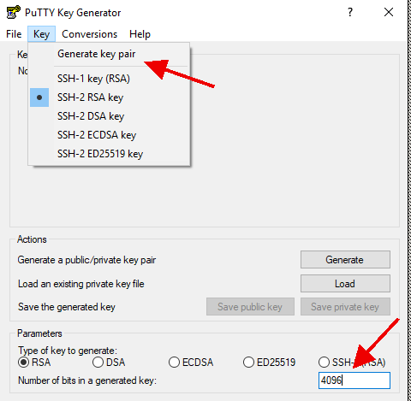
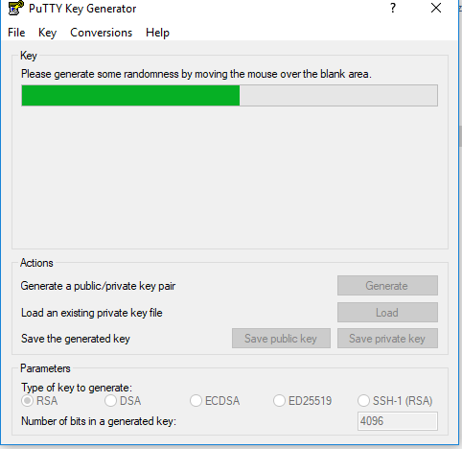
- You should be prompted to move your mouse around to generate randomness. Do so until the green bar is all the way across the screen.
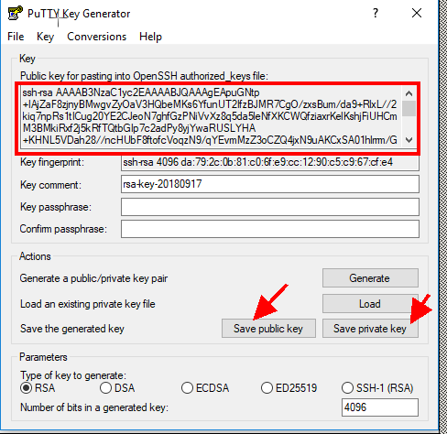
- Save the public and private key to your own Documents folder. Provide the text in the red box to us or attach the saved private key. We will add this to the server you want to log onto.

