HelpDiabetes

Carb Counter on your cellular phone

Authors : Johan Degraeve
Date : September 2010
Versie : 0.2

Licence :
This work is licensed under the Creative Commons Attribution 2.0 Belgium License. To view a copy of this license, visit http://creativecommons.org/licenses/by/2.0/be/ or send a letter to Creative Commons, 171 Second Street, Suite 300, San Francisco, California, 94105, USA.

Table Of Contents
1 Introduction 3
2 The screens 3
2.1 Home 3
2.1.1 Food Counter 4
2.1.1.1 Add Item 6
2.1.1.2 Own Item 8
2.1.1.3 Load Template 9
2.1.1.4 ItemsFound 10
2.1.2 Tracking 11
2.1.2.1 Edit Meal Event 12
2.1.2.2 Edit Medicin Event 13
2.1.2.3 Edit Exercise Event 14
2.1.2.4 Edit BG Event 15
2.1.2.5 Edit Filter 15
2.1.3 Food Table 15
2.1.4 Settings 15
2.1.5 Info/About 16
3 Additional functionalities 16
3.1 New Meal 16
4 Non-Functional 16
4.1 Icons 16
4.2 Text 16
4.3 MultiLanguage 16
4.3.1 Application Texts 17
4.3.2 Food Composition Tables 17
5 Priorities 17
5.1 Priority 1 17
5.2 Priority 2 18

Introduction

To be completed

The screens
Colors used here can be changed later on but will be consistent through all applications.

ScreenFlow

Home
Here it is :

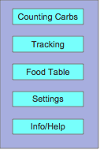

Food Counter
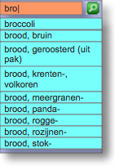
User can enter letters in the search box, a-z. As soon as letter is typed, application starts searching for items that start with the already entered letters.

Search button allows user to search for items that contain the already typed letters and show them in a new list. This will bring the user to the Screen ItemsFound

User can select an item from the list which brings him (her) to the Screen_AddItem

The amount can be entered via a custom keyboard that only contains the letters a..z, and a back key that will erase already typed letters. The aim is that the application makes optimal use of the screen width and height. For example, following figure shows a typical Android keyboard when set to numeric. Half of the keyboard is not necessary for this application.
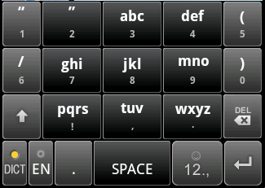

User can chose between azerty/qwerty/numeric, making use of the full screen width (example for Android devices : http://stackoverflow.com/questions/1896939/android-app-specific-soft-keyboard).

Menu options :
- "Home" : go back to Screen Home. This button is not necessary if the phone offers a native back key, which will bring the user back to the Home Screen (for example Android Devices)
- "Meal" : With this option, the user will get a list of food items already entered for the current mealtime. It brings the user to the Screen EditMealEvent.
- “to Tracking” : will bring the user to the Screen Tracking, here the user can see the necessary amounts of insulin for the current meal.
- "Own Food Item" : go to Screen OwnItem
- "Load Template" : go to Screen LoadTemplate

Add Item

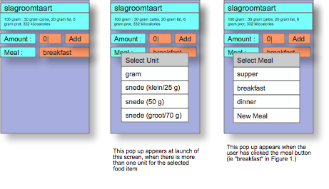
Screen will have :
- the food item description
- the selected unit, with per unit, the amount of carbs, fat, proteins and kilocalories.
- a text box where the entered amount is shown. The initial amount depends on the standard amount, if the standard amount = 100, then initial amount 0, else initial amount = standard amount.
- the selected meal, depending on timings, again according to preferences (meal switch times). By clicking on the meal, a pop-up appears that allows the user to select one meal before or one meal after the current meal (ie current meal automatically chosen based on preferences). In case the user chooses "New Meal", then a new meal is created , with the name chosen by the user (see section "New Meal").
- an 'Add' button, which will add the food item to the currently selected meal and return to the previous screen.
In case there's no meal created yet for the current period, then a meal event will be created, and the fooditem will be added.
The timestamp of the meal event will be set to the time and date that the fooditem was added.

There are two flows to reach this screen with a "Save" button in stead of an "Add" button :
- Screen FoodCounter ==> click on "to Tracking", user arrives in Screen EditMealEvent ==> click on an item which is not an OwnItem, user Arrives here. After saving the modified meal , user returns directly to Screen FoodCounter
- Screen Tracking ==> click on a meal item, user arrives on Screen EditMealEvent ==> click on an item which is not an OwnItem, user Arrives here. After saving the modified meal, user returns to the Screen EditMealEvent.

The amount can be entered via a custom keyboard that only contains the digits 0, 1, ..9 , '.' and back key that will erase already typed digits or the decimal point. The aim is that the application makes optimal use of the screen width and height. (See also Screen FoodCounter).

At appearance of this screen, in case the food item has multiple units, pop up immediately a list from which user can select a unit.

Menu options
- modify unit : when chosing this option, a list of units appears, user can select, immediately after selecting, the text in top is changed (selected unit, with amount of grams, ..), and also the amount is reset depending on the value of the standard amount (0 or other).

Own Item
This screen is to add a one time item to a meal or to modify an already added item.

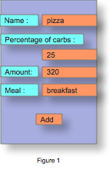

As in the Screen AddItem, when clicking on the meal, the user can switch to another meal, ie right before or after.

An 'Add' button, which will add the food item to the currently selected meal and return to the previous screen.

In case there's no meal created yet for the current period, then a meal event will be created, and the fooditem will be added.
The timestamp of the meal event will be set to the time and date that the fooditem was added.

The same screen will be used, if the user selects an item from the list in Screen EditMealEvent. In that case, the 'Add' button is replaced by a 'Save' button.
There are two flows to reach this screen with a "Save" button in stead of an "Add" button :
- Screen FoodCounter ==> click on "to Tracking", user arrives in Screen EditMealEvent ==> click on an item which is an OwnItem, user Arrives here. After saving the modified meal , user returns directly to Screen FoodCounter
- Screen Tracking ==> click on a meal item, user arrives on Screen EditMealEvent ==> click on an item which is an OwnItem, user Arrives here. After saving the modified meal, user returns to the Screen EditMealEvent.

Load Template
To be completed

ItemsFound

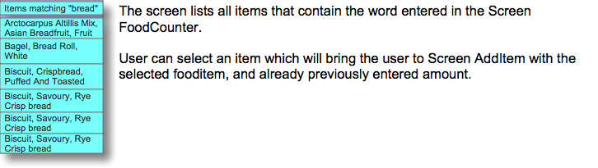

Tracking

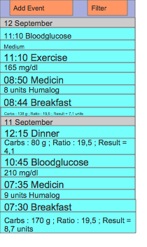

- Events are shown in chronological order, the newest event on top. Each event has a time stamp, format HH:mm. The dates are also shown in a full line (without year)
- Possible events are
- exercise
- Bloodglucose
- Meal : Breakfast, Dinner, Snack, Lunch or custom meal (see $ 3.1)
- Medicin

- user can scroll through the events
- user can click an event which opens op a detailed screen, which allows to edit, delete, ..
- clicking an event of type Bloodglucose => Screen EditBGEvent
- clicking an event of type Exericse ==> Screen EditExerciseEvent
- clicking an event of type Medicin ==> Screen EditMedicinEvent
- clicking an event of type Meal (breakfast, dinner, ..) ==> Screen EditMealEvent
- by clicking on Filter, user can create a display filter via Screen EditFilter
- by clicking on 'Add Event', user can chose which Event to create, via Screen AddEvent

Edit Meal Event
Screen to edit a meal event, not to create an event because this is done via the Screen FoodCounter
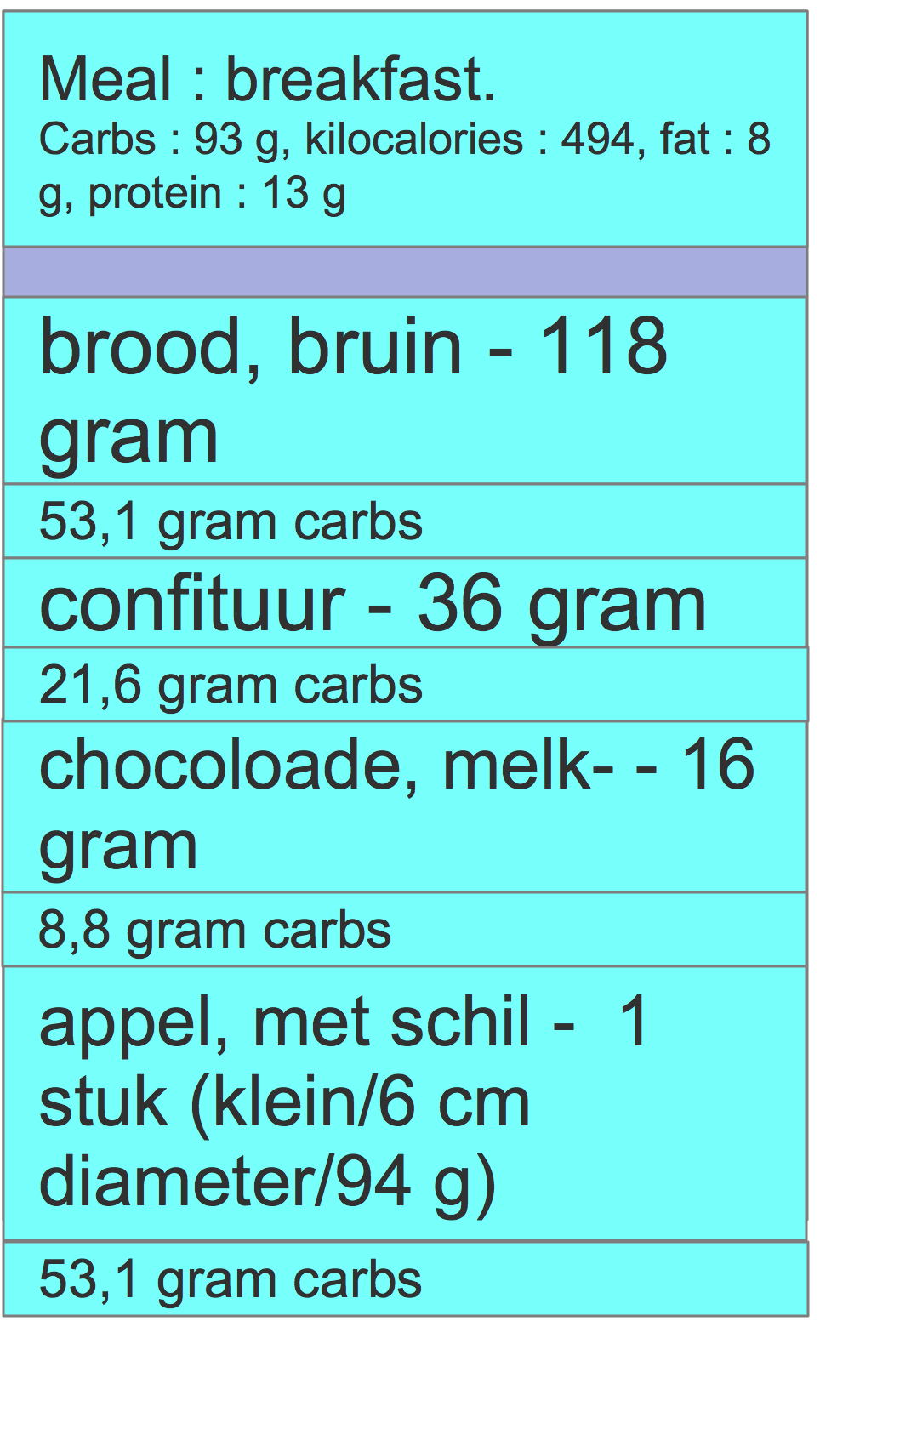

On top a row is shown with type of meal (breakfast, dinner, ...own meal..).
The second row show the total amount of carbs, fat and protein for the meal.
Then several rows, two per food item in the meal with :
- food item name – amount and unit
- amount of carbs (depending on personal settings, it may also show the amount of kilocalories, fat or proteins)

When clicking on an item, the user goes to Screen AddItem. The field amount, unit and meal are preset based on the values of the clicked item. The Screen AddItem will open without pop up for selecting the unit, and with “Add” replaced by “Save”.
! | When clicking Save in the Screen AddItem, then the next Screen depends on how the user got here.  When coming via Screen Food Counter, to Screen EditMeal Event, to Screen Add Item, then the user returns immediatelly to Screen FoodCounter.  When coming via Screen Tracking, to Screen EditMeal Event, to Screen Add Item, then the user returns to Screen EditMealEvent.  When clicking return or cancel (depending on type of device), then the user returns to Screen EditMealEvent

Edit Medicin Event
Screen to create, or edit a medicin event
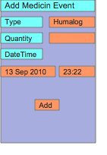
- Date and Time are set by default to current date and time, user can modify it
- clicking 'Add' saves the entry and returns to previous screen
- Clicking type (in this example “humalog”) allows user to chose another medicin type
- In case user clicked an existing entry in the Screen Tracking, then “Add Medicin Event” is replaced by “Edit Medicin Event”, and “Add” button is replaced by “Save” button

Edit Exercise Event
Screen to create, or edit an exercise event
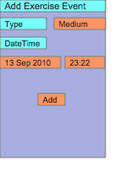
- Date and Time are set by default to current date and time, user can modify it
- clicking 'Add' saves the entry and returns to previous screen
- Clicking type (in this example “medium”) allows user to add chose other exercise type
- In case user clicked an existing entry in the Screen Tracking, then “Add Exercise Event” is replaced by “Edit Exercise Event”, and “Add” button is replaced by “Save” button

Edit BG Event
Screen to create, or edit a bloodglucose event
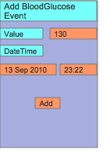
- Date and Time are set by default to current date and time, user can modify it
- clicking 'Add' saves the entry and returns to previous screen
- In case user clicked an existing entry in the Screen Tracking, then “Add BloodGlucose Event” is replaced by “Edit BloodGlucose Event”, and “Add” button is replaced by “Save” button

Edit Filter
To be completed

Food Table
to be completed

Settings

Global overview, to be grouped
- what is the user mainly interested in ? Carbs, proteins, fat or kilocalories. To be used in Screens EditMealEvent, Tracking

Info/About
to be completed

Additional functionalities

New Meal

The standard application-built in meals are “breakfast”, “dinner”, “snack”, “supper”.
A user may take additional meals. In that case it is possible to create a one-time additional meal in the Screen AddItem by clicking on the button that shows the current meal.

When clicking a pop-up appears where the user can select a name for the meal, with a default name that consists of the time the meal was created, for example “Meal-17:38”.

In case the user has selected a new Meal, whenever the user adds again a food item to a meal (from Screen FoodCounter) , the application will fill in by default the new Meal, except if the time has passed to a new period (as per settings ..)

In case meal filtering is used in Screen Tracking, these meals will not be shown at all.

Non-Functional

Icons
Nowhere in this document, icons are used. All menu options, buttons, etc. could finally be replaced by icons.

Text
Text used here in the screens is only as example. All texts should be easily modifiable (in source code, resource file, xml file, …)

MultiLanguage
The application should support multiple languages.

Application Texts
It should be possible to use the application in multiple languages. The language is either automatically selected based on phone Settings (eg Android) or needs to be selected at start up by the user.

Food Composition Tables
Food composition tables are available in 10 languages in the format required for this application : http://www.johandegraeve.net/Food_Composition_Table_Other_Languages.html
A lot more food composition tables in other languages are available on the Internet.
The correct table is either automatically selected based on phone Settings (eg Android) or needs to be selected at start up by the user.
It should also be possible to select another language table via the Screen Food Table

Priorities
Priority 1 = highest priority

Priority 1
- Carb Counting
  - Count carbohydrates, fat, proteins, kilocalories in a meal.
  - Food Composition Table, alphabetically ordered (follow Excel sorting rules)
  - Calculate required insuline dose, based on personal carb-to-insulin ratio
  - personal carb-to-insulin ratio can be set for breakfast/dinner/snack/supper, ‘switch-times’ can also be configured and application picks up correct value
  - Food Composition Table can be modified by user via PC (Excel)
  - Food Composition Table can be modified by user via mobile, modified table can be exported to .csv
- Tracking
  - Blood Glucose tracking
  - Food Tracking
  - Medication tracking
  - Exercise tracking
  - Export to .csv , XML
- Device Types
  - Android
  - iPhone
  - Symbian
  - BlackBerry (still to be checked if feasible to implement a good “search-as-you-type” application)
- Simple website with explanation, with reference to places where application can be installed (iTunes, Android Market, BlackBerry app World, OVI store)
- Language
  - Dutch and English but should be easy to extend to other languages
  - Choose among different food composition tables (1 per language, for free apps at least 10 different languages are available, see http://www.johandegraeve.net/Food_Composition_Table_Other_Languages.html)

Priority 2
- Synchronize tracking data with server
- Charts for analysis of tracking data
- Website where user can analyse/modify tracking data
- PC client to analyse/modify tracking data
- Mac client to analyse/modify tracking data
- Community forum
- Develop download platform, with device recognition and automatically select the right application or redirect to market (iPhone/iPad and Android). Also for currently available J2ME app (http://www.johandegraeve.net/)

