HelpDiabetes

Carb Counter on your cellular phone

Authors : Johan Degraeve
Date : September 2010
Versie : 0.1

Licence :
This work is licensed under the Creative Commons Attribution 2.0 Belgium License. To view a copy of this license, visit http://creativecommons.org/licenses/by/2.0/be/ or send a letter to Creative Commons, 171 Second Street, Suite 300, San Francisco, California, 94105, USA.

Table Of Contents
1 Introduction 3
2 The screens 3
2.1 ScreenFlow 3
2.2 Home 6
2.2.1 Food Counter 7
2.2.1.1 Add Item 9
2.2.1.2 Own Item 11
2.2.1.3 Load Template 12
2.2.1.4 ItemsFound 13
2.2.2 Tracking 14
2.2.2.1 Edit Meal Event 16
2.2.2.2 Edit Medicin Event 18
2.2.2.3 Edit Exercise Event 19
2.2.2.4 Edit BG Event 20
2.2.2.5 Filter 20
2.2.2.6 Add Event 21
2.2.3 Food Table 21
2.2.4 Settings 21
2.2.5 Info/About 21
3 Additional functionalities 22
3.1 Detailed Contents of a MealEvent row in Screen Tracking 22
3.2 New Meal 22
4 Non-Functional 22
4.1 Icons 22
4.2 Text 22
4.3 MultiLanguage 23
4.3.1 Application Texts 23
4.3.2 Food Composition Tables 23
5 Priorities 23
5.1 Priority 1 23
5.2 Priority 2 24

Introduction

This document describes the requirements for HelpDiabetes, a carbcounter for mobile phones, more specific smart phones like iPhone, Android devices, Symbian, ..

The carbcounter application should be made easy to use, so that it can be used for every meal that a diabetic takes. Someone who counts carbs, weighs everything to detail : bread, potatoes, jam, …
In addition the application can keep track of meals, blood glucose levels, exercise and medicin.

Open
Here a list of open items to be treated in this document
- where to show for a meal, the total number of carbs, kilocalories, proteins and fat. For the moment it's only one item being shown, depending on user settings (in the screenshots always carbs)

Terminology
- Breakfast, lunch, snack supper
Some languages use different names for meals depending on culture. For example there's a difference between French in Belgium and France. Also in English there are variants.
This document uses breakfast (morning), lunch (noon), snack (around 16 Hr), and supper (evening). In the end the actual texts used should be fully configurable, language and region dependent.

The screens
Colors used here can be changed later on but will be consistent through all applications.
§ 2.1 shows the sequence of screens to be shown to the user, depending on the actions he or she is taking.
In the next paragraphs ($ 2.2 ..) there are more details about the individual screens.

ScreenFlow

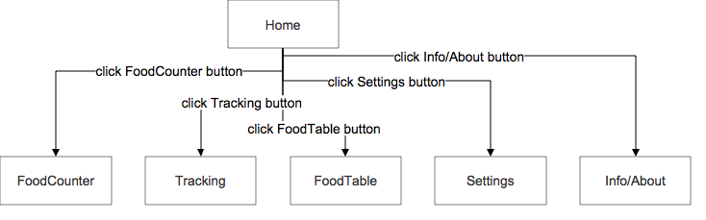
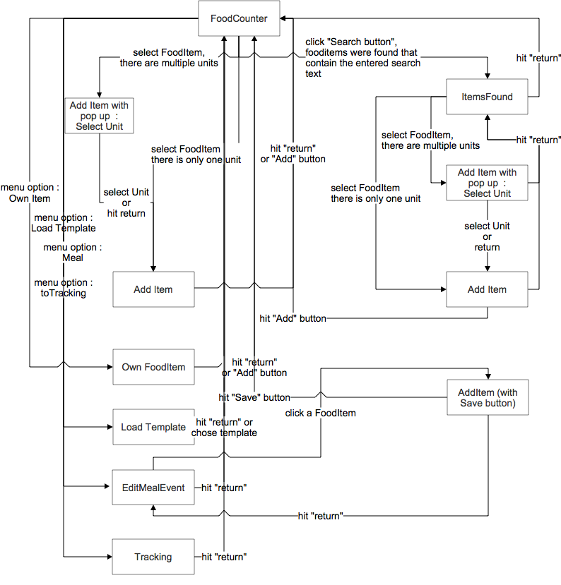
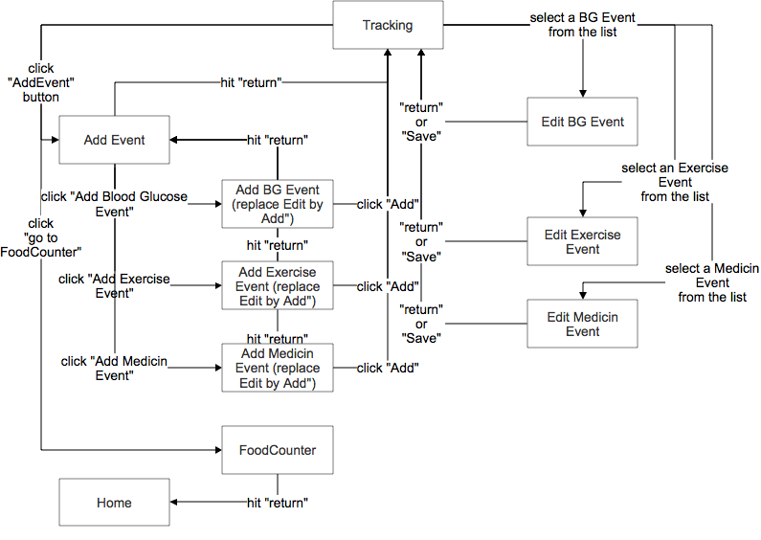

Home
Here it is :

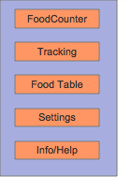

Food Counter
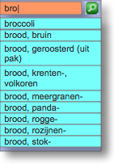
User can enter letters in the search box, a-z. As soon as letter is typed, application starts searching for items that start with the already entered letters.

Search button allows user to search for items that contain the already typed letters and show them in a new list. This will bring the user to the Screen ItemsFound

User can select an item from the list which brings him (her) to the Screen_AddItem

The amount can be entered via a custom keyboard that only contains the letters a..z, and a back key that will erase already typed letters. The aim is that the application makes optimal use of the screen width and height. For example, following figure shows a typical Android keyboard when set to numeric. Half of the keyboard is not necessary for this application.
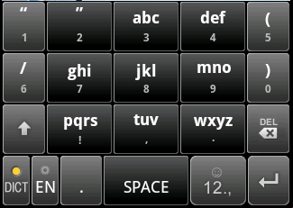

User can chose between azerty/qwerty/numeric, making use of the full screen width (example for Android devices : http://stackoverflow.com/questions/1896939/android-app-specific-soft-keyboard).

Menu options :
- "Home" : go back to Screen Home. This button is not necessary if the phone offers a native back key, which will bring the user back to the Home Screen (for example Android Devices)
- "Meal" : With this option, the user will get a list of food items already entered for the current mealtime. It brings the user to the Screen EditMealEvent.
- “to Tracking” : will bring the user to the Screen Tracking, here the user can see the necessary amounts of insulin for the current meal.
- "Own Food Item" : go to Screen OwnItem
- "Load Template" : go to Screen LoadTemplate

Add Item

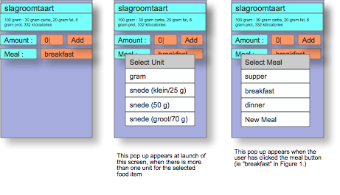
Screen will have :
- the food item description
- the selected unit, with per unit, the amount of carbs, fat, proteins and kilocalories.
- a text box where the entered amount is shown. The initial amount depends on the standard amount, if the standard amount = 100, then initial amount 0, else initial amount = standard amount.
- the selected meal, depending on timings, again according to preferences (meal switch times). By clicking on the meal, a pop-up appears that allows the user to select one meal before or one meal after the current meal (ie current meal automatically chosen based on preferences). In case the user chooses "New Meal", then a new meal is created , with the name chosen by the user (see section "New Meal").
- an 'Add' button, which will add the food item to the currently selected meal and return to the previous screen.
In case there's no meal created yet for the current period, then a meal event will be created, and the fooditem will be added.
The timestamp of the meal event will be set to the time and date that the fooditem was added.

There are two flows to reach this screen with a "Save" button in stead of an "Add" button :
- Screen FoodCounter ==> click on "to Tracking", user arrives in Screen EditMealEvent ==> click on an item which is not an OwnItem, user Arrives here. After saving the modified meal , user returns directly to Screen FoodCounter
- Screen Tracking ==> click on a meal item, user arrives on Screen EditMealEvent ==> click on an item which is not an OwnItem, user Arrives here. After saving the modified meal, user returns to the Screen EditMealEvent.

The amount can be entered via a custom keyboard that only contains the digits 0, 1, ..9 , '.' and back key that will erase already typed digits or the decimal point. The aim is that the application makes optimal use of the screen width and height. (See also Screen FoodCounter).

At appearance of this screen, in case the food item has multiple units, pop up immediately a list from which user can select a unit.

Menu options
- modify unit : when chosing this option, a list of units appears, user can select, immediately after selecting, the text in top is changed (selected unit, with amount of grams, ..), and also the amount is reset depending on the value of the standard amount (0 or other).

Own Item
This screen is to add a one time item to a meal or to modify an already added item.

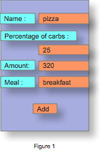

As in the Screen AddItem, when clicking on the meal, the user can switch to another meal, ie right before or after.

An 'Add' button, which will add the food item to the currently selected meal and return to the previous screen.

In case there's no meal created yet for the current period, then a meal event will be created, and the fooditem will be added.
The timestamp of the meal event will be set to the time and date that the fooditem was added.

The same screen will be used, if the user selects an item from the list in Screen EditMealEvent. In that case, the 'Add' button is replaced by a 'Save' button.
There are two flows to reach this screen with a "Save" button in stead of an "Add" button :
- Screen FoodCounter ==> click on "to Tracking", user arrives in Screen EditMealEvent ==> click on an item which is an OwnItem, user Arrives here. After saving the modified meal , user returns directly to Screen FoodCounter
- Screen Tracking ==> click on a meal item, user arrives on Screen EditMealEvent ==> click on an item which is an OwnItem, user Arrives here. After saving the modified meal, user returns to the Screen EditMealEvent.

Load Template
To be completed

ItemsFound

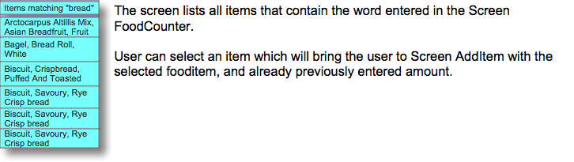

Tracking

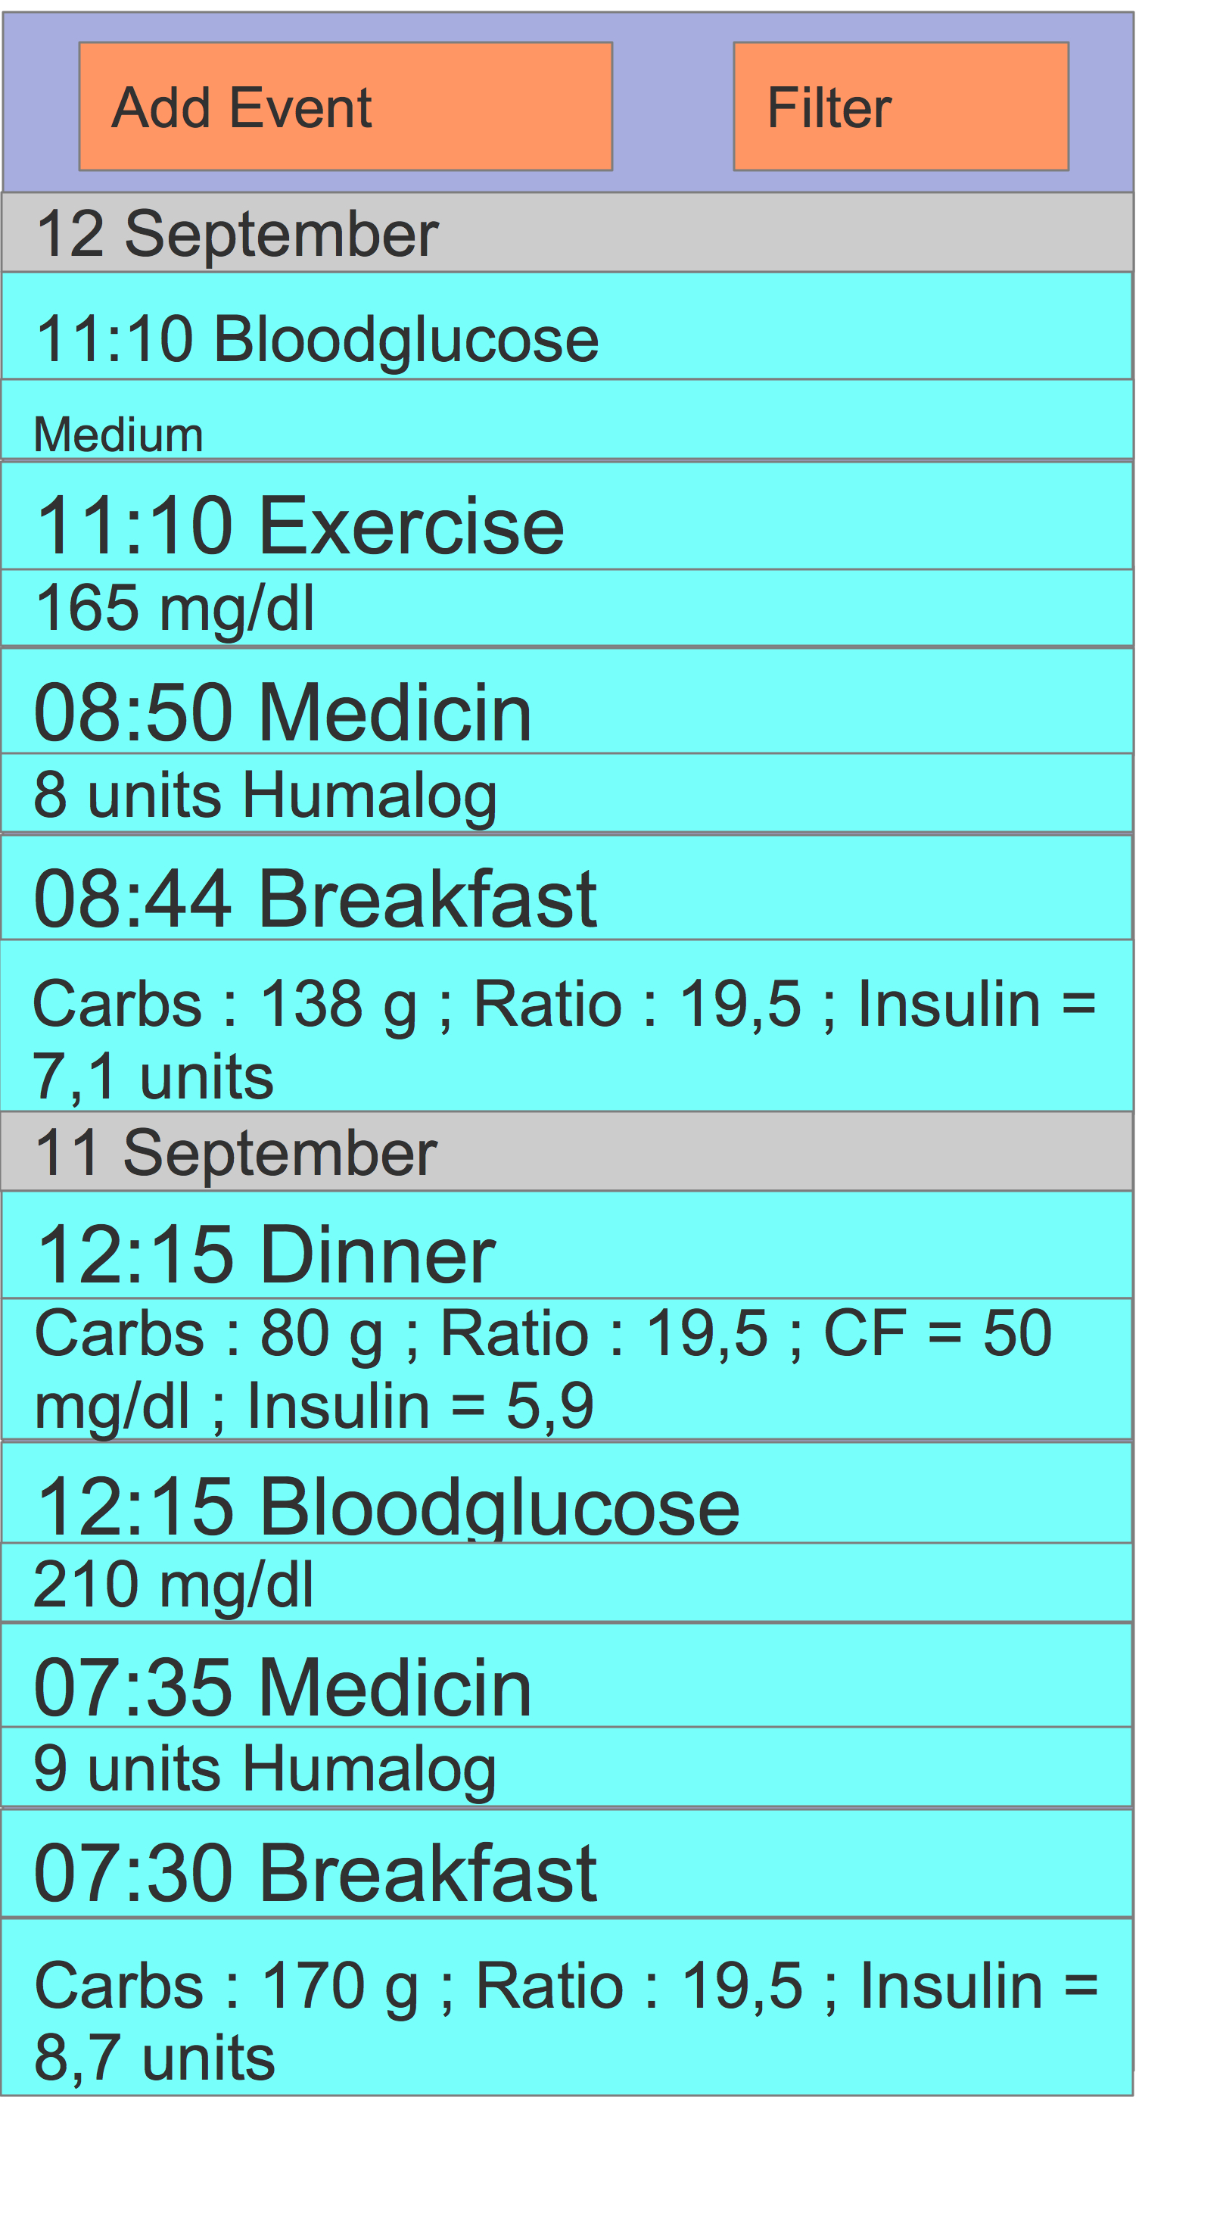

- Events are shown in chronological order, the newest event on top. Each event has a time stamp, format HH:mm. The dates are also shown in a full line (without year)
- Possible events are
- exercise
- Bloodglucose
- Meal : Breakfast, Lunch, Snack, Supper or custom meal (see $ 3.1). A meal event also shows the calculated amount of insulin, based on carb value, carb ratio, correction factor and blood glucose value before the meal (if available). More Details in § 3.1.
- Medicin

- user can scroll through the events
- user can click an event which opens op a detailed screen, which allows to edit, delete, ..
- clicking an event of type Bloodglucose => Screen EditBGEvent
- clicking an event of type Exericse ==> Screen EditExerciseEvent
- clicking an event of type Medicin ==> Screen EditMedicinEvent
- clicking an event of type Meal (breakfast, lunch, ..) ==> Screen EditMealEvent
- by clicking on Filter, user can create a display filter via Screen EditFilter
- by clicking on 'Add Event', user can chose which Event to create, via Screen AddEvent

Edit Meal Event
Screen to edit a meal event, not to create an event because this is done via the Screen FoodCounter
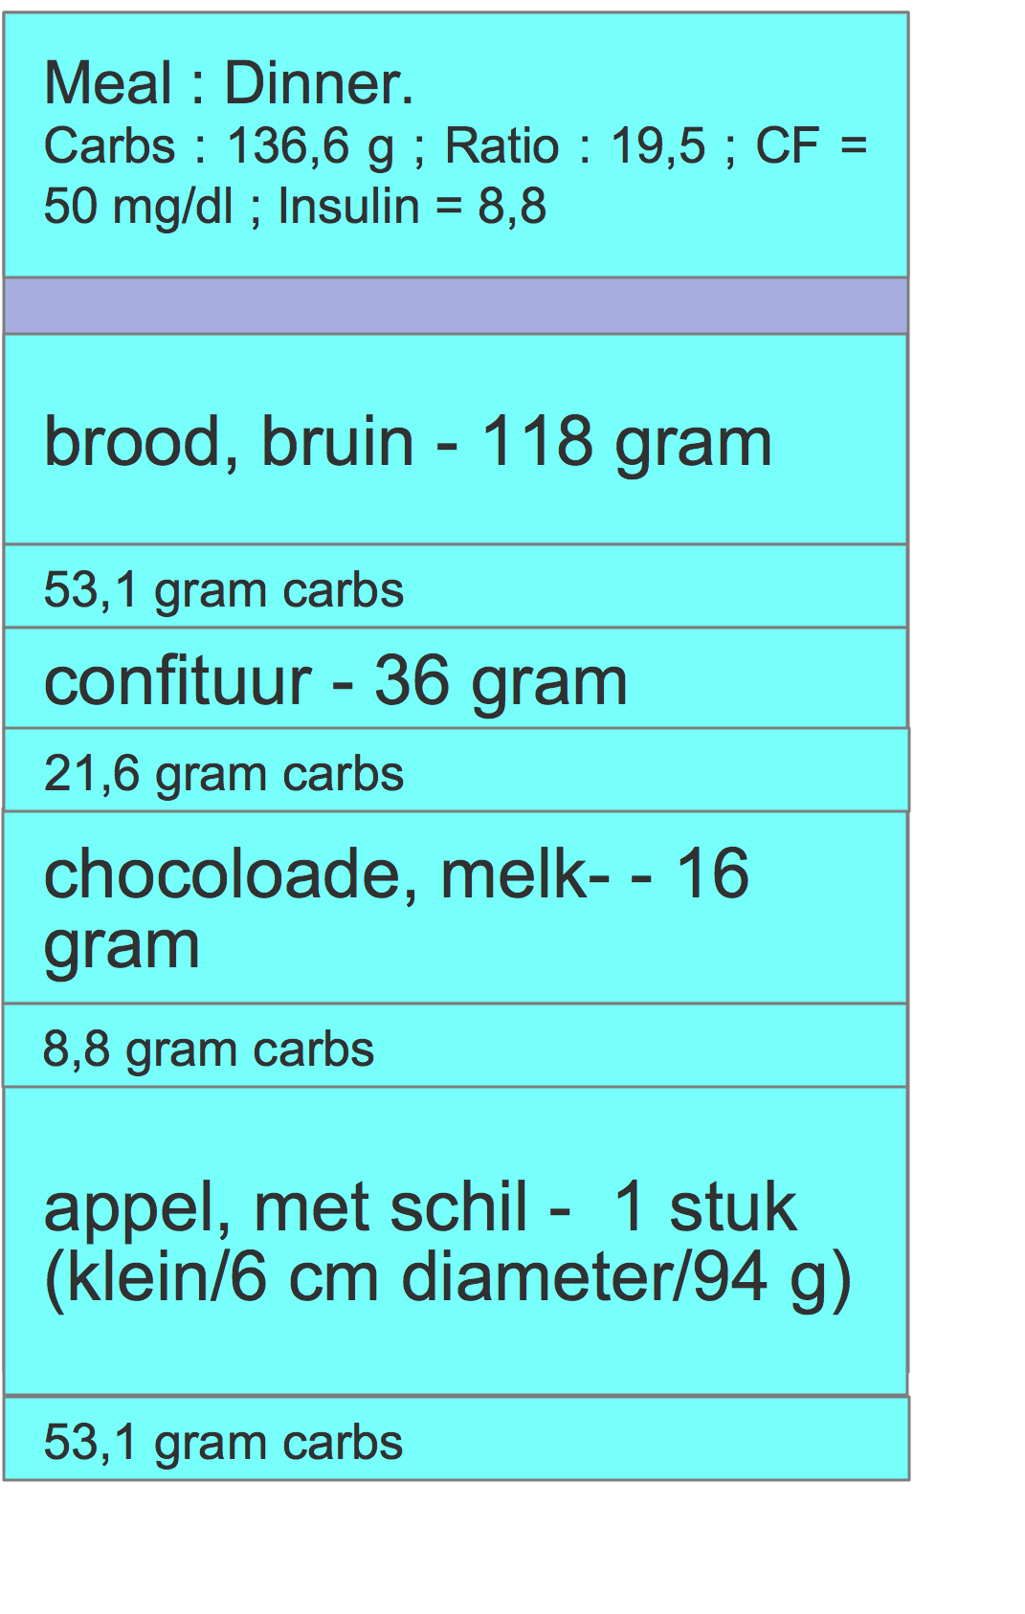

On top a row is shown with type of meal (breakfast, lunch, ...own meal..).
The second row show the total amount of carbs, fat and protein for the meal.
Then several rows, two per food item in the meal with :
- food item name – amount and unit
- amount of carbs (depending on personal settings, it may also show the amount of kilocalories, fat or proteins)

When clicking on an item, the user goes to Screen AddItem. The field amount, unit and meal are preset based on the values of the clicked item. The Screen AddItem will open without pop up for selecting the unit, and with “Add” replaced by “Save”.
! | When clicking Save in the Screen AddItem, then the next Screen depends on how the user got here.  When coming via Screen Food Counter, to Screen EditMeal Event, to Screen Add Item, then the user returns immediatelly to Screen FoodCounter.  When coming via Screen Tracking, to Screen EditMeal Event, to Screen Add Item, then the user returns to Screen EditMealEvent.  When clicking return or cancel (depending on type of device), then the user returns to Screen EditMealEvent

Edit Medicin Event
Screen to create, or edit a medicin event
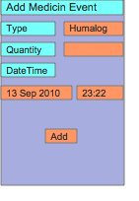
- Date and Time are set by default to current date and time, user can modify it
- clicking 'Add' saves the entry and returns to previous screen
- Clicking type (in this example “humalog”) allows user to chose another medicin type
- In case user clicked an existing entry in the Screen Tracking, then “Add Medicin Event” is replaced by “Edit Medicin Event”, and “Add” button is replaced by “Save” button

Edit Exercise Event
Screen to create, or edit an exercise event
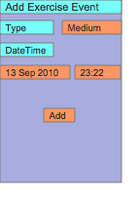
- Date and Time are set by default to current date and time, user can modify it
- clicking 'Add' saves the entry and returns to previous screen
- Clicking type (in this example “medium”) allows user to add chose other exercise type
- In case user clicked an existing entry in the Screen Tracking, then “Add Exercise Event” is replaced by “Edit Exercise Event”, and “Add” button is replaced by “Save” button

Edit BG Event
Screen to create, or edit a bloodglucose event
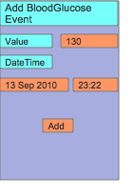
- Date and Time are set by default to current date and time, user can modify it
- clicking 'Add' saves the entry and returns to previous screen
- In case user clicked an existing entry in the Screen Tracking, then “Add BloodGlucose Event” is replaced by “Edit BloodGlucose Event”, and “Add” button is replaced by “Save” button

Filter
To be completed

Add Event
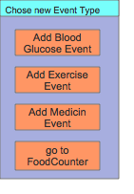

Food Table
to be completed

Settings

Global overview, to be grouped

Meal Times
This setting is used in the Screen AddItem, to determine to which meal type a food item should be added.
- Breakfast until
  - If a fooditem is added between midnight and “breakfast until”, then the fooditem will be added to the breakfast. If no breakfast exists yet for today, then a new meal event will be created.
  - Type and format “HH:mm”
  - Default : “10:00”
- Lunch until
  - If a fooditem is added between “breakfast until” and “Lunch until”, then the fooditem will be added to the lunch. If no lunch exists yet for today, then a new meal event will be created.
  - Type and format “HH:mm”
  - Default “14:00”
- Snack until
  - If a fooditem is added between “lunch until” and “snack until”, then the fooditem will be added to the snack. If no snack exists yet for today, then a new meal event will be created.
  - If a fooditem is added between “snack until” and midnight, then the fooditem will be added to the supper. If no supper exists yet for today, then a new meal event will be created.
  - Type and format “HH:mm”
  - Default “16:30”

Setting Insulin-to-Carbohydrate Ratio, per type of meal

Insulin-to-Carbohydrate Ratio (I:C) determines the amount of grams of carbs that can be absorbed by one unit of insulin. The user can set different values for breakfast, lunch, snack and supper.
Value can be a real number (eg 10,5)
The user may also chose to set the number of insulin units per 10 grams of carbs.
Example : 2 units per 10 grams of carbs = 5 grams of carbs per unit of insulin

Default value : 0 grams of carbs per unit of insulin. This value corresponds to “not used”

target blood glucose level

correction factor
Default value : 0. This value corresponds to “not used”

Maximum time difference between latest BloodGlucoseEvent and start of meal

What is the user mainly interested in ?
Carbs, proteins, fat or kilocalories. To be used in Screens EditMealEvent, Tracking

Screen to show at launch
The user may chose to go directly to a specific screen at launch, for example if the user uses mainly the Screen FoodCounter, the application will always launch with this screen as start Screen.
Possible values : Home, FoodCounter, Tracking
Default value : Home

Info/About
to be completed

Additional functionalities

Initial application start
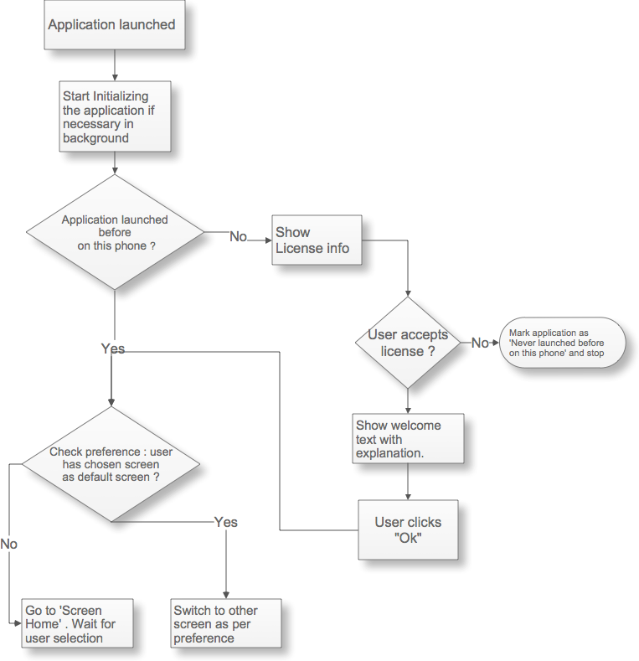

Detailed Contents of a MealEvent row in Screen Tracking and in Screen EditMealEvent – Insulin dose calculation

A meal event in Screen Tracking and in Screen Edit Meal Event shows the amount of insulin units needed for the meal.

This is how the amount is calculated :
- The total amount of carbohydrates (in grams) is the sum of the amount of carbohydrates for the individual food items.
- Insulin-to-carbohydrate Ratio (I:C) : tells how many units of insulin is needed to take to "cover" a specified number of carbohydrate grams
- Then it's the simple Rule of Three to apply and to calculate the insulin dose, for example, if I:C is 1:12, you'll need 1 unit of insulin for every 12 grams of carbohydrate you eat
- The Insulin-to-carbohydrate Ratio is different for everyone and can also be different per type of meal (breakfast, lunch, snack, supper). The value should be configurable via the Settings.
The application will automatically pick up the right I:C value dependent on the type of meal (breakfast, lunch, …).
example :
  - let's assume the current meal is breakfast, there's two fooditems with a total of 40 grams of carbs, the I:C for breakfast is 1:12, then insulin units = 3,3
  - Then I decide to change my I:C value, via the settings, for breakfast, to 1:15.
  - If I go now to Screen Edit Meal Event or Screen Tracking, then the amount of insulin will be 2,7
- The I:C ratio used for a meal will not change anymore once the meal has passed.
Example :
  - Assume a list of events exists as in § Tracking
  - the I:C value used for both breakfasts (11 and 12 September) is 19,5
  - The switch time from breakfast to lunch is 10:00
  - It is now 09:00
  - the I:C value for breakfast is changed to 21
  - The Ratio and Insulin amount for breakfast on 11 September is not changed. The Ratio and Insulin amount for breakfast on 12 September take the new value.
  - It is now 10:15, again the I:C value for breakfast is changed , now to 23
  - Non of the ratios and insulin amounts for breakfast on 11 and 12 September are changed.
- Then there's also the Correction Factor. This factor defines as how much one unit of rapid-acting insulin will drop the blood sugar.
  - A correction dose = difference between actual blood glucose level and target blood glucose level divided by the correction factor
  - the correction factor is different for everyone. The value should be configurable via the Settings.
  - The target blood glucose level is different for everyone. The value should be configurable via the Settings.
  - Example : carbs = 80 grams, I:C ratio = 19,5. Target blood glucose level = 120, actual blood glucose level = 210. Correction Factor = 50.
==> correction dose = 1,8 units, resulting amount of units = 80/19,5 + 1,8 = 5,9
  - Correction dose can be negative, in case the actual blood glucose level is less than the target blood glucose level.
  - The correction dose used for a meal will not change anymore once the meal has passed.
  - The correction dose is calculated only if the Correction Factor is not 0 and if there exists a BloodGlucose Event x minutes before the start of the meal. Start of the meal = the timestamp that the meal was created the first time. X = configurable via settings.
  - If there are multiple BloodGlucose Events in the last x minutes before meal start, then the youngest BloodGlucose Event Value is used.

What is shown in the Screens EditMealEvent and in a row in Screen Tracking

Row in Screen Tracking
This is only applicable for rows showing meal contents (breakfast, lunch, ..).
- Depending on user Settings, it will show the total amount of carbs or kilocalories or proteins or fat.
- If I:C ratio for the specific meal type is 0 then the row contains nothing else
- If I:C ratio is not 0
  - The correction dose is shown only if the Correction Factor is not 0 and if there exists a BloodGlucose Event x minutes before the start of the meal. Start of the meal = the timestamp that the meal was created the first time. X = configurable via settings. If the Correction Factor is 0 the row will not display the Correction Factor Value.
  - the calculated insulin dose.

Example :
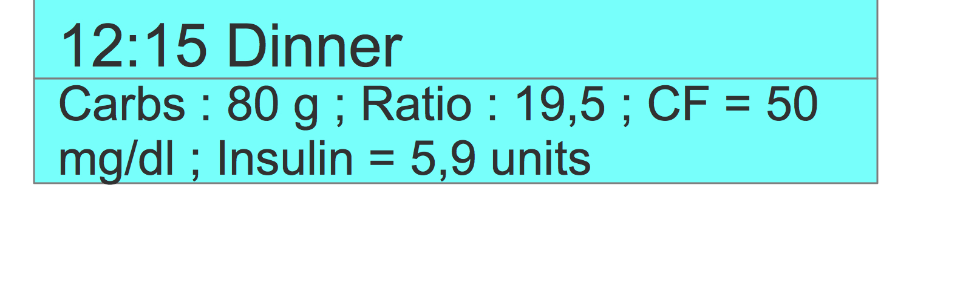

Screen EditMealEvent
The first row on top shows the same as in Screen Tracking, in addition it shows the total amount of carbs, kilocalories, fat and proteins.
Example :
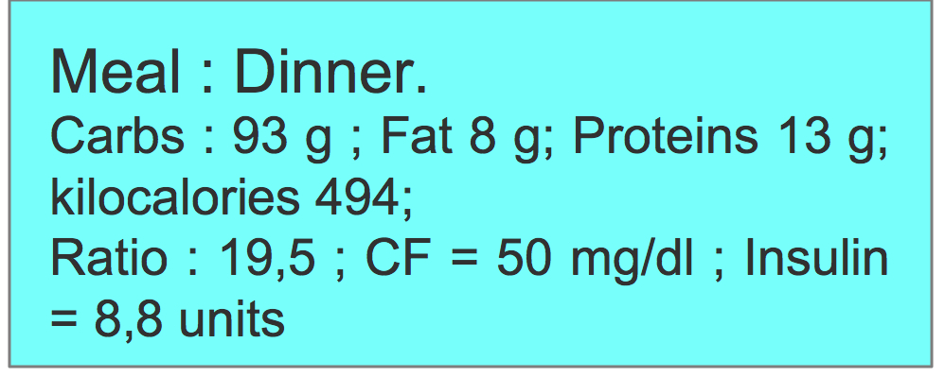

The other rows will show per food item in the meal, the column the user is interested in (by setting).
Example :
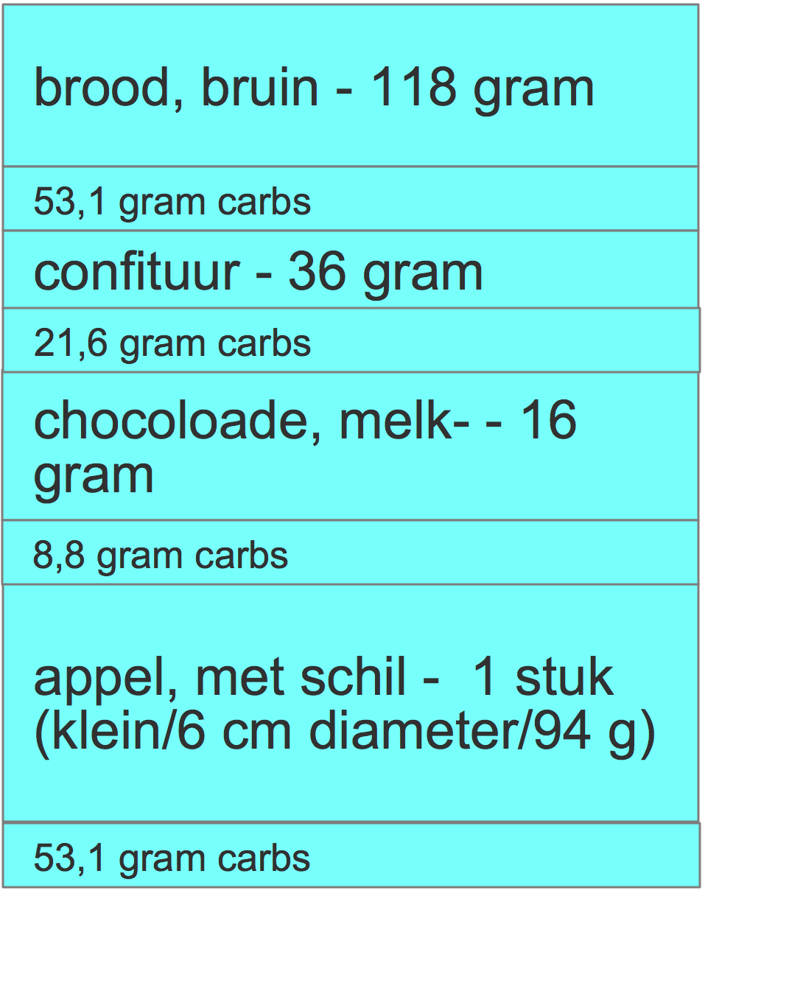

New Meal

The standard application-built in meals are “breakfast”, “lunch”, “snack”, “supper”.
A user may take additional meals. In that case it is possible to create a one-time additional meal in the Screen AddItem by clicking on the button that shows the current meal.

When clicking a pop-up appears where the user can select a name for the meal, with a default name that consists of the time the meal was created, for example “Meal-17:38”.

In case the user has selected a new Meal, whenever the user adds again a food item to a meal (from Screen FoodCounter) , the application will fill in by default the new Meal, except if the time has passed to a new period (as per settings ..)

In case meal filtering per type of meal is used in Screen Tracking, these meals will not be shown at all.

Non-Functional

Icons
Nowhere in this document, icons are used. All menu options, buttons, etc. could finally be replaced by icons.

Text
Text used here in the screens is only as example. All texts should be easily modifiable (in source code, resource file, xml file, …)

MultiLanguage
The application should support multiple languages.

Application Texts
It should be possible to use the application in multiple languages. The language is either automatically selected based on phone Settings (eg Android) or needs to be selected at start up by the user.

Food Composition Tables
Food composition tables are available in 10 languages in the format required for this application : http://www.johandegraeve.net/Food_Composition_Table_Other_Languages.html
A lot more food composition tables in other languages are available on the Internet.
The correct table is either automatically selected based on phone Settings (eg Android) or needs to be selected at start up by the user.
It should also be possible to select another language table via the Screen Food Table

Priorities
Priority 1 = highest priority

Priority 1
- Carb Counting
  - Count carbohydrates, fat, proteins, kilocalories in a meal.
  - Food Composition Table, alphabetically ordered (follow Excel sorting rules)
  - Calculate required insuline dose, based on personal carb-to-insulin ratio
  - personal carb-to-insulin ratio can be set for breakfast/lunch/snack/supper, ‘switch-times’ can also be configured and application picks up correct value
  - Food Composition Table can be modified by user via PC (Excel)
  - Food Composition Table can be modified by user via mobile, modified table can be exported to .csv
- Tracking
  - Blood Glucose tracking
  - Food Tracking
  - Medication tracking
  - Exercise tracking
  - Export to .csv , XML
- Device Types
  - Android
  - iPhone
  - Symbian
  - BlackBerry (still to be checked if feasible to implement a good “search-as-you-type” application)
- Simple website with explanation, with reference to places where application can be installed (iTunes, Android Market, BlackBerry app World, OVI store)
- Language
  - Dutch and English but should be easy to extend to other languages
  - Choose among different food composition tables (1 per language, for free apps at least 10 different languages are available, see http://www.johandegraeve.net/Food_Composition_Table_Other_Languages.html)

Priority 2
- Synchronize tracking data with server
- Charts for analysis of tracking data
- Website where user can analyse/modify tracking data
- PC client to analyse/modify tracking data
- Mac client to analyse/modify tracking data
- Community forum
- Develop download platform, with device recognition and automatically select the right application or redirect to market (iPhone/iPad and Android). Also for currently available J2ME app (http://www.johandegraeve.net/)

