Patrice Boulet (6583832), Nicholas Gagnon (7453294)

Professor Timothy Lethbridge

SEG2105 Introduction to Software Engineering

4 November 2014

Assignment 5

**PROBLEM STATEMENT**

Students need part-time work in order to fund their studies and gain experience, while startups need smart and creative employees who are willing to work for lower hourly wages.

**REQUIREMENTS**

StudentsMeetStartups.com is a website that connects students with local startups for part-time work. It will allow debuting entrepreneurs to meet with students through informal meet-ups that, in contract with traditional interviews, will provide them with a much deeper and realistic impression of those students.

Students have a name, an age, a short self-description, an address, an optional personal website, an email address, a telephone number, an academic record, a resume, and a set of credentials to allow them to sign into the website. In order to attend meetups, a student has to be a member of the website. Both the academic record and resume will be uploaded as PDF documens.

A startup has a company name, a description, a postal address, a telephone number, an optional fax number, a website, an email address and a set of credentials to allow them to sign into the website. In order to post meetups, an employer must be a registered member.

An address has a street number, an optional apartment number, a street name, a postal code, a province and a municipality.

The meet-ups have start and end times, an address, an employer and participating students. Participants do not necessarily meet physically, hence the address could be omitted. After the meet-up has taken please, the startup will write a review of each student, whil each student will write a review of the startup. Such reviews include a 5-star based rating as well as a short textual comment.

**ARCHITECTURE & TECHNOLOGIES**

Since today's personal computers and mobile devices have the capabilities to perform very advanced computations, our system will be designed around a fat-client architecture in which the server component will merely serve as an adapter for the underlying SQL server.

The JavaScript language will be used for both the client and the server components. Our sytem will favor re-use of existing components, hence the KnockoutJS and jQuery frameworks will be used on the client-side, while Expressjs will be used by the server-side.

The MySQL database server will be used for persistant storage of information. At first, it will be running on the same server as our server component.

Our codebase will be hosted on GitHub, and as a consequence, we will use git as a version control system in order to keep track of changes.

The client and the server components will communicate using the HTTP protocol following the RESTful principles. The body of the HTTP requests and responses will contain JSON-formatted objects that are perfectly compatible with our choice of programming language.

Bootstrap 3 will be used for creating responsive and cross-platform layouts. This easy-to-use CSS framework will thus allow our website to run both on traditional personal computers and mobile devices such as tables and smartphones.

Finally, we will use the Zombie.js framework to provide us with an easy-to-use API to write functional tests for our whole system. This framework emulates a Web browser an navigates through the pages as a normal user would.

**USER STORIES**

1. As a student, I would like to create a profile in order to enroll in meet-ups with potential startups. The following use case maps illustrate who a student would sign up to the website.

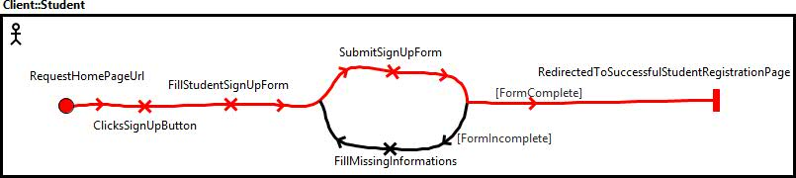

**Figure 1.** Use Case 1A: Student signs up successfully

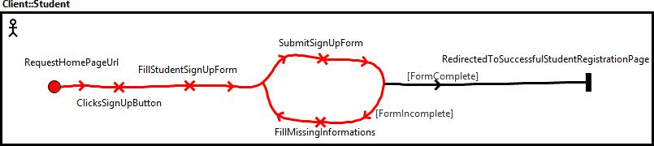

**Figure 2.** Use Case 1B: Student signs up and all mandatory information were present at submission of the sign up form.

*The only difference in these use cases when a startup representent signs up is that the sign up form and the successful registration page are different than when it’s a student that signs up.

2. As a startup representent I would like to sign in to the website in order to access exclusive to startup members content and rights. The following are use case maps illustrate two use cases where a startup representent signs in to the website.

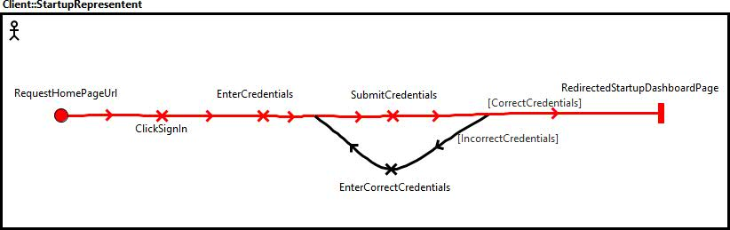

**Figure 3.** Use Case 2A: A startup representent tries to sign in with correct credentials.

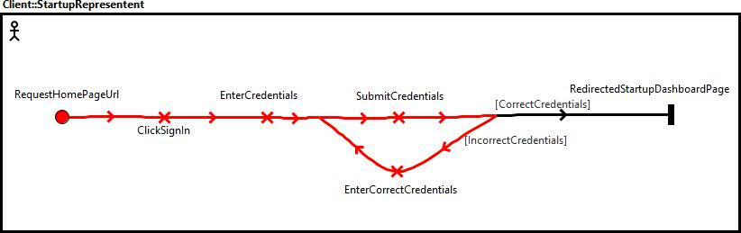

**Figure 4.** Use Case 2B: A startup representent tries to sign in with incorrect credentials.

3. As a startup representent I would like to schedule a meetup in order to set up a place and time to meet students. The following are use case maps illustrate two use cases where a startup representent schedules a meetup.

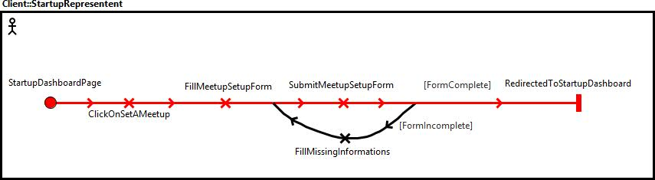

**Figure 5.** Use Case 3A : Startup representent schedules a meetup with all mandatory information present at submission of the setup form.

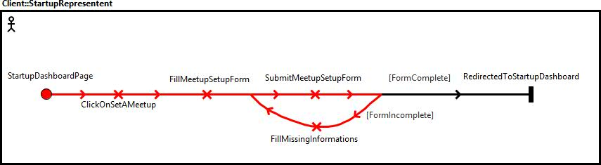

**Figure 5.** Use Case 3A : Startup representent schedules a meetup with some incomplete mandatory information present at submission of the setup form.

4. As a student I would like to enroll to a meetup in order to meet a startup representant.

5. As a non-member user of the website, I would like to consult the startups profiles in order to explore studentsmeetstartups.com.

6. As a student I would like to modify my profile in order to display more up to date information about me.

7. As a startup employee I would like to modify my profile in order to display more up to date information about my business.

**MESSAGE EXAMPLES**

|  |  |  |  |
| --- | --- | --- | --- |
| **Message example # (matches use case # )** | **Request** | **Response** | **Description** |
| 1 | POST /student  (html form values as a JSON object) | * | Student signs up. |
| 2 | POST /startup  (html form values as a JSON object) | * | Startup signs up. |
| 3 | POST /meetup  (html form values as a JSON object) | * | Startup schedules a meetup. |
| 4 | PUT /meetup/:id (JSON object containing student unique account id) | * | Student enrols in a meetup. |
| 5 | GET /startup/:id | * | Non-member user want to check out startups profiles. |
| 6 | PUT /student/:id (html form value as a JSON object) | * | Student modifies his profile. |
| 7 | PUT /startup/:id (html form value as a JSON object) | * | Startup modifies his profile. |

* JSON object containing a confirmation or an error message.