**Vienna's Districts and Their Respective Real Estate Prices**

15.09.2019

**Patrick Brachner**

1. **Introduction**
   1. **Background**

On 13.09.2019, the Austrian National Bank has published a report in which they examined Vienna’s recent surge in housing prices throughout the past year. Prices for apartments rose by almost 10% within the last year and are up 170% since the year 2000. In the face of this development and the current environment of low interest rates for consumer credits, many Viennese, who are currently renting apartments, now consider buying housing in order to protect themselves from even higher prices in the future.

1. **Problem & Potential Beneficiaries**

After deciding to switch from renting to buying, one very important question remains:

***Which districts are cheaper than others, given that they are similar in type?***

This report should give a basic, but quantitative overview of Vienna's 23 districts and their respective real estate prices. Using location data, districts will be classified into several clusters and subsequently compared based on average apartment prices per square meter. This information should serve as a starting point on deciding in which district people would want to consider searching for an apartment.

1. **Data Sources and Acquisition**

**2.1 Data Sources**

Three main sources of data served as a basis for the development of this report:

**Database - City of Vienna:** Current data of average real estate prices per district  
 **Open Data Austria:**  GeoJSON files containing the district and city borders  
 **Foursquare:**  Location data for different areas within the city

**2.2 Data Acquisition:**

I scraped the website of the city of Vienna for current prices (in Euros €) per square meter using BeautifulSoup and then converted the data to a pandas-Dataframe. Secondly, I decided on representative and central spots within the districts and used the Geopy/Nominatim – package to retrieve the corresponding latitude and longitude values. Using these geographical points, I used the Foursquare API to retrieve location data within a circle of 1,500m radius, grouped the elements with regards to their venue categories and listed the 10 most frequent occurrences per district. Given this data, it was possible to cluster districts based on similar venue categories using the k-means clustering algorithm. Lastly, I downloaded the GeoJSON file from the Open Data Austria database and deployed it to a Choropleth map generated with folium to visualize price differences between districts.

1. **Exploratory Data Analysis**
   1. 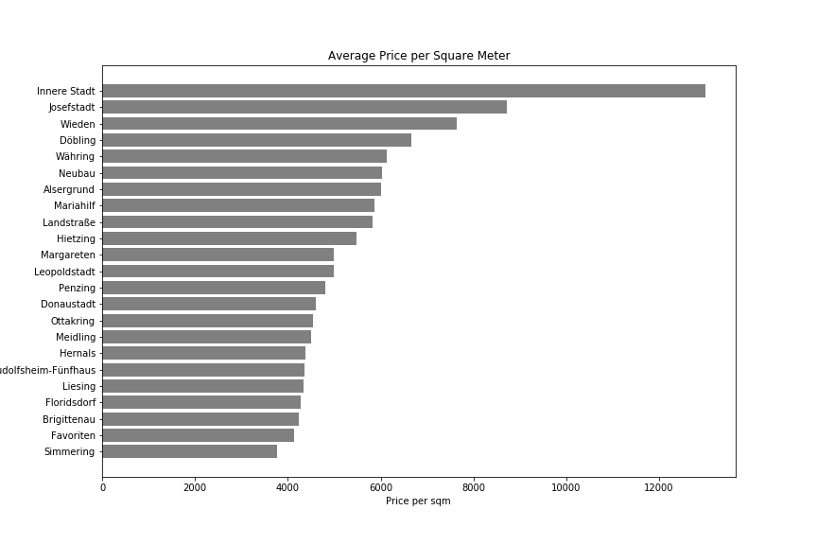 **Average real estate prices per district (Bar Chart):**

Looking at the bar chart comparing average apartment prices per square meter it can clearly be determined that Vienna’s first district, Innere Stadt, has significantly higher prices than all other districts, whereas many other districts have average price levels that are very close to each other.

Unfortunately, the data does not take into account frequency of different features of apartments and doesn’t distinguish between apartment sizes. However, as the same blur is applied across all districts and the main focus is not on absolute numbers but comparison between areas, the data should still provide valuable insights.

* 1. **Distribution of average real estate prices (Box Plot):**

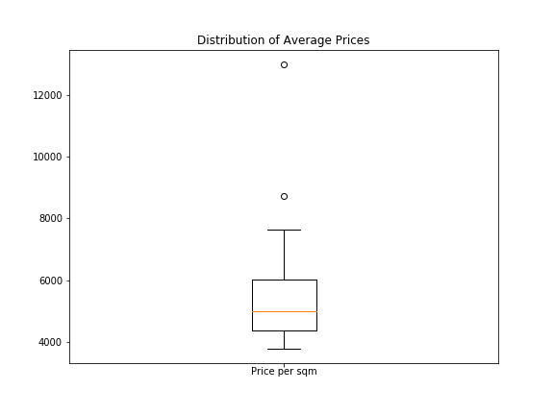

Considering a box plot, visualizing the distribution of average housing prices per district, it can also be seen that one data point constitutes a significant outlier. As the analysis is intended primarily towards districts interesting for housing purposes, the central district „Innere Stadt“ (upper outlier) was excluded from the analysis due to being largely occupied by corporations, ministries or embassies. However, as almost 120,000 Viennese commute to this district for work every day, proximity of housing opportunities to the city center remains an important factor for many people when deciding on buying an apartment.

On the other hand, the 8th district, “Josefstadt”, is also classified as an outlier by the pandas-function due to its high prices but will remain in the analysis as the district has a totally different characteristic as “Innere Stadt”. “Josefstadt” is a much more popular and important residential area with almost no large corporations or public offices.

**Remark:** As this analysis is primarily geared towards people who already live in Vienna or are familiar with the peculiarities of the city, the public and individual transport system as well their personal regional preferences, I desist from describing the different clusters in greater detail and let the segmentation of the districts speak for itself.

* 1. **Clustering and Choropleth Map with regards to housing prices**

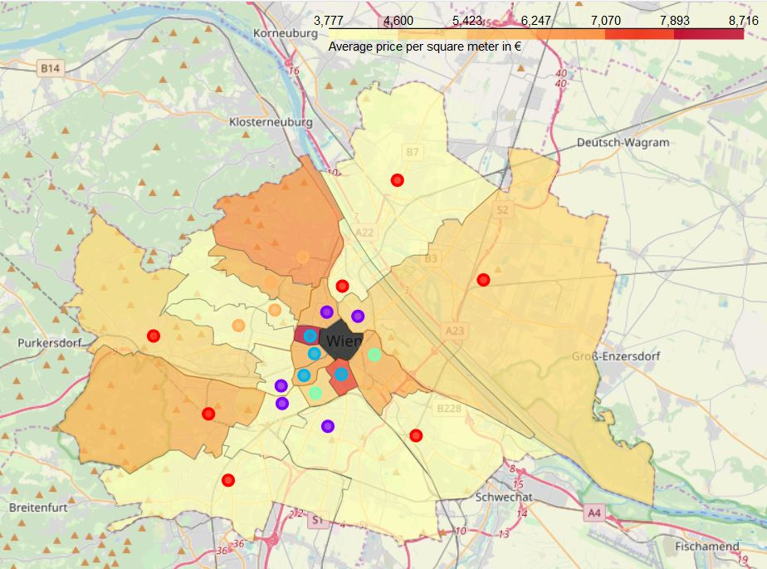

Using k-means clustering, it was found to be optimal to divide Vienna’s districts into 5 different clusters. Districts within certain clusters are represented with purple, blue, green, red and orange dots. The areas of the districts are filled in different colors with regards to their average real estate prices per square meter.

1. **Results & Discussion**

**4.1 Results**

* Central districts tend to have higher real estate prices and are similar to each other with regards to quantitative location data
* There are districts with still very high proximity to the city center, but significantly lower prices
* Prices tend to rise again towards city boundaries
* Price differences can be found throughout clusters of similar location data and similar proximity to the city center

**4.2 Discussion**

Looking at the clustering, it can be concluded that Vienna’s districts can be broadly separated into “centrally oriented” and “suburbian” districts. “Centrally oriented districts” contain the purple, blue and green cluster, whereas “suburbian districts” are marked with red and orange dots. However, within both categories and their respective clusters, significant differences in prices can be found while offering similar public amenities.

Within the “centrally oriented districts” Brigittenau (20th district) and Margareten (5th district) show the most potential of finding interesting options for good prices.

In the “suburbian” areas, especially Simmering (11th district), Favoriten (10th district) and Floridsdorf (21st district) tend to have the most reasonable prices while still be comparable to more expensive areas in terms of location data.

1. **Conclusion**

Throughout all clusters and preferences there are opportunities to choose districts with similar characteristics for a lower price.

Interested parties should first decide which category of districts they would be interested in and afterwards proceed with analyzing the cheapest candidates.

As Foursquare is not the primary location data platform used in Austria, it would probably be more fruitful to the carry out the analysis with data from Google Maps. However, as the objective of the project was to use the Foursquare API, the results still yields valuable insights.