

[Insert Company Name]
Reuse Strategy

Version 1.0
Date:

Contents
1 Introduction 1
1.1 Purpose 1
2 Key Concepts 2
2.1 Asset-Based Development 2
2.2 Assets and Artifacts 3
2.3 Asset Standards 4
3 Reuse Vision 4
3.1 Vision 5
3.2 Identified Risks 9
3.2.1 Asset mis-identification 9
3.2.2 Asset consumer mis-target 9
3.2.3 Volume-centric repository 9
3.2.4 Asset governance 9
3.2.5 Budget and Resources 9
4 Reuse Environment 11
4.1 Asset-Based Development Process 11
4.2 Organization 12
4.3 Asset Production Strategy 15
4.4 Reuse Infrastructure 16
5 Reuse Adoption Strategy 16
6 Reuse Implementation Plan 17
6.1 Phase 1 – Line of Business Assets 17
6.2 Phase 2 – [Insert Company Name] Federated Assets 19
6.3 Phase 3 – Model-driven Architectures (MDA) 20
6.4 Phase 4 – Federated Assets 21
7 Metrics for Measuring Progress 21
7.1 Economic metrics 22
7.2 Primary metrics 23
7.3 Asset consumer feedback 23
7.4 Library metrics 23
8 Additional Considerations 24
8.1 Reuse Incentives 24
8.2 Internal Communication Model 25
8.3 Training Model 25
8.4 Funding Model 26
9 References 26

Figures
Figure 1: Standards, Tooling, Processes, and Assets in Asset-based Development 2
Figure 2: Asset-Based Development Motivations 3
Figure 3: Assets and their Artifacts 3
Figure 4: Reusable Asset Specification 4
Figure 5: Asset Reuse Scope 7
Figure 6: High-Level ABD Process Steps 8
Figure 7: [Insert Company Name] ABD Overview Diagram 11
Figure 8: [Insert Company Name] Organization Chart 13
Figure 9: ABD Tooling Infrastructure 16
Figure 10: Reuse Adoption Steps (adapted from Lim, p. 56) 16
Figure 11: Phase 1a: Pilot Project 1: Portal Framework 18
Figure 12: Phase 1b: Pilot Project 2: [Insert Project Name] Components 19
Figure 13: Phase 3 - MDA Approach 20
Figure 14: Reuse metrics framework (adapted from Lim, Managing Software Reuse, p. 301) 22

Introduction

Purpose
Systematic software reuse is the purposeful creation, management, support, and reuse of assets. In Software Reuse: Architecture, Process, and Organization for Business Success, Jacobsen et al estimate the following benefits of systematic reuse:
- Time to market: 2 to 5 times reduction
- Defect density: 5 to 10 times reduction
- Maintenance cost: 5 to 10 times reduction
The mission of the reuse program is to help continuously improve the delivery of OCIO information products and services; help provide and support a world-class IT operation that meets or exceeds end-user needs; and provide end-to-end solutions that increase asset reuse and reduce software development costs. The [Insert Company Name] helps to realize this mission by developing tools, processes, and policies that will establish, maintain, and encourage strategic reuse.
There are many challenges, however, to implementing software reuse at an organization that uses a more traditional development approach. This document discusses the changes in policy and practice that will be required at [Insert Company Name] to apply asset-based development techniques. (Some of these changes have already begun.) It also presents a strategy for getting started using these techniques.

Key Concepts
This section defines some key asset-based development concepts. These terms form the vocabulary that we will use throughout this document and in the other guideline documents.

Asset-Based Development
Asset-based development is a way to develop software solutions using and reusing cohesive, documented software artifacts. It is organizing software development in a way that leverages previous investments and influences the nature of future investments. In addition, its modular approach of using components and assets makes it easier to adopt changes to a system that has already been built.
The following are the four elements of asset-based development:
- Assets—cohesive, documented software artifacts that provide a solution to a problem for a given context
- Standards—consistent specification and representation of software assets and processes
- Process—conducting software development in a way that leverages previous investments and preserves current investments
- Tooling—automation that supports the process (i.e., the production, management, and consumption of assets)
The relationships among the elements are shown in Figure 1.
Figure 1: Standards, Tooling, Processes, and Assets in Asset-based Development
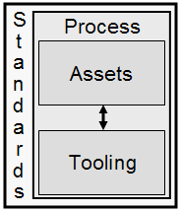

Motivations for Asset-Based Development
Some motivations for asset-based development are described in Figure 2.
Figure 2: Asset-Based Development Motivations
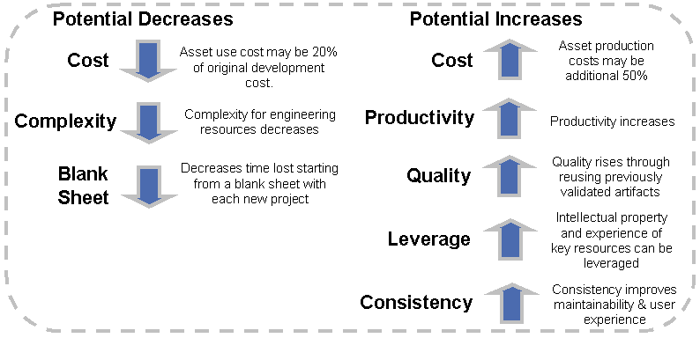

Assets and Artifacts
An asset is a collection of artifacts that provides a solution to a problem for a given context with rules for usage and variability points. Types of assets include components, patterns, Web services, frameworks, code, documentation, models, and templates. Artifacts are work products from the software development process, e.g., requirements, models, source code, tests. The relationship between assets and artifacts is shown in Figure 3.
Figure 3: Assets and their Artifacts
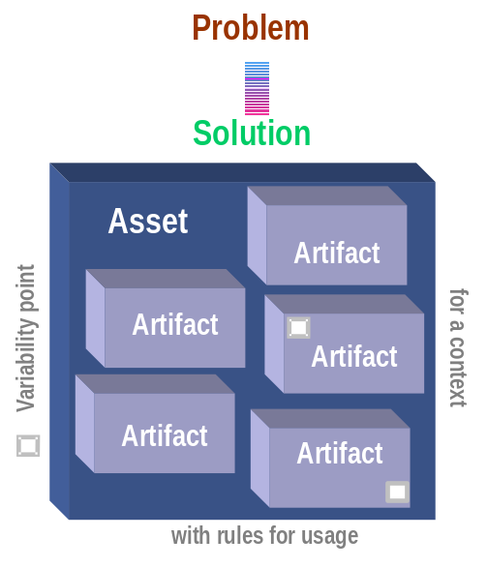

Asset Standards
The Reusable Asset Specification (RAS) describes a standard for consistently organizing and packaging assets. This standard requires that assets include the following sections, which are also shown in Figure 4.
- Classification, which contains name/value pairs that describe/classify/categorize the asset (including references to [Insert organizational reference model name] Reference Model)
- Solution, which contains the asset’s “payload” (i.e., the artifacts – models, code, etc. -- that comprise the solution the asset provides),
- Usage, which provides usage instructions
- Related Assets, which describes the association, aggregation, dependency, etc. with other assets
Figure 4: Reusable Asset Specification
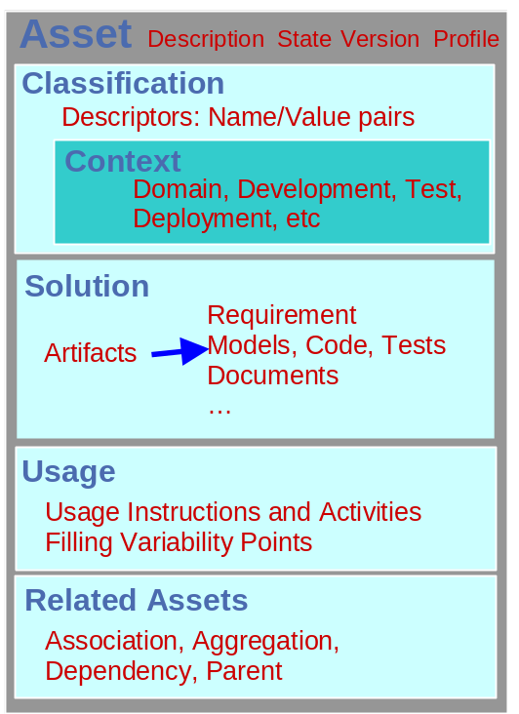

Reuse Vision
Asset-based development uses standards, processes, and tooling so that software development artifacts can be reused. This development method leverages previous development efforts, reduces development time and costs, reduces maintenance costs, and improves product quality.
The [Insert Company Name] has initiated efforts in asset-based development and strategic reuse to support the [Insert Company Initiatives], to reduce software development costs, increase software quality, and reduce software maintenance costs. This approach to software development will enable [Insert Company Name] to implement electronic government in its patent and trademark business areas to reduce paper handling and enhance business processes. It will also improve both business and IT efficiency and effectiveness.
In this section, we describe [Insert Company Name] vision for asset-based development.

Vision
The overall vision of the [Insert Company Name] ABD strategy is to produce systems through reusable assets in support of the following themes:
- Agility
- Capability
- Productivity
- …
The [Insert Company Name] business drivers that motivate this vision are:
- Improve [Insert Company Name] efficiency
- Reduce latency of business events
- Integrate across delivery channels
The [Insert Company Name] IT drivers that motivate this vision are:
- (a) Unify/simplify complexity
- (b) Leverage legacy investments, integrate with back-end systems, and collaborate with other systems
- (c) Leverage reuse strategy in all architectural layers, including into the code
- Comply with [Insert name of domain or organization-specific standards] guidelines
- Maintainability, availability, scalability
- Minimize total cost of ownership
Reuse is a two-part decision process; first, the organizational level decision to institute systematic reuse; and second is the decision to practice reuse at lower levels of the organization. Both decision levels require management support and enforcement. For the reuse vision to be successful the application development teams must see from the start that the reuse efforts are providing value to their development challenges and assignments. Relying on a reuse strategy that holds out benefits in the distant future will suffer the fate of failure.
Therefore assets must be identified early that have high value for a targeted asset consumer audience, namely the application development teams. There are two approaches here, one – identify assets that are reusable across a broad sector of the development teams, or two – identify assets that are highly valuable to a narrow sector, perhaps for a specific project, or two. The latter strategy tends to be more approachable as it helps to control scope, cost, training, project coordination, and so on.
To successfully implement the reuse vision there are some fundamental principles that should be observed. Without support for these principles, implementing the reuse vision is placed at risk.
- Management support for asset-based development
- Seek ways to shift the extra costs and risks of reuse production and consumption out of the individual application development projects and into the core asset development team
- Look for high quality, relevant assets that are critically needed by the target asset consumers, namely the application development teams
- The functional and non-functional requirements must be well understood by both the application development teams as well as the core asset development team
- Application development teams have limited resources available for reinvention
- There is a strong architect who acts as reuse guardian for asset assessment and usage
- Seek reuse opportunities where it has the highest probability of a net positive project payoff
- Recognize and encourage all forms of reuse that have net benefits at a project level, this includes reusing document templates, procedures, and so on
With these principles in mind, the reuse vision is to provide cost-effective assets that provide value to asset consumers, in particular application development teams, such that there is business value to using these assets. The business value may be described in terms of increased production time, or lower development and maintenance costs, or improved return on investment, and so on. The reuse program may be altered to focus on the identified value that the business seeks to obtain.
A critical element to this vision is that the reuse program should be implemented such that the costs of reusing assets are continually pushed down. The reuse cost is a major factor in the success of the reuse program. Increasing the packaging costs to decrease reuse costs is generally a reasonable strategy. However, having nicely documented non-reusable assets only increases costs for the business. See the Identified Risks section below.
Considering cost as a primary driver to the reuse program, there are some key elements to consider. The general principle here is that the higher the reuse level within the organization, meaning the level of formality and rigor in the reuse program, the more rigor, commitment, and cost is generally incurred. Consequently the promise of higher value may be obtained. These reuse levels include:
- Ad hoc (lowest level of reuse)
The activities around this are generally spontaneous and are focused on individual reuse.
- Systematic
This is organized reuse and typically goes more broadly to teams.
- Domain-oriented
This is targeted reuse for a specific line of business and families of products.
- Strategic (highest level of reuse)
Strategic plans are elaborated within the context of leveraging reuse opportunities and/or market opportunities are opened due to reuse.
The initial efforts of applying asset-based development in [Insert Company Name] will begin with Systematic reuse. This includes establishing and organizing the necessary process guidance, tooling infrastructure, and policies and guidelines. This approach to beginning the reuse activities permits [Insert Company Name] to gain some returns while controlling the level of investment.
Initially there will be no efforts to support a product-line approach to assets. However, this will clearly be the next step as common lines of business may be identified across organizations.
A critical aspect to controlling asset/reuse costs is through the nature of the relationship of the asset development team and the asset consumer teams. As part of the reuse vision the asset development team provides resources for ensuring the success of assets on the asset consumption teams. This not only helps the asset consumption teams in terms of their costs, but also provides valuable feedback on the assets that benefits future asset development efforts.
In addition to the organization’s reuse level affecting cost, the scope of the reusable assets can also affect the cost. Generally the higher the asset’s scope for reuse, the higher the testing, packaging, communicating, and maintenance cost. The strategy for this, as outlined in the Reuse Implementation Plan in this document, is to start with lower scoped assets and then grow the scope across the phases over time as experience and lessons learned are gathered.
Figure 5: Asset Reuse Scope
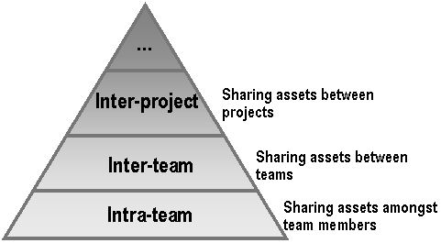

With the guiding principles outlined in this vision, the real focus becomes what can help [Insert Company Name] develop systems to meet the overall vision and business drivers that have been specified.
The overall vision is to provide a set of assets which conduct a series of transformations from a description of the business / organization ultimately to the code. This vision should be approached in controlled steps. These steps are outlined in the Reuse Implementation Plan section of this document. Implementing the entire vision requires a level of familiarity with pattern technology and a commitment to support sophisticated assets. Figure 6 describes the significant steps for doing this.
This approach is a top-down, model-driven style of reuse. There are multiple styles for addressing reuse. This template only illustrates one approach.
Figure 6: High-Level ABD Process Steps
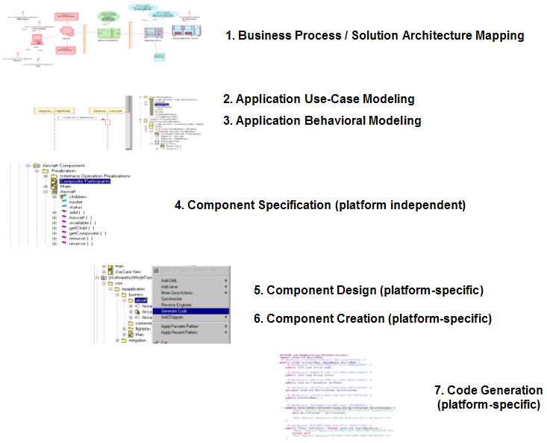
The following is a brief description of each of these steps. For more information on [Insert Company Name]’s asset-based development (ABD) process, see Part 2: Asset-Based Development Process Overview.
- Step 1: Business Process / Solution Architecture Mapping – Starting with the [Insert Company Name] Business Model (considered a mandatory input), the IBM Patterns for e-business are applied, which describes the mapping of the business processes onto a runtime topology. Then the product mapping is developed, which identifies the technologies / products that are to be used within the high-level Solution Architecture.
- Step 2: Application Use-Case Modeling – The application use cases which implement the business processes are defined.
- Step 3: Application Behavioral Modeling – The key abstractions, use-case realizations (e.g., interaction diagrams), and other behavioral models are created.
- Step 4: Component Specification – The components, component interactions, and interfaces are specified, but no specific platform is identified.
- Step 5: Component Design – Detailed design decisions are made for the component.
- Step 6: Component Creation – A platform-specific component is created.
- Step 7: Code Generation – The code is generated for the component.

Identified Risks
There are several key risks that must be understood and mitigated in the organization. A list of some of these and a mitigation strategy is below.

Asset mis-identification
There is a general tendency in asset identification to consider that each “interesting” piece of code or other artifact is reusable. If this course of action is followed it tends to produce a large number of assets that are in fact “interesting”, but in reality are not reusable. This tends to drive up the costs of the asset / reuse effort, thereby pushing out the timeline when a return on investment can be achieved.
Mitigation strategy: Identify asset identification criteria and conduct regular asset surveys and assessments with these criteria. Establish governance policies and acceptance policies whereby management has the option to accept / deny the development and long-term maintenance of the asset.

Asset consumer mis-target
Although an asset may have been thoroughly evaluated and the proper governance strategies have been identified, the asset may be packaged and organized at a level that misses the skill level of the target asset consumer. What this means is assets are produced that are too difficult or complex for the target asset consumer to use. This drives up the reuse costs, which drives down the business value proposition and the timeline for achieving return on investment.
Mitigation strategy: Establish an asset packaging policy that tests the organization of the asset’s documentation, guidance, and even variability points that eases the effort to reuse the asset. Increasing packaging costs to lower reuse costs are a critical part of the success of the asset / reuse activities. Another key element to the mitigation strategy for this risk is to establish training for the asset consumers on the process, tooling, and policies and guidelines early in the asset / reuse program.

Volume-centric repository
A mandate from management may be articulated which states that there must be “X” number of assets within a certain timeframe. With this motivation the organization may focus its energies on meeting this objective. The result is the repository may truly reflect this number, but the value of the repository is generally low while the cost goes up as fewer valuable, reusable assets are found in the cadre of assets.
Mitigation strategy: Set objectives in place that seek to positively impact the value to the asset consumer’s project, such as increased productivity or decreased development and maintenance cost, and so on. The repository should always be kept fresh through asset usage reviews, statistics, and feedback. Assets should be retired that are not providing value to the asset consumers.

Asset governance
Assets are identified and developed but no clear sponsor has been identified for the asset. The sponsor owns the responsibility of funding the development and maintenance of the asset over the life of the asset.
Mitigation strategy: The assets which are commissioned and developed by the reuse team will be owned and maintained by the reuse sponsor’s funding. Those assets developed by the application development teams will be owned and maintained on the budgets of the respective projects.
The application development teams may propose assets to the reuse team to own and maintain. The business case for the cross-project relevance of the proposed asset must be achieved. If the reuse team takes ownership of a project-developed asset, the funding model must support the reuse teams ownership and maintenance costs associated with the asset, as there will generally need to be refinements to the newly acquired asset to support a broader reuse scope.

Budget and Resources
The level and number of resources required to support asset-based development is underestimated. The organization does not have a sufficient budget to establish and maintain the reuse environment, including both processes and tools. The lack of both resources and budget can severely jeopardize the success of the reuse program.
Mitigation strategy:. ….

Reuse Environment
A very important part of a successful reuse program is the establishment of a reuse environment, where that environment consists of both a well-defined process and automation that directly supports the process. In this section, we provide a high-level view of the envisioned reuse environment at [Insert Company Name]. The reuse environment focuses on the IT Drivers listed above (namely a, b, and c) with a heavy emphasis on making the application development process simple and avoiding undue complexity for the organization roles supporting the process.

Asset-Based Development Process
For the asset-based development process to be used at [Insert Company Name] it needs to implement the reuse strategy defined in this document. A high-level view of the process is shown in Figure 7.
Figure 7: [Insert Company Name] ABD Overview Diagram
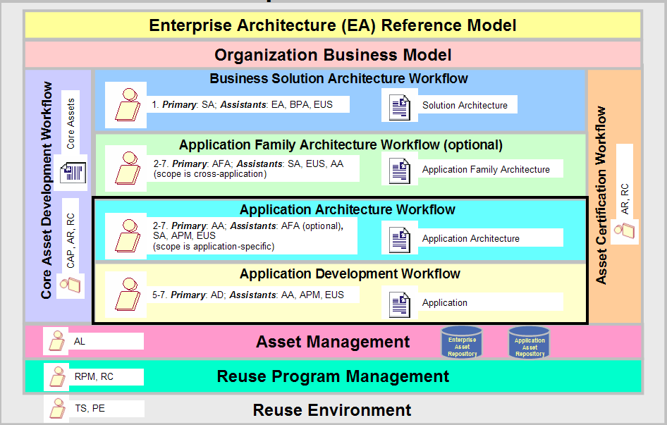
The primary inputs to the ABD process is the Enterprise Architecture (EA) Reference Model and the Business Model. The EA Reference Model is based on the [Insert domain or industry-specific standards names] guidelines. The [Insert Company Name] Business Model describes the core [Insert Company Name] business processes.
A key part of the [Insert Company Name] ABD process is a set of workflows that have been defined which incorporate and extend the workflows defined in the RUP ABD plug-in:
- Business Solution Architecture Workflow
Describes the business needs and high-level architecture that should be used for application development. The Solution Architecture incorporates the [Insert name of organizational architectural framework] Reference Model and maps business processes defined in the [Insert Company Name] Business Model to runtime topologies and product offerings using IBM’s patterns for e-business.
- Application Family Architecture Workflow (optional )
Describes the nature of an application family’s software organization within the context of the Solution Architecture. This is where the commonality across a family of applications is leveraged and packaged as an enterprise asset (an Application Family Architecture). This workflow is optional because developing an Application Family Architecture is considered optional.
- Application Architecture Workflow
Describes the nature of an application’s software organization within the context of an Application Family Architecture (if one exists) or within a Solution Architecture.
- Application Development Workflow
Describes building applications using assets that work within the context of the prescribed software architecture.
- Core Asset Development Workflow
Describes developing assets for future consumption.
- Asset Certification Workflow
Describes the activities for certifying the assets for future consumption.
These [Insert Company Name] ABD workflows leverage existing roles and responsibilities while refining and adding items to those roles for defining architectures and assets that leverage [Insert Company Name]’s software investments. In Figure 7, for each workflow, a series of steps, participating roles, and produced artifacts are shown. The steps correspond to the steps shown in Figure 6. For more information on the workflows, the roles, and the artifacts, see Part 2: Asset-Based Development Process Overview..
Note: The overlap of the step numbers in Figure 7 is intentional and is meant to indicate that the Application Family Architecture and the Application Architecture workflows are truly partially hydrated solutions that may include code.

Organization
In this section we describe how the [Insert Company Name] organization will be structured to support asset-based development. The [Insert Company Name] entities involved in the asset-based development process are shown in Figure 8.
Figure 8: [Insert Company Name] Organization Chart
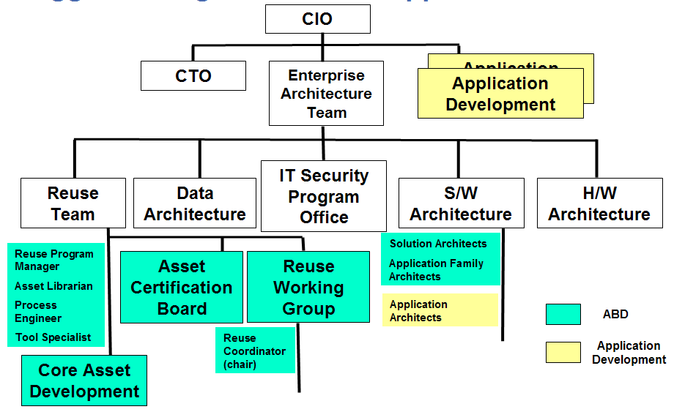
These organizational roles and their responsibilities with regards to reuse are described below.
- [Insert Company Name] management (CIO, CTO)
[Insert Company Name] management needs to support the reuse efforts in order for those efforts to be successful.
- Chief Technology Officer (CTO)
The chief Technology Officer is considered the [Insert Company Name] Enterprise Architect. The CTO oversees and leads the Solution Architects.
- Enterprise Architecture (EA) Team
The EA Team is responsible for developing, implementing, and maintaining [Insert Company Name] Enterprise Architecture. Within [Insert Company Name], the Enterprise Architecture is represented in multiple levels, each with its own architectural framework, and each with its own architect.
Solution Architects are responsible for assembling and integrating core assets and developing of solutions to specific technical requirements (Solution Architectures). The Solution Architects are led by the CTO
Application Family Architects are responsible for partially hydrated application architectures that leverage commonality across a family of applications (Application Family Architectures).
Application Architects are responsible for the development of the software architectures for specific application architectures.
- Reuse Team
The Reuse Team shoulders much of the asset-based development responsibilities. The Reuse Team provides the reuse environment (both process and tools), develops the core reusable assets, certifies all produced enterprise assets, manages the enterprise asset repositories, and manages and coordinates the overall reuse program.
- Core Asset Development (CAD) Team
The Core Asset Development (CAD) Team is responsible for doing the heavy lifting of qualifying, harvesting, and delivering the core reusable assets.
Assets may be commissioned to be built from respected asset producers, which may be the Reuse Team or a specific domain expert. The Reuse Team will build some of the assets; and will gather funding to pay respected asset producers to develop and maintain reusable assets.
At times a respected asset producer may need to be pulled into an application development project to provide support. The CAD team requires the funding to support this kind of activity.
- Reuse Working Group (RWG)
The Reuse Working Group (RWG) includes representatives fulfilling each of the asset-based development process roles (e.g., asset production, asset consumption, etc.). The RWG serves as the champion for the reuse program, communicating management’s goals regarding the reuse program and reporting on the progress of achieving those goals.
The RWG supports the development of the asset-based development environment (including the ABD guidelines), identifies candidate assets, approves the development of enterprise assets, and encourages inter-organizational cooperation.
The RWG provides asset marketing services to the architecture and application development teams (the primary asset consumers). Representatives from the RWG work with the development teams to understand their requirements and then they communicate to those teams the kinds of assets that are in the repository that might fit those needs.
The RWG also provides asset support services to the architecture and application development teams to help ensure the success of using the assets. They formally solicit feedback from the development teams in order to understand the effectiveness of the assets, Such information is then communicated to the Asset Development team to improve the assets.
- Asset Certification Board (ACB)
The Asset Certification Board (ACB) is responsible for certifying assets before they are published in the asset repository.
- Application Development (AD) Team
The Application Development (AD) Team is responsible for delivering quality, highly available automated applications that meet the needs of the [Insert Company Name]’s customers. There is one team per application.
- User Requirements (UR) Team
The User Requirements (UR) Team is the liaison representing the users and their requirements, this role is impacted by the set of assets that begin to flow within a description of the requirements and the user’s needs.
- Business Architect (BA)
Drives the activities for describing the business requirements, processes, and use cases. The BA is impacted through assets that describe the business and also for ultimately driving the technical solution from the basis of the business description.
The above organizational role descriptions provided a high-level strategy for how the [Insert Company Name] organization will support asset-based development. For details on the asset-based development process roles, as well as a mapping of [Insert Company Name] organization roles to the asset-based development process roles, see Part 2.

Asset Production Strategy
Before producing assets, some important decisions must be made regarding what assets will be developed, who will develop them and when they will be built.
There are multiple approaches for identifying the assets to be built:
- Identifying candidate assets based on an analysis of the domain (top-down approach), or
- Identifying candidate assets by reviewing existing artifacts (bottom-up approach).
Surveying the landscape of existing artifacts and systems in [Insert Company Name] and the potential for reusable assets, and also the prohibitive costs of doing top-down analysis of the [Insert Company Name] domain, the initial strategy for selecting assets to build will follow the practice of evaluating and harvesting artifacts from existing systems into reusable assets,. This does not preclude developing reusable assets based on doing domain analysis or building new assets from scratch, which may be pursued further down the implementation of this strategy
There are also multiple options for determining where in the lifecycle the assets are built:
- Before application development projects start
- During application project development
- After application projects have completed (harvesting assets)
As noted in the Reuse Organization section, there are several places within the organization that assets can be produced; the reuse team and the application development teams. The reuse team operates outside the context of any given project, but certainly must be tightly associated with the application development teams to ensure the success of the teams’ use of reusable assets. Application development teams may also develop reusable assets, though the scope of these assets is bound by the current project on which they are created. Application development teams building assets should be aware of the potential costs of creating and maintaining reusable assets. In some cases (i.e., with small, closely located teams) informal reuse may occur, and this is encouraged where possible and where the obvious benefits exist.
Initially the reuse team will create assets based on conducting reuse assessments and determining redundant problems and solutions across the teams. The artifacts from these projects will be harvested and organized for reuse. It is possible to see a time when the reuse team may create artifacts and assets from scratch, rather than from harvesting activities.
There are several reuse failures that can occur during asset consumption. These failures should be addressed as part of the reuse program management and the asset production activities. A reuse failure is ultimately when an asset is not discovered, found, or cannot be used, as listed below.
- Assets are not searched for.
In other words, the asset repositories are not being used. This speaks to the need for incentives and influencing the behavior of potential asset consumers.
- Assets are not found.
Tracking the nature of the queries on the repository to help asset producers understand the needs of asset consumers helps mitigate this.
- Asset cannot be used
The asset does not accomplish what is needed. The earlier in the asset consumption workflow that it can be determined that the asset is not going to meet the needs; the less expensive the reuse failure. Therefore – this drives to the need to have strong packaging / documentation that outlines the asset very clear so the decision to not use the asset can be made as early as possible. This also drives the need for a strong asset certification workflow.
The real goal is to lower the costs of reuse; and this falls squarely into asset production (effective asset consumption depends on effective asset consumption. The goal here is to reduce the number of reuse failures that are the more costly, such as discovering the asset will not work after the asset has already been brought into a project and development activities are taking place, or discovering the asset won’t work during testing and validation. This is very expensive reuse failure, and many times can be mitigated through strong asset packaging and documentation strategies. The assets must be high quality and well documented. There may be variants of the same asset supporting the same functionality but support different performance requirements.

Reuse Infrastructure
The general tooling infrastructure for supporting asset-based development is illustrated in Figure 9.
Figure 9: ABD Tooling Infrastructure
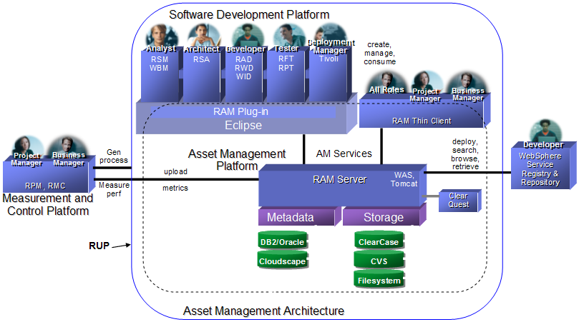

Reuse Adoption Strategy
The reuse adoption process that is being applied at [Insert Company Name] is shown in Figure 10.
Figure 10: Reuse Adoption Steps (adapted from Lim, p. 56)
It includes the simple steps of initiation, investigation, planning, implementation and continuous improvement.
During initiation, the Reuse Team gained an understanding of asset-based development and presented it to several levels of management for support and commitment The Reuse Team then initiated a program (investigation) to explore asset-based development concepts and work with Rational to develop an initial set of guidelines and standards to prepare [Insert Company Name] for asset-based development.
[Insert Company Name] is currently in the investigation phase. With the support of Rational, [Insert Company Name] has started to investigate how to implement a reuse program within [Insert Company Name]. The results are described in the [Insert Company Name] Asset-Based Development and Strategic Reuse Guidelines and Standards document set. The purpose of the guidelines and standards is to provide a solid foundation for the [Insert Company Name] asset-based development and strategic reuse initiative. The [Insert Company Name] Asset-Based Development and Strategic Reuse Guidelines and Standards are as follows:
- Part 1: Reuse Strategy (this document)
- Part 2: Asset-Based Development Process Overview
- Part 3: Asset Packaging Guidelines
- Part 4: Asset Configuration Management and Version Control Guidelines
- Part 5: IBM Patterns for e-Business Guidelines
- Part 6: Asset Modeling Guidelines
- Part 7: Asset Certification
- Part 8: Asset-Based Development User’s Guide
As part of investigation, [Insert Company Name] also worked with Rational to develop an initial phase plan for implementing asset-based development at [Insert Company Name]. This initial plan is described in section 6.
Once the results of the investigation have been presented to [Insert Company Name] management (CIO) and those results are approved, [Insert Company Name] will enter the planning phase.
During planning, [Insert Company Name] will work with Rational to refine the initial implementation plan and prepare a detailed plan for implementing asset-based development within the organization, including identifying the steps to get started.
In parallel with the planning phase, Reuse Working Group will provide leadership and out reach to the [Insert Company Name] community and will present the ABD strategy to several levels of management for support and commitment.
During implementation and improvement, the implementation plan will be conducted and the reuse program (including the reuse environment) will be refined as lessons are learned.

Reuse Implementation Plan
In this section we describe the initial plan for introducing the reuse program to the organization. As noted in section 5, this plan we be refined and expanded on during the planning phase, and a detailed implementation plan will be created.
The implementation plan described in this section is a phased adoption plan where variations of the workflows introduced in section 4.1 are applied over time to meet [Insert Company Name] needs. The phases describe the major steps to adopting the reuse program within [Insert Company Name]. The phases increase in asset reuse scope and complexity over time.
Each phase of the implementation plan are described in the following sections.

Phase 1 – Line of Business Assets
The focus of this phase is the development of a few core assets that can be reused across application families, as well as an application architecture that provides the framework in which those core assets are assembled.
The initial pilot projects will be lead by CTO and the Solution Architect team. The Reuse Team will be the primary asset producer, with the assistance of the application architects and the Application Development (AD) Teams (the AD Teams hold the requirements for the applications, which are the requirements for the components to be harvested).
Duration: This phase will occur from [Insert date range]
The highlights of this phase are described below and represented in Figure 11 and Figure 12.
- Establish the initial reuse environment, including both process and tools. This includes identifying the resources and involved organizational unit to perform the related roles (i.e., the reuse program plan)
Note: The reuse environment will be continually refined/improved throughout all of the phases.
- Rollout of the reuse environment. All affected [Insert Company Name] organizations will receive training in the asset-based development environment, both process and tools..
- Harvest enterprise assets from existing applications. The enterprise assets to be harvested include an architectural framework and a set of supporting core assets. The enterprise assets will be largely black-box (or perhaps grey-box) and their reuse scope is the [Insert Company Name] enterprise (i.e., the assets will be line-of-business, cross application assets). Also, the harvested assets will be template-based; meaning there will be minimal use of patterns and UML model transformations. [Insert Company Name] will exercise the IBM patterns for e-business; but there will not be heavy emphasis on using patterns throughout the development workflows)
- Support the application development teams who use the components
- Start discussions with other organizations regarding federated component governance and development, project/component selection, and so on (in preparation for the development of federated assets in later phases).
- Refine the reuse environment, especially the [Insert Company Name] Asset-Based Development and Strategic Reuse Guidelines and Standards, based on the experiences on the pilot projects
- Proposed Pilot Project 1 (Phase 1a): Harvest a [Insert framework name] Framework in (see Figure 11 below)
- Proposed Pilot Project 2 (Phase 1b): Harvest [Insert application name] components (see Figure 12 below).
Figure 11: Phase 1a: Pilot Project 1: Portal Framework
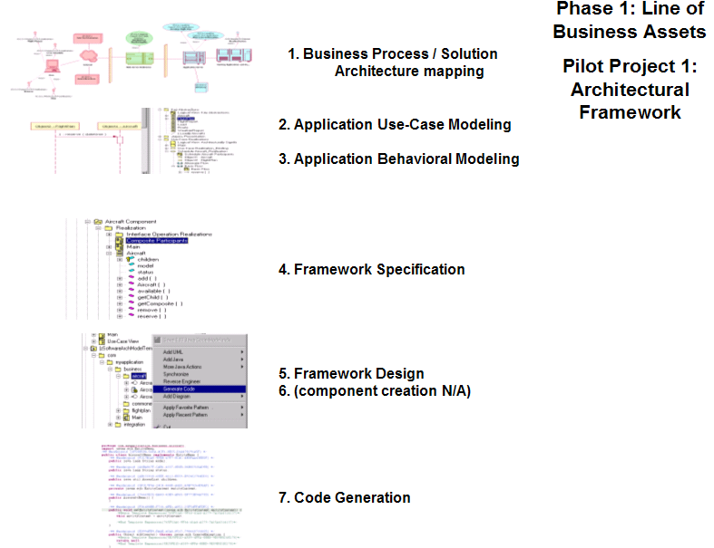

The figure above articulates a vision for building systems that are driven from the business processes ultimately into the code. This vision aligns the technology with the core processes of [Insert Company Name]. In this phase the [Insert framework name] framework is developed for which components will be potentially acquired and/or developed to work within the framework. The depth and breadth of building artifacts for each of these steps (1-9) in this phase still needs to be determined.

Figure 12: Phase 1b: Pilot Project 2: [Insert Project Name] Components
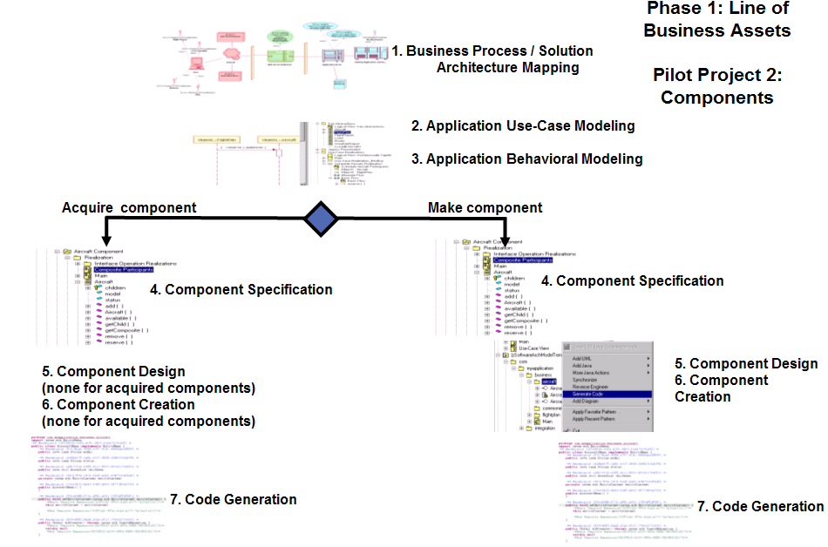

Figure 12 articulates a vision for building systems that are driven from the business processes ultimately into the code. This vision aligns the technology with the core processes of the organization. In this phase [Insert application name] components wil be harvested or acquired. These components will be used in architectural assets produced within [Insert Company Name]. Specifically, the [Insert Project Name] components will be used within the the framework developed in Pilot Project 1. The depth and breadth of building artifacts for each of these steps (1-8) in this phase still needs to be determined.

Phase 2 – [Insert Company Name] Federated Assets
The focus in this phase is on developing components that are to be used throughout [Insert Company Name] (i.e., they cross-application families). Examples of federated components include security, Single Sign-On, etc..
Duration: This phase will occur from [Insert date range] and will include potentially 2 pilot projects]
This phase has similar activities and deliverables as Phase 1, except the assets being produced have a larger scope – they are enterprise-wide rather than application family-wide, which means some inter-application coordination must be introduced. For more information, see the Phase 1 section.

Phase 3 – Model-driven Architectures (MDA)
The focus in this phase is to incorporate automation into the ABD process that was tested out in phases 1 and 2. In other words, in this phase patterns will be used to automate the vision of building systems starting with business processes and resulting in the production of source code. The initial phases were “light” on the use of patterns (they used templates instead).
Duration: This phase will begin [Insert date range]
The highlights of this phase are described below and represented in Figure 13.
- The Solution Architecture team will use patterns to create architecture assets based on the reference architectures and the known commonality across applications (e.g., Solution Architectures, Application Family Architectures) and these patterns will be applied across the various workflows to automate as much of the work as possible.
- A will be implemented using a general workflow similar to the one shown in Figure 13.
Figure 13: Phase 3 - MDA Approach
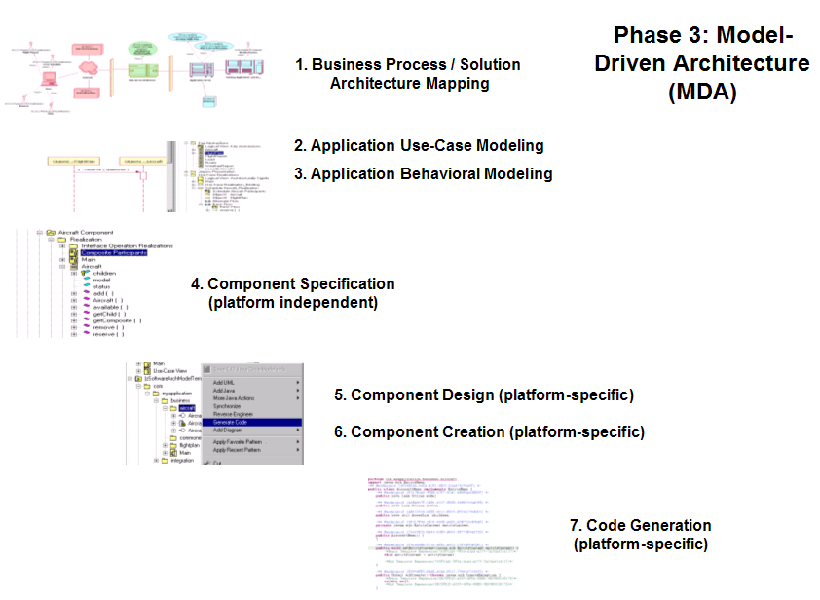

Figure 13 articulates a vision for building systems that are driven from the business processes ultimately into the code. This vision aligns the technology with the core processes of the organization. In this phase a collection of patterns are built that can be applied to drive the solution from the business processes. The depth and breadth of building artifacts for each of these steps (1-8) in this phase still needs to be determined.

Phase 4 – Federated Assets
The focus in this phase is the development of assets that span organizations (i.e., the development of assets with a scope greater than just [Insert Company Name]).
Duration: This phase will occur [Insert date range] after implementation of MDA approach within [Insert Company Name].
This phase has similar activities and deliverables as Phases 1 and 2, except the assets being produced have a larger scope – they are organization-wide rather than enterprise family-wide, which means some inter-organization coordination must be introduced. The Solution Architecture Team will provide asset services support with other organizations to help developed assets to succeed in other organizations.
For more information, see the Phase 1 and Phase 2 sections.

Metrics for Measuring Progress
Successfully measuring the reuse program is based on the fundamental premise of a consistent measurement and comparison framework. Crucial to this framework is the need to come to agreement early on how reuse will be measured in the organization. There must be some agreement on the metrics and the definition of how those metrics are calculated and captured for reasonable comparison and reporting.
Identifying the business needs and the measurements on meeting those needs ultimately guides the organization to the set of behaviors for addressing the needs. The reuse program should operate within the context of the business needs. Progress toward meeting those needs should be measured on a regular basis. To do this the list below identifies some business motivators for conducting reuse activities. The metrics for these motivators and the approach for collecting them should be defined. In practice there should be a minimal set of motivators that are initially selected; once selected the proper metrics and measurement techniques should be put in place.
- Reduce development costs
- Reduce maintenance costs
- Increase productivity
- Improve product quality
- Provide consistent look-and-feel
- Remove barriers to entry for new products
The general framework for categorizing these metrics is illustrated in Figure 14.
Figure 14: Reuse metrics framework (adapted from Lim, Managing Software Reuse, p. 301)
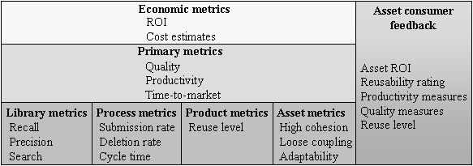

Each category in the figure above lists sample metrics to consider. Given the potential breadth and depth of the metrics outlined in this figure and the costs of capturing those metrics, for the purposes of the [Insert Company Name] reuse program a subset of these metrics will be gathered initially. The categories for these initial metrics should include Economic metrics, Primary metrics, and Asset consumer feedback. As the program matures additional metrics should be added to each category as well as specific categories of metrics should be added, such as Library metrics, and so on.

Economic metrics
For general economic metrics consider two categories, producer costs and consumer benefits. In the area of producer costs there are startup costs and ongoing costs. There may be a different funding model for the startup costs than for the ongoing costs. The simple spreadsheet below illustrates some items to consider tracking.

End of year |  | FY 06 | FY 07 | FY 08
Producer Costs
Startup
 | Reuse management
 | Work product creation
 | Library creation
 | Tools creation
 | Training/marketing
 | Other
Total Startup |  | $0 | $0 | $0
Ongoing
 | Reuse management
 | Workproduct creation
 | Library creation
 | Tools creation
 | Training/marketing
 | Other
Total Ongoing Costs |  | $0 | $0 | $0
Total Startup and Ongoing Costs |  | $0 | $0 | $0
Consumer Benefits
 | Total Asset ROI
 | Dev Resources Saved
 | QA Resources Saved
 | Dev Mgr Resources Saved
Total Benefits |  | $0 | $0 | $0
Net Result |  | $0 | $0 | $0

Primary metrics
Each of the application development teams should capture the metrics from using the assets such as quality impact and productivity impact. These metrics should be reported to the reuse team for assimilation and reporting.
These metrics capture items such as level of quality, productivity, and time-to-market. The individual application development teams should identify the impact of an asset on their development efforts.

Asset consumer feedback
Vital to any program is the need to collect and evaluate feedback. Early in the reuse program there should be mechanisms in place to capture, assimilate, and report asset consumer feedback.
The asset consumer / application development teams should identify the asset’s ROI using a simple asset ROI calculator. Also the asset consumer should identify and report the percentage of reusable assets within the application. The links below help capture asset ROI and other measurements.
- http://home.stny.rr.com/jeffreypoulin/html/reucalc_basic.html
- http://home.stny.rr.com/jeffreypoulin/html/reucalc_adv.html

Library metrics
The driver for these metrics should not be the number of assets in a repository. This will not measure the success of the program. Rather the Reuse Team should keep track of the locations where assets are used and should glean from the application development projects the amount of time and money that was saved using the assets.
There are several kinds of metrics to track on the library. At the very least the reuse team should capture these kinds of metrics for the repositories they manage. However, this will take time to get to the point where these can be captured and should be given time throughout the implementation of the phases to make this happen.
- Asset defect rate/time period
The number of defects submitted for an asset in a given time period.
- Asset defect correction turnaround
The amount of time from receiving a change request to publishing the revised asset.
- Library search missed hits/time period
The number and content of searches for which no hits were found in the library in a given time period.
- Library search hits/time period
The number of searches for which there were hits in a given time period.
- Library retrievals/time period
The number of retrievals from the library in a given time period.
- Library deletion rate/time period
The number of asset removals from the library in a given time period.
- Asset change request rate/time period
The number of change requests for an asset in a given time period.
- Asset maturity
A breakdown of the asset versions in the library.

Additional Considerations
An effective reuse strategy involves some additional considerations. These considerations are described in the following sections:

Reuse Incentives
Planning the reuse program also calls for evaluating the asset consumer incentives and asset producer incentives. Incentives generally are needed to align the behaviors of one group with the intentions of another group. As such, an elaborate incentive model can articulate a deeper problem in terms of the nature of the reuse program itself. This is not to say that there should be no incentive plan, but rather that it should be modest and should rely on a foundation and approach that, by its very nature, provides an immediate value proposition to those that are seeking to do reuse.
The reuse program should be structured, where possible, so that existing values of developers naturally lead to the outcomes desired by management. The values of the target asset consumers should be understood and the assets and activities should be prepared that meet managements needs and leverage the values of the target asset consumers.
When creating the incentive only use modest control systems such as those listed below (Fichman, pg. 8).
- Behavioral-based approach
Rewarding projects and individuals based on the levels of reuse. This requires consistency in capturing what is counted, how, and when.
- Outcome-based approach
Identifying the results of applying assets such as improved quality, time-to-market, and productivity. Refer to the Measuring Progress section for an introduction of the types of metrics to capture for this. These are more difficult metrics to capture and therefore the incentives for this may be more difficult.
- Socialization-based approach
Indoctrinating developers on the value of reuse; reach to the set of values that developers have and seek to change them; seek to make developer’s values the same as management
For example, if the target asset consumers value high quality in reusable assets, then the asset producers should have incentives that are attached to defect reports, which would reflect the quality level of the assets; this would be an outcome-based approach.
[Insert Company Name] should evaluate the values of the target asset consumers and producers and identify the necessary incentives. These should be identified within the context of asset-based development activities that benefit the target asset consumers. To accomplish this, there needs to be a consistent effort to communicate the status of the asset-based development efforts to key stakeholders and their needs to be sufficient training for all stakeholders. Without these elements of the program the incentives will not be as effective. CTO and Solution Architect team will determine the best approach for [Insert Company Name] under the direction of CIO and other executives

Internal Communication Model
The reuse activities within the organization should be communicated to several stakeholders including executive management, department / division management, project management, and engineers. The Reuse Coordinator is responsible for all communication of the reuse program to the various stakeholders. The kind of information about the asset-based development activities that needs to be communicated includes the following:
- Executive management (CIO) – value to organization
- Application Project Management – asset / reuse impact to deadlines, budgets, and quality
- Architects (solution architects, application architects) – relevance of architectural assets to applications and problems the organization is trying to solve
- Core Asset Development Team – reusability of assets, quality, feedback
- Application Developers – upcoming asset support, impact on development workflows, asset complexity
The communication of this information is very critical during the adoption phase and should be communicated on a regular basis. This communication is very necessary for the life of the reuse program. The earlier this information can be communicated the sooner the organization can make appropriate refinements in implementing the reuse strategy.

Training Model
The various roles need to be trained on asset-based development processes / workflows, tools, standards, and policies. This training should occur within the context of each of the phases listed above. The table below identifies the training that is relevant to the [Insert Company Name] workflows. Each [Insert Company Name] workflow has within it the RUP ABD workflows. Having the training on these [Insert Company Name] workflows implies training on supporting tooling and policies.
The training needs to provide an overview of the tooling / reuse infrastructure for several of the roles such as the BA, Application Development (AD) Teams, and the User Requirements (UR) Team. However, other roles will need detailed training on applying asset production, asset management, and asset consumption within the context of the [Insert Company Name] workflows.
Table 1 - [Insert Company Name] Workflow Training Model
[Insert Company Name] Workflow | SA | AA | BA | AD | UR | Reuse
Business Solution Architecture Workflow
- Asset production
- Asset management
- Asset consumption
Software Architecture Workflow
- Asset production
- Asset management
- Asset consumption
Application Development Workflow
- Asset production
- Asset management
- Asset consumption
Core Asset Development Workflow
- Asset production
- Asset management
- Asset consumption
Asset Certification Workflow

Funding Model
In typical funding situations the funds are allocated for the activities to deliver the artifacts for the project. This relationship changes with the reuse model where the funding for assets and their artifacts may provide value for several projects.
There are several models for funding the reuse team and related reuse efforts.
- Overhead funding
The costs for the reuse team are handled in the pool of overhead expenses.
- Tax funding
Each application development project pays a tax which covers the cost of the reuse team.
- Payments for assets / services
The application development teams pay for the assets and services they use from the reuse team.
Clearly [Insert Company Name] needs to determine its funding model for conducting asset-based development. An initial recommendation is to start with overhead funding and shift to payments for assets / services. The purpose for this recommendation is to provide time for startup costs and then move to another funding model such as for services or assets when the initial value has been verified. One approach here is to use the overhead funding model throughout the four phases identified in this document and then shift to an asset / services funding model thereafter. CTO and Solution Architect Team will determine the best approach for [Insert Company Name] under the direction of CIO and other executives.

References
Incentive Compatibility and Systematic Software Reuse, Journal of Systems and Software, Apr 27, 2001; Vol. 57, Iss. 1, Robert G. Fichman
Managing Software Reuse, Prentice Hall, 1998, Wayne Lim
Measuring Software Reuse, Addison Wesley, 1997, Jeffrey S. Poulin

