**Program: application.py**

* Author: Perry Brandiezs
* Date: May 1, 2019

This program demonstrates CRUD operations using an Item Catalog.

* Create: Ability to create an airplane item
* Read: Ability to read an inventory list showing category name, item name, item description. Ability to show item detail, login required.
* Update: Ability to edit item detail, login required.
* Delete: Ability to delete an item, login required and must be item creator.

This program demonstrates OAuth2 authentication and authorization using a third party provider.

* Login / Logout using Facebook is provided, link can be found at the top-right of the main screen.
* Login required to display item detail, update an item, or delete an item.
* Must also be the item creator to delete.

This program demonstrates API endpoints.

* Display all items
* Display specific item detail
* Display all users

**See the README.md at vagrant/catalog/README.md**

# Expected Output:

## Initial DB setup:

vagrant@vagrant:/vagrant/catalog$ python models.py

## Initial Data Loading:

vagrant@vagrant:/vagrant/catalog$ python create_planes.py

User Perry Brandiezs added

User Mickey Mouse added

Plane G650ER added

Plane G550 added

Plane G650ER added

Plane Piper Cub added

Plane 10X added

Plane Phenom 100 added

Plane Concorde added

## Webserver start:

vagrant@vagrant:/vagrant/catalog$ python application.py

* Serving Flask app "application" (lazy loading)

* Environment: production

WARNING: Do not use the development server in a production environment.

Use a production WSGI server instead.

* Debug mode: on

* Running on http://0.0.0.0:8000/ (Press CTRL+C to quit)

* Restarting with stat

* Debugger is active!

* Debugger PIN: 325-904-188

## Main screen

<http://localhost:8000/>

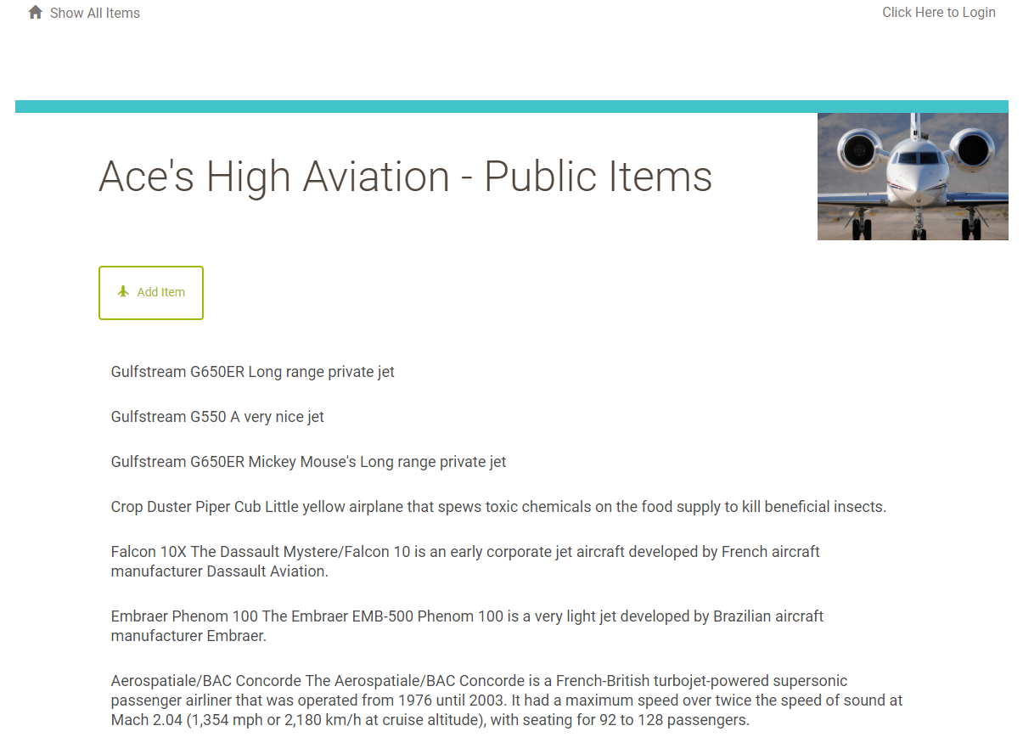

## Login screen:

<http://localhost:8000/login>

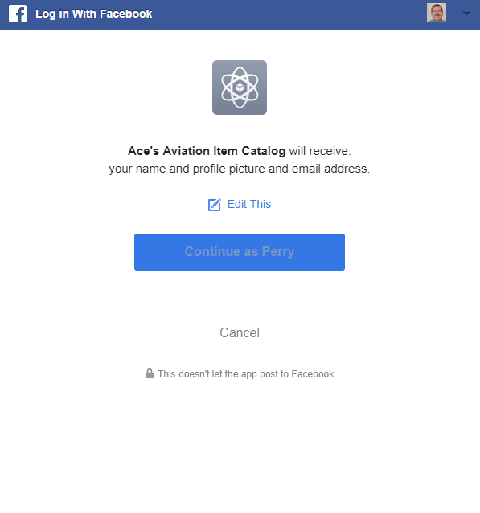

## Main screen – logged in

<http://localhost:8000/>

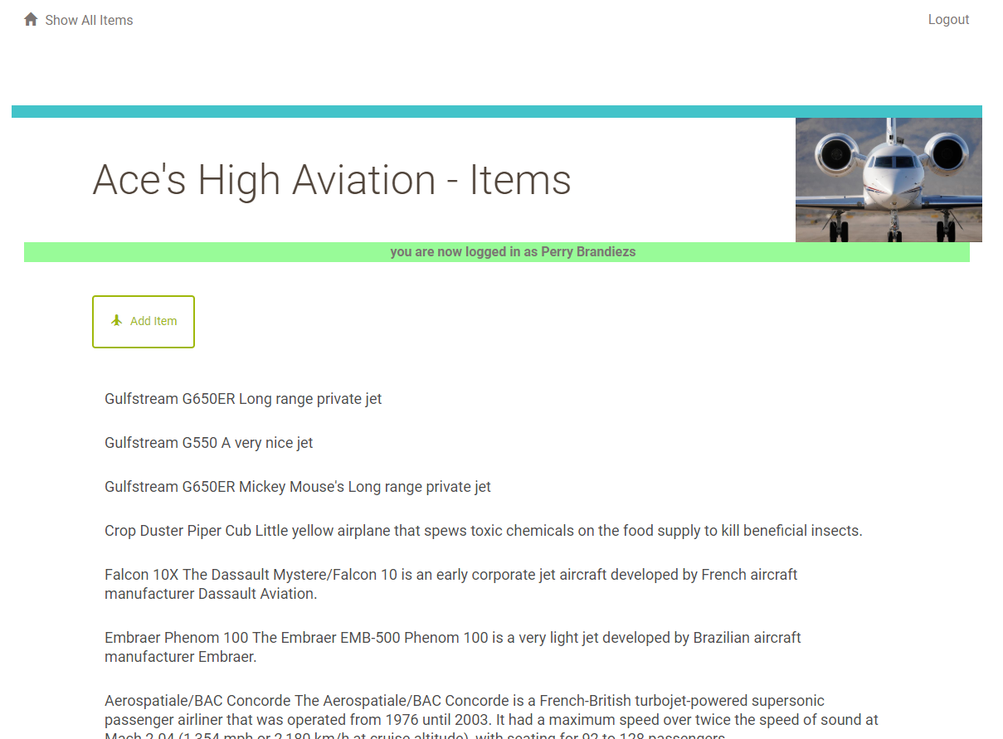

## Item Detail (click on a specific item)

<http://localhost/item/7/>

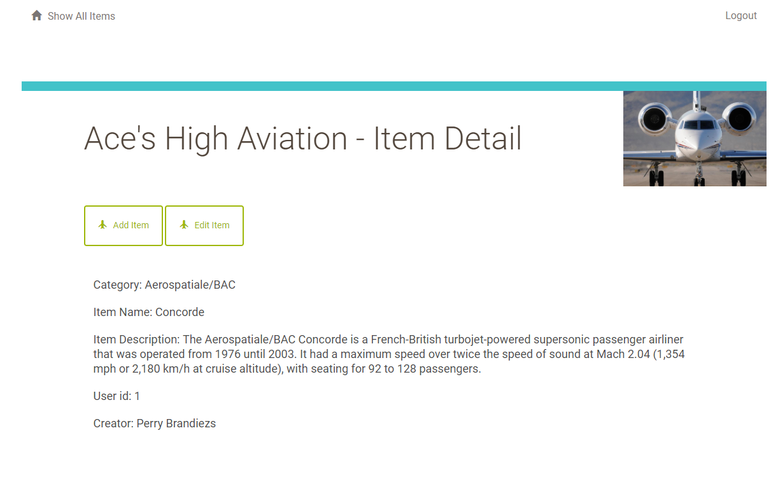

## Add item:

<http://localhost:8000/item/new/>

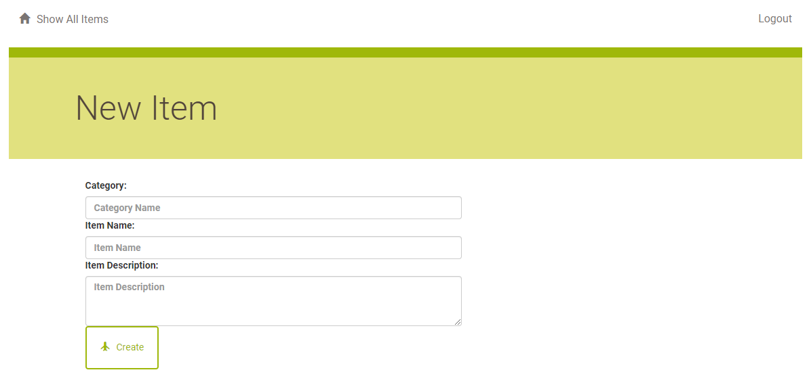

## Edit item:

<http://localhost:8000/item/2/edit/>

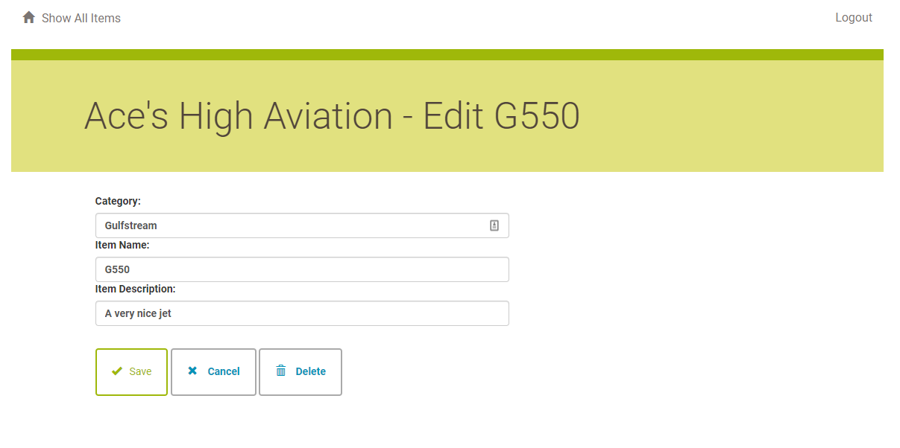

## Delete item:

<http://localhost:8000/item/2/delete/>

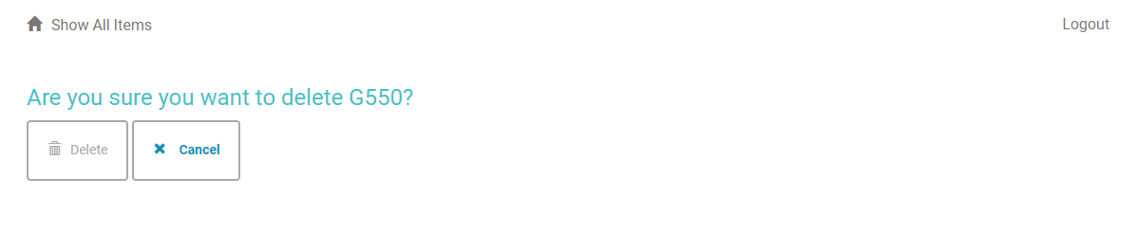

## Attempt to delete an item, which you have not created:

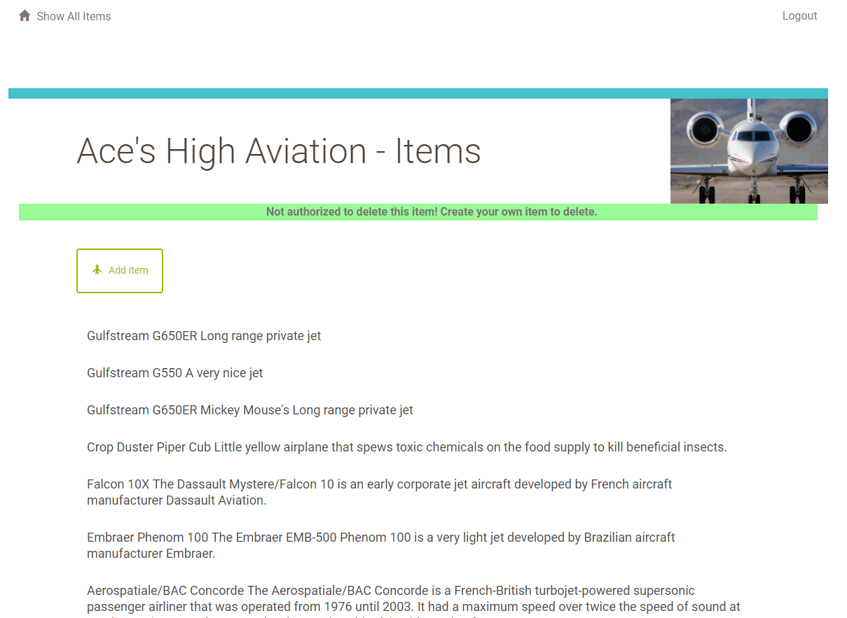

## Attempt to view item detail when not logged in:

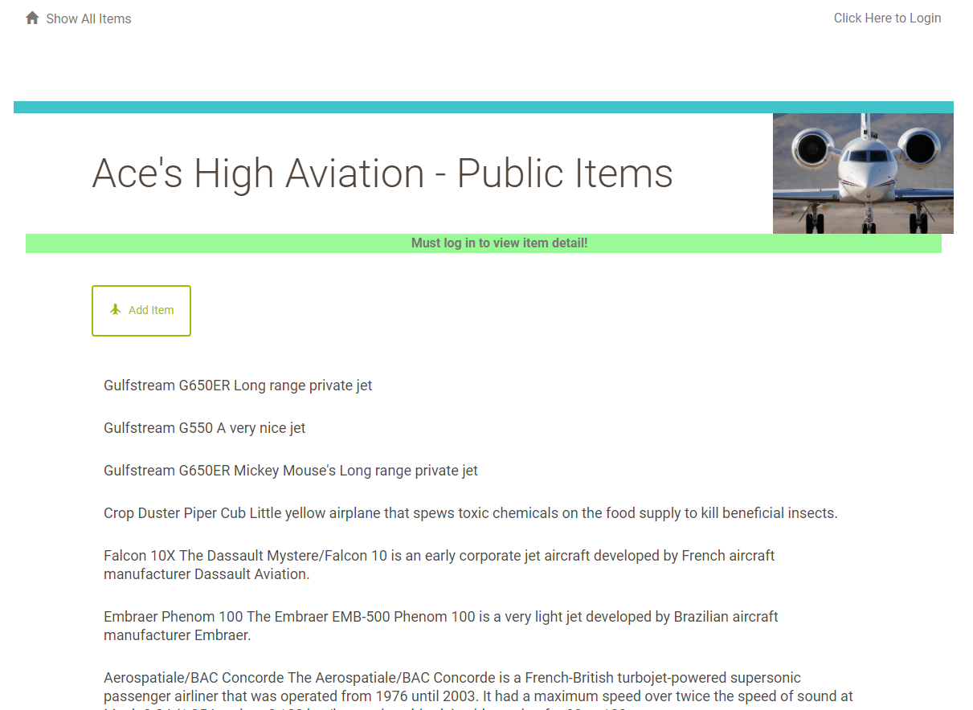

## API endpoint – all items

<http://localhost:8000/items/JSON>

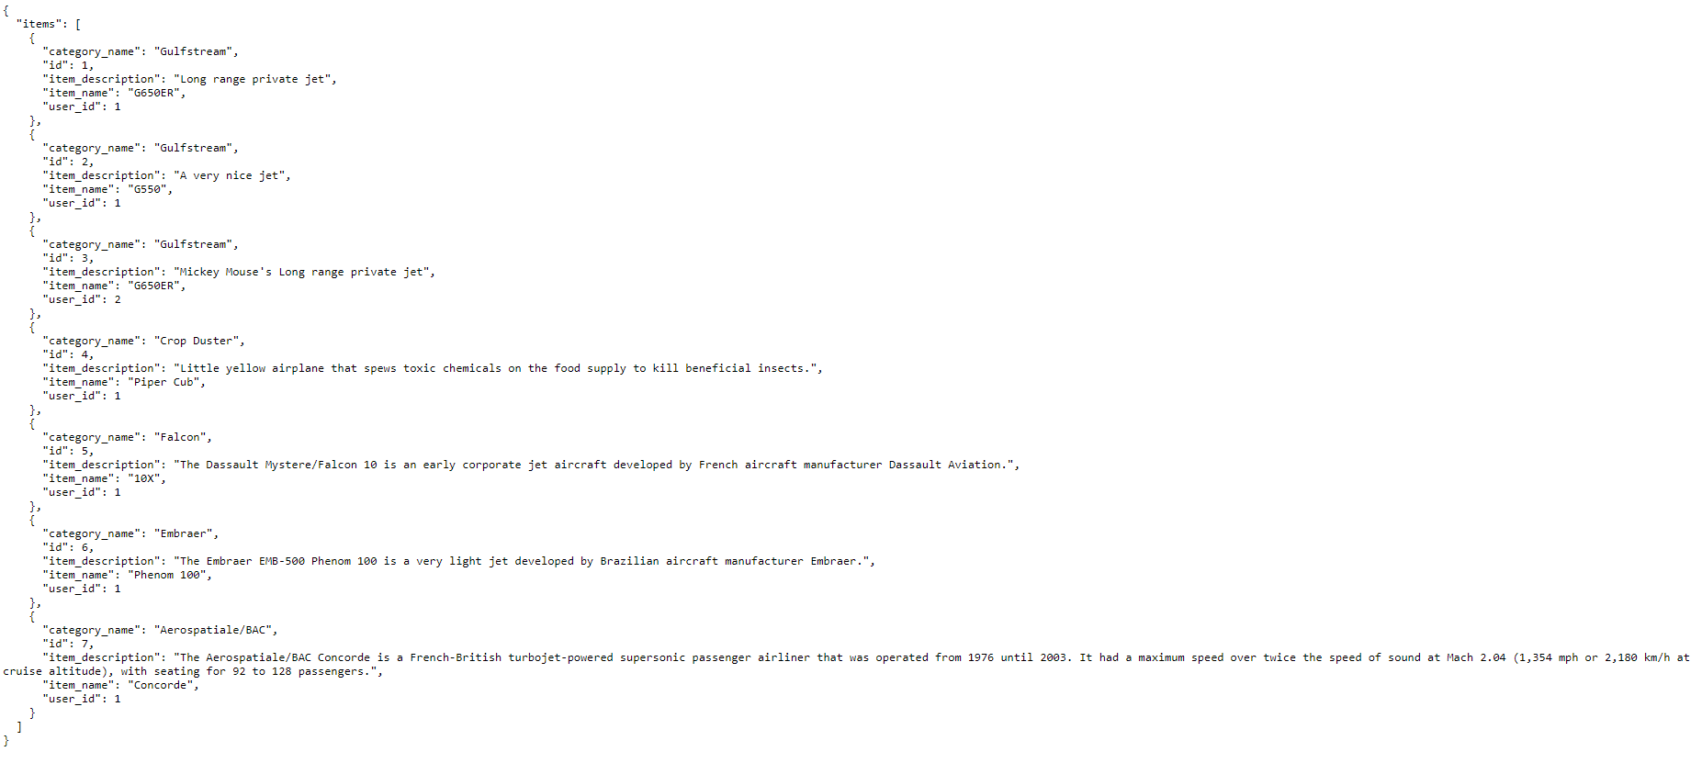

## API endpoint – specific item:

<http://localhost:8000/item/7/JSON>

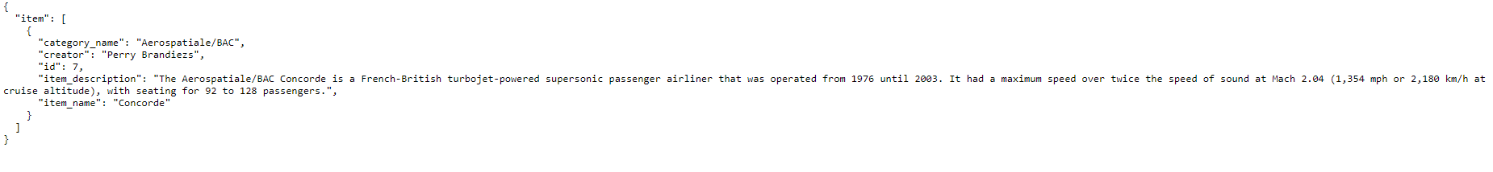

## API endpoint – all users:

