YOLO TOURNAMENT

Complete illustrated
instruction set
Participant rules • scoring guide • workbook safety • multiplier planning
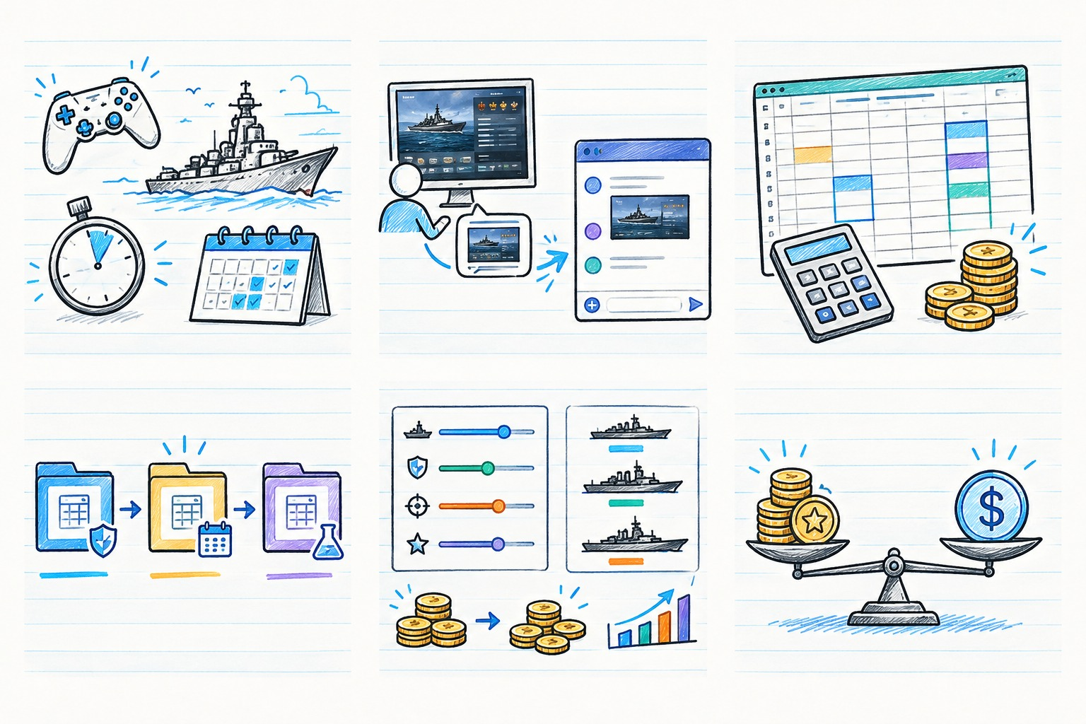
A shared reference for players, room hosts, scorekeepers, and organizers
Prepared from the supplied event, scoring, and workbook documents
Draft for organizer review • 25 October 2026

Contents and quick navigation
How to use this guide
Reader roles, source status legend, and scope.
Part 1 — YOLO event rules and participant instructions
Pilot format, setup, timing, reporting, restarts, forfeits, and participant checklist.
Part 2 — YOLO scoring guide for players
Pilot scoring versus the broader workbook model, formulas, worked example, and totals.
Part 3 — Excel workbook backup and safe use
Master/working/sandbox/approved states, protection, macro-enabled format, and backup plan.
Part 4 — How the YOLO workbook works and multiplier planning
Tabs, formulas, controlled experiments, budget checks, workbook findings, and approval checklist.
Part 5 — Frequently asked questions and rule decisions
Participant FAQs and the organizer decision register.
Appendix A — Copy-ready Discord message bank
Announcement, result submission, scoring, workbook, and settings update messages.
Appendix B — Source inventory and evidence notes
Input documents, external references, and maintenance steps.
Quick path: Players → Part 1 and Part 2. Organizers and scorekeepers → Parts 3 and 4, then the decision register before publishing.

How to use this guide
This manual combines four related sources into one practical reference: the detailed pilot-event rules, the short participant-facing Discord summary, the Discord scoring guide, and the organizer notes for the Excel workbook. It is designed for players, event hosts, scorekeepers, and the person who approves scoring settings.
If you are… | Start here | Your main job
A player / participant | Participant guide, then scoring guide | Follow the current event announcement; play fairly; upload clear results; ask staff about disputes.
A room host / referee | Event setup and dispute procedures | Use confirmed room settings, meet the timing rules, and record exceptions consistently.
A scorekeeper | Workbook safety, then workbook map | Enter verified results in input cells; check formulas and player-row coverage before publishing.
An organizer setting rewards | Multiplier planning and validation checklist | Compare scenarios in a sandbox copy, verify totals, approve one settings set, and communicate it before the event.

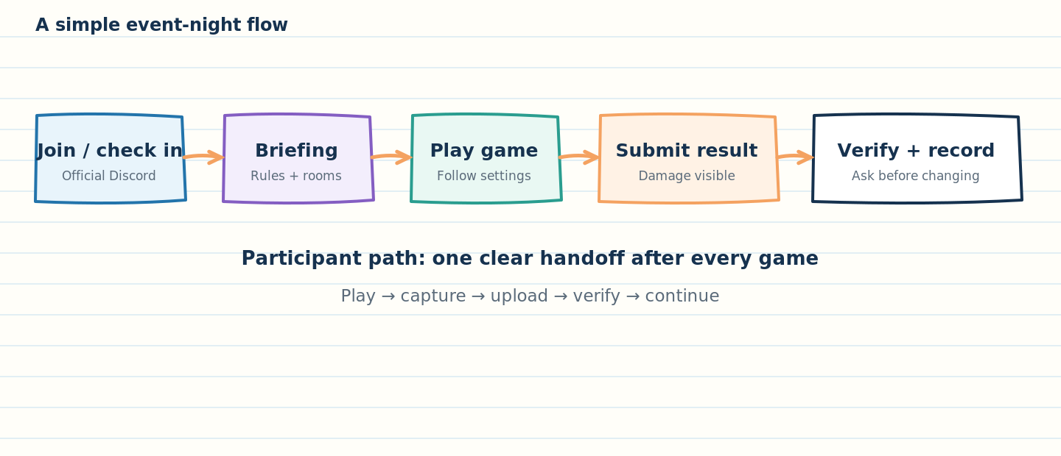
Figure 1. The participant path after a battle: capture the result, upload it, and get it verified.
Source status legend
SOURCE RULE means the supplied file explicitly says this. WORKBOOK OBSERVATION means the statement comes from direct inspection of the included sample workbook. ORGANIZER DECISION means the supplied files conflict or leave an important detail undefined. EXAMPLE means a teaching example, not an approved tournament rule.

What this manual does not do
It does not silently rewrite the pilot rules, create new penalties, guarantee a prize pool, certify that every workbook control works, or assume that the future recurring tournament is already in force. Where a detail is missing or inconsistent, it is listed for the organizer to decide and publish.
This edition covers four selected topics only. Clan governance, Tier X Clan Battles strategy, and the optional Dyson Sphere paper are separate companion materials and are not tournament rules.

Part 1 — YOLO event rules and participant instructions
Audience: players and participants. The detailed source is yolo_event.docx. The shorter yolo summary discord.txt is meant for Discord announcements and should link back to this section or to the full event rules.

Event at a glance
Item | What the source says | Practical meaning
Event status | The event is a Pilot Event; recurring weekly or bi-weekly events are a future plan. | Treat the pilot announcement as the current authority. Do not assume future-season rules apply yet.
Who can participate | Clan members and close friends are named in the introduction. | Confirm eligibility with the organizer if you are unsure.
Participation | No registration; show up at the announced date/time; the rules also say joining closes one hour before start. | The signup/join cutoff needs clarification; see the decision register.
Expected games | About seven games per participant. | “About” is an estimate, not a guarantee of exactly seven.
Game length | Normally ten minutes; one “last battle” is stated as five minutes. | Organizer must confirm which battle is shortened.
Breaks | Ten minutes between matches for score reporting and a fifteen-minute middle break. | Upload results promptly; the event is expected to finish in under three hours.
Placement in pilot | Individual total damage across games determines final placement. | Team wins and losses do not determine the individual prize under the pilot wording.
Pilot prize | The person with the highest tournament score is promised Doubloons; the exact amount is announced before games begin. | Confirm prize number and whether any other placements are paid before play starts.

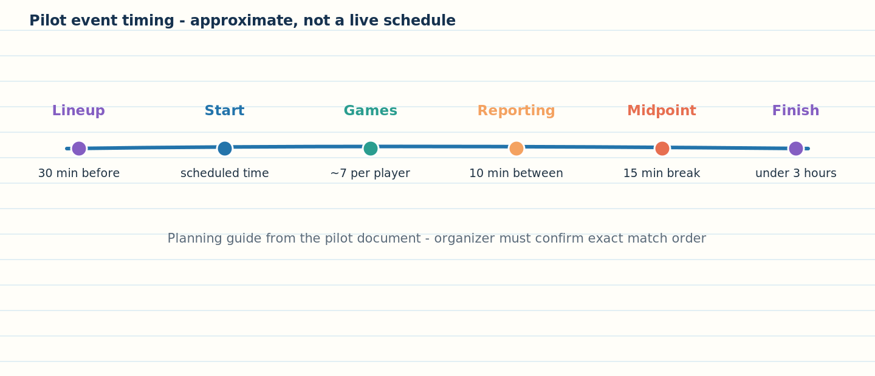
Figure 2. The source gives an approximate event cadence. This is not a precise minute-by-minute schedule.
Pilot rules versus future format
The Discord summary describes three rounds, about seven games per player, weekly random teams, rounds 1 versus bots, rounds 2–3 versus teams of humans and bots, and a future Grand YOLO season finale. The event document calls the current event a slimmed-down pilot and says total individual damage determines pilot placement. Until the organizer confirms the current round format, present the three-round/future-season details as planned format—not as settled pilot requirements.

Before you join
1. Check the official event announcement for date, start time, eligibility, the required Discord server/channel, and the current rule revision.
2. Join the designated team voice channel during game time. A Help Desk voice channel is named as the main podium for help.
3. Check the final lineup announcement. The source says lineups are released 30 minutes before games begin.
4. If the join cutoff, roster, or game count is unclear, ask the organizer before the briefing. Do not assume that “no registration” cancels the stated one-hour cutoff.
5. Use only mods covered by the approved rule: Aslain’s Mod Pack, Wargaming ModStation, or the mod-download-corner on the official World of Warships Discord, as listed in the source. The organizer should re-check links and current permissions before each event.

How the training-room setup is meant to work
The source says the tournament uses Training Rooms. Unless an organizer states otherwise, the “Home Team” is the top team in the bracket for that matchup, opens the room, invites the opponent and approved streamers, and names the room using Team 1 vs Team 2. Both teams are responsible for confirming correct settings.
- Place each team on its correct side.
- Enable spectator mode, but reserve spectator slots for official streamers, tournament staff, or other designated staff.
- The source explicitly says lineups will be visible to opponents in this YOLO format. Hosts should not accidentally imply that ship selection is hidden.
- Teams can change their ship lineup between games. During a restart, they cannot change ships or ship settings; permitted personnel changes are described in the restart rules below.
- If a team is short, the source says a bot may replace each missing player and bots must use high intelligence. The exact intended human/bot count is unresolved; do not use an assumed roster layout until the organizer publishes it.

Room settings and match length
Setting | Source rule | Check before readying up
Battle timer | Ten minutes for normal battles; five minutes for “the last battle.” | Organizer must define which battle is the last battle for the pilot.
Mode | Standard Battle for tourneys; “Armor Resilience” for the last match. | The map table says “Armor Resilient Test” for Ocean. Confirm the exact mode label and intended application.
Maps | Islands, Polar, Archipelago, Ring, Straight, New Dawn, and Ocean are listed. | Verify these maps are available in the current client and correct tier/context before publishing the map pool.
Map size / tiers | Source describes maps as 30x30 to 36x36 and intended for low tiers. | Verify what those measurements mean in the source and confirm ship-tier limits; no precise tier list is provided.
Lineups | Visible to the opponent under the YOLO exception. | Confirm both sides and every lineup before starting.
Bot fill | High-intelligence bots where allowed. | Use the organizer-approved roster rule; current source language is ambiguous.

Do not guess at room settings
If the event announcement does not name the exact timer, mode, map, tier, and bot configuration for a match, ask the host/referee before the match starts. Do not rely on an old screenshot of room settings.

When to report a setting problem
1. If you notice an incorrect setting after the battle starts, notify the opponent/referee immediately.
2. Under the source rule, once two minutes of game time have elapsed, the match must be played to completion and the result is valid. The source also says restarts cannot be requested after two minutes.
3. Do not unilaterally stop or restart the game. Follow the referee’s instruction and record the issue in the designated channel.

Attendance, late arrivals, and forfeits
The event rules say that ten minutes after the scheduled start, if neither team is fully ready in the training-room lobby, both teams forfeit. If one team is ready and the other is not, the available team receives the game win. The same ten-minute wait applies between games within a match.
The text requires the reporting team to provide a screenshot with visible client time. The rules do not define every edge case—for example, how to record a partial lineup, a server outage, or a host who never opens the room. Ask staff to resolve these cases consistently and include the ruling in the event log.

Restart rules
Situation | Source says | Participant action
Player fails to load or disconnects | A restart may be requested. | Notify the assigned referee promptly.
Incorrect spawns or room settings | A restart may be requested. | Describe the error and capture evidence if possible.
Bugged spawns | A restart may be requested. | Notify referee; wait for the call.
Restart readiness | The timer is five minutes from the restart call. | Be ready promptly and do not assume the standard ten-minute timer applies.
Per-team allowance | One restart per team; extra restarts may be granted at organizer discretion for training-room issues. | The rule is not an absolute ban on exceptions; staff decision controls.
Regional organizer / battle fault | Restarts requested by regional organizers for battle faults do not count against the team limit. | Let the organizer classify the reason.
After two minutes of battle time | No restart may be requested; play to completion. | Report the issue but do not stop the match.
During a restart | No ship lineup or ship-setting changes, including signals, consumables, captains, and other modifications. Players may be replaced if unable to reconnect, or moved between ships. | Keep ships and configurations unchanged; ask referee if uncertain.

What every player must submit
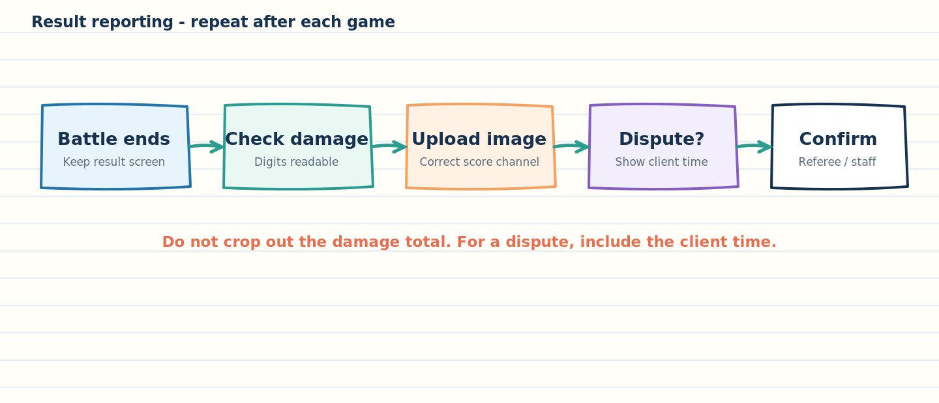
Figure 3. Reporting checklist: keep the damage total readable and include client time when a dispute requires it.
1. Open the post-game result screen after each game.
2. Capture a screenshot that clearly shows your ship damage for that battle.
3. Upload the screenshot to the designated score-reporting channel on the clan Discord server.
4. Use the channel/thread naming or message format specified in the current event announcement, if one is provided.
5. For a dispute or forfeit claim, include a screenshot with the client time visible as required by the rules.
6. Keep the original screenshot until staff confirms the result has been recorded or the dispute is closed.
A screenshot is evidence, not an automatic ruling
If damage digits, player identity, or the client time are unreadable, staff may need clarification. Do not alter the screenshot in a way that removes context. If you provide a crop for convenience, keep the full original available.

Broadcasting and streamers
The source allows tournaments to be broadcast by streamers. It says the list of streamers and their information will be available in the main tournament-info channel on the Starfleet Discord server. Spectator places are limited to authorized streamers or designated staff.

Participant quick checklist
When | Checklist
Before event | ☐ Read current announcement. ☐ Confirm date/time and voice channel. ☐ Check lineup. ☐ Ask about unresolved room settings.
Before each game | ☐ Correct teams/sides. ☐ Correct map, mode, timer, and bot fill. ☐ Lineups visible as required. ☐ Host and opponent agree.
After each game | ☐ Capture result. ☐ Confirm damage is readable. ☐ Upload to correct channel. ☐ Report problems promptly.
If a dispute occurs | ☐ Ping referee. ☐ Keep client time visible where required. ☐ Follow the two-minute restart rule. ☐ Wait for an organizer ruling.

Discord message: pilot event announcement
AUDIENCE: Players / participants
🎮 YOLO PILOT EVENT — READ BEFORE PLAYING
🏆 Pilot scoring: individual total damage determines placement; team wins and losses do not determine the individual prize. The pilot prize amount will be announced before games begin.
🕒 Plan for about seven games per player, a 10-minute normal battle timer, 10 minutes between matches for reporting, and a 15-minute middle break. The evening is expected to last no more than three hours. Exact game order and the special last-battle setting will be confirmed by the organizer.
📸 After every game: upload a post-game screenshot with your damage clearly visible to the designated score-reporting channel. For a dispute/forfeit, include visible client time when required.
🎧 Join your assigned Discord voice channel during game time. Use Help Desk for questions. Check the pinned/current rules for the exact date, lineup, map, room settings, and any updates.
⚠️ The rules include a join cutoff and roster/mode details that must be confirmed in the final event announcement. Ask staff rather than guessing.

Part 2 — YOLO scoring guide for players
Audience: players and participants. The ready-to-post source is yolo scoring guide discord.txt; the longer workbook explainer is how yolo wkbk work discord.txt. This section explains the documented model without claiming it has been approved for the current pilot.

First, determine which scoring rules are in effect
Current pilot wording | Workbook / future-format wording
Placement is based on total individual damage over the pilot games. The highest scorer is described as receiving the pilot Doubloon prize. | The workbook models four events: damage, kills, race time, and Grand YOLO combined scoring, then totals rewards.
The pilot is described as a slimmed-down event. | The Discord summary describes future weekly rounds, season accumulation, and a Grand YOLO finale.
The exact pilot prize amount is announced before games begin. | The workbook has a Doubloon Pool parameter and settings that can be explored by organizers.

Player rule
For a specific event, follow the event announcement and its approved rules. Do not assume every workbook tab is active in the pilot just because the workbook contains it.

How the pilot ranking works
The supplied event document says each participant’s total damage over their played games determines placement. The top individual damage total wins the stated pilot prize. The document also says participation in one or all games is allowed. It does not define a normalized score for different numbers of games.
Fairness question to confirm
Raw cumulative damage generally gives someone who plays more games more opportunities to add damage. Since the rules permit participation in one or all games, the organizer should publish whether ranking is raw total damage, per-game average, or another approved calculation. The source says total damage, so this manual does not replace it with an average.

How the four-event workbook model is organized
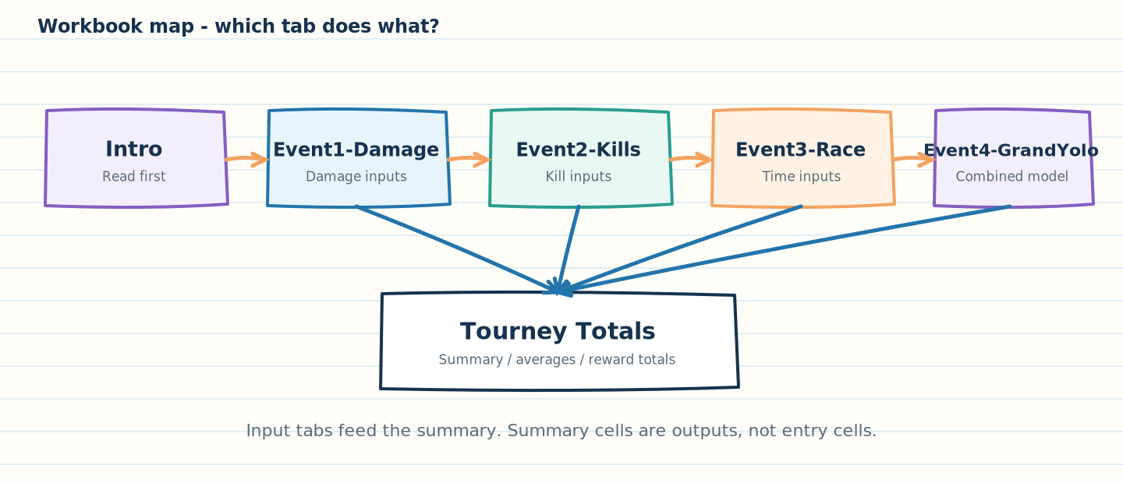
Figure 4. The scoring workbook is split into four event tabs and one summary tab.
Tab | Metric or purpose | Player-facing interpretation
Event1-Damage | Damage-based rewards; up to seven game entries per player in the supplied sample. | Damage contributes under the damage-event settings.
Event2-Kills | Kill-based rewards. | Kills contribute under the kill-event settings.
Event3-Race | Race/time event rewards. | Time values are processed by the workbook; check the event rules for whether lower or higher values are better.
Event4-GrandYolo | Weighted combined score. | The guide describes class, tier, damage, kills, and time weights.
Tourney Totals | Totals and derived averages / dollar equivalents. | Combines rewards from all four event tabs and displays summary metrics.

Understand the general event formula
The source Discord guide presents this general model for the damage and kill sheets:
Doubloons = 2 × Pool × Σ(Class Weight × Performance Share ÷ Tier^Tier Weight)
In the actual formula pattern visible in the supplied sample workbook, an additional scale factor appears before the pool: 2 × C10 × F8 × SUM(...). Here F8 is the displayed Doubloon Pool input (500 in the supplied sample), and G10 is used as the tier exponent in the Event 1–3 formula pattern. Confirm the exact meaning of all settings in the specific workbook version before editing them.
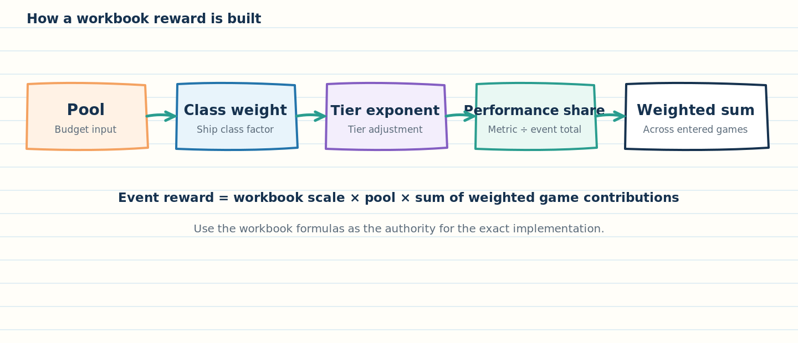
Figure 5. Each game contributes a weighted piece to the event reward; the workbook sums those pieces.

What the terms mean
Term | Meaning
Pool | A named workbook input that scales rewards. Do not assume it is a hard payout ceiling; see workbook validation notes.
Class weight | A numeric factor assigned to a ship class or class entry. Raising it can increase that entry’s reward contribution when the formula uses it.
Performance share | For damage or kills, the player/game metric divided by the event-wide total for that metric in the workbook formula.
Tier^Tier Weight | The tier value raised to a configured exponent. For tier > 1, a larger exponent produces a larger denominator and therefore a smaller contribution, all else equal.
Σ (sum) | The weighted contributions from the games are added together. The sample has seven game entry groups per player.
Scale factor | The supplied formula also multiplies by a factor in C10. Confirm its label and intended purpose in the workbook you are using.

Worked example: one damage-game contribution
This is the source guide’s illustrative example. It is not an event payout promise.
Input | Example value
Pool | 500
Scale factor | 1
Class weight | 4
Tier | 2
Tier weight / exponent | 1
Damage in one game | 20,000
Event-wide total damage used as denominator | 1,000,000
Games for illustration | 7 identical contributions

Performance share = 20,000 ÷ 1,000,000 = 0.02
Weighted game contribution = 4 × 0.02 ÷ 2^1 = 0.04
Reward contribution = 2 × 1 × 500 × 0.04 = 40 Doubloons
If all seven contributions were identical: 7 × 40 = 280 Doubloons
Why your actual result can differ
Actual payouts depend on every player’s data, all settings, the workbook formula, and the event-wide denominator. Do not calculate a participant payout from this single-player example alone.

How Grand YOLO is described
The source says the Grand YOLO sheet combines class weight, tier, damage, kills, and time. It says game scores are weighted, adjusted by the player’s share of total damage, summed across seven games, and divided by three. The source sentence calls these “four factors” and then lists five; that wording is inconsistent. Use the workbook formula and organizer-approved settings to define the final model, rather than relying on the inconsistent count.

How the Tourney Totals tab summarizes players
Column / label | Documented calculation
Avg. Dmg | Average of the player’s total damage from Event 1 and Grand YOLO: (Event 1 total damage + Grand YOLO damage total) ÷ 2.
Avg. Tier | Average tier across 21 entries from Events 1, 2, and 4 (seven per event).
Avg. Kills | Average kills across seven games in Event 2.
Avg. Class | Average numeric class weight across 21 entries from Events 1, 2, and 4.
Avg. Class label | DD if average > 3.6; CA if average is 2.7 through 3.6; BB if average < 2.7.
Doubloons | Sum of the rewards from Event 1 + Event 2 + Event 3 + Grand YOLO.
Dollars | The workbook’s conversion is Doubloons × 0.54 ÷ 100. This is a workbook conversion, not necessarily the official retail price of in-game currency.

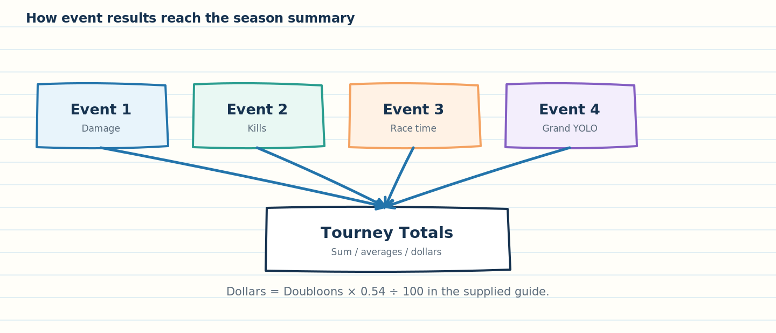
Figure 6. The summary tab combines reward outputs from the four event tabs.

How to ask a scoring question
When asking about a result, include the player name, event/round, game number if known, the recorded metric, the screenshot, and a concise description of the discrepancy. For a time-sensitive room dispute or forfeit claim, include visible client time as required by the event rules. Do not post private data or unrelated screenshots.

Discord message: scoring guide
AUDIENCE: Players / participants
📊 YOLO SCORING — QUICK GUIDE
For the pilot event, the supplied rules say placement is based on individual total damage, not the team’s win/loss record. The pilot prize amount will be announced before play. Ask staff which scoring version applies if the announcement mentions other events.
The organizer workbook contains four scoring tabs: Event1-Damage, Event2-Kills, Event3-Race, and Event4-GrandYolo. Tourney Totals combines the four event rewards and displays averages and a workbook dollar estimate. These tabs describe the broader model; they are not automatically all in use for the pilot.
🧮 In the workbook, class weights, ship tier, performance share, pool, and tier weight affect calculated rewards. The Grand YOLO tab combines multiple metrics.
❓ Scoring question? Send the player name, round/game, screenshot, and the value you believe is wrong in the designated score-help channel. For a dispute/forfeit, keep client time visible when required. Staff will check the approved rules and workbook.

Part 3 — Excel workbook backup and safe use
Audience: organizers and scorekeepers. The supplied file is macro-enabled (.xlsm). Treat the untouched master as a reference, and keep experiments separate from approved event results. The workbook should not be the only copy of the tournament’s scoring state.
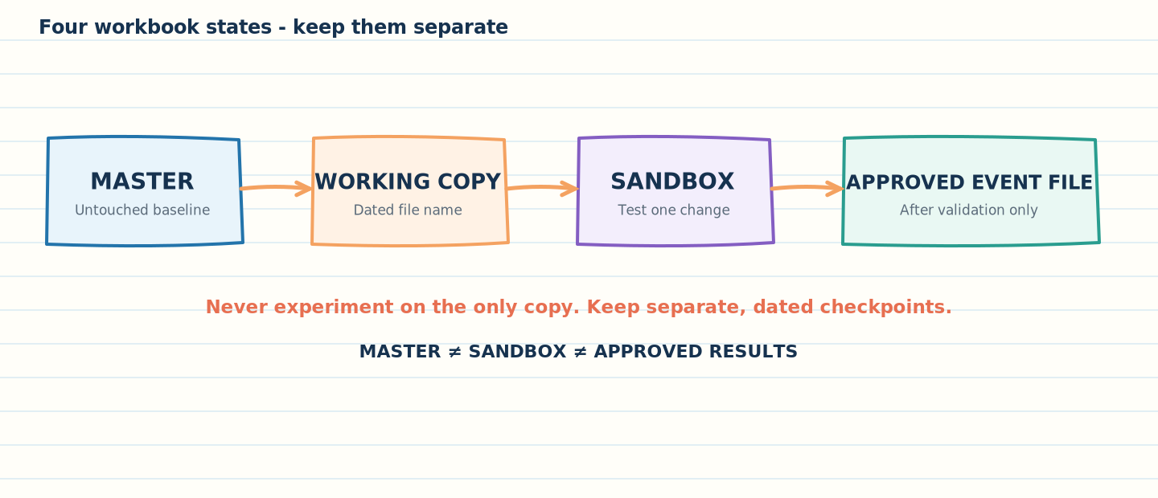
Figure 7. Preserve a master, use dated working copies, test in a sandbox, and publish only after validation.

Use four separate workbook states
State | Purpose | Example filename | Rules
Master / baseline | Known-good source kept unchanged. | YOLO_Workbook_MASTER_YYYY-MM-DD.xlsm | Read-only or stored in a protected location; do not use it for experiments.
Working copy | Data entry or planned edits for a named event. | YOLO_Workbook_2026-10-25_Pilot_WORKING_v01.xlsm | Dated; one owner at a time; save after verified checkpoints.
Sandbox / experiment | Multiplier trials, test data, or formula checks. | YOLO_Workbook_2026-10-25_Sandbox_MultiplierA.xlsm | Never publish these numbers as approved rewards. Reset or discard after test.
Approved / archived | Reviewed event settings and final recorded results. | YOLO_Workbook_2026-10-25_Pilot_APPROVED.xlsm | Mark version and approver; retain the prior approved file and source results.

Create a safe working copy
1. Close the current workbook if practical and locate the approved master file.
2. In Excel, choose File > Save As. Select a separate working folder and give the new copy an explicit date, event name, and version number.
3. For a workbook that must retain macros, save as Excel Macro-Enabled Workbook (*.xlsm). Saving as .xlsx removes VBA macros and may change workbook behavior.
4. Open the copy from the working folder. Confirm the filename in the title bar so you do not accidentally edit the master.
5. Before changing scoring settings, save a baseline checkpoint and record the current pool and multiplier values in a change log.
6. After a meaningful change, save, close, reopen, and verify key formulas and outputs. Keep a separate copy of the input screenshots and the final approved scores.
Do not rely only on “Undo”
Undo history is not a backup strategy. A fresh, dated file lets you return to a known baseline even after a series of changes, recalc errors, or accidental overwrites.

Recommended folder arrangement
YOLO_Tournament/
├── 00_Master_ReadOnly/
├── 01_Event_Working/
├── 02_Multiplier_Sandbox/
├── 03_Approved_Settings/
├── 04_Final_Results/
└── 05_Archive_And_Evidence/
Keep screenshots, the final workbook, the approved settings note, and any dispute evidence together using consistent event identifiers. Avoid using filenames such as “final2”, “reallyfinal”, or “newest” without a date/version.

Protect formula cells from accidental edits
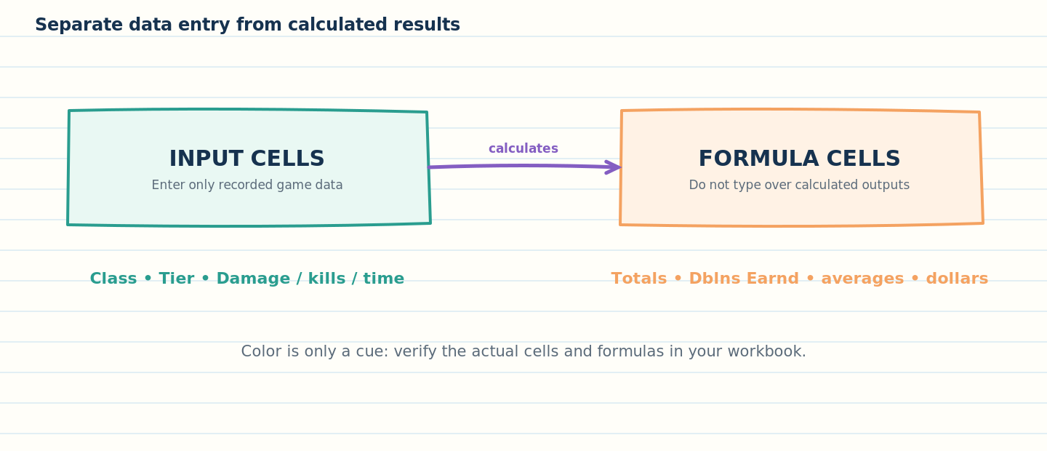
Figure 8. Separate input cells from formula outputs; color can be a cue but never a substitute for checking the cell.
1. In the working copy, identify the cells the organizer is allowed to edit (player names, class, tier, game metrics, and approved setting inputs). Confirm these from the actual sheet, not from color alone.
2. Leave calculated cells locked. In Excel, select the approved input ranges, open Format Cells > Protection, and clear Locked for those input cells only.
3. On the Review tab, choose Protect Sheet and allow only the actions that scorekeepers need. Keep formula cells locked.
4. Test protection using a throwaway copy: confirm input cells accept entry and formula cells cannot be overwritten accidentally.
5. Record the protection password in the approved password-management location, if one is used. Do not rely on worksheet protection to protect confidential data.
Protection is not encryption
Worksheet protection helps prevent accidental changes. Microsoft explicitly cautions that worksheet protection is not intended as a security feature. Keep sensitive files and credentials out of the workbook and control folder access separately.

Macro-enabled file safety
- Keep the .xlsm extension for a workbook that needs VBA macros. Do not convert the only master to .xlsx as a casual cleanup step.
- Enable macros only for a workbook from a trusted source and only when the function is understood. A macro warning is not a reason to bypass normal checks.
- If a copy will be shared only for reading, consider distributing a PDF or a values-only report instead of a macro-enabled workbook, unless recipients need workbook interactivity.
- Never use a workbook copy to store Discord bot tokens, passwords, personal information, or unrelated confidential information.

Back up and recover
A minimum backup plan is three points: the untouched master, a dated working copy, and an approved checkpoint before the event. Store the master and archive somewhere separate from the only working copy. If the file is stored in OneDrive or SharePoint, version history can provide an additional recovery layer, but it does not replace a separately retained approved copy.

Pre-event workbook safety checklist
Check | Pass condition
Correct source | Filename/version and event date match the approved plan.
Backup | Master and dated working copy both exist; working copy is not the master.
Format | .xlsm retained where VBA is required.
Inputs | Scorekeeper knows exactly which cells are editable.
Formulas | Sample formula cells still contain formulas and expected references.
Roster coverage | Every intended participant fits in formula ranges; no player rows are omitted.
Settings | Multipliers respond as expected in sandbox tests.
Totals | Per-player totals and overall sum are checked against expectations.
Approval | Organizer approves the chosen settings and stores the approved copy.

Part 4 — How the YOLO workbook works and how to plan multipliers
Audience: organizers and scorekeepers. The workbook is a model for comparing reward settings before an event. The purpose of changing multipliers is to see how they redistribute Doubloons and influence the estimated event amount before organizers approve a setting set.

Understand the tabs
Tab | What to do here | What to avoid
Intro | Read the workbook’s framing and any notes. | Do not assume old introductory notes reflect the current pilot announcement.
Event1-Damage | Enter each player’s class, class weight, tier, and damage for up to seven games in the supplied layout. Review Total Dmg and Dblns Earnd. | Do not overwrite Total Dmg or Dblns Earnd formulas.
Event2-Kills | Enter class, weight, tier, and kills for the relevant games. | Do not put damage or race times in the kills metric cells.
Event3-Race | Enter the race/time values prescribed by the race rules. | Do not assume a smaller or larger time is better unless the rule and formula confirm it.
Event4-GrandYolo | Enter the combined-event inputs and review the weighted result. | Do not change weights during the event without explicit organizer approval.
Tourney Totals | Review player averages, labels, total Doubloons, and dollar estimates. | Treat this as a summary/output tab, not a place to key over values.

How to enter results consistently
1. Use the same participant name in the linked player list. Do not create near-duplicate variants for one person.
2. Enter one game’s class, numeric class weight, tier, and required metric into the matching game block.
3. Follow the actual workbook’s class-weight mapping. The supplied example uses DD=4, CA=3, and BB=2 in its sample inputs; these values are not guaranteed to be the approved weights for every event.
4. Use numeric tier values, not strings such as “Tier VIII”, unless the workbook is explicitly built for that format.
5. Check for blanks, accidental text, duplicate entries, and impossible values before reading the reward output.
6. Compare the event-level total and a few hand-calculated samples to confirm that the expected formulas are active.

Plan multipliers before the tournament
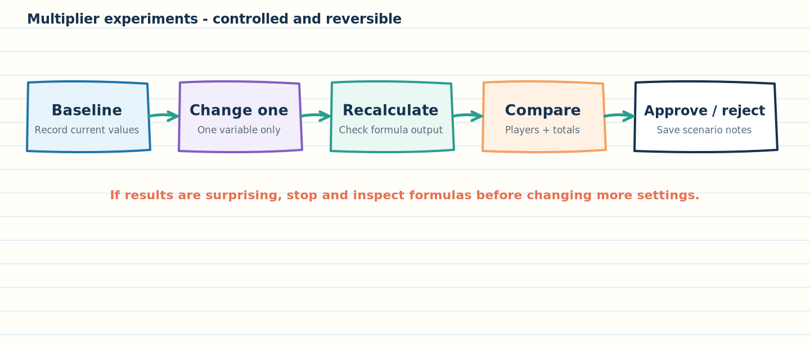
Figure 9. Change one variable at a time, compare results, and approve only a validated scenario.
The purpose of a multiplier experiment is to answer a policy question before players compete. Examples include: “Should lower-tier destroyers receive more relative reward?”, “How much should kill performance matter?”, or “What pool input gives an event total close to the approved budget?”

Recommended experiment procedure
1. Duplicate the master into a dated sandbox. Do not test settings in the approved event file.
2. Enter a representative but non-sensitive test dataset. Use the same player/game input values for each scenario so that only the setting under study changes.
3. Record a baseline: all current settings, total event Doubloons, estimated dollar value, reward by player, and reward by class/tier where available.
4. Change only one multiplier or one pool input. Use the increments and permitted range shown by the actual workbook; do not invent a new range.
5. Recalculate, then compare the baseline and new results: total payout estimate, distribution among players, top/bottom reward, and whether the intended class/tier is advantaged.
6. Restore the baseline before trying a different variable. Record each scenario name, values, outputs, and notes.
7. Once a scenario meets the organizer’s goals, test a second example dataset and inspect formula coverage. Then submit the result to the designated approver.
8. After approval, copy only the approved settings into the approved event workbook, verify them again, save a new version, and include the settings in the event announcement where relevant.

What common changes tend to do
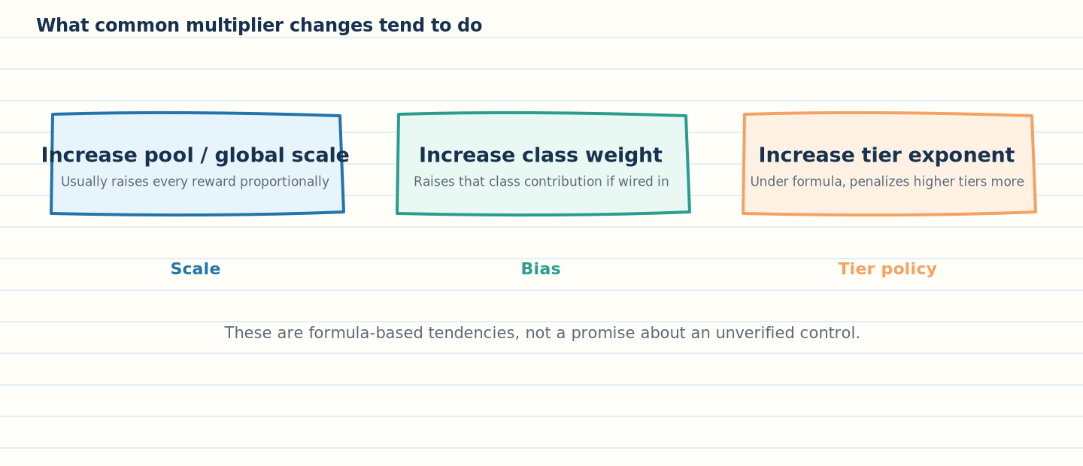
Figure 10. Typical effects depend on whether the actual formula uses a control and on the other inputs.
Change | Expected effect if correctly wired into the formula | What to measure
Increase pool input | Raises rewards at the same scale when all other inputs remain fixed. | Per-player reward sum and event-wide projected amount.
Increase a global scale factor | Usually multiplies every affected reward by the same factor. | Check whether every target reward changes proportionally.
Increase a class weight | Raises the contribution associated with entries using that weight. It may redistribute rewards across classes. | Compare DD, CA, and BB outcomes with identical data and other settings held constant.
Increase the tier exponent | Under the documented Tier^Tier Weight denominator, higher tier numbers are reduced more strongly for tiers greater than 1; lower tiers gain relative advantage. | Compare tier-level reward shares while keeping performance and class weights fixed.
Change Grand YOLO metric weights | Changes the relative influence of damage, kills, and time if the formula uses those settings. | Compare rankings, individual rewards, and total distribution.

Plan for a target budget
Use the workbook as a scenario tool, not as an automatic spending cap. Because the example formula includes a factor of 2, class weights, tier terms, and performance shares—and because the supplied sample’s summed Event 1 rewards can exceed its 500 pool input—the label “Doubloon Pool” does not prove that the final computed rewards cannot exceed that number. The organizer must calculate the sum of all intended payouts.
1. State the target clearly: maximum event budget, target reward total, or target per-player range. Do not mix these goals.
2. Choose a baseline input dataset and save the baseline outputs.
3. Adjust the pool or global multiplier in a sandbox. Recalculate and inspect the actual sum of player rewards, not merely the pool cell.
4. Convert the computed Doubloon total using the documented workbook formula (Doubloons × 0.54 ÷ 100) for a workbook estimate. Confirm separately what this estimate means for the organizer’s actual purchase/spending plan.
5. Repeat at a second pool value to confirm that the expected scaling relationship holds. Record rounding and any maximum/minimum award constraints separately.
6. Approve the final budget in writing and retain the workbook snapshot that produced it.
Budget safeguard
If the organization requires a hard ceiling, treat it as a separate acceptance criterion. Verify that the sum of every player’s final reward is below the ceiling. A cell named “Doubloon Pool” is not sufficient evidence that the formulas enforce a cap.

Worked scenarios: policy questions before events

Scenario A — Favor lower-tier destroyers
Goal: intentionally give a lower-tier destroyer contribution more weight relative to higher-tier ships. Start with identical test performance, class values, and pool. Change only the tier exponent or the approved destroyer-weight control that is proven to feed the formula. Compare the reward shares by tier and class. If a visible “More Dubs to Destroyers” control does not change outputs in the isolated test, do not use it as if it were active.

Scenario B — Shift emphasis to kills
Goal: make the kill event or kill metric matter more under the approved rules. Use the sandbox to compare the baseline and candidate Grand YOLO weights. Inspect both rankings and overall payout. If the formula does not separate kill weight from other factors, document that limitation and ask the workbook owner to clarify the intended calculation; do not approximate silently.

Scenario C — Keep event spending near a target
Goal: bring the total expected awards closer to a target amount. Change only the pool/global scaling input at first. Check summed player rewards, not just the input cell. If the total is too high, reduce the scale, recalculate, and repeat until the total falls within the approved range. Save a scenario log, then validate on another dataset to make sure the change does not produce an unintended class/tier distribution.

Scenario worksheet / change log template
Field | What to record
Scenario ID | e.g., PILOT-BASELINE or PILOT-DD-LOWTIER-02
Workbook version | Exact filename, modified date, and if available a file checksum.
Dataset | Sample or approved dataset identifier; note whether any entries are synthetic.
Settings changed | Cell or named control, old value, new value, reason. Only one logical change per scenario.
Reward totals | Event totals, total Doubloons, dollar estimate, highest and lowest individual rewards.
Distribution checks | Reward totals by class/tier, top-heavy versus broad distribution, unexpected changes.
Formula checks | Sample cells inspected; formulas present; control demonstrably affects expected outputs.
Decision | Accept / reject / investigate; who approved; approval date.

Workbook-specific findings that must be resolved before use
Finding 1 — sample roster size
The workbook included in documentation.zip appears to use nine sample player rows (event tabs use rows 15–23; Tourney Totals uses rows 3–11 in its summary formulas). Do not assume it is the correct production workbook for a larger participant list. Before use, verify that every intended player row is covered by every relevant formula and total.

Finding 2 — class-preference controls
The supplied Event 1–3 sheets show values at S10:S12 beside labels for “More Dubs to Destroyers/Cruisers/Battleships,” but the displayed Event 1–3 Dblns Earnd formulas do not reference S10:S12 directly. Their live effect is therefore not established by the formula pattern inspected. Verify the controls in a sandbox; if changing a supposed control has no effect, treat it as inactive until corrected through an approved workbook change.

Finding 3 — pool is not demonstrated as a hard cap
In the supplied example, Event1-Damage shows a pool input of 500 and a cached sum of player rewards around 666.67. This is consistent with the formula acting as a multiplier input rather than a strict cap. If the intention is a hard maximum, the workbook model needs explicit review and approval before the event.

Finding 4 — race-time direction and Grand YOLO weighting
The text describes race time as a metric but does not clearly define whether lower time receives a higher score. The Grand YOLO guide also says “four factors” while listing class, tier, damage, kills, and time. Document the exact intended scoring behavior before publishing the model to participants.

Before approving a multiplier scenario
Question | Approval evidence
Does each intended control work? | Change it in isolation and observe the expected cells change.
Are all player rows included? | Check the first and last participant formulas plus the summary total ranges.
Does the budget target hold? | Sum the actual reward outputs and compare to the approved cap/target.
Is the distribution intentional? | Compare class/tier/player distribution to the baseline.
Are race and Grand YOLO rules clear? | Written definitions and exact formulas align.
Can the results be reproduced? | Save input data, setting values, scenario ID, workbook version, outputs, and approver.

Discord message: workbook scoring explanation for organizers
AUDIENCE: Organizers / scorekeepers
📊 YOLO WORKBOOK — ORGANIZER NOTE
Use a dated working copy. Keep the master unchanged and run multiplier tests in a separate sandbox. The workbook has tabs for damage, kills, race time, Grand YOLO, and Tourney Totals. Enter recorded game values only in the intended input cells; do not overwrite total or reward formulas.
Before approving settings, verify every participant row is covered, test each multiplier by changing one value at a time, compare player/class/tier rewards, and sum all payout outputs. The “Doubloon Pool” input is not automatically a guaranteed maximum payout.
⚠️ In the supplied sample copy, there are nine sample player rows and the class-specific “More Dubs” controls on Event 1–3 need formula verification. Confirm the intended production workbook and test those controls before relying on them.
Save the approved scenario, note the workbook version and settings, and publish only the approved rule set.

Part 5 — Frequently asked questions and rule decisions

Participant FAQ
Question | Answer
Do team wins determine the pilot prize? | The supplied pilot rules say individual total damage determines placement; team W/L does not determine individual prizes.
Must I play every game? | The source says you may participate in one or all games. It does not define a score normalization method for different numbers of games; ask the organizer how the current event handles this.
Do I need to register? | The source says no registration, but also sets a join cutoff one hour before start and a lineup release 30 minutes before start. The organizer should clarify the actual check-in procedure.
Where do I send a result? | Upload the post-game screenshot to the designated score-reporting Discord channel. The current announcement should name the exact channel.
What if I notice wrong room settings? | Notify the opponent/referee immediately. After two minutes of game time, the stated rules require the match to finish and prevent a restart request.
Can I change ships during a restart? | No. The source prohibits changes to ship lineup or ship settings during a restart, with limited personnel movement/replacement exceptions.
Is the full workbook scoring formula automatically used in the pilot? | No such link is established. The pilot rules describe damage-based placement; the workbook describes a broader four-event model. Follow the event’s approved announcement.
Does the pool cell guarantee the total spent? | Not in the supplied sample: the sum of calculated rewards can exceed the displayed pool input. Check actual output totals and validate the model.

Organizer decision register — resolve before publishing final rules
ID | Unresolved point | Decision needed | Why it matters
D-01 | Pilot round format: event DOCX versus Discord summary. | Confirm whether the current pilot uses the slimmed-down damage-only format or the three-round bot/human structure. | Players need accurate expectations.
D-02 | “No registration” versus one-hour join cutoff. | Define what “joinable” means, how players check in, and whether late joiners are refused. | Prevents attendance disputes.
D-03 | Human/bot ratio and 12-player roster. | State whether six humans/six bots is per side, per room, or per team, and how the last short team is filled. | Room composition and parity depend on it.
D-04 | Last five-minute battle / Armor Resilience setting. | Define which battle is “last,” the exact game mode name, and whether it applies to the pilot. | Prevents inconsistent room settings.
D-05 | Pilot prizes. | Confirm if only first place receives Doubloons or if additional placements are awarded; publish amount and tie-breaker. | The source uses both plural reward language and a single highest-scoring pilot winner.
D-06 | Variable number of games. | Confirm how rankings are handled if a participant plays one game versus all available games. | Raw total damage rewards more game opportunities.
D-07 | Map pool and tier restrictions. | Verify the listed maps, size definition, and eligible ship tiers against the current client and event intent. | Avoid unavailable maps and unclear tier rules.
D-08 | Workbook active version and capacity. | Identify the authoritative workbook for the event and verify all intended rows/formula ranges. | The archive copy is a nine-player example.
D-09 | Class preference controls. | Verify S10:S12 controls affect rewards on each intended sheet or label them as inactive. | Avoid false confidence in a setting that may not be wired in.
D-10 | Pool versus cap. | Decide whether “Doubloon Pool” is a multiplier input or a hard event maximum. If hard cap, validate the formula model. | Ensures spending target is meaningful.
D-11 | Race-time direction and Grand YOLO factor count. | Define lower/higher-time preference and publish one consistent factor list. | Avoids scoring ambiguity.
D-12 | Dollar conversion. | Confirm that 0.54/100 remains the intended planning conversion and explain whether it is only an estimate. | Avoids presenting a workbook estimate as an official store price.

Rule revision and publication checklist
1. An organizer resolves all decision-register items that affect the next event, or marks clearly which ones are not in scope.
2. Publish a dated event rules revision and a short summary that match one another.
3. Publish the relevant scoring settings, prize amount, roster/mode details, and reporting channel before the event begins.
4. Give hosts/referees a room checklist and use the same terms for game, match, round, restart, and forfeit throughout.
5. Keep a dated copy of the approved announcement, workbook, and final score summary for later questions.

Appendix A — Copy-ready Discord message bank
These messages are duplicated here so organizers can copy them without extracting text from the relevant chapters. Replace bracketed placeholders only after they have been confirmed. Keep messages for current pilot rules separate from future-season announcements.

A1. Event announcement template
AUDIENCE: Players / participants
🎮 YOLO [PILOT / EVENT NAME]
📅 Date: [DATE] | Start: [TIME + TIME ZONE]
🎧 Voice: [VOICE CHANNEL] | Score reports: [CHANNEL]
🏆 Scoring for this event: [APPROVED SCORING RULE]. The pilot document says individual total damage determines placement; team W/L does not determine individual prizes.
⏱️ Plan for about seven games per player, 10-minute regular battles, 10-minute gaps for result reporting, and a 15-minute midpoint break. Expected duration is under three hours. Confirm the exact match order and any special last-battle rule in the pinned event instructions.
📸 After every game, upload a post-game screenshot showing your damage clearly. For a dispute/forfeit, include visible client time when required.
👥 Eligibility / check-in: [CONFIRMED INSTRUCTIONS]. Prize: [APPROVED AMOUNT / PLACEMENTS]. Map / mode / bot fill: [CONFIRMED SETTINGS].
Read the full event rules: [LINK]. Ask questions in [HELP CHANNEL] before play.

A2. After-game result submission
AUDIENCE: Players / participants
📸 AFTER EACH GAME — SUBMIT YOUR RESULT
1. Capture your post-game results screen.
2. Make sure the damage number is readable.
3. Upload it to [SCORE-REPORTING CHANNEL].
4. If you are reporting a dispute or forfeit, keep the game client time visible.
5. Keep the original screenshot until staff confirms it is recorded.
If the image is unreadable or the wrong channel was used, contact [REFEREE / HELP CHANNEL]. Do not alter the evidence in a way that removes context.

A3. Scoring guide
AUDIENCE: Players / participants
📊 YOLO SCORING — QUICK GUIDE
For the pilot, use the scoring rule stated in the event announcement. The supplied pilot rules describe placement by individual total damage rather than team W/L. The prize amount is announced before play.
The broader workbook model includes Event1-Damage, Event2-Kills, Event3-Race, and Event4-GrandYolo. Tourney Totals combines rewards and displays averages and a workbook dollar estimate. These tabs are not automatically active for every event.
Questions? Post the player name, event/round, game number if known, screenshot, and disputed value in [SCORING HELP CHANNEL].

A4. Organizer workbook reminder
AUDIENCE: Organizers / scorekeepers
📊 WORKBOOK SAFETY CHECK
✅ Keep the master unchanged.
✅ Save a dated .xlsm working copy before edits.
✅ Test multiplier changes in a separate sandbox.
✅ Enter only in designated input cells.
✅ Do not overwrite Total Dmg / Total Kills / Total Time / Dblns Earnd formulas.
✅ Verify all player rows, event sums, and the actual total of payouts.
✅ Confirm each visible multiplier really changes the intended formulas.
✅ Save the approved settings and record who approved them.
⚠️ The supplied sample workbook has nine sample player rows; it also has class-preference labels on Event 1–3 that need formula verification. The pool cell is not demonstrated as a strict maximum payout.

A5. Rule clarifier / settings update
AUDIENCE: Players / participants
📌 EVENT SETTINGS UPDATE
The organizer has confirmed the following for [EVENT NAME]:
• Round / game format: [DETAIL]
• Human / bot roster: [DETAIL]
• Map and ship tier: [DETAIL]
• Timer and battle mode: [DETAIL]
• Restart / forfeit contact: [REFEREE / CHANNEL]
• Final scoring rule and prize: [DETAIL]
This update supersedes earlier draft wording only for the items listed above. Full rules: [LINK]. If anything still appears inconsistent, ask staff before the next match.

Discord formatting rules
- Keep one primary message focused on one job: announcement, result submission, scoring explanation, or organizer workbook operations.
- Use bold labels for dates, channels, and action phrases; avoid huge decorative dividers that push the actual rules off-screen.
- Use placeholders only during drafting. Replace every bracketed placeholder before posting.
- Link the detailed rules from the summary, and link the scoring guide from the scoring-question answer.
- When rules change, update the detailed rules and summary together and include the revision date.

Appendix B — Source inventory and evidence notes

Source documents used
Source file | How it was used
yolo_event.docx | Primary source for pilot-event rules, participant eligibility, event timing, training-room setup, room settings, result reporting, restarts, forfeits, and broadcasts.
yolo summary discord.txt | Source for the concise participant-facing Discord event summary and described future multi-round / recurring format. Kept distinct from the detailed pilot rules.
yolo scoring guide discord.txt | Source for ready-to-post scoring explanation, formula summary, Grand YOLO description, totals, and dollar conversion.
how yolo wkbk work discord.txt | Longer workbook explanation and illustrative reward calculation.
test27xlsm.xlsm | Inspected the workbook sheet structure and formula patterns in the supplied archive. The included sample uses nine player rows and fixed formula ranges; findings are called out in the organizer section.

External writing and Excel handling references
The manual’s writing approach uses plain-language documentation practices: audience-first organization, descriptive sentence-case headings, short numbered procedures for multi-step tasks, and illustrations when they reduce explanation length.
- Microsoft Style Guide, “Procedures and instructions”: https://learn.microsoft.com/en-us/style-guide/procedures-instructions/
- Microsoft Style Guide, “Writing step-by-step instructions”: https://learn.microsoft.com/en-us/style-guide/procedures-instructions/writing-step-by-step-instructions
- Google developer documentation style guide, “Headings and titles”: https://developers.google.com/style/headings
- Google developer documentation style guide, “Procedures”: https://developers.google.com/style/procedures
- Microsoft Support, “Save your workbook”: https://support.microsoft.com/en-us/excel/save-your-workbook
- Microsoft Support, “Protect a worksheet”: https://support.microsoft.com/en-us/excel/protect-a-worksheet
- Microsoft Support, “Saving .xls to .xlsx or .xlsm”: https://support.microsoft.com/en-us/excel/saving-xls-to-xlsx-xlsm
- Microsoft Support, “Restore a previous version of an Excel file”: https://support.microsoft.com/en-us/excel/restore-a-previous-version-of-an-excel-file
External references checked on 25 October 2026. Excel menus vary across versions; the documented steps use the familiar desktop Excel workflow. Follow the workbook’s actual labels and the version installed on the organizer’s computer.

Document maintenance
This is an integrated draft based on the supplied source files. Before it becomes an official event manual, the organizer should resolve the decision register, approve the scoring model and budget, confirm the production workbook version/capacity, and update the date/revision number. After each event, record any clarification that should become a stable rule and update both the full manual and Discord message bank.
Final publication gate
Do not publish a message containing unresolved bracketed placeholders. Do not describe a proposed rule as approved. If a rule remains undecided, say that it will be confirmed by the organizer before the event.

