class04.R
paulbrencick
2026-01-16
x <- 1:50
plot(x)
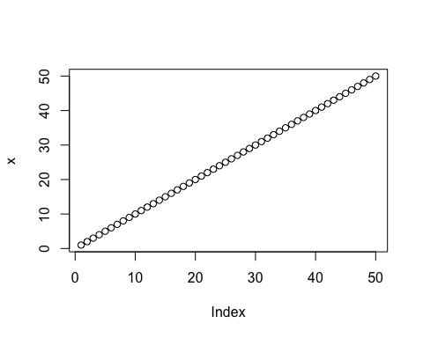
plot(x,sin(x),typ="l",col="red",lwd=2.5,
xlab="Is it lunch time yet?")
