# Apply Filters to SQL Queries

## Project description:

I am a security professional for a large organization. Part of my job is to investigate security issues to help keep the system secure. I recently discovered some potential security issues that involve login attempts and employee machines.

My task is to examine the organization’s data in their employees and log_in_attempts tables. I will need to use SQL filters to retrieve records from different datasets and investigate the potential security issues.

## Retrieve after hours failed login attempts:

The screen shot below shows how I used a SQL query to obtain the data in the table below. To complete this query, I selected all the columns from the log_in_attempts table in the database. I then asked for only the login_time after “18:00” or 6:00 pm that were failed login attempts.

## Retrieve login attempts on specific dates:

The screen shot below shows how I used a SQL query to obtain the data in the table below. To complete this query, I selected all the columns from the log_in_attempts table in the database. I then asked for login attempts that are on either one of the dates by using following syntax login_date = “2022-05-09” OR login_date = “2022-05-08”**.**

## Retrieve login attempts outside of Mexico:

The screen shot below shows how I used a SQL query to obtain the data in the table below. To complete this query, I selected all the columns from the log_in_attempts table in the database. I then asked for login attempts that originated outside of Mexico by using the following syntax WHERE NOT country LIKE “MEX%”. I used % as a wildcard for any character that follow that pattern in the log_in_attemptstable.

## Retrieve employees in Marketing:

The screen shot below shows how I used a SQL query to obtain the data in the table below. To complete this query, I selected all the columns from the employees table in the database. I then asked for all the Marketing employees assigned to the East building by using the following syntax, WHERE department = “Marketing” AND office LIKE “EAST%”**.** I used the % as a wildcard to match the string pattern used in the LIKE statement.

## Retrieve employees in Finance or Sales:

The screen shot below shows how I used a SQL query to obtain the data in the table below. To complete this query, I selected all the columns from the employees table in the database. I then asked for all the employees in the Sales and Finance department by using this syntax, WHERE department = “Sales” OR department = “Finance”**.**

## Retrieve all employees not in IT:

The screen shot below shows how I used a SQL query to obtain the data in the table below. To complete this query, I selected all the columns from the employees table in the database. I then asked for a list of employees that don’t work in the Information Technology department by using the following syntax, WHERE NOT department = “Information Technology”**.** This produces a list of employees who don’t work in IT.

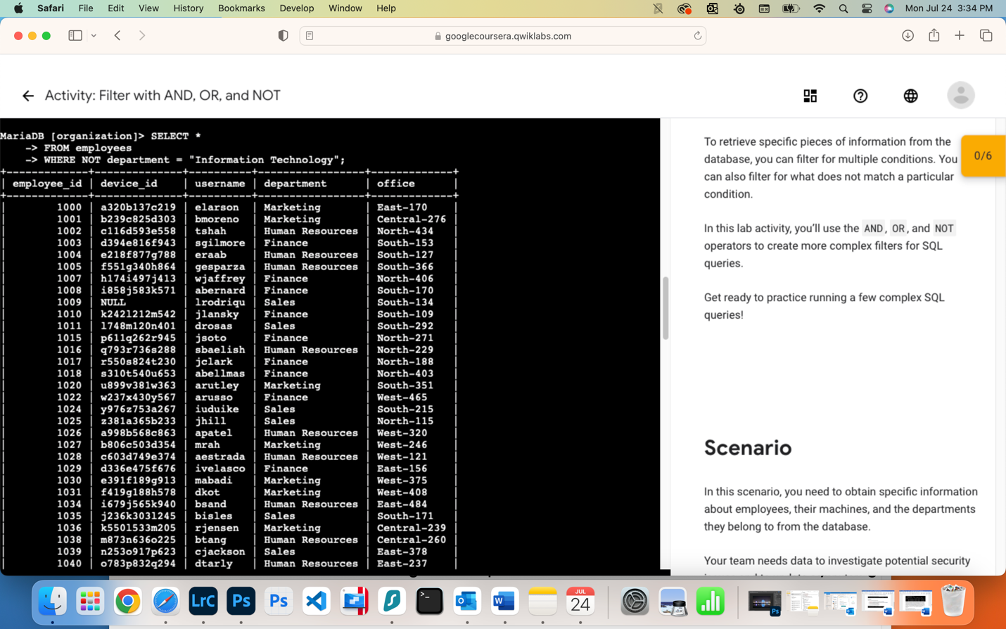

## Summary:

During this exercise, I reviewed two different table in the database. I then ran SQL queries against both database tables to retrieve necessary information. I did this to improve my SQL skills and get practice. I also included screen shots of all my work for validity.