SPHERE3D: A Matlab® Function to Plot 3-Dimensional Data on
a Spherical Surface

J M De Freitas
QinetiQ Ltd, Winfrith Technology Centre
Winfrith, Dorchester
Dorset DT2 8XJ
United Kingdom

28 September 2005

Occasionally one is required to plot intensity or magnitude information obtained from a spherical surface. This technical note describes SPHERE3D, a Matlab® function that allows the user to plot 3-Dimensional data on a sphere. Typical applications include shape, stress and temperature profiles obtained for spherical structures, and modelling involving the temporal and spatial evolution of wavefronts. SPHERE3D is similar to POLAR3D and CYL3D where the latter two are for 3D information plotted over a disc and on the curved surface of a cylinder, respectively.

Terms and Conditions of Use

- This function is made available to Matlab® users under the terms and conditions set out in the Matlab Exchange by The Mathworks, Inc.
- Where the use of SPHERE3D is to be cited, the following is recommended:
J M De Freitas. ‘SPHERE3D: A Matlab® Function to Plot 3-Dimensional Data on a Spherical Surface’. QinetiQ Ltd, Winfrith Technology Centre, Winfrith, Dorchester DT2 8XJ. UK. 28 September 2005.
- No offer of warranty is made or implied by the author and use of this work means that the user has agreed to take full responsibility for its use.
3D PLOT ON A SPHERICAL SURFACE

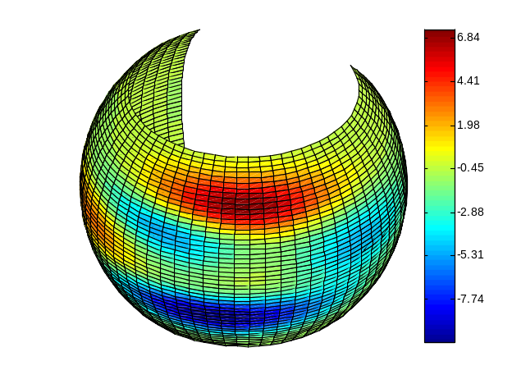
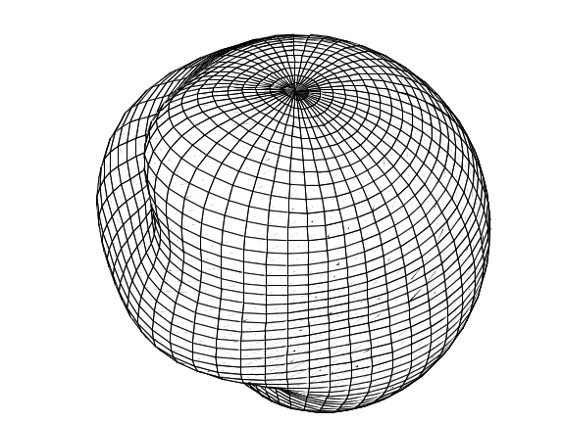

MESH PLOT
SURF/FILLED CONTOUR

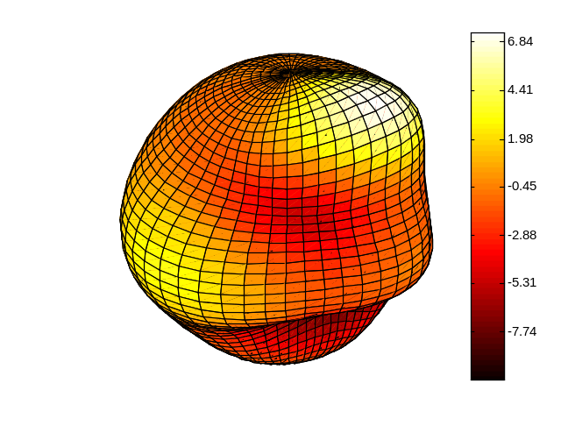
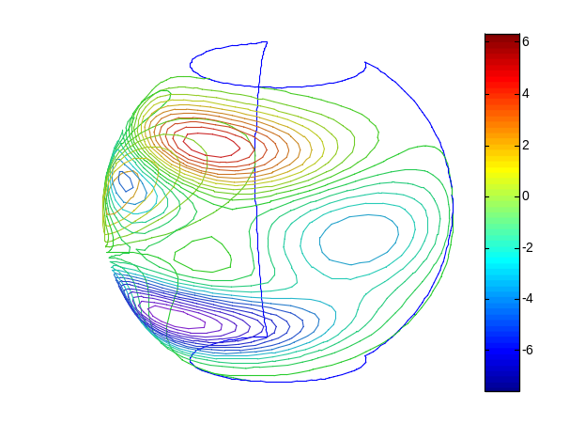

CONTOUR
SURF HOT MAP

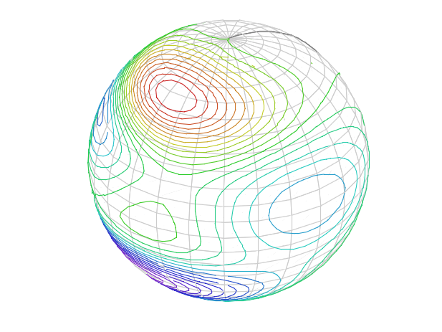

CONTOUR / MESH

θ
ϕ
z
y
x
ρ

Fig.1. Coordinate system on which SPHERE3D is based.

Coordinate System

Fig.1 shows the coordinate system on which SPHERE3D is based. Note that in the function, φ is constrained to vary over π, i.e. the difference between φ_{max} (phi_max) and φ_{min} (phi_min) can be no more than π. In a similar manner, θ is constrained over 2π and as such the difference between θ_{max} (theta_max) and θ_{min} (theta_min) can be no more than 2π.

Mesh Plot

The mesh plot shown above was produced using:

P = peaks(20);
sphere3d(-P,-pi,pi,-pi/2,pi/2,20,.4,'mesh','spline');

In this case, the angular range for θ covers -180º to 180º, while φ takes up -90º to +90º, with sphere radius 20. The spline interpolation method was used to increase the dimension of the input matrix from 20x20 to 50x50 using a mesh scale value of 0.4. Since the Zscale factor is not specified, it defaults to 1.

Contour Plot

The contour plot shown above was produced using:

P = peaks(20);
sphere3d(-P,-pi/2,pi,-pi/3,pi/3,20,.4,'contour','spline');

The angular range and radius are unchanged from the mesh example above. Note further that the colour scheme of the contour plot is unaffected by the colormap command. See Surf Plot below. Moreover, when the angular range of θ is 360º, a vertical line on the spherical surface is used to show the reference or start point.

Surf Plot

The surf plot is slightly different to the standard Matlab surf plot. In SPHERE3D the colour intensity varies radially from inside (lowest value) to outside (highest value). This allows the user to easily spot peaks and troughs on the surface.

The surf plots produced by this function accept the colormap command. For example, the hot scale map shown above was produced using:

P = peaks(20);
sphere3d(-P,-pi,pi,-pi/2,pi/2,20,.4,'surf','spline');
colormap hot

Any standard colour mapping could be used. Note that there is no reference line in the surf plot as in the contour plot. The output (x,y,z,c) can be used to produce other colour plots with colour mapping c. Standard properties, e.g. axes, axis labels, title, etc. for the plot can then be manipulated to suit the user. See Contour/Mesh Plot below.

Surf / Filled Contour Plot

The surf plot function could be used to produce a map similar to a filled contour plot. This is done by either scaling up the radius, or preferably, using the Zscale factor. Using a small value for Zscale means that peaks and troughs are not noticeable on the plot giving the impression of a filled contour plot e.g. in this case, Zscale is 0.001.

P = peaks(20);
sphere3d(-P,-pi/2,pi,-pi/4,pi/4,8,.4,'surf','spline',.001);

Contour / Mesh Plot

A mesh can be combined with contour plot by first plotting the mesh using the (x,y,z) output from the function then overlay the contour as:

P = peaks(20);
R = 20; % contour radius
mR = 0.995*R; % mesh radius
[x,y,z,c] = sphere3d(P,-pi,pi,-pi/2,pi/2,mR,.75,'off','spline',0);
mesh(x,y,z)
colormap ([.8 .8 .8]);
hold on
sphere3d(-P,-pi,pi,-pi/2,pi/2,R,.25,'contour','spline',0);
s = colorbar;
delete(s)
hold off

Note that Zscale is 0, and that the radius R for the contour plot is slightly larger than the radius mR of the mesh plot; this avoids pixel colour writing conflicts. It is recommended that the mesh radius should be 0.5% smaller than the contour radius i.e., mR = 0.995*R. Note further that the contour with mesh plot is no longer transparent as when using the contour function only.

The example above allows you to get smoother contours by specifying the smaller meshscale value of 0.25 for the contour plot, but specifying a coarser mesh of scale value 0.75 for the mesh plot i.e., the mesh plot sets the spacing between longitudes and latitudes. The colormap for the mesh plot is now gray. There are other ways of combining these plots.

Surf / Filled Contour – Concentric Plots

The surf/filled contour option can be plotted several times over each other to create a concentric set of plots with different radii. For example, the script

P = peaks(20);
[x1,y1,z1,c] = sphere3d(-P,pi/2,2*pi,- pi/4,pi/4,8,.4,'off','spline',.001);
[x2,y2,z2,c] = sphere3d(-P,pi/2,2*pi,-pi/4,pi/4,15,.4,'off','spline',.001);
[x3,y3,z3,c] = sphere3d(-P,pi/2,2*pi,-pi/4,pi/4,25,.4,'off','spline',.001);
surf(x1,y1,z1,c); hold on
surf(x2,y2,z2,c); hold on
surf(x3,y3,z3,c);
axis off;
grid off;
set(gca,'DataAspectRatio',[1 1 1])
set(gca,'XDir','rev','YDir','rev');
hold off

produces three concentric surf/filled contour plots. There are other ways of setting out the script e.g. by using loops. This type of plot could be useful in visualizing spatio-temporal evolutions of wavefronts e.g. sonar, astronomy etc.

A similar set could be made using mesh plots. For example,

P = peaks(20);
[x1,y1,z1,c] = sphere3d(-P,-pi/8,pi/8,- pi/8,pi/8,8,.4,'off','spline',1);
[x2,y2,z2,c] = sphere3d(-P,-pi/8,pi/8,-pi/8,pi/8,15,.4,'off','spline',1);
[x3,y3,z3,c] = sphere3d(-P,-pi/8,pi/8,-pi/8,pi/8,25,.4,'off','spline',1);
colormap([0 0 0]);
mesh(x1,y1,z1); hold on
mesh(x2,y2,z2); hold on
mesh(x3,y3,z3);
axis off;
grid off;
set(gca,'DataAspectRatio',[1 1 1])
set(gca,'XDir','rev','YDir','rev');
hold off

produces a smaller rectangular solid angle of 3D information for various radii.

Function Description

A detailed description of the function can be found from the standard help command – help sphere3d – once installed, or the header information in the file sphere3d.m.

