# [PUBLICATION TITLE]

[Mandatory. The title must include the name of the assessed stock “[stock area] [species] (*formal taxonomic treatments*), ‘Stock Assessment’ or ‘Update’ in [assessment year]”. Assessment year is normally the last year of the data being used in the assessment.]

## CONTEXT

[Mandatory. Maximum length 150 words. Include only information about the request for advice, including the meeting objectives and the date of the peer-review meeting.] [Include link to IFMP/rebuilding/management plan(s)]

This Science Advisory Report is from the [scope, ex. regional, multi-regional, national] peer review of [meeting date and title (e.g., regional peer review of January 25, 2011 on the Assessment of Quebec Inshore Waters Softshell Clam)The meeting process, date and title **MUST BE EXACTLY** as they appear for the meeting on the Science Advisory Schedule]. [Include link to IFMP/rebuilding plan] Additional publications from this meeting will be posted on the [Fisheries and Oceans Canada (DFO) Science Advisory Schedule](http://www.isdm-gdsi.gc.ca/csas-sccs/applications/events-evenements/index-eng.asp) as they become available.

[See Guidance Document for examples of additional information to provide in the Context section.]

## SCIENCE ADVICE

[Mandatory. Maximum length 500 words. This section is for summary bullets representing the main scientific conclusions of the meeting, focusing on ones that are most relevant for decision-making. Each bullet should reflect information in the body of the report. Please refer to the Guidance Document for instructions and examples.]

### Status

* [Mandatory bullet(s)]

### Trends

* [Mandatory bullet(s)]

### Ecosystem and Climate Change Considerations

* [Mandatory bullet(s), section is optional for FSRR]

### Stock Advice

* [Mandatory bullet(s)]

### **Other Management Questions** [if applicable, otherwise do not include]

* [Other bullets if applicable]

## BASIS FOR ASSESSMENT

### Assessment Details

[Mandatory]

#### Year Assessment Approach was Approved

[Mandatory; year and reference]

#### Assessment Type

[Mandatory; select one of the following: Full Assessment, Interim-Year Update. See the Guidance Document for definitions.]

#### Most Recent Assessment Date

1. Last Full Assessment: [date and reference]
2. Last Interim-Year Update: [date and reference]

#### Stock Assessment Approach

1. Broad category: [Select one of the following: Data-poor (e.g., catch-MSY, very limited data), index-based (trends in empirical indices only), single stock assessment model, model ensemble, MSE (full or MSE-lite), Wild Salmon Policy Integrated Assessment, multiple approaches, other (specify)]
2. Specific category: [Select one or as many as apply: No data, Index-based (fishery-dependent indices only), Index-based (including fishery-dependent and fishery-independent indices), Delay difference, Biomass dynamics, Virtual population analysis, Statistical catch-at-length, Statistical catch-at-age, State-Space, Sequential Population Analysis, Surplus Production, Stock-Recruitment Relationship, Potential Biological Removal, Other (please explain)]

[Optional short plain language summary of stock assessment methodology. Include a reference to a Research Document or other publication, and/or footnote to the working paper. Less than 100 words.]

#### Ecosystem and Climate Change Assessment Approach

[Optional short plain language summary of the methodology used to consider/assess ecosystem variables in the advice. Include a reference to a Research Document or other publication, and/or footnote to the working paper. Maximum 100 words.]

#### Operating Models [alternative title: Model Scenarios]

[Optional. High-level descriptions (text, table or figures) that convey to decision-makers the key uncertainties and scenarios represented where multiple models are used in stock advice. Do not include equations. Include a reference to a Research Document or other publication, and/or footnote to the working paper.]

### Stock Structure Assumption

[Mandatory. Maximum length 150 words. Briefly summarize current assumptions for stock structure and distribution to provide context for understanding scale of reference points, management and assessment.]

### Reference Points

[Mandatory. A table may be used in lieu of bullets for this section. Refer to the Guidance Document for further instructions.]

* Limit Reference Point (LRP):
* Upper Stock Reference (USR):
* Removal Reference (RR):
* Target Reference Point (TRP):

#### Other Stock Reference Points

[If applicable (otherwise, do not include). A table may be used in lieu of bullets for this section.] (e.g. hatchery, habitat, ecosystem)

### Management Objectives

[Optional (if applicable and if provided by fisheries managers; otherwise, do not include). Describe the measurable objectives and/or performance metrics for advice being provided.]

Can include HDR, MPs, Enhancement plan, habitat restoration plan

### Data

[Mandatory. Maximum length 200 words. Briefly summarize the main data inputs for the assessment.]

Data changes: [Optional (otherwise, do not include).]

## ASSESSMENT

[Standard figure, if applicable, comes first – example shown. All figures and tables should be referenced in the text. Refer to the Guidance Document for exceptions, options and further instructions.]

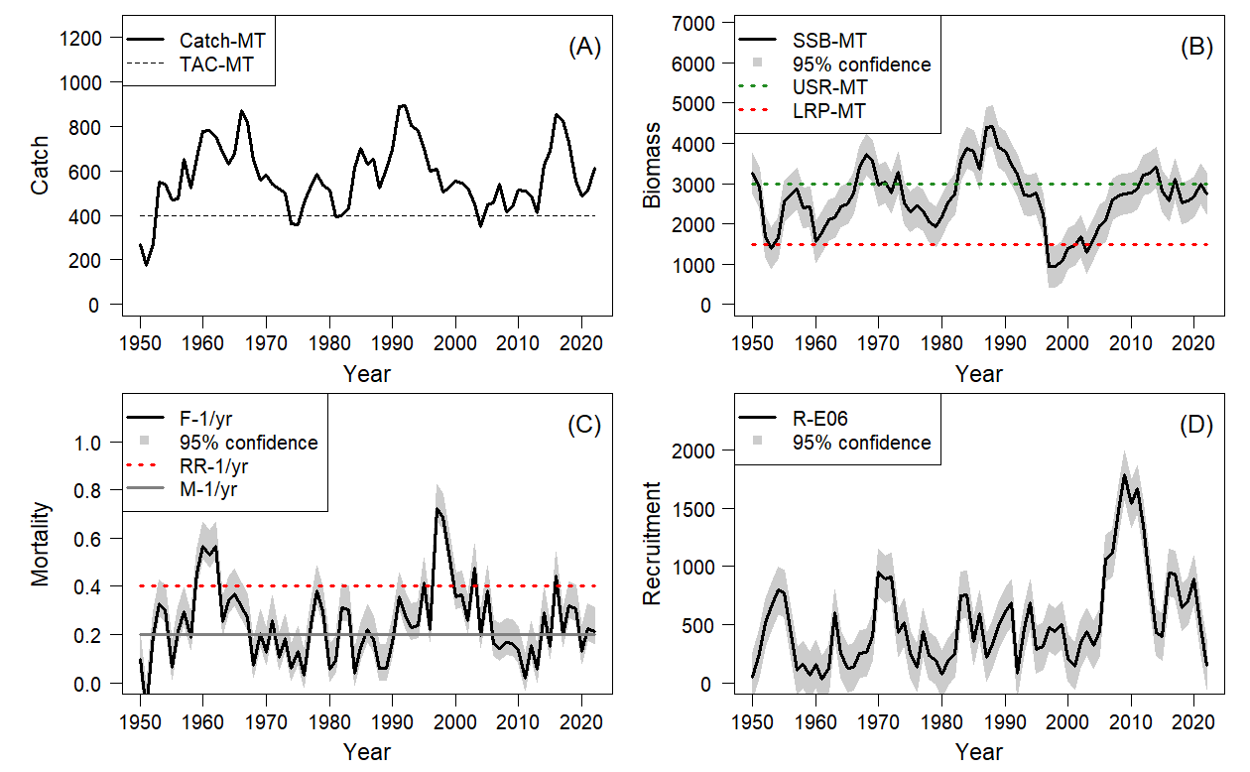

Figure 1. (A – upper left panel) Catch and Total Allowable Catch, (B – upper right panel) Spawning Stock Biomass (SSB) in relation to the Limit Reference Point (LRP; X) and (proposed) Upper Stock Reference (USR; X), (C – bottom left panel) Fishing Mortality (F; X) on the left in relation to the Removal Reference (RR) and Natural Mortality (M), (D- bottom right panel) Recruitment (numbers).

[Optional. Add an additional optional panel of 4 indicators if relevant to developing advice.]

[Optional. If the FSAR or FSRR is being used to provide advice for more than one stock or subunit, the mandatory and optional panels can be repeated for each stock or subunit.]

### Stock Status and Trends

[Mandatory. Maximum section length one page. Must be first section in Assessment section.If needed, this section can be duplicated for each stock or subunit, although it may be preferable to maintain one section in which all stocks and subunits are described.]

[Provide information on stock status and all the key indicators for the stock(s) relevant to decision-making, over timescales relevant to the stock. Tables can be used if helpful for decision-making. Cite mandatory and optional figures and tables in the text as needed. Report trends in relevant indicator(s), one per paragraph, in the following format:]

#### **[Indicator 1]** [specify name, e.g., Abundance]

[Provide values and trends for the stock (as applicable). Use as many indicators as relevant to providing advice for decision-making.]

#### **Current** Status

[Mandatory. Indicate stock status relative to its reference point(s) or state status is unknown if there are no reference points.]

#### Unknown

[Optional. Indicate what indicators are not available for the stock (as applicable); otherwise, do not include.]

### History of [Management; Landings/Harvest/Effort, TAC & Catch Advice]

[Mandatory. Title can vary. Maximum section length one page. Similar to Stock Status and Trends, the purpose of this section is to provide information on past and present key indicator(s) and reference level(s) of harvest, hatchery or habitat management that are relevant to decision-making, over timescales relevant to the stock.]

#### History of Hatchery and Supplementation

[If applicable (otherwise, do not include).]

#### History of Freshwater Habitat Impacts

[If applicable (otherwise, do not include).]

### Ecosystem and Climate Change Considerations

[Mandatory. Less than 300 words. Sub-headings, tables or figures may be used. The purpose of this section is to briefly describe the environmental, ecosystem, ecological and/or climate change considerations affecting the fish stock(s),and explain how they were accounted for in the advice, in a way that can be easily referenced by decision-makers.]

### Stock Advice [optional titles: Projections, Simulations, Future Scenarios]

[Mandatory. Title can vary. Sub-headings may be used. The purpose of this section is to provide forward-looking science advice on the prospects for the stock to Fisheries Management, usually in the context of current or proposed future range of harvest levels, harvest decision rules, or other management measures, procedures or scenarios that may be considered by decision-makers. There is no length limit to this section, however the overall document length guidance still applies. Tables or figures can be used as needed to support decision-making.]

### Harvest Decision Rule

[If applicable (otherwise, do not include).To provide information needed to apply an established Harvest Decision Rule for the stock.]

### Exceptional Circumstances

[If applicable (otherwise, do not include). Proposal for or evaluation of any already-established exceptional circumstances that may indicate a need for re-evaluation of management procedures in an MSE context.]

## **PROCEDURE FOR INTERIM-YEAR UPDATES**

[Optional (otherwise, do not include). If a process for interim-year updates (DFO 2016) is being set for the first time in this meeting, or an established one exists for the stock, describe it briefly in this section.]

### Evaluation of Assessment Triggers

[If applicable (otherwise, do not include). Applicable during Interim-Year Updates. Evaluation of any triggers that would prompt a stock assessment sooner than the pre-agreed cycle.]

## BYCATCH

[Optional (otherwise, do not include). Estimates of bycatch of non-target species. If the target species that is the focus of this assessment is caught in other fisheries, that information should be summarized in the landings portion of the assessment.]

## OTHER MANAGEMENT QUESTIONS

[Optional (otherwise, do not include). If there is another management question(s) to be addressed during a full assessment, such as other types of management or rebuilding measures, advice on candidate reference points or measurable objectives requested by Fisheries Management, or advice in relation to other Sustainable Fisheries Framework policies, a brief summary of the evaluation can be placed here. Content should be relevant for decision making, and corresponding summary bullets can then also be added to the Science Advice section under the optional Other Management Questions heading. Tables or figures may be used, if relevant for advice.]

## SOURCES OF UNCERTAINTY

[Mandatory. Less than 500 words.To identify and explain key uncertainties, including assumptions, that may impact the advice, in order to avoid misinterpretation of advice presented in the sections above.]

## LIST OF MEETING PARTICIPANTS

[Mandatory. The list is to include the name of each participant and their role and affiliation.]

## SOURCES OF INFORMATION

[Mandatory.]

[References should only be included to understand the advice and should not be included to give credit to the work as is the case in the Research Document. References to the unpublished working paper should be integrated as footnotes throughout this document.]

[References must be formatted according to the *[Guide for the Production of Fisheries and Oceans Canada Reports](https://waves-vagues.dfo-mpo.gc.ca/Library/333125.pdf)*[.](https://waves-vagues.dfo-mpo.gc.ca/Library/333125.pdf) [Include hyperlinks only if the site is hosted by the Government of Canada or a DOI handle system is used.]](https://waves-vagues.dfo-mpo.gc.ca/Library/333125.pdf)

[References listed in the References Cited section should be publicly available when the report is posted on the website. The only exception is for books or articles that have been accepted for publication (page proof stage or where there is an acceptance letter). These can be listed followed by the notation “in press”. All others should be included in the text as unpublished data or working papers with footnotes.]

## THIS REPORT IS AVAILABLE FROM THE:

Center for Science Advice (CSA)   
[Name of Region]   
Fisheries and Oceans Canada  
[Complete mailing address of CSA Office]

E-Mail: [email]   
Internet address: [www.dfo-mpo.gc.ca/csas-sccs/](http://www.dfo-mpo.gc.ca/csas-sccs/" \o "Fisheries and Oceans Canada / Canadian Science Advisory Secretariat)

ISSN 1919-5087  
ISBN 978-0-660-xxxxx-x Cat. No. Fs70-6/2025-nnnE-PDF  
© His Majesty the King in Right of Canada, as represented by the Minister of the  
Department of Fisheries and Oceans, 2025

This report is published under the [Open Government Licence - Canada](https://open.canada.ca/en/open-government-licence-canada#:~:text=Open%20Government%20Licence%20-%20Canada%201%20Using%20Information,Governing%20Law%20...%208%20Definitions%20...%20More%20items)

please recycle

Correct Citation for this Publication:

DFO. 2025. [Title – title must be exactly as it appears on the cover page, but in title case]. DFO Can. Sci. Advis. Sec. Sci. Advis. Rep. 2025/nnn.

Aussi disponible en français :

MPO. 2025. [titre – il doit correspondre exactement à celui de la page couverture, mais en lettres minuscules]. Secr. can. des avis sci. du MPO. Avis sci. 2025/nnn.

Inuktitut Atuinnaummijuq: [if applicable]

Copy and paste Inuktitut citation here.

# FONT AND STYLE FORMATTING INFORMATION

Please refer to the Checklist and the [CSAS Publications Toolkit](http://intra.dfo-mpo.gc.ca/csas-sccs/index-eng.html) located on the CSAS [Sharepoint site](https://086gc.sharepoint.com/sites/CSASWebandPubTeam/SitePages/Web%20and%20Pub%20Resources%20-%20CSAS%20hub.aspx?ga=1&LOF=1).

# LAYOUT REQUIREMENTS (FORMATTING AND STYLES)

## HEADING 2: ARIAL, SIZE 14, BOLD, CENTERED, ALL CAPS, PARAGRAPH SPACING 12 PT (0.17 IN, 0.42 CM) BEFORE AND 6 PT (0.08 IN, 0.21 CM) AFTER

### Heading 3: Arial, 12, bold, left-aligned, paragraph spacing 12 pt (0.17 in, 0.42 cm) before and 6 pt (0.08 in, 0.21 cm) after

#### Heading 4: Arial, 11, bold, left-aligned, left indentation 18 pt (0.25 in, 0.63 cm), paragraph spacing 6 pt (0.08 in, 0.21 cm) before and after

Body Text: Arial, size 11, left-aligned, paragraph spacing 6 pt (0.08 in, 0.21 cm) before and after

* List Bullet: Arial, size 11, left-aligned, hanging indentation 18 pt (0.25 in, 0.63 cm), paragraph spacing 0 pt before and 6 pt (0.08 in, 0.21 cm) after
* List Bullet 2: Arial, size 11, left-aligned, left indentation 18 pt (0.25 in, 0.64 cm), hanging indentation 18 pt (0.25 in, 0.63 cm), paragraph spacing 0 pt before and 6 pt (0.08 in, 0.21 cm) after

Examples of List number:

1. List Number: Arial, size 11, left-aligned, numbering style: 1, 2, 3, hanging indentation 18 pt (0.25 in, 0.63 cm), paragraph spacing 0 pt before and 6 pt (0.08 in, 0.21 cm) after
2. List Number
3. List Number 2: Arial, size 11, left-aligned, numbering style: a, b, c, left indentation 18 pt (0.25 in, 0.63 cm), hanging indentation 18 pt (0.25 in, 0.63 cm), paragraph spacing 0 pt before and 6 pt (0.08 in, 0.21 cm) after
4. List Number 2

Caption – Table: Arial, size 10, italics, left-aligned, paragraph spacing 12 pt (0.17 in, 0.42 cm) before and 6 pt (0.08 in, 0.21 cm) after, keep with next paragraph, keep with next paragraph, keep lines together. Table caption goes above the table.

Caption – Figure: Arial, size 10, italics, left-aligned, paragraph spacing 6 pt (0.08 in, 0.21 cm) before and 12 pt (0.17 in, 0.42 cm) after, keep lines together. Figure caption goes below the figure.

citation: Arial, size 11, left aligned, hanging indentation 18 pt (0.25 in, 0.63 cm), paragraph spacing 6 pt (0.08 in, 0.21 cm) before and after, keep lines together.

Blockquote: Arial, size 11, left-aligned, left indentation 36 pt (0.5 in, 1.27 cm), paragraph spacing 6 pt (0.08 in, 0.21 cm) before and after