- Trawl Surveys
  - Introduction
This appendix summarises the derivation of relative Pacific Cod (PAC) abundance indices from the following bottom trawl survey:
- National Marine Fisheries Service (NMFS) Triennial survey operated off the lower half of Vancouver Island (Section B.3);

  - Analytical methods
Catch and effort data for strata in year yield catch per unit effort (CPUE) values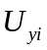. Given a set of data 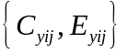 for tows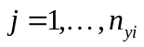,
Eq. B.1 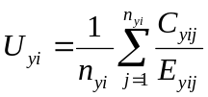,
where 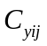 = catch (kg) in tow , stratum , year ;
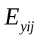 = effort (h) in tow , stratum , year ;
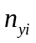 = number of tows in stratum , year .
CPUE values convert to CPUE densities 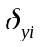 (kg/km²) using:
Eq. B.2 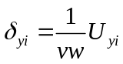,
where = average vessel speed (km/h);
= average net width (km).
Alternatively, if vessel information exists for every tow, CPUE density can be expressed
Eq. B.3 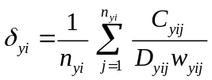,
where 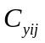 = catch weight (kg) for tow , stratum , year ;
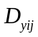 = distance travelled (km) for tow, stratum, year;
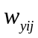 = net opening (km) for tow, stratum, year;
= number of tows in stratum, year.
The annual biomass estimate is then the sum of the product of CPUE densities and bottom areas across strata:
Eq. B.4 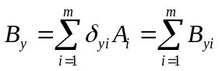,
where = mean CPUE density (kg/km²) for stratum , year ;
 = area (km²) of stratum;
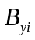 = biomass (kg) for stratum, year;
= number of strata.
The variance of the survey biomass estimate 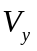 (kg²) follows:
Eq. B.5 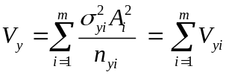,
where 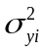 = variance of CPUE density (kg²/km⁴) for stratum , year ;
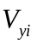 = variance of the biomass estimate (kg²) for stratum, year .
The coefficient of variation (CV) of the annual biomass estimate for year is
Eq. B.6 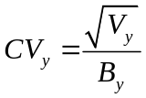.
  - NMFS Triennial Trawl Survey
    - Data selection
Tow-by-tow data from the US National Marine Fisheries Service (NMFS) triennial survey covering the Vancouver INPFC (International North Pacific Fisheries Commission) region were provided by Mark Wilkins (NMFS, pers. comm.) for the seven years that the survey worked in BC waters (Table B.1; 1980: Figure B.1; 1983: Figure B.2; 1989: Figure B.3; 1992: Figure B.4; 1995: Figure B.5; 1998: Figure B.6; 2001: Figure B.7). These tows were assigned to strata by the NMFS, but the size and definition of these strata have changed over the life of the survey (Table B.2). The NMFS survey database also identified in which country the tow was located. This information was plotted and checked against the accepted Canada/USA marine boundary: all tows appeared to be appropriately located with respect to country, based on the tow start position (Figure B.1 to Figure B.7). The NMFS designations were accepted for tows located near the marine border.
All usable tows had an associated median net width (with 1-99% quantiles) of 13.4 (11.3-15.7) m and median distance travelled of 2.8 (1.4-3.5) km, allowing for the calculation of the area swept by each tow. Biomass indices and the associated analytical CVs for Pacific Cod were calculated for the total Vancouver INPFC region and for each of the Canadian- and US-Vancouver sub-regions, using appropriate area estimates for each stratum and year (Table B.2). Strata that were not surveyed consistently in all seven years of the survey were dropped from the analysis (Table B.1; Table B.2), allowing the remaining data to provide a comparable set of data for each year (Table B.3).
Table B.1. Number of tows by stratum and by survey year for the NFMS triennial survey. Strata coloured grey have been excluded from the analysis due to incomplete coverage across the seven survey years or were from locations outside the Vancouver INPFC area (Table B.2).
Stratum No. | 1980 |  | 1983 |  | 1989 |  | 1992 |  | 1995 |  | 1998 |  | 2001
Stratum No. | CDN | US | CDN | US | CDN | US | CDN | US | CDN | US | CDN | US | CDN | US
10 |  | 15 |  | 7
11 | 38 |  |  | 34
12 |  |  | 32
17N |  |  |  |  |  | 8 |  | 9 |  | 8 |  | 8 |  | 8
17S |  |  |  |  |  | 27 |  | 27 |  | 24 |  | 26 |  | 25
18N |  |  |  |  | 1 |  | 1
18S |  |  |  |  |  | 31 |  | 20 |  | 12 |  | 20 |  | 14
19N |  |  |  |  | 56 |  | 53 |  | 55 |  | 48 |  | 33
19S |  |  |  |  |  | 4 |  | 6 |  | 3 |  | 3 |  | 3
27N |  |  |  |  |  | 2 |  | 1 |  | 2 |  | 2 |  | 2
27S |  |  |  |  |  | 4 |  | 2 |  | 3 |  | 4 |  | 5
28N |  |  |  |  | 1 |  | 1 |  | 2 |  | 1
28S |  |  |  |  |  | 6 |  | 9 |  | 7 |  | 6 |  | 7
29N |  |  |  |  | 7 |  | 6 |  | 7 |  | 6 |  | 3
29S |  |  |  |  |  | 3 |  | 2 |  | 3 |  | 3 |  | 3
30 |  | 4 |  | 2
31 | 7 |  |  | 11
32 |  |  | 5
37N |  |  |  |  |  |  |  |  |  | 1 |  | 1 |  | 1
37S |  |  |  |  |  |  |  |  |  | 2 |  | 1 |  | 1
38N |  |  |  |  |  |  |  |  | 1
38S |  |  |  |  |  |  |  |  |  | 2 |  |  |  | 3
39 |  |  |  |  |  |  |  |  | 6 |  | 4 |  | 2
50 |  | 4 |  | 1
51 | 3 |  |  | 10
52 |  |  | 2
Total | 48 | 23 | 39 | 65 | 65 | 85 | 61 | 76 | 71 | 67 | 59 | 74 | 38 | 72
The stratum definitions used in the 1980 and 1983 surveys were different than those used in subsequent surveys, particularly in Canadian waters (Table B.3). Therefore, the 1980 and 1983 indices were scaled up by the ratio (9166 km² / 7399 km² = 1.24) of the total stratum areas relative to the 1989 and later surveys so that the coverage from the first two surveys would be comparable to the surveys conducted from 1989 onwards. The tow density was much higher in US waters although the overall number of tows was approximately the same for each country (Table B.3). This occurs because the size of the total area fished in the INPFC Vancouver area was about twice as large in Canadian waters than in US waters (Table B.3). Note that the northern extension of the survey has varied from year to year (Figure B.1 to Figure B.7), but this difference has been compensated for by using a constant survey area for all years and assuming that catch rates in the unsampled areas were the same as in the sampled area.
Table B.2. Stratum definitions by year used in the NMFS triennial survey to separate the survey results by country and by INPFC area. Stratum definitions in grey are those strata which have been excluded from the final analysis due to incomplete coverage across the seven survey years or because the locations were outside the Vancouver INPFC area.
Year | Stratum No. | Area (km²) | Start | End | Country | INPFC area | Depth range
1980 | 10 | 3537 | 47°30 | US-Can Border | US | Vancouver | 55-183 m
1980 | 11 | 6572 | US-Can Border | 49°15 | CDN | Vancouver | 55-183 m
1980 | 30 | 443 | 47°30 | US-Can Border | US | Vancouver | 184-219 m
1980 | 31 | 325 | US-Can Border | 49°15 | CDN | Vancouver | 184-219 m
1980 | 50 | 758 | 47°30 | US-Can Border | US | Vancouver | 220-366 m
1980 | 51 | 503 | US-Can Border | 49°15 | CDN | Vancouver | 220-366 m
1983 | 10 | 1307 | 47°30 | 47°55 | US | Vancouver | 55-183 m
1983 | 11 | 2230 | 47°55 | US-Can Border | US | Vancouver | 55-183 m
1983 | 12 | 6572 | US-Can Border | 49°15 | CDN | Vancouver | 55-183 m
1983 | 30 | 66 | 47°30 | 47°55 | US | Vancouver | 184-219 m
1983 | 31 | 377 | 47°55 | US-Can Border | US | Vancouver | 184-219 m
1983 | 32 | 325 | US-Can Border | 49°15 | CDN | Vancouver | 184-219 m
1983 | 50 | 127 | 47°30 | 47°55 | US | Vancouver | 220-366 m
1983 | 51 | 631 | 47°55 | US-Can Border | US | Vancouver | 220-366 m
1983 | 52 | 503 | US-Can Border | 49 °15 | CDN | Vancouver | 220-366 m
1989&after | 17N | 1033 | 47°30 | 47°50 | US | Vancouver | 55-183 m
1989&after | 17S | 3378 | 46°30 | 47°30 | US | Columbia | 55-183 m
1989&after | 18N | 159 | 47°50 | 48°20 | CDN | Vancouver | 55-183 m
1989&after | 18S | 2123 | 47°50 | 48°20 | US | Vancouver | 55-183 m
1989&after | 19N | 8224 | 48°20 | 49°40 | CDN | Vancouver | 55-183 m
1989&after | 19S | 363 | 48°20 | 49°40 | US | Vancouver | 55-183 m
1989&after | 27N | 125 | 47°30 | 47°50 | US | Vancouver | 184-366 m
1989&after | 27S | 412 | 46°30 | 47°30 | US | Columbia | 184-366 m
1989&after | 28N | 88 | 47°50 | 48°20 | CDN | Vancouver | 184-366 m
1989&after | 28S | 787 | 47°50 | 48°20 | US | Vancouver | 184-366 m
1989&after | 29N | 942 | 48°20 | 49°40 | CDN | Vancouver | 184-366 m
1989&after | 29S | 270 | 48°20 | 49°40 | US | Vancouver | 184-366 m
1995&after | 37N | 102 | 47°30 | 47°50 | US | Vancouver | 367-500 m
1995&after | 37S | 218 | 46°30 | 47°30 | US | Columbia | 367-500 m
1995&after | 38N | 66 | 47°50 | 48°20 | CDN | Vancouver | 367-500 m
1995&after | 38S | 175 | 47°50 | 48°20 | US | Vancouver | 367-500 m
A reviewer from NOAA for Yellowtail Rockfish in 2014 (DFO 2015) noted that a number of the early Triennial survey tows had been deemed “water hauls” (catching no fish or invertebrates) and should be discarded. The tows used to estimate relative Pacific Cod biomass (summarised in Table B.3) exclude these water haul tows.
Table B.3. Number of usable tows performed and area surveyed in the INPFC Vancouver region separated by the international border between Canada and the United States. Strata 18N, 28N, 37, 38 and 39 (Table B.2) were dropped from this analysis as they were not consistently conducted over the survey period. All strata occurring in the Columbia INPFC region (17S and 27S; Table B.2) were also dropped.
 | Number of tows |  |  | Area surveyed (km²)
Survey year | CDN waters | US  waters | Total | CDN waters | US  waters | Total
1980 | 48 | 23 | 71 | 7,399 | 4,738 | 12,137
1983 | 39 | 65 | 104 | 7,399 | 4,738 | 12,137
1989 | 63 | 54 | 117 | 9,166 | 4,699 | 13,865
1992 | 59 | 47 | 106 | 9,166 | 4,699 | 13,865
1995 | 62 | 35 | 97 | 9,166 | 4,699 | 13,865
1998 | 54 | 42 | 96 | 9,166 | 4,699 | 13,865
2001 | 36 | 37 | 73 | 9,166 | 4,699 | 13,865
Total | 361 | 303 | 664 | – | – | –

    - Methods
The data were analysed using the equations in Section B.1. When calculating the variance for this survey, it was assumed that the variance and CPUE within any stratum were equal, even for strata that were split by the Canada/USA border. The total biomass 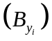 within a stratum that straddled the border was split between the two countries 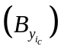 by the ratio of the relative area within each country:
Eq. B.7 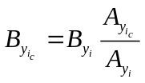,
where 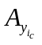 = area (km²) within country c in year y and stratum i.
The variance 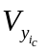 for that part of stratum i within country c was calculated as being in proportion to the ratio of the square of the area within each country c relative to the total area of stratum i. This assumption resulted in the CVs within each country stratum being the same as the CV in the entire stratum:
Eq. B.8 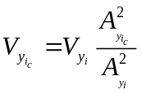.
The partial variance for country c was used in Eq. B.5 instead of the total variance in the stratum 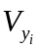when calculating the variance for the total biomass in Canadian or American waters. CVs were calculated as in Eq. B.6.
The biomass estimates Eq. B.4 and the associated standard errors were adjusted to a constant area covered using the ratios of area surveyed provided in Table B.3. This was required to adjust the Canadian biomass estimates for 1980 and 1983 to account for the smaller area surveyed in those years compared to the succeeding surveys. he 1980 and 1983 biomass estimates from Canadian waters were consequently multiplied by the ratio 1.24 (= 9166 km² / 7399 km²) to make them equivalent to the coverage of the surveys from 1989 onwards.
Biomass estimates were bootstrapped for 1000 random draws with replacement to obtain bias-corrected (Efron 1982) 95% confidence intervals for each year and for three area categories (total Vancouver region, Canadian-Vancouver only and US-Vancouver only) based on the distribution of biomass estimates and using the above equations.
    - Results
Pacific Cod (PAC) are characterised with most catches taken along the shelf edge and in the deep gully entering Juan de Fuca Strait (e.g., Figure B.1 and Figure B.2). A more consistent biomass estimate was obtained by excluding deep strata that were not covered in the earlier surveys (Table B.2). Figure B.8 shows that this species was mainly found between 57 and 256 m (1 and 99% quantiles of [bottom_depth]), with infrequent observations at depths up to 326 m which means that the deeper strata (>367 m) are not needed to monitor PAC. Note that the deep strata which were not used in the biomass estimation are included in Figure B.8.
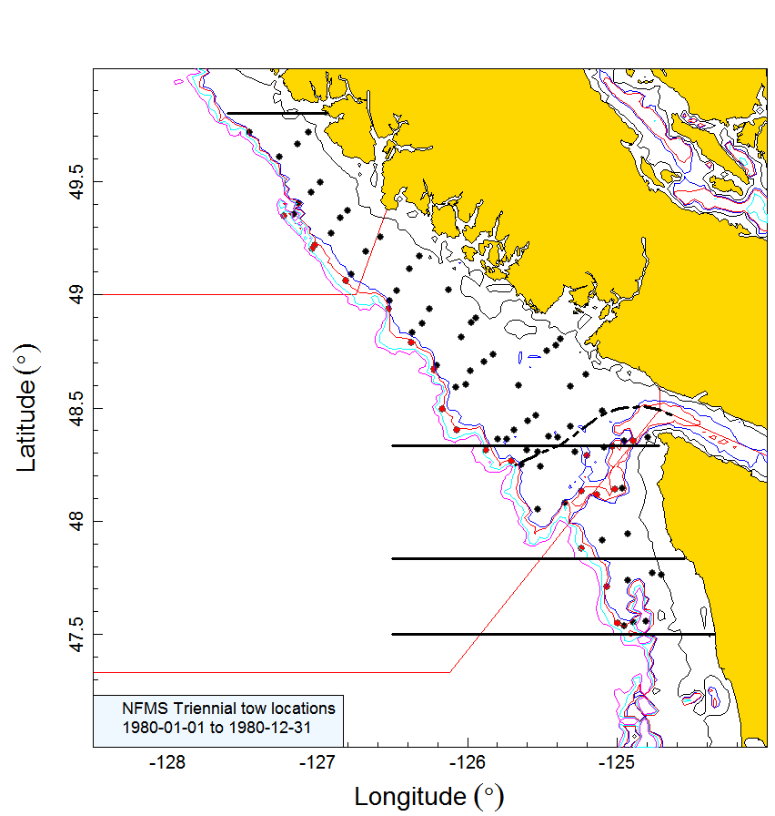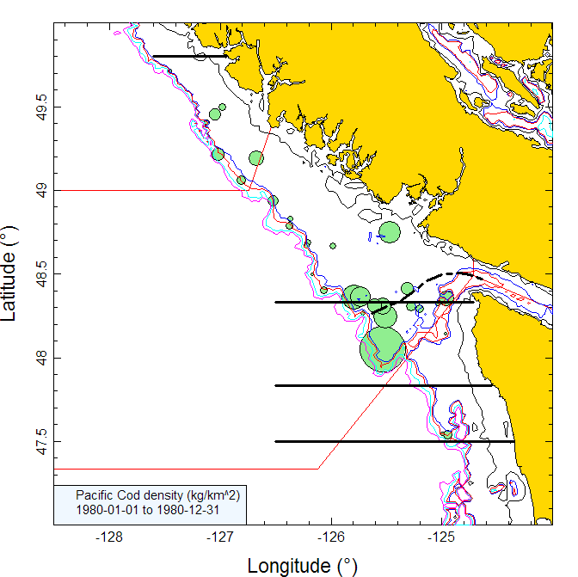
Figure B.1. [left panel]: plot of tow locations in the Vancouver INPFC region for the 1980 NMFS triennial survey in US and Canadian waters. Tow locations are colour-coded by depth range: black=55–183m; red=184-366m; grey=367-500m. Dashed line shows approximate position of the Canada/USA marine boundary. Horizontal lines are the stratum boundaries: 47°30′, 47°50′, 48°20′ and 49°50′. Tows south of the 47°30' line were not included in the analysis. [right panel]: circle sizes in the density plot are scaled across all years (1980, 1983, 1989, 1992, 1995, 1998, and 2001), with the largest circle = 7,229 kg/km² in 1989. The red solid lines indicate the boundaries between PMFC areas 3B, 3C and 3D.
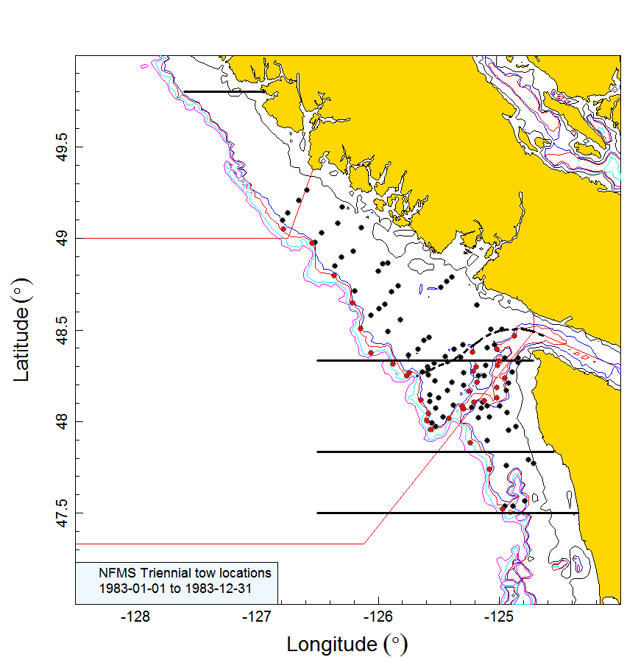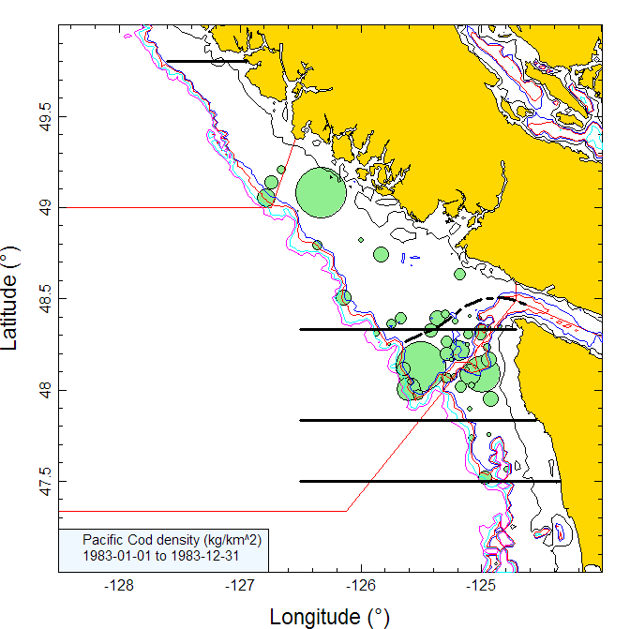
Figure B.2. Tow locations and density plots for the 1983 NMFS triennial survey in US and Canadian waters (see Figure B.1 caption).
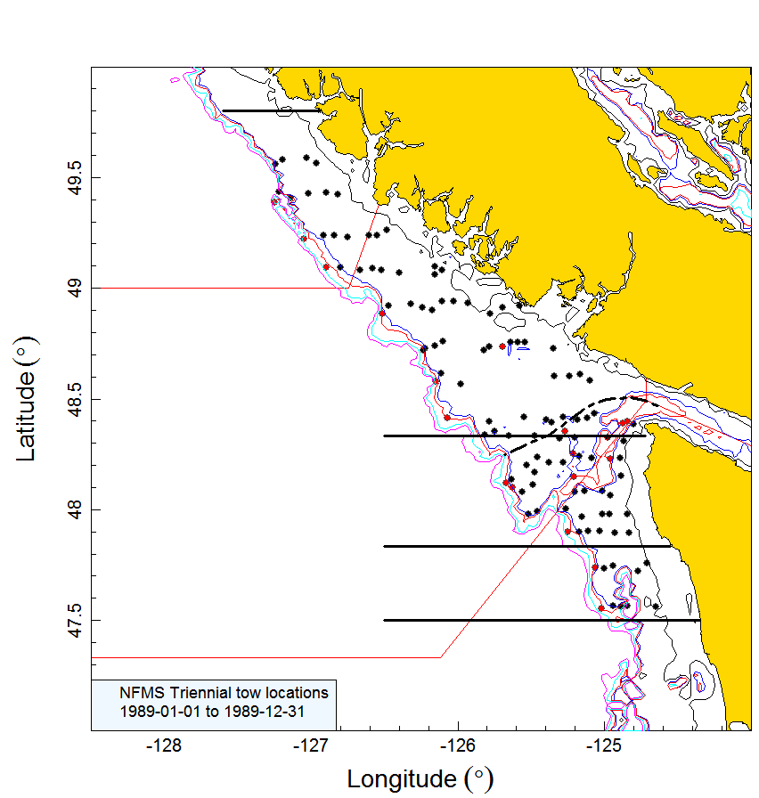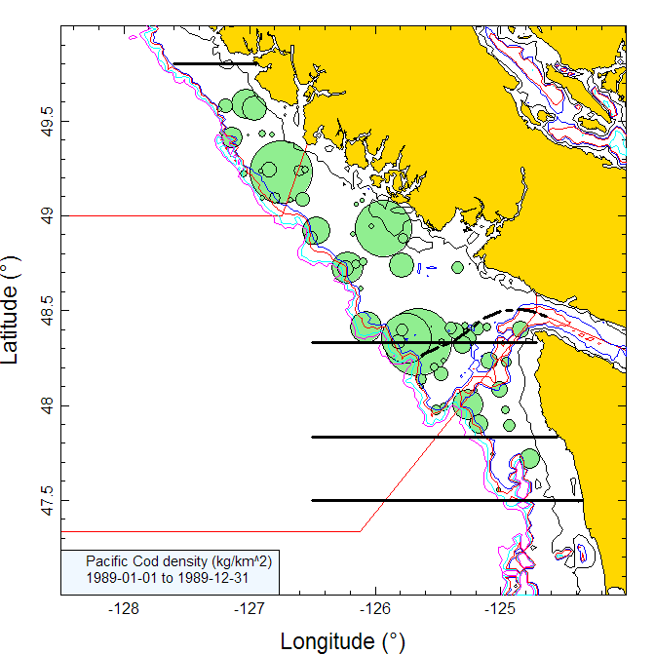
Figure B.3. Tow locations and density plots for the 1989 NMFS triennial survey in US and Canadian waters (see Figure B.1 caption).
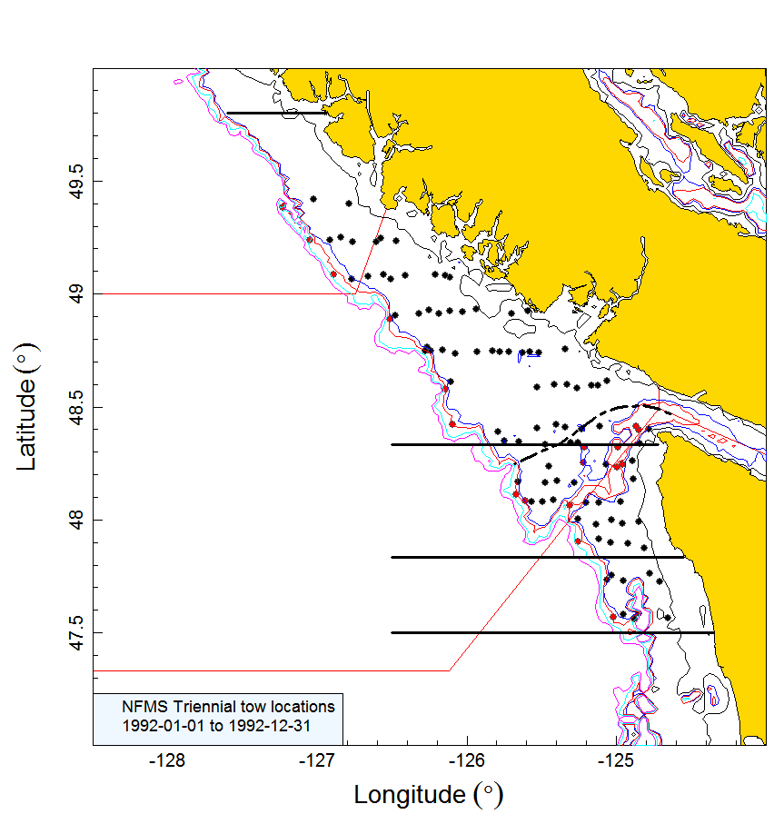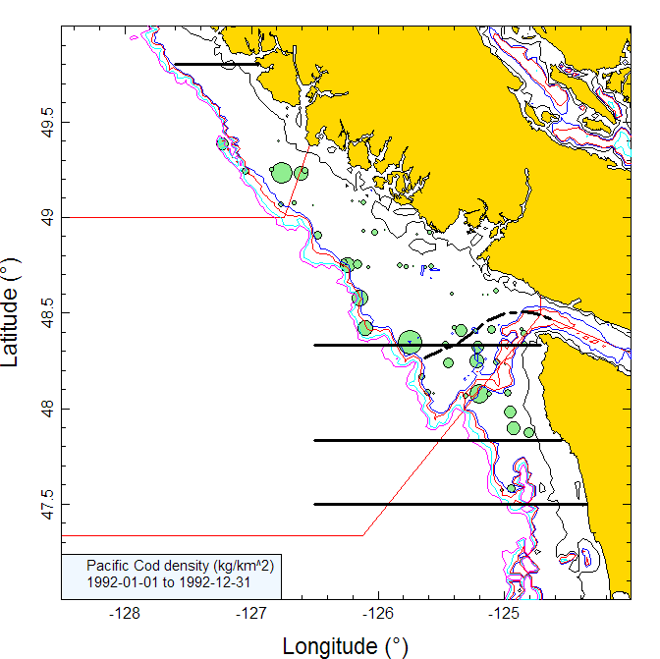
Figure B.4. Tow locations and density plots for the 1992 NMFS triennial survey in US and Canadian waters (see Figure B.1 caption).
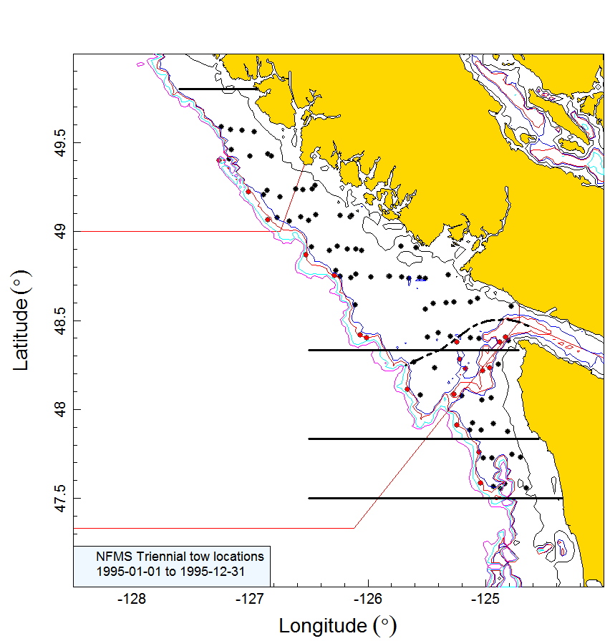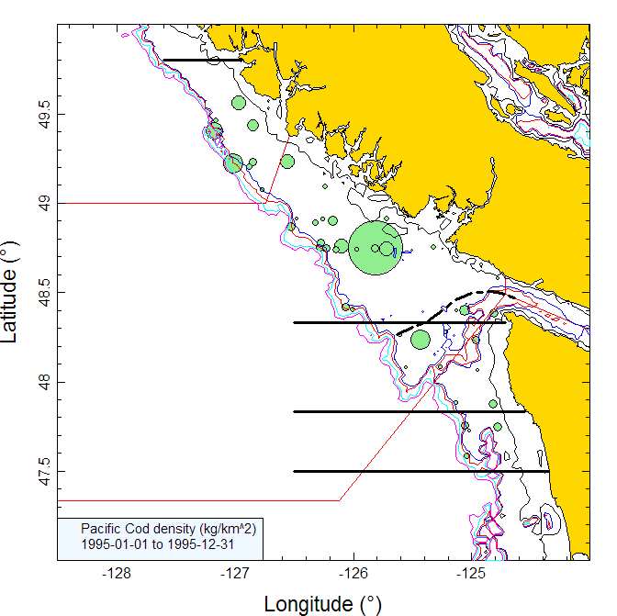
Figure B.5. Tow locations and density plots for the 1995 NMFS triennial survey in US and Canadian waters (see Figure B.1 caption).
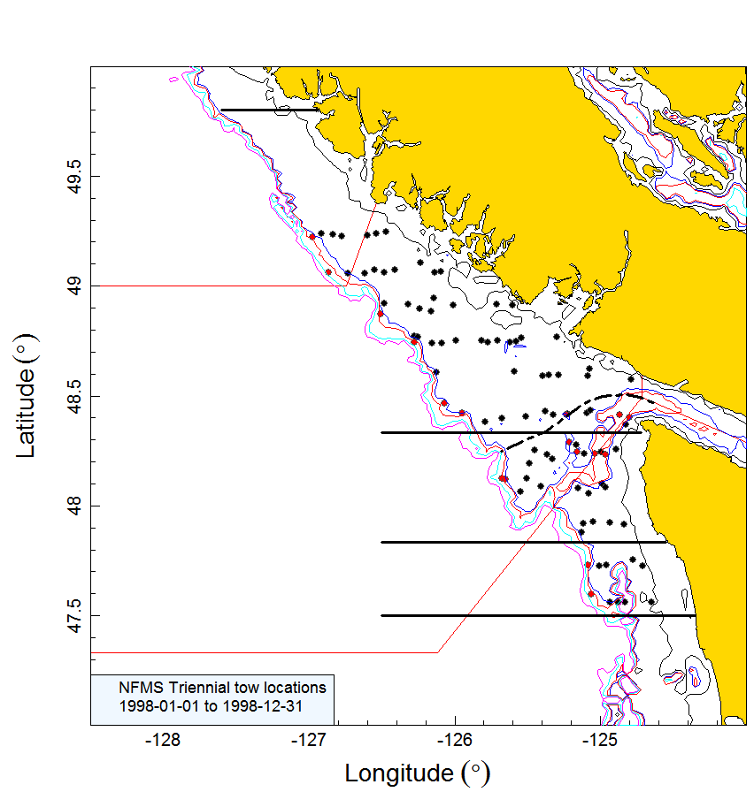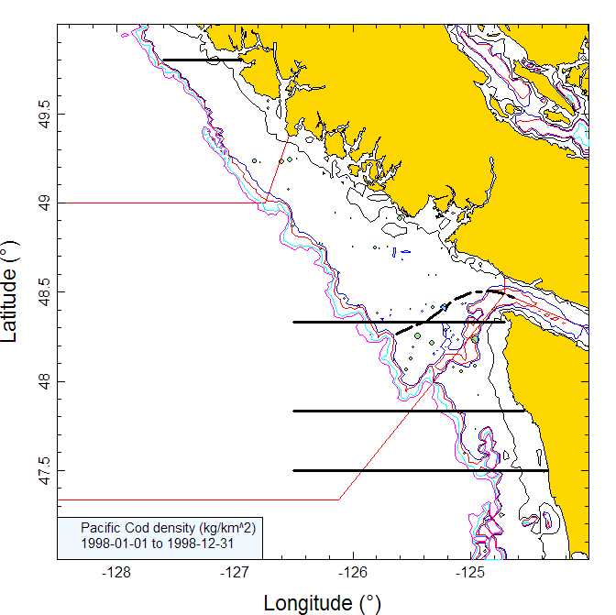
Figure B.6. Tow locations and density plots for the 1998 NMFS triennial survey in US and Canadian waters (see Figure B.1 caption).
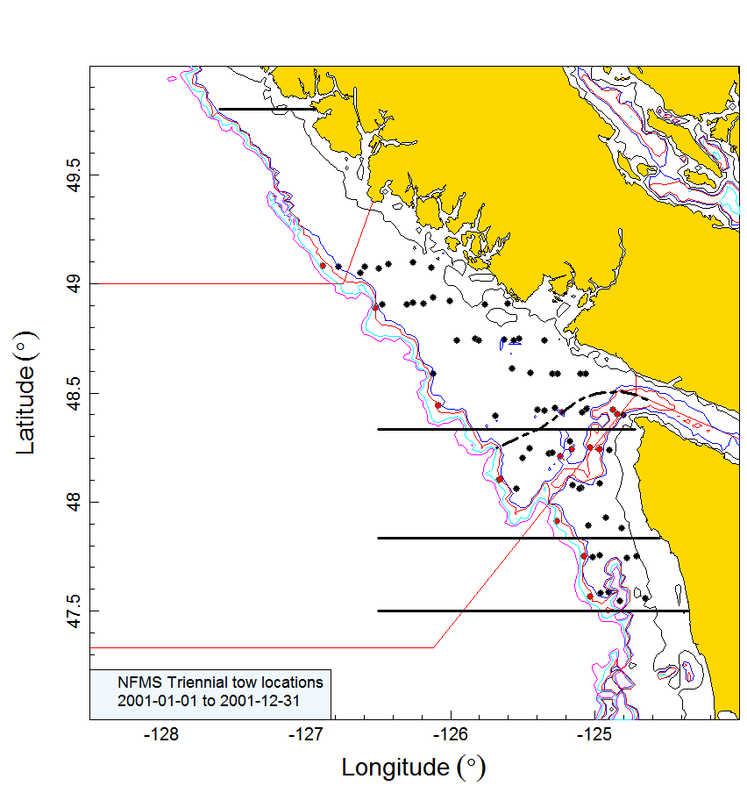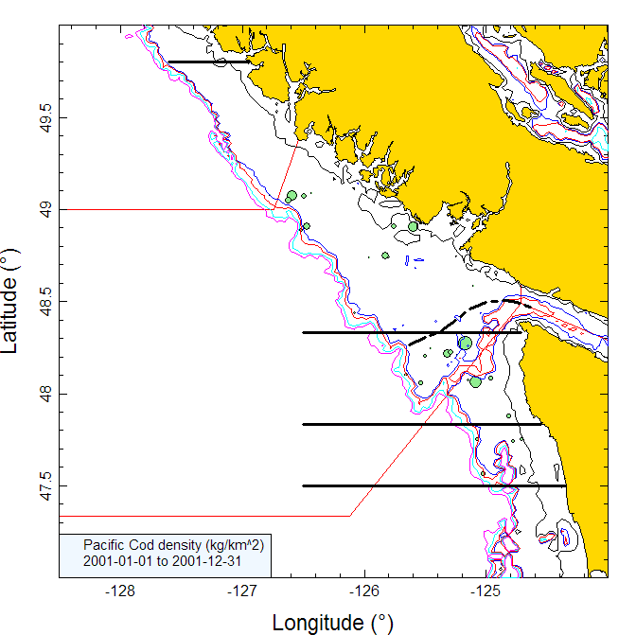
Figure B.7. Tow locations and density plots for the 2001 NMFS triennial survey in US and Canadian waters (see Figure B.1 caption).
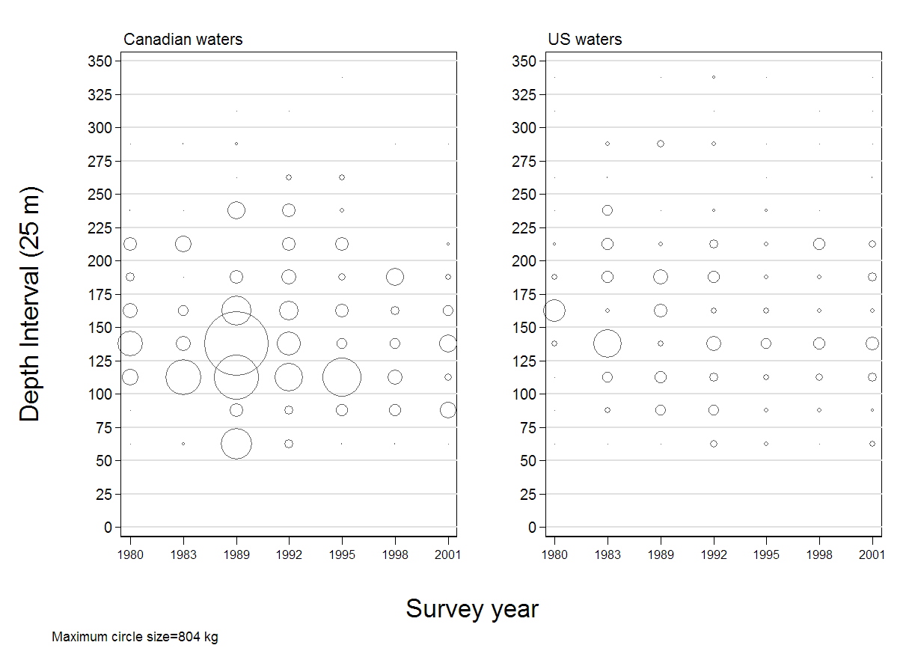
Figure B.8. Distribution of Pacific Cod catch weights for each survey year summarised into 25 m depth intervals for all tows (Table B.2) in Canadian and US waters of the Vancouver INPFC area. Catches are plotted at the mid-point of the interval. Note that the deep strata introduced in 1995 (see Table B.2) have been included in this plot but were not used in the biomass estimation.
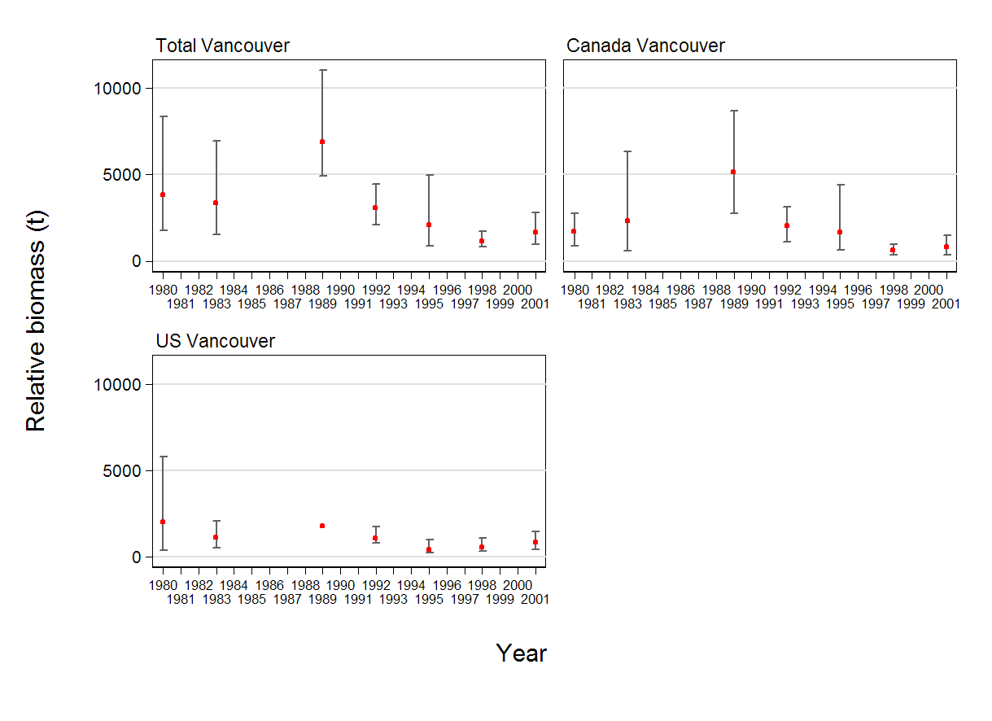
Figure B.9. Biomass estimates for three series of Pacific Cod in the INPFC Vancouver region (total region, Canadian waters only, US waters only) with 95% error bars estimated from 1000 bootstraps.
Table B.4. Biomass estimates for Pacific Cod in the Vancouver INPFC region (total region, Canadian waters only, and US waters only) with 95% confidence bounds based on the bootstrap distribution of biomass. Bootstrap estimates are based on 1000 random draws with replacement.
Estimate series | Year | Biomass  (Eq. B.4) | Mean bootstrap  biomass | Lower bound biomass | Upper bound biomass | CV  bootstrap | CV Analytic  (Eq. B.6)
Total Vancouver | 1980 | 3,842 | 3,778 | 1,775 | 8,349 | 0.41 | 0.42
Total Vancouver | 1983 | 3,386 | 3,389 | 1,522 | 6,941 | 0.41 | 0.42
Total Vancouver | 1989 | 6,923 | 5,777 | 4,943 | 11,058 | 0.28 | 0.27
Total Vancouver | 1992 | 3,097 | 2,933 | 2,077 | 4,449 | 0.21 | 0.19
Total Vancouver | 1995 | 2,077 | 2,038 | 863 | 4,985 | 0.47 | 0.45
Total Vancouver | 1998 | 1,164 | 1,100 | 836 | 1,724 | 0.18 | 0.19
Total Vancouver | 2001 | 1,653 | 1,587 | 985 | 2,791 | 0.25 | 0.25
Canada Vancouver | 1980 | 1,697 | 1,692 | 869 | 2,748 | 0.30 | 0.31
Canada Vancouver | 1983 | 2,317 | 2,307 | 609 | 6,326 | 0.60 | 0.63
Canada Vancouver | 1989 | 5,142 | 5,022 | 2,751 | 8,726 | 0.30 | 0.30
Canada Vancouver | 1992 | 2,023 | 2,011 | 1,091 | 3,119 | 0.26 | 0.26
Canada Vancouver | 1995 | 1,662 | 1,685 | 620 | 4,410 | 0.53 | 0.53
Canada Vancouver | 1998 | 631 | 623 | 369 | 975 | 0.24 | 0.26
Canada Vancouver | 2001 | 836 | 838 | 356 | 1,464 | 0.33 | 0.36
US Vancouver | 1980 | 1,993 | 1,941 | 358 | 5,792 | 0.66 | 0.67
US Vancouver | 1983 | 1,093 | 1,104 | 505 | 2,069 | 0.36 | 0.37
US Vancouver | 1989¹ | 1,782 | – | – | – | – | 0.50
US Vancouver | 1992 | 1,074 | 922 | 804 | 1,710 | 0.25 | 0.22
US Vancouver | 1995 | 415 | 353 | 221 | 969 | 0.41 | 0.37
US Vancouver | 1998 | 532 | 477 | 336 | 1,069 | 0.28 | 0.27
US Vancouver | 2001 | 817 | 749 | 433 | 1,458 | 0.34 | 0.33
¹ Bootstrap failed for US Vancouver in 1989
Pacific Cod biomass estimates in Canadian waters were higher in the three early surveys (1980 to 1989) than in US waters (Figure B.9; Table B.4). The final four surveys (1992 to 2001) in both areas were generally lower than for the first three surveys. The relative error estimates are variable, with the lowest relative error occurring at 0.18 in 1998 for Total Vancouver and the greatest at 0.66 in 1980 for the US Vancouver stratum (Table B.4). The relative error estimates for the sub-divided national strata tend to be higher than for Total Vancouver in the same years. Note that the bootstrap estimates of relative error do not include any uncertainty with respect to the ratio expansion required to make the 1980 and 1983 survey estimates comparable to the 1989 and later surveys. Therefore, it is likely that the true uncertainty for this series is greater than estimated.
Over 50% of the 664 tows used for biomass estimation captured PAC (342 tows or 51.5%). The largest tow was 804 kg in 1989. The proportion of tows which contained Pacific Cod ranged from 39% to 71% in Canadian waters and between 39% and 57% in US, with no apparent trend (Figure B.10).
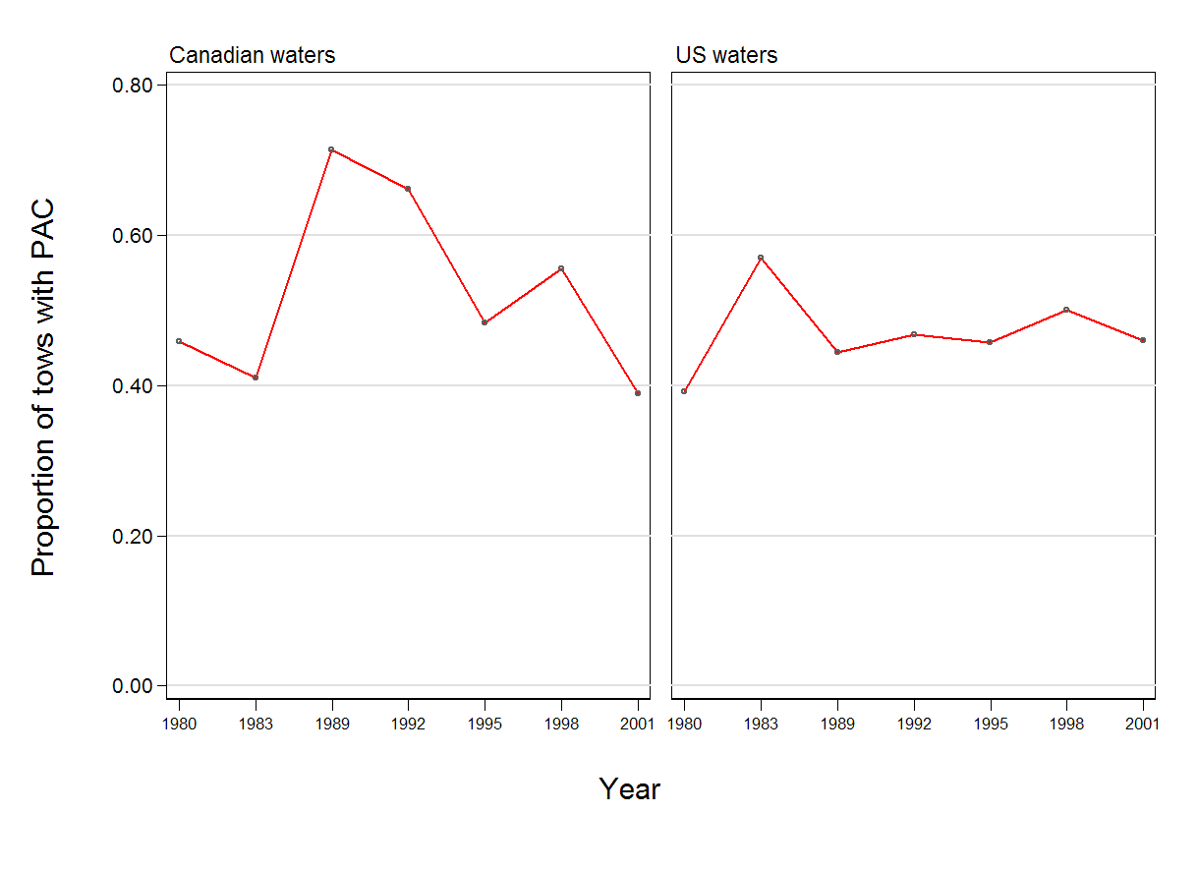
Figure B.10. Proportion of tows with Pacific Cod by year for the Vancouver INPFC region (Canadian and US waters).
  - References – Surveys
DFO. 2015. Proceedings of the Pacific regional peer review on Stock assessment for Yellowtail Rockfish (Sebastes flavidus) in British Columbia; November 18-19, 2014. DFO Can. Sci. Advis. Sec. Proceed. Ser. 2015/020.

