Cover Page

Abstract

Declaration

Acknowledgments

Table of Contents

1. **Introduction**

With the development of the economy, people's demand for tourism is growing. However, it is very difficult to plan a reasonable, economic and specific travel route in a short period of time. So this project offers a convenient and fast way to plan the travel route for the user. The user only needs to input multiple destinations and the total travelling time and then the system recommends the best travel route based on the comprehensive consideration of the travel route cost. In addition, the system will also plan the detailed route between the travel spots in the city.

* 1. **The subject matter and the scope of the investigation**

Travel route planning is to develop a route in a certain area, in order to enable visitors to get the maximum viewing effect in the shortest time and have certain characteristics. And the route is reasonably connected by a number of tourist spots or tourist cities by the traffic line.

Under the constraints of attractions, transportation expenses, travel time, and travel locations, how to choose the right and best series of attractions from a variety of attractions, and form a route for tourists to refer to. In terms of applications, it is necessary to combine attractions, itineraries, and routes and maps. When you select an attraction, you can see its location on the map. While planning the itinerary and route, you can also see the distribution of the itinerary and the direction of the route on the map.

* 1. **The purpose of the project**

It is very difficult to plan a reasonable, economic and specific travel route in a short period of time from plenty of travelling spots which can be shown in Figure 1. So this system aims to provide a convenient and fast way to plan the travel route for the user.

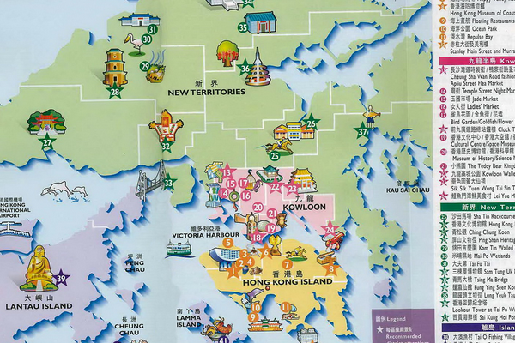

**Figure 1. Travelling Spots Diagram**

Travelling Route Generation System offers a convenient and fast way to plan the travel route.

This web-based system contains at least three shining points. The first point is the system is clean and simple to use. The user only needs to input multiple destinations and the total travelling time and then the system recommends the best travel plan based on the comprehensive consideration of the whole travel route cost. The second thing is the system is easy to customize. For example, if you do not like the hotel recommended, you can just throw away this hotel option and then the system will generate a new route includes a new hotel. Lastly, the system is fully responsive to phone and computers.

* 1. **The organization of the report**

The principle of determining the tourist route is designed according to the purpose of tourism, the physiological conditions of the tourist subject, the economic and time purchasing power of the tourists, the hobby of the tourists and the special tourism subject.

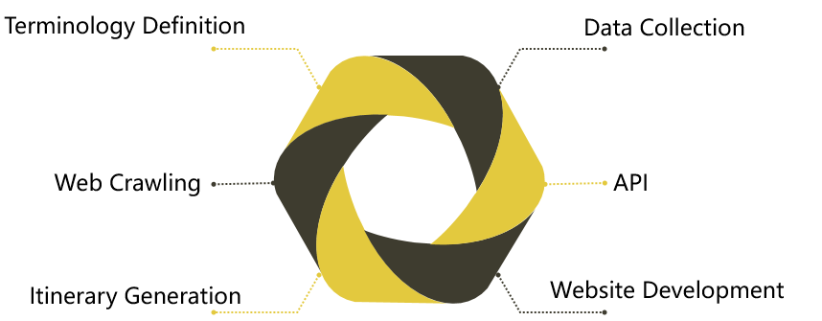

**Figure 2. Techniques used in the project**

The traditional tourist attraction recommendation is generally based on the popularity of the attraction or the recommendation algorithm for personalized recommendation, but there are few studies considering the recommendation of the top-level hot spots. In terms of travel route planning, the algorithm for considering both time and cost is still a vacancy between two different points. This paper makes up for the lack of research on the recommendation of popular tourist attractions and multi-factor travel route planning. At the same time, the system integrates the functions from the scenic spots to the route to meet the needs of tourists.

This project report is divided into five chapters, each of which reads as follows:

The first chapter introduces the background, purpose and challenge of the work of this project. And this report also illustrates related technologies, including travel itinerary planning algorithms.

The second chapter illustrates the analysis of this project.

The third chapter shows the techniques, algorithms and methodology used in the system.

The fourth chapter introduces whole Design and construction of this system.

The fifth chapter shows the algorithmic results and the presentation of the website.

The sixth part is about the analysis of the results above. And in the conclusions’ section, critical evaluation of the techniques employed and results obtained are carried out. And we also include recommendations for further investigations.

* 1. **Survey of previously published work and current trends**

The travel route planning problem is based on the evolution of the classic TSP problem. The TSP problem is a typical combinatorial optimization problem. At present, there are many researches on TSP in the world. It has been proposed based on the classical algorithm Dijk-stra algorithm, dynamic programming algorithm, branch and bound method, etc., and improved ant colony based on heuristic optimization algorithm. Algorithm, genetic algorithm, simulated annealing algorithm, tabu search algorithm, Hopfieltl neural network, particle swarm optimization algorithm, immune algorithm, etc. In recent years, the research of Chinese domestic scholars mainly focuses on the application and optimization of ant colony algorithm in route planning.

Xu proposed the encounter algorithm based on the classical ant colony algorithm in the article "Improving the application planning of ant colony algorithm in tourism route planning", which effectively improved the quality of the ant colony algorithm. In addition, Xu improved the travel path, so that the ant colony algorithm can achieve dynamic planning.

In the article "Improving the Application of TSP Model in Optimal Tourism Route Planning", Wang proposed an improved TSP model with multiple time constraints in combination with actual tour conditions (such as queuing). Xu has made reasonable adjustments and analysis in light of the various situations that may be encountered in real life.

Yang specifically designed the constraints of tourism route planning in the article "Research on the Planning of Tourism Route Planning in the National 5A Level Scenic Spots". It includes the number of holidays and time requirements for current city residents, combined with time, distance and cost.

On the basis of Yang's research, Wan improved the input variables of the whole system, including latitude and longitude coordinates, ticket fees, best travel routes and accommodation expenses, etc. in the article "Research on 5A Attractions Tourism Route Planning Problem Based on Ant Colony Algorithm". Wan uses the ant colony algorithm to propose four target benefit maximization models for comprehensive time, cost, distance and comfort which improves the accuracy of recommendation.

1. **Analysis of problem**
2. **Methodology**
3. **Design and construction of software system**
4. **Theoretical/Algorithmic/Experimental results**
5. **Analysis of results**
   1. **Analysis of data collection results**

This project uses Ctrip.com as the information source of city names, attraction names, attraction recommendation rankings and addresses.

In addition, the use of Qunar.com as the information source of the attraction time and the city information time.

The Baidu Maps API serves as a source of information for obtaining latitude and longitude data of scenic spots and cities, and routes between scenic spots.

* + 1. **Advantages**

1. Using the travel website as a data source, it is very straightforward and convenient to get the desired DIV from the HTML code of the web page.
2. Using the Baidu Maps API, we can quickly and accurately get the latitude and longitude corresponding to the address and the transit routes between the attractions.
3. The reason for choosing different travel websites as data sources is that the information of a single travelling website is incomplete and inaccurate, and multiple travel websites as information sources can ensure the accuracy of the data.
   * 1. **Disadvantages**
4. Data sources cannot guarantee reasonable travel time data. Because it is relatively subjective tourism data, it changes with people's preferences.
5. Multiple travel sites cannot guarantee the matching of special data. For example, a certain attraction can be found on the Ctrip.com, but it cannot be found on the Qunar.com.
6. Compared to the Google Maps API, the Baidu Map API ensures the normal display of transit routes. But it has lost some of display features, such as the ability to display multiple routes at the same time.
   1. **Analysis of web crawling results**

This project gets the html code directly through the page url, and then parses the html to get the required elements.

* + 1. **Advantages**

1. Separate crawler data will make the data more transparent. Therefore, developers will also feel a sense of security.
2. The data of the crawler can be directly called by the route planning algorithm, which makes the performance of the algorithm greatly improved.
   * 1. **Disadvantages**
3. Parsing html can only grab some specific data. If the page uses Ajax asynchronous requests, we can't crawl this part of the data.
4. The dependency on the page's HTML code is too large, and once the site is updated, the crawler code will fail. This requires routine maintenance and its frequent work.
   1. **Analysis of map API results**
      1. **Advantages**
5. From the perspective of most O2O developers, the role of maps can be more understood as the need for "positioning", which is to meet the "peripheral" option in the product. Baidu map API is accurate and the surrounding resources are relatively rich. This is a good fit for the needs of this project.
6. Baidu Maps API products are faster to iterate. It works well in real-world scenarios.
7. Compared to Google Maps API, Baidu Maps API can offer stable and accurate transit route in mainland China without high usage costs which cannot be offered by using Google Maps API.

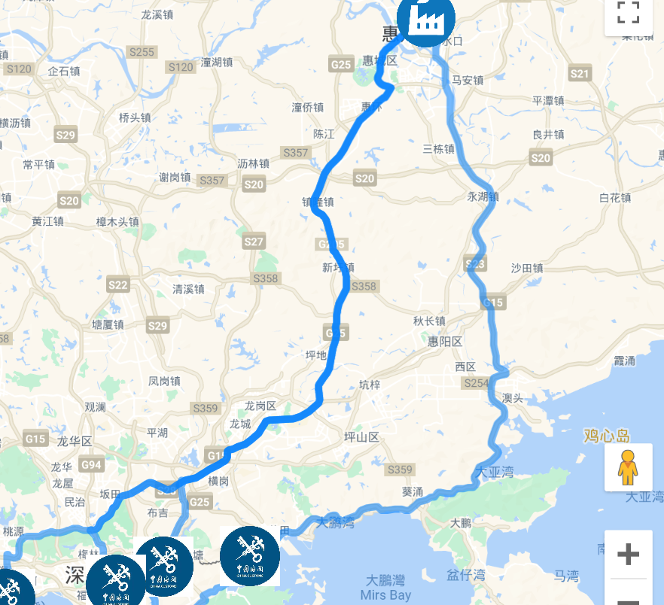

**Figure 3. Google map API**

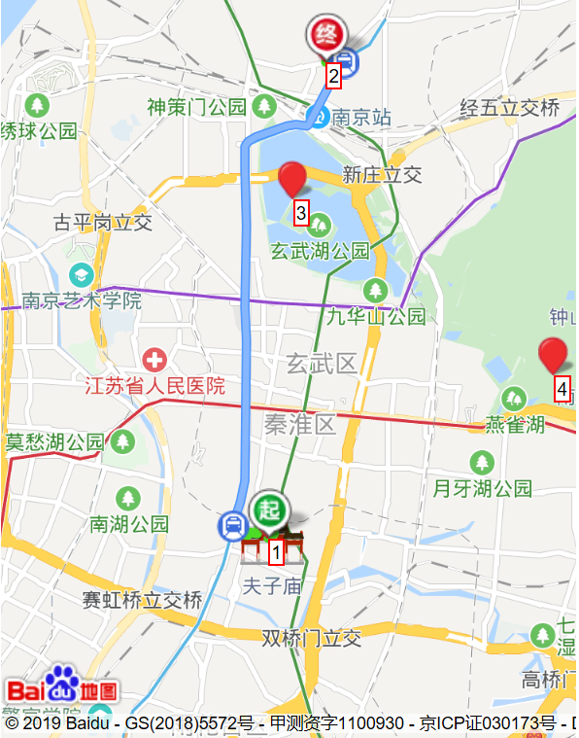

**Figure 4. Baidu map API**

* + 1. **Disadvantages**

1. Compared to the Google Maps API and the Apple Maps API, Baidu's map data system is relatively independent. It caused the data of Google Maps not to be accurately positioned on Baidu maps.
2. The source of information about the attractions of Baidu Map is unknown and unsafe. This can easily lead to bad users’ experience and even users’ complaints.
   1. **Analysis of website development results**

This project mainly uses PHP's Laravel framework. This enables the entire project to be managed by the team, and it speeds up development.

* + 1. **Advantages**

1. The framework can better organize code and files.
2. It can provide a huge amount of public code and class libraries. For example, it provides code for form validation, input and output data filtering, database abstraction, session and cookie handling, email, calendar, and paging. This greatly speeds up development.
3. For a framework, most of the filtering work can be done automatically. For example, any value passed through the database will be filtered to prevent sql injection attacks. All html can be generated automatically. It is easy to change a configuration option to encrypt a cookie.
   * 1. **Disadvantages**
4. The Laravel framework is a component-based framework. Therefore it is bloated and reduces the performance of PHP.
5. There are fewer examples of official Laravel framework documentation. It has less guidance and consideration for the Model layer. This has led to a significant increase in the time we spend on learning the framework.
   1. **Analysis of route generation algorithm results**
6. **Conclusions**

**Appendices**

**References**