PBSadmb 0.65: User’s Guide

Jon T. Schnute, Rowan Haigh, and Alex Couture-Beil

Fisheries and Oceans Canada

Science Branch, Pacific Region

Pacific Biological Station

3190 Hammond Bay Road

Nanaimo, British Columbia

V9T 6N7

2013

User’s Guide Formatted as a
Canadian Technical Report of
Fisheries and Aquatic Sciences



© Her Majesty the Queen in Right of Canada, 2013

Revised from Cat. No. Fs97-6/2674E ISSN 0706-6457

Last update: May 6, 2013

Correct citation for this publication:

Schnute, J.T., Haigh, R., and Couture-Beil, A. 2013. PBSadmb 0.65: user’s guide formatted as a Canadian Technical Report of Fisheries and Aquatic Sciences: ii + 36 p. Last updated May 6, 2013

TABLE OF CONTENTS

Abstract ii
Preface ii
1. Introduction 1
2. Using PBSadmb 3
3. The PBSadmb GUI 4
4. ADMB in action 6
5. R scripts to run ADMB 7
Acknowlegements 10
Appendix A. Installing PBSadmb 12
Appendix B. ADMB scripts 15
Appendix C. Detailed PBSadmb documentation 15
C.1. Functions in ADMB 15
C.2. PBSadmb manual 16

LIST OF TABLES
Table 1. The Report Section in vonb.tpl 8
Table 2. The report file vonb.rep produced by running vonb.exe 9
Table 3. The R source file vonb.r 9

LIST OF FIGURES
Figure 1. PBSadmb Graphical User Interface (GUI) 5
Figure 2. Fitted von Bertalanffy growth curve 11
Figure 3. Scatter plot of points from the vonb posterior distribution 12

ABSTRACT

Schnute, J.T., Haigh, R., and Couture-Beil, A. 2013. PBSadmb 0.65: user’s guide formatted as a Canadian Technical Report of Fisheries and Aquatic Sciences: ii + 36 p. Last updated May 6, 2013.

This report describes the R package PBSadmb, an R wrapper for the powerful software package ADMB (AD Model Builder, http://admb-project.org/) released into the public domain in 2009. The ADMB framework constitutes a remarkably efficient tool for estimating parameters and their uncertainty, based on complex nonlinear statistical models. Its effectiveness stems partly from the use of automatic differentiation (AD, also called algorithmic differentiation) to compute the gradient of an objective function to be minimized. It includes robust algorithms for modal estimation and Markov chain Monte Carlo (MCMC) sampling from Bayesian posterior distributions. It also supports other common inference methods, such as asymptotic covariances and likelihood profiles. With the package PBSadmb, commands to ADMB can be integrated with R commands in the same script file. We introduce standards that make it possible to preserve variable names between R scripts and ADMB template files. For example, a single R script can use ADMB to make an executable file, generate an MCMC sample, and draw a pairs plot of the results. More generally, PBSadmb allows a user to treat ADMB as just another R application, with the same interface in all supported operating systems (currently Windows, Linux, or Mac OS).

Preface

(Eventually, this section should include some colourful history of ADMB.)

User’s Guide to the R Package PBSadmb
by Jon Schnute, Rowan Haigh, and Alex Couture-Beil
Pacific Biological Station, Nanaimo, BC, Canada

1. Introduction

Perhaps only a small minority of R users know about the powerful software package ADMB (AD Model Builder, http://admb-project.org/) released into the public domain in 2009. It provides a remarkably efficient tool for estimating parameters and their uncertainty, based on complex nonlinear statistical models. Its effectiveness stems partly from the use of automatic differentiation (AD, also called algorithmic differentiation) to compute the gradient of an objective function to be minimized. It includes robust algorithms for modal estimation and Markov chain Monte Carlo (MCMC) sampling from Bayesian posterior distributions. Other common inference methods, such as asymptotic covariances and likelihood profiles, are also supported. ADMB allows you to examine your data with any statistical model that has a properly defined likelihood function or Bayesian posterior. The model can have hundreds or even thousands of unknown parameters that require estimation.

Originally, ADMB was developed commercially by its principal author David Fournier and the company Otter Research Ltd. (http://www.otter-rsch.com/). It quickly gained wide use in fishery data analyses, although it has potential value in many scientific fields. Thanks to a generous grant from the Gordon and Betty Moore Foundation (http://www.moore.org/), the ADMB Project (http://admb-project.org/) acquired rights to the software and began releasing it to the public domain in 2008. Several releases have now been completed, and many people have worked hard to make this possible. We thank all of them for their efforts and mention a few names in the Acknowledgements below. An authoritative history of ADMB remains to be written, but it would make a very colourful story for an ambitious historian of computer science who has a lively sense of humour. It involves a cast of remarkable personalities who know how to develop serious scientific tools while having a great deal of fun. Not by accident, some of the spin-off packages bear the names of New Zealand wines, such as Coleraine (http://fish.washington.edu/research/coleraine/) and Awatea (http://code.google.com/p/pbs-awatea/). Currently, PBSadmb supports ADMB version 10 or higher (we hope!).

The R software environment easily accommodates external programs. R packages routinely include C/C++ code, and the packaging system automatically compiles the code for all supported operating systems. More generally, R can connect to a wide range of software written independently. For example, the open source program ggobi (http://www.ggobi.org/, “Good pictures force the unexpected upon us”) allows users to visualize high dimensional data in a number of creative ways. This software runs independently from R, but the package rggobi allows R users to think of it as just another R application. Commands in R allow you to do anything that you could otherwise do with ggobi. To make things work, a user may need to install ggobi in the operating system of choice before installing the R package rggobi.

ADMB necessarily involves a C++ environment that cannot be entirely masked by R. The automatic differentiation algorithms, implemented with C++ classes, require a user to express the posterior or likelihood in C++. The author (Dave Fournier) had the ingenious idea of making this process as easy as possible with a template that handles most of the annoying bookkeeping, so that a user need only write code (very similar to R code) that expresses the model analytically. Program development involves three distinct steps: (1) converting the template to true C++ code, (2) compiling the C++ code, and (3) linking the resulting object module to ADMB libraries. The complete cycle makes an executable file that recognizes a variety of command line arguments. PBSadmb implements these steps with the R commands convAD (convert to C++), compAD (compile C++), and linkAD (link to libraries). A composite command makeAD performs all three steps sequentially. Another command runAD runs the executable file with specified arguments.

The native interface to ADMB differs slightly among operating systems. For example, a Windows platform uses DOS batch files, whereas a Linux system uses bash scripts. Although this doesn’t create any serious problems, it does require a bit of adjustment when moving from one system to another. The R platform, available on Windows, Linux, and MacOS X, offers a common interface that appears the same, regardless of the operating system. We have designed PBSadmb to take advantage of this fact. Consequently, a user who interacts with ADMB via R sees exactly the same interface on every platform.

PBSadmb allows a user to enter all ADMB commands in an R terminal, rather than a DOS or bash terminal. Furthermore, because R is now the language of choice, commands to ADMB can be integrated with R commands in the same script file. We introduce standards that make it possible to preserve variable names between R scripts and ADMB template files. A single R script can use ADMB to make an executable file, generate an MCMC sample, and produce a pairs plot of the results.

Although PBSadmb has the primary goal of accessing ADMB via R scripts, we also provide a Graphical User Interface (GUI) that greatly facilitates ADMB model development. New users may find it particularly helpful for editing code, testing it rapidly, and inspecting results (such as MCMC simulations). The GUI gives links to help files and examples that illustrate key aspects of ADMB model development. Use of the GUI is, however, entirely optional, and experienced users of ADMB and R may confine their applications of PBSadmb entirely to R script files. They might also find the GUI useful for configuring the software to run properly.

The initials ‘PBS’ refer to the Pacific Biological Station, a major fisheries laboratory operated by Fisheries and Oceans Canada on the Pacific coast in Nanaimo, British Columbia, Canada (http://www.pac.dfo-mpo.gc.ca/science/facilities-installations/pbs-sbp/index-eng.htm). We have developed a number of packages for R, each starting with the acronym PBS. Three of these (PBSmapping, PBSmodelling, and PBSddesolve) existed prior to PBSadmb on the Comprehensive R Archive Network (CRAN, http://cran.r-project.org/). We use Google Code web sites to maintain a source code archive for each of our packages. See http://code.google.com/p/pbs-software/ for links to all of them. In particular, http://code.google.com/p/pbs-admb/ has the source code and other information about PBSadmb.

Arguably, this package should have been called pbsADMB to put the proper emphasis on the role of ADMB. We have chosen, however, to preserve the naming style of our other packages because they tend to be closely linked. For example, PBSadmb uses numerous functions from PBSmodelling and extends many of the programming goals of that earlier package. We encourage users to try all of our packages, or at least read their descriptions.

If you are an R user who wants the freedom to build arbitrarily complex statistical models, we believe you’ll find this package an invaluable tool. Although ADMB was motivated by problems in fisheries science, professionals in many other fields (such as economics, finance, medicine, genetics, physics, and chemistry) will likely be surprised, if not astonished, at its power. We’ve written this package to help make ADMB transparent, useful, and available to a much wider audience than its traditional core in fishery science.

2. Using PBSadmb

To use PBSadmb, you first need to install it properly by the detailed procedure in Appendix A. As suggested in the introduction, this involves the two R packages PBSadmb and PBSmodelling, as well as ADMB itself. A C/C++ compiler is also required, which needs special installation on a Windows platform, but may come automatically as part of Linux or MacOS X. The GUI also requires a suitable choice of text editor.

Because this package applies to R, we assume that our readers have at least some familiarity with R itself and the standard methods of installing packages from the CRAN repository. If you are new to ADMB, you need to know that a typical project has a file prefix (*) and three associated files to hold the code (*.tpl), input data (*.dat), and initial parameter values (*.pin).

We illustrate the use of ADMB by considering a very simple estimation problem for the familiar von Bertalanffy growth curve:

(1) 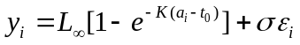, where 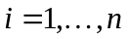.

This formula calculates observed lengths  from observed ages  and a vector 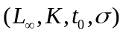 of four unknown parameters. The residuals 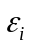 in (1) are assumed to be independent normal random variables with mean 0 and standard deviation 1. From the density function for a normal distribution, the negative log likelihood for this model is:

(2) 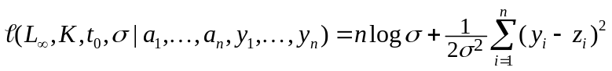,

where the predicted length at age is

(3) 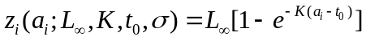.

We drop an additive constant in (2) that does not affect the analysis. The notation emphasizes that we regard as a function of the parameters for fixed values of the data.

If the ADMB prefix for this project is vonb, then the three text files vonb.tpl, vonb.dat, vonb.pin would contain, respectively:
- the code for in (2),
- the data 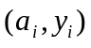 for , and
- initial values of the parameters .
This operational framework motivates the scripting language developed in PBSadmb, which includes the following commands (some mentioned previously):

convAD convert *.tpl to *.cpp,
compAD compile *.cpp to a binary object,
linkAD link the binary object with ADMB libraries and create an executable file,
makeAD convert, compile, and link to make an executable file,
runAD run an ADMB executable with specified command line arguments,
showArgs show all possible command line arguments for an ADMB executable,
runMC run an ADMB executable in MCMC mode,
plotMC plot the results of an MCMC simulation,
editAD edit text files for the current project in the text editor,
readRep read one of the standard reports generated by an ADMB executable,
startLog start a log file (*.log) of ADMB activity,
appendLog append to a log file of ADMB activity,
cleanAD remove files created by ADMB that tend to proliferate in the working directory,
convOS convert text files to the format for the operating system (Windows or Unix).

These commands illustrate the functions available in PBSadmb. For a complete list, see Appendix C.

3. The PBSadmb GUI

As we have emphasized, PBSadmb principally defines a scripting language for interacting with ADMB. However, the package ADMB itself is quite complex, and new users might find it rather intimidating. Even experienced users like us sometimes forget key details needed to accomplish certain tasks. For this reason we offer a GUI that greatly facilitates ADMB model development. In our own workshops, we have found it an invaluable tool for educational purposes.

The GUI (Figure 1) allows a user to explore all aspects of ADMB model development. The interface emphasizes four distinct phases:
- Initialize the package with appropriate paths , check that they make sense, and save them in a file normally called Adopts.txt.
- Make the executable file for a chosen prefix, with options between “Safe” and “Optimized” compilation and a choice to have random effects or not.
- Run the executable code with suitable command line arguments, where the “All args” button shows all available arguments. The interface gives particular support for generating MCMC samples and likelihood profiles. The “Custom” button supports arbitrary “AD args”.
- Inspect the Output by “View”ing various reports or “Import”ing them into the R working environment. As mentioned earlier, we give special support to MCMC samples with plots that allow a user to inspect the sampled chain. The widgets “Thin and “Var” (for “Variables”) enable a user to thin the current chain and select variables for plotting.

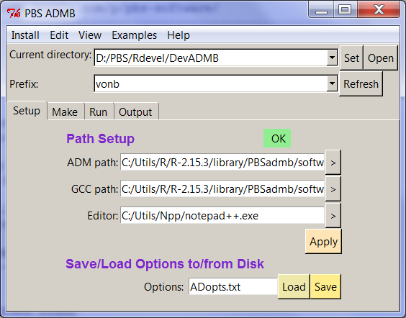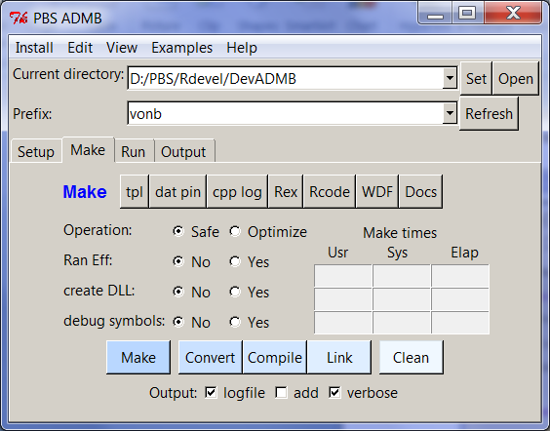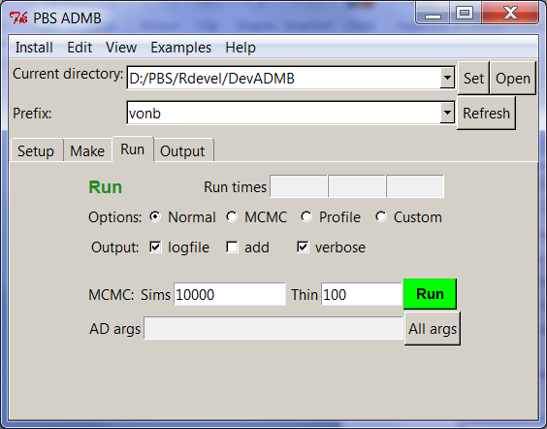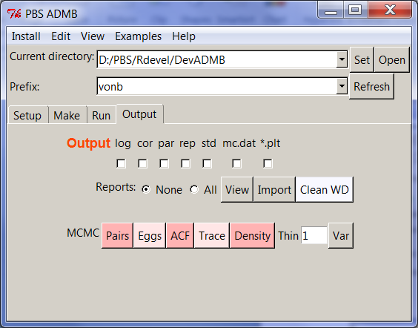

Figure 1. The graphical user interface (GUI) in PBSadmb, generated by the R command admb() on a Windows platform. The window makes use of notebook tabs: from left to right – Setup, Make, Run, and Output. Figure 1

Buttons labelled “>” in the “Initialize” and “Make” sections allow a user to browse for available choices. Text boxes in the “Make” section show the times required for converting (row 1) compiling (row 2), and linking (row 3). The R function proc.time reports the ‘user time’ and ‘system time’, as well as the elapsed time, and these correspond to the three columns in the interface. Similarly, text boxes in the “Run” section show the run times.

Experienced ADMB users know that ADMB leaves many “footprints” as files in the current working directory. The interface gives you “Clean” buttons to help clean them up. To make things easy, each “Clean” button activates a second GUI that displays potential files associated with the project prefix, as well as other debris files spawned by ADMB. The user can fine-tune the selection using the “Select” and “Deselect” buttons. When the “Clean” button is pressed, a final prompting GUI pops up to confirm deletion of the selected files. Once the files have been deleted, the Clean window remains and the user can choose another prefix (by typing manually or pressing the selection button “>”) AND hitting the “Refresh” button. This causes the GUI to rebuild itself with files having the newly selected prefix. If no additional files are apparent, the Clean window disappears. Files with suffixes .tpl, .dat, .pin, .r, and .pdf are never picked for potential deletion. Be careful when cleaning; for example don’t delete an output file until you’re sure you’re ready to do so.

After you’ve successfully installed PBSadmb, we encourage you to experiment with the GUI. You can quickly see the functionality available in the main menu items. <Edit> allows you to edit the main project files, and <View> displays the output files. <Examples> copies various examples (discussed below) into your working directory. <Package> shows the R code for this package and the Window description file used to create the GUI in Figure 1. <Help> points to manuals in the package, online resources, and this User’s Guide.

4. ADMB in action

If you’re like us, whenever you install a software package, you immediately want to see it do something. PBSadmb includes a number of examples that teach new users (and remind experienced users) how to write, test, and implement an ADMB template. To see them click <Examples> on the GUI menu. If you click one of them (the file prefix), the program will load all related files into your current working directory. Typically, these have the suffixes
- .tpl – the ADMB template file;
- .dat – the data used for this template;
- .pin – initial values for the parameter estimates;
- .r – R code that can be sourced to obtain an extended analysis using both ADMB and R;
- .pdf – documentation for this example.

When the GUI copies text files to the working directory, they automatically get converted (via the function convOS) to the correct format for the operating system, with line endings <CR><LF> in Windows and <LF> in Unix. Sometimes ADMB fails when the input files have a format inappropriate for the OS. (We encountered this problem with the ADMB command tpl2rem, called by our function convAD.) If you move files across platforms, remember that conversion might be necessary. Linux users probably have the native OS commands todos and fromdos for this purpose. Windows users can get similar utilities from the Internet.

We encourage new users to explore the examples in the following order:
simple, adapted from an example in the ADMB manual, codes the likelihood for regressing a vector y on a vector x. Take special note of how code is written for the four SECTIONs (DATA, PARAMETER, PROCEDURE, REPORT). Values initialized in the DATA_SECTION come from simple.dat, and values initialized in the PARAMETER_SECTION come from simple.pin.
simple_mc, a variant of simple, can give a Bayesian posterior sample of the parameters. The GUI allows you to perform a run with “MCMC” options (the number of simulations and the thinning frequency). You can then view results visually with plots generated from the “Output” section of the GUI.
simple_pbs, a variant of simple_mc, has a REPORT_SECTION written explicitly for PBSadmb to ensure that variable names in R code match those from ADMB. In this case, the file simple_pbs.r performs four tasks:
- making the executable file simple_pbs.exe (in Windows) or simple_pbs (in Linux) from simple_pbs.tpl,
- running the executable file,
- loading the data from simple_pbs.rep into R, while preserving variable names, and
- producing a standard regression plot for the data exported imported from simple_pbs.rep.
vonb, similar to simple_pbs, implements the estimation problem posed by equations (1)–(3) in Section 2. It can also generate a likelihood profile for the parameter Linf, renamed for this purpose as VonBLinf. In this case, ADMB generates a file named VonBLinf.plt, with the parameter name prefix, not the prefix vonb.
catage, taken from ADMB web sites, implements a more complex model designed for estimating biological parameters from fishery data on catch and age structure. In the case, the code allows a user to compute a likelihood profile for the predicted biomass pred_B.
pheno, also taken from ADMB web sites, implements a model with the “random effects” feature. The lines declaring a random_effects_vector play a role similar to init_vector in earlier examples, except that the estimation method for random effects variables works differently (and much more slowly). The file pheno.pin includes initial values for the two random effects vectors declared in pheno.tpl.

5. R scripts to run ADMB

The examples simple_pbs and vonb both contain R files (*.r) that illustrate the use of R scripts to code ADMB analyses in R. We focus here on the vonb example. Table 1 shows the Report Section in the model template. It writes variable names (preceded by $) and variable values. Running the executable file produces the report file vonb.rep listed in Table 2. This file has “PBS format”, defined in the package PBSmodelling. Think of it as an R list object with named components.

Once you understand the relationship between the Report Section in Table 1 and the report file in Table 2, examine the R code in Table 3. It produces the plot in Figure 2, based entirely on data exported from the ADMB model. The functions readList and unpackList from PBSmodelling produce R variables with the same names as corresponding variables in the template file, given the structure of the Report Section in Table 1. This technique represents a standard in PBSadmb for writing ADMB template code to ensure variables with identical names and values in the R environment. Just write the Report Section to export both names and values, as illustrated in Table 1.

Table 1. The Report Section in vonb.tpl. It generates a report file vonb.rep that contains both variable names and values for easy import into the R environment. This technique ensures variables with common names and values in both ADMB and R. Table 1
REPORT_SECTION
report << "$Linf" << endl;
report << Linf << endl;
report << "$K" << endl;
report << K << endl;
report << "$t0" << endl;
report << t0 << endl;
report << "$sigma" << endl;
report << sigma << endl;
report << "$fval" << endl;
report << fval << endl;
report << "$age" << endl;
report << age << endl;
report << "$y" << endl;
report << y << endl;
report << "$ypred" << endl;
report << ypred << endl;
report << "$mcnames" << endl;
report << "Linf K t0 sigma LK fval" << endl;
report << "$mcest" << endl;
report << Linf << " " << K << " " << t0 << " " << sigma << " "
<< LK << " " << fval << endl;

Table 2. The report file vonb.rep produced by running vonb.exe. To fit in the space available on this page, the vectors y and ypred have been truncated. The file represents an R list with named components. Table 2
$Linf
57.2689
$K
0.164044
$t0
0.152865
$sigma
0.492146
$fval
-3.34367
$age
1 2 3 4 5 6 7 8 9 10 11 12 13 14 15 16
$y
7.36 14.3 21.8 27.6 31.5 35.3 39 41.1 43.8 45.1 ...
$ypred
7.43029 14.9707 21.3702 26.8015 31.4111 35.3233 ...
$mcnames
Linf K t0 sigma LK fval
$mcest
57.2689 0.164044 0.152865 0.492146 9.39464 -3.34367

Table 3. The R source file vonb.r. In the R console, the command source("vonb.r") initializes PBSadmb from a file Adopts.txt (presumably available and correct), makes vonb.exe from vonb.tpl, generates the plot in Figure 2, and compares results computed independently by ADMB and R. Table 3
# Initialize
require(PBSmodelling); require(PBSadmb); readADopts("Adopts.txt")

# Make and run "vonb.exe"
makeAD("vonb"); runAD("vonb");

# Read and unpack the report;
# i.e., create R variables with the same names used in "vonb.tpl"
vonb <- readList("vonb.rep"); unpackList(vonb);

# Plot the data
plot(age,y); lines(age,ypred,col="red",lwd=2);

# Check the calculations in R
ypredR <- Linf*(1-exp(-K*(age-t0)));
nobs <- length(age);
fvalR <- nobs*log(sigma) + sum((ypredR-y)^2)/(2.0*sigma^2)

cat("Functions values (ADMB & R):\n");
cat(fval," ",fvalR,"\n")

cat("Predictions (ADMB & R):\n");
cat(ypred,"\n");
cat(ypredR,"\n");

The code in Table 3 can be supplemented by two simple commands:
> runMC("vonb",100000,100)
> plotMC("vonb")
to give the Bayesian posterior scatter plot shown in Figure 3. The first line runs 100,000 simulations, thinning to keep only 1 of every 100 results. The second line plots the 1,000 points that result from this calculation. The following lines from the Report Section (Table 1) play a key role in producing Figure 3:
report << "$mcnames" << endl;
report << "Linf K t0 sigma LK fval" << endl;
report << "$mcest" << endl;
report << Linf << " " << K << " " << t0 << " " << sigma << " "
<< LK << " " << fval << endl;

by communicating the names of the variables preserved in the MCMC simulation ($mcnames) and their values at the posterior mode ($mcest). These provide the graph with variable names along the diagonal and coordinates of the mode, shown as a red point corresponding to the minimum (fval).

The results in Figure 3 can also be obtained directly from the GUI. Furthermore, plotMC can also draw a variety of plots, as indicated by the five coloured buttons along the bottom line of the GUI. Try them!

Acknowlegements

Our intrepid programmer, Alex Couture-Beil, greatly assisted the development of PBSadmb by improving its integration with PBSmodelling. In some cases, this meant changing PBSmodelling to enhance support for external packages. We thank all members of the ADMB community for their efforts on the open source project, particularly Dave Fournier, John Sibert, Mark Maunder, and Johnoel Ancheta. Ian Taylor helped us experiment with early conversions of PBSadmb from Windows to Linux. Saang-Yuan Hyun conducted tests and made a number of helpful suggestions. Andy Edwards generously contributed funding to support programming expenses.

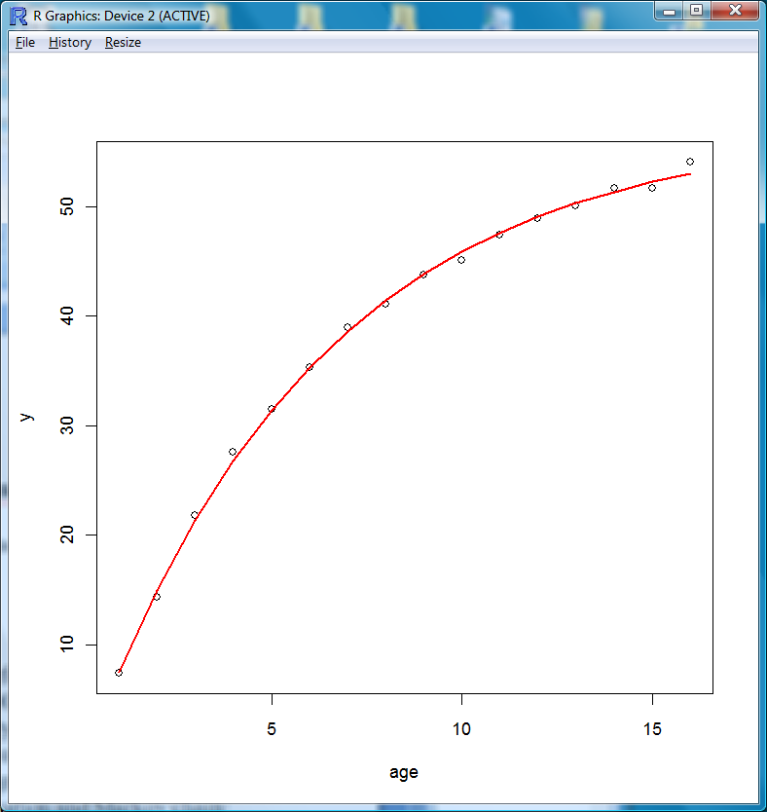
Figure 2. Plot of data points and a fitted von Bertalanffy growth curve, obtained by sourcing the R code in Table 3. The data portrayed here come entirely from the ADMB model. The source code compares these numbers with independent calculations in R. Figure 2

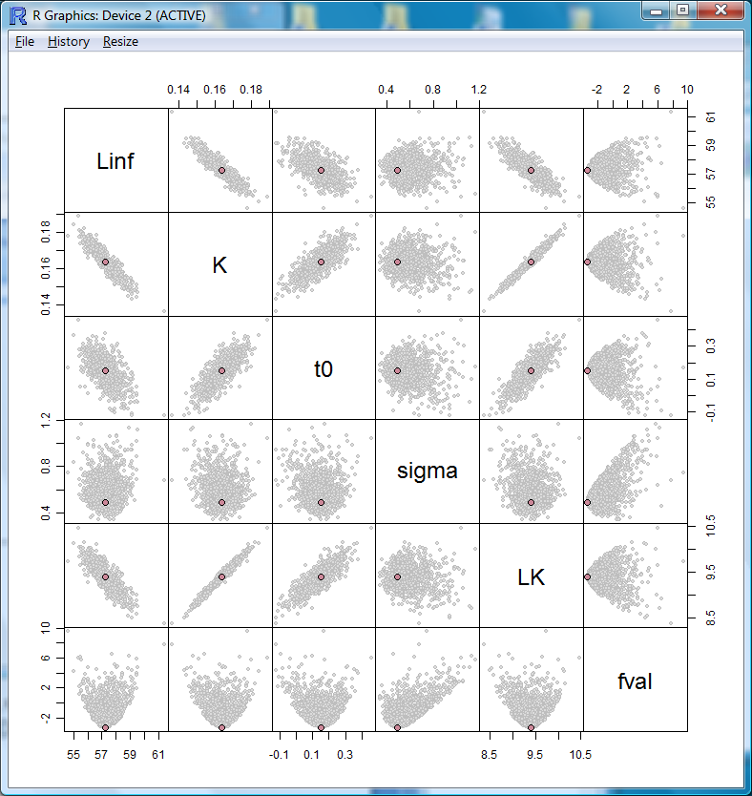
Figure 3. Scatter plot of 1,000 points from the vonb posterior distribution, generated by the code in vonb.r and the two additional commands: runMC("vonb",100000,100); plotMC("vonb"). The red point indicates the posterior mode, where fval is minimized. The variables labelled Linf, K, t0, sigma, LK, and fval represent 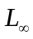, K, , , the product 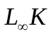, and , respectively. Figure 3

Appendix A. Installing PBSadmb

As for most R packages, installation of PBSadmb is fairly easy. Unfortunately, this one requires other software as well, so please be patient while going through all the required steps. Essentially, you need to install R, PBSmodelling, PBSadmb, a C/C++ compiler (which normally comes installed on a Unix platform), and a text editor suitable for writing templates and viewing reports. Then you need to run R, load PBSadmb, and give it some configuration information. At this point, you should have a working version of the interface in Figure 1. Here are the details.

Step 1. Install the current version of R for your operating system from a package manager or the CRAN web site http://cran.r-project.org/. For fast downloads, choose a mirror near you. We assume that you have enough familiarity with R to do this without difficulty. If you have a version of R already installed, update it to the current version (R 2.15.3 at the time of revising this report) if necessary.

Step 2. Run R and install current versions of the packages PBSmodelling and PBSadmb. Ideally, both of these should be available on CRAN, but we also plan to keep current versions of Windows binary (*.zip) and package source (*.tar.gz) files on our web sites:
http://code.google.com/p/pbs-modelling/ for PBSmodelling,
http://code.google.com/p/pbs-admb/ for PBSadmb.
In Windows, you can install packages from the R GUI, but on all systems you can use the command install.packages().

Step 3 (Windows). Next you need to install a suitable C++ compiler for Windows, along with a corresponding version of the ADMB package. In the current implementation of PBSadmb, we make this step easy by using the GUI (Figure 1, Setup tab). Select the menu item Install and then the (only available) choice ADMB and MinGW for Windows. This gives the interactive window shown below, where the default paths for these two packages lie in the software directory of the R library for PBSadmb. You can choose other directories with the "..." buttons.
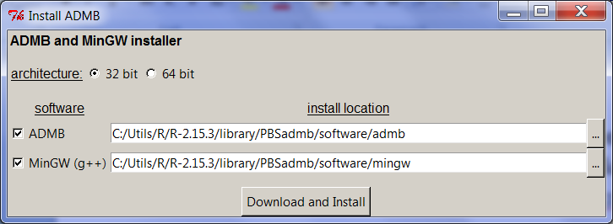
The files used for this installation are archived on our Google code site at http://code.google.com/p/pbs-admb/downloads/list, as referenced in the file versions.txt.
Please note that we do not support other compilers such as those by Borland or Microsoft. Users interested in such a compiler need to ensure that it is properly installed, along with corresponding version of ADMB. Correct paths must also be specified in the configuration file (by default ADopts.txt).

Step 3 (Linux or MacOS X). If you have a Unix system, hopefully you already have compiler support for C/C++. To check this, open a bash terminal window and type
g++ --version
Hopefully, you’ll see a result like
g++ (Ubuntu 4.3.3-5ubuntu4) 4.3.3
You also need to know where the executable g++ is located. On our Ubuntu system, it’s in the directory /usr/bin/, but you may to go to the root directory (cd /) and run a command (whereis g++) to find the path.
You also need to obtain ADMB for your system. Start at the "Downloads" page: http://www.admb-project.org/downloads and look for support for your operating system. The most reliable method will probably come from downloading the full source distribution and following the instructions to build and install the package from source. That way, you guarantee that the binary version of ADMB matches the compiler on your system. You also need to find the path to the installed version of ADMB.
Step 4. Obtain a good text editor that you can use for code development. On Windows, the Notepad will work, but much better options are available. Currently, we recommend Notepad++, available free at http://notepad-plus-plus.org/. Other colleagues have used the Crimson Editor (http://www.crimsoneditor.com/) or Tinn-R (http://www.sciviews.org/Tinn-R/). Ideally, use an editor that supports syntax highlighting and displays multiple files in a single window, with tabs to select among them.

On Linux systems, gedit seems to work reasonably well. In Mac OS X, you might consider using TextWrangler available free at http://www.barebones.com/products/textwrangler/download.html.

Step 6. Run R in an empty working directory. Then type these two commands into the R console:
> require(PBSadmb)
> admb()
The GUI should appear at the Setup tab, probably with a red field Fix and a warning message about missing files. You can use the GUI to set the three required paths, always using the Unix syntax in which the forward slash / (rather than the Windows backslash \) separates subdirectories.
- The “ADM path” should refer to the directory with the installed ADMB binary version. Typically it includes a few files (such as LICENSE and README.txt) and several subdirectories, including bin, include, and lib.
- The “GCC Path” should be the path discussed in Step 3. It should include a bin subdirectory with the file g++.exe.
- The “Editor” should be the complete path to executable file for the editor chosen in Step 4, such as C:/Utils/Npp/notepad++.exe.
You can use the buttons labelled “>” to navigate to the appropriate directories or files.
Step 7. Click the Apply button. If everything is OK, the red Fix should be replaced by a green OK. If Fix persists, then something essential can’t be found on the paths you’ve specified. Either you haven’t installed something correctly, or one of the paths is wrong.

When everything is OK, click Save to save your options in a text file in your current working directory, with the default name ADopts.txt. You can inspect it with the text editor. Potentially, you can have multiple options files that point to different text editors or different compilers (e.g., 32 bit or 64 bit).

In the future, when you issue the R command admb() with this working directory, the file Adopts.txt will automatically determine the paths in the GUI. Furthermore, you can copy this file to any other directory from which you want to use PBSadmb. Conceivably, you might use different option files for projects in different directories.

Appendix B. ADMB scripts

As we have discussed, ADMB involves the three basic operations convAD, compAD, and linkAD to convert, compile, and link a template file. These are implemented in ADMB with scripts written as batch files for Windows or bash files for Unix. The scripts generally have the file prefix as an argument, along with other arguments that determine compilation options like safe or optimized code. The Make tab of the PBSadmb GUI has radio buttons that support four binary alternatives – safe or optimized code, normal or random effects model, create .exe or .dll, and include debugging symbols or not.

Appendix C. Detailed PBSadmb documentation

C.1. Functions in ADMB

The list of functions in this section comes from the PBSmodelling command
> viewCode("PBSadmb",output=2)

Function Description
admb Start the PBS ADMB GUI
appendLog Append Data to Log File
checkADopts Check ADMB Options for Link Integrity
cleanAD Clean ADMB-Generated Files from the Working Directory
compAD Compile C Code
convAD Convert TPL Code to CPP Code
convOS Convert Text Files to Default OS Format
copyFiles Copy System Files
editAD Edit ADMB Files
editADfile Edit a File
installADMB Install windows admb binary (for gcc)
linkAD Link Object Files to Make an Executable
makeAD Make an Executable Binary File from a C File
makeADopts Creates the ADMB Options List
plotMC Plot Results of MCMC Simulation
readADopts Reads an ADMB Options List into Memory From a File
readRep Read an ADMB Report into R Memory
runAD Run an Executable Binary File
runMC Run an Executable Binary File in MCMC Mode
setADMBPath Creates the ADMB Options List
showADargs Show All Arguments for an ADMB Executable
startLog Start a Log File
writeADopts Writes the ADMB Options List from Memory to a File

C.2. PBSadmb manual

The following pages show the standard R manual for PBSadmb, including help pages for all objects, a table of contents, and an index. This manual also appears on the CRAN web site: http://cran.r-project.org/web/packages/PBSadmb/index.html. (Or from CRAN’s root, locate “Packages” and find “PBSmodelling”.)

For a description of the method used to generate the pages that follow, see Appendix D.2 of the PBSmodelling User’s Guide included with PBSmodelling.

This page intentionally left blank.

