A User’s Guide to the R Package “PBSddesolve”
Version 1.10 – May 8, 2013

Jon T. Schnute, Alex Couture-Beil, and Rowan Haigh

1. Introduction

The R package PBSddesolve generates numerical solutions for systems of delay differential equations (DDEs) and ordinary differential equations (ODEs). The numerical routines come from Simon Wood’s program solve95 (http://www.maths.bath.ac.uk/~sw283/simon/dde.html, file: solv95.zip), originally written in C for the Microsoft Windows operating systems. With PBSddesolve, a user can write the gradient code for a system of DDEs or ODEs in the R language, rather than C. The code will then run on all platforms supported by R, and the results can be inspected using R’s extensive graphics capabilities. Simon has very generously given us permission to publish PBSddesolve (including his embedded routines) under the GNU GENERAL PUBLIC LICENSE Version 2 or greater.

For more information about Simon and his work at the University of Bath (Bath, United Kingdom), see his home page http://www.maths.bath.ac.uk/~sw283/index.html. He has recently published a book about Generalized Additive Models (GAMs; Wood 2006) with two supporting R libraries gamair and mgcv, both available on the Comprehensive R Archive Network (CRAN, http://cran.r-project.org/). The first example in his book presents data from the Hubble Space Telescope and an analysis from Hubble’s law that suggests the universe is about 13 billion years old. If this example piques your interest, install gamair from CRAN, and run the R code:

require(gamair)
data(hubble)
plot(hubble)

to see the distance x and velocity y relative to the earth for each of 24 galaxies. The relationship 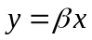 determines Hubble’s constant 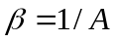, where A is the age of the universe. See Simon’s book for further details about this interesting estimation problem.

We originally noticed the solv95 program in the context of a Python implementation called PyDdDE by Ben Cairns at the School of Biological Sciences, University of Bristol (UK), now at the University of Oxford (http://users.ox.ac.uk/~clme1073/python/PyDDE/). For more information about Ben, see his website at http://users.ox.ac.uk/~clme1073/index.shtml. We have designed PBSddesolve from solv95 to perform similarly to the earlier R package odesolve (now called deSolve), written by R. Woodrow Setzer and Thomas Petzoldt with Fortran algorithms (notably lsoda) by Linda Petzold and Alan Hindmarsh at the Lawrence Livermore National Laboratory in Livermore, California.

At the time we wrote PBSddesolve, no other R package dealt with delay differential equations, but deSolve now includes the function dede as an alternative solver. Our users report that this function sometimes gives better performance than dde in PBSddesolve. Probably this improvement results from a better starting point with the robust algorithm lsoda, to which Karline Soetaert has added the functions lagvalue and lagderiv. We thank all contributors to deSolve for their excellent work on this problem, and we encourage our users to test this alternative.

The history of PBSddesolve illustrates the advantages of open source software. Jon (author JTS above) wanted to use R to solve delay differential equations. He knew about another implementation in the commercial package Matlab® (http://www.mathworks.com/), based on the function dde23 (Shampine and Thomson 2000). Our programming wizard Alex (author ACB) looked at the code and thought it might be tricky to implement in R, partly because dde23 was in Fortran and we knew more about the interface between R and C. Then Alex discovered PyDDE and solv95, and he obtained Simon’s permission (and encouragement) to implement it in R. Based on his experience with another package PBSmodelling (Schnute et al. 2006), Alex quickly altered calls in the solv95 C code to get values of the gradient from an R function. When Ben tried our initial R package, he liked it, but he wanted to obtain solutions at specified times, rather than the slightly irregular times generated by Simon’s code. So Ben changed the C source code, using Simon’s interpolation algorithms to get interpolated values at definite times. As a final touch, Alex implemented another feature of Simon’s code called “switches”, discussed below.

The demos included with PBSddesolve require PBSmodelling version 2.65 or later (http://cran.r-project.org/web/packages/PBSmodelling/index.html). Although the numerical routines in PBSddesolve work without this extra package, PBSmodelling adds user interfaces that make it easier to experience and understand the operation of PBSddesolve. PBSddesolve originally appeared on CRAN under the name ddesolve. That version is no longer supported. The current name emphasizes a close association with other packages developed at the Pacific Biological Station (PBS) in Nanaimo, British Columbia.

2. Defining DDEs

To define a system of DDEs, a user must supply an R function that calculates the gradient of each variable in the system with respect to time. This gradient function must have one of the following two forms:
gradfunc(t,y) or gradfunc(t,y,parms)
where t = the current time of integration;
y = a vector of estimated state values at time t;
parms = an optional R object (such as a vector, list, or data frame) of additional
input parameters for the DDE system.
The length n of the vector y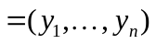 corresponds to the number of states in the system, where 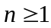.

The function gradfunc must calculate the derivative 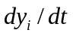 for each variable  (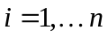) and return the derivative values in one of the following two formats:
a vector of n derivatives , or
a list in which the first element comprises a vector of n derivatives, and the second element comprises a numeric vector with additional values (of interest to the user) calculated within gradfunc at time t.
Consistent with the idea of delay differential equations, gradfunc can also depend on state values and their derivatives at times prior to the current time t. These must be accessed with calls to pastvalue() and pastgradient(). Both functions take a single argument, a time 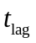 in the range 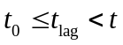, where is the starting time of integration and is the current time. The functions return a numeric vector of length n, where pastvalue(tlag) and pastgradient(tlag) have the components 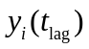 and 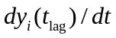, respectively, for 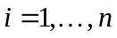. Usually, 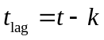 is calculated as a fixed offset k back from the current time t; and a typical call might have the form pastvalue(t-k). The calculation of gradfunc can involve numerous past values and gradients at various different time lags.

Wood (1999) also introduced the concept of switches that allow the DDE system to produce discontinuous changes in the state vector y. To implement k switches (i.e., k conditions in which the state vector can be discontinuous) with 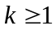, a user needs to define two functions:
switchfunc(t,y) or switchfunc(t,y,parms), which returns a numeric vector of length k; and
mapfunc(t,y,sid) or mapfunc(t,y,sid,parms), which depends on a switch id number (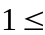 sid 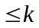) and returns a numeric vector of length n.
These functions specify, respectively, the circumstances that trigger a switch and the behaviour of the system when a switch occurs. Think of switchfunc defined by a vector of k functions 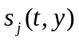 with 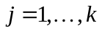. Switch j takes place when 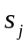 vanishes due to a change from positive to negative values (mathematically 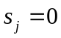 and 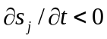, where the symbol denotes partial differentiation). At a time t when switch j is triggered, dde automatically calls mapfunc with sid = j. Our “ice cream” demo in Section 4 below illustrates the process of writing code that includes switches.

3. Solving DDEs

Simon Wood’s (1999) numerical routines produce the core functionality of PBSddesolve. The function

dde(y, times, func, parms=NULL, switchfunc=NULL, mapfunc=NULL, tol=1e-08, dt=0.1, hbsize=10000)

invokes the C routines used to numerically solve systems of DDEs, where

y = a vector of initial values for the states (this also determines n);
times = a numeric vector of explicit times at which the solution should be obtained;
func = a gradient function written to the specifications of gradfunc in Section 2;
parms = an optional vector of parameters to pass to func;
switchfunc = an optional function that determines conditions when the DDE system experiences switches, as describe in Section 2;
mapfunc = an optional function associated with switchfunc that describes how the DDE system changes (possibly discontinuously) at switch times;
tol = a scalar that sets the maximum error tolerated in the solution;
dt = the maximum initial time step used in constructing the numerical solution;
hbsize = history buffer size required for retaining lagged state variable values;
For consistency with the package deSolve, the argument name func corresponds to the system gradient function.

The return value of dde depends on the output format of the gradient, i.e., options (1) or (2) for the output of gradfunc in Section 2. With format (1), dde returns a data frame with 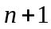 columns and default column names t, y1, y2, ..., yn. The first column represents the times at which the solution is reported (times , plus any additional times specified by switchfunc) and the remaining n columns contain the components of y estimated at these times. The default column names for these n columns are overridden by names(y) if the initial vector y has a names attribute. If gradfunc has format (2), then the data frame returned by dde is extend by an additional m columns, where m is the length of the vector of additional values reported by gradfunc. By default, these have column names extra1, extra2, ..., extram. The names can be overridden by assigning a names attribute to the vector of additional information returned by gradfunc, i.e., the second component of the list output from gradfunc.

In summary, an application of PBSddesolve can include three user-defined functions:
- myGrad(t,y) or myGrad(t,y,parms),
- mySwitch(t,y) or mySwitch(t,y,parms),
- myMap(t,y,sid) or myMap(t,y,sid,parms),
as well as a call to dde:
- dde(y, times, func=myGrad, parms, switchfunc=mySwitch, mapfunc=myMap, tol=1e-08, dt=0.1, hbsize=10000)
The gradient function must be defined, but the switch and map functions are optional (either both or neither). Similarly, the code may or may not involve an R object parms of parameters kept constant during the integration. The gradient function can call the predefined functions pastvalue(tlag) and pastgradient(tlag) to obtain lagged values of the state variables and their derivatives.

Remember that the gradient, switch, and map functions are called internally by dde; consequently, the argument list must precisely correspond to one of the prototypes listed at the start of the previous paragraph. Values of the arguments, t, y, sid, and parms will be set by dde when these functions are called. By default, parms=NULL, so that the user’s functions should not depend on parms unless a value of parms is explicitly specified in the call to dde. Typically, parms might be a vector or list with named components.

4. Demos

The PBSddesolve package currently includes four demos that illustrate simple applications. As mentioned in Section 1, these require the R package PBSmodelling (version 2.65 or later) to create graphical user interfaces (GUIs) that aid model testing and exploration. Once PBSmodelling is installed and loaded with require(PBSmodelling), call the function runDemos(), select PBSddesolve, and then choose one of the available demos. Alternatively, run R’s native demo() function in lieu of runDemos().

4.1. Cooling - Newton’s Law of Cooling (ODE Example)

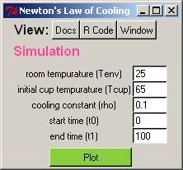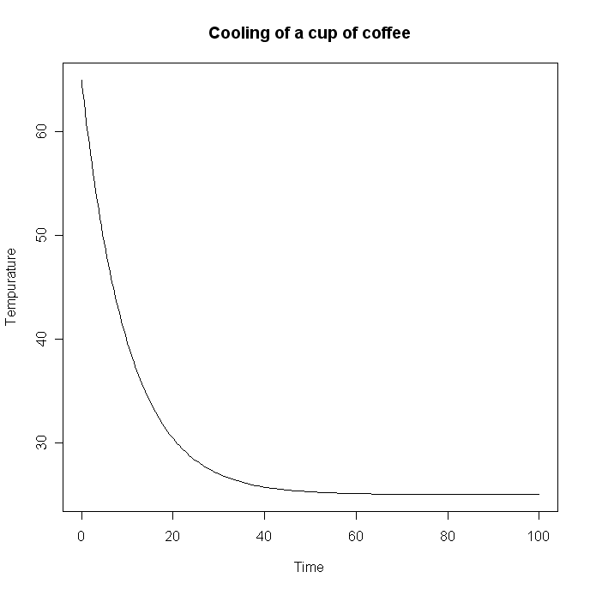
Figure 1. Newton’s Law of Cooling demonstration.

This demo illustrates how to set up and solve a single ODE with PBSddesolve.
For historical background, see http://en.wikipedia.org/wiki/Heat_conduction#Newton.27s_law_of_cooling.
Imagine a hot cup of coffee that cools toward room temperature, where a constant  determines the rate of cooling. Newton’s Law of Cooling suggests a simple differential equation to determine the coffee temperature 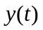 at time t:
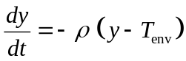,
where 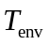 is the ambient room temperature. If 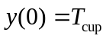 denotes the initial temperature of the coffee, then this equation has the analytical solution
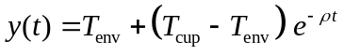,
where 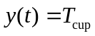 when  and 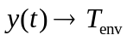 as 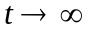. The GUI in Figure 1 displays the code when you press the “R Code” button, as long as R-files (*.r) are associated with a suitable text editor on your system. Similarly, “Docs” displays documentation and “Window” displays the script used to produce the GUI. In this example, two key lines of the code are:
myGrad <- function(t, y) {return( -rho*(y[1]-Tenv)}
dde(y=Tcup, func=myGrad, times=seq(t0,t1,length=100), hbsize=0)
The parameters rho, Tenv, Tcup, t0 (the start time), and t1 (the end time) come from the GUI. This ordinary differential equation does not need a history buffer, so hbsize=0.

4.2 Blowflies – (DDE Example)

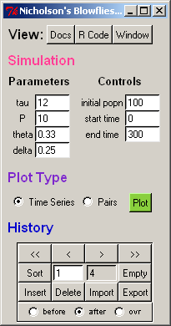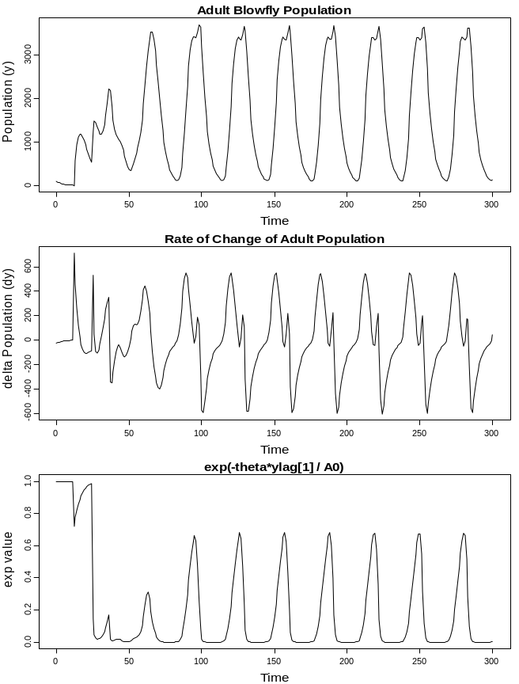

Figure 2. Nicholson’s blowflies model demonstration (included in Simon Wood’s Solv95 User Manual as an example of solving a DDE).

As an example with a delay, Wood (1999) suggested a blowfly population model for adults 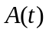 at time t:
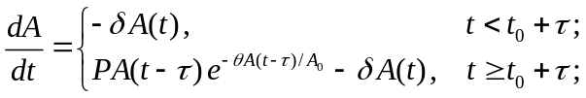,
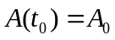.
Here is the development time from egg to adult, P is the net production rate determined by adult fecundity and egg survival to adulthood, is a parameter determining how quickly fecundity declines with an increasing adult population, is the adult death rate, and is the initial time when starts with the value 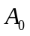. We assume that 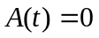 for 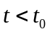. In our formulation, the differential equation also includes the parameter , so that becomes dimensionless. Essentially, sets the scale for .

The GUI in Figure 2 allows the four parameters (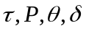) to be adjusted, along with the initial conditions 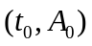 and the final time . The graph at the left shows three panels: , 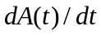, and 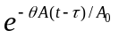. In this case, a key portion of the R code is:
myGrad <- function(t, y) {
if (t-t0 >= tau) ylag <- pastvalue(t-tau)
else ylag <- 0
yexp <- exp(-theta*ylag[1]/A0)-delta*y[1]
yp <- P*ylag[1]*yexp
return( list(yp, c(dy=yp, exp=yexp)) ) }
where values of tau, P, theta, delta, t0, and A0 come from the GUI.

4.3 Lorenz – (ODE Example)
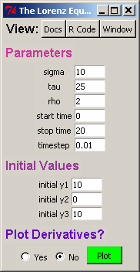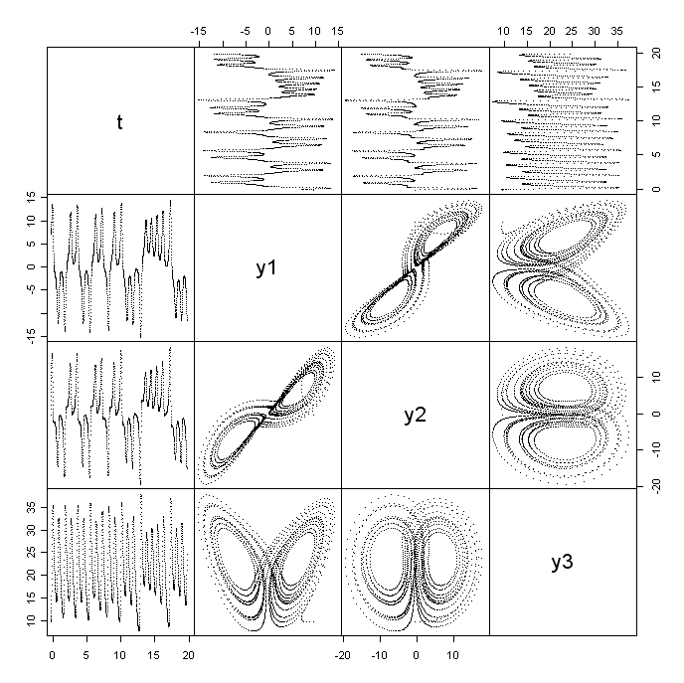

Figure 3. The Lorenz model demonstrates chaotic behaviour in the solution of thee linked differential equations.

The Lorenz model (http://planetmath.org/encyclopedia/LorenzEquation.html) consists of three ordinary differential equations for a three-dimensional state vector y:
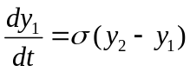,
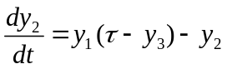,
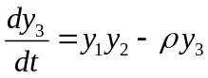,
with three parameters 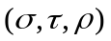. This demonstration includes a GUI for adjusting the parameters and initial conditions to see results from integrating the Lorenz model. It also allows the solution to be obtained with either PBSddesolve or deSolve. The choice of numerical solver should not affect the results of the plot, even though these two packages use different underlying algorithms for estimating the solution. Tests (not shown here) indicate that both solvers return comparable results, a result that gives us some confidence that PBSddesolve performs correctly.

4.4 Ice Cream Parlor – Raiders of the Lost Cone (Switches)

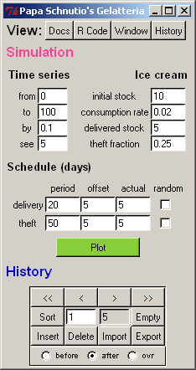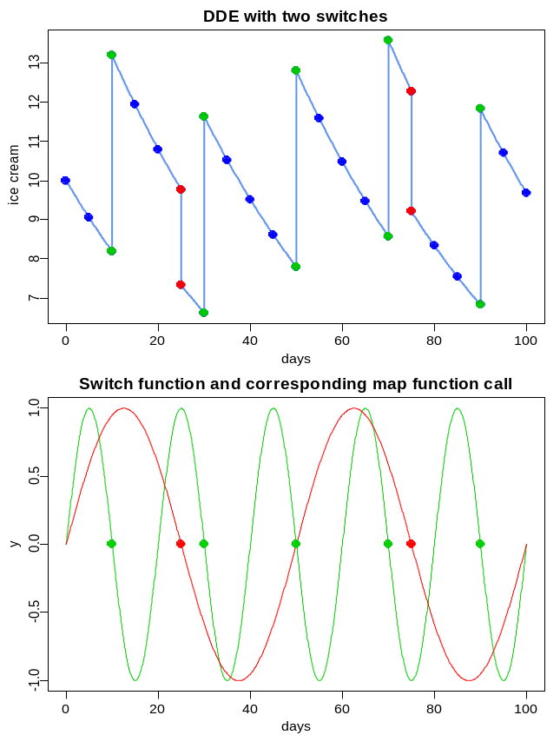

Figure 4. The ice cream parlor receives deliveries (switch 1, green) and experiences theft (switch 2, red).

To illustrate switches, Alex (author ACB) suggested an ice cream parlor that gets restocked periodically. But Jon (author JTS) wanted at least two switches, so he suggested that thieves might occasionally raid the parlor and steal some of the stock. Comments in Alex’s code soon suggested a snappy title: Raiders of the Lost Cone. Rowan (author RH) and Alex quickly agreed that the parlor should have a flashing sign with the logo “Papa Schnutio’s” that puts an Italian twist on Jon’s Germanic last name. Jon hesitated, but he once lived in Italy for a year and couldn’t resist the idea of Italian ice cream (gelato). So he agreed to an establishment named
Papa Schnutio’s Gelatteria

Our model assumes an exponential depletion of the ice cream stock with rate r:
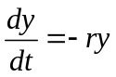,
perhaps because a lower stock would offer fewer choices and thus discourage consumption. (Sometimes a gelatteria just doesn’t have that perfect flavour you came for. It was there yesterday, but not today – a great disappointment!) We need two switch functions that we chose to be the sinusoids
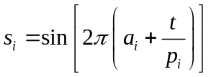
with offset parameters  and periods 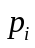 for 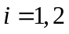. Switch 1 triggers restocking
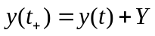
and switch 2 triggers theft events
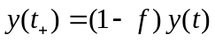,
where 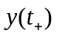 denotes the value of y after the switch, Y is the fixed amount of ice cream added to the stock, and f is the fraction of the stock removed by thieves.
In this example, key features of the code involve the sine wave used for switching
sinWave <- function(t,aa,pp) { sin( 2*pi*(aa + (t/pp)) ) }
the switch function
mySwitch <- function(t,y) {
c( sinWave(t,a[1],p[1]), sinWave(t,a[2],p[2]) ) }
the map function
myMap <- function(t,y,swID) {
if (swID==1) y <- y + Y else y <- (1-f)*y }
the gradient function
myGrad <- function(t,y) { -r*y }
and the call to the main routine
yout <- dde(y=y0, times=tt, func=myGrad,
switchfunc=mySwitch, mapfunc=myMap)
where the initial stock y0, the desired output times tt, the consumption rate r, the amount Y brought by the supplier, the theft fraction f, the offset vector a (of length 2), and the period vector p (of length 2) correspond to values prescribed by the GUI.

4.5 Fish Population with a Fishery and a Reserve

Our motivation to produce PBSddesolve came primarily from biological models of fish populations that experience recruitment from larval production at an earlier time. (The blowflies example in Section 4.2 illustrates similar behaviour.) The package PBSmodelling includes a much more elaborate example (with complete documentation) in which a reserve from fishing protects a portion of the fish population. The model appears in two versions, with discrete and continuous time t. This example requires at least versions 2.65 and 1.10 of PBSmodelling and deSolve, respectively. After these two packages have been installed, type the following commands in the R console:
require(PBSmodelling)
runExamples()
In the GUI to “Choose an Example”, press the radio button for the simulation “FishRes”.
View the manual by pressing the “Docs” button, as in the examples discussed above in Sections 4.1-4.4.

5. The Algorithm

The R package PBSddesolve provides an interface to Simon Wood’s numerical routines found in solv95. The algorithm implemented in this package is the same as that in solv95, and is described by Wood (1999) in his user manual:
“The method used for integration is an embedded RK2(3) scheme due to Fehlberg, and reported on page 170 of Hairer et al. (1987). Lagged variables (and gradients) are stored in a ring buffer at each step of the integrator. Interpolation is required to estimate values of the lagged variables between storage times. For numerical probity it is essential that the interpolation of lagged variables is of a higher order of approximation than the integrator, otherwise the assumptions underlying the error estimate from the RK pair will not be met. The algorithm used in Solv95 uses cubic hermite interpolation (e.g. Burden and Faires 1987) to achieve this (which is the reason that gradients need to be stored along with lagged values). The consequences of not using consistent interpolation and integration schemes are vividly illustrated in Highman (1993). Paul (1992) was also influential in the design of the method used here, and the step size selection is straight out of Press et al. (1992) (method, not code!). The RK2(3) pair used is not actually optimal - it should be possible to derive an improved scheme - see Butcher (1987) for an explanation of how to go about it.”

The original solv95 software requires a user to write C code for a system of DDEs. This must be compiled and linked with solv95; then the resulting executable file gives a numerical solution. With PBSddesolve, a user codes the model in R, rather than C. A compiled version of the integration algorithm automatically comes with the package, which makes the numerical C routines compatible with R. Because the output appears as an object in R, a user can interpret the results using R’s extensive capabilities for analysis and graphics.

The numerical routines have been preserved in the files ddeq.c and ddeq.h. The interface to dde() has been significantly altered and now appears in the file PBSddesolve.c, which replaces solv95.c. The link between R and C is contained in r_model.c, adapted from a basic model template in the original solv95 code bundle. This file now has many calls to the R application programming interface (API).

6. References

Burden, R.L., and Faires, J.D. (1985) Numerical Analysis. Pridle Weber and Schmidt, Boston.
Butcher, J.C. (1987) The Numerical Analysis of Ordinary Differential Equations: Runge-Kutta and General Linear Methods. John Wiley & Sons, Inc. 528 pp.
Hairer, E., Norsett, S.P., and Wanner, G. (1987) Solving Ordinary Differential Equations I. Springer-Verlag Berlin. 170 pp. RKF2(3)B.
Higman, D.J. (1993) Error control for initial value problems with discontinuities and delays. Applied Numerical Mathematics 12(4): 315-330.
Paul, C.A.H. (1992) Developing a delay differential equation solver. Applied Numerical Mathematics 9: 403-414.
Press, W.H., Teukolsky, S.A., Vetterling, W.T., and Flannery, B.P. (1992) Numerical Recipes in C : The Art of Scientific Computing. Cambridge University Press.
Schnute, J.T., Couture-Beil, A., and Haigh, R. (2006) PBS Modelling 1: user’s guide. Canadian Technical Report of Fisheries and Aquatic Sciences 2674: viii + 112 pp.
URL: http://cran.r-project.org/web/packages/PBSmodelling/index.html
Shampine, L.F., and Thompson, S. (2000) Solving delay differential equations with dde23. Tutorial: http://www.radford.edu/~thompson/webddes/tutorial.html
Wood, S.N. (1999) Solv95: a numerical solver for systems of delay differential equations with switches. Saint Andrews, UK. 10 pp.
URL: http://www.maths.bath.ac.uk/~sw283/simon/dde.html, file: solv95.zip
(See solv95-Manual.pdf in the root library directory for PBSddesolve.)
Wood, S.N. (2006) Generalized Additive Models: An Introduction with R. Chapman & Hall/CRC. 416 pp.

Appendix A. R-manual for PBSddesolve
This appendix documents the objects (functions) available in PBSddesolve. Subsequent pages give indexed technical documentation for every object generated from *.Rd files written for the R documentation system. The package PBSmodelling includes a directory called PBStools\ that contains useful batch files for building R packages, including the creation of the indexed manual included here.

