PBSmapping 2.66: User’s Guide

Jon T. Schnute, Nicholas M. Boers, Rowan Haigh, and Alex Couture-Beil

Fisheries and Oceans Canada

Science Branch, Pacific Region

Pacific Biological Station

3190 Hammond Bay Road

Nanaimo, British Columbia

V9T 6N7

2013

User’s Guide Revised from
Canadian Technical Report of
Fisheries and Aquatic Sciences 2549



© Her Majesty the Queen in Right of Canada, 2013

Revisions to: Cat. No. Fs97-6/2549E ISSN 0706-6457

Last update: May 1, 2013

Correct citation for this publication:

Schnute, J.T., Boers, N.M., Haigh, R., and Couture-Beil, A. 2013. PBSmapping 2.66: user’s guide revised from Canadian Technical Report of Fisheries and Aquatic Sciences 2549: vi + 115 p. Last updated May 1, 2013.

TABLE OF CONTENTS

Abstract iii
Résumé iii
Preface iv
1. Introduction 1
1.1. Software Installation 2
2. PBSmapping: Functions and Data 3
2.1. Data Structures for Maps 3
PolySet 3
PolyData 4
EventData 5
LocationSet 5
2.2. Map Projections 5
2.3. PBSmapping Functions and Algorithms 8
Import Functions 8
Graphics Functions 9
Computational Functions 10
Associating Points with Polygons 13
Set Theoretic Operations 14
2.4. Shoreline Data 15
2.5. Bathymetry Data 17
2.6. Examples and Applications 18
2.7. Strengths, Limitations, and Alternatives 21
3. Command-line Utilities 23
3.1. clipPolys.exe (Clip Polygons) 23
3.2. convUL.exe (Convert between UTM and LL) 23
3.3. findPolys.exe (Points-in-Polygons) 24
Acknowlegements 24
References 25
Appendix A. PBSdata package 27
Appendix B. Bathymetry Data 29
Appendix C. Generic Mapping Tools (GMT) 30
Appendix D. Source Code for Figures 34
Appendix E. PBSmapping Function Dependencies 40
Appendix F. PBSmapping Functions and Data 43

LIST OF TABLES

Table 1. Principal graphics functions in the PBSmapping package 9
Table 2. PolySets derived from GSHHS databases 16
Table A1. Data sets available in PBSdata 27
Table F1. Functions and data sets defined in PBSmapping 43

LIST OF FIGURES

Figure 1. Map of the world 6
Figure 2. Map of the northeastern Pacific Ocean (longitude-latitude) 7
Figure 3. Map of the northeastern Pacific Ocean (UTM easting-northing) 8
Figure 4. Illustration of the thinPolys function 13
Figure 5. Example of the joinPolys logic operations 15
Figure 6. Polylines created by contourLines and convCP 17
Figure 7. Tow tracks from a longspine thornyhead survey in 2001 18
Figure 8. Areas of islands in the southern Strait of Georgia 19
Figure 9. Pacific ocean perch survey data (1966-89) 20
Figure 10. Proof of Pythagoras’ Theorem 21
Figure C1. PBSmapping compared with GMT – Vancouver Island 31
Figure C2. PBSmapping compared with GMT – tow tracks 33

ABSTRACT

Schnute, J.T., Boers, N.M., Haigh, R., and Couture-Beil, A. 2013. PBSmapping 2.66: user’s guide revised from Canadian Technical Report of Fisheries and Aquatic Sciences 2549: vi + 115 p. Last updated May 1, 2013.

This report describes a second version of software designed to facilitate the compilation and analysis of fishery data, particularly data referenced by spatial coordinates. Our research stems from experiences with information on Canada’s Pacific groundfish fisheries compiled at the Pacific Biological Station (PBS). Despite its origins in fishery data analysis, our software has broad applicability. The library PBSmapping extends the R-statistical language to include two-dimensional plotting features similar to those commonly available in a Geographic Information System (GIS). Embedded C code speeds algorithms from computational geometry, such as finding polygons that contain specified point events or converting between longitude-latitude and Universal Transverse Mercator (UTM) coordinates. We also present a number of convenient utilities for Microsoft Windows operating systems that support computational geometry outside the framework of R. Our results, which depend significantly on the work of students, illustrate the convergence of goals between academic training and applied research.

RÉSUMÉ

Schnute, J.T., Boers, N.M. Haigh, R., et Couture-Beil, A. 2013. PBSmapping 2.66: Guide de l’utilisateur révisé de Canadian Technical Report of Fisheries and Aquatic Sciences 2549: vi + 115 p. Dernier mis à jour May 1, 2013.

Le présent rapport décrit la seconde version du logiciel conçu pour faciliter la compilation et l’analyse de données halieutiques, en particulier les données référencées par des coordonnées spatiales. Nos travaux de recherche ont capitalisé sur des expériences menées à l’aide de données sur les pêches des poissons démersaux le long du littoral Pacifique du Canada, données compilées à la Station biologique du Pacifique (SBP). Bien que conçu initialement pour l’analyse de données halieutiques, notre logiciel peut s’appliquer à toute une variété de domaines. La bibliothèque PBSmapping (Cartographie de la SBP) étend le langage R pour inclure une capacité d’impression en deux dimensions semblable à celle habituellement disponible dans les systèmes d’information géographiques (SIG). Des modules en C permettent d’accélérer les algorithmes grâce à la géométrie numérique, en trouvant par exemple les polygones qui contiennent des événements ponctuels spécifiques ou en convertissant les longitudes et les latitudes en coordonnées de la projection transversale universelle (UTM). Nous présentons également un certain nombre d’applications intéressantes pour les systèmes d’exploitation Microsoft Windows, qui peuvent effectuer des opérations de géométrie numérique en dehors du cadre de travail R. Nos résultats, auxquels plusieurs étudiants ont grandement contribué, illustrent la convergence des objectifs de la formation académique et de la recherche appliquée.

PREFACE

During the last decade, I’ve had the pleasure of directing work by computer science students from various local universities. My research as a mathematician in fish stock assessment requires an extensive software toolkit, including statistical languages, compilers, and operating system utilities. It helps greatly to have bright, adaptive students who can learn new languages quickly, investigate software possibilities, answer technical questions, and design programs that assist scientific analysis. I’m particularly grateful for contributions from the following students:
- Robert Swan (University of Victoria), 1996;
- Mike Jensen (Malaspina University-College and Simon Fraser University), 1997 and 1999;
- Chris Grandin (Malaspina University-College), 2000 and 2001;
- Nick Henderson (Malaspina University-College), 2002;
- Nick Boers (Malaspina University-College), 2003-2006.
- Alex Couture-Beil (Malaspina University-College), 2005-2007

Starting in 1998, I began a formal connection with the Computing Science Department at Malaspina University-College (MUC). My discussions with faculty members, particularly Dr. Peter Walsh and Dr. Jim Uhl, highlighted the convergence of goals between academic training and scientific research. Projects designed for fish stock assessment give students an opportunity to further their computing science careers while producing useful software. Both MUC and the Pacific Biological Station (PBS), where I work, are located in Nanaimo, British Columbia, Canada. This happy juxtaposition makes it easy to engage students in the exchange of ideas between academia and applied research. For example, Jim Uhl participated directly in Nick Boers’ PBS work term during the summer of 2003. Nick had completed a course in computer graphics taught by Jim in the fall of 2002. Algorithms in the textbook (Foley et al. 1996) proved invaluable for writing software to produce maps of the British Columbia coast with related fishery information.

Quantitative fishery science requires a strong connection between theory and practice. In his book on computing theory, Michael Sipser (1997, p. xii) tells students that:

“. . . theory is good for you because studying it expands your mind. Computer technology changes quickly. Specific technical knowledge, though useful today, becomes outdated in just a few years. Consider instead the abilities to think, to express yourself clearly and precisely, to solve problems, and to know when you haven't solved a problem. These abilities have lasting value. Studying theory trains you in these areas.”

While dealing with the issues addressed here, I found myself asking simple questions that have numerically interesting answers. How do you locate fishing events within management areas or other polygons? How should regional boundaries on maps be clipped to lie within a smaller rectangle? I soon realised that I had touched upon the emerging field of computational geometry, where people have devised clever and efficient algorithms for addressing such questions.

Remarkably effective software can now be obtained freely from the Internet. I’m particularly fond of R, a version of the powerful statistical language S (and later S-PLUS) devised by Becker et al. (1988). Venables and Ripley (1999, 2000) give excellent guidance for using either language. Although written originally for Unix, R has also been implemented for Microsoft’s Windows operating systems. The web site http://cran.r-project.org/ describes R as GNU S, “a freely available language and environment for statistical computing and graphics”. The GNU project (http://www.gnu.org/), where the recursive acronym GNU means “GNU’s Not Unix”, offers a wealth of free software including compilers for C/C++, Fortran, and Pascal. Code can be written in these compiled languages to speed computations that would otherwise run more slowly in R. Nick Boers has used such linkages intelligently to bring fast computational geometry into our R-package PBSmapping.

To some extent, this report constitutes a second edition of an earlier report (Schnute et al. 2003) that describes a suite of software utilities developed at PBS. In particular, the package PBSmapping has undergone extensive renovations and improvements, and this document provides a definitive manual for using version 2. To accommodate the new material presented here, my co-authors and I have decided to remove sections of the earlier report that discuss other PBS software utilities, free software available on the Internet, and related technical information. Readers of this current report may also wish to acquire the earlier version for additional material not included here.

I want to mention two milestones achieved during the production of PBSmapping, Version 2. First, we have posted the current software as a contributed package on the Comprehensive R Archive Network (CRAN, http://cran.r-project.org/). Thanks to a remarkable collection of Perl scripts developed for the R project, source code in both C and R, along with suitable documentation files, can be tested and compiled automatically for distribution as both source and binary packages. Nick Boers ensured that our source materials met the necessary standards, and (after we made minor changes in the C code to avoid compiler warnings) the authors of the CRAN web site in Vienna, Austria accepted our contribution. Second, Nick applied to the Canadian Natural Sciences and Engineering Research Council (NSERC) for a grant to support graduate studies in computing science. His application cited his successful experience developing PBSmapping, Version 1, as documented in Schnute et al. (2003). To the delight of Nick’s supporters at PBS and MUC, he won a substantial award, in fact the only NSERC grant given to a student from MUC this year. Congratulations, Nick, from your colleagues at PBS and professors at MUC. We’ll follow your career at the University of Alberta in Edmonton with great interest.

Jon Schnute

This page has been left intentionally blank for printing purposes.

1. INTRODUCTION

This report describes software written to facilitate the compilation and analysis of fishery data, particularly data referenced by spatial coordinates. Our work developed from experiences constructing databases that capture information from Canada’s Pacific groundfish fisheries. Fishing events take place across a broad range of coastal waters and result in the capture of many species. Initially, we focused on issues related to database design and development, as described in previous reports by Schnute et al. (1996), Haigh and Schnute (1999), Rutherford (1999), Schnute et al. (2001, Section 2 and Appendix A), and Sinclair and Olsen (2002). Analyses of these databases shifted our attention to the problem of portraying and understanding such complex information. Maps with statistical information proved especially useful, and we found ourselves facing questions commonly addressed by Geographic Information Systems (GIS).

Commercial GIS packages can be expensive, with an additional requirement for specialized training. Because analysts who deal with Pacific groundfish data often have experience using the statistical languages R (http://cran.r-project.org/, available for free) or S-PLUS (http://en.wikipedia.org/wiki/S-PLUS, available commercially), we began by writing bilingual functions for these languages to produce the maps required. Schnute et al. (2003) describe the package PBSmapping, Version 1, which evolved from these early experiences. After another year of development, we extensively revised the software, and Schnute et al. (2004) presented a user’s manual for PBSmapping, Version 2. Subsequently, we have dropped the bilingual (R/S-PLUS) nature of PBSmapping, producing revisions solely for R, and now refer to the package as PBSmapping rather than ‘PBS Mapping’ used in earlier documents. Additionally, we maintain most of our PBS packages, including PBSmapping, at http://code.google.com/p/pbs-software/.

Section 2 covers the mapping software itself, which contains functions that perform numerous calculations on polygons. These include standard set theoretic operations (union, intersection, difference, exclusive-or), clipping, thinning, thickening, testing convexity, forming the convex hull, and calculating various statistics (such as mean, centroid, and area). We discuss public data that represent shorelines and ocean bathymetry, and the package includes sample data sets drawn from these sources. We also discuss the Universal Transverse Mercator (UTM) projection that gives a particularly accurate flat projection of the earth’s surface. Our software can convert between longitude-latitude and UTM coordinates.

Section 3 documents a number of convenient command-line utilities, compiled separately from C code written for the PBSmapping package. These make it possible to perform some of the polygon functions outside the framework of R. Appendices provide additional information about various topics related to PBSmapping, including

- a package (PBSdata) of supplementary information for PBSmapping;
- an Internet source for global bathymetry data;
- alternative Generic Mapping Tools (GMT);
- source code for the figures in this report;
- function dependencies in PBSmapping;
- documentation for PBSmapping functions and data,
including an indexed manual based on the *.Rd files.

We anticipate that our software will continue to change for the better, due to bug fixes and other improvements. This report documents version 2.66, which currently appears as a contributed package on the R archive (http://cran.r-project.org/). We will post subsequent versions as they become available. All software required to develop and use PBSmapping is freely available from the Internet.

1.1. Software Installation

We provide two mapping packages:
- PBSmapping – the mapping software discussed in Section 1;
- PBSdata – various additional data sets relevant to fisheries investigated at PBS (Appendix A).

Installation of PBSmapping can be achieved in two ways – (1) navigate to:
http://cran.r-project.org/web/packages/PBSmapping/index.html, download the appropriate binary, and install from R using the menu <Packages><Install package(s) from local zip files...>, or (2) in R, use the menu <Packages><Install package(s)>, choose a CRAN mirror near you, highlight PBSmapping, and press OK. Note that the software is available in two forms:
- PBSmapping_2.65.tar.gz – source code for the R distribution, which can be used to build a binary package;
- PBSmapping_2.65.zip – binary package ready for installation into R;

The package PBSdata can be found on the Google Code website: https://code.google.com/p/pbs-data/ .

To remove PBSmapping from R, open the library\ directory and delete the associated subdirectory PBSmapping\. Before loading a new version of a package, we recommend the removal of any previous version. Eventually, the installation files may have names that reflect a version number later than the current version.

Additionally three other PBS packages are available from CRAN that facilitate fisheries analysis and research:
- PBSmodelling – http://cran.r-project.org/web/packages/PBSmodelling/index.html;
- PBSddesolve – http://cran.r-project.org/web/packages/PBSddesolve/index.html;
- PBSadmb – http://cran.r-project.org/web/packages/PBSadmb/index.html.

The PBSmodelling library includes a directory called PBStools that contains useful batch files for building R packages and generating an indexed manual based on the *.Rd files. This is not to be confused with another PBS package called PBStools at: https://code.google.com/p/pbs-tools/.

2. PBSmapping: FUNCTIONS AND DATA

Niklaus Wirth, the author of Pascal and Modula-2, summarises the essence of software design in the title of his book Algorithms + Data Structures = Programs (Wirth 1975). Our software package PBSmapping begins with data structures that embody two essential concepts. First, polygons define boundaries, such as shorelines and fishery management areas. Second, fishing events occur at specific locations defined by two geographical coordinates, such as longitude and latitude. The R language conveniently supports such structures through the concept of a data frame, essentially a database table in which rows and columns define records and fields, respectively. Objects like data frames in R can also have attributes that store additional properties, such as the projection used in defining a geographic coordinate system.

2.1. Data Structures for Maps

PBSmapping introduces four data structures, each stored as a data frame. Field names, attributes, and other properties of these objects implicitly dictate their type. An object may also identify its type explicitly in the class attribute. Each type requires a particular structure, as outlined below.

PolySet

In our software, a PolySet data frame defines a collection of polygonal contours (i.e., line segments joined at vertices), based on four or five numerical fields:

- PID – the primary identification number for a contour;
- SID – (optional) the secondary identification number for a contour;
- POS – the position number associated with a vertex;
- X – the horizontal coordinate at a vertex;
- Y – the vertical coordinate at a vertex.

The simplest PolySet lacks an SID column, and each PID corresponds to a different contour. By analogy with a child’s “follow the dots” game, the POS field enumerates the vertices to be connected by straight lines. Coordinates (X, Y) specify the location of each vertex. Thus, in familiar mathematical notation, a contour consists of n points 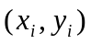 with 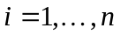,
where i corresponds to the POS index. A PolySet has two potential interpretations. The first associates a line segment with each successive pair of points from 1 to n, giving a polyline (in GIS terminology) composed of the sequential segments. The second includes a final line segment joining points n and 1, thus giving a polygon.

The secondary ID field allows us to define regions as composites of polygons. From this point of view, each primary ID identifies a collection of polygons distinguished by secondary IDs. For example, a single management area (PID) might consist of two fishing areas, each associated with a different SID. A secondary polygon can also correspond to an inner boundary, like the hole in a doughnut. We adopt the convention that POS goes from 1 to n along an outer boundary, but from n to 1 along an inner boundary, regardless of rotational direction. This contrasts with other GIS software, such as ArcView (ESRI 1996), in which outer and inner boundaries correspond to clockwise and counter-clockwise directions, respectively.

The SID field in a PolySet with secondary IDs must have integer values that appear in ascending order for a given PID. Furthermore, inner boundaries must follow the outer boundary that encloses them. The POS field for each contour (PID, SID) must similarly appear as integers in strictly increasing or decreasing order, for outer and inner boundaries respectively. If the POS field erroneously contains floating-point numbers, fixPOS can renumber them as sequential integers, thus simplifying the insertion of a new point, such as point 3.5 between points 3 and 4.

A PolySet can have a projection attribute, which may be missing, that specifies a map projection. In the current version of PBSmapping, projection can have character values "LL" or "UTM", referring to “Longitude-Latitude” and “Universal Transverse Mercator”. We explain these projections more completely below. If projection is numeric, it specifies the aspect ratio r, the number of x units per y unit. Thus, r units of x on the graph occupy the same distance as one unit of y. Another optional attribute zone specifies the UTM zone (if projection="UTM") or the preferred zone for conversion from Longitude-Latitude (if projection="LL").

A data frame’s class attribute by default contains the string "data.frame". Inserting the string "PolySet" as the class vector’s first element alters the behaviour of some functions. For example, the summary function will print details specific to a PolySet. Also, when PBSprint is TRUE, the print function will display a PolySet’s summary rather than the contents of the data frame.

PolyData

We define PolyData as a data frame with a first column named PID and (optionally) a second column named SID. Unlike a PolySet, where each contour has many records corresponding to the vertices, a PolyData object must have only one record for each PID or each (PID, SID) combination. Conceptually, this object associates data with contours, where the data correspond to additional fields in the data frame. The R language conveniently allows data frames to contain fields of various atomic modes (“logical”, “numeric”, “complex”, “character”, and “null”). For example, PolyData with the fields (PID, PName) might assign character names to a set of primary polygons. Additionally, if fields X and Y exist (perhaps representing locations for placing labels), consider adding attributes zone and projection. Inserting the string "PolyData" as the class attribute’s first element alters the behaviour of some functions, including print (if PBSprint is TRUE) and summary.

Our software particularly uses PolyData to set various plotting characteristics. Consistent with graphical parameters used by the R functions lines and polygon, column names can specify graphical properties:

- lty – line type in drawing the border and/or shading lines;
- col – line or fill colour;
- border – border colour;
- density – density of shading lines;
- angle – angle of shading lines.

When drawing polylines (as opposed to closed polygons), only lty and col have meaning.

EventData

We define EventData as a data frame with at least three fields named (EID, X, Y). Conceptually, an EventData object describes events (EID) that take place at specific points (X, Y) in two-dimensional space. Additional fields specify measurements associated with these events. For example, in a fishery context EventData could describe fishing events associated with trawl tows, based on the fields:

- EID – fishing event (tow) identification number;
- X, Y – fishing location;
- Duration – length of time for the tow;
- Depth – average depth of the tow;
- Catch – biomass captured.

Like PolyData, EventData can have attributes projection and zone, which may be absent. Inserting the string "EventData" as the class attribute’s first element alters the behaviour of some functions, including print (if PBSprint is TRUE) and summary.

LocationSet

A PolySet can define regional boundaries for drawing a map, and EventData can give event points on the map. Which events occur in which regions? Our function findPolys, discussed in Section 2.3 below, solves this problem. The output lies in a LocationSet, a data frame with three or four columns (EID, PID, SID, Bdry), where SID may be missing. One row in a LocationSet means that the event EID occurs in the polygon (PID, SID). The boundary (Bdry) field specifies whether (Bdry=T) or not (Bdry=F) the event lies on the polygon boundary. If SID refers to an inner polygon boundary, then EID occurs in (PID, SID) only if Bdry=T. An event may occur in multiple polygons. Thus, the same EID can occur in multiple records. If an EID does not fall in any (PID, SID), or if it falls within a hole, it does not occur in the output LocationSet. Inserting the string "LocationSet" as the first element of a LocationSet’s class attribute alters the behaviour of some functions, including print (if PBSprint is TRUE) and summary.

2.2. Map Projections

The simplest projection associates each point on the earth’s surface with a longitude x (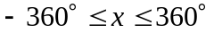) and latitude y (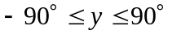), where 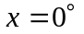 on the Greenwich prime meridian. The chosen range of x depends on the region of interest, where negative longitudes refer to displacements west of the prime meridian. When plotted on a rectangular grid with equal distances for each degree of longitude and latitude, this projection exaggerates the size of objects near the earth’s poles, as illustrated in Figure 1. For points near the latitude y, a more realistic map uses the aspect ratio

(2.1) 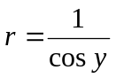,

where r degrees of longitude x should occupy the same distance as 1 degree of latitude y.

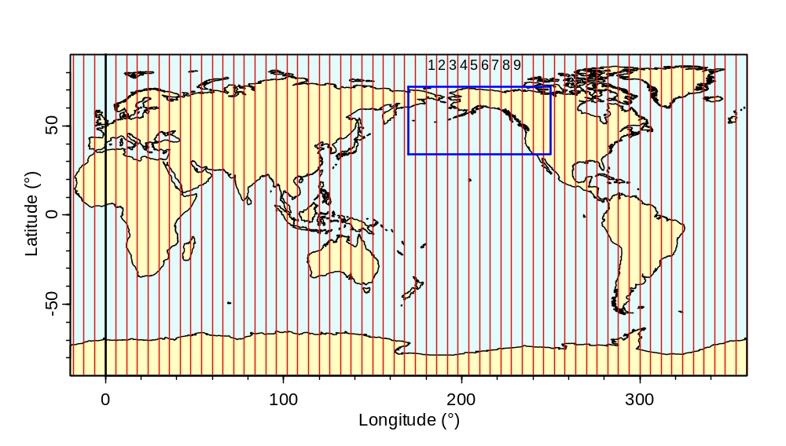

Figure 1. Map of the world projected in longitude-latitude coordinates. This image, based on our PolySet worldLL, uses the longitude range 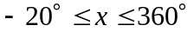 to produce a convenient cut in the eastern Atlantic Ocean. Red vertical lines show boundaries for the 60 Universal Transverse Mercator (UTM) zones, with explicit labels for zones 1 to 9. A black line indicates the prime meridian 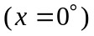. Our PolySet nepacLL lies within the clipping boundary shown as a blue rectangle.Figure 1

The Universal Transverse Mercator (UTM) projection gives a more realistic portrayal of the earth’s surface within 60 standardized longitude zones. Each zone spans 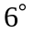, and zone i includes points with longitude x in the range

(2.2) 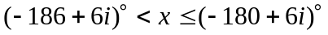 [UTM zone i]

The mid-longitude in (2.2)

(2.3) 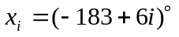 [Central meridian, zone i]

defines the central meridian of zone i. In particular, zone 9 has central meridian 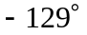 and covers the range

(2.3) 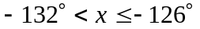. [UTM zone 9]

Canada’s Pacific coast lies in zones 8 to 10 (Figure 2), and the projection to zone 9 gives a reasonably accurate map for fisheries in this region.

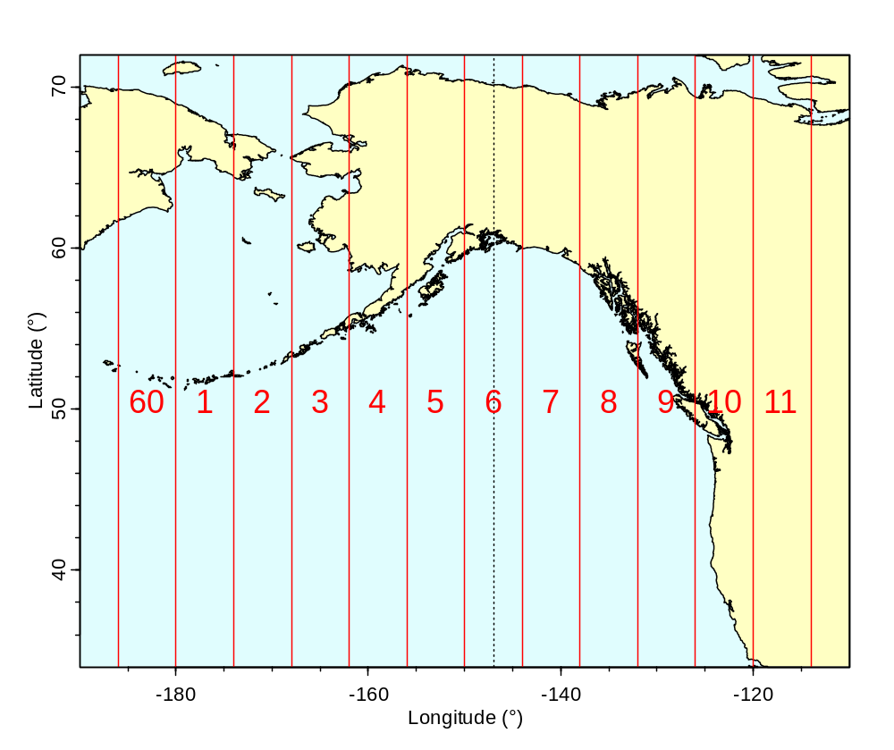

Figure 2. Shoreline data in longitude-latitude coordinates for the northeastern Pacific Ocean, as captured in our PolySet nepacLL. Vertical red lines display UTM boundaries for zones 60, 1, 2, …, 11. A vertical dotted line indicates the central meridian of zone 6, near the centre of this figure.Figure 2

Visually, UTM zones look like sections of orange peel cut from top to bottom. Each relatively narrow section can be flattened without too much distortion to give coordinates 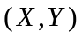 measured as actual distances, as illustrated by zone 6 in Figure 3. Complex formulas, compiled in detail by the UK Ordnance Survey (Anonymous 1998, Ordnance Survey 2010), allow conversion between two projections: the UTM easting-northing coordinates and the usual longitude-latitude coordinates 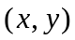. These take account of the earth’s ellipsoidal shape, with a wider diameter at the equator than the poles. The UTM projection scales distances exactly along two great circles: the equator and the central meridian, which act as X and Y axes, respectively. Along the equator, 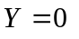km by definition; elsewhere, Y indicates the distance north (positive Y) or south (negative Y) of the equator. The central meridian is assigned a standard easting 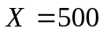km, rather than the usual 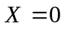km. This ensures that 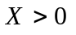km throughout the zone. In effect, the difference 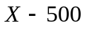km represents the distance east of the central meridian, where a negative distance corresponds to a westward displacement. These interpretations are exact along the equator and central meridian, but approximate elsewhere.

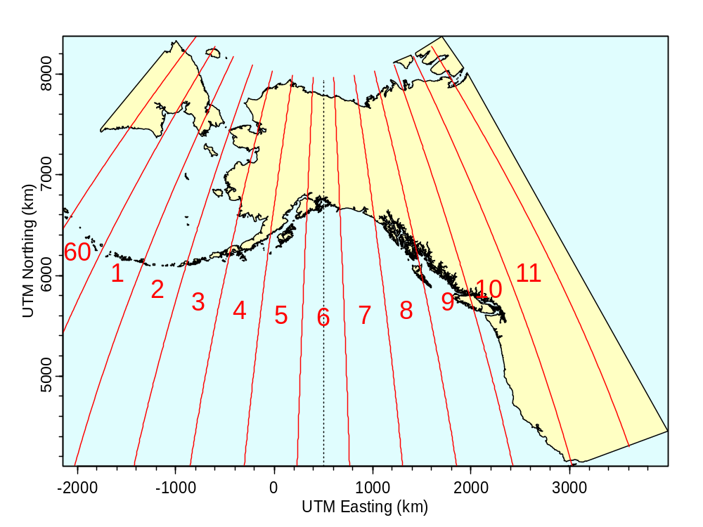

Figure 3. Shoreline data for the northeastern Pacific Ocean, projected in UTM coordinates (zone 6) from our PolySet nepacLL. Vertical red lines show UTM zone boundaries. The central axis of zone 6 (vertical dotted line at 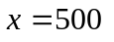km) corresponds to the central meridian shown in Figure 2. Figure 3

2.3. PBSmapping Functions and Algorithms

Our software produces maps from the data structures defined in Section 2.1. Following typical design concepts in R, it uses functions to generate plots, implement algorithms, and perform other tasks. Where possible, function arguments often have explicit default values. PBSmapping includes many functions not mentioned in this section. We encourage readers to examine Appendix F, which gives detailed technical descriptions of all our software’s functions and other components.

Import Functions

The following functions provide some support for importing GIS data from other users and other mapping platforms:

- importEvents import a text file and convert into EventData.
- importLocs import a text file and convert into a LocationSet.
- importPolys import a text file and convert into a PolySet with optional PolyData attribute.
- importGSHHS import data from a GSHHS database and convert data into a PolySet with a PolyData attribute. GSHHS: A Global Self-consistent, Hierarchical, High-resolution Shoreline Database, http://www.soest.hawaii.edu/wessel/gshhs/gshhs.html
See Section 2.4 below for more details.
- importShapefile imports an ESRI shapefile (.shp) into either a PolySet or EventData. The function relies on C-code provided by Roger Bivand’s package maptools.

Graphics Functions

In the R language, high-level commands (like plot) create new graphs; lower-level commands (like points and lines) add features to an existing graph. Similarly, we provide functions (plotLines, plotMap, plotPoints, plotPolys) that create graphs and others (addLabels, addLines, addPoints, addPolys, addStipples) that add graphical features.

Some of these plotting functions draw objects defined by a PolySet, while others expect EventData, a LocationSet, or PolyData. Both plotLines and addLines treat their input PolySet as polylines, with no connection between the last and first vertices. By contrast, plotMap, plotPolys, and addPolys regard their input as polygons, where a final line segment connects the last vertex to the first. The functions plotMap and plotPolys behave similarly, except that plotMap’s default behaviour guarantees the correct aspect ratio, as defined by either the PolySet’s projection attribute or the function’s projection argument. If both are specified, the attribute supersedes the argument. When this attribute is missing, plotMap uses a 1:1 projection. Table 1 summarises the default behaviour of our principal graphics commands. A user concerned with drawing maps, where the correct aspect ratio plays a key role, would likely initiate a graph with the plotMap function. However, plotPolys, plotLines, and plotPoints can also set the correct aspect ratio when passed a suitable projection argument.

Table 1. Behaviour of the principal graphics functions in the PBSmapping software package.Table 1

Function | Creates a Graph | Plots as Polygons | Sets Aspect Ratio by Default
addLabels | No | - | -
addLines | No | No | -
addPoints | No | - | -
addPolys | No | Yes | -
addStipples | No | - | -
plotLines | Yes | No | No
plotMap | Yes | Yes | Yes
plotPoints | Yes | - | No
plotPolys | Yes | Yes | No

Our high-level graphics functions accept a common set of arguments, consistent with existing par parameters where possible. These include

- xlim and ylim to specify horizontal and vertical coordinate ranges;
- projection to specify the projection used in drawing the map or graph;
- plt to define the plot region relative to the figure region;
- polyProps to support plotting properties for individual contours (Section 2.1);
- lty, cex, col, border, density, pch, and angle to adjust properties of labels, lines, points, and polygons where applicable;
- axes to disable plotting axes;
- tck to control (major) tick mark lengths;
- tckMinor, a counterpart of tck, to set a different length for minor tick marks;
- tckLab, with Boolean values, to determine whether to include numeric tick labels.

We introduce tckMinor and tckLab to give finer control over the appearance of tick marks. Each of tck, tckLab, and tckMinor can have length one or two. A single value pertains to both axes, and two values specify distinct parameters for the horizontal and vertical axes, respectively.

Our low-level graphics functions (e.g., addLines) use many of the same arguments as their high-level counterparts (e.g., plotLines). However, they do not accept parameters that affect the overall plot, such as xlim, ylim, projection, plt, axes, or any of the tck arguments.

The par parameter plt plays a special role in PBSmapping, because we use it to set the aspect ratio required for a particular projection. Recall that in R the plot region lies inside the figure region, which similarly lies inside the overall device region. The parameter plt specifies the plot region boundaries as fractions (left, right, bottom, top) of the current figure region. Our high-level plotting functions use the initial default value
plt=c(0.11,0.98,0.12,0.88),
but then alter plt by shrinking the width or height to achieve the required aspect ratio. In the function call, the argument plt can set a different default value, but again this may be changed by the graphics function to set the aspect ratio. In effect, the argument plt sets minimum margins for the plot within the figure region, but the aspect ratio may force the plot to shrink in width or height, giving wider margins in one direction.

Standard high-level commands in R (like plot) do not allow layout parameters (like plt) to be passed as arguments. Instead, users normally use par to set these parameters before invoking a graphics command. However, unlike normal graphics commands, those in PBSmapping actually alter the margins, so we adopt a different approach in which plt is reset with each high-level command. Advanced users wishing to set the plot region using the par parameters mai or mar can disable the default initial size with the argument plt=NULL.

Computational Functions

PBSmapping contains many functions that perform computations on PolySets and other data structures. Appendix F lists them all, but we give further details for some of them here, including formulas or algorithms for implementation and references for further reading. In alphabetic order, this list below highlights key features of selected functions in the package.
- calcArea computes polygon areas by the formula (Rokne 1996)

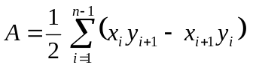,

for the area A of a polygon with vertices 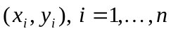, where vertices 1 and n correspond to the same point: 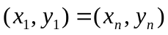. This formula assumes identical units for x and y (an aspect ratio 1), as in UTM coordinates. The function automatically converts longitude-latitude coordinates to UTM before calculating the area.
- calcCentroid computes polygon centroid coordinates by the formulas (Bourke 1988)

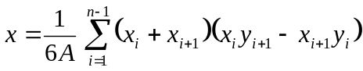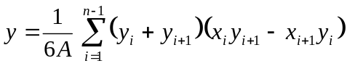
for a polygon with vertices , where vertices 1 and n correspond to the same point: and A is computed by the formula shown above in the definition of calcArea. These formulas scale automatically to the units of x and y and consequently do not depend on the projection attribute.
- calcConvexHull calculates the convex hull for a given set of points using the function chull() in R’s package grDevices.
- calcLength calculates polyline lengths using Pythagoras’ Theorem when the projection is UTM or 1. Thus, the distance d between points and 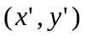 is

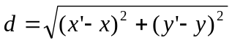.

The function also supports longitude-latitude coordinates by calculating great circle distances between polygon vertices. In this case, the distance d between two points is (Chamberlain 2001)

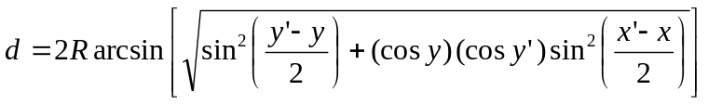,

where 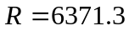 km denotes the earth’s mean radius (Wikipedia 2004).
- calcMidRange calculates midpoints of the X and Y ranges for each given polygon.
- calcSummary calculates summary statistics for a PolySet, given a user-defined function.
- calcVoronoi calculates the Voronoi (Dirichlet) tesselation for a set of points (using the deldir function from the package deldir) and creates a PolySet. See Figure 8 of the PBSmodelling user’s guide (Schnute et al. 2006) for an example called CalcVor.
- clipLines (and clipPolys) clips polylines (and polygons) within a specified rectangle, possibly smaller than the bounding rectangle, using the Sutherland-Hodgman clipping algorithm (Foley et al. 1996, p. 124-127).
- closePolys adds corners from the bounding rectangle, if needed, to close polylines into polygons.
- combinePolys combines several polygons into a single polygon by modifying the PID and SID indices.
- convCP converts results from contourlines into a PolySet.
- convDP converts EventData/PolyData into a PolySet.
- convLP converts two polylines into a polygon.
- convUL converts between UTM and longitude-latitude coordinates using the extensive formulas presented in Ordnance Survey (2010).
- dividePolys divides a single polygon (with several outer-contour components) into several polygons, a polygon for each outer contour, by modifying the PID and SID indices.
- findCells finds the cells in a grid PolySet that contain events specified in EventData, using the “crossings test” algorithm described later in this section.
- findPolys finds the polygons in a PolySet that contain events specified in EventData, using the “crossings test” algorithm described later in this section.
- isConvex determines which polygons in a PolySet are convex, using an algorithm described below.
- isIntersecting finds polygons that self-intersect by comparing each edge pairwise with every other edge.
- joinPolys performs set theoretic operations (union, intersection, difference, and exclusive-or) on polygons using the Clipper library developed by Angus Johnson (http://www.angusj.com/delphi/clipper.php). See Figure 13 of the PBSmodelling user’s guide (Schnute et al. 2006) for an example called FishTows (Fig.14 in most recent version).
- thickenPolys adds vertices to polygons using an algorithm described below.
- thinPolys thins the number of polygon vertices, based on the Douglas-Peuker line simplification algorithm (Douglas and Peucker 1973), as illustrated in Figure 4.

Our function isConvex first calls isIntersecting to determine whether or not a polygon self-intersects. If it does, it cannot be convex and the result is FALSE. Otherwise, the function proceeds. Three sequential points in a non-self-intersecting polygon describe a left turn, a straight line, or a right turn. The function locates the first non-straight turn (left or right) in a polygon and checks that all subsequent turns are either the same or straight. If so, the polygon is convex; otherwise it is not.

Like calcLength, thickenPolys also supports the longitude-latitude projection. In this case, tol is measured in kilometres and distances are computed along great circles (Chamberlain 2001).

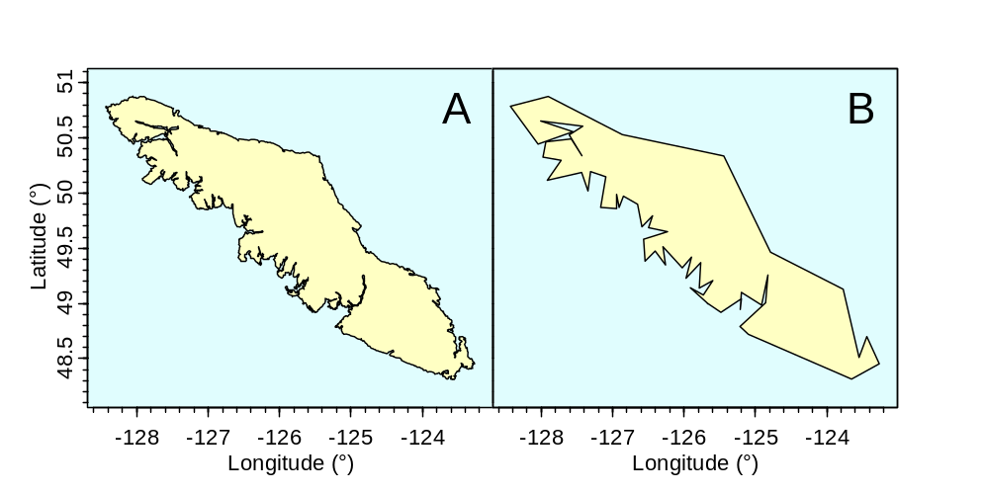

Figure 4. (A) Vancouver Island clipped from the PolySet nepacLL and (B) the result of applying thinPolys to this polygon with a tolerance of ten kilometres.Figure 4

When the projection is UTM or 1, our function thickenPolys accepts a tolerance specified in X or Y units (kilometres in the UTM case). It operates in two distinct modes. When keepOrig=TRUE, it retains all original vertices and adds vertices, as required, along each edge. Thus, if the distance between two sequential original vertices exceeds the specified tolerance tol, it adds enough vertices spaced evenly between them so that sequential vertices lie at most the distance tol apart. When keepOrig=FALSE, the algorithm guarantees only that the first vertex of each polygon appears in the result. Starting at that vertex, the algorithm walks through the polygon while summing distances between vertices. When the cumulative distance exceeds tol, it adds a vertex on the line segment under inspection. It then resets the distance sum and continues walking the polygon from this new vertex.

Associating Points with Polygons

As discussed in the definition of LocationSet (Section 2.1), our function findPolys solves the “points-in-polygons” problem. Given a set of points (EventData) and a collection of polygons (a PolySet), which points lie in which polygons? Several algorithms solve this problem, including:
- The crossings test. Draw a ray from the trial point in a fixed direction (e.g., upward). If the ray crosses an even number of polygon edges, the point must be outside. For an inside point, the number of crossings must be odd.
- The angle summation (or winding number) test. Sum the angles swept by a ray from the trial point to sequential vertices of the polygon. For a point outside the polygon, the angles sum to 0 because the ray sweeps back and forth, returning to the starting point. For an inside point, the ray traces a full circle, and the angles do not sum to zero.

We use the crossings test because it performs faster than angle summation (Hains 1994, p. 26-27). The latter requires large numbers of trigonometric function calls.

After finding the polygons that contain various events, an analyst often wants to compute statistics associated with the events that occur inside each polygon. For example, in a fishery context, what is the total catch from all fishing events within each management region? Our function combineEvents supports such calculations. The function makeProps can then relate polygon properties, such as colour used for plotting, to these computed statistical values.

Set Theoretic Operations

We include the function joinPolys to apply set theoretic operations (difference, intersection, union, and exclusive-or) to one or two PolySets. Our joinPolys function interfaces with the Clipper library (http://www.angusj.com/delphi/clipper.php) developed by Angus Johnson. Previously, it interfaced with the General Polygon Clipper library (http://www.cs.man.ac.uk/aig/staff/alan/software/) by Alan Murta at the University of Manchester. We keep this historic reference to GPC because joinPolys remains faithful to Murta’s definition of a generic polygon, which we describe below.

Murta (2004) defines a generic polygon (or polygon set) as zero or more disjoint polygonal contours that define boundaries of the polygon region. Some contours can represent inner boundaries that define holes in the region. Each contour can be convex, concave, or self-intersecting.

In our PolySet, the polygons associated with each unique PID correspond to a generic polygon with some restrictions. Some of our functions do not support self-intersecting polygons. Furthermore, the SID contours cannot be arranged in arbitrary order because we require that hole contours follow the outer contours in which they lie.

The function joinPolys can also accept two PolySet arguments P and Q. In this case, the function returns a PolySet with all possible pairwise applications of op between generic polygons in P and Q. For example, if P contains (A, B, C) and Q contains (D, E), then joinPolys returns a PolySet with six PIDs corresponding to the six generic polygons A op D, B op D, C op D, A op E, B op E, and C op E. More generally, if P and Q include m and n generic polygons, respectively, then the function returns a PolySet with generic polygons. If 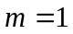 or 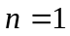, the output preserves PIDs from the PolySet with more than one generic polygon. Figure 5 illustrates the four supported set theoretic operations applied to crescent-shaped polygons A and B.

Applied to one PolySet P, our function joinPolys applies the set theoretic operation op sequentially to the generic polygons in P. For example, suppose that P contains three generic polygons (A, B, C). Then the function returns a PolySet containing the generic polygon ((A op B) op C), represented as one PID with possibly many SIDs.

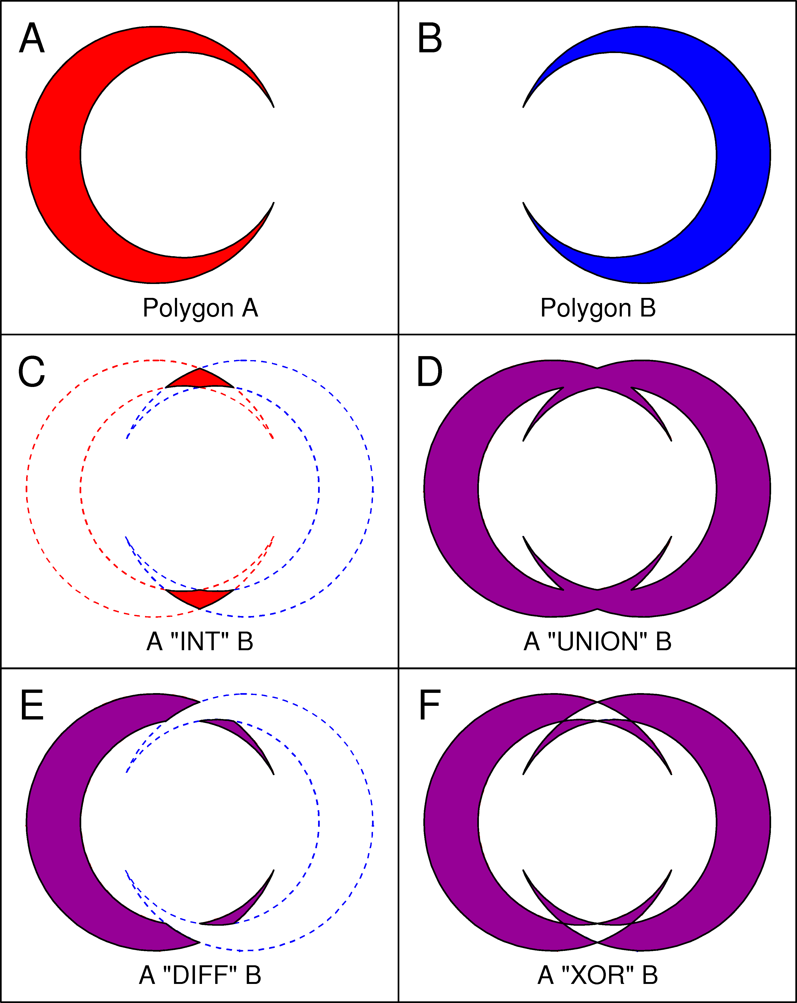
Figure 5. Example of the joinPolys logic operations. Panels A and B display the first and second PolySets, respectively. Panels C to F illustrate the intersection, union, difference, and exclusive-or operations, respectively. Figure 5

2.4. Shoreline Data

To portray fishery data along Canada’s Pacific coast, we need a PolySet that defines the relevant shoreline. Originally, we began with a polyline of the British Columbia coast, digitized manually from a marine map. To convert this object to a meaningful closed polygon, we devised the functions fixBound and closePolys. Satellite imagery and other sources, however, make our initial coastline obsolete. For example, Wessel and Smith (1996) have used information from the public domain to assemble a Global Self-consistent, Hierarchical, High-resolution Shoreline (GSHHS, http://www.soest.hawaii.edu/wessel/gshhs/gshhs.html) database for the entire planet. They make this available via the Internet as binary files in five different resolutions: full (gshhs_f.b), high (gshhs_h.b), intermediate (gshhs_i.b), low (gshhs_l.b), and crude (gshhs_c.b). They also supply software as C source code for .

- converting the data to an ASCII (plain text) format (gshhs.c);
- thinning the data by reducing the number of points sensibly (gshhs_dp.c).

Their thinning software uses an algorithm devised by Douglas and Peucker (1973), whose initials dp appear in the file name. The dp is also an abbreviation of “decimate polygons”.

We have created a function called importGSHHS that works directly on a specified binary data file from Wessel (resolution choice left to the user) to create a PBSmapping PolySet. The user can choose to further alter the resolution of the newly created PolySet using our function thinPolys. Alternatively, the user can thin Wessel’s full-resolution database (gshhs_f.b) directly using gshhs_dp.c (after compilation to an executable file) to a desired resolution, then use PBSmapping’s importGSHHS on the modified binary database. At the time of writing, importGSHHS supports Wessel’s format for data files version 2.2.0, created July 15, 2011. Wessel’s database gshhs+wdbii_2.2.0.zip contains geographical coordinates for shorelines (gshhs), rivers (wbd_rivers), and borders (wdb_borders). The latter two come from World DataBank II (WDBII) with the five resolutions mentioned above.

PBSmapping includes four data sets derived from the GSHHS databases (Table 2). These all use longitude-latitude (LL) coordinates. The nepac data sets contain the northeastern Pacific Ocean shoreline in a region that extends roughly from California to Alaska (Figure 2), and the world data sets cover the planet (Figure 1). As discussed in section 2.2, longitude coordinates x take continuous values meaningful for the intended map, with on the Greenwich prime meridian.

Table 2. PolySets derived from various resolution GSHHS databases. Table 2

PolySet | Wessel DB | Thin | Longitude | Latitude | Vertices | Polygons
nepacLL* | gshhs_h.b | 0.2 km | 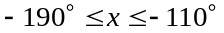 | 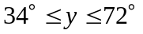 | 75,305 | 495
nepacLLhigh | gshhs_f.b | 0.1 km |  |  | 192,762 | 9,986
worldLL* | gshhs_l.b | 5.0 km | 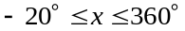 | 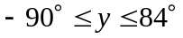 | 30,129 | 190
worldLLhigh* | gshhs_i.b | 1.0 km |  | 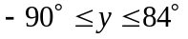 | 187,101 | 1,367

*Excludes polygons with fewer than 15 vertices after thinning.

Explicitly, the commands to create the above PolySets are:

worldLL <-importGSHHS("gshhs_l.b", xlim=c(-20,360), ylim=c(-90,90), level=1, n=15, xoff=0)
worldLL <- .fixGSHHSWorld(worldLL)

worldLLhigh <-importGSHHS("gshhs_i.b", xlim=c(-20,360), ylim=c(-90,90), level=1, n=15, xoff=0)
worldLLhigh <- .fixGSHHSWorld(worldLLhigh)

nepacLL <-importGSHHS("gshhs_h.b", xlim=c(-190,-110), ylim=c(34,72), level=1, n=15, xoff=-360)

nepacLLhigh <-importGSHHS("gshhs_f.b", xlim=c(-190,-110), ylim=c(34,72), level=1, n=0, xoff=-360)
nepacLLhigh <- thinPolys(nepacLLhigh, tol=0.1, filter=3)

2.5. Bathymetry Data

Smith and Sandwell (1997) have produced global seafloor topography from satellite altimetry and ship depth soundings. Their database appears on the Internet at http://topex.ucsd.edu/cgi-bin/get_data.cgi. A web-based data acquisition form allows users to extract a region after entering longitude and latitude coordinate ranges. Appendix B documents how to import their data for use with PBSmapping.

R provides a contour function to plot contour lines. This function lacks a save argument and does not return contour coordinates. Instead, the contourLines function accomplishes this task, giving a list that captures continuous contours as single polylines (Figure 6).
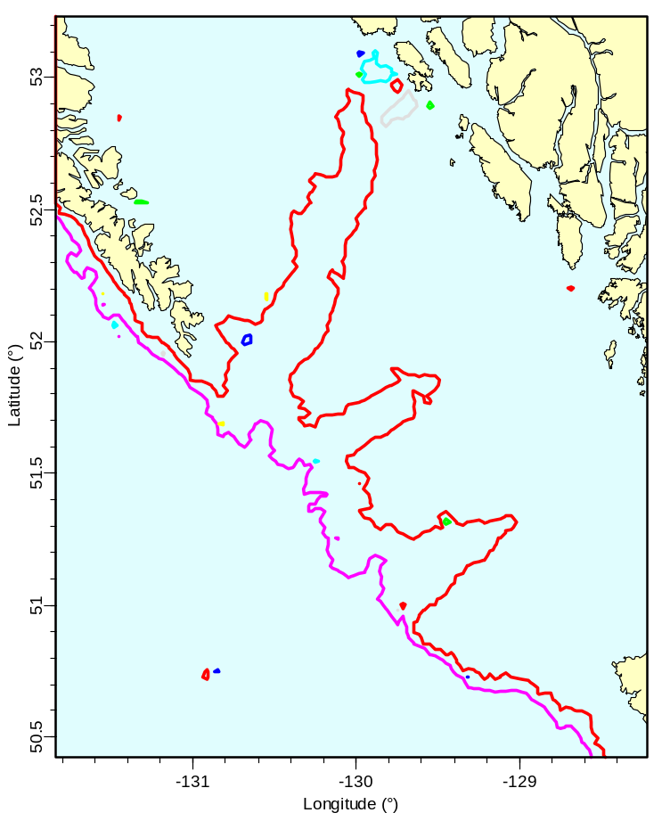
Figure 6. The R contourLines function returns a single polyline for each continuous contour. Figure 6

Our function convCP converts the list output from contourLines into a list object that has two components: a PolySet with contour coordinates and PolyData with the depth of each contour. The package PBSdata includes a data set (isobaths) of bathymetric contours for Canada’s Pacific coast. In addition, several functions ease the manual procedure of converting polylines into polygons, including

- convLP to convert two polylines into a single polygon;
- closePolys to close the polygons in a PolySet;
- fixBound to fix the boundary points of a PolySet.

2.6. Examples and Applications

Our library includes an illustrative PolySet towTracks containing the longitude-latitude coordinates of 45 tow tracks from a longspine thornyhead (Sebastolobus altivelis) survey in 2001. Figure 7 portrays these data relative to the west coast of Vancouver Island, drawn with shoreline data clipped from the PolySet nepacLL. The PolyData object towData specifies the depth of each tow, represented in the figure by colours corresponding to depth intervals (black = 500-800 m, red = 800-1200 m, dark blue = 1200-1600 m).

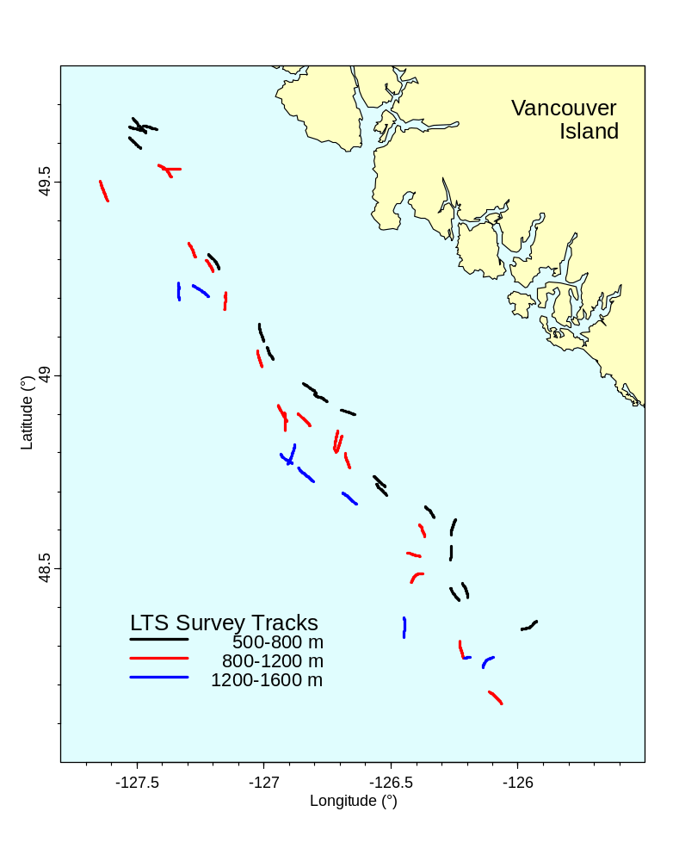
Figure 7. Tracks for 45 tows performed during the 2001 longspine thornyhead (Sebastolobus altivelis) survey along the west coast of Vancouver Island (Starr et al. 2002). Each tow track is colour-coded by depth stratum. Data: PolySet towTracks and PolyData towData. Figure 7

Figure 8 illustrates the use of our software to calculate polygon areas using the function calcArea. We examine a region along the south-west British Columbia coast that includes a cluster of islands in the Strait of Georgia. Shoreline data come from the PolySet nepacLLhigh. Because area calculations do not make sense in the longitude-latitude projection, we convert the PolySet to UTM coordinates, with comparable X and Y coordinates (km), and then clip to the desired region. (The calcArea function will also automatically convert PolySets with projection=“LL” to UTM before calculation.) The figure shows areas for six selected islands, highlighted in yellow. Island centroids, derived using calcCentroid, give reference coordinates for printing island names and areas.
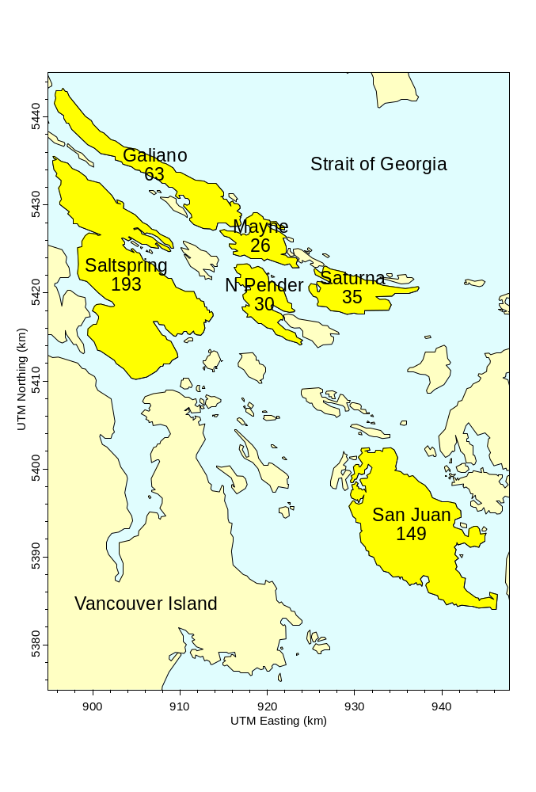
Figure 8. Areas (km²) of selected islands in the southern Strait of Georgia. Shoreline data have been clipped from nepacLLhigh after conversion to UTM coordinates. Figure 8

Figure 9 portrays data from Pacific ocean perch (Sebastes alutus) surveys conducted along the central BC coast during the years 1966-1989. The EventData object surveyData contains information from each tow, including the longitude, latitude, depth, catch, and effort (tow duration). These data also imply the computed value of catch per unit effort (CPUE = catch/effort). Code for this figure includes the following key function calls:

- plotMap to draw a coastal map of this region, clipped from nepacLL;
- makeGrid to create a grid in the region of interest;
- findCells to associate tows with the appropriate grid cells;
- combineEvents to calculate the mean CPUE within each cell;
- addPolys to draw cells with colours (in the polyProps argument) scaled to the CPUE;
- points (the native R function) to plot events on the map.
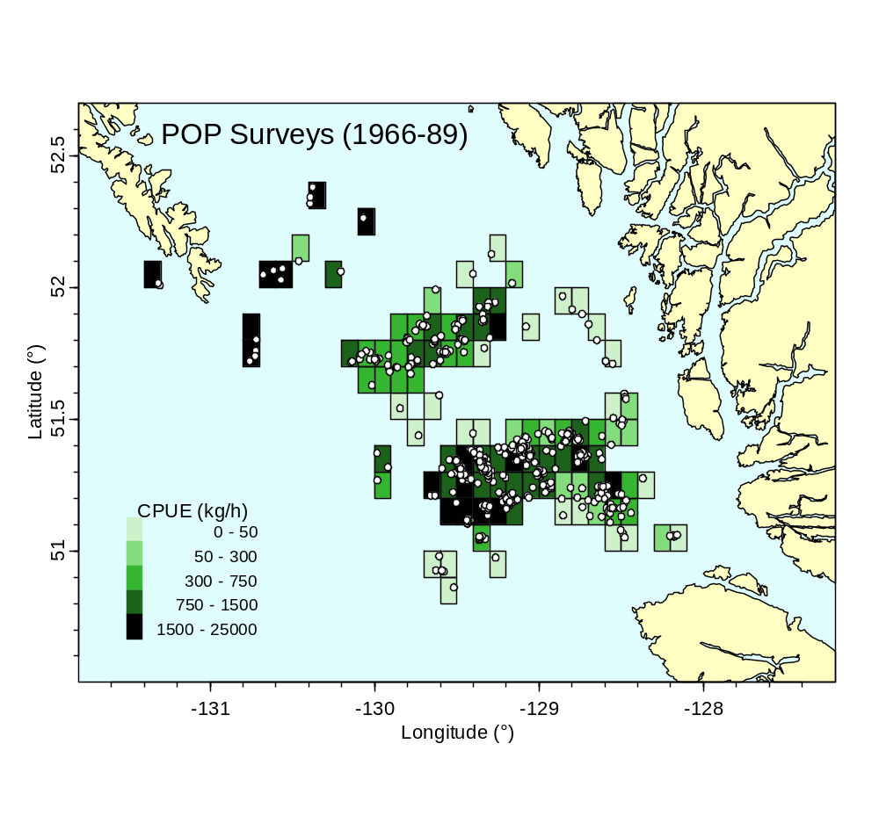
Figure 9. Portrayal of surveyData from Pacific ocean perch (Sebastes alutus) surveys in the central coast region of British Columbia from 1966-89, with shoreline data clipped from nepacLL. Colours portray the mean catch per unit effort (CPUE) within each grid cell (0.1º by 0.1º). Circles show locations of individual tows. Figure 9

PBSmapping can also display non-geographical data, such as technical drawings, network diagrams, and transportation schematics. For example, we use a PolySet to construct the proof of Pythagoras’ Theorem in Figure 10, where the caption explains the logic leading to the famous result 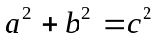. Incidentally, Devlin (1998, chapter 6, p. 221) mentions an historical incident that nicely distinguishes maps from network diagrams. A now familiar drawing of the London Underground (see the PDF file marked “Standard Tube map” at the web site http://www.tfl.gov.uk/gettingaround/1106.aspx) fails to represent geography correctly, but contains exactly the information passengers need to navigate the system. It took two years for the designer, Henry C. Beck, to persuade his superiors that his drawing would prove useful to the public.

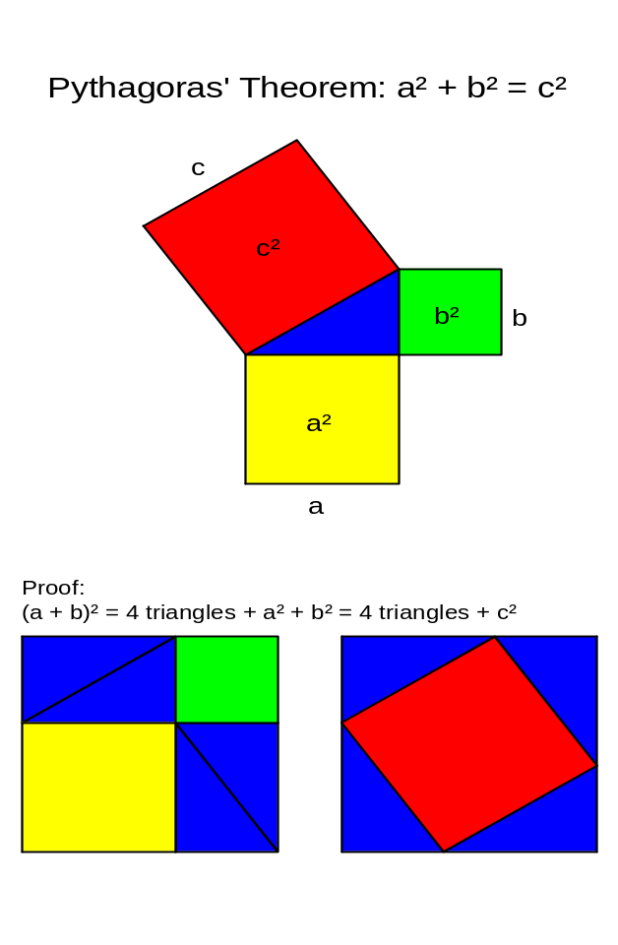
Figure 10. Proof of Pythagoras’ Theorem. A PolySet defines all geometric objects in this figure, and PolyData determine the colours for plotting. Four blue triangles plus the yellow square 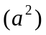 and the green square 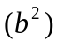 equal four blue triangles plus the red square 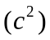; consequently, .Figure 10

2.7. Strengths, Limitations, and Alternatives

PBSmapping works with data exported from database tables, where records may not have a definite order. The POS field in our PolySet definition imposes the required order for polylines and polygons. This field also provides a convenient means of distinguishing inner and outer boundaries. Our PolySets have a flat structure with at most two levels, corresponding to primary and secondary IDs. We have found these limitations acceptable in the context of our work. Sceptical readers might challenge our choices and prefer more complex hierarchical structures. For example, Becker and Wilks (1993, 1995) define polygons as composites of polylines, so that a common boundary between two regions need be defined only once and then referenced in each regional definition. In our approach, all vertices of a common boundary must be repeated in each regional definition.

We designed our software explicitly to address a few key issues in the spatial representation of fishery data:

- easy importation from databases, Geographic Information Systems, and other sources, such as the shoreline data compiled by Wessel and Smith (1996);
- precise control over the boundaries chosen for clipping from a larger map;
- support for longitude-latitude and UTM easting-northing coordinates;
- computational ability to associate events with polygons in which they lie;
- flexible plotting tools that summarise events within grids and other polygons.
Different purposes could well lead to other designs.

In addition to their comprehensive shoreline database, Wessel and Smith have designed and released a free collection of Generic Mapping Tools (GMT; http://gmt.soest.hawaii.edu/) that provide a serious alternative to our software. These tools operate in the DOS/UNIX environment and support many more projections than PBSmapping. They also store polygons in a more efficient file format than our PolySet data frames. We designed PBSmapping for the R environment, with its rich support for statistical and mathematical analysis. We have also included numerous algorithms from computational geometry, such as findPolys and joinPolys. Readers may, however, find GMT more useful for map formats not supported in PBSmapping. Appendix C shows some comparative examples of code written in both environments.

Because PBSmapping includes features often supported by a Geographic Information System (GIS), a free GIS package might also provide an alternative to the software described here. The FreeGIS web site (http://www.freegis.org) summarizes the current status of free GIS programs and data. Their listings receive frequent updates and show a pattern of steady growth.

3. COMMAND-LINE UTILITIES

The PBSmapping package for R includes several algorithms that we have also implemented as stand-alone command-line utilities. These can handle very large data sets that may be too large for the R working environment. Furthermore, some users may wish to implement computational geometry calculations without reference to the R language. Our utilities make this possible by directly processing text files with the appropriate data format. They have been compiled with the same C code used for the dynamically linked library (DLL) in R. For each utility, a corresponding .c file provides a front end to shared code for the algorithms. Source code appears in the R library directory \PBSmapping\Utils\.

3.1. clipPolys.exe (Clip Polygons)

The application clipPolys.exe reads an ASCII file containing a PolySet (explained further below) and then clips it. The command

clipPolys.exe /i IFILE [/o OFILE] [/x MIN_X] [/X MAX_X] [/y MIN_Y] [/Y MAX_Y]

has five arguments as follows:

- /i IFILE ASCII input file containing a PolySet (required);
- /o OFILE ASCII output file (defaults to standard output);
- /x MIN_X lower X limit (defaults to minimum X in the PolySet);
- /X MAX_X upper X limit (defaults to maximum X in the PolySet);
- /y MIN_Y lower Y limit (defaults to minimum Y in the PolySet);
- /Y MAX_Y upper Y limit (defaults to maximum Y in the PolySet).

The first line of the PolySet input file must contain the field names (PID, SID, POS, X, Y), where SID is optional. Subsequent lines must contain the data, with the same number of fields per row as in the header line. All fields must be delimited by white space. The program generates a properly formatted PolySet. By default (unless otherwise specified by /o), this result goes to standard output, which can be redirected to a text file (e.g., > file.txt).

3.2. convUL.exe (Convert between UTM and LL)

The application convUL.exe reads an ASCII file containing two fields named X and Y, as described further below. The command

convUL.exe /i IFILE [/o OFILE] (/u | /l) [/m] /z ZONE

has the arguments:

- /i IFILE ASCII input file containing the X and Y data (required);
- /o OFILE ASCII output file (defaults to standard output);
- /u (or /l) convert to UTM (longitude-latitude) coordinates (required);
- /m use metres instead of kilometres as UTM measurement;
- /z ZONE source or destination zone for the UTM coordinates (required).

The input file must have an initial header line with field names, including X and Y. Subsequent lines contain the data, with all fields separated by white space. The program converts each (X, Y) pair to a new pair (X2, Y2). The output file matches the input file, with the fields (X2, Y2) appended to the end of each line. The default standard output can be redirected to a text file.

3.3. findPolys.exe (Points-in-Polygons)

The application findPolys.exe reads two ASCII files: one containing a PolySet and the other containing EventData. The program then determines which events fall inside the available polygons. The command

findPolys.exe /p POLY_FILE /e EVENT_FILE [/o OFILE]

has the arguments:

- /p POLY_FILE ASCII input file containing the PolySet (required);
- /e EVENT_FILE ASCII input file containing EventData (required);
- /o OFILE ASCII output file (defaults to standard output).

The header line in both input files must contain field names, and subsequent lines must contain the relevant fields of data delimited by white space. The PolySet must have field names (PID, SID, POS, X, Y), where SID is optional. The EventData must have fields (EID, X, Y). The program writes a properly formatted LocationSet with three or four columns (EID, PID, SID, Bdry), where SID may be missing (Section 2.1). The default standard output can be redirected to a text file.

ACKNOWLEDGEMENTS

We thank Dr. Jim Uhl and Dr. Peter Walsh in the Computing Science Department, Malaspina University-College, for encouraging and facilitating the role of students in applied fisheries research. Without the dedicated work of these students, named in the Preface, we could not have produced the software described here. We also acknowledge the valuable shoreline and bathymetry databases compiled by Dr. Paul Wessel, Dr. Walter Smith, and Dr. D. T. Sandwell (Wessel and Smith 1996; Smith and Sandwell 1997). In particular, we thank Dr. Paul Wessel for permission to redistribute data from the GSHHS database. Code from other authors seriously enhances this version of PBSmapping. Dr. Gary Robinson has kindly allowed us to use his code for a stack-based Douglas-Peuker line simplification routine, implemented in our thinPolys function. Our colleague Brian Krishka helped prepare various data objects. The PBSmapping package could not exist without R and GCC. We express admiration and gratitude to the remarkable teams that build, document, and distribute such outstanding free software.
REFERENCES

Anonymous. 1998. The ellipsoid and the Transverse Mercator projection. Geodetic Information Paper No. 1 (version 2.2). Ordnance Survey, Southampton, UK. 20 p. URL: http://www.ordsvy.gov.uk/.
Becker, R.A., Chambers, J.M., and Wilks, A.R. 1988. The new S language: a programming environment for data analysis and graphics. Wadsworth and Books/Cole. Pacific Grove, CA.
Becker, R.A., and Wilks, A.R. 1993. Maps in S. Statistics Research Report 93.2. AT&T Bell Laboratories, Murray Hill, NJ. 21 p. URL: http://www.research.att.com/areas/stat/doc/.
Becker, R.A., and Wilks, A.R. 1995 (rev. 1997). Constructing a geographical database. Statistics Research Report 95.2. AT&T Bell Laboratories, Murray Hill, NJ. 23 p. URL: http://www.research.att.com/areas/stat/doc/.
Boers, N.M., Haigh, R., and Schnute, J.T. 2004. PBS Mapping 2: developer’s guide. Canadian Technical Report of Fisheries and Aquatic Sciences 2550.
Bourke, P. 1988 Jul. Calculating the area and centroid of a polygon. URL: http://astronomy.swin.edu.au/~pbourke/geometry/polyarea/ Accessed Aug. 3, 2004.
Chamberlain, R. 2001 Feb. Q5.1: what is the best way to calculate the distance between 2 points. URL: http://www.census.gov/cgi-bin/geo/gisfaq?Q5.1 Accessed Aug. 3, 2004.
de Berg, M., van Kreveld, M., Overmars, M., and Schwarzkopf, O. 2000. Computational geometry: algorithms and applications: second edition. Springer: Berlin.
Devlin, K.J. 1998. The language of mathematics: making the invisible visible. W. H. Freeman and Company. New York, NY. 344 p. (Reference taken from the first paperback printing 2000)
Douglas, D.H., and Peucker, T.K. 1973. Algorithms for the reduction of the number of points required to represent a digitized line or its caricature. Canadian Cartographer 10:112-22.
Environmental Systems Research Institute (ESRI). 1996. ArcView GIS: the geographic information system for everyone. ESRI Press, Redlands, CA.
Foley, J.D., van Dam, A., Feiner, S.K., and Hughes, J.F. 1996. Computer graphics principles and practice: second edition in C. Addison-Wesley Publishing Co. Boston, MA.
Haigh, R., and Schnute, J. 1999. A relational database for climatological data. Canadian Manuscript Report of Fisheries and Aquatic Sciences 2472. 26 p.
Hains, E. 1994. Point in polygon strategies. Chapter 1.4, p. 24-46 in: Heckbert, P.S. 1994. Graphics Gems IV. Academic Press, San Diego, CA. 575 p.
Murta, A. 2004 Jul 15. General polygon clipper homepage. URL: http://www.cs.man.ac.uk/~toby/alan/software/ Accessed Aug. 3, 2004.
Ordnance Survey. (2010) A guide to coordinate systems in Great Britain. Report D00659 (v2.1). Southampton, UK.
URL: http://www.ordnancesurvey.co.uk/oswebsite/gps/docs/A_Guide_to_Coordinate_Systems_in_Great_Britain.pdf.
Rokne, J. 1996. The area of a simple polygon. p. 5-6 in: Arvo, J. 1996. Graphics Gems II. Academic Press. San Diego, CA. 672 p.
Rutherford, K.L. 1999. A brief history GFCATCH (1954-1995), the groundfish catch and effort database at the Pacific Biological Station. Canadian Technical Report of Fisheries and Aquatic Sciences 2299. 66 p.
Schnute, J.T., Boers, N.M., and Haigh, R. 2003. PBS Software: maps, spatial analysis, and other utilities. Canadian Technical Report of Fisheries and Aquatic Sciences 2496: 82 p.
Schnute, J.T., Couture-Beil, A., and Haigh, R. 2006. PBS Modelling 1: user’s guide. Canadian Technical Report of Fisheries and Aquatic Sciences 2674: viii + 114 p.
Schnute, J.T., Haigh, R., Krishka, B.A., and Starr, P. 2001. Pacific ocean perch assessment for the west coast of Canada in 2001. Canadian Science Advisory Secretariat (CSAS) Research Document 2001/138. 90 p.
Schnute, J.T., Wallace, C.G., and Boxwell, T.A. 1996. A relational database shell for marked Pacific salmonid data (Revision 1). Canadian Technical Report of Fisheries and Aquatic Sciences 2090A. 28 p.
Sinclair, C.A., and Olsen N. 2002. Groundfish research cruises conducted by the Pacific Biological Station, Fisheries and Oceans Canada, 1944-2002. Canadian Manuscript Report of Fisheries and Aquatic Sciences 2617. 91 p.
Sipser, M. 1997. Introduction to the theory of computation. PWS Publishing Company. Boston, MA. 396 p.
Smith, W.H.F., and Sandwell, D.T. 1997. Global seafloor topography from satellite altimetry and ship depth soundings. Science 277:1957-1962.
Starr, P.J., Krishka, B.A., and Choromanski, E.M. 2002. Trawl survey for thornyhead biomass estimation off the west coast of Vancouver Island, September 15 – October 2, 2001. Canadian Technical Report of Fisheries and Aquatic Sciences 2421. 60 p.
Venables, W.N., and Ripley, B.D. 1999. Modern applied statistics with S-PLUS (3rd Edition). Springer-Verlag. New York, NY. 501 p.
Venables, W.N., and Ripley, B.D. 2000. S programming. Springer-Verlag. New York, 264 p.
Wessel, P., and Smith, W.H.F. 1996. A global, self-consistent, hierarchical, high-resolution shoreline database. Journal of Geophysical Research 101:8741-8743. URL: http://www.soest.hawaii.edu/pwessel/pwessel_pubs.html.
Wikipedia. 2004. Earth radius. URL: http://en.wikipedia.org/wiki/Earth_radius Accessed Aug. 19, 2004.
Wirth, N. 1975. Algorithms + data structures = programs. Prentice-Hall. Englewood Cliffs, NJ. 366 p.
Appendix A. PBSdata packageA

This appendix documents the objects available in the R-package PBSdata, which is not distributed on CRAN but remains available on Google Code: http://code.google.com/p/pbs-data/. Fisheries and Oceans personnel can also obtain the package from the PBS Intranet website: http://svbcpbsgfiis/sql/. Look for a link on the left entitled “Most recent PBS R Packages”.

Table A1. Data sets available in PBSdata. Table A1

Object | Description
bctopo | Topo: British Columbia Sea Floor Topography
bgcp | Topo: Biogeochemical Provinces
claradat | Data: Tow Catches of Species in Queen Charlotte Sound
dbr.rem | Data: Annual Catches of Rockfish by Sector
eez.bc | Topo: Exclusive Economic Zone for BC Coast
fos.fid | Code: Fishery Codes in GFFOS
gear | Code: Gear Codes for Various DFO Databases
hsgrid | Topo: Hecate Strait Assemblage Survey Grid
hsisob | Topo: Hecate Strait Isobaths
hssa | Topo: Hecate Strait Survey Area
iphc.rbr | Data: Longline Indices of Rockfish Catch from the IPHC SSA
iphc.rer | Data: Longline Indices of Rockfish Catch from the IPHC SSA
iphc.yyr | Data: Longline Indices of Rockfish Catch from the IPHC SSA
isobath | Topo: Isobaths (100 to 1800 m, at 100 m intervals)
locality | Topo: Localities in Pacific Marine Fisheries Commission Minor Areas
ltea | Topo: Longspine Thornyhead Exploratory Management Areas
ltmose07 | Topo: Longspine Thornyhead Fishing Grounds (WCVI)
ltmose12 | Topo: Longspine Thornyhead Fishing Grounds (WCVI)
ltsa | Topo: Longspine Thornyhead Survey Strata (WCVI)
ltsa.bad | Topo: No-Trawl Zones in Longspine Thornyhead Survey Area
ltxa | Topo: Longspine Thornyhead Experimental Management Areas
major | Topo: Pacific Marine Fisheries Commission Major Areas
minor | Topo: Pacific Marine Fisheries Commission Minor Areas
nage394 | Data: Age Frequency by Year for Rougheye Rockfish
orfhistory | Data: Historic Landings of Rockfish in BC
parVec | Data: Initial Parameter Vector for Model Fits
pcoda | Topo: Hecate Strait Pacific Cod Monitoring Survey Areas
pjsa | Code: Paul J Starr Locality Codes
pl230 | Topo: 230 Degree True Line from Lookout Island
pmfc | Code: Pacific Marine Fisheries Commission Areas
pop.age | Data: Pacific Ocean Perch Age Data (5AB, 5CD)
pop.pmr.qcss | Data: Pacific Ocean Perch (p, mu, rho) for QCS Synoptic Survey
popa | Topo: Pacific Ocean Perch Population Areas
qcb | Topo: Queen Charlotte Basin Surficial Geology
qcssa | Topo: Queen Charlotte Sound Survey Strata
rca | Topo: Rockfish Conservation Areas
species | Code: Species Codes and Names
spn | Code: Species Code Vector
srfa | Topo: Slope Rockfish Assessment Areas
srfs | Topo: Slope Rockfish Assessment Subareas
testdatC | Data: Fisheries Catch Data with Species by Column
testdatR | Data: Fisheries Catch Data with Species by Row
trawlability | Topo: Fisher Knowledge of Towable Bottom
utilize | Code: Utilization Codes for Various DFO Databases
wchgsa | Topo: West Coast Haida Gwaii Survey Area
wcvisa | Topo: West Coast of Vancouver Island Survey Strata
ymr.rem | Data: Annual Catches of Rockfish by Sector

Appendix B. Bathymetry DataB

Smith and Sandwell (1997) have produced a global seafloor topography database from satellite altimetry and ship depth soundings. Using the web-based data acquisition form at http://topex.ucsd.edu/cgi-bin/get_data.cgi, users can extract a region from this database. The form returns an ASCII file containing X, Y, and Z coordinates. To use this data file with PBSmapping, first load it into R with the native function read.table, which creates a data frame with three fields. Our function makeTopography can convert this data frame to a list object with vectors x and y and an outer product matrix z, ready for use by the functions contour or contourLines. In particular, contourLines produces a list object that can be easily converted to a PolySet using convCP, which in turn produces a list object consisting of a PolySet (with contour coordinates) and PolyData (with the depth of each contour).

Example
Bathymetry for a small section of the Aleutian Islands, Alaska,
where a user would specify coordinates xlim=c(-162,-158) and ylim=c(53,57) in the web-based acquisition form referenced above, and save Topography to a file called aleutian.txt (also provided in the library directory PBSmapping\extra\).

require(PBSmapping);
isob <- c(100,500,1000,2500,5000);
icol <- rgb(0,0,seq(255,100,len=length(isob)),max=255);

afile <- paste(system.file(package="PBSmapping"),
"/extra/aleutian.txt",sep="")
aleutian <- read.table(afile, header=F,col.names=c("x","y","z"))
aleutian$x <- aleutian$x - 360
aleutian$z <- -aleutian$z
alBathy <- makeTopography(aleutian)
alCL <- contourLines(alBathy,levels=isob)
alCP <- convCP(alCL)
alPoly <- alCP$PolySet
attr(alPoly,"projection") <- "LL"

plotMap(alPoly,type="n");
addLines(alPoly,col=icol);
data(nepacLL); addPolys(nepacLL,col="gold");
legend(x="topleft",bty="n",col=icol,lwd=2,legend=as.character(isob));
Appendix C. Generic Mapping Tools (GMT) C

Generic Mapping Tools (GMT) and PBSmapping have many similar features, although they operate in different environments. We built PBSmapping for the R statistical platform, whereas Wessel and Smith developed GMT to run as commands for the UNIX operating system. Each environment imposes limitations on its respective tools. The following discussion focuses on image types, one of the fundamental areas where the programs differ.

Images are commonly stored in two basic formats, raster and vector. The raster (or bit map) format uses a grid of squares, where each square is assigned characteristics like colour and transparency. The image’s resolution, often measured in “dots per inch”, determines the density of the grid. When this density is less than the resolution of the output device, the image may appear jagged because distinct squares are visible. Choosing a sufficiently high-resolution image for an output device may result in a large file size. The vector format stores coordinates for control points of lines, curves, and other shapes. Scaling algorithms use these coordinates to produce an image at any specified size with a consistently smooth appearance. In a mapping context, vector formats are usually preferred over raster formats.

Unlike R, the UNIX environment does not have native support for generating images. Wessel and Smith decided that GMT programs would output (optionally encapsulated) postscript files. This vector-based format is more popular in UNIX than Windows and is poorly supported by some word processors, such as Microsoft Word. On the other hand, PBSmapping inherits support from the R environment for common raster (e.g., BMP, JPG) and vector (e.g., WMF) file formats. Users of Windows operating systems may find PBSmapping’s output somewhat more convenient than that from GMT.

Converting GMT’s postscript output to a better-supported graphics format can be achieved through the Ghostscript graphical user interface GSview (http://www.cs.wisc.edu/~ghost/gsview/). Through an option in GSview’s “Edit” menu, the program converts PS files to the popular EMF and WMF vector formats. However, we obtained somewhat erratic results from this process and had greater success with raster images produced with the convert option in the “File” menu.

Figure C1 and Figure C2 compare PBSmapping with GMT. We show the code used to produce these images in both environments. Although one R command can span multiple lines, one GMT command cannot. For clarity, however, we span GMT commands across multiple lines in the listing below. In familiar UNIX notation, we indicate spanning by escaping the new-line character with a backslash (\).
Code for Figure C1
R: (Panel A)
data(nepacLL); # load the nepacLL data set
plotMap(nepacLL, # plot the nepacLL data set
xlim=c(-129.3, -122.2), # limit the region horizontally
ylim=c(47.5, 51.5), # limit the region vertically
plt=c(0.16, 0.97, 0.16, 0.97), # specify the plot region size
col=rgb(255, 255, 195, # set the foreground colour
maxColorValue=255),
bg=rgb(224, 253, 254, # set the background colour
maxColorValue=255),
tck=c(-0.03), # set the tick mark length
cex = 1.8, # adjust the font size
mgp=c(1.9, 0.7, 0)); # adjust the axis label locations

GMT: (Panel B)
gmtset ANOT_FONT_SIZE = 26p # set the annotation font size
pscoast –Dh \ # plot the high resolution data set
-A0/0/1 \ # skip inner polygons (holes)
-R-129.3/-122.2/47.5/51.5 \ # limit the region horizontally and vertically
-JM7i \ # use the Mercator projection, 7 inches wide
-G255/255/195 \ # set the foreground colour
-S224/253/254 \ # set the background colour
-Ba2/a1WSne \ # mark every 2 (X) and 1 (Y) degrees on W & S axes
-W0.5p \ # set the pen width to 0.5 points
-P \ # portrait mode
> GMT-VI.ps # output to the postscript file GMT-VI.ps

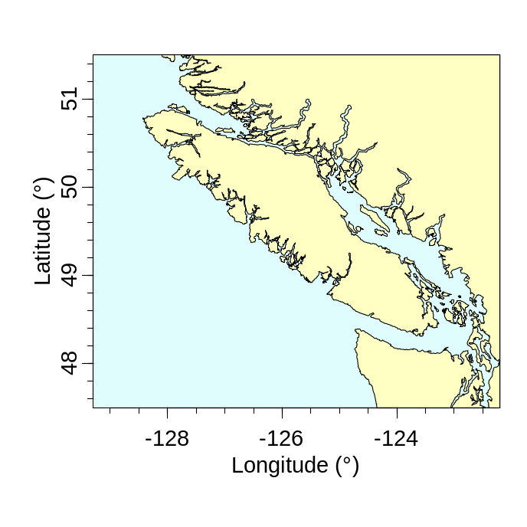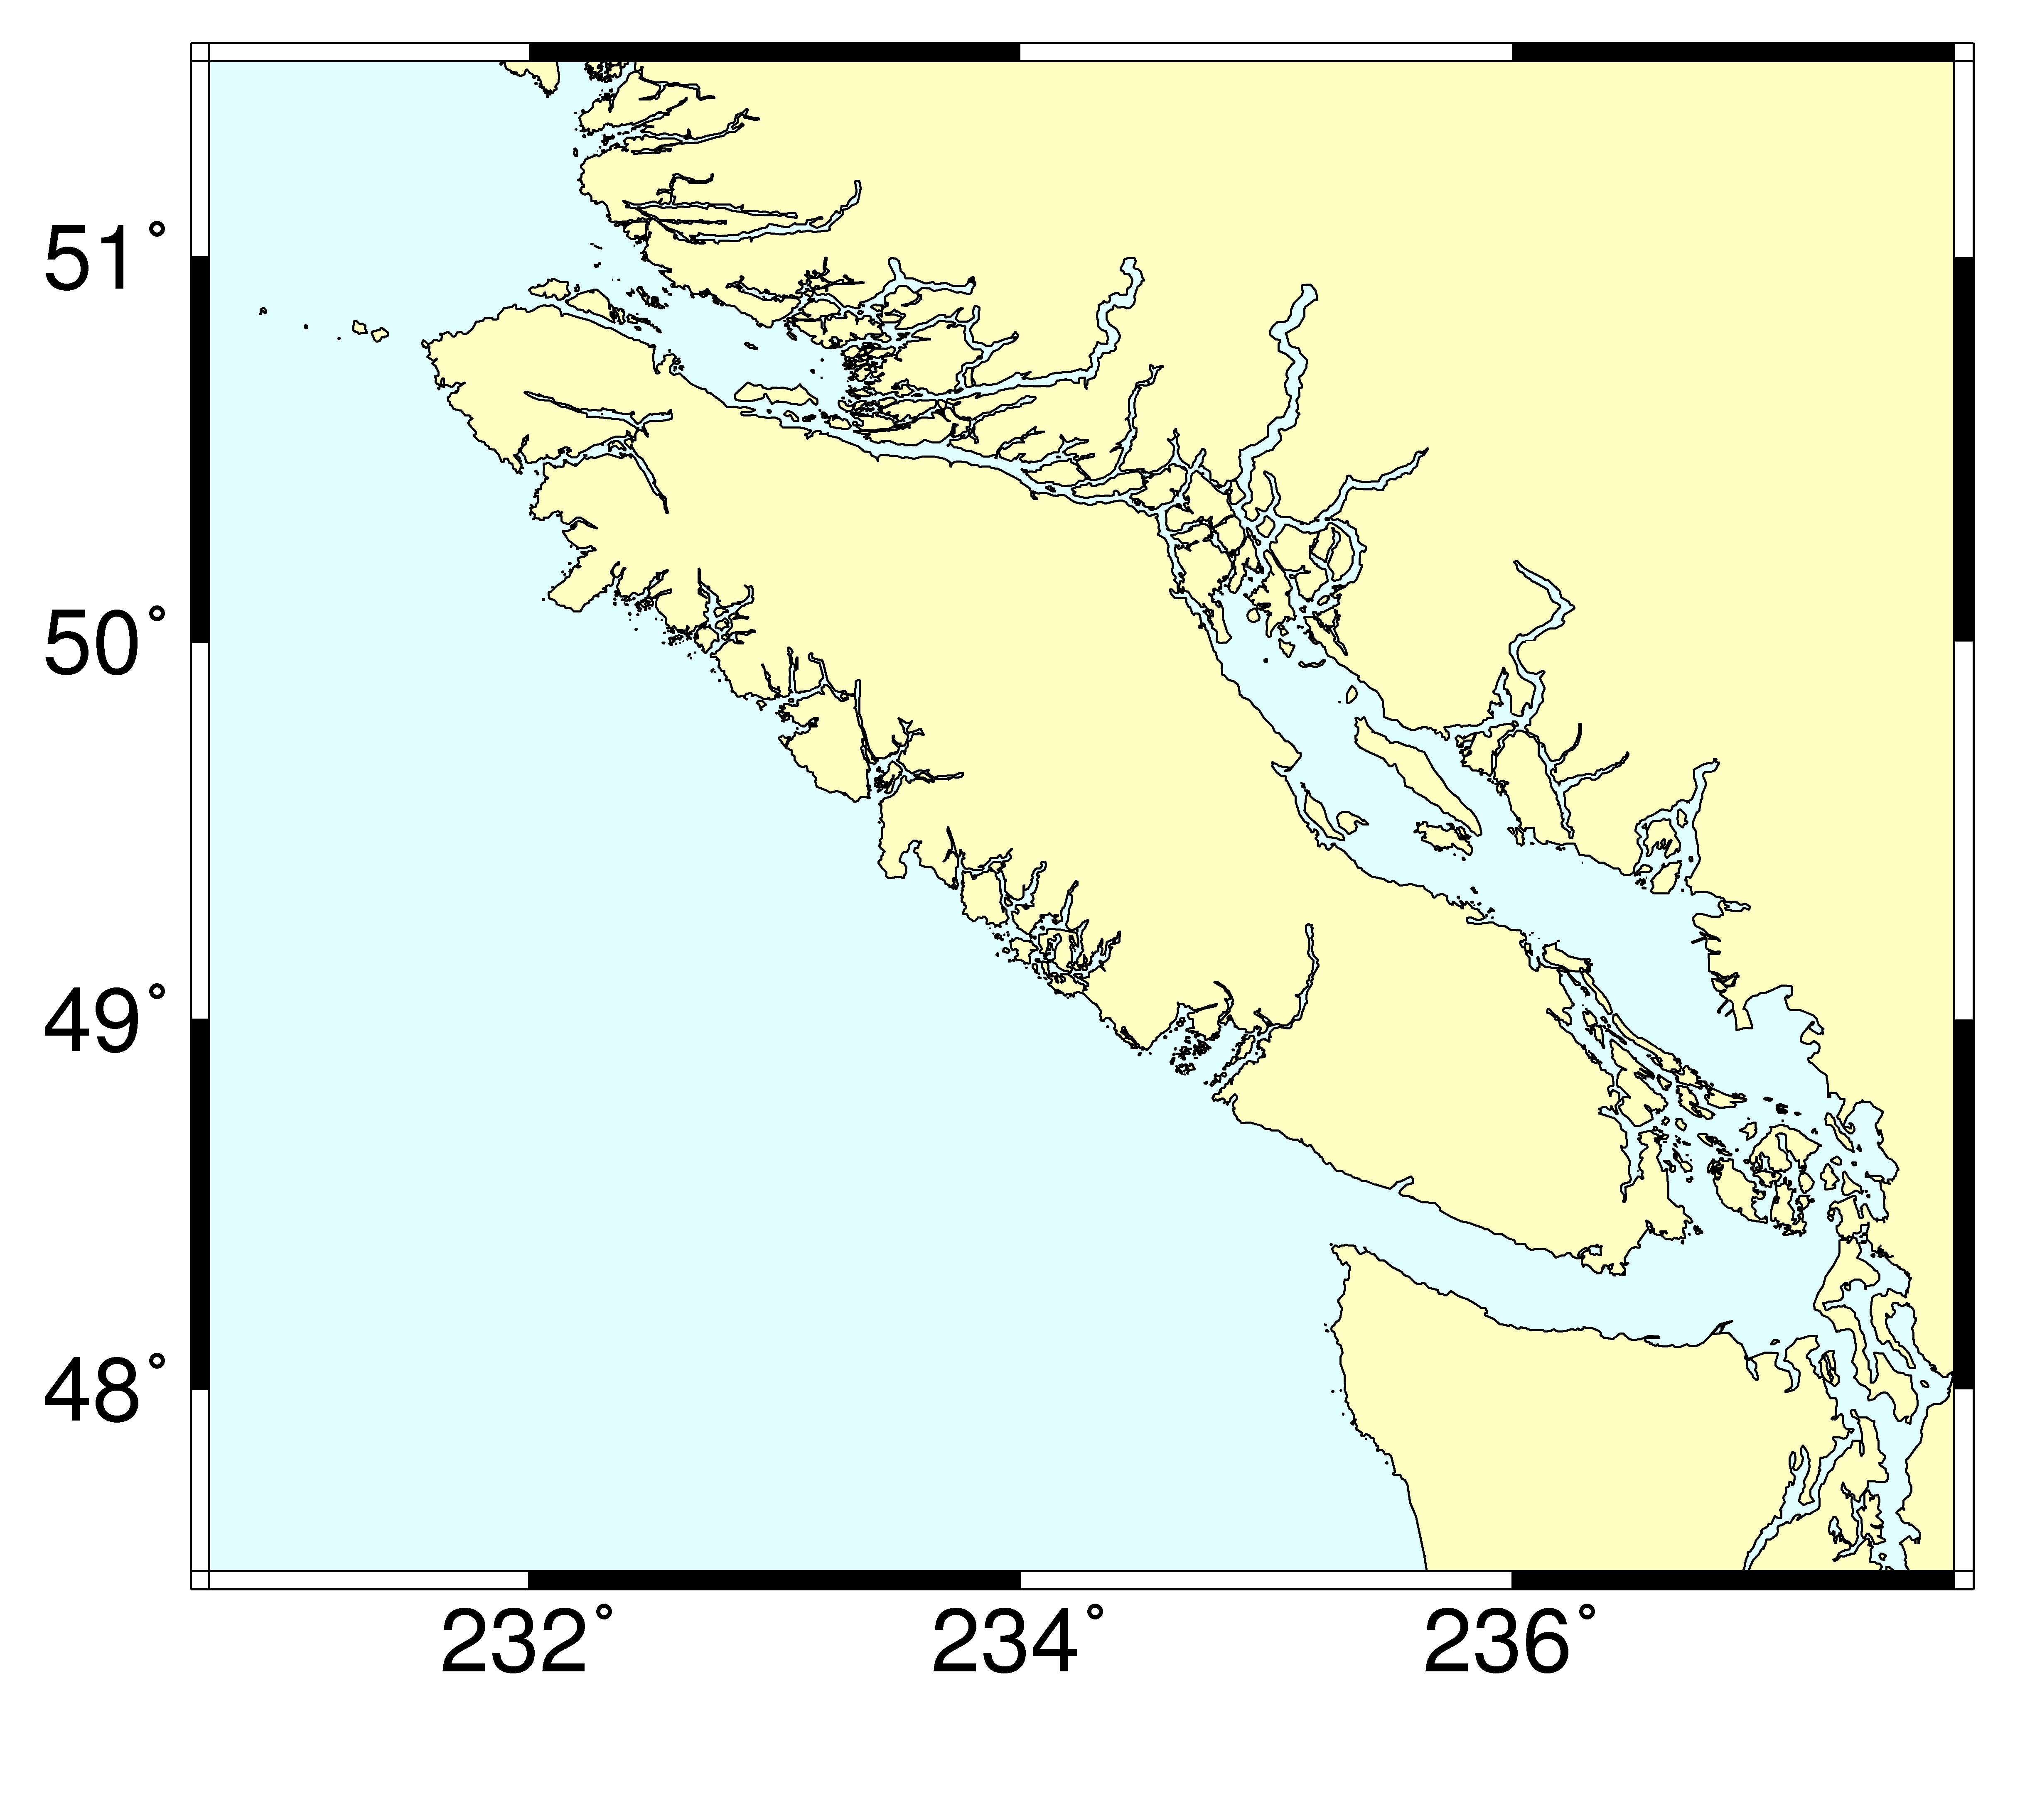
A
B

Figure C1. (A) Vancouver Island, as plotted in PBSmapping, compared with (B) the same region as output from GMT. Figure C1

Code for Figure C2
R: (Panel A)
data(nepacLL); # load the nepacLL data set
plotMap(nepacLL, # plot the nepacLL data set
xlim=c(-127.89, -125.68), # limit the region horizontally
ylim=c(47.85, 49.97), # limit the region vertically
plt=c(0.16, 0.97, 0.16, 0.97), # specify the plot region size
col=rgb(255, 255, 195, # set the foreground colour
maxColorValue=255),
bg=rgb(224, 253, 254, # set the background colour
maxColorValue=255),
tck=c(-0.03), # set the tick mark length
cex=1.8, # adjust the font size
mgp=c(1.9, 0.7, 0)); # adjust the axis label locations
data(towTracks); # load the towTracks data set
addLines(towTracks, # add the towTracks data set
col=rgb(255, 0, 0, # set the colour
maxColorValue=255),
lwd=0.5); # set the line width

GMT: (Panel B)
gmtset ANOT_FONT_SIZE = 20p # set the annotation font size
pscoast -Dh \ # plot the high resolution data set
-R-127.89/-125.68/47.85/49.97 \ # limit the region horizontally and vertically
-JM5i \ # use the Mercator projection, 5 inches wide
-G255/255/195 \ # set the foreground colour
-S224/253/254 \ # set the background colour
-Ba0.5/a0.5WSne \ # mark every 0.5 (X) and 0.5 (Y) degrees on W & S axes
-W0.5p \ # set the pen width to 0.5 points
-P \ # portrait mode
-K \ # allow for appending more plot code
> GMT-Tow.ps # output to the postscript file GMT-Tow.ps
psxy -R-127.89/-125.68/47.85/49.97 \ # limit the region
-JM5i \ # add using the Mercator projection, 5 inches wide
-W0.5p/255/0/0 \ # set the pen width to 0.5 points and set the colour
-M \ # ASCII file contains multiple polylines
-H0 \ # ASCII file does not contain a header
-O \ # overlay; lay plot on top of earlier one
< GMT-Tow.txt \ # input ASCII file GMT-Tow.txt
>> GMT-Tow.ps # append output to the postscript file GMT-Tow.ps

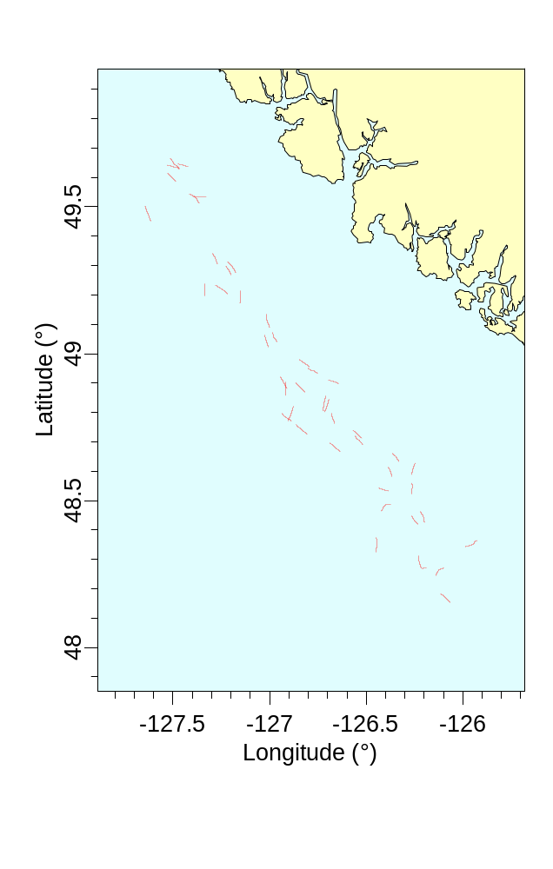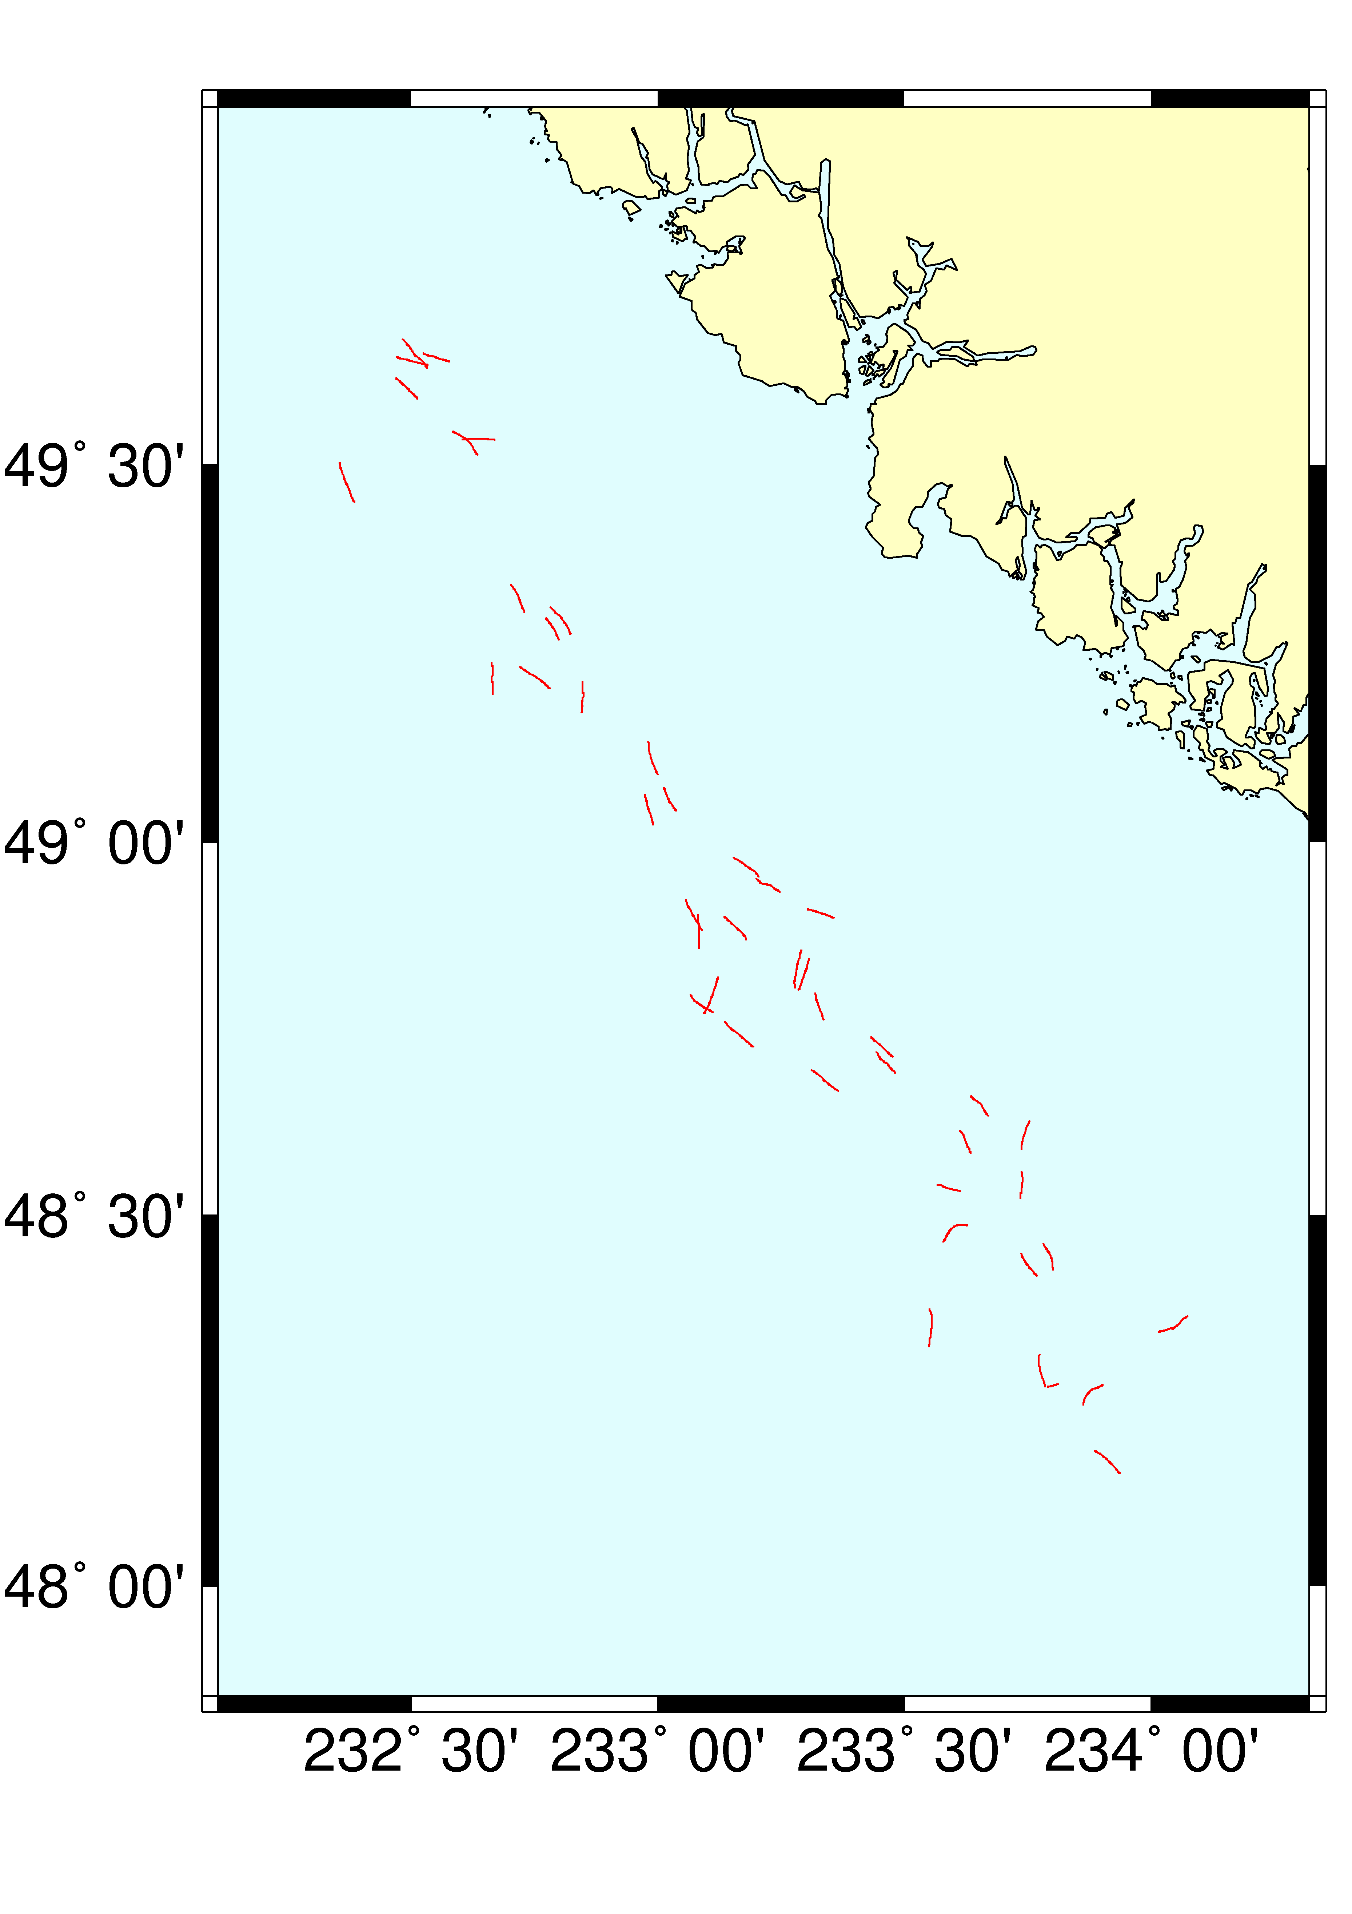
B
A

Figure C2. Tow tracks off the west coast of Vancouver Island drawn by (A) PBSmapping (B) GMT produced (B). Figure C2

Format of GMT-tow.txt:
> # a ‘>’ signifies the start of each polyline
-126.26545 48.523133 # vertices follow: X coordinate, white space, Y coordinate
-126.265233 48.523716
-126.265183 48.524283
…
>
-126.385483 48.532567
-126.3861 48.5327
-126.3868 48.53285
…
Appendix D. Source Code for FiguresD

To help beginners use PBSmapping, we include source code for all figures in this report. A global function .PBSclr provides the colours for the examples, and default dots and dashes are provided by .PBSdot and .PBSdash, respectively. These objects are exported from the NAMESPACE and are globally available once PBSmapping is loaded.

Global colours, dots, and dashes
# Figures for PBSmapping examples (last modified: 2013-04-10)
#------------------------------------------------------------
# Historical values for compatibilityy with S-Plus (defunct)
.PBSdot <- 3; .PBSdash <- 2
.PBSclr <- function(){
PBSclr = list( black=c(0,0,0),
sea=c(224,253,254), land=c(255,255,195), red=c(255,0,0),
green=c(0,255,0), blue=c(0,0,255), yellow=c(255,255,0),
cyan=c(0,255,255), magenta=c(255,0,255), purple=c(150,0,150),
lettuce=c(205,241,203), moss=c(132,221,124), irish=c(54,182,48),
forest=c(29,98,27), white=c(255,255,255), fog=c(223,223,223) )
PBSclr <- lapply(PBSclr,function(v) {rgb(v[1],v[2],v[3],maxColorValue=255) })
return(PBSclr) }

Figure 1 – World UTM Zones
.PBSfig01 <- function() { # World UTM Zones
clr <- .PBSclr()
data(worldLL,nepacLL,envir=sys.frame(sys.nframe()))
par(mfrow=c(1,1),omi=c(0,0,0,0)) #------Plot-the-figure------
plotMap(worldLL, ylim=c(-90, 90), bg=clr$sea, col=clr$land, tck=-0.023,
mgp=c(1.9, 0.7, 0), cex=1.2, plt=c(.08,.98,.08,.98))
# add UTM zone boundaries
abline(v=seq(-18, 360, by=6), lty=1, col=clr$red)
# add prime meridian
abline(v=0, lty=1, lwd=2, col=clr$black)
# calculate the limits of the 'nepacLL' PolySet
xlim <- range(nepacLL$X) + 360
ylim <- range(nepacLL$Y)
# create and then add the 'nepacLL' rectangle
region <- data.frame(PID=rep(1,4), POS=1:4, X=c(xlim[1],xlim[2],xlim[2],xlim[1]),
Y=c(ylim[1],ylim[1],ylim[2],ylim[2]))
region <- as.PolySet(region, projection="LL")
addPolys(region, lwd=2, border=clr$blue, density=0)
# add labels for some UTM zones
text(x=seq(183.2, by=6, length=9), y=rep(85,9), adj=0.5, cex=0.65, label=1:9)
box() }

Figure 2 – nepacLL UTM Zones in LL Space
.PBSfig02 <- function() { # nepacLL UTM Zones in LL Space
clr <- .PBSclr(); dot <- .PBSdot
data(nepacLL,envir=sys.frame(sys.nframe()))
par(mfrow=c(1,1),omi=c(0,0,0,0)) #------Plot-the-figure------
plotMap(nepacLL, col=clr$land, bg=clr$sea, tck=-0.014,
mgp=c(1.9,0.7,0), cex=1.2, plt=c(.08,.98,.08,.98))
# add lines separating UTM zones
utms <- seq(-186, -110, 6)
abline(v=utms, col=clr$red)
# add the central meridian of zone 6
abline(v=-147, lty=dot, col=clr$black)
# create and then add labels for the UTM zones
cutm <- diff(utms) / 2
nzon <- length(cutm)
cutm <- cutm + utms[1:nzon]
text(cutm,rep(50.75,nzon),c(60,1:(nzon-1)),cex=1.3,col=clr$red)
box() }

Figure 3 – nepacLL UTM Zones in UTM Space
.PBSfig03 <- function() { # nepacLL UTM Zones in UTM Space
clr <- .PBSclr(); dot <- .PBSdot
data(nepacLL,envir=sys.frame(sys.nframe()))
zone <- 6; xlim <- range(nepacLL$X); ylim <- range(nepacLL$Y)
utms <- seq(-186,-110,6) #'utms' vector for creating PolySet and EventData below
# create UTM zones
lutms <- data.frame(PID=rep(1:length(utms), each=2),
POS=rep(c(1,2), times=length(utms)), X=rep(utms,each=2),
Y = rep(c(ylim[1], ylim[2]), times=length(utms)))
lutms <- as.PolySet(lutms, projection="LL", zone=zone)
lutms <- thickenPolys(lutms, tol=25, close=FALSE)
uutms <- convUL(lutms)
# create label locations (central meridians)
lcms <- data.frame(EID=1:(length(diff(utms)/2)),
X=utms[1:(length(utms)-1)]+diff(utms)/2,
Y=rep(50.75, length(diff(utms)/2)))
lcms <- as.EventData(lcms, projection="LL", zone=zone)
ucms <- convUL(lcms)
nepacUTM <- nepacLL; attr(nepacUTM,"zone") <- zone # convert to correct zone
nepacUTM <- convUL(nepacUTM)
par(mfrow=c(1,1),omi=c(0,0,0,0)) #------Plot-the-figure------
plotMap(nepacUTM, col=clr$land, bg=clr$sea, tck=-0.017,
mgp=c(1.9,0.7,0), cex=1.0, plt=c(0.07,0.97,0.07,0.98))
addLines(uutms, col=clr$red)
lines(x=c(500, 500),y=c(4100,7940),lty=dot,col=clr$black)
text(ucms$X,ucms$Y,c(60,1:(length(utms)-2)),cex=1.3,col=clr$red)
box() }

Figure 4 – thinPolys on Vancouver Island
.PBSfig04 <- function() { # thinPolys on Vancouver Island
clr <- .PBSclr();
data(nepacLL,envir=sys.frame(sys.nframe()))
par(mfrow=c(1,2),omi=c(0,0,0,0)) #------Plot-the-figure------
vi <- nepacLL[nepacLL$PID==33,]
xlim <- range(vi$X) + c(-0.25, 0.25); ylim <- range(vi$Y) + c(-0.25, 0.25)
# plot left figure (normal Vancouver Island)
plotMap(vi, xlim, ylim, col=clr$land, bg=clr$sea, tck=-0.028,
mgp=c(1.9,0.7,0), cex=1.0, plt=c(0.14,1.00,0.07,0.97))
text(x=xlim[2]-0.5, y=ylim[2]-0.3, "A", cex=1.6)
# plot right figure (thinned Vancouver Island)
plotMap(thinPolys(vi, tol=10), xlim, ylim, col=clr$land, bg=clr$sea,
tck=c(-0.028, 0), tckLab=c(TRUE, FALSE),
mgp=c(1.9, 0.7, 0), cex=1.0, plt=c(0.00, 0.86, 0.07, 0.97))
text(x=xlim[2]-0.5, y=ylim[2]-0.3, "B", cex=1.6)
box() }
Figure 5 – joinPolys on Crescents
.PBSfig05 <- function() { # joinPolys on Crescents
clr <- .PBSclr(); dash <- .PBSdash
radius <- c(5, 4) # two radii of the circles
size <- abs(diff(radius)) + 0.1 # size of crescent
shiftB <- 3.5 # distance to shift second crescent
pts <- 120 # points in outer circle
cex <- 1.0 # character expansion for labels
off <- 1.2 # panel label offset
xlim <- c(0, radius[1]*2 + shiftB) + c(-1,1)
ylim <- c(0, radius[1]*2) + c(-2,1)
Mmin <- .10 # minimum OMI
Rdin <- par()$din[2]/par()$din[1]
Rfig <- (3*diff(ylim))/(2*diff(xlim))
if (Rdin > Rfig) {
width <- par()$din[1] - 2 * Mmin
height <- width * (3*diff(ylim))/(2*diff(xlim))
Mmax <- (par()$din[2] - height) / 2
parOmi <- c(Mmax,Mmin,Mmax,Mmin) }
else {
height <- par()$din[2] - 2 * Mmin
width <- height * (2*diff(xlim))/(3*diff(ylim))
Mmax <- (par()$din[1] - width) / 2
parOmi <- c(Mmin,Mmax,Mmin,Mmax) }
polyA <- list()
for (i in 1:length(radius)) {
polyA[[i]] <- as.PolySet(data.frame(PID=rep(1,pts), POS = 1:pts,
X =radius[i]*cos(seq(0, 2*pi, len=pts)),
Y =radius[i]*sin(seq(0, 2*pi, len=pts))), projection = 1)
polyA[[i]][, c("X","Y")] <- polyA[[i]][, c("X","Y")] + radius[i] }
# centre B within A
polyA[[2]][,c("X","Y")] <- polyA[[2]][,c("X","Y")] + (radius[1]-radius[2])
# shift B right
polyA[[2]]$X <- polyA[[2]]$X + size
# create 'polysA' and 'polysB'
polyA <- as.PolySet(joinPolys(polyA[[1]], polyA[[2]], operation="DIFF"), projection=1)
polyB <- polyA
polyB$X<- abs(polyB$X - (radius[1] * 2)) + shiftB
par(mfrow=c(3,2),mai=c(0,0,0,0),omi=parOmi) #------Plot-the-figure------
lab <- list()
lab$text <- c("Polygon A", "Polygon B", "A \"INT\" B","A \"UNION\" B",
"A \"DIFF\" B", "A \"XOR\" B")
lab$cex <- rep(cex, 6); lab$x <- rep(mean(xlim), 6); lab$y <- rep(-0.8, 6)
# panel A: polyA
plotMap(polyA,xlim=xlim,ylim=ylim,xlab="",ylab="",axes=FALSE,col=clr$red,plt=NULL)
text(lab$text[1], x=lab$x[1], y=lab$y[1], cex=lab$cex[1])
text(xlim[1]+off, ylim[2]-off, "A", cex=1.6); box()
# panel B: polyB
plotMap(polyB,xlim=xlim,ylim=ylim,xlab="",ylab="",axes=FALSE,col=clr$blue,plt=NULL)
text(lab$text[2], x=lab$x[2], y=lab$y[2], cex=lab$cex[2])
text(xlim[1]+off, ylim[2]-off, "B", cex=1.6); box()
# panels C to F
ops <- c(NA, NA, "INT", "UNION", "DIFF", "XOR")
cols <- c(NA, NA, clr$red, clr$purple, clr$purple, clr$purple)
panel <- c(NA, NA, "C", "D", "E", "F")
for (i in 3:6) {
plotMap(NULL,xlim=xlim,ylim=ylim,projection=1,xlab="",ylab="",axes=FALSE,plt=NULL)
addPolys(polyA, border=clr$red, lty=dash)
addPolys(polyB, border=clr$blue, lty=dash)
addPolys(joinPolys(polyA, polyB, operation=ops[i]), col=cols[i])
text(lab$text[i], x=lab$x[i], y=lab$y[i], cex=lab$cex[i])
text(xlim[1]+off, ylim[2]-off, panel[i], cex=1.6); box(); } }

Figure 6 – contourLines in Queen Charlotte Sound
.PBSfig06 <- function() { # contourLines in Queen Charlotte Sound
clr <- .PBSclr();
data(nepacLL,bcBathymetry,envir=sys.frame(sys.nframe()));
isob <- contourLines(bcBathymetry, levels=c(250, 1000))
p <- convCP(isob)
attr(p$PolySet,"projection") <- "LL"
p$PolyData$col <- rep(c(clr$red, clr$green, clr$blue, clr$yellow,
clr$cyan, clr$magenta, clr$fog), length=nrow(p$PolyData))
xlim <- c(-131.8382, -128.2188)
ylim <- c(50.42407, 53.232476)
region <- clipPolys(nepacLL, xlim=xlim, ylim=ylim)
par(mfrow=c(1,1),omi=c(0,0,0,0)) #-----Plot-the-figure------
plotMap(region, xlim=xlim, ylim=ylim, col=clr$land, bg=clr$sea, tck=-0.02,
mgp=c(2,.75,0), cex=1.2, plt=c(.08,.98,.08,.98))
addLines(p$PolySet, polyProps=p$PolyData, lwd=3)
box() }

Figure 7 – towTracks from Longspine Thornyhead Survey
.PBSfig07 <- function() { # towTracks from Longspine Thornyhead Survey
clr <- .PBSclr();
data(nepacLL,towTracks,towData,envir=sys.frame(sys.nframe()));
# add a colour column 'col' to 'towData'
pdata <- towData; pdata$Z <- pdata$dep
pdata <- makeProps(pdata, breaks=c(500,800,1200,1600), "col",
c(clr$black, clr$red, clr$blue))
par(mfrow=c(1,1),omi=c(0,0,0,0)) #------Plot-the-figure------
plotMap(nepacLL, col=clr$land, bg=clr$sea, xlim=c(-127.8,-125.5), ylim=c(48,49.8),
tck=-0.01, mgp=c(2,.5,0), cex=1.2, plt=c(.08,1,.08,.98))
addLines(towTracks, polyProps=pdata, lwd=3)
# right-justify the legend labels
temp <- legend(x=-127.6, y=48.4, legend=c(" "," "," "), lwd=3, bty="n",
text.width=strwidth("1200-1600 m"), col=c(clr$black,clr$red,clr$blue))
text(temp$rect$left+temp$rect$w, temp$text$y,
c("500-800 m", "800-1200 m", "1200-1600 m"), pos=2)
text(temp$rect$left+temp$rect$w/2,temp$rect$top,pos=3,"LTS Survey Tracks");
text(-125.6,49.7,"Vancouver\nIsland",cex=1.2,adj=1)
box() }

Figure 8 – calcArea of the Southern Gulf Islands
.PBSfig08 <- function() { # calcArea of the Southern Gulf Islands
clr <- .PBSclr();
data (nepacLLhigh,envir=sys.frame(sys.nframe()))
xlim <- c(-123.6, -122.95); ylim <- c(48.4, 49); zone <- 9
# assign 'nepacLLhigh' to 'nepacUTMhigh' (S62) and change to UTM coordinates
nepacUTMhigh <- nepacLLhigh; attr(nepacUTMhigh,"zone" ) <- zone
nepacUTMhigh <- convUL(nepacUTMhigh)
# convert limits to UTM
temp <- data.frame(PID=1:4,POS=rep(1,4),X=c(xlim,xlim),Y=c(ylim,rev(ylim)))
temp <- convUL(as.PolySet(temp, projection="LL", zone=zone))
xlim <- range(temp$X); ylim <- range(temp$Y)
# prepare areas
isles <- clipPolys(nepacUTMhigh,xlim,ylim)
areas <- calcArea(isles);
# PIDs and labels for Gulf Islands
bigPID <- areas[rev(order(areas$area)),][c(2:4,6:8),"PID"];
labelData <- data.frame(PID = bigPID,
label=c("Saltspring","San Juan","Galiano","Saturna","N Pender","Mayne"))
labelData <- merge(labelData, areas, all.x=TRUE)
labelData$label <- paste(as.character(labelData$label),
round(labelData$area), sep="\n")
par(mfrow=c(1,1),omi=c(0,0,0,0)) #------Plot-the-figure------
plotMap(isles, col=clr$land, bg=clr$sea, tck=-.010,
mgp=c(1.9,.7,0), cex=1, plt=c(.07,.98,.07,.98))
# add the highlighted Gulf Islands
bigisles <- isles[is.element(isles$PID,labelData$PID),]
addPolys(bigisles,col=clr$yellow)
labXY <- calcCentroid(isles)
labXY$Y<- labXY$Y + 2 # centre vertically
labelData <- merge(labelData, labXY, all.x = TRUE)
attr(labelData,"projection") <- "UTM"
addLabels(labelData, placement="DATA", cex=1.25)
text(898,5385,"Vancouver Island",adj=0, cex=1.25)
text(925,5435,"Strait of Georgia",adj=0, cex=1.25) }

Figure 9 – combineEvents in Queen Charlotte Sound
.PBSfig09 <- function() { # combineEvents in Queen Charlotte Sound
clr <- .PBSclr();
data(nepacLL,surveyData,envir=sys.frame(sys.nframe()));
events <- surveyData
xl <- c(-131.8, -127.2); yl <- c(50.5, 52.7)
# prepare EventData; clip it, omit NA entries, and calculate CPUE
events <- events[events$X >= xl[1] & events$X <= xl[2] &
events$Y >= yl[1] & events$Y <= yl[2], ]
events <- na.omit(events)
events$cpue <- events$catch/(events$effort/60)
# make a grid for the Queen Charlotte Sound
grid <- makeGrid(x=seq(-131.6,-127.6,.1), y=seq(50.6,52.6,.1),
projection="LL", zone=9)
# locate EventData in grid
locData<- findCells(events, grid)
events$Z <- events$cpue
pdata <- combineEvents(events, locData, FUN=mean)
brks <- c(0,50,300,750,1500,25000); lbrks <- length(brks)
cols <- c(clr$lettuce, clr$moss, clr$irish, clr$forest, clr$black)
pdata <- makeProps(pdata, brks, "col", cols)
par(mfrow=c(1,1),omi=c(0,0,0,0)) #------Plot-the-figure------
plotMap(nepacLL, col=clr$land, bg=clr$sea, xlim=xl, ylim=yl, tck=-0.015,
mgp=c(2,.5,0), cex=1.2, plt=c(.08,.98,.08,.98))
addPolys(grid, polyProps=pdata)
for (i in 1:nrow(events)) {
# plot one point at a time for clarity
points(events$X[i], events$Y[i], pch=16,cex=0.50,col=clr$white)
points(events$X[i], events$Y[i], pch=1, cex=0.55,col=clr$black) }
yrtxt <- paste("(",min(events$year),"-",
substring(max(events$year),3),")",sep="")
text(xl[1]+.5,yl[2]-.1,paste("POP Surveys",yrtxt),cex=1.2,adj=0)
# add a legend; right-justify the legend labels
temp <- legend(x=xl[1]+.3, y=yl[1]+.7, legend = rep(" ", 5),
text.width=strwidth("1500 - 25000"), bty="n", fill=cols)
text(temp$rect$left + temp$rect$w, temp$text$y, pos=2,
paste(brks[1:(lbrks-1)],brks[2:lbrks], sep=" - "))
text(temp$rect$left+temp$rect$w/2,temp$rect$top,pos=3,"CPUE (kg/h)",cex=1); }

Figure 10 – Pythagoras' Theorem Visualized
.PBSfig10 <- function() { # Pythagoras' Theorem Visualized
clr <- .PBSclr();
data(pythagoras,envir=sys.frame(sys.nframe()))
# create properties for colouring the polygons
pythProps <- data.frame(PID=c(1, 6:13, 4, 15, 3, 5, 2, 14),
Z=c(rep(1, 9), rep(2, 2), rep(3, 2), rep(4, 2)))
pythProps <- makeProps(pythProps, c(0, 1.1, 2.1, 3.1, 4.1), "col",
c(clr$blue, clr$red, clr$yellow, clr$green))
par(mfrow=c(1,1),omi=c(0,0,0,0)) #------Plot-the-figure------
plotMap(pythagoras, plt=c(.01,.99,.01,.95), lwd=2,
xlim=c(.09,1.91), ylim=c(0.19,2.86), polyProps=pythProps,
axes=FALSE, xlab="", ylab="", main="Pythagoras' Theorem: a\262 + b\262 = c\262")
text(x = 0.1, y = 1.19, adj=0, "Proof:")
text(x = 0.1, y = 1.10, adj=0,
"(a + b)\262 = 4 triangles + a\262 + b\262 = 4 triangles + c\262")
labels <- data.frame(X=c(1.02,1.66,0.65),Y=c(1.50,2.20,2.76),label=c("a","b","c"))
text(labels$X, labels$Y, as.character(labels$label), cex=1.2)
text(1.03, 1.81, "a\262", cex=1.2, col=clr$black)
text(1.43, 2.21, "b\262", cex=1.2, col=clr$black)
text(0.87, 2.46, "c\262", cex=1.2, col=clr$black) }

Run command file “PBSfigs.r”
.PBSfigs <- function(nfigs=1:10) { # Draw all figures with numbers in nfigs
#while (!is.null(dev.list())) dev.off(dev.cur())
for (i in nfigs) {
figStr <- paste(".PBSfig",ifelse(i<10,"0",""),i,sep="")
get(figStr)();
cat(figStr); readline(); } }
Appendix E. PBSmapping Function DependenciesE

This appendix documents function dependencies within PBSmapping. All functions appear as underlined entries in the alphabetic list. If a function depends on others, the list of dependencies appears below the underlined name. Following a standard in UNIX and R, functions whose name begins with a period (dot functions) are considered hidden from the user, who would normally use only the non-hidden functions that call them. The names here apply primarily to the R working environment, but functions designated ‘(C)’ are implemented in C source code and compiled in the DLL for the mapping package. R invokes these functions with the call .C(…). Functions designated ‘(S)’ exist as subfunctions only within the R function.

.addAxis

.addAxis2

.addBubblesLegend

.addCorners
calcConvexHull

.addFeature
.addProps
.validatePolyProps

.addLabels

.addProps

.calcDist

.calcOrientation
calcOrientation (C)

.checkClipLimits

.checkProjection

.checkRDeps

.clip
clip (C)
extractPolyData

.closestPoint

.createFastIDdig

.createGridIDs

.createIDs
.createFastIDdig

.expandEdges
.closestPoint
calcConvexHull

.fixGSHHSWorld
findPolys
fixPOS

.getBasename

.getGridPars
makeGrid

.initPlotRegion

.insertNAs

.mat2df

.plotMaps
.addAxis
.addLabels
.initPlotRegion
.validateXYData
addLines
addPoints
addPolys

.preparePolyProps
.createIDs
.validatePolyData

.rollupPolys
rollupPolys (C)

.validateData
.createIDs

.validateEventData
.validateData

.validateLocationSet
.validateData

.validatePolyData
.validateData

.validatePolyProps
.validateData

.validatePolySet
.validateData

.validateXYData
.validateData

addBubbles
.addBubblesLegend
.validateEventData

addLabels
.addFeature
.checkProjection
.validateEventData
.validatePolyData
.validatePolySet
calcCentroid
calcMidRange
calcSummary
is.EventData
is.PolyData

addLines
.addProps
.checkProjection
.clip
.createFastIDdig
.createIDs
.preparePolyProps
.validatePolyProps
.validatePolySet
is.PolyData

addPoints
.addFeature
.checkProjection
.validateEventData
.validatePolyData
is.PolyData

addPolys
.addProps
.checkProjection
.clip
.createFastIDdig
.createIDs
.preparePolyProps
.rollupPolys
.validatePolyProps
.validatePolySet
is.PolyData

addStipples
.addFeature
.checkProjection
.clip
.validatePolySet
findPolys
is.PolyData
thickenPolys
appendPolys
.validatePolySet
is.PolySet

as.EventData
.validateEventData
is.EventData

as.LocationSet
.validateLocationSet
is.LocationSet

as.PolyData
.validatePolyData
is.PolyData

as.PolySet
.validatePolySet
is.PolySet

calcArea
.rollupPolys
.validatePolySet
calcArea (C)
convUL
is.PolyData

calcCentroid
.rollupPolys
.validatePolySet
calcCentroid (C)
is.PolyData

calcConvexHull
.validateXYData
grDevices::chull
is.PolySet

calcLength
.validatePolySet
.rollupPolys
.calcDist
.createIDs

calcMidRange
.validatePolySet
calcSummary
is.PolyData

calcSummary
.createIDs
.rollupPolys
.validatePolySet
is.PolyData
calcVoronoi
.checkRDeps
.validateXYData
deldir::deldir
.addCorners
.expandEdges

clipLines
.clip
.validatePolySet
is.PolySet

clipPolys
.clip
.validatePolySet
is.PolySet

closePolys
.validatePolySet
closePolys (C)
is.PolySet

combineEvents
.validateEventData
is.PolyData

combinePolys
.validatePolySet
.createIDs

convCP
is.PolyData

convDP
.validatePolyData
is.PolySet

convLP
.validatePolySet
is.PolySet

convUL
.validateXYData
convUL (C)

dividePolys
.validatePolySet
.createIDs

extractPolyData
.createIDs
.validatePolySet
is.PolyData

findCells
.validateEventData
.validatePolySet
findCells (C)
is.LocationSet

findPolys
.validateEventData
.validatePolySet
findPolys (C)
is.LocationSet

fixBound
.validatePolySet
is.PolySet

fixPOS
.rollupPolys
.validatePolySet
is.PolySet

importEvents
as.EventData

importGSHHS
checkClipLimits
importGSHHS (C)

importLocs
as.LocationSet

importPolys
as.PolySet
as.PolyData

importShapefile
.checkRDeps
.getBasename
maptools:Rshapeget (C)
.calcOrientation
foreign:read.dbf

is.EventData
.validateEventData

is.LocationSet
.validateLocationSet

is.PolyData
.validatePolyData

is.PolySet
.validatePolySet

isConvex
.validatePolySet
is.PolyData
isConvex (C)

isIntersecting
.validatePolySet
is.PolyData
isIntersecting (C)

joinPolys
.validatePolySet
is.PolySet
joinPolys (C)

locateEvents
is.EventData

locatePolys
.validatePolyData
is.PolySet

makeGrid
is.PolySet

makeProps
.validatePolyData
is.PolyData

makeTopography

placeHoles
.calcOrientation
.checkRDeps

plotLines
.plotMaps
is.PolyData

plotMap
.plotMaps
is.PolyData

plotPoints
.plotMaps
is.PolyData

plotPolys
.plotMaps
is.PolyData

print.EventData
summary.EventData

print.LocationSet
summary.LocationSet

print.PolyData
summary.PolyData

print.PolySet
summary.PolySet

print.summary.PBS

refocusWorld
.createIDs
.shiftRegion (S)
.validatePolySet

summary.EventData

summary.LocationSet
.createIDs

summary.PolyData
.createIDs

summary.PolySet
.createIDs

thickenPolys
.calcDist
.createIDs
.validatePolySet
is.PolySet
thickenPolys (C)

thinPolys
.validatePolySet
is.PolySet
thinPolys (C)

Appendix F. PBSmapping Functions and DataF

This appendix documents the objects (functions and data) available in PBSmapping. Subsequent pages give indexed technical documentation for every object generated from *.Rd files written for the R documentation system. The package PBSmodelling includes a directory called PBStools\ that contains useful batch files for building R packages, including the creation of the indexed manual included after Table F1.

Table F1. Functions and data sets in PBSmapping, arranged alphabetically within categories. Table F1

Category | Object | Description
User constant | PBSprint | Specify whether to print summaries
Import | importEvents | Import a text file and convert into EventData
functions | importLocs | Import a text file and convert into a LocationSet
 | importPolys | Import a text file and convert into a PolySet
 | importGSHHS | Import data from a GSHHS database
 | importShapefile | Import an ESRI shapefile
Plotting | addBubbles | Add bubbles to maps
functions | addLabels | Add labels to an existing plot
 | addLines | Add a PolySet to an existing plot as polylines
 | addPoints | Add EventData/PolyData to an existing plot as points
 | addPolys | Add a PolySet to an existing plot as polygons
 | addStipples | Add stipples to an existing plot
 | plotLines | Plot a PolySet as polylines
 | plotMap | Plot a PolySet as a map
 | plotPoints | Plot EventData/PolyData as points
 | plotPolys | Plot a PolySet as polygons
Computational | appendPolys | Append a two-column matrix to a PolySet
functions | calcArea | Calculate the areas of polygons
 | calcCentroid | Calculate the centroids of polygons
 | calcConvexHull | Calculate the convex hull for a set of points
 | calcLength | Calculate the length of polylines
 | calcMidRange | Calculate midpoints of the X and Y ranges for polygons
 | calcSummary | Apply functions to polygons in a PolySet
 | calcVoronoi | Calculate Voronoi tesselation for a set of points
 | clipLines | Clip a PolySet as polylines
 | clipPolys | Clip a PolySet as polygons
 | closePolys | Close a PolySet
 | combineEvents | Combine measurements of events in same polygon
 | combinePolys | Combine several polygons into a single polygon
 | convCP | Convert results from contourlines into PolySet
 | convDP | Convert EventData/PolyData into a PolySet
 | convLP | Convert polylines into a polygon
 | convUL | Convert coordinates between UTM/LL projections
 | dividePolys | Divide a single polygon into several polygons
 | extractPolyData | Extract PolyData from a PolySet
 | findCells | Find cells in a grid that contain events in EventData
 | findPolys | Find polygons that contain events in EventData
 | fixBound | Fix the boundary points of a PolySet
 | fixPOS | Fix the POS column of a PolySet
 | isConvex | Determine whether polygons are convex
 | isIntersecting | Determine whether polygons are self-intersecting
 | joinPolys | Join one or two PolySets using a set theoretic operation
 | locateEvents | Locate events on the current plot
 | locatePolys | Locate polygons on the current plot
 | makeGrid | Make a grid of polygons
 | makeProps | Make polygon properties
 | makeTopography | Make topography data from freely available online data
 | placeHoles | Place holes under correct solids
 | refocusWorld | Refocus the worldLL / worldLLhigh data sets
 | thickenPolys | Thicken a PolySet of polygons
 | thinPolys | Thin a PolySet of polygons
Object-related | as. | Coerce a data frame to an object with class:
functions | EventData | EventData
 | LocationSet | LocationSet
 | PolyData | PolyData
 | PolySet | PolySet
 | is. | Determine whether an object is:
 | EventData | EventData
 | LocationSet | a LocationSet
 | PolyData | PolyData
 | PolySet | a PolySet
 | print. | Print:
 | EventData | an EventData object
 | LocationSet | a LocationSet object
 | PolyData | a PolyData object
 | PolySet | a PolySet object
 | summary.PBS | the summary of a PBSmapping object
 | summary. | Summarize:
 | EventData | EventData
 | LocationSet | a LocationSet
 | PolyData | PolyData
 | PolySet | a PolySet
Data sets | bcBathymetry | Bathymetry data spanning British Columbia’s coast
 | nepacLL | Northeast Pacific shoreline (normal resolution)
 | nepacLLhigh | Northeast Pacific shoreline (high resolution)
 | pythagoras | Pythagoras’ theorem diagram PolySet
 | surveyData | Survey data
 | towData | Tow data
 | towTracks | Tow track polyline data
 | worldLL | World ocean shoreline (normal resolution)
 | worldLLhigh | World ocean shoreline (high resolution)

This page has been left intentionally blank for printing purposes.

