PBSmodelling SVN setup

1) Install Tortoise SVN: http://tortoisesvn.tigris.org/

2) Sign in to Google Code and navigate to the “Source” tab

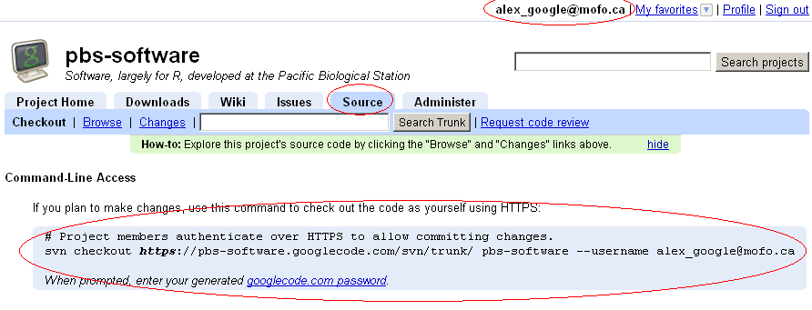

Click on the googlecode.com password link to retrieve your SVN password
Also note the username at the end of the line: it should be the same google account you sign in with.

3) create a new folder and rightclick anywhere in it
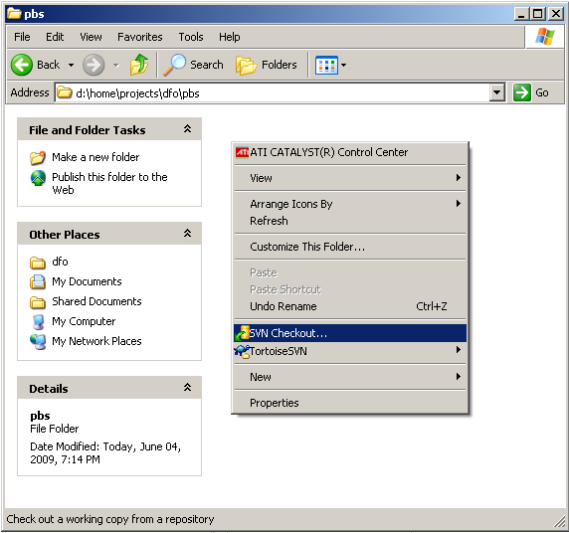

4) Enter the URL: https://pbs-software.googlecode.com/svn/
This URL is different from the complete URL google shows.
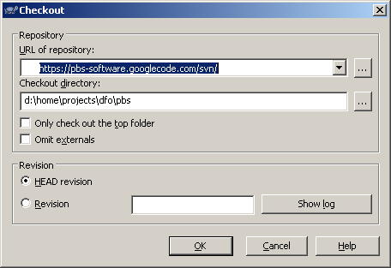

5) Enter username (google account – as indicated in step 2)
And the googlecode.com generated password (different from the regular password)
Check “save authentication”
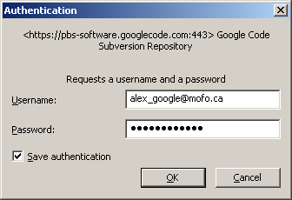

6) Files download automatically
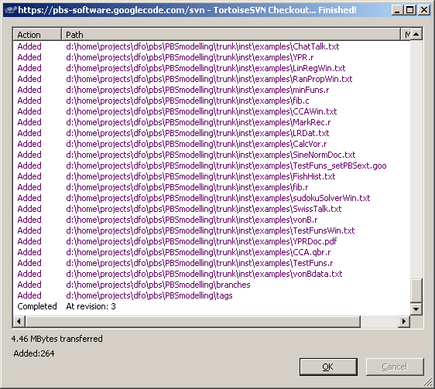

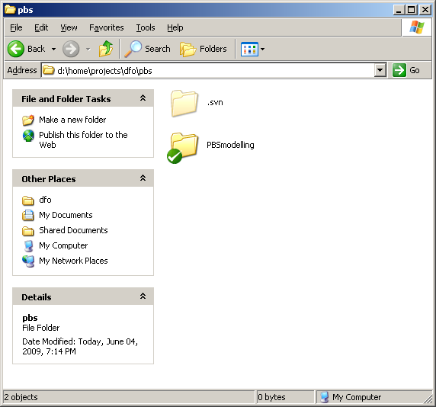

Directories and files under source revision appear with a checkmark, which indicates they are synced with the server copy.

This concludes the setup procedure.

Directory Layout:
There’s no real rule as to the layout; however, the common practice is to use a directory called trunk where the main development occurs.
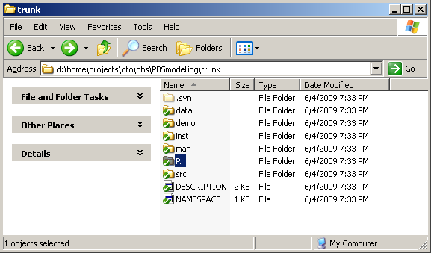

Modified Files:
When files are modified they will appear with a red exclamation mark – indicating that you have local modifications which are not backed up
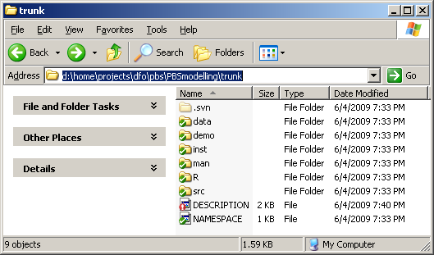

Committing Changes:
Right click in the directory, and select SVN Commit
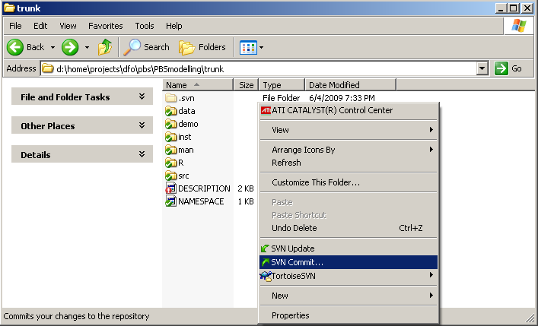

Enter a message to describe what you changed, then hit OK
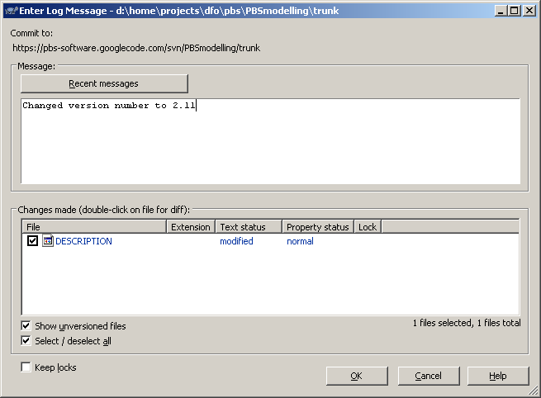

File Upload Log
